1.ls list files
cat command allows us to create single or multiple files, view contain of file, concatenate files and redirect output in terminal or files.
BoJ9jbbUNNfktd78OOpsqOltutMc3MY1
2.dash (-) as first character from Linux command line. It can be difficult, because the script “thinks” the marks after the dash are parameters.
cat ./-
CV1DtqXWVFXTvM2F0k09SHz0YwRINYA9
3.cat "spaces in this filename"
UmHadQclWmgdLOKQ3YNgjWxGoRMb5luK
4.#ls
#cd inhere
inhere#ls -a
inhere#cat .hidden
pIwrPrtPN36QITSp3EQaw936yaFoFgAB

5.#ls
#cd inhere
inhere#ls
and i did cat ./filename to every file
koReBOKuIDDepwhWk7jZC0RTdopnAYKh
koReBOKuIDDepwhWk7jZC0RTdopnAYKh

6.find . -type f -size 1033c ! -executable -exec file {} + | grep -w text

find . -size 1033c ! -executable
cat ./maybehere07/.file2

DXjZPULLxYr17uwoI01bNLQbtFemEgo7

7.The file have multiple parameters to find so
#file / -user bandit7 -group bandit6 -size 33c
#cat /var/lib/dpkg/info/bandit7.password
HKBPTKQnIay4Fw76bEy8PVxKEDQRKTzs

8.Display N lines around match
strings data.txt | grep millionth
cvX2JJa4CFALtqS87jk27qwqGhBM9plV

9.when I searched for previous problem word million appeared only once
#cat data.txt | sort | uniq -u
UsvVyFSfZZWbi6wgC7dAFyFuR6jQQUhR

10.#strings data.txt | grep =
truKLdjsbJ5g7yyJ2X2R0o3a5HQJFuLk

11.#base64 -d data.txt
IfukwKGsFW8MOq3IRFqrxE1hxTNEbUPR

12.#cat data.txt | tr 'A-Za-z' 'N-ZA-Mn-za-m'
5Te8Y4drgCRfCx8ugdwuEX8KFC6k2EUu
13.From the list of command, xxd is to make a hexdump or do the reverse
#xxd -r data.txt > xyz
To know what kind of file it is use
#file data2
1. Identify what type of file is this, using the file command
2.Rename it to that particular file format, using the mv command to change its file type 3.Decompress/unzip the files using the correct type of tool
4.Repeat the above process until you have the ascii
bzip2 -d xyz.bz2file //to unzip a bzip2 file
gzip -d xyz.gz

8ZjyCRiBWFYkneahHwxCv3wb2a1ORpYL
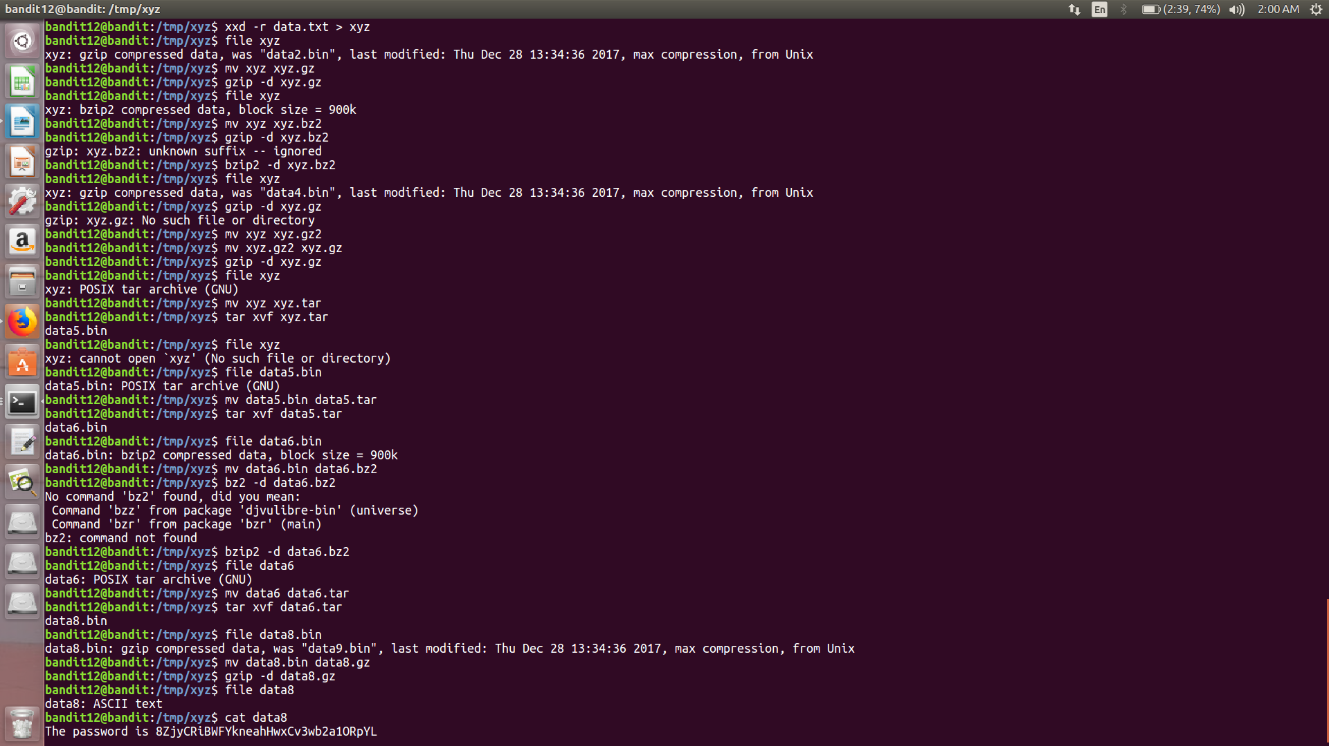

14.#ls -al to see all files including root files
#ssh bandit14@localhost -i sshkey.private
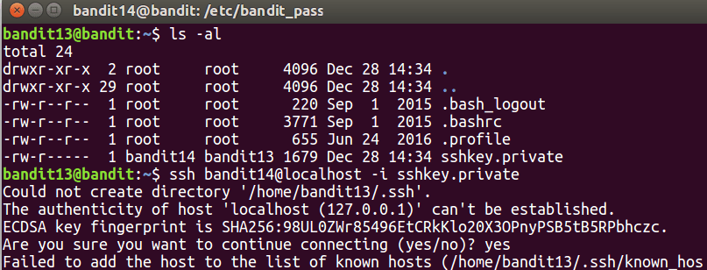
15.#cd /etc/bandit_pass
#cat bandit14
4wcYUJFw0k0XLShlDzztnTBHiqxU3b3e

16.nc command is used to connect to port
#nc localhost 30000
4wcYUJFw0k0XLShlDzztnTBHiqxU3b3e
Flag:BfMYroe26WYalil77FoDi9qh59eK5xNr

17.#openssl s_client -quiet -connect 127.0.0.1:30001
BfMYroe26WYalil77FoDi9qh59eK5xNr
Flag:cluFn7wTiGryunymYOu4RcffSxQluehd

18.scan all the open ports in range 31000 -32000
#nmap localhost -p31000-32000
Now connect the all portsvto server by using nc command
#echo hello | nc localhost 31046
#echo hello | nc localhost 31518
#echo hello | nc localhost 31790
#echo hello | nc localhost 31691
now we have two ports that reply with an SSL error.
#echo cluFn7wTiGryunymYOu4RcffSxQluehd | openssl s_client -quiet -connect localhost:31790 it #gives an RSA key
copy the RSA key and save it
#mkdir /tmp/bandit16
#cd /tmp/bandit16
#vim sshkey.private
#ssh -i ./sshkey.private bandit17@localhost
it asks for a password of which is a private key press ctrl+z
#chmod 600 sshkey.private
#ssh -i ./sshkey.private bandit17@localhost
it allows to next level

19.#ls
to compare between two files we use diff command
#diff passwords.old passwords.new
it gives the flag
Flag:kfBf3eYk5BPBRzwjqutbbfE887SVc5Yd

20.#ls
#./bandit20-do
#./bandit20-do cat /etc/bandit_pass/bandit20
GbKksEFF4yrVs6il55v6gwY5aVje5f0j

21.I made port 2345 communicate with localhost such that when localhost reads port 2345 listens to localhost
terminal-1
#echo “GbKksEFF4yrVs6il55v6gwY5aVje5f0j” | nc -l 2345
terminal-2
#./suconnect 1234
gE269g2h3mw3pwgrj0Ha9Uoqen1c9DGr

22.#cd /etc/cron.d
#ls
#cat cronjob_bandit22
#cat /usr/bin/cronjob_bandit22.sh (it gives an output which reads from current file and write it to
#/tmp/t7O6lds9S0RqQh9aMcz6ShpAoZKF7fgv
#cat /tmp/t7O6lds9S0RqQh9aMcz6ShpAoZKF7fgv
Flag:Yk7owGAcWjwMVRwrTesJEwB7WVOiILLI

23.#cd /etc/cron.d
#ls
#cat cronjob_bandit23 it gives result
@reboot bandit23 /usr/bin/cronjob_bandit23.sh &> /dev/null
* * * * * bandit23 /usr/bin/cronjob_bandit23.sh &> /dev/null
#cd /usr/bin
#cat cronjob_bandit23 it gives
#!/bin/bash

myname=$(whoami)
mytarget=$(echo I am user $myname | md5sum | cut -d ' ' -f 1)

echo "Copying passwordfile /etc/bandit_pass/$myname to /tmp/$mytarget"

cat /etc/bandit_pass/$myname > /tmp/$mytarget
#./cronjob_bandit23.sh
Copying passwordfile /etc/bandit_pass/bandit22 t0
/tmp/8169b67bd894ddbb4412f91573b38db3

# echo I am user bandit23 | md5sum | cut -d ' ' -f 1
7db97df393f40ad1691b6e1fb03d53eb
#cat /tmp/8ca319486bfbbc3663ea0fbe81326349

jc1udXuA1tiHqjIsL8yaapX5XIAI6i0n

24.

