Prathish T

GYM PERFORMANCE ANALYSIS USING SQL AND PYTHON

1.Project Overview
This project focuses on analyzing the business performance of a multi-branch gym management system using SQL and Python. The objective is to evaluate revenue generation, customer retention, branch performance, and member engagement through structured analytical methods.
The dataset was synthetically generated to simulate a real-world gym business scenario. The project demonstrates end-to-end data handling, including database design, SQL-based business analysis, and Python-based exploratory data analysis.
2.Tools and Technologies Used
- MySQL for database design and SQL analysis.
- Python with Pandas and Matplotlib for data analysis and visualization.
- Jupyter Notebook for Python implementation.
- MS Word for documentation.
3.Dataset Description
The dataset was synthetically generated using Python to simulate a realistic gym management system. It consists of five relational tables.
Branches table contains: branch_id, branch_name, and city.
Members table contains: member_id, member_name, age, gender, join_date, and branch_id.
Membership Plans table contains: plan_id, plan_name, price, and duration_months.
Subscriptions table contains: subscription_id, member_id, plan_id, start_date, end_date, and status.
Workout Logs table contains: log_id, member_id, workout_type, calories_burned, and workout_date.
Dataset scale includes approximately 5,000 members, 12,000 subscriptions, and 50,000 workout records.
4.Database Design
A relational database schema was created in MySQL with proper primary key and foreign key constraints to ensure referential integrity.
- One branch can have many members.

- One member can have many subscriptions.
- One member can have many workout logs.
- One membership plan can have many subscriptions.
This structure simulates a real-world business database system.
5.SQL Analysis
Revenue Analysis
Total revenue was calculated by joining the subscriptions table with the membership plans table and aggregating the price column. The total revenue generated was approximately 41.87 million.
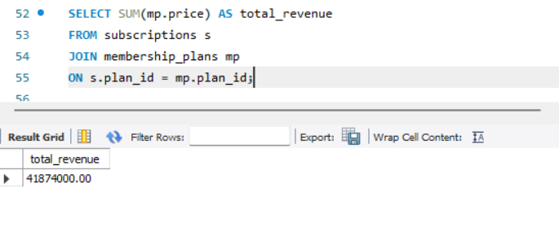
Revenue by Plan
Revenue contribution was analyzed for each membership plan. The Elite plan generated the highest revenue despite having fewer subscriptions compared to the Premium plan.
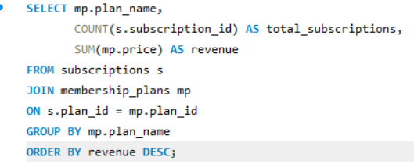
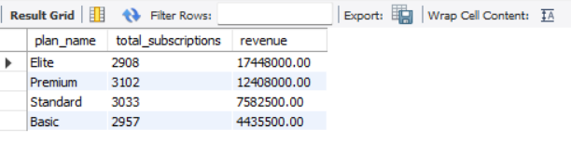
Revenue by City
Revenue distribution across cities was analyzed. Bangalore contributed the majority of total revenue.
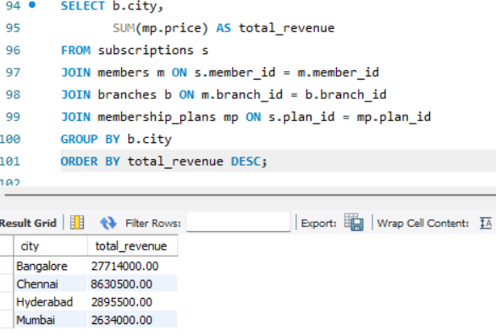
Branch Performance
Top performing branches were identified based on revenue contribution. Marathahalli branch generated the highest revenue.
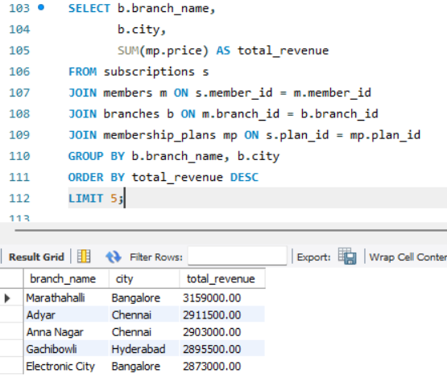
Monthly Revenue Trend
Monthly revenue was calculated using date formatting functions to analyze revenue patterns over time.
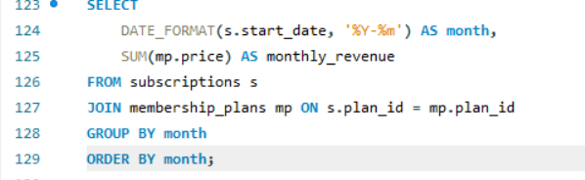
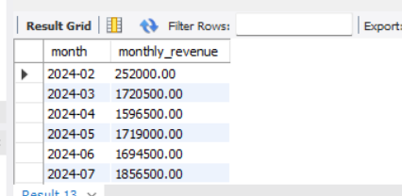
Churn Analysis
Churn was defined as expired subscriptions. Churn rate was calculated as expired subscriptions divided by total subscriptions multiplied by 100. The overall churn rate was approximately 77 percent.
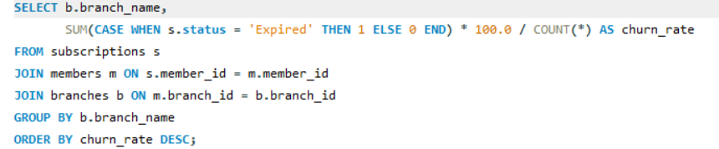
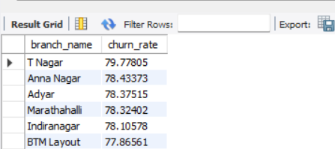

Churn by Plan
Churn rate was analyzed across membership plans to identify plan-level retention differences.
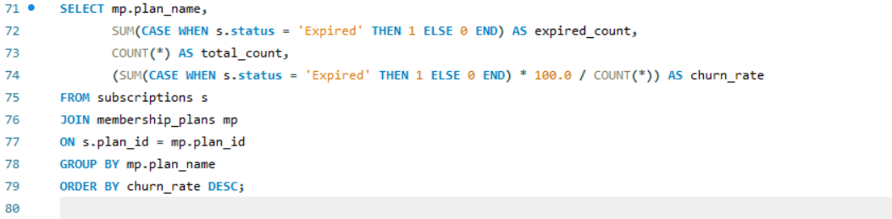
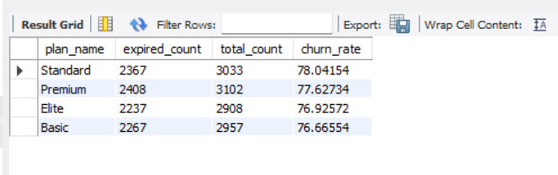
Engagement Analysis
Workout logs were aggregated at the member level before analysis to avoid duplication issues. Average workouts per member and workout distribution were analyzed.
6.Python Analysis
Data Merging
Relational tables were merged carefully using proper join keys. Workout logs were aggregated before merging to maintain correct granularity.
Revenue Validation
Revenue calculated in SQL was validated using Python groupby operations to ensure consistency.
Churn Validation
Subscription status distribution was analyzed to confirm churn percentage.
Visualizations
Bar charts and line charts were created to visualize

Revenue by plan
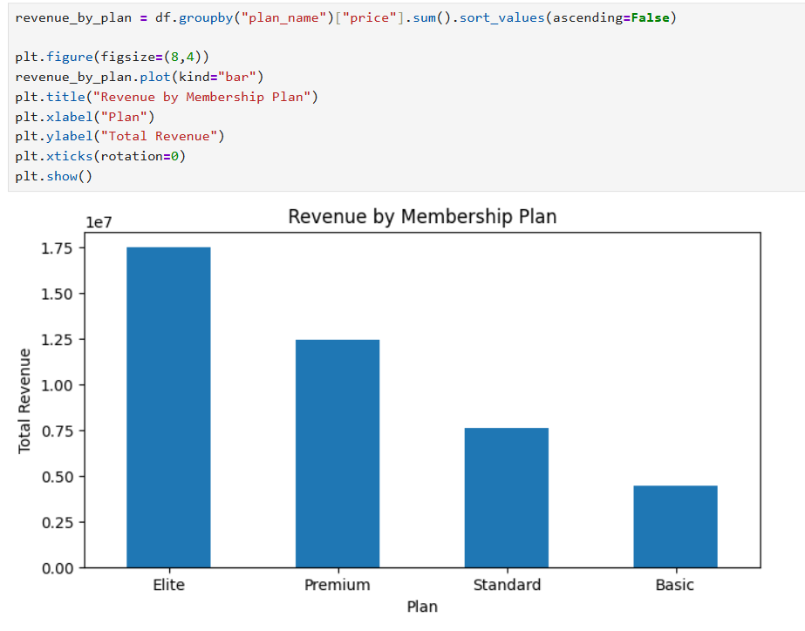
Revenue by city
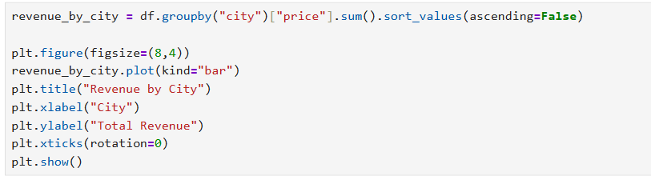
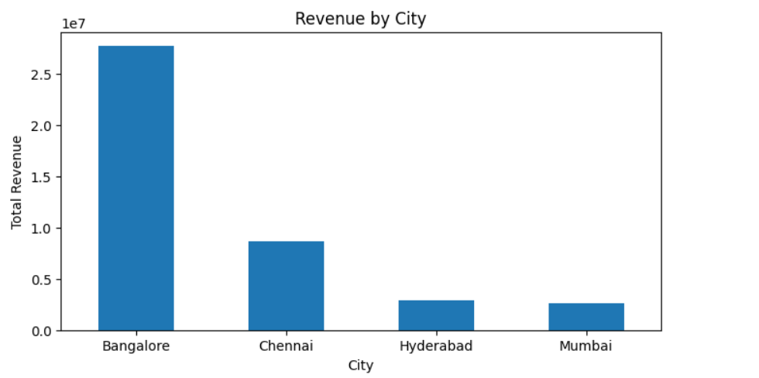

Monthly Revenue Trends
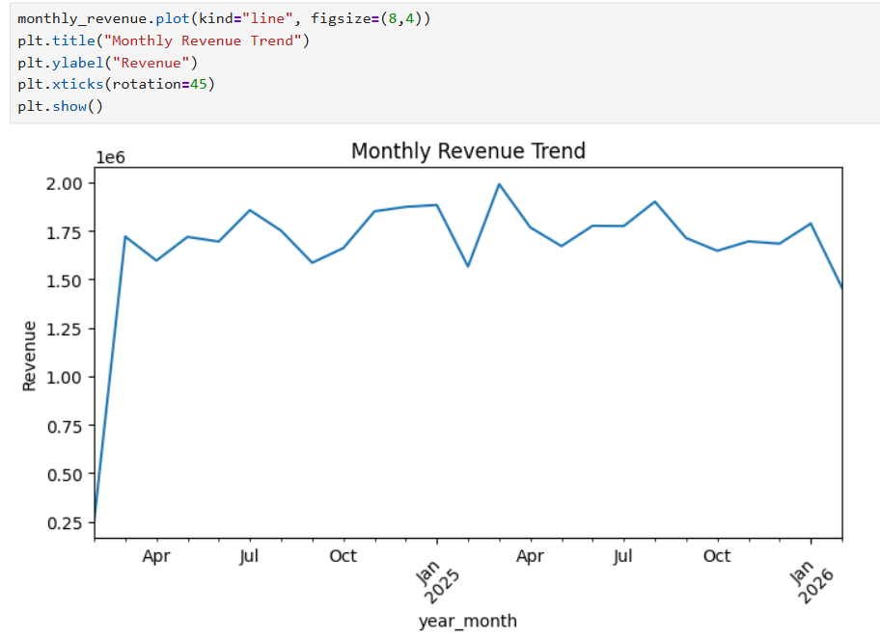

Engagement Analysis
Workout frequency and workout type distribution were analyzed to understand member engagement patterns.
Demographic Analysis
Age distribution of members was analyzed to understand customer demographics.
7.Key Findings
- Total revenue generated was approximately 41.87 million.
Elite plan generated the highest revenue.
- Bangalore contributed the largest share of revenue.
Overall churn rate was high at approximately 77 percent.
- Branch performance varied significantly across cities.
Customer engagement levels differed among members.
8.Conclusion
This project demonstrates a complete analytical workflow including database schema design, SQL-based business analysis, Python-based validation and visualization, and generation of business insights. The analysis provides a structured framework for evaluating revenue performance, retention challenges, and operational efficiency in a subscription-based gym business model.

