**1. A group of n 2 people decide to play an exciting game of Rock-Paper Scissors. As you may**

**recall, Rock smashes Scissors, Scissors cuts Paper, and Paper covers Rock (despite Bart**

**Simpson saying “Good old rock, nothing beats that!”). Usually, this game is played with 2**

**players, but it can be extended to more players as follows. If exactly 2 of the 3 choices**

**appear when everyone reveals their choice, say a, b 2 {Rock, P aper, Scissors} where a beats**

**b, the game is decisive: the players who chose a win, and the players who chose b lose.**

**Otherwise, the game is indecisive and the players play again. For example, with 5 players, if**

**one player picks Rock, two pick Scissors, and two pick Paper, the round is indecisive and they**

**play again. But if 3 pick Rock and 2 pick Scissors, then the Rock players win and the Scissors**

**players lose the game. 1 Assume that the n players independently and randomly choose**

**between Rock, Scissors, and Paper, with equal probabilities. Let X, Y, Z be the number of**

**players who pick Rock, Scissors, Paper, respectively in one game.**

**(a) Find the joint PMF of X, Y, Z.**

**(b) Find the probability that the game is decisive. Simplify your answer (it should not involve**

**a sum of many terms).**

**🡪**

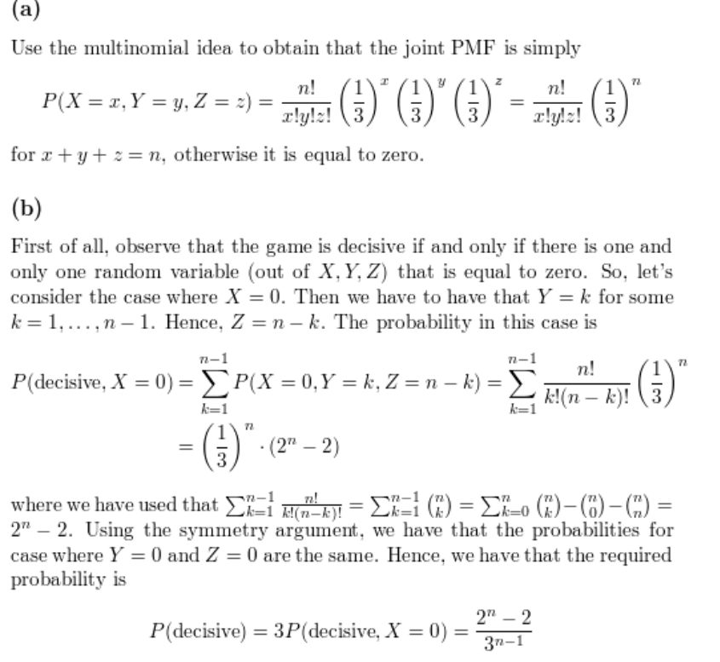

**(c) What is the probability that the game is decisive for n = 5? What is the limiting probability**

**that a game is decisive as n ! 1? Explain briefly why your answer makes sense.**

**🡪**

