What Is a Flowchart?
“A diagram that shows step-by-step progression through a procedure or system especially using connecting lines and a set of conventional symbols.”
What does this mean? What it means is that a flowchart can be used to break big ideas into small, bite-sized pieces that are expressed visually.
Knowing how to flowchart is like having access to a Universal language which makes it possible to communicate all sorts of things with all sorts of people.
They are widely used by both technical and non-technical people in multiple fields to document, study, plan, improve and communicate often complex processes in clear, easy-to-understand diagrams.
Flowcharts, use simple shapes like rectangles, ovals, diamonds and other shapes to define the type of step, along with connecting arrows to define flow and sequence.
They can range from simple, hand-drawn charts to comprehensive computer-drawn diagrams depicting multiple steps and routes.

Basic Flowchart Symbols
In order to create a good flowchart you must first familiarize yourself with the most commonly used flowchart symbols.
1. The Oval/ Terminal
An End or a Beginning

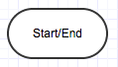
The oval is used to represent the start and end of a process/ program. The terminator is used to show where your flow begins or ends. Ideally, you would use words like 'Start', 'Begin', 'End' inside the terminator object to make things more obvious.
2. The Rectangle
A Step in the Flowcharting Process

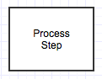
It represents any step in the process you’re depicting and is the workhorse of the flowchart diagram. Indicates processes like mathematical operations. the text in the rectangle mostly includes a verb.
3. The Arrow
Directional Flow

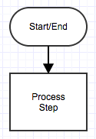
The arrow is used to guide the viewer along their flowcharting path. Shows relationships between different shapes.
4. The Diamond
Call for a Decision


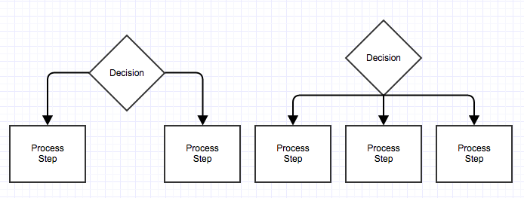
The diamond symbolizes that a decision needs to be made. It is always used in a process flow to as a question. And, the answer to the question determines the arrows coming out of the Diamond. If there are only two choices, you can draw arrows directly from the diamond to the next step (example on the left). If there are more than two choices, refer to digram on the right.

5. Input/ Output


Used for denoting the Inputs to and Outputs from a process (but NOT manual inputs).
6. On-page Connector

Connects two or more parts of a flowchart which are on the same page.

7. Off-page Connector


Connects two or more parts of a flowchart which are spread over different pages.

8. Some Other Symbols
Delay | 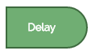 | The delay symbol represents a waiting period, such as processing time or attempting to get something done
Merge Extract | 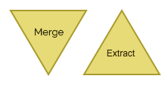 | Use merge or extract when a number of different paths converge into one or for when one path splits into many.
Predefined Process | 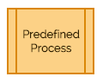 | The predefined process shape serves as a placeholder for multiple steps that you aren’t going to spell out in your flowchart. For example, if you’re illustrating the process of setting up a home computer you might label a predefined process as “connect to the internet,” knowing that describing all the ins and outs of that step is beyond the scope of your flowchart.
Card | 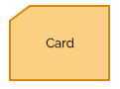
Preparation | 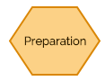 | Get ready for the preparation symbol, which marks a point in the process that requires groundwork.
Information Storage Symbols (database) | 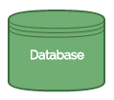 | If you’re representing a step in your process in which data is being transferred to or from a database, use this symbol.

