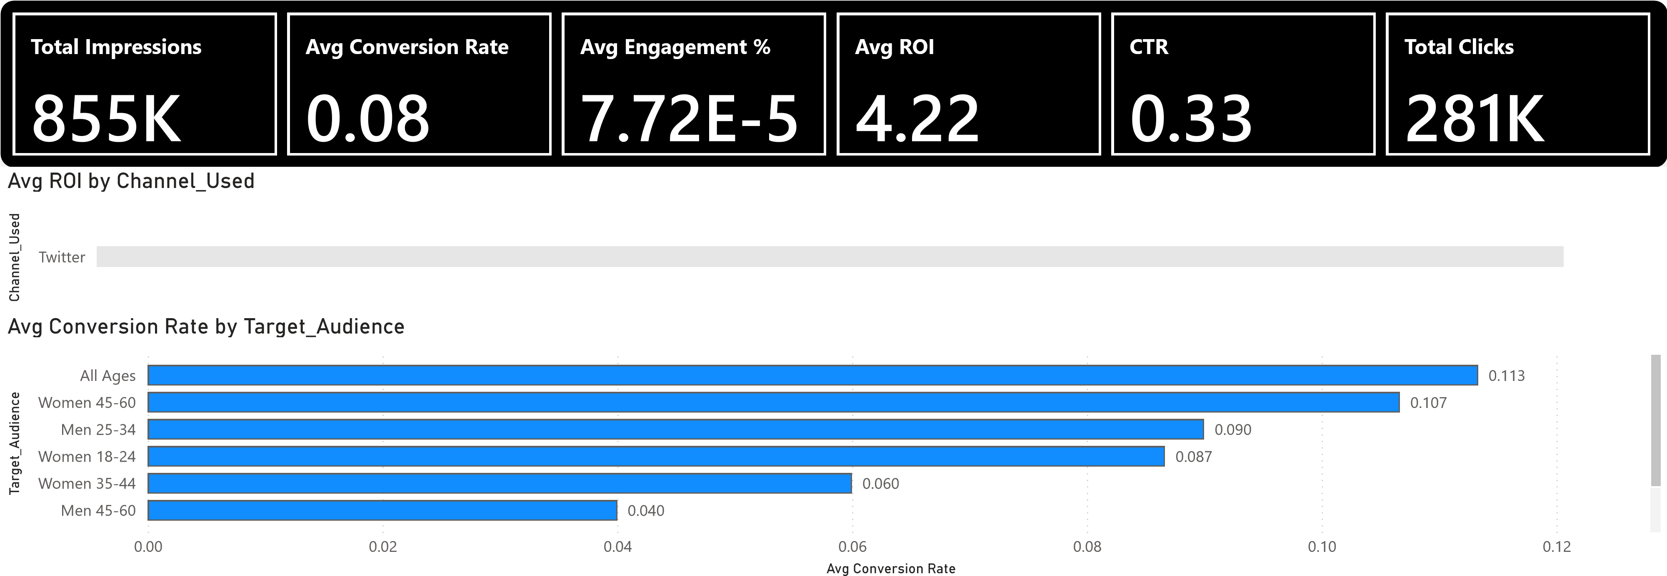
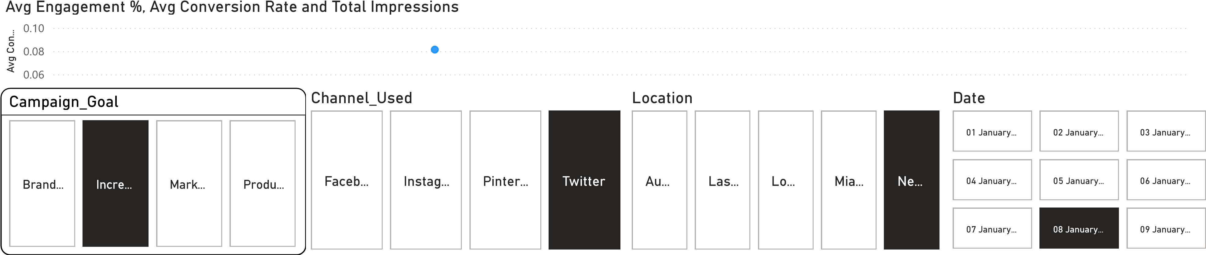
BI Desktop
er
Pow
Total Campaigns
K
255
Avg ROI
3.18
Conversion Rate Breakdown by Audience Group
0.0
0.2
0.4
0.6
0.8
Channel_…
Twitter
Target_Audience
All Ages
Men 18-24
Men 25-34
Men 35-44
Men 45-60
Women 18-24
Women 25-34
Women 35-44
Women 45-60
Campaign Distribution by Customer Segment
)
K (20.05%
58
K (20.01%
58
)
)
58
K (20.01%
K (19.99%
)
58
58
K (19.94%
)
Customer_Segment
Health
Home
Food
ROI by Location and Channel

Location
Miami
Los Angeles
New York
Austin
Las Vegas
© 2025 TomTom, © 2025 Microsoft Corporation
© 2025 TomTom, © 2025 Microsoft Corporation
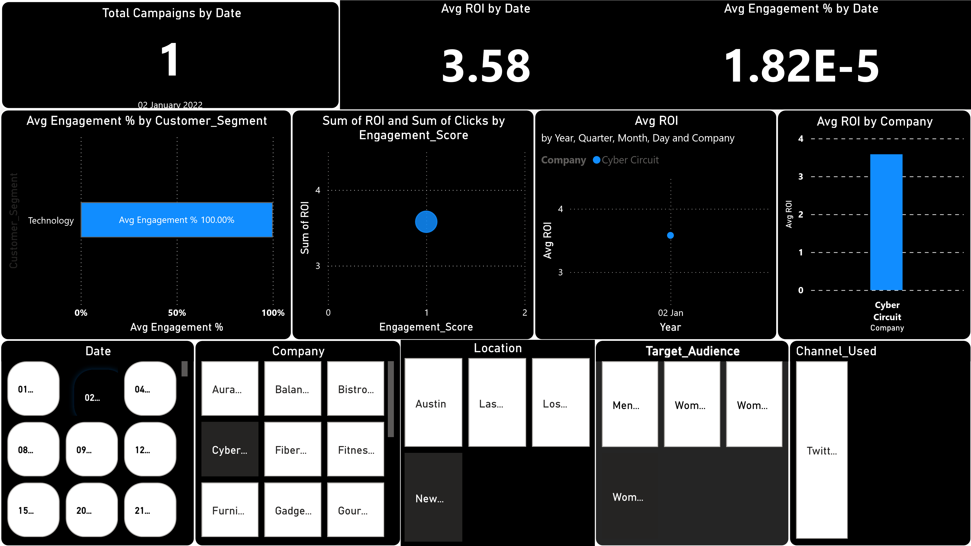

Power BI Desktop
Avg ROI
Total Campaigns
255
K
Avg Engagement %
7.80E-5
Avg ROI
3.18
📌
KEY INSIGHTS SUMMARY
1
. Channel Performance
•
Instagram delivers the highest engagement and strong ROI.
•
Facebook has high impressions but lower ROI.
•
Twitter and Pinterest show weaker results.
2
. Audience Insights
•
Women 25–34 and Women 18–24 give the strongest conversion rates.
•
Men audience groups have comparatively lower conversions.
3
. Location Insights
•
Miami, New York, Austin show the highest ROI.
•
Los Angeles and Las Vegas underperform in conversion.
4
. Company-Level Insights
•
Chic Couture and Nest Neat deliver strong results.

