NAME : PRATHMESH H. MAGAR [SE-A-22]

**EXPERIMENT NO. 1**

**AIM** - Identify the real word problem and develop the problem statement . Design an ER model.

**THEORY** -

Bank Data Requirements

The initial specification of user requirements may be based on interviews with the database users, and on the designer’s own analysis of the enterprise. The description that arises from this design phase serves as the basis for specifying the conceptual structure of the database. Here are the major characteristics of the banking enterprise.

• The bank is organized into branches. Each branch is located in a particular city and is identified by a unique name. The bank monitors the assets of each branch.

• Bank customers are identified by their customer-id values. The bank stores each customer’s name, and the street and city where the customer lives. Customers may have accounts and can take out loans. A customer may be associated with a particular banker, who may act as a loan officer or personal banker for that customer.

• Bank employees are identified by their employee-id values. The bank administration stores the name and telephone number of each employee, the names of the employee’s dependents, and the employee-id number of the employee’s manager. The bank also keeps track of the employee’s start date and, thus,length of employment.

• The bank offers two types of accounts—savings and checking accounts. Accounts can be held by more than one customer, and a customer can have more than one account. Each account is assigned a unique account number. The bank maintains a record of each account’s balance, and the most recent date on which the account was accessed by each customer holding the account. In addition, each savings account has an interest rate, and overdrafts are recorded for each checking account.

• A loan originates at a particular branch and can be held by one or more customers. A loan is identified by a unique loan number. For each loan, the bank keeps track of the loan amount and the loan payments. Although a loan payment number does not uniquely identify a particular payment among those for all the bank’s loans, a payment number does identify a particular payment for a specific loan. The date and amount are recorded for each payment.

In a real banking enterprise, the bank would keep track of deposits and withdrawals from savings and checking accounts, just as it keeps track of payments to loan accounts. Since the modeling requirements for that tracking are similar, and we would like to keep our example application small, we do not keep track of such deposits and withdrawals in our model.

**What is ER Model**

The Entity Relational Model is a model for identifying entities to be represented in the [database](https://www.geeksforgeeks.org/what-is-database/) and representation of how those entities are related. The ER data model specifies enterprise schema that represents the overall logical structure of a database graphically.

**Why Use ER Diagrams In DBMS?**

* ER diagrams are used to represent the E-R model in a database, which makes them easy to be converted into relations (tables).
* ER diagrams provide the purpose of real-world modeling of objects which makes them intently useful.
* ER diagrams require no technical knowledge and no hardware support.
* These diagrams are very easy to understand and easy to create even for a naive user.
* It gives a standard solution for visualizing the data logically.

**Symbols Used in ER Model**

ER Model is used to model the logical view of the system from a data perspective which consists of these symbols:

* **Rectangles:**Rectangles represent Entities in ER Model.
* **Ellipses:**Ellipses represent Attributes in ER Model.
* **Diamond:**Diamonds represent Relationships among Entities.
* **Lines:**Lines represent attributes to entities and entity sets with other relationship types.
* **Double Ellipse:**Double Ellipses represent Multi-Valued Attributes.
* **Double Rectangle:**Double Rectangle represents a Weak Entity.

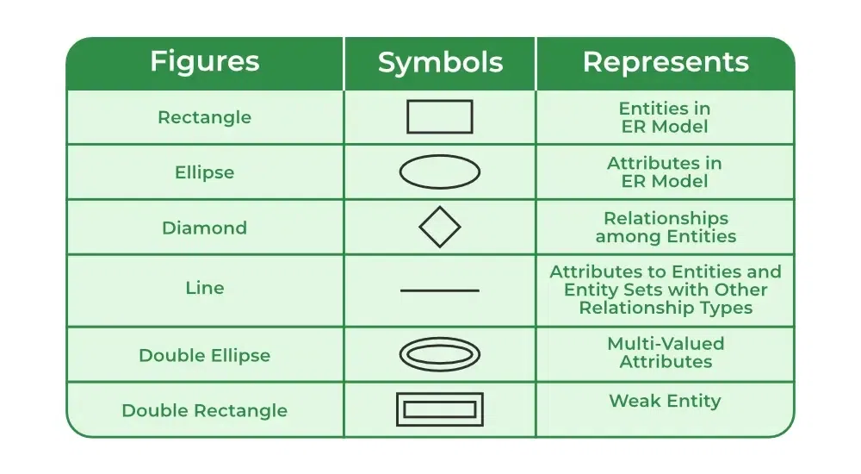

## Components of ER Diagram

ER Model consists of Entities, Attributes, and Relationships among Entities in a Database System.

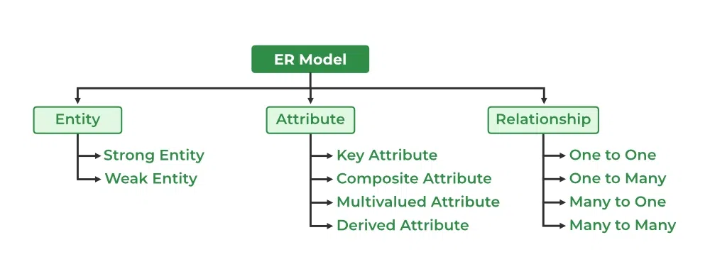

### Entity

An Entity may be an object with a physical existence – a particular person, car, house, or employee – or it may be an object with a conceptual existence – a company, a job, or a university course.

**Entity Set:** An Entity is an object of Entity Type and a set of all entities is called an entity set. For Example, E1 is an entity having Entity Type Student and the set of all students is called Entity Set. In ER diagram, Entity Type is represented as:

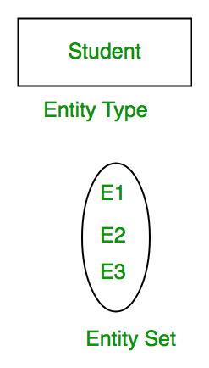

#### 1. Strong Entity

A [Strong Entity](https://www.geeksforgeeks.org/difference-between-strong-and-weak-entity/) is a type of entity that has a key Attribute. Strong Entity does not depend on other Entity in the Schema. It has a primary key, that helps in identifying it uniquely, and it is represented by a rectangle. These are called Strong Entity Types.

#### 2. Weak Entity

An Entity type has a key attribute that uniquely identifies each entity in the entity set. But some entity type exists for which key attributes can’t be defined. These are called [Weak Entity types](https://www.geeksforgeeks.org/weak-entity-set-in-er-diagrams/).

### **Attributes**

[Attributes](https://www.geeksforgeeks.org/types-of-attributes-in-er-model/) are the properties that define the entity type. For example, Roll_No, Name, DOB, Age, Address, and Mobile_No are the attributes that define entity type Student. In ER diagram, the attribute is represented by an oval.

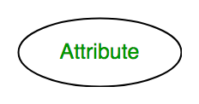

#### **1. Key Attribute**

The attribute which **uniquely identifies each entity** in the entity set is called the key attribute. For example, Roll_No will be unique for each student. In ER diagram, the key attribute is represented by an oval with underlying lines.

#### **2. Composite Attribute**

An attribute **composed of many other attributes** is called a composite attribute. For example, the Address attribute of the student Entity type consists of Street, City, State, and Country. In ER diagram, the composite attribute is represented by an oval comprising of ovals.

#### **3. Multivalued Attribute**

An attribute consisting of more than one value for a given entity. For example, Phone_No (can be more than one for a given student). In ER diagram, a multivalued attribute is represented by a double oval.

#### **4. Derived Attribute**

An attribute that can be derived from other attributes of the entity type is known as a derived attribute. e.g.; Age (can be derived from DOB). In ER diagram, the derived attribute is represented by a dashed oval.

The Complete Entity Type Student with its Attributes can be represented as:

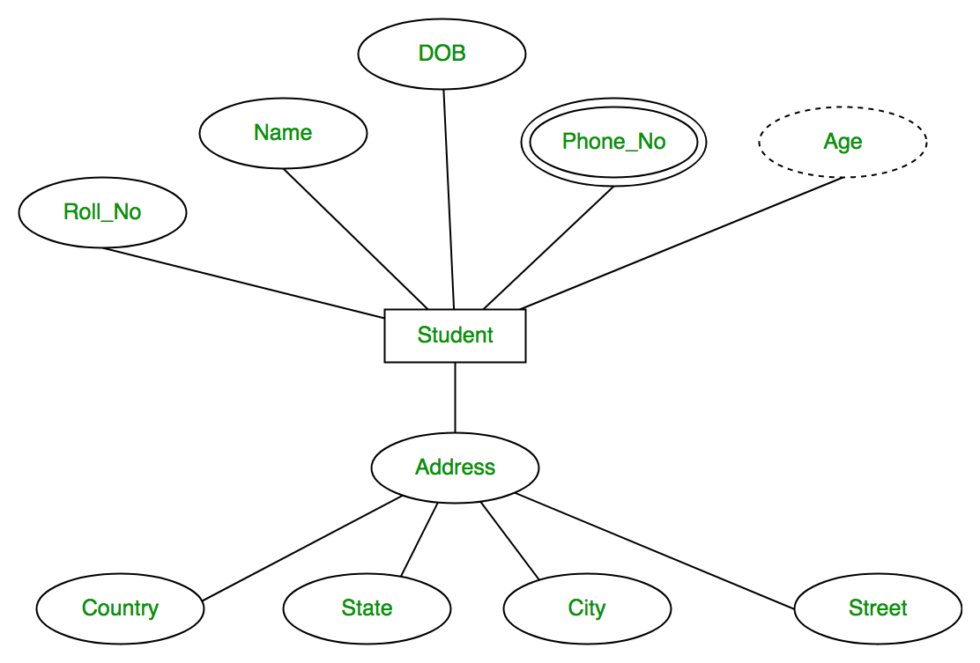

### **Relationship Type and Relationship Set**

A Relationship Type represents the association between entity types. For example, ‘Enrolled in’ is a relationship type that exists between entity type Student and Course. In ER diagram, the relationship type is represented by a diamond and connecting the entities with lines.

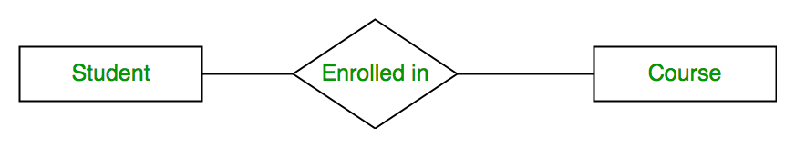

**1. Unary Relationship:**When there is only ONE entity set participating in a relation, the relationship is called a unary relationship. For example, one person is married to only one person.

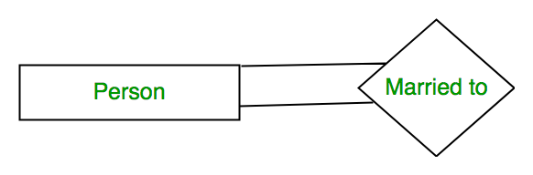

*Unary Relationship*

**2. Binary Relationship:**When there are TWO entities set participating in a relationship, the relationship is called a binary relationship. For example, a Student is enrolled in a Course.

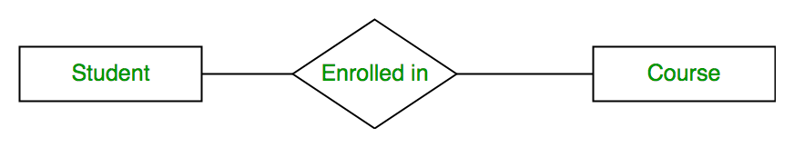

*Binary Relationship*

**3. n-ary Relationship:**When there are n entities set participating in a relation, the relationship is called an n-ary relationship.

#### **Cardinality**

The number of times an entity of an entity set participates in a relationship set is known as [cardinality](https://www.geeksforgeeks.org/cardinality-in-dbms/). Cardinality can be of different types:

**1. One-to-One:** When each entity in each entity set can take part only once in the relationship, the cardinality is one-to-one. Let us assume that a male can marry one female and a female can marry one male. So the relationship will be one-to-one.

the total number of tables that can be used in this is 2.

Using Sets, it can be represented as:

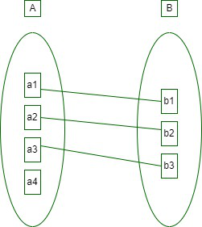

*Set Representation of One-to-One*

**2. One-to-Many:** In one-to-many mapping as well where each entity can be related to more than one relationship and the total number of tables that can be used in this is 2.

**3. Many-to-One:** When entities in one entity set can take part only once in the relationship set and entities in other entity sets can take part more than once in the relationship set, cardinality is many to one. Let us assume that a student can take only one course but one course can be taken by many students. So the cardinality will be n to 1. It means that for one course there can be n students but for one student, there will be only one course.

The total number of tables that can be used in this is 3.

*Many-to-One Relationship*

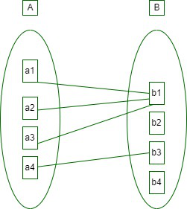

*Set Representation of Many-to-One*

In this case, each student is taking only 1 course but 1 course has been taken by many students.

**4. Many-to-Many:**When entities in all entity sets can take part more than once in the relationship cardinality is many to many. Let us assume that a student can take more than one course and one course can be taken by many students. So the relationship will be many to many.

the total number of tables that can be used in this is 3.

Using Sets, it can be represented as:

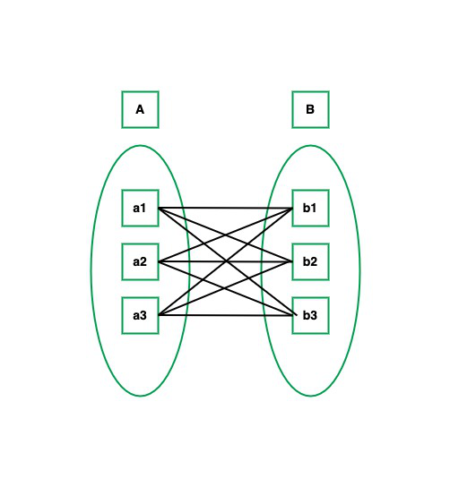

*Many-to-Many Set Representation*

In this example, student S1 is enrolled in C1 and C3 and Course C3 is enrolled by S1, S3, and S4. So it is many-to-many relationships.

**Implementation –**

**ER DIAGRAM FOR BANK DATABASE SYSTEM**

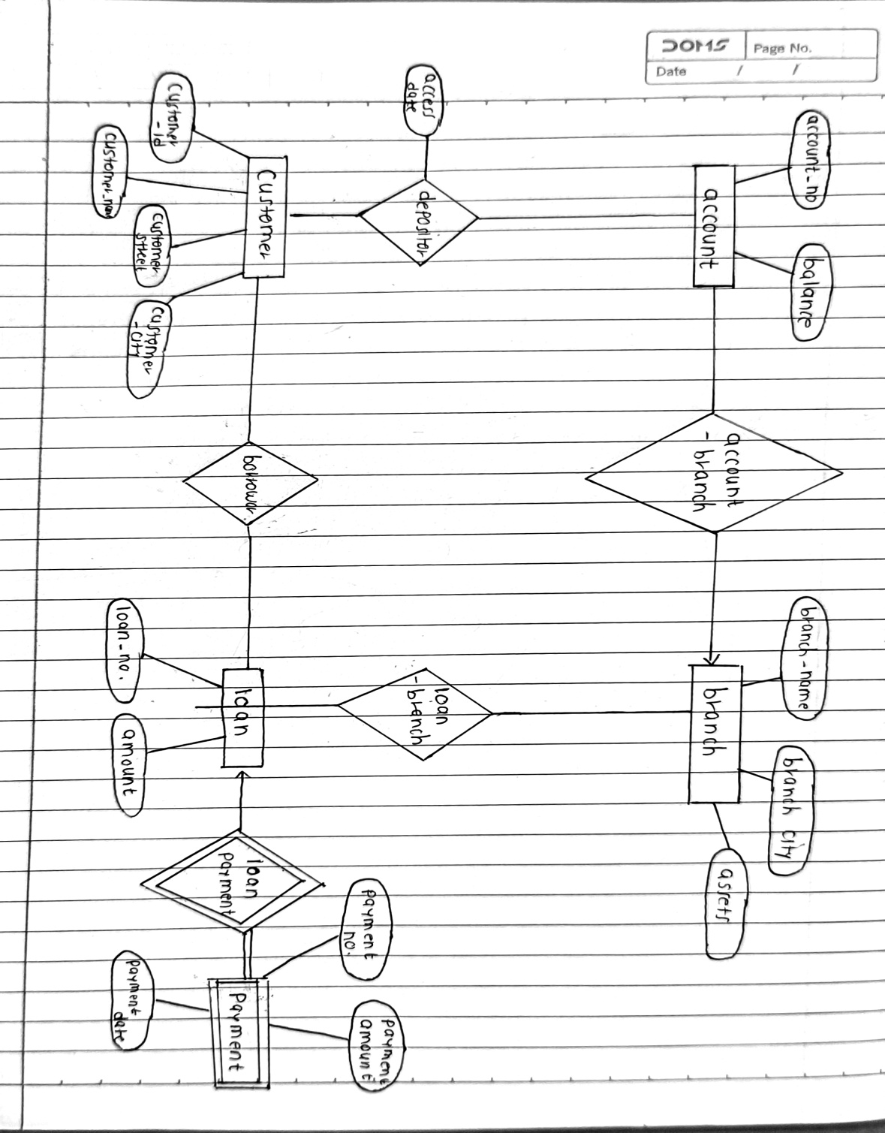

**CONCLUSION** –

Thus we have successfully implemented the ER model.