Document Edit History

|  |  |  |  |
| --- | --- | --- | --- |
| Version | Date | Additions/Modifications | Prepared/Revised by |
| Version 1.0 | 02/07/2025 | Initial Draft | Prathmesh Joshi |
|  |  |  |  |

**Document Review/Approval History**

|  |  |  |  |
| --- | --- | --- | --- |
| Date | Name | Organization/Title | Comments |
|  |  |  |  |
|  |  |  |  |
|  |  |  |  |

Contents

1 Introduction 3

2 Matillion Integration 3

2.1 Prerequisites 3

2.2 Connecting Github to Matillion 3

2.2.1 Set up Matillion Project 3

2.2.2 Connecting GitHub to Matillion 4

2.2.3 Authorize Matillion 4

2.2.4 Matillion App Installation 4

2.2.5 Configuring the Repository to Project 6

2.2.6 Review the Project and Branches in Matillion 6

3 DBT Integration 7

3.1 Prerequisites 7

3.2 DBT Action Items 7

3.2.1 User Group Creation 7

3.2.2 Invite User 7

3.3 Connecting Github to dbt Cloud 7

3.4 Configuring the Repository 7

3.4.1 Authenticate GitHub account 8

3.4.2 Repository Access 8

3.4.3 App Installation 8

3.4.4 Authorize the DBT App 8

3.4.5 Review the Repository and Branches in DBT 8

# Introduction

This document aims to detail the step-by-step process for integrating GitHub with Matillion and Data Build Tool (DBT).

## 

# Matillion Integration

The high-level data flow captures process of loading data from source system till consumption layer through curated and processed layer.

## Prerequisites

* A Github account with a repository.
* A Matillion ETL instance.
* Make sure you are logged into GitHub with Montefiore details.

## Connecting Github to Matillion

### Set up Matillion Project

* Login to Matillion and create a new project using ‘Add project’:

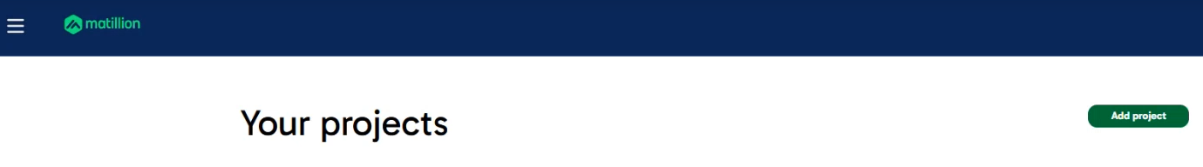

#### Provide necessary details for the project setup:

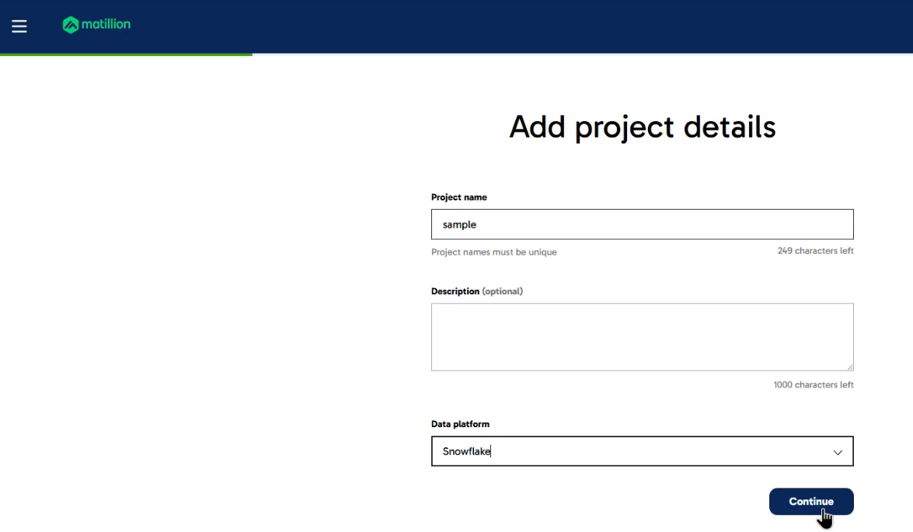

### Connecting GitHub to Matillion

* Navigate to Advanced Settings to configure your own Git integration.

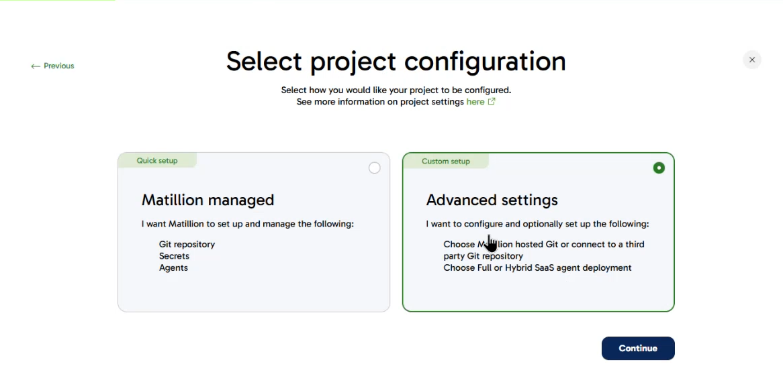

### Authorize Matillion

* Authorize Matillion with your GitHub credentials. The system will identify the organization using the Montefiore account you are logged into.

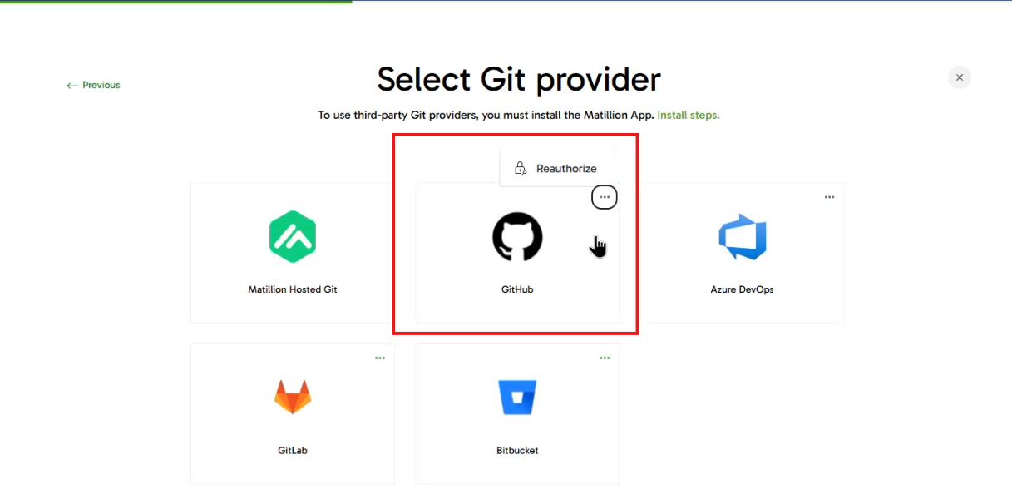

### Matillion App Installation

* Follow the installation steps or visit the appropriate page to install the Matillion app for GitHub integration.

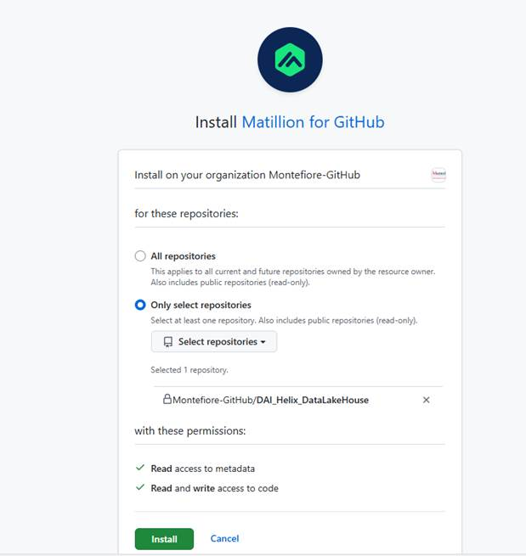

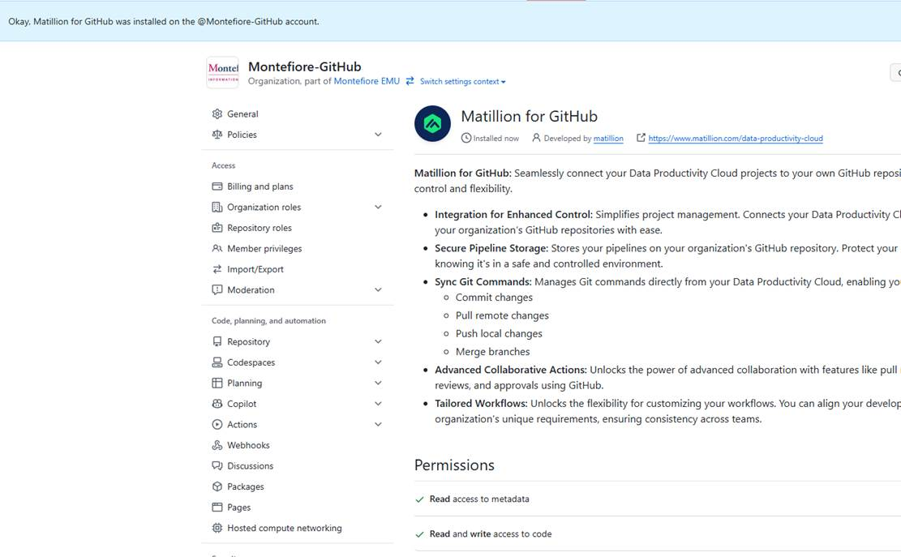

* After installing the app, a request will be sent to the admin for approval. Once approved, you will see Matillion for GitHub installed in your Developer Settings.

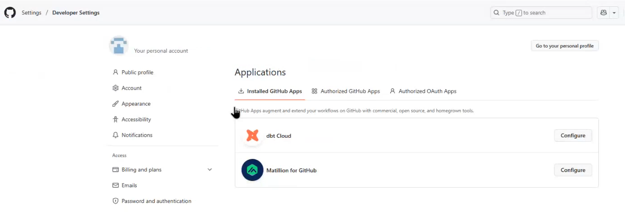

### Configuring the Repository to Project

* After Matillion is installed in your GitHub account, return to the GitHub page and select an available repository that is not linked to any existing project for your Matillion project.

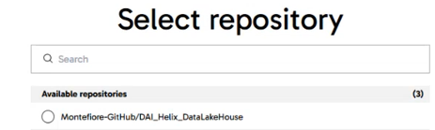

### Review the Project and Branches in Matillion

* Verify the project connected with the repository.

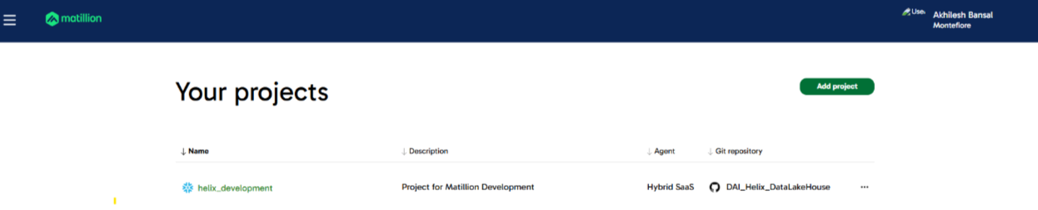

* Review the feature branch connected for the project.

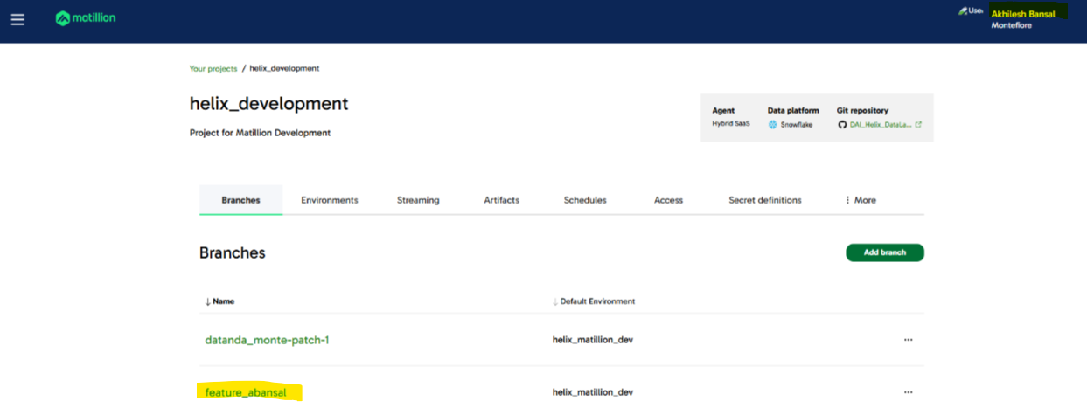

* Verify the folder structure.

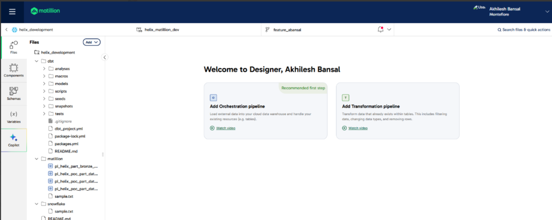

# DBT Integration

## Prerequisites

* A GitHub account with a repository.
* DBT Cloud Access

## DBT Action Items

### User Group Creation

* Navigate to the Account settings in DBT and click Groups & Licenses on the left-side menu.
* Click Create Group
* Enter the new group name "helix_acct_admin" in the SSO field.
* Configure the Access and permissions fields. Select permission set as Account admin, the project as helix-development, and Environment Write Access as All environments.

### Invite User

* Navigate to the Account settings in DBT and click Users on the left-side menu.
* Click Invite Users
* Enter Email Address: <GitHub Organization Admin>
* Select License: Developer
* Select Groups : helix_acct_admin
* Click send invitations

## Connecting Github to dbt Cloud

## Configuring the Repository

### Authenticate GitHub account

* Navigate to the Account settings in DBT and click ‘Configure Repository’
* It will take you to App Installation page
* Authenticate using your Montefiore connections.
* Once authenticates, it will find the Montefiore repository and identify Montefiore-Github organization.

### Repository Access

* Within Montefiore-Fithub organization, we will find multiple repositories.
* Select DAI_Helix_DataLakeHouse.

### App Installation

* After selecting the repository, we will be asked to install the dbt app. DBT will install an app in Github so that it can manage everything on GitHub.
* After successful installation, please go to Settings-Integration-Application and verify if you are able to see dbt app installed.

#### 

* This DBT Cloud app will help dbt interact with GitHub.

### Authorize the DBT App

* Authorize the DBT app in Authorized GitHub Apps.

#### 

#### 

### Review the Repository and Branches in DBT

* Post authentication, verify the Git repository in DBT

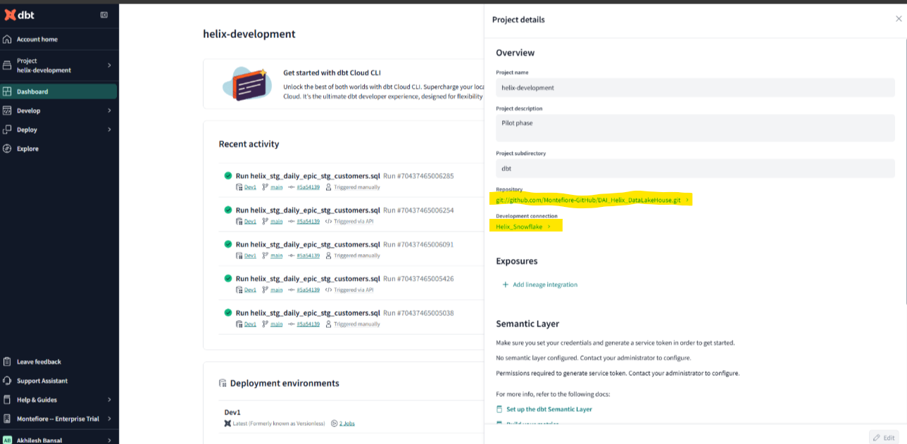

* Review the feature branch

