1. Display (In text file too) :

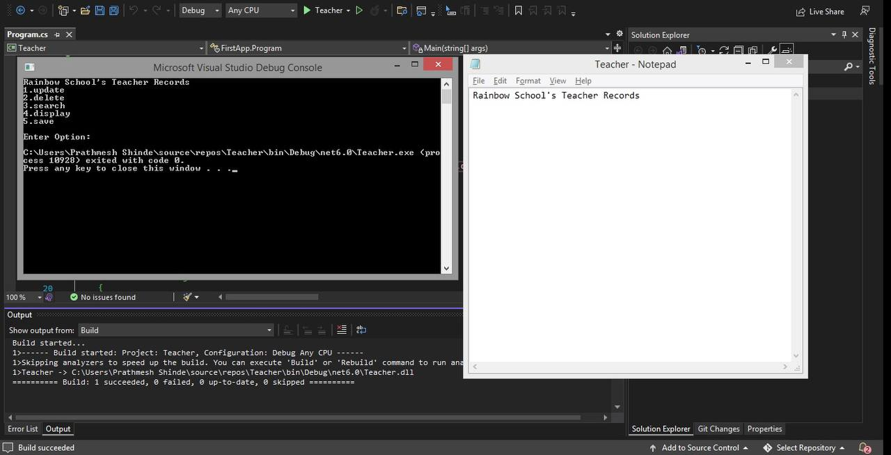

1. Now we are going to add 1st Teacher. The there is nothing perilously so we are just entering the details :

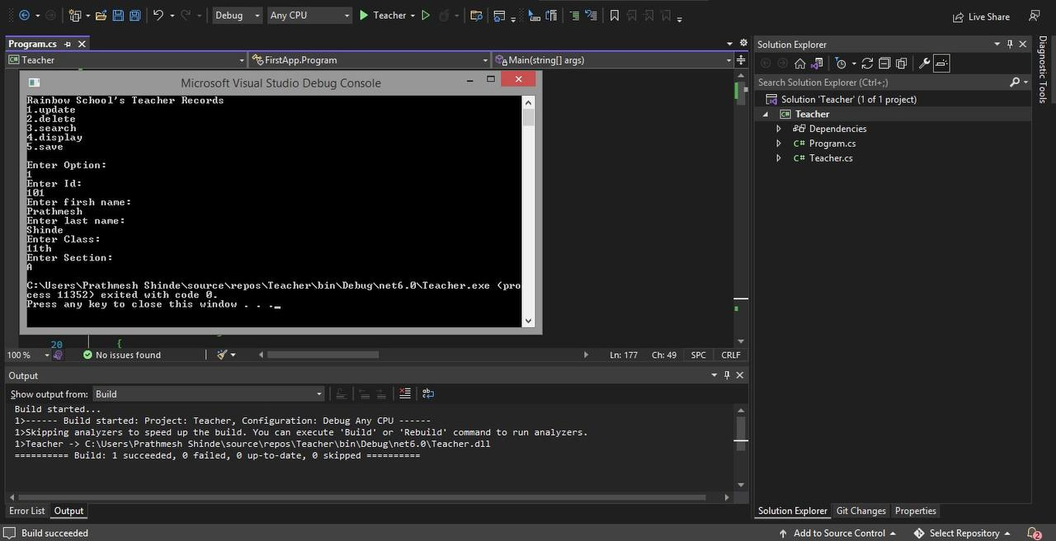

3. Display 1st Teacher details (In text file too) :

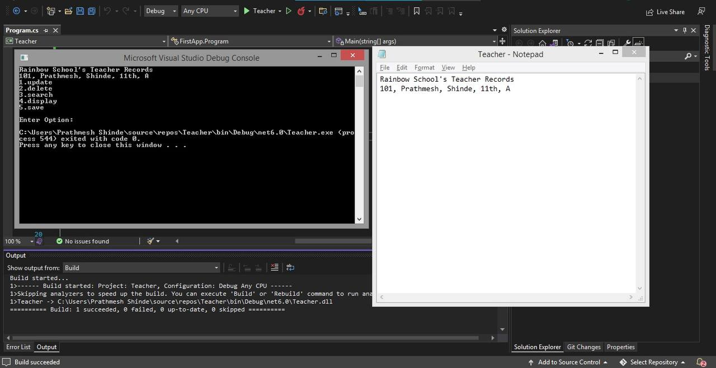

4. Similarly we are going to add some more Teachers :

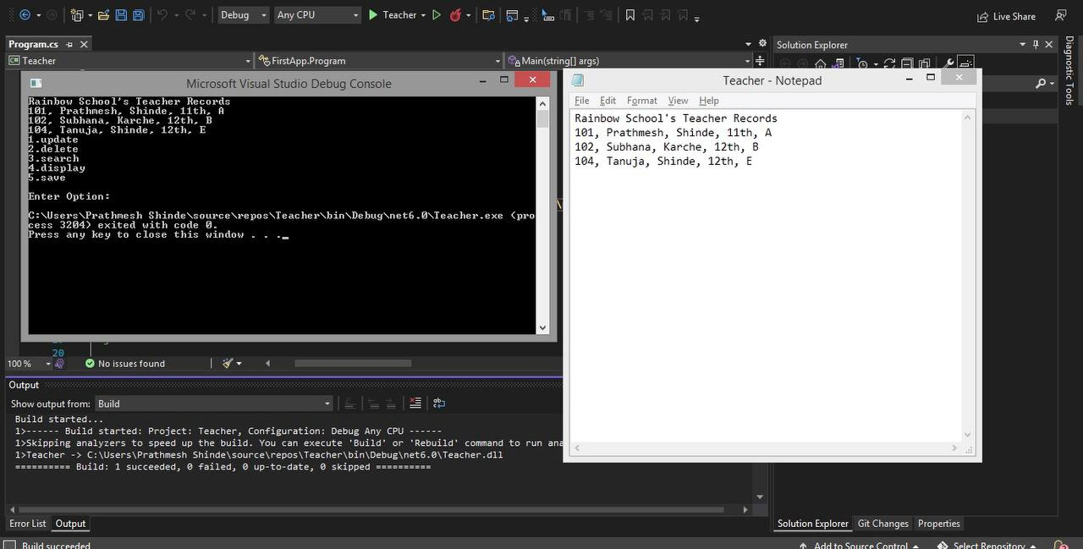

5. Now we are going to update the one of the teacher’s details :

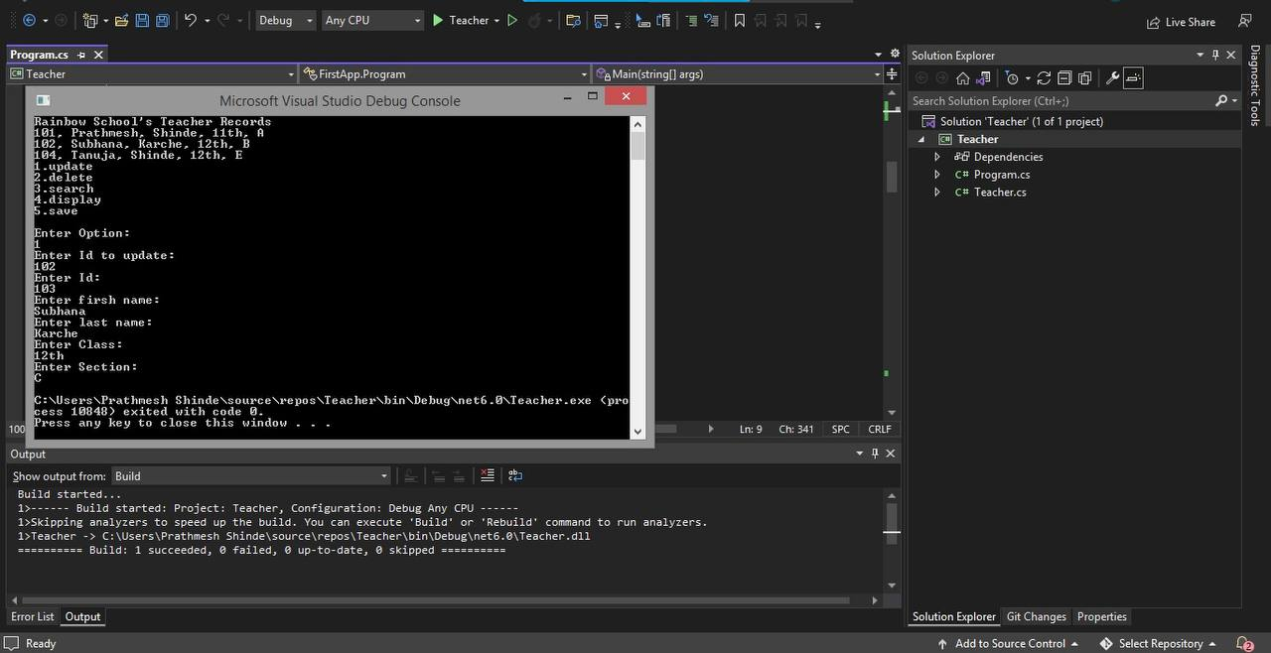

6. Display (In text file too) :

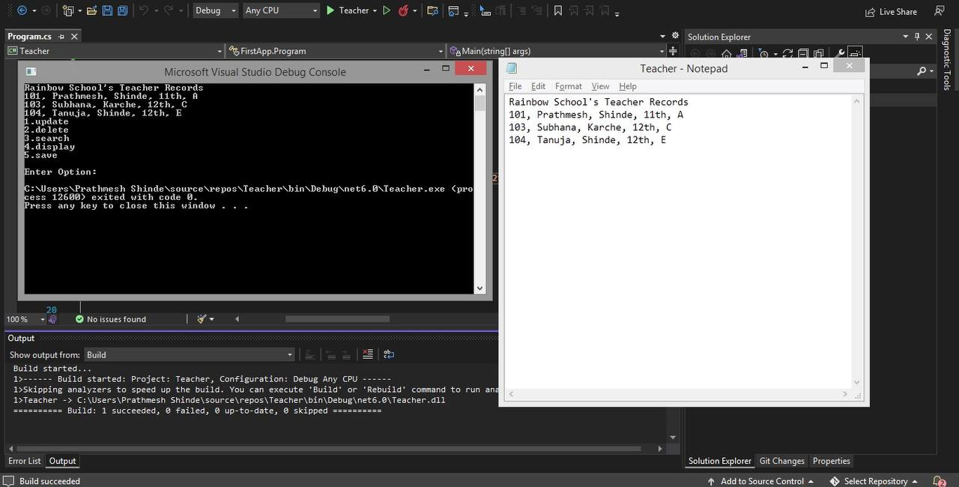

7. Now we are going to delete the one of teacher’s details :

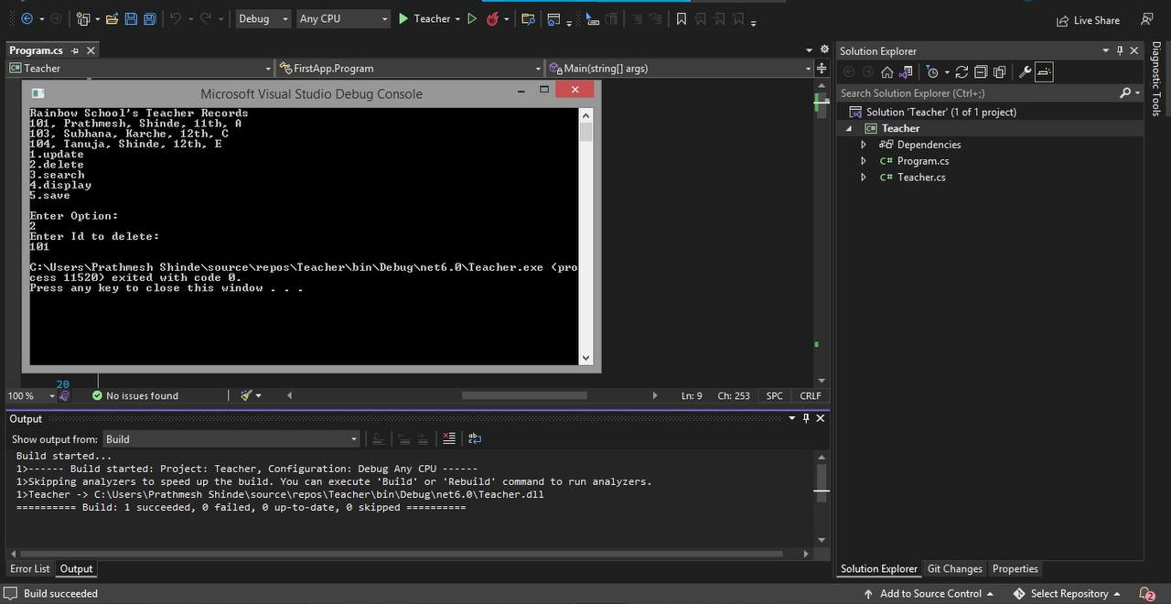

8. Display (In text file too) :

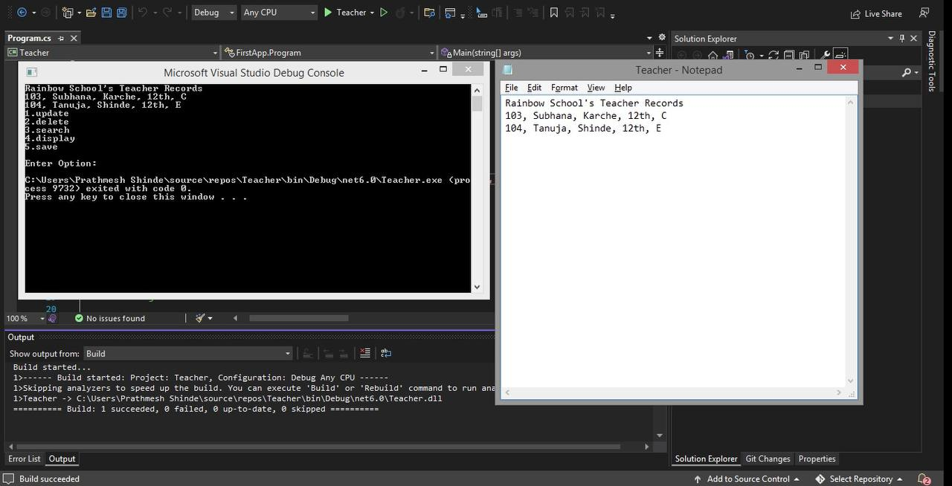

The  GitHub repositories link : <https://github.com/Prathmesh2702/Project>