Department of Computer Engineering
A Web Technology Mini Project Report
“TaskFlow: A Full-Stack Task and Productivity Management Web Application”
SUBMITTED TO THE DEPARTMENT OF COMPUTER ENGINEERING
AISSMS IOIT
T. Y. BTech Engineering

SUBMITTED BY

Prathmesh Tulshiram Adhav (Roll No. 01)
PRN: 24410143

2026-27


All India Shri Shivaji Memorial Society’s Institute of Information Technology, Pune-01
(An Autonomous Institute)
Affiliated to Savitribai Phule Pune University, Pune.

Department of Computer Engineering
CERTIFICATE
This is to certify that the project report
“TaskFlow: A Full-Stack Task and Productivity Management Web Application”
Submitted by
Prathmesh Tulshiram Adhav (Roll No. 01, PRN: 24410143) is a bonafide student of this institute and the work has been carried out by him/her under the supervision of Ms. Prajakta Kamble and it is approved for the partial fulfillment of the Department of Computer Engineering AISSMS IOIT.

Ms. Prajakta Kamble Dr. K.S.Wagh
Guide Head,
Department of Computer Engineering Department of Computer Engineering

Place : Pune Date :

ACKNOWLEDGEMENT

I would like to express my heartfelt gratitude to Ms. Prajakta Kamble for her valuable guidance, continuous support, and encouragement throughout the development of this Web Technology mini project. Her guidance and suggestions played an important role in the successful completion of this project.
I would also like to extend my sincere thanks to AISSMS Institute of Information Technology, Pune, and the Department of Computer Engineering for providing the necessary support and learning environment
Finally, I would like to thank everyone who directly or indirectly contributed to the successful completion of this mini project.

Prathmesh Tulshiram Adhav
Roll No.: 01

__________________

ABSTRACT
TaskFlow is a full-stack task and productivity management web application developed as a Web Technology mini project. Users register, sign in securely and manage tasks with priorities and optional due dates. The dashboard provides statistics, a completion-rate bar, overdue detection, and real-time search, filtering and sorting. A Next.js 16 frontend (TypeScript, React 19) communicates over REST with a layered Go net/http backend that stores data in MySQL 8.0.

1.1 Context
Students, professionals and small teams track many assignments, deadlines and goals, and web-based task managers make this information available from any browser. TaskFlow is designed as a focused, distraction-free tool that combines a modern component-based user interface with a secure, layered REST API and a relational database.

1.2 Problem Statement
Tasks maintained on paper, in scattered notes or in spreadsheets are difficult to prioritise, search and review, and they provide no automatic indication of overdue work or overall progress. A multi-user web application must also keep each user's data private and resist attacks such as SQL injection, XSS-based token theft and CSRF. The problem addressed is to design and implement a secure web application that stores each user's tasks in a structured database and presents them through an interactive, responsive interface.

1.3 Objective
• To implement secure registration and session-based authentication with bcrypt and HttpOnly cookies.
• To provide the complete task lifecycle (create, read, update, delete, status toggle) with priorities, due dates and overdue detection.
• To provide search, filtering, sorting, statistics and a normalised MySQL schema behind a layered Go REST API with per-user data isolation.
INDEX
Sr. No. | Chapter No | Title Of Chapter |  | Page no.
1 | 1 | ABSTRACT | …………… | 4
 | 1.1 | Context | …………… | 4
 | 1.2 | Problem Statement | …………… | 4
 | 1.3 | Objective | …………… | 4
2 | 2 | INTRODUCTION | …………… | 6
 | 2.1 | Background Information on the Chosen Topic | …………… | 6
 |  | Importance of Databases in the Task Management Domain | …………… | 6
 | 2.2 | Scope of the Project | …………… | 7
 | 2.3 | Functional and Non-Functional Requirements | …………… | 8
 | 2.4 | System Requirements | …………… | 8
3 | 3 | SYSTEM DESIGN | …………… | 9
 | 3.1 | Database Schema and UML Diagrams | …………… | 9
 | 3.2 | Tables and Relationships | …………… | 16
 | 3.3 | Application / User Interface Design | …………… | 18
4 | 4 | IMPLEMENTATION | …………… | 19
 | 4.1 | Description of the Development Environment | …………… | 19
 | 4.2 | Tools and Technologies Used | …………… | 19
 | 4.3 | Backend Implementation | …………… | 20
 | 4.4 | REST API Implementation | …………… | 21
 | 4.5 | Frontend Implementation | …………… | 22
 | 4.6 | Security Implementation | …………… | 23
 | 4.7 | Setup and Execution | …………… | 23
5 | 5 | OUTPUT | …………… | 24
 | 5.1 | Public and Authentication Screens | …………… | 24
 | 5.2 | Dashboard and Task Management Screens | …………… | 25
6 | 6 | ADVANTAGES & LIMITATIONS | …………… | 28
 | 6.1 | Advantages | …………… | 28
 | 6.2 | Limitations | …………… | 28
 | 6.3 | Future Enhancements | …………… | 29
7 | 7 | CONCLUSION | …………… | 30
 | 7.1 | Summary of the Project Achievements | …………… | 30
 | 7.2 | Key Learning | …………… | 30
8 | 8 | REFERENCES | …………… | 31
 | 8.1 | Books, Articles, Websites and Other Resources | …………… | 31

INTRODUCTION

2.1 Background Information on the Chosen Topic
Modern web applications are commonly built as two cooperating parts: a client-side application that renders the user interface, and a server-side API that applies business rules and persists data, exchanging JSON through RESTful endpoints over HTTP.
TaskFlow applies this model to personal task management. Its frontend is built with Next.js 16 using the App Router and the Turbopack bundler, React 19 and TypeScript, styled with Tailwind CSS and a custom design system. Interactive screens are implemented as Client Components (marked with "use client") that fetch data asynchronously from the backend. The backend is written in Go and uses the standard library net/http server together with the httprouter request multiplexer, while MySQL 8.0 stores users, sessions and tasks. The project thus covers core Web Technology topics: component-based HTML rendering, CSS, client-side validation, HTTP methods and status codes, cookies and sessions, CORS, REST API design and database connectivity.

Importance of Databases in the Task Management Domain
A task manager is fundamentally a data-driven application. Every dashboard element is computed from stored records. A relational database such as MySQL provides persistent storage that survives server restarts, enforces data integrity through primary keys, foreign keys, unique and check constraints, and supports efficient filtered and sorted retrieval through indexes. In TaskFlow the InnoDB storage engine supplies ACID transactions and foreign-key enforcement, the utf8mb4 character set with utf8mb4_unicode_ci collation allows full Unicode (including emoji) in task titles and descriptions, and composite indexes beginning with user_id match the dashboard's most frequent per-user queries.

Existing System and Proposed System
In the existing approach, tasks are commonly recorded on paper, in personal notes or in spreadsheets. Such methods offer no access control, require manual effort to sort and prioritise, cannot highlight overdue items automatically and provide no summary of progress.
The proposed system, TaskFlow, replaces these methods with an authenticated web application. Each user's tasks are stored in a central database and are visible only to that user, because every task query is scoped by the authenticated user's ID. The dashboard computes statistics automatically, marks pending tasks whose due date has passed as overdue, and allows instant searching, filtering and sorting. A responsive interface with toast notifications and modal forms makes these operations quick to perform.

2.2 Scope of the Project
The scope of TaskFlow is a single-user-per-account task management application intended for individuals and teams who want focused task tracking with priorities, deadlines and progress statistics. The following functionality is within the documented scope:
• Account registration, login, logout and retrieval of the current user's profile.
• Creation, listing, retrieval, editing, deletion and completion toggling of tasks owned by the signed-in user.
• Task attributes: title (1 to 200 characters), optional description, status (pending or completed), priority (low, medium or high) and optional due date.
• Search by title or description, filtering by status and priority, six sort orders, and limit/offset pagination (default 50, maximum 100 items).
• Dashboard statistics: total, pending, completed, high-priority and overdue counts and the completion rate.
• Local deployment: MySQL (3306), Go API (8080) and Next.js frontend (3000).
Shared task lists between users, role-based administration, notifications and production deployment configuration are not part of the documented implementation and are discussed as possible future enhancements in Chapter 6.

2.3 Functional and Non-Functional Requirements
Table 2.1: Functional requirements of TaskFlow
ID | Functional requirement | Supporting endpoint / screen
FR-1 | A visitor can register with name, email and password. | POST /auth/register, /register
FR-2 | A registered user can log in and receive a session cookie. | POST /auth/login, /login
FR-3 | The signed-in user's profile is shown in the dashboard. | GET /auth/me
FR-4 | The user can log out, which clears the session cookie. | POST /auth/logout
FR-5 | The user can create a task with title, description, priority and due date. | POST /tasks, task modal
FR-6 | The user can list, search, filter, sort and paginate tasks. | GET /tasks, filter bar
FR-7 | The user can view and edit a single task. | GET / PUT /tasks/:id
FR-8 | The user can toggle a task between pending and completed. | PATCH /tasks/:id/status
FR-9 | The user can delete a task after confirmation. | DELETE /tasks/:id
FR-10 | The dashboard shows statistics and the completion rate. | GET /tasks/stats

Table 2.2: Non-functional requirements
Quality attribute | Requirement as addressed by the design
Security | bcrypt password hashes, SHA-256 hashed session tokens, HttpOnly and SameSite=Lax cookies, parameterised SQL, exact-origin CORS
Data isolation | every task query restricted by the authenticated user_id
Integrity | foreign keys with cascade delete, unique email and token hash, check constraints
Performance | per-user composite indexes, database/sql connection pooling, HTTP server timeouts
Usability | responsive design system, toast feedback, modal task editor
Maintainability | monorepo, layered backend, strict TypeScript, ordered idempotent migrations

2.4 System Requirements
The specification documents the software stack rather than minimum hardware figures. The required software is: Go 1.22 or later (developed with Go 1.27 on Windows amd64); Node.js with npm for Next.js 16.4.3, React 19 and TypeScript; MySQL Server 8.0 or later; and a modern browser with JavaScript and cookies enabled. Ports 3000 (frontend), 8080 (API) and 3306 (MySQL) must be available.

SYSTEM DESIGN
System design describes how TaskFlow is organised before and during implementation: which components exist, how they communicate, what data is stored and how users interact with the system. This chapter presents the overall architecture, the UML and data-flow diagrams, the database schema with its tables and relationships, and the design of the user interface.

3.1 Database Schema and UML Diagrams

3.1.1 System Architecture
TaskFlow follows a decoupled, layered client-server architecture, shown in Figure 3.1. The browser loads the Next.js frontend (port 3000), which calls the Go REST API (port 8080, base URL /api/v1) with JSON bodies and credentialed requests so that the session cookie is included. Inside the API, requests pass through the router and middleware layer, the handler layer and the repository layer before reaching the MySQL database (port 3306). Responses travel back along the same path as JSON objects wrapped in a data field.
The backend follows a clean layered (repository) pattern. The router (internal/router) registers routes with httprouter's radix-tree multiplexer and wraps them with CORS and authentication middleware. The handlers (internal/handlers) form the controller layer: they decode requests, validate input, manage cookies, call the repository and encode responses. The repository (internal/repository) is the only layer that executes SQL, always through parameterised queries. The models (internal/models) define the User, Task and Stats structures with JSON tags, and config (internal/config) loads environment variables, automatically reading the .env file. This separation keeps HTTP concerns, business rules and data access independent, so each layer can be understood and changed in isolation.
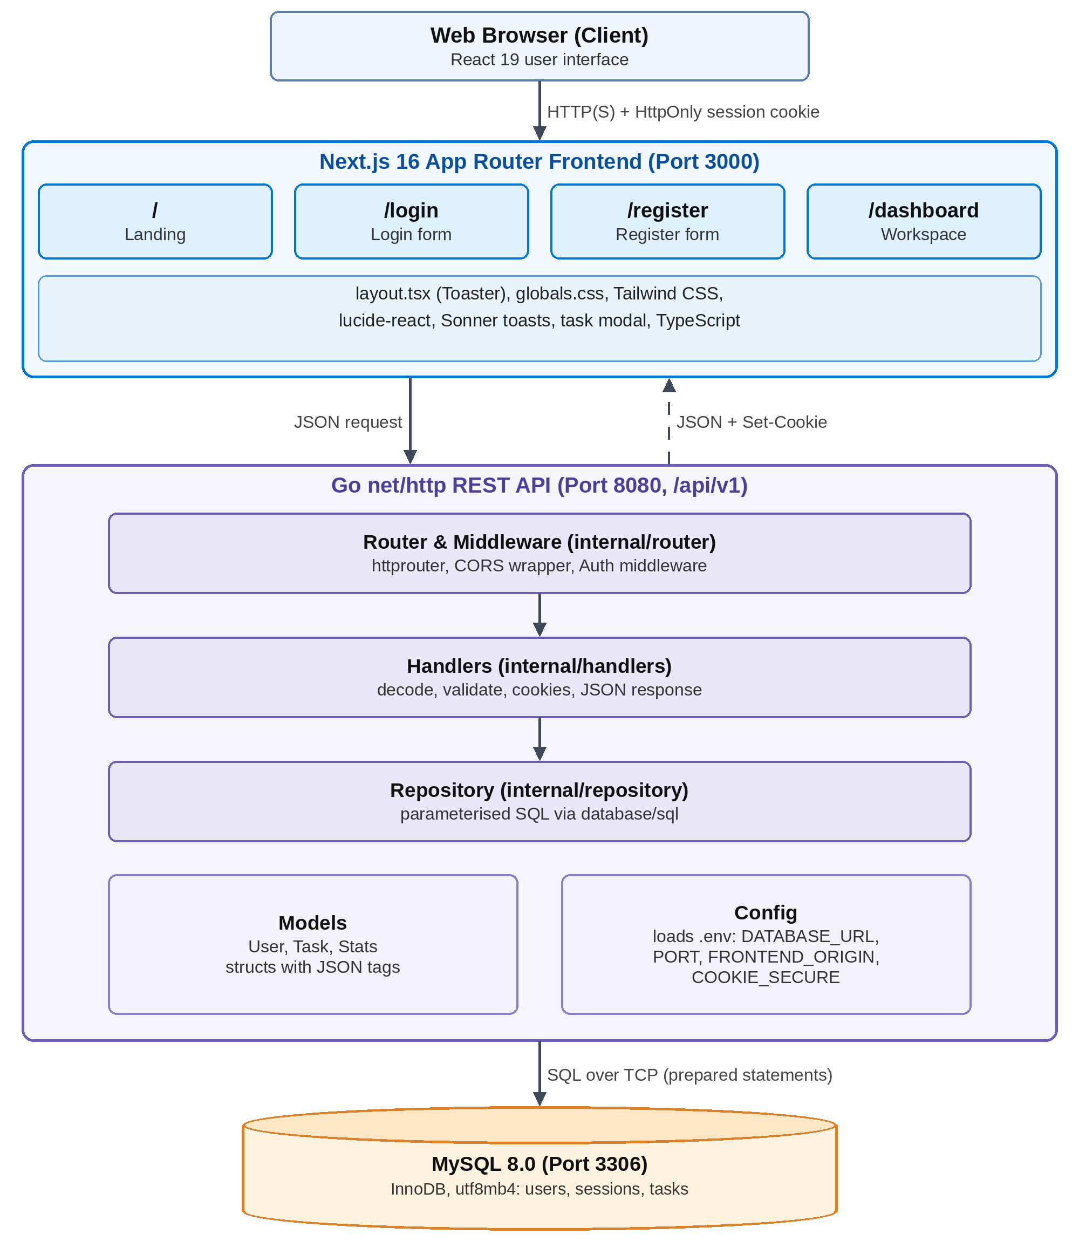
Figure 3.1: System architecture of TaskFlow

3.1.2 Frontend Architecture
Figure 3.2 shows the structure of the Next.js App Router frontend. The root layout (app/layout.tsx) wraps every route and provides the Sonner toast provider, while app/globals.css defines design tokens, cards, badges and the modal. The four routes are the landing page (/), the login and registration pages and the dashboard. Successful login or registration redirects to /dashboard, whose components call the REST endpoints listed at the bottom of the figure.
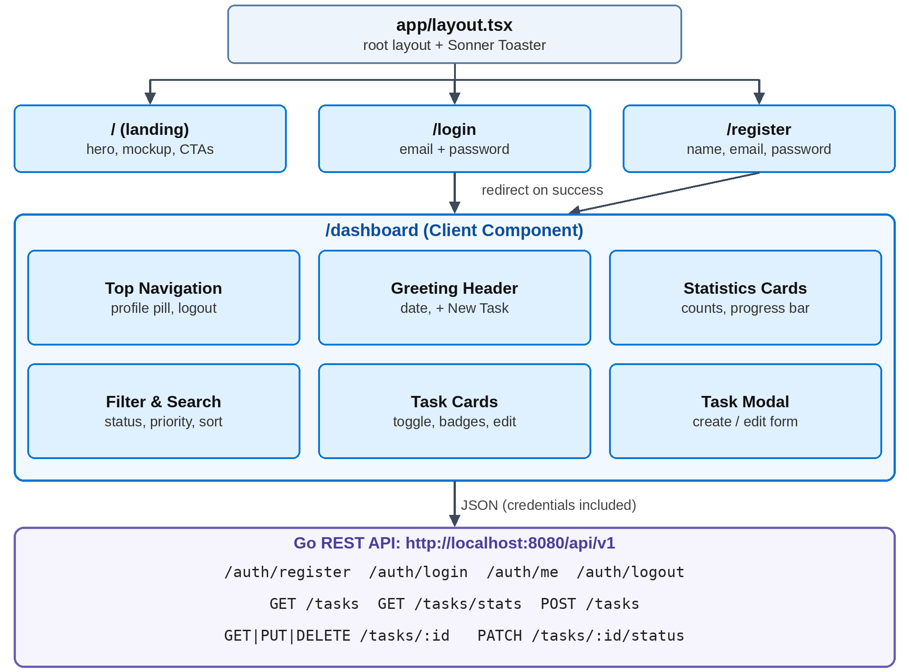
Figure 3.2: Frontend routes, dashboard components and API communication

3.1.3 Use Case Diagram
The use case diagram in Figure 3.3 identifies two actors. A Visitor can view the landing page, register and log in. A Registered User, a specialisation of the visitor, can manage tasks, search and filter them, view statistics and the profile, and log out. Every use case of the registered user includes Authenticate Session, because the corresponding endpoints require a valid session cookie.
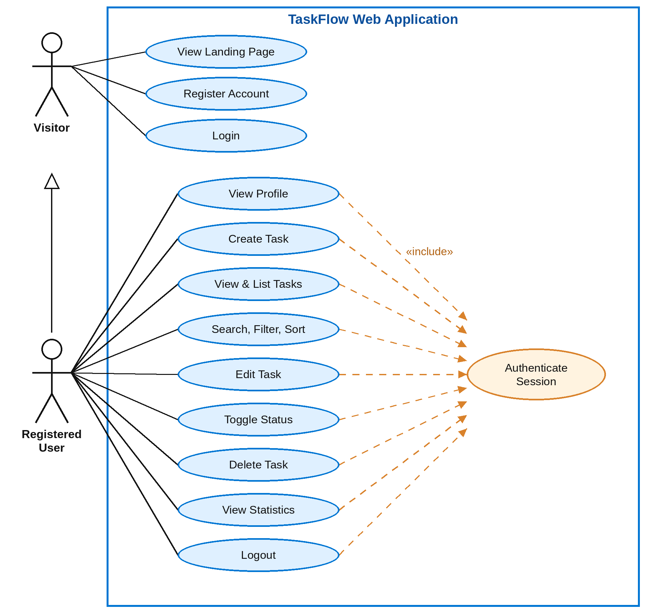
Figure 3.3: UML use case diagram of TaskFlow

3.1.4 Entity Relationship Diagram
Figure 3.4 shows the relational schema. The users entity is the parent of two child entities. One user may have zero or more sessions and may own zero or more tasks; each session and each task belongs to exactly one user through its user_id foreign key. Both foreign keys use ON DELETE CASCADE, so deleting a user also removes that user's sessions and tasks.
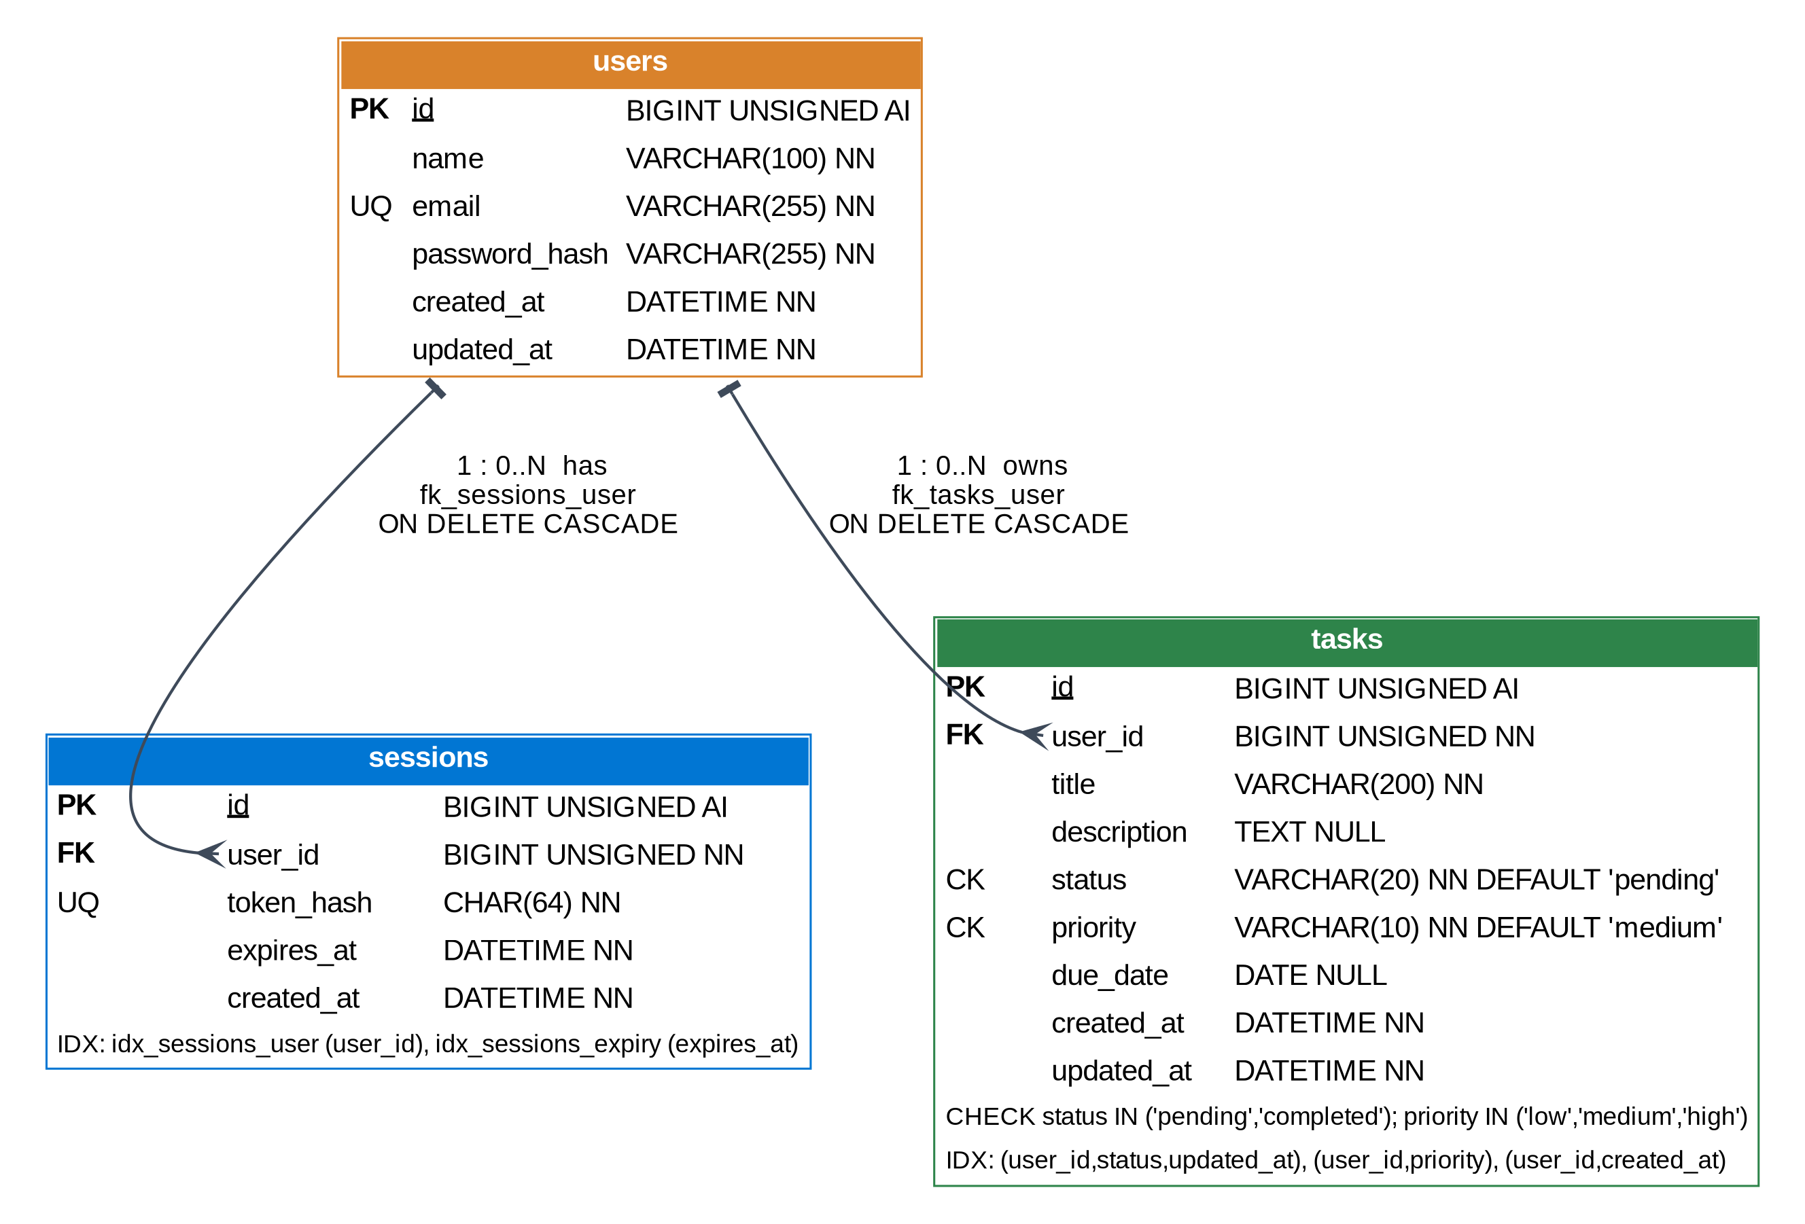
Figure 3.4: Entity relationship diagram (PK, FK, UQ, CK and indexes)

3.1.5 Sequence Diagrams
Figure 3.5 illustrates the login workflow. After client-side validation, the login page sends the credentials to POST /auth/login. The handler retrieves the user by email, verifies the password against the stored bcrypt hash, generates a 32-byte random token with crypto/rand, stores only its SHA-256 hash in the sessions table and returns the raw token in the HttpOnly taskflow_session cookie. The frontend then redirects to the dashboard.
Figure 3.6 illustrates task creation. The browser automatically sends the session cookie with the request; the authentication middleware hashes the token, resolves the session to a user ID and passes the request to the task handler, which validates the input and asks the repository to insert the task for that user. The API responds with 201 Created and the new task object.
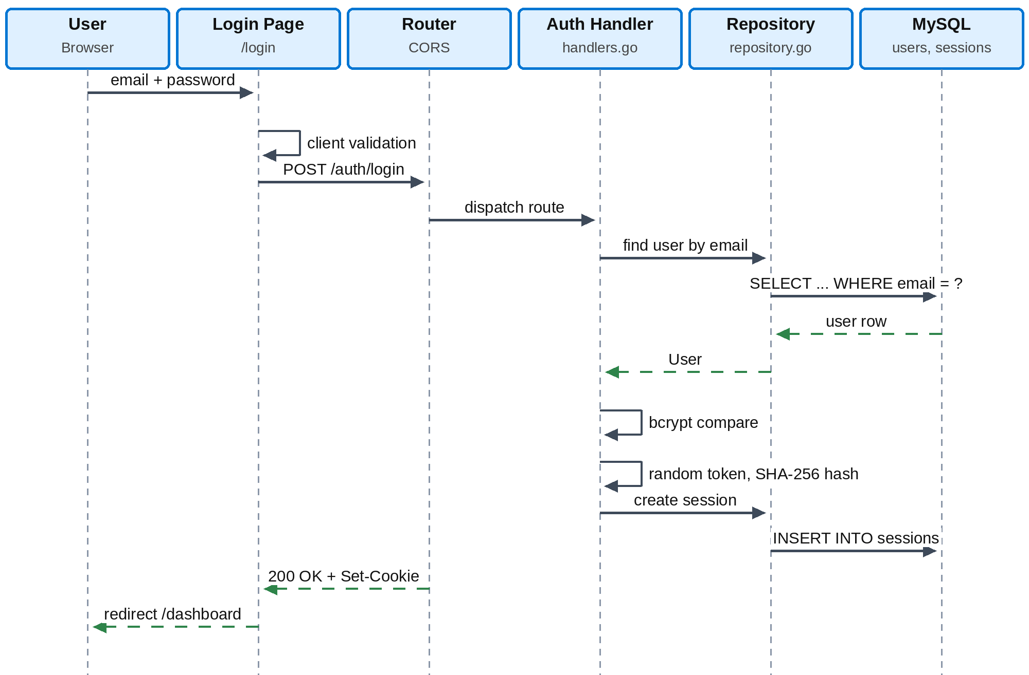
Figure 3.5: Sequence diagram for user login
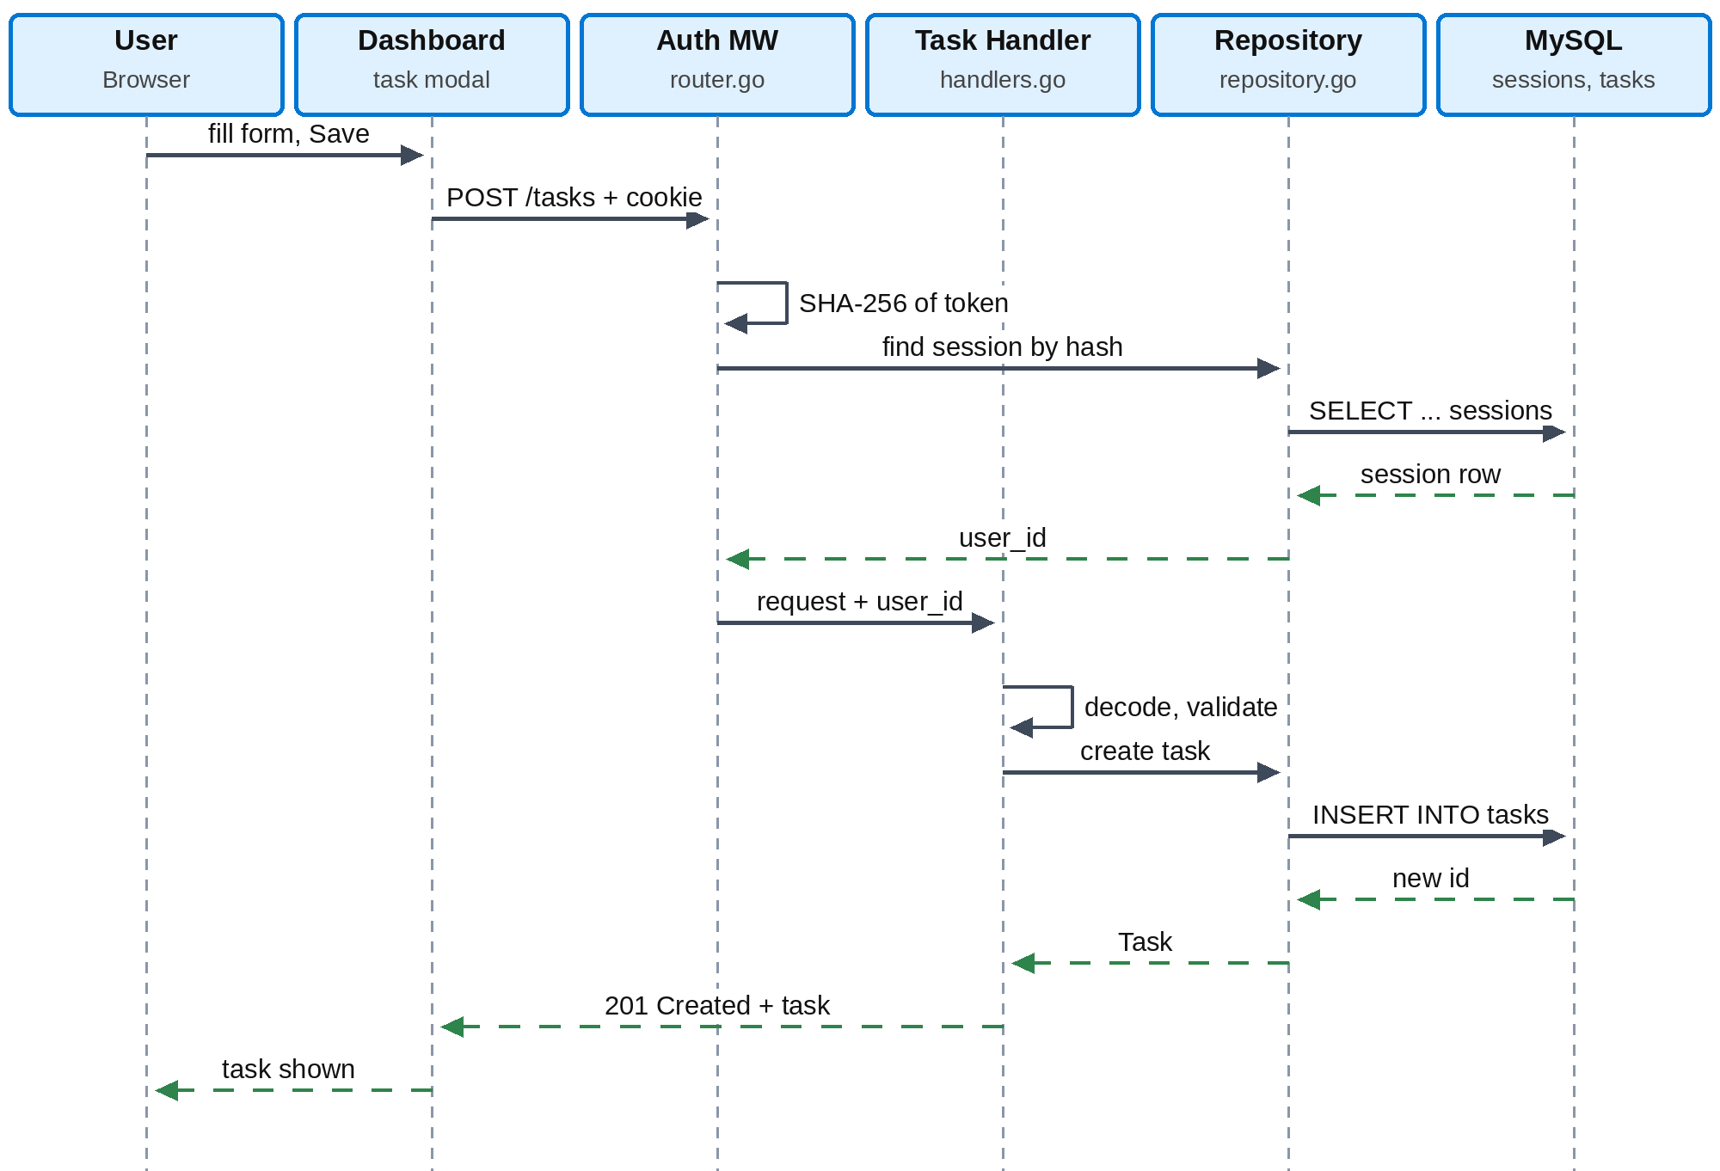
Figure 3.6: Sequence diagram for creating a task

3.1.6 Data Flow Diagrams
The context-level DFD (Figure 3.7) treats TaskFlow as a single process that exchanges data with one external entity, the user. The level-1 DFD (Figure 3.8) decomposes it into five processes and three data stores corresponding to the database tables.
In the level-1 diagram, process 1.0 creates users and sessions, process 2.0 validates the session on each protected request and supplies the user ID, process 3.0 performs task changes on D3, process 4.0 reads matching tasks for the search, filter and sort criteria, and process 5.0 aggregates the user's tasks into the statistics shown on the dashboard.
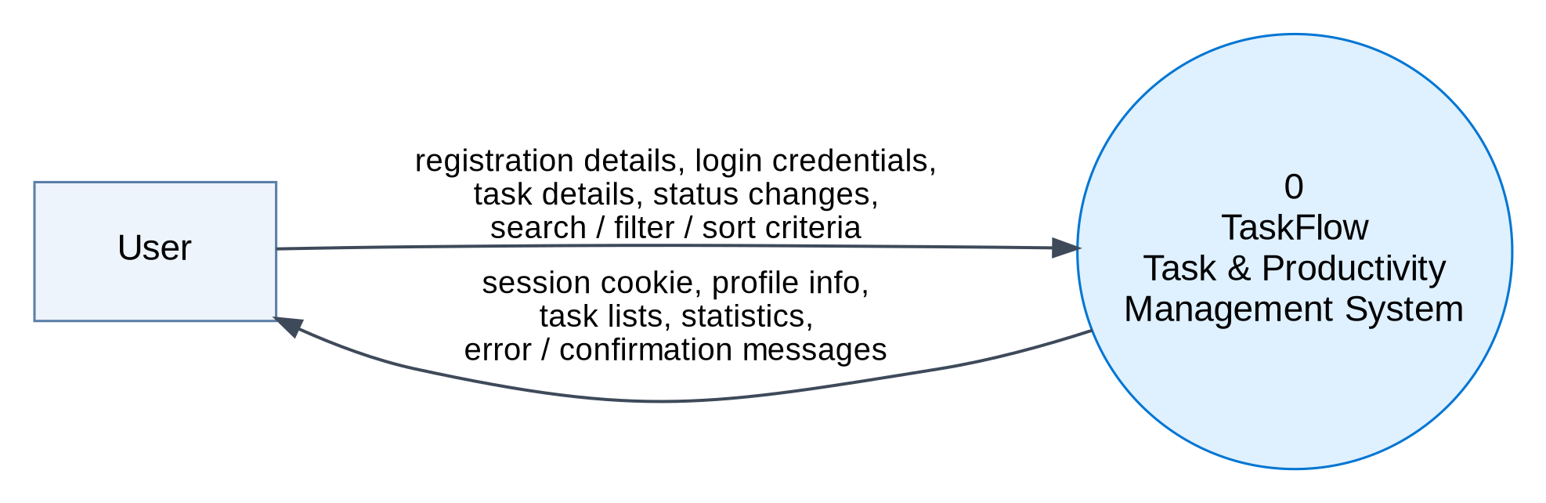
Figure 3.7: Context-level (level-0) data flow diagram
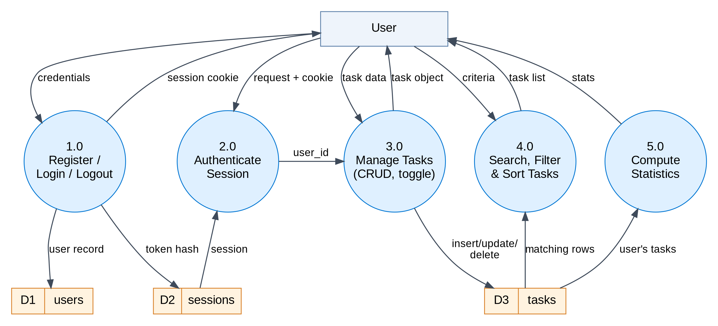
Figure 3.8: Level-1 data flow diagram

3.2 Tables and Relationships
The database taskflow contains three InnoDB tables using the utf8mb4 character set and utf8mb4_unicode_ci collation. They are created by numbered migration scripts: 001_create_users.sql, 002_create_sessions.sql, 003_create_tasks.sql and 004_add_priority_to_tasks.sql, the last of which adds the priority column to installations created before priorities existed. The data dictionaries below are taken from the documented schema; where no default is listed, none is specified.
Table 3.1: Data dictionary of the users table
Column | Data type | Key | Null | Constraints / default | Description
id | BIGINT UNSIGNED | PK | No | AUTO_INCREMENT | Unique user identifier
name | VARCHAR(100) |  | No |  | Full name of the user
email | VARCHAR(255) | UQ | No | UNIQUE | Login email address
password_hash | VARCHAR(255) |  | No | bcrypt hash | Salted password hash; plaintext never stored
created_at | DATETIME |  | No | UTC timestamp | Account creation time
updated_at | DATETIME |  | No | UTC timestamp | Last update time

Table 3.2: Data dictionary of the sessions table
Column | Data type | Key | Null | Constraints / default | Description
id | BIGINT UNSIGNED | PK | No | AUTO_INCREMENT | Unique session identifier
user_id | BIGINT UNSIGNED | FK | No | REFERENCES users(id) ON DELETE CASCADE | Owner of the session
token_hash | CHAR(64) | UQ | No | UNIQUE | Hex-encoded SHA-256 hash of the session token
expires_at | DATETIME |  | No |  | Session expiry date and time
created_at | DATETIME |  | No | UTC timestamp | Session creation time

Table 3.3: Data dictionary of the tasks table
Column | Data type | Key | Null | Constraints / default | Description
id | BIGINT UNSIGNED | PK | No | AUTO_INCREMENT | Unique task identifier
user_id | BIGINT UNSIGNED | FK | No | REFERENCES users(id) ON DELETE CASCADE | Owner of the task
title | VARCHAR(200) |  | No | 1 to 200 characters | Task title
description | TEXT |  | Yes |  | Optional notes or links
status | VARCHAR(20) |  | No | DEFAULT 'pending'; CHECK IN ('pending','completed') | Completion state
priority | VARCHAR(10) |  | No | DEFAULT 'medium'; CHECK IN ('low','medium','high') | Task priority
due_date | DATE |  | Yes | YYYY-MM-DD | Optional target date
created_at | DATETIME |  | No | UTC timestamp | Creation time
updated_at | DATETIME |  | No | UTC timestamp | Last update time

Table 3.4: Indexes and constraints
Table | Index / constraint | Columns | Purpose
sessions | idx_sessions_user | (user_id) | Fast session-to-user resolution
sessions | idx_sessions_expiry | (expires_at) | Efficient cleanup of expired sessions
sessions | fk_sessions_user | user_id → users(id) | Referential integrity, cascade delete
tasks | idx_tasks_user_status_updated | (user_id, status, updated_at) | Dashboard queries by status
tasks | idx_tasks_user_priority | (user_id, priority) | Priority filters
tasks | idx_tasks_user_created | (user_id, created_at) | Default chronological sorting
tasks | chk_tasks_status, chk_tasks_priority | status, priority | Allow only documented values
tasks | fk_tasks_user | user_id → users(id) | Referential integrity, cascade delete

Relationships and integrity
Both relationships are one-to-many: users (1) to sessions (0..N) and users (1) to tasks (0..N). The foreign keys guarantee that no session or task can reference a non-existent user, and ON DELETE CASCADE keeps the database consistent when a user row is deleted. Primary keys are surrogate BIGINT UNSIGNED AUTO_INCREMENT values, the unique constraint on email prevents duplicate accounts, the unique constraint on token_hash ensures every session token maps to exactly one session, and the two check constraints prevent invalid status or priority values even if application validation were bypassed.

Normalisation, indexing and transactions
Each table stores facts about a single entity, every non-key column depends on the whole primary key, and no column repeats information held in another table: user details are stored once in users and referenced by ID. The schema therefore satisfies third normal form. The composite indexes all begin with user_id because every task query is scoped to the authenticated user; MySQL can then use the leftmost prefix of an index to filter by user and status or priority and to return rows in creation order. Statistics such as overdue counts are computed from the stored status and due_date values rather than stored separately, which avoids redundant data. InnoDB provides ACID transactions and row-level locking, so each insert, update or delete statement executes atomically; the specification does not document explicit multi-statement transactions.

3.3 Application / User Interface Design
The interface follows a custom responsive design system built with Tailwind CSS, CSS variables, Inter typography and gradients, with lucide-react icons and Sonner toast notifications. The landing page presents the brand, a hero headline and value proposition, a live interactive mockup preview and call-to-action buttons leading to login and registration. The authentication pages validate input on the client, show error toasts and redirect to the dashboard on success.
The dashboard is arranged from top to bottom: a navigation bar with the logo, a profile pill (gradient avatar with initials, name and email) and a logout button; a greeting header with the weekday, date and + New Task button; four statistics cards (total, pending with the high-priority count, completed, and completion rate with a progress bar); and a filter bar with status pills, priority and sort dropdowns and a search input with a clear action. Each task card offers a circular completion toggle, a title that is struck through when completed, the optional description, a colour-coded priority badge (soft red with a flame icon for High, amber for Medium, blue for Low), a due-date chip that turns into a red Overdue badge for pending tasks past their date, and edit and delete buttons. The create/edit modal contains a required title, an optional description, three priority buttons and a native date picker.

IMPLEMENTATION

4.1 Description of the Development Environment
TaskFlow is developed as a monorepo containing two independent applications, backend/ (the Go module taskflow/backend) and frontend/ (the Next.js client), together with the project README and specification. The backend was developed and run with Go 1.27 on Windows amd64 against a local MySQL 8.0 server. The directory structure is shown below.
project/
|-- README.md, PROJECT_DETAILS.txt
|-- backend/ Go REST API (module taskflow/backend)
| |-- .env, .env.example environment variables (.env is gitignored)
| |-- go.mod, go.sum module definition and dependency checksums
| |-- cmd/api/main.go API server entry point
| |-- cmd/migrate/main.go idempotent migration runner
| |-- internal/config/ config loader with .env parser
| |-- internal/handlers/ HTTP handlers, validation, cookies
| |-- internal/models/ User, Task, Stats structs with JSON tags
| |-- internal/repository/ database operations, auto-migration hooks
| |-- internal/router/ route registry, CORS wrapper, auth middleware
| `-- migrations/001..004_*.sql SQL migrations run in numerical order
`-- frontend/ Next.js App Router client
|-- package.json, tsconfig.json, next.config.mjs, postcss.config.mjs
`-- app/layout.tsx, globals.css, page.tsx,
login/page.tsx, register/page.tsx, dashboard/page.tsx

Configuration is supplied through environment files. The backend reads DATABASE_URL (a go-sql-driver DSN with parseTime=true and charset=utf8mb4), PORT (8080), FRONTEND_ORIGIN (http://localhost:3000, used for CORS) and COOKIE_SECURE (false locally, true in production HTTPS). The frontend reads NEXT_PUBLIC_API_URL = http://localhost:8080/api/v1. Real credentials are kept only in the gitignored .env and .env.local files, while the .env.example files document the expected variables.

4.2 Tools and Technologies Used
Table 4.1: Tools and technologies
Layer | Technology | Role in TaskFlow
Backend language | Go 1.22+ (run on Go 1.27) | Compiled, concurrent language for the REST API
HTTP server | net/http (standard library) | HTTP server with configured timeouts
Routing | julienschmidt/httprouter v1.3.0 | Radix-tree request multiplexer with path parameters
Database access | database/sql + go-sql-driver/mysql v1.8.1 | Connection pooling and MySQL driver
Password security | golang.org/x/crypto/bcrypt v0.27.0 | Salted password hashing (default cost)
Token security | crypto/rand, crypto/sha256 | Random session tokens and their hashes
Frontend framework | Next.js 16.4.3 (App Router, Turbopack) | Routing, rendering and bundling
UI library | React 19, React-DOM 19 | Component-based interface and state
Language | TypeScript (strict) | Static typing of frontend code
Styling | Tailwind CSS, PostCSS, Autoprefixer | Utility classes and custom design system
Icons / feedback | lucide-react, Sonner | SVG icons and toast notifications
Forms (available) | react-hook-form, zod, @hookform/resolvers | Form and schema validation libraries included in dependencies
Database | MySQL 8.0, InnoDB, utf8mb4 | Persistent relational storage

4.3 Backend Implementation
The backend has two entry points. cmd/migrate/main.go is a standalone, idempotent migration runner that creates the taskflow database and executes the files in migrations/ in numerical order; because it is idempotent it can be run repeatedly without damaging an existing schema. cmd/api/main.go starts the API server: it loads configuration, opens the MySQL connection pool, builds the router and listens on the configured port.
When a request arrives, the processing follows a fixed lifecycle. (1) The CORS wrapper checks the Origin header against FRONTEND_ORIGIN, adds Access-Control-Allow-Credentials: true and answers preflight OPTIONS requests with 204 No Content. (2) httprouter matches the method and path and extracts parameters such as :id. (3) For protected routes the authentication middleware reads the taskflow_session cookie, computes its SHA-256 hash and resolves it to a user through the sessions table. (4) The handler decodes and validates the JSON body or query parameters and calls a repository method with the authenticated user ID. (5) The repository executes a parameterised statement and maps rows to model structs. (6) The handler encodes the result as JSON inside a data object with the appropriate status code.
Validation is applied at more than one level. The frontend checks email format, password length and confirmation before sending a request; the handlers validate request fields such as the task title, status, priority, sort order and the pagination limit (maximum 100); and the database enforces NOT NULL, UNIQUE, CHECK and FOREIGN KEY constraints as a final safeguard. The specification documents the success responses of each endpoint; specific error status codes and error-body formats are not documented and are therefore not reproduced in this report.

Data access and per-user isolation
Every task query issued by the repository contains the authenticated user's ID as a bound parameter, for example WHERE id = ? AND user_id = ? for single-task operations. A request for a task that belongs to another user therefore matches no row, so users can neither read nor modify each other's data. The listing query combines optional conditions for status, priority and a text search over title and description with one of the documented sort orders and the limit and offset values, and returns a pagination object containing limit, offset and total.

4.4 REST API Implementation
All endpoints share the base URL http://localhost:8080/api/v1, accept and return JSON, and use cookie authentication. Table 4.2 lists the twelve documented endpoints.
Table 4.2: REST API reference
Method | Endpoint | Auth | Purpose / success response
GET | /health | No | Health check: 200 {"status":"ok"}
POST | /auth/register | No | Create account; 201 with user; sets session cookie
POST | /auth/login | No | Verify credentials; 200 with user; sets session cookie
GET | /auth/me | Yes | Current user profile (id, name, email, created_at)
POST | /auth/logout | Yes | End session; 200 logged_out; cookie MaxAge = -1
GET | /tasks | Yes | List tasks with search, filter, sort and pagination
GET | /tasks/stats | Yes | Aggregated counts and completion rate
POST | /tasks | Yes | Create task; 201 with task object
GET | /tasks/:id | Yes | Retrieve one task
PUT | /tasks/:id | Yes | Update task fields; 200 with updated task
PATCH | /tasks/:id/status | Yes | Set status; 200 with new status
DELETE | /tasks/:id | Yes | Delete task; 200 deleted

Table 4.3: Query parameters of GET /tasks
Parameter | Allowed values | Default
status | pending | completed | all statuses
priority | low | medium | high | all priorities
search | text matched against title or description | none
sort | created_desc | created_asc | due_date_asc | due_date_desc | priority_desc | title_asc | not specified
limit | items per page, maximum 100 | 50
offset | pagination offset | 0

The following request and responses are the examples given in the project specification for task creation and statistics (the example password value in the specification is omitted here):
POST /api/v1/tasks (cookie: taskflow_session)
{ "title": "Build API",
"description": "Implement authentication endpoints",
"priority": "high", "due_date": "2026-11-01" }
-> 201 Created {"data": { ...task object... }}

GET /api/v1/tasks/stats
-> 200 OK {"data": {"total": 10, "pending": 4, "completed": 6,
"high_priority": 2, "overdue": 1, "completion_rate": 60.0}}

4.5 Frontend Implementation
The frontend uses the Next.js App Router, in which each folder under app/ defines a route through its page.tsx file. layout.tsx renders the root HTML structure and the Sonner Toaster, so any page can display notifications. The login, registration and dashboard pages are interactive Client Components that keep form and view state in React and call the API asynchronously using NEXT_PUBLIC_API_URL. Requests are made with credentials enabled so that the browser stores the HttpOnly cookie set by the API and sends it with later requests; the frontend code never reads the token itself.
On the dashboard, user actions are translated into API calls. Changing a status pill, the priority or sort dropdown, or the search text issues GET /tasks with the corresponding query parameters; the check button sends PATCH /tasks/:id/status; the edit button opens the modal pre-filled with the task and saves with PUT /tasks/:id; the delete button asks for confirmation before sending DELETE /tasks/:id; and the statistics cards are populated from GET /tasks/stats. Overdue status is shown for pending tasks whose due date is earlier than the current date, and the completion bar is drawn from the completion rate.

4.6 Security Implementation
Table 4.4: Security mechanisms
Threat / concern | Mechanism implemented in TaskFlow
Password disclosure | bcrypt with automatic salt and default cost; plaintext passwords are never logged or stored
Session theft from the database | Only the SHA-256 hash of the token is stored; the raw 64-hex-character token exists only in the cookie
Token guessing | 32 cryptographically secure random bytes from crypto/rand
XSS token theft | Cookie flag HttpOnly hides the token from JavaScript
CSRF | Cookie flag SameSite=Lax; exact-origin CORS
Interception | Secure flag enabled through COOKIE_SECURE for production HTTPS
SQL injection | Prepared statements with ? placeholders; user input is never concatenated into SQL
Cross-user access | Every task query scoped with user_id of the authenticated session
Stale sessions | Seven-day cookie expiry; expires_at stored and indexed for cleanup

4.7 Setup and Execution
The project is run locally in the following order, as documented in the specification:
1. Start MySQL Server 8.0 on port 3306 and set credentials in backend/.env
2. cd backend
go run ./cmd/migrate # creates database 'taskflow' and runs migrations
3. go run ./cmd/api # API listens on http://localhost:8080
4. cd ../frontend
npm install
npm run dev # Next.js starts on http://localhost:3000
5. Open http://localhost:3000 in a web browser

OUTPUT

5.1 Public and Authentication Screens
5.1: Landing Page
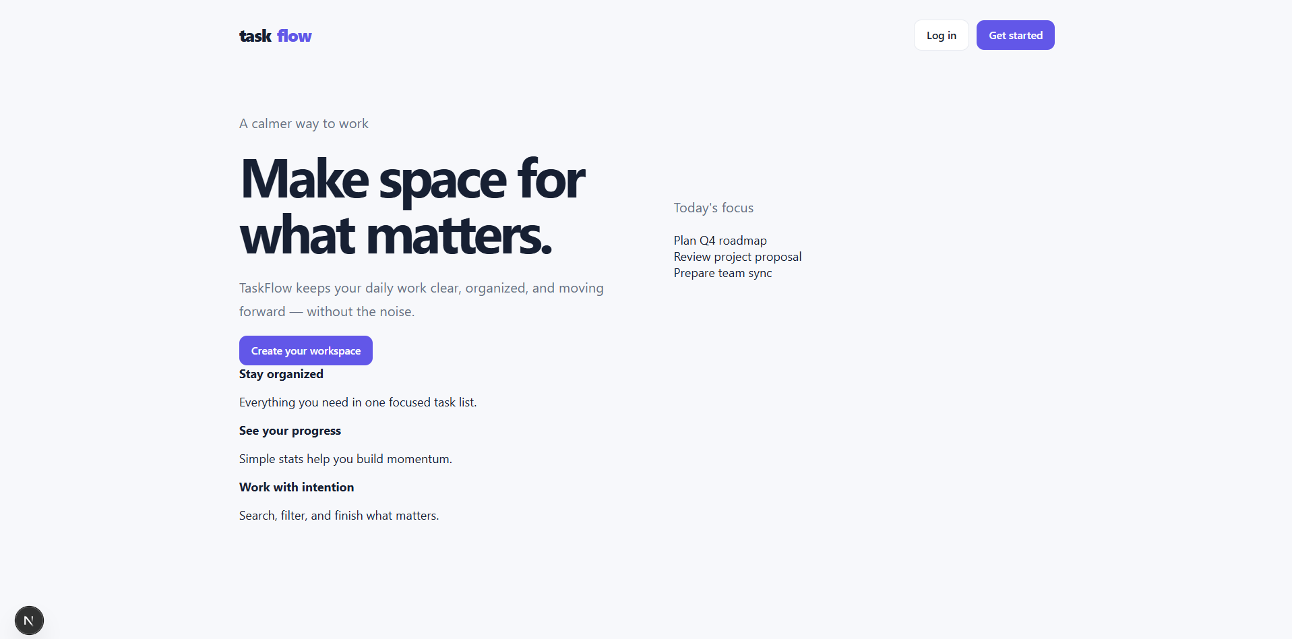
Figure 5.1: TaskFlow landing page

5.2: Registration Page
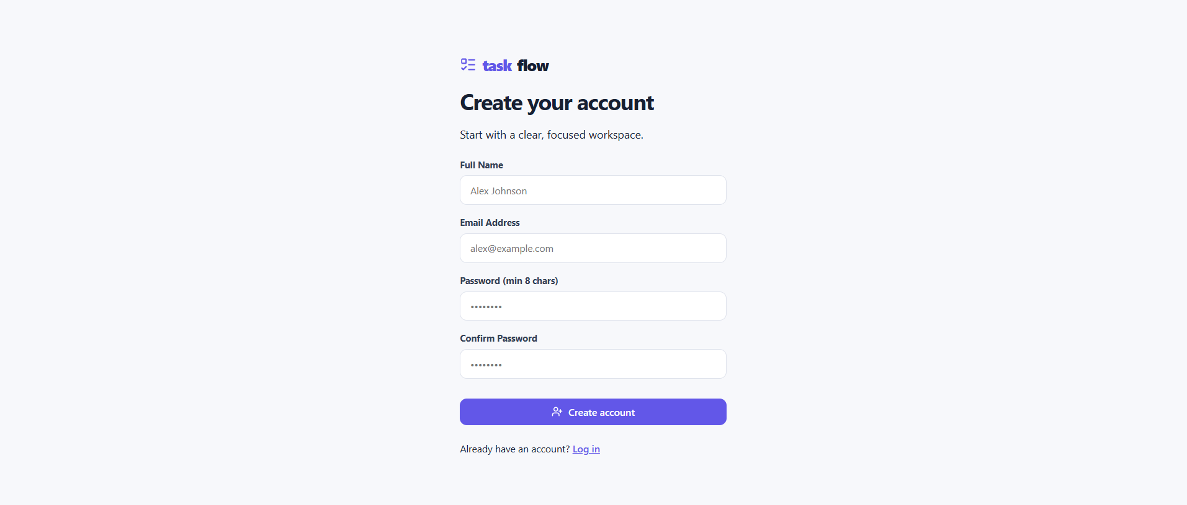

Figure 5.2: User registration page

5.3: Login Page
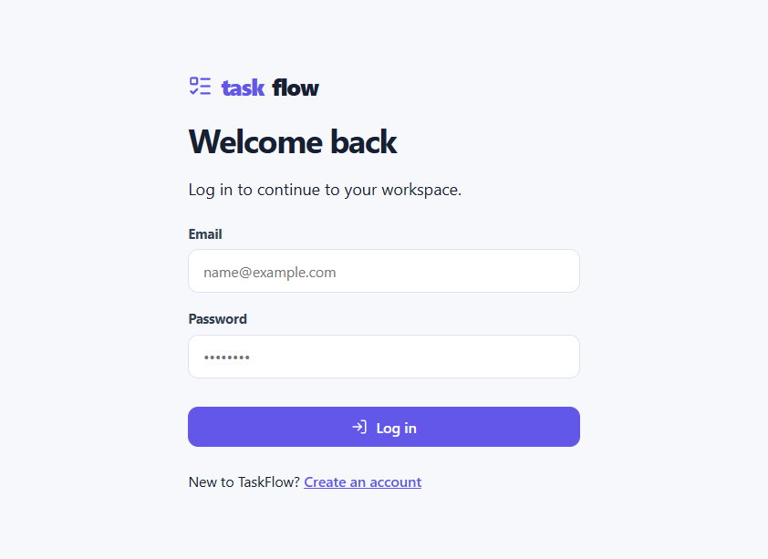
Figure 5.3: User login page

5.2 Dashboard and Task Management Screens
5.4: Dashboard Overview
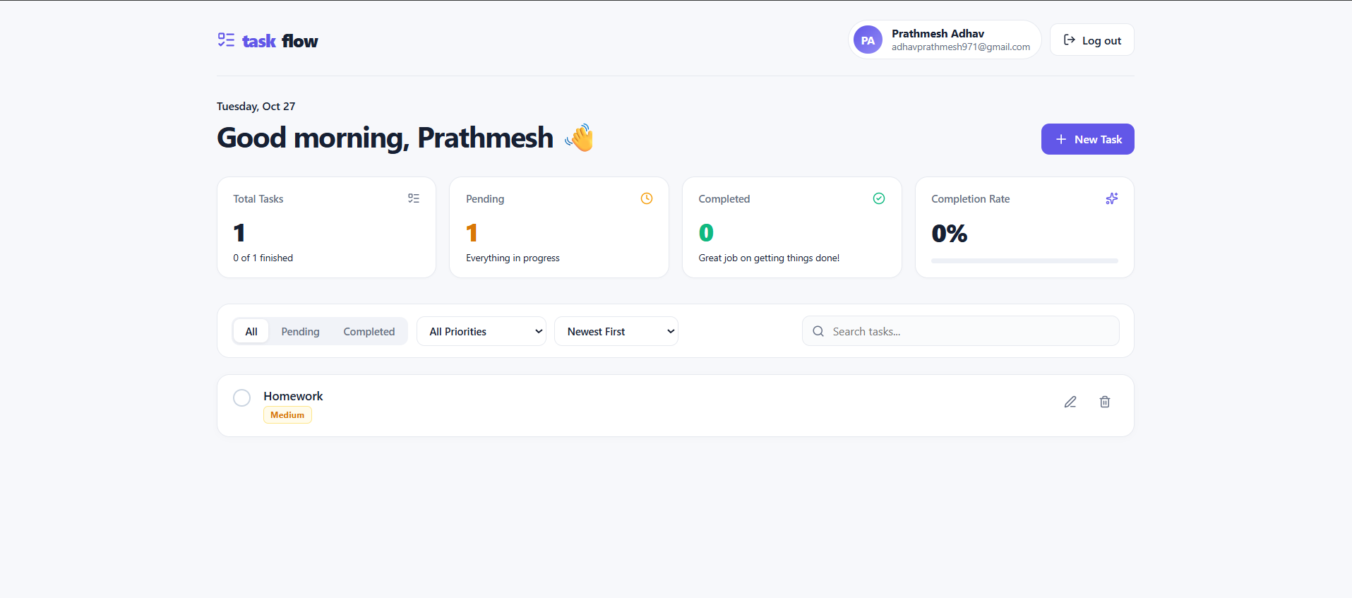
Figure 5.4: Dashboard with profile and task statistics

Screenshot 5.5: Create Task Modal
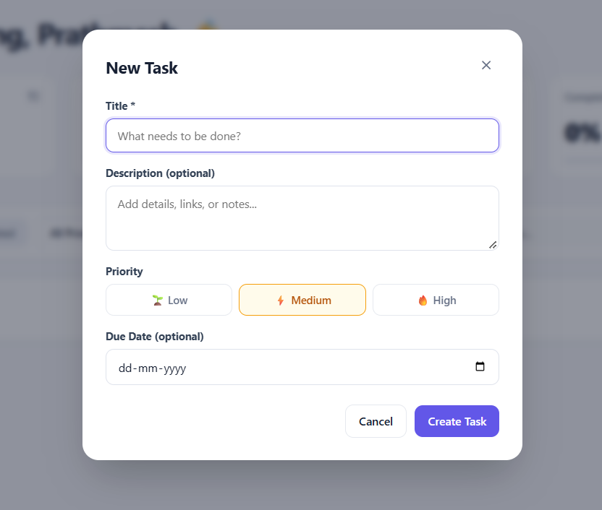

Figure 5.5: Create task modal dialog

Screenshot 5.6: Task List with Priorities and Overdue Badge
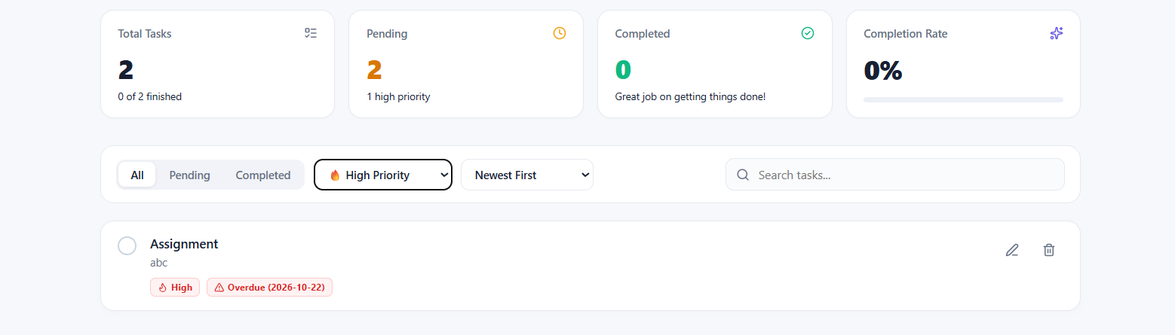
Figure 5.6: Task list showing priorities, completion and overdue detection

Screenshot 5.7: Search, Filter and Sort
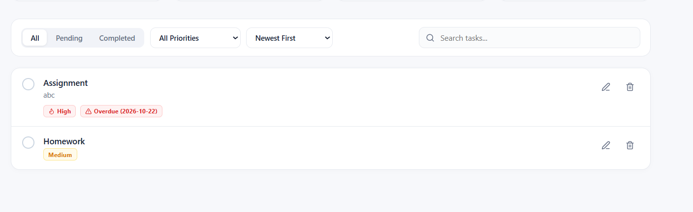
Figure 5.7: Search, filtering and sorting of tasks

Screenshot 5.8: Edit and Delete Task
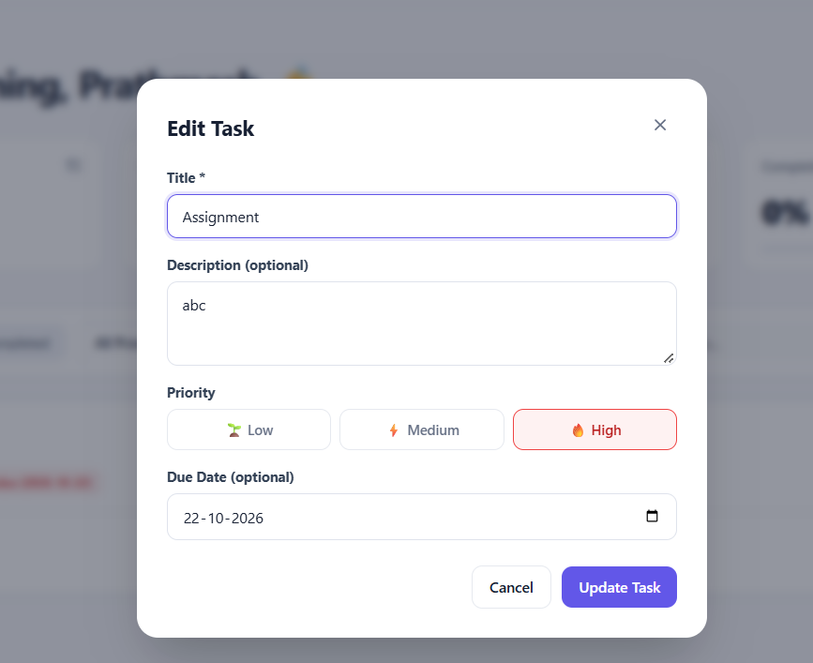
Figure 5.8: Editing and deleting a task

ADVANTAGES & LIMITATIONS

6.1 Advantages
• Strong security by design: bcrypt password hashes, hashed session tokens, HttpOnly and SameSite cookies, exact-origin CORS and parameterised SQL address the most common web-application vulnerabilities.
• Strict data isolation: scoping every task query by user_id ensures that each user sees and changes only their own tasks.
• Clean, maintainable architecture: the decoupled frontend and API and the layered router-handler-repository backend allow each part to be developed and tested independently.
• Reliable data integrity: foreign keys with cascade delete, unique constraints and check constraints keep the database consistent even if invalid input reaches it.
• Query efficiency: composite indexes that start with user_id match the dashboard's filtering and sorting patterns, and connection pooling reuses database connections.
• Productive user experience: statistics, a completion bar, overdue badges, instant search and filtering, colour-coded priorities and modal editing make task tracking quick.
• Repeatable setup: environment files and idempotent, ordered migrations allow the project to be installed consistently on a new machine.
• Lightweight backend: the API relies mainly on Go's standard library with a small number of focused dependencies.

6.2 Limitations
• Individual scope: tasks belong to a single account; sharing tasks, team workspaces and role-based permissions are not implemented.
• Local deployment: the documented configuration targets localhost; production hosting, HTTPS certificates and deployment automation are not described.
• Limited task model: tasks have one status pair (pending/completed) and no categories, tags, sub-tasks, attachments or reminders.
• No notifications: overdue tasks are highlighted only when the dashboard is opened; no email or push alerts are sent.
• Account management: password reset, email verification and profile editing are not part of the documented endpoints.
• Testing and performance evidence: the specification does not document automated tests or load measurements, so performance and scalability under heavy use have not been verified.
• Session cleanup: an index on expires_at supports cleanup of expired sessions, but a scheduled cleanup job is not described.

6.3 Future Enhancements
The following improvements are proposals and are not part of the current implementation: shared projects and team task assignment with role-based access; email or browser notifications for approaching and overdue deadlines; password reset and email verification; tags, categories and sub-tasks; automated unit, integration and end-to-end tests; containerised deployment with HTTPS and a managed MySQL instance; and a scheduled job that deletes expired sessions using the existing idx_sessions_expiry index.

CONCLUSION
TaskFlow demonstrates the design and implementation of a complete, secure web application using current web technologies. A Next.js 16 and React 19 frontend written in TypeScript provides a responsive dashboard, while a layered Go REST API and a normalised MySQL schema provide reliable, user-isolated storage of tasks.

7.1 Summary of the Project Achievements
• Implemented registration, login, logout and profile retrieval with bcrypt-hashed passwords and SHA-256-hashed, cookie-based sessions.
• Implemented the full task lifecycle with priorities, due dates and overdue detection, plus search, filtering, six sort orders and pagination.
• Built a dashboard with statistics cards, a completion-rate progress bar, colour-coded priority badges and modal editing.
• Designed three InnoDB tables with primary keys, foreign keys with cascade delete, unique and check constraints and query-oriented composite indexes, created through ordered migrations.
• Applied credentialed CORS, parameterised SQL and per-user query scoping to protect data.

7.2 Key Learning
Key learning outcomes include designing RESTful endpoints with suitable HTTP methods and status codes; implementing cookie-based session authentication with HttpOnly, SameSite and Secure attributes; configuring CORS for credentialed cross-origin requests; structuring a Go backend into router, handler, model and repository layers; designing a relational schema with keys, constraints and indexes that match application queries; preventing SQL injection with prepared statements; and building typed, component-based user interfaces with Next.js, React and Tailwind CSS.

REFERENCES

8.1 Books, Articles, Websites and Other Resources
[1] R. T. Fielding, “Architectural Styles and the Design of Network-based Software Architectures,” Ph.D. dissertation, University of California, Irvine, 2000.
[2] R. Fielding, M. Nottingham and J. Reschke, “HTTP Semantics,” RFC 9110, IETF, June 2022. https://www.rfc-editor.org/rfc/rfc9110
[3] A. Barth, “HTTP State Management Mechanism,” RFC 6265, IETF, April 2011. https://www.rfc-editor.org/rfc/rfc6265
[4] The Go Authors, “Package net/http,” Go Documentation. https://pkg.go.dev/net/http
[5] The Go Authors, “Package database/sql,” Go Documentation. https://pkg.go.dev/database/sql
[6] Go-MySQL-Driver contributors, “Go-MySQL-Driver.” https://github.com/go-sql-driver/mysql
[7] J. Schmidt, “HttpRouter.” https://github.com/julienschmidt/httprouter
[8] The Go Authors, “Package bcrypt,” golang.org/x/crypto. https://pkg.go.dev/golang.org/x/crypto/bcrypt
[9] Vercel, “Next.js Documentation: App Router.” https://nextjs.org/docs/app
[10] Meta Open Source, “React Documentation.” https://react.dev
[11] Microsoft, “TypeScript Documentation.” https://www.typescriptlang.org/docs/
[12] Tailwind Labs, “Tailwind CSS Documentation.” https://tailwindcss.com/docs
[13] Oracle Corporation, “MySQL 8.0 Reference Manual.” https://dev.mysql.com/doc/refman/8.0/en/
[14] Mozilla, “Using HTTP cookies,” MDN Web Docs. https://developer.mozilla.org/en-US/docs/Web/HTTP/Cookies
[15] Mozilla, “Cross-Origin Resource Sharing (CORS),” MDN Web Docs. https://developer.mozilla.org/en-US/docs/Web/HTTP/CORS
[16] OWASP Foundation, “SQL Injection Prevention Cheat Sheet.” https://cheatsheetseries.owasp.org/cheatsheets/SQL_Injection_Prevention_Cheat_Sheet.html
[17] OWASP Foundation, “Session Management Cheat Sheet.” https://cheatsheetseries.owasp.org/cheatsheets/Session_Management_Cheat_Sheet.html
[18] OWASP Foundation, “Password Storage Cheat Sheet.” https://cheatsheetseries.owasp.org/cheatsheets/Password_Storage_Cheat_Sheet.html

