Advanced Data Analysis and Visualization in Logistics
Exploring Delivery Performance Patterns for SwiftCart Logistics
Week 3 Deliverable | Logistics Data Analysis Project

1. Introduction
Weeks 1 and 2 of this project defined the SwiftCart Logistics scenario and built a clean, analysis-ready delivery dataset. This report is the next step: exploring that data in depth and using visualization to turn it into insight. The goal is not just to describe the data but to identify concrete patterns — which zones are costliest to serve, how distance and delivery time relate, and where the biggest bottlenecks in the network actually are — that can feed directly into the modeling and optimization work planned for later weeks.
A simulated dataset of 2,000 deliveries across six zones over a ten-week period was generated in Python for this analysis, with fields for distance, delivery time, package weight, shipment volume, and transport cost. The sections below walk through the exploratory analysis, present six visualizations built with matplotlib and seaborn, and interpret what each one reveals about SwiftCart's operations.

2. Data Simulation
The dataset (swiftcart_week3_dataset.csv) was generated with the following structure, consistent with the fields defined in the Week 2 cleaning pipeline:
- delivery_id, date, zone — identifiers and timing
- distance_km — route distance from depot to customer
- delivery_time_min — actual time taken, modeled as a function of distance and a zone-specific congestion factor
- package_weight_kg, shipment_volume — shipment characteristics
- transport_cost — modeled as a base fee plus a per-kilometer and per-kilogram charge, with random noise
- first_attempt_success — whether the delivery succeeded on the first attempt
Each zone was assigned a different base distance and congestion multiplier so that the simulated data reflects a realistic urban network, where some zones are inherently harder to serve than others — West Zone 1 and South Zone 2 were modeled as the most distant and congested, South Zone 1 and North Zone 1 as the most efficient.

3. Exploratory Data Analysis

3.1 Central Tendencies and Spread
Summary statistics across the five numeric variables are shown below. The average delivery takes 27.6 minutes over 9.1 km and costs ₹81.17, but the standard deviation on delivery time (18.9 minutes) is large relative to the mean, which already signals a wide, likely zone-driven spread rather than a tightly clustered distribution.
Metric | Distance (km) | Delivery Time (min) | Weight (kg) | Volume (units) | Cost (₹)
Mean | 9.09 | 27.60 | 3.99 | 6.98 | 81.17
Std. Dev. | 4.03 | 18.86 | 2.78 | 2.48 | 15.10
Median | 8.93 | 22.85 | 3.37 | 7.00 | 80.91
Min | 0.50 | 4.00 | 0.36 | 1 | 37.98
Max | 21.57 | 92.10 | 18.82 | 19 | 124.98

3.2 Zone-Level Averages
Breaking the same metrics down by zone makes the spread concrete. Average delivery time ranges from 9.25 minutes in South Zone 1 to 57.53 minutes in West Zone 1 — a more than six-fold difference — and average cost follows the same ordering, from ₹67.69 up to ₹97.47.
Zone | Avg. Distance (km) | Avg. Delivery Time (min) | Avg. Cost (₹)
South Zone 1 | 4.95 | 9.25 | 67.69
North Zone 1 | 6.22 | 13.34 | 72.36
East Zone 1 | 8.02 | 19.26 | 77.90
North Zone 2 | 9.18 | 25.24 | 81.02
South Zone 2 | 12.10 | 41.19 | 90.90
West Zone 1 | 14.17 | 57.53 | 97.47

3.3 Correlation Analysis
Distance and delivery time are strongly correlated (r = 0.91), which is expected but useful to confirm quantitatively. Distance and cost are similarly correlated (r = 0.85), while delivery time and cost sit at r = 0.77. Package weight has a moderate positive correlation with cost (r = 0.32) but is essentially uncorrelated with delivery time (r = − 0.01), meaning cost is driven both by how far a package travels and by how heavy it is, while delivery time is driven almost entirely by distance and zone congestion. Shipment volume shows negligible correlation with every other variable, suggesting it behaves as an independent operational factor rather than a cost or time driver in this dataset.

4. Visualizations
Six visualizations were produced to examine distributions, zone comparisons, relationships between variables, and trends over time. Each chart type was chosen to match the specific question being asked of the data.

4.1 Distribution of Delivery Times
A histogram with a kernel density overlay is the right tool for examining the shape of a single continuous variable — here, whether delivery times cluster tightly or spread out, and whether the distribution is symmetric or skewed.
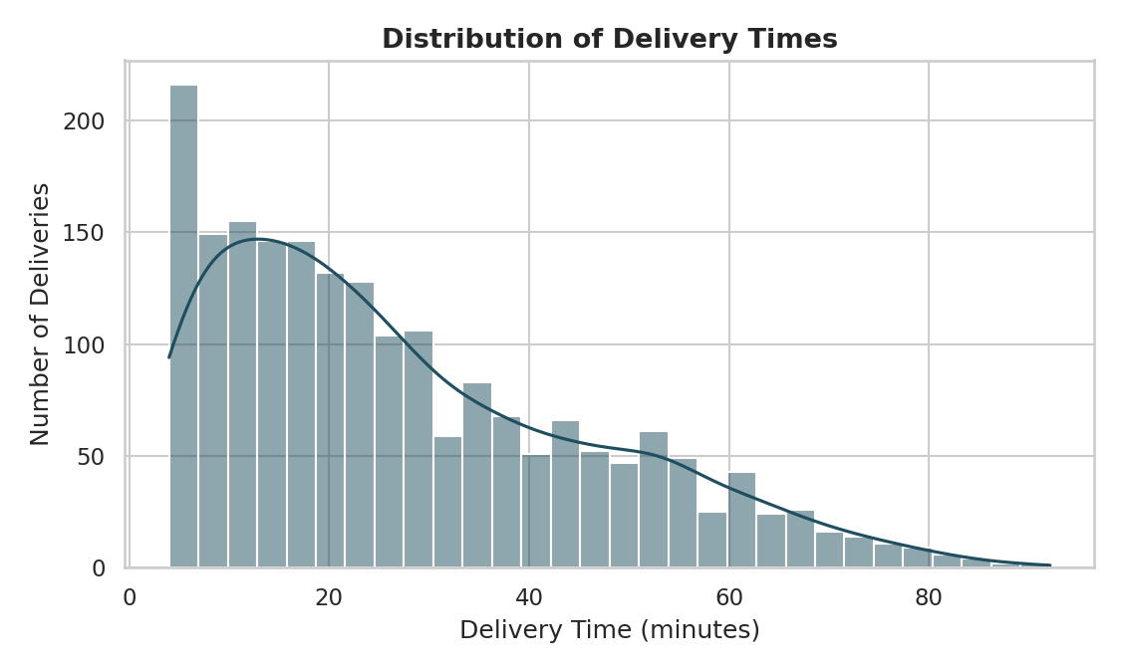
Figure 1. Distribution of delivery times across all 2,000 simulated deliveries.
The distribution is right-skewed: most deliveries complete within 10–25 minutes, but a long tail extends out to 90 minutes. This shape is typical of urban delivery networks, where the majority of stops are routine but a minority — likely the more distant or congested zones — pull the average upward. This matters for the ETA regression model proposed in Week 1, since a right-skewed target variable benefits from log-transformation or the use of tree-based models that don't assume a normal distribution.

4.2 Average Transport Cost by Zone
A horizontal bar chart is well suited to ranking a metric across a small number of categories, since it makes direct comparison across zones easy to read at a glance.
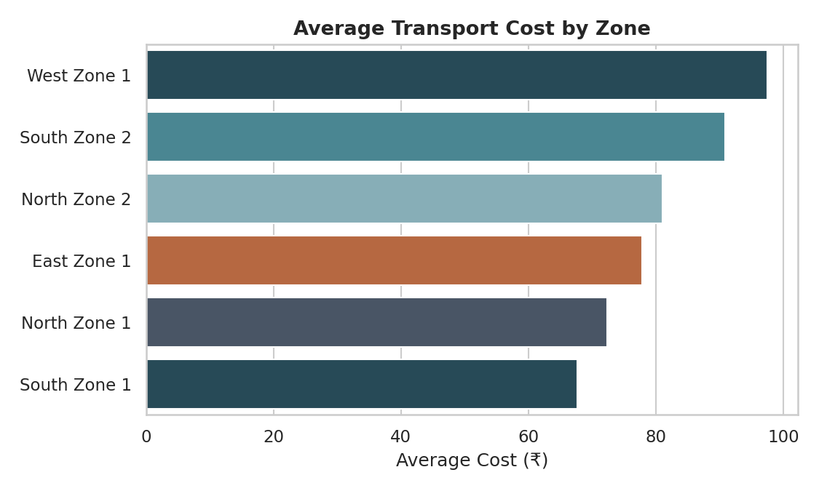
Figure 2. Average transport cost per delivery, by zone.
West Zone 1 and South Zone 2 are the two most expensive zones to serve, averaging ₹97.47 and ₹90.90 per delivery respectively — roughly 30–44% higher than the cheapest zone, South Zone 1. This immediately flags these two zones as priority candidates for the route optimization work planned in Week 1, since even a modest reduction in distance driven per delivery in these zones would have an outsized effect on total cost.

4.3 Delivery Distance vs. Delivery Time
A scatter plot, colored by zone, is the standard choice for examining the relationship between two continuous variables while checking whether that relationship holds consistently across categories or diverges by group.
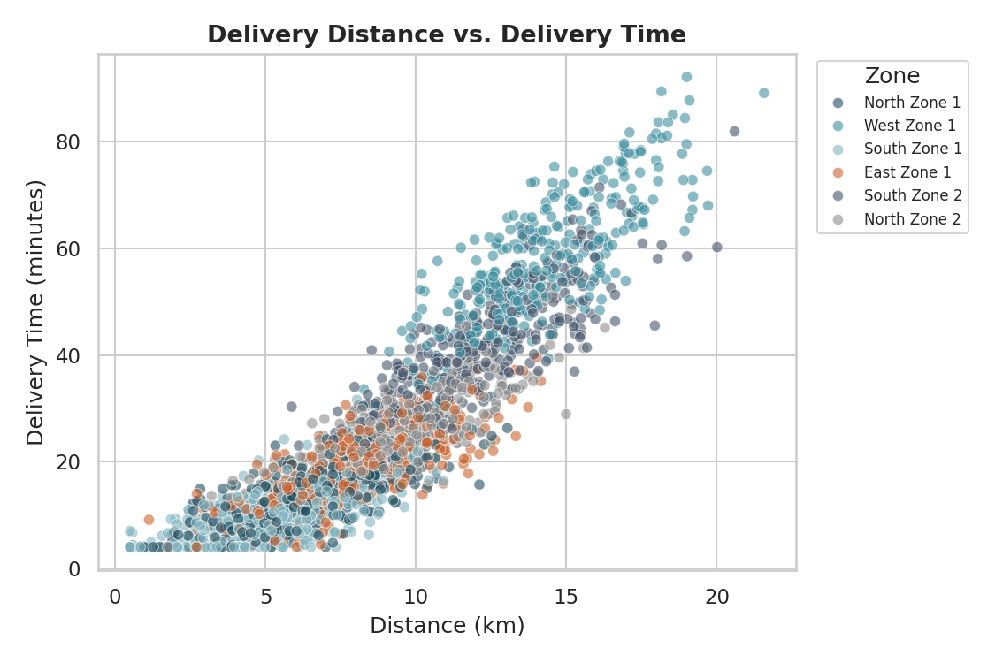
Figure 3. Delivery distance plotted against delivery time, colored by zone.
The overall relationship is clearly positive and roughly linear, consistent with the r = 0.91 correlation, but the zones separate into distinct bands rather than falling on a single line. For a given distance, West Zone 1 deliveries consistently take longer than South Zone 1 deliveries — visual confirmation that congestion, not just distance, is a meaningful separate driver of delivery time, and that any ETA model should include zone or congestion as a feature rather than relying on distance alone.

4.4 Transport Cost Spread by Zone
A boxplot was chosen over a simple bar chart here because it shows the full spread and outliers within each zone, not just the average — important for understanding cost consistency, not only cost level.
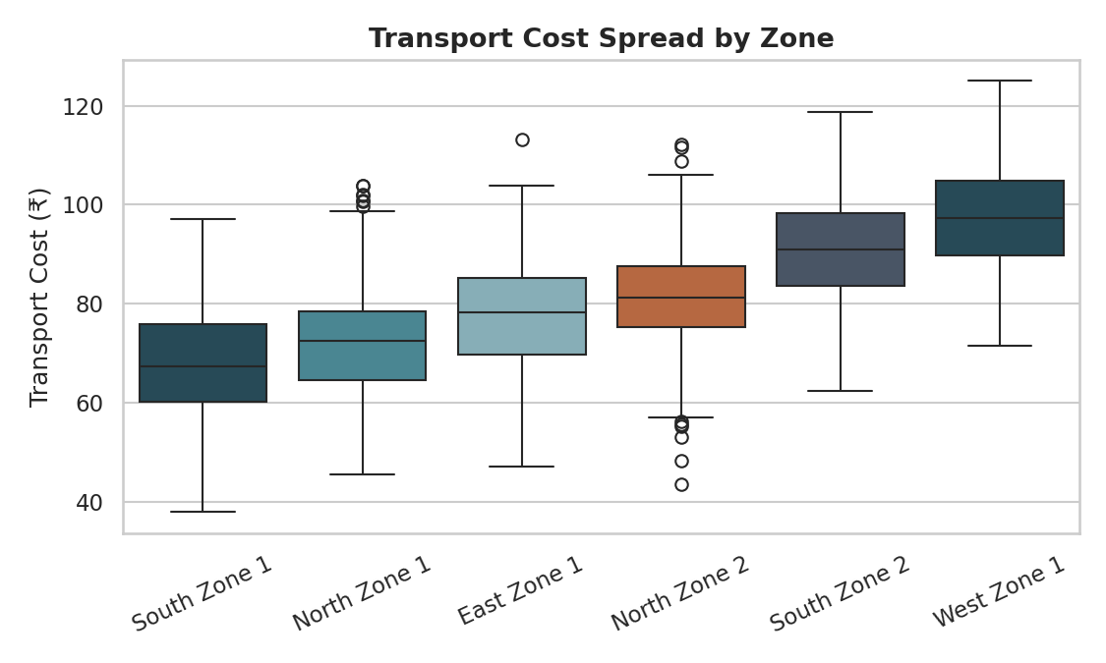
Figure 4. Distribution of transport cost within each zone.
Beyond confirming the same zone ordering seen in Figure 2, this view shows that West Zone 1 and South Zone 2 also have the widest interquartile ranges — meaning cost in these zones is not just higher on average but less predictable. That unpredictability is itself an operational problem: it makes budgeting and route planning harder in exactly the zones where getting it right matters most.

4.5 Correlation Between Key Variables
A heatmap is the clearest way to present a full correlation matrix at once, letting every pairwise relationship be scanned visually rather than read one number at a time.
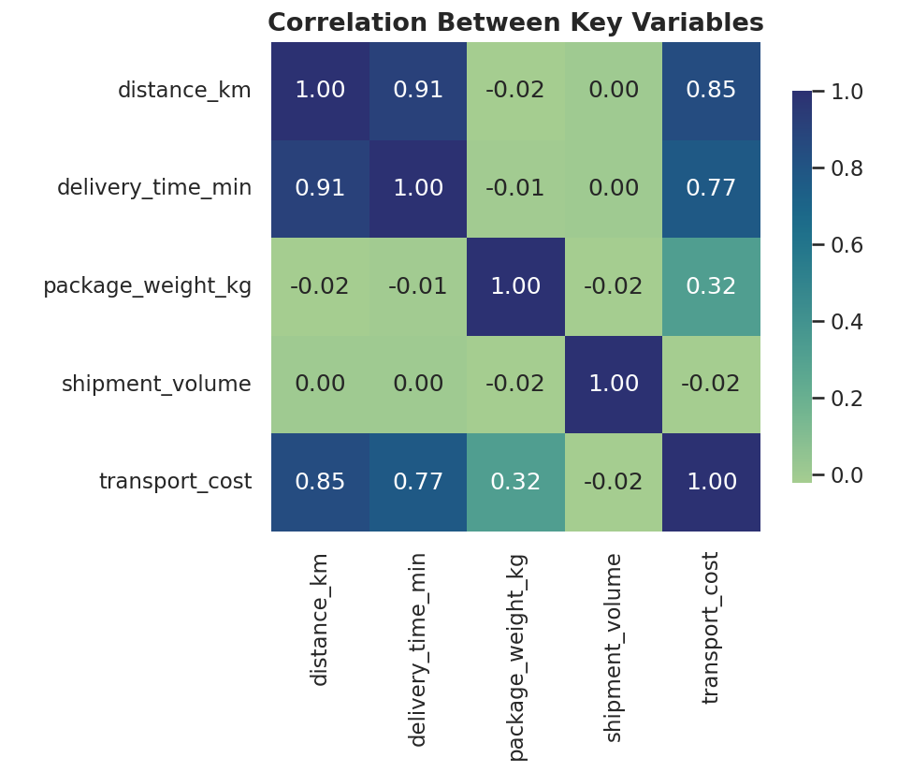
Figure 5. Correlation matrix across distance, delivery time, weight, volume, and cost.
This view confirms quantitatively what Figures 1–4 suggest visually: distance is the dominant driver of both delivery time and cost, weight contributes to cost but not time, and shipment volume is essentially unrelated to any other variable in this dataset — useful to know when selecting features for the predictive models proposed in Week 1, since volume would add little value to an ETA or cost model despite intuitively seeming relevant.

4.6 Transport Cost Trend Over Time
A line chart with a rolling average is the appropriate choice for a time-based question, since it smooths day-to-day noise and makes underlying trends or cyclical patterns visible.
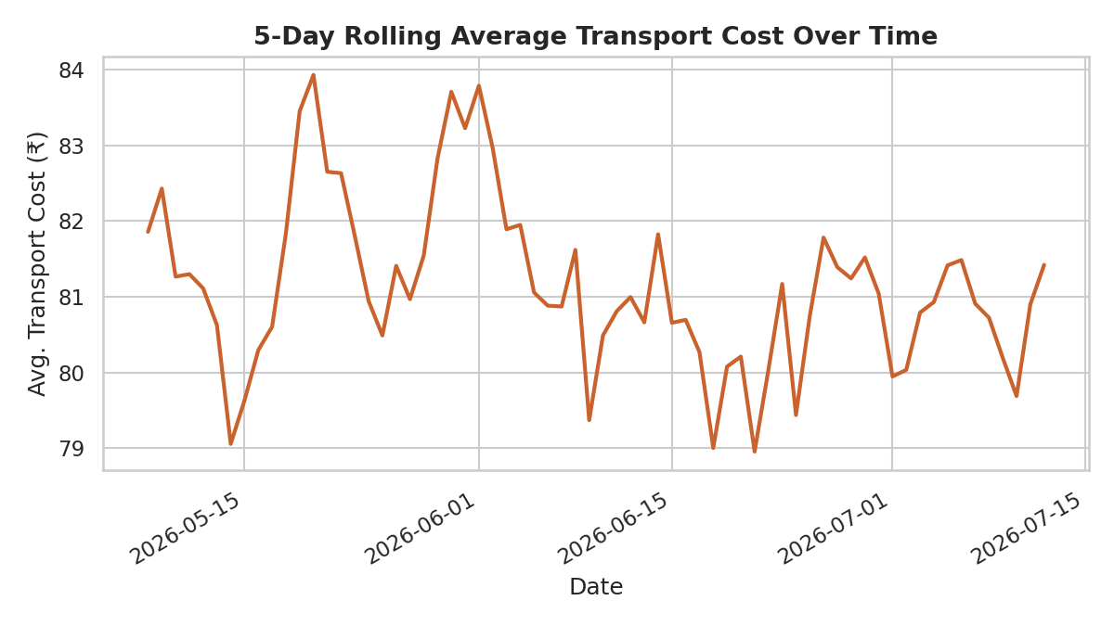
Figure 6. 5-day rolling average transport cost across the 10-week simulation period.
Cost fluctuates within a fairly stable band across the ten-week window rather than trending consistently upward or downward, with mild cyclical bumps that align with the day-of-week congestion pattern built into the simulation. In a real deployment, this same chart would be the first place to look for early warning signs — a sustained upward trend would indicate a systemic issue (fuel prices, fleet aging, growing zone congestion) rather than normal day-to-day variation.

5. Python Code
The core of the analysis and visualization pipeline is shown below (pandas for data handling, matplotlib/seaborn for plotting).

5.1 Loading Data and Summary Statistics
import pandas as pd

df = pd.read_csv('swiftcart_week3_dataset.csv', parse_dates=['date'])
numeric_cols = ['distance_km', 'delivery_time_min', 'package_weight_kg',
'shipment_volume', 'transport_cost']

print(df[numeric_cols].describe())
print(df.groupby('zone')[numeric_cols].mean())
print(df[numeric_cols].corr())

5.2 Distribution Plot
import seaborn as sns
import matplotlib.pyplot as plt

fig, ax = plt.subplots(figsize=(7.5, 4.5))
sns.histplot(df['delivery_time_min'], bins=30, kde=True, ax=ax)
ax.set_title('Distribution of Delivery Times')
ax.set_xlabel('Delivery Time (minutes)')
fig.savefig('01_delivery_time_distribution.png', dpi=150)

5.3 Zone Comparison and Scatter Plot
zone_cost = df.groupby('zone')['transport_cost'].mean().sort_values(ascending=False)
sns.barplot(x=zone_cost.values, y=zone_cost.index)

sns.scatterplot(data=df, x='distance_km', y='delivery_time_min',
hue='zone', alpha=0.6, s=35)

5.4 Correlation Heatmap
corr = df[numeric_cols].corr()
sns.heatmap(corr, annot=True, fmt='.2f', cmap='crest', square=True)

5.5 Rolling Trend Line
daily = df.groupby('date')['transport_cost'].mean().rolling(5).mean()
plt.plot(daily.index, daily.values)
plt.title('5-Day Rolling Average Transport Cost Over Time')

6. Analytical Insights and Recommendations
Pulling the EDA and visualizations together, three findings stand out as directly actionable for SwiftCart's operations:
- Zone is the dominant cost and efficiency driver. West Zone 1 and South Zone 2 cost 30–44% more per delivery than the most efficient zone and show the widest cost variability. These two zones should be the first priority for the route optimization (VRPTW) work outlined in Week 1, since they carry the largest potential savings per route improved.
- Distance explains delivery time far better than any other variable, but not completely — the zone-level banding in Figure 3 shows congestion adds a meaningful, zone-specific penalty on top of raw distance. Any ETA prediction model should include a zone or congestion feature rather than distance alone, or it will systematically underpredict delivery time in high-congestion zones.
- Shipment volume is not a meaningful driver of either time or cost in this dataset, despite being an intuitive candidate. This is useful early information for feature selection in later modeling weeks — it suggests effort is better spent capturing congestion and route-sequencing effects than shipment-volume effects.
Together, these findings support a clear recommendation: prioritize route optimization in West Zone 1 and South Zone 2 first, incorporate a congestion or zone feature into any predictive model rather than relying on distance alone, and continue monitoring the cost trend over time to catch systemic increases early rather than only reacting to zone-level averages after the fact.

