1. Write a R program to create a sequence of numbers from 20 to 50 and find the mean

of numbers from 20 to 60 and sum of numbers from 51 to 91.

print("sequence of numbers from 20 to 50: ")

print(seq(20,50))

print("mean of num from 20 to 60: ")

print(mean(20:60))

print("sum of numbers from 51 to 91: ")

print(sum(51:90))

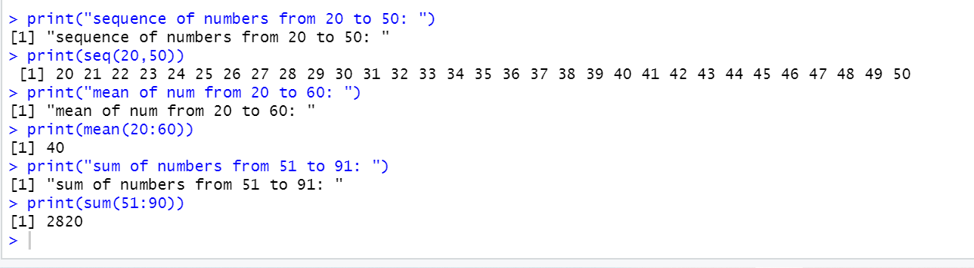

2-

for (n in 1:100) {

if (n %% 3 == 0 & n %% 5 == 0) {print("FizzBuzz")}

else if (n %% 3 == 0) {print("Fizz")}

else if (n %% 5 == 0) {print("Buzz")}

else print(n)

}

