1.INTRODUCTION TO PROJECT

Hospital Management System provides the benefits of streamlined operations, enhanced administration, control, superior patient care, strict cost control and improved profitability. HMS is powerful, flexible, and easy to use and is designed and developed to deliver real conceivable benefits to hospitals. More importantly it is backed by reliable and dependable support. The project ‘Hospital Management System’ is based on the database, object oriented and networking techniques.
Hospital Management System is custom built to meet the specific requirement of the mid and large size hospitals across the globe. All the required modules and features have been particularly built to just fit in to your requirement. Entire application is web based and built on 3 tier architecture using the latest technologies. The sound database of the application makes it more users friendly and expandable. The package is highly customizable and can be modified as per the needs and requirements of our clients.
The purpose of this project is to automate or make online, the process of day to-day activities like Room activities; Admission of New Patient, Discharge of Patient, Assign a Doctor, and finally compute the bill etc. We have tried our best to make the complicated process Hospital Management System as simple as possible using Structured Modular technique Menu oriented interface.
We have tried to design the software in such a way that user may not have any difficulty in using this package further expansion is possible without much effort. We have used React at our front end for user interface and Spring boot for backend. We have used MySql as our database.

2.REQUIREMENTS

2.1 FUNCTIONAL REQUIREMENTS

2.1 Admin Account
Admin manages the whole system. He is responsible for employee management.
He is interested into tracking revenue. There are major roles that admin has to handle
Like doctor, receptionist, patient, lab manager. The functionalities are as following.
After login admin can see his/her profile information.
• Appoint employee:

Admin add the detail of employee like name, email, password date of birth, contact number and then select the gender, role and department .
• View, update and remove employee :

When admin click on view employee button he can view the name and role of employee. He can update and also delete the details of employee
• Payment history :

When admin click on Payment history he can view the revenue as per
consultation, ward, test charges in graph format.

Fig.2.1.Admin Functionalities
2.2 Doctor Account
Doctor can able to see appointments booked by patients. After login he can see his profile as well as following functionalities.
• View appointments :

When doctor click on view appointments he can able to see the appointments for current date only. He can able to see the patient id , appointment date, patient name. Doctor can create prescription for medicine as well as test. While creating medicine he has to select quantity and medicine from list , for creating he can select the test from test list.
Fig.2.2 Doctor’s Functionalities

2.3 Patients Account
• View appointments :
Patient first need to sign up by clicking on book appointment. He/she need to feel the details like name, gender, email and password. After he /she can login and book the appointment.
• Book appointments :

After login patient can select the doctor and particular appointment date, patient
need to pay the charges and he will get notification that appointment has booked.

Fig.2.3.Patient’s Functionalities

2.4 Receptionist Account
• View appointments :
After login receptionist can see her profile just by clicking on home. she can view the doctor wise and date wise appointments.
• Admit patient :

Receptionist will able to see the details made by patients using book appointments.
According to that list she will be able to admit the patient.
• Discharge Patient :

When the patient is get admitted that list is visible to receptionist and she can discharge that particular patient.
• Accept payment :

As per patient id and appointment she will take ward charges and lab test charges.

Fig.2.4.Receptionist Functionalities

2.5 Lab manager Account
Lab manager can view the prescription of test by using patient id. He can also able to see list of tests. The test are suggested by doctor to patient are visible to him by view prescription.

Fig.2.5.LabManager Functionalities

  - NON FUNCTIONAL REQUIREMENTS

2.2.1 Interface
Go to Appendix B for user interfaces
2.2.2 Performance
HMS shall be able to handle at least 1000 transactions/inquiries per second.
2.2.3 Constraint
HMS shall be able to handle at least 1000 transactions/inquiries persecond.
2.2.4 Other Requirements:
▪ Hardware Interfaces

The SPMS is expected to function on Intel PIII 900 MHz Processor equivalent or above, 128 MB RAM, 20 GB HDD.
▪ Software Interfaces

The SPMS shall work on MS Windows operating systems family (MS Windows 98, MS Windows NT Workstation, MS Windows 2000, MS Windows XP). It configures to work with Mysql database. This System works on Apache Tomcat server.
We used Spring tool suit(STS) for coding purpose at backend(version: 3.9.18.RELEASE). Visual Studio for front end (version : 1.71.2) and MySql database .

3. DESIGN

3.1 Database Design

The following table structures depict the database design.

Table1: admit_patients

Column Name | Data Type | Length | Allow Null (1=Yes;0=No)
ID(primary key) | int | - | 0
Admit_date | Date | 3 | 1
discharge_date | Date | 3 | 1
appt_id | int | 4 | 1
dept_id | int | 4 | 1
patient_id | int | 4 | 1

Table2: Appointments

Column Name | Data Type | Length | Allow Null (1=Yes;0=No)
ID(primary key) | int | - | 0
appt_id | int | 4 | 1
doc_id | int | 4 | 1
patient_id | int | 4 | 1

Table3: Departments

Column Name | Data Type | Length | Allow Null (1=Yes;0=No)
ID(primary key) | int | - | 0
name | varchar | 20 | 1

Table4: Employees

Column Name | Data Type | Length | Allow Null (1=Yes;0=No)
ID(primary key) | int | - | 0
Contact | varchar | 20 | 1
email | varchar | 20 | 1
gender | varchar | 255 | 1
name | varchar | 20 | 1
password | varchar | 20 | 1
dob | Date | 3 | 1
role | varchar | 255 | 1
dept_id | int | 4 | 1

Table5: med_presc

Column Name | Data Type | Length | Allow Null (1=Yes;0=No)
ID(primary key) | int | - | 0
presc_date | date | 3 | 1
doc_id | int | 4 | 1
patient_id | int | 4 | 1

Table6:medical_tests

Column Name | Data Type | Length | Allow Null (1=Yes;0=No)
ID(primary key) | int | - | 0
charge | double | 8 | 0
name | varchar | 20 | 1
Test_presc_id | int | 4 | 1
Table7:medicine_item_qty

Column Name | Data Type | Length | Allow Null (1=Yes;0=No)
qty | int | - | 0
med_presc_id(pr  imary) | int | 4 | 0
Med_id(primary  ) | int | 4 | 0
id | int | 4 | 0
Medicine_id | int | 4 | 1

Table8:medicines

Column Name | Data Type | Length | Allow Null (1=Yes;0=No)
ID(primary key) | int | - | 0
name | varchar | 20 | 1
Price_per_tab | double | 8 | 0

Table9:patients

Column Name | Data Type | Length | Allow Null (1=Yes;0=No)
ID(primary key) | int | - | 0
Contact | varchar | 20 | 1
email | varchar | 20 | 1
gender | varchar | 255 | 1
name | varchar | 20 | 1
password | varchar | 20 | 0
age | int | 4 | 0
Blood_group | varchar | 10 | 1
city | varchar | 20 | 1
Table10:payments

Column Name | Data Type | Length | Allow Null (1=Yes;0=No)
ID(primary key) | int | - | 0
consultation_cha  rges | double | 8 | 0
test_charges | double | 8 | 0
ward_charges | double | 8 | 0
appt_id | int | 4 | 0
patient_id | int | 4 | 0
Last_pay_date | int | 3 | 1

Table11:test_presc

Column Name | Data Type | Length | Allow Null (1=Yes;0=No)
ID(primary key) | int | - | 0
presc_date | date | 3 | 1
doc_id | int | 4 | 1
patient_id | int | 4 | 1

Table12:test_reports

Column Name | Data Type | Length | Allow Null (1=Yes;0=No)
ID(primary key) | int | - | 0
content_type | date | 3 | 1
data | longbolb | - | 1
name | varchar | 255 | 1
med_test_id | int | 4 | 1
test_presc_id | int | 4 | 1
Table13:test_reports

Column Name | Data Type | Length | Allow Null (1=Yes;0=No)
Presc_id(primary) | int | 4 | 0
test_id(primary) | int | 4 | 0

E-R Diagram:

Go to Appendix A

4. CODING STANDARDS IMPLEMENTED

Naming and Capitalization

Below summarizes the naming recommendations for identifiers in Pascal casing is used mainly (i.e. capitalize first letter of each word) with camel casing (capitalize each word except for the first one) being used in certain circumstances.

Identifier | Case | Examples | Additional Notes
Class | Pascal | Employees, Patients | Class names should be based on "objects" or "real things" and should generally be nouns. No ‘_’ signs  allowed. Do not use type prefixes like ‘C’ for class.
Method | Camel | getId,getRole | Methods should use verbs or verb phrases.
Parameter | Camel | patientId | Use descriptive parameter names. Parameter names should be descriptive enough that the name of the parameter and its type can be used to determine its  meaning in most scenarios.
Interface | Pascal with "I"  prefix | IDoctorService | Do not use the ‘_’ sign
Property | Pascal | Role, Gender | Use a noun or noun phrase to name properties.
Exception Class | Pascal with "Exception"  suffix | WebException,

Comments

    - Comment each type, each non-public type member, and each region declaration.

    - Use end-line comments only on variable declaration lines. End-line comments are comments that follow code on a single line.
    - Separate comments from comment delimiters (apostrophe) or // with one space.

    - Begin the comment text with an uppercase letter.

    - End the comment with a period.

    - Explain the code; do not repeat it.

5. TEST REPORT

GENERAL TESTING:

SR- NO | TEST CASE | EXPECTED RESULT | ACTUAL RESULT | ERROR MESSAGE
1 | Register Page | Redirected to Next page | OK | Nothing
2 | Login Page | Pop-up will come | Ok | Please enter username and  password again .
4 | Sign in of patient | Need to fill the information and  password | Ok | Nothing
5 | Booking appointment | All the fields should be filled for submission | Ok | Nothing
6 | Checking login or not | User is logged in or not | Ok | Nothing
7 | Edit profile for patient | Update the information | Ok | Nothing
8 | All profile of  employees and patients | Visible after login | Ok | Nothing
9 | Payment add | After adding payment  result is payment booked | Ok | Nothing
10 | Admin add  and remove employee | Data gets added into  database according to the role | Ok | Nothing
11 | View test reports | Lab manager can  view test list according to patient id | Ok | Nothing
12 | Create  prescription by doctor | List of medicines and test gets added | Ok | Nothing
13 | Revenue generation | When payment gets added into account it is visible according to type of charges in  graph | Ok | Nothing
14 | View appointment of doctor | Only todays appointment is visible to doctor | Ok | Nothing
15 | View appointment  of receptionist | Doctor wise and date wise appointments are  visible to receptionist | Ok | Nothing

16 | Accept  payment by receptionist | Ward charges and test charges get accepted | Ok | Nothing
17 | Discharge patient | After clicking on discharge patient data  get removed from database | Ok | Nothing
18 | Admit patient | She can able see the booked appointment and select the date and department and  can admit it | Ok | Nothing
19 | Logout | It will logout from user profile. | Ok | Nothing
 | STATIC TESTING
SR- NO | Deviation | Program
 | Commenting not followed | All Web Application

6. PROJECT MANAGEMENT RELATED STATISTICS

DATE | WORK PERFORMED | SLC Phase | Additional Notes
MAY 6, 2022 | Project Allotment and User Requirements Gathering | Feasibility Study | We discussed about project to know the requirements.
MAY10,2022 | Initial SRS Document Validation  And Team Structure Decided | Requirement Analysis (Elicitation) | The initial SRS was presented to the client to understand his requirements better
MAY 22,2022 | Designing the use-cases, Class Diagram, Collaboration Diagram, E-R Diagram and  User Interfaces | Requirement Analysis & Design Phase | Database Design completed
JUN 19,2022 | Business Logic Component design Started | Design Phase | ----------------------
SEPT 5,2022 | Coding Phase Started | Coding Phase | 70% of Class Library implemented.
SEPT 8,2022 | Implementation of Web Application and Window Application Started | Coding Phase | Class Library Development going on.
SEPT 10, 2022 | Implementation of Web Application and Window Application Continued | Coding Phase and Unit Testing | Class Library Modified as per the need.
SEPT 12, 2022 | The Project was Tested by the respective Team Leaders and the Project Manager | Testing Phase (Module Testing) | --
SEPT 19, 2022 | The Project was Submitted to Other Project Leader of Other Project Group For Testing | Testing Phase (Acceptance Testing) | The Project of Other Team was Taken up by the Team for Testing

SEPT 28, 2022 | The project was deployed on AWS | Deploying | The Project was complete for submission
SEPT 28, 2022 | Final Submission of Project

Appendix A

Entity Relationship Diagram

Appendix B

Homepage:

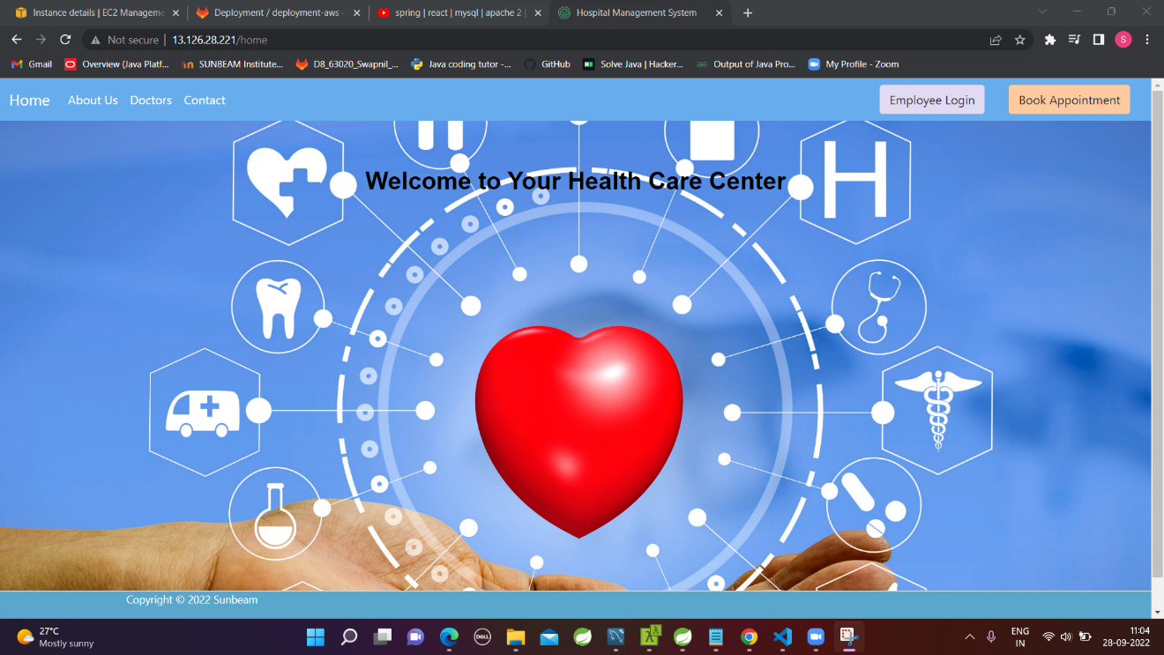

Admin_HomePage:

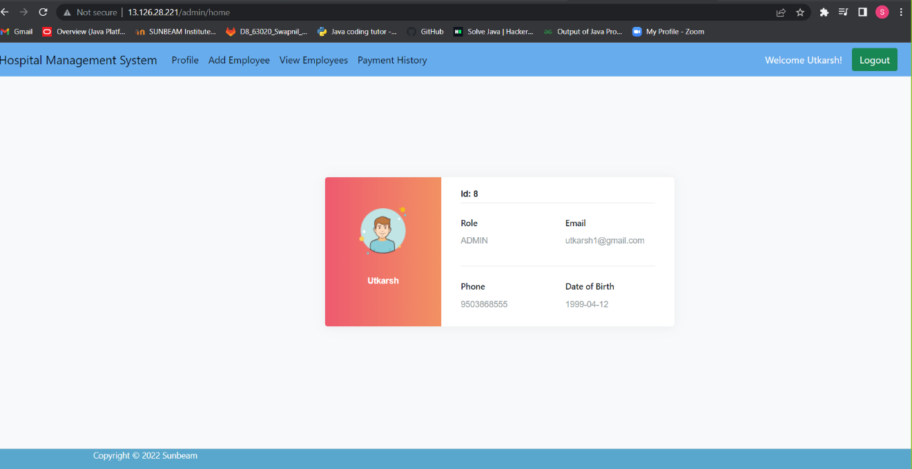

Patients Signin:

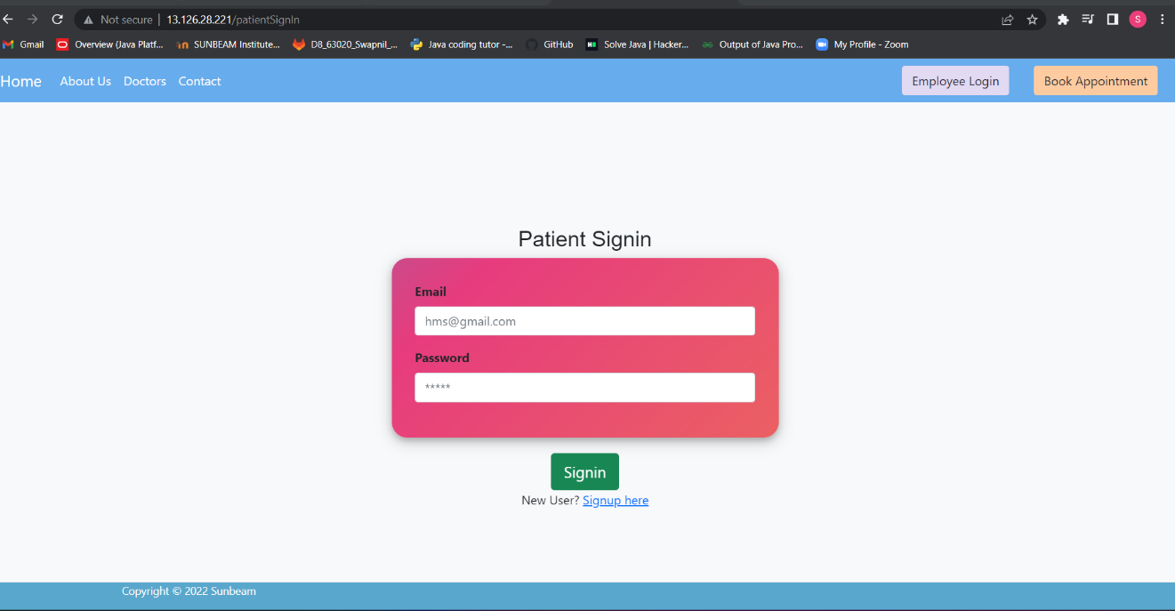

Patients SignUp:

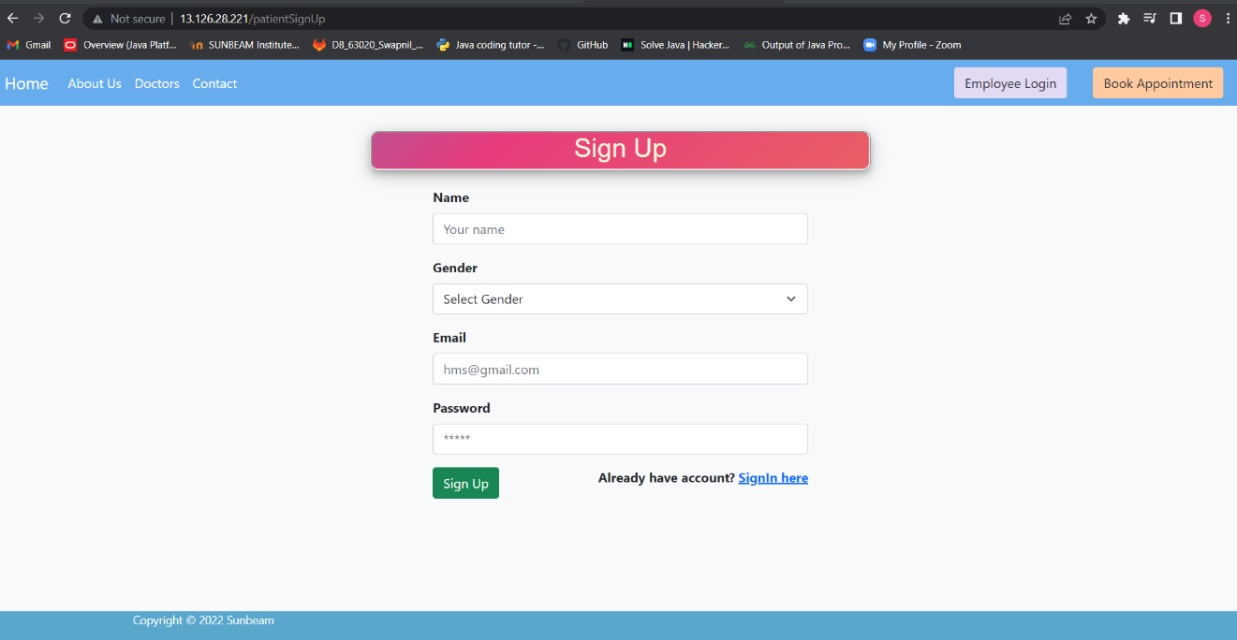

Book appointment:

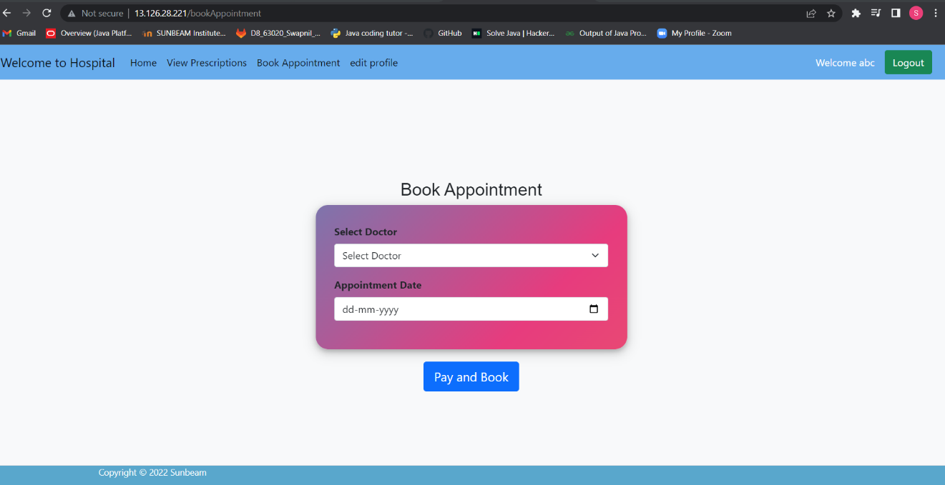

Payment successful:

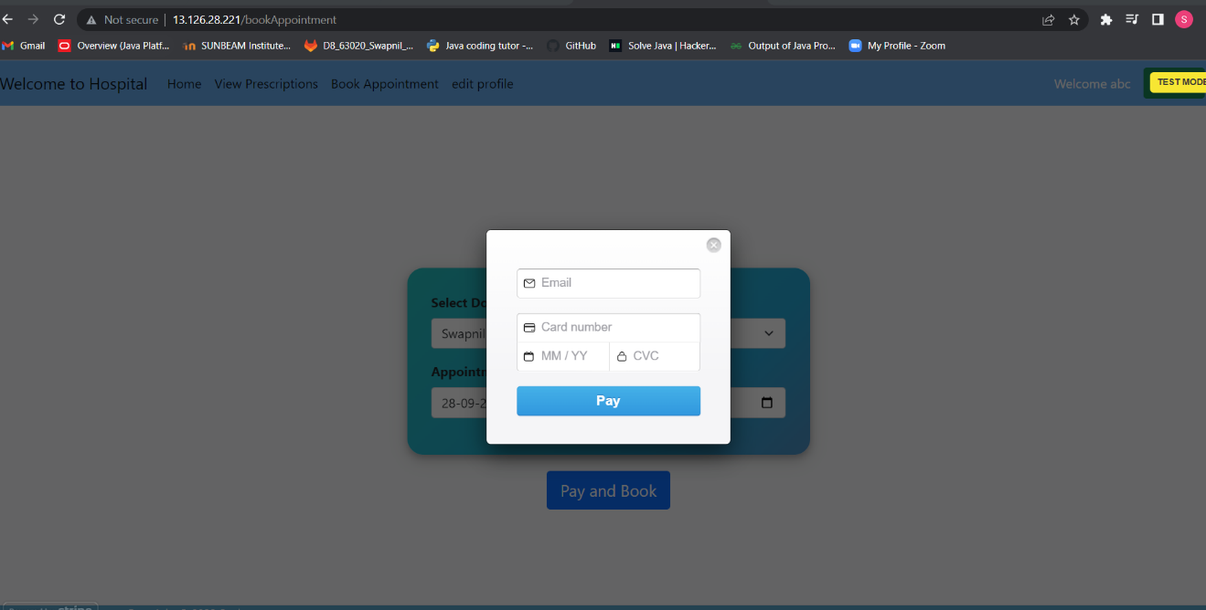

Edit_Patients_Profie:

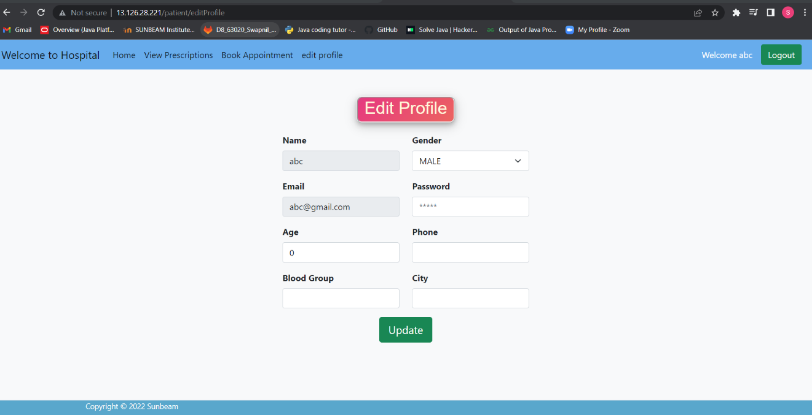

View Employee By Admin:

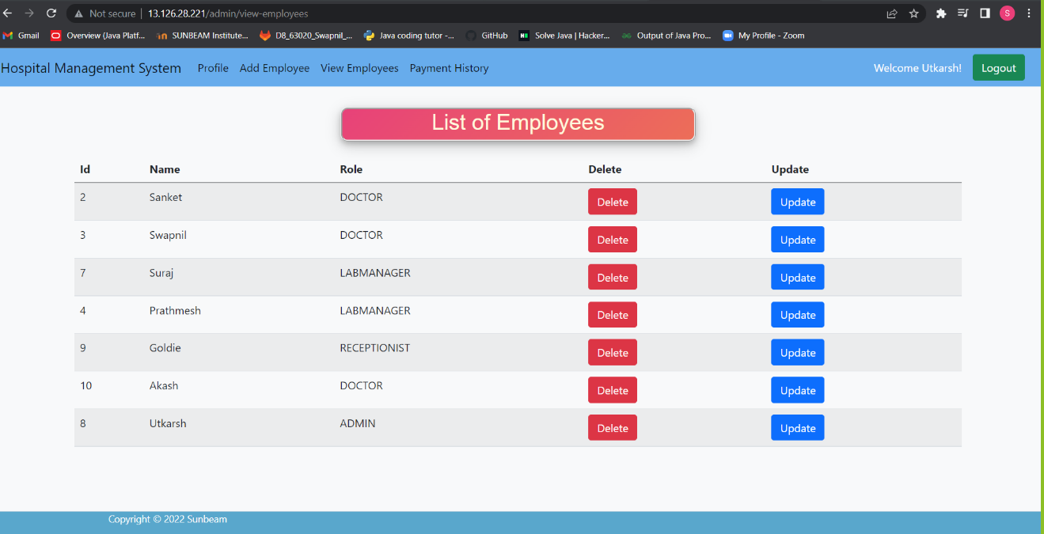

Add employee at admin login:

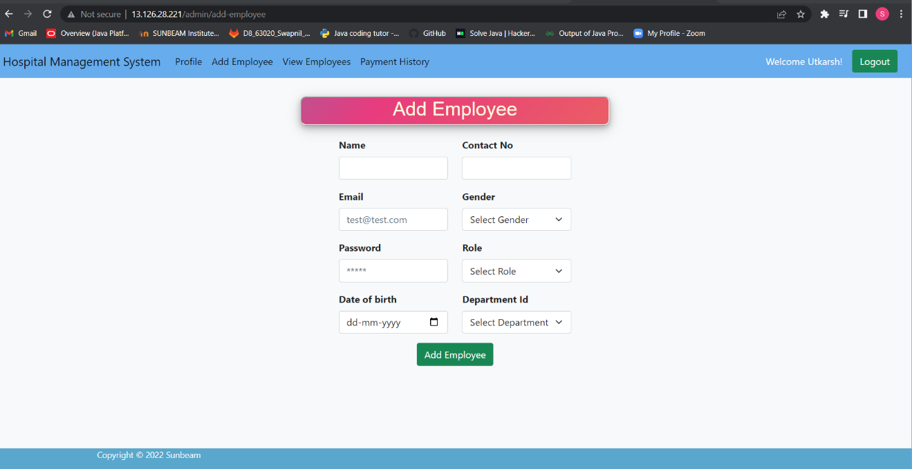

Remove employee by Admin:

Revenue generation at admin login:

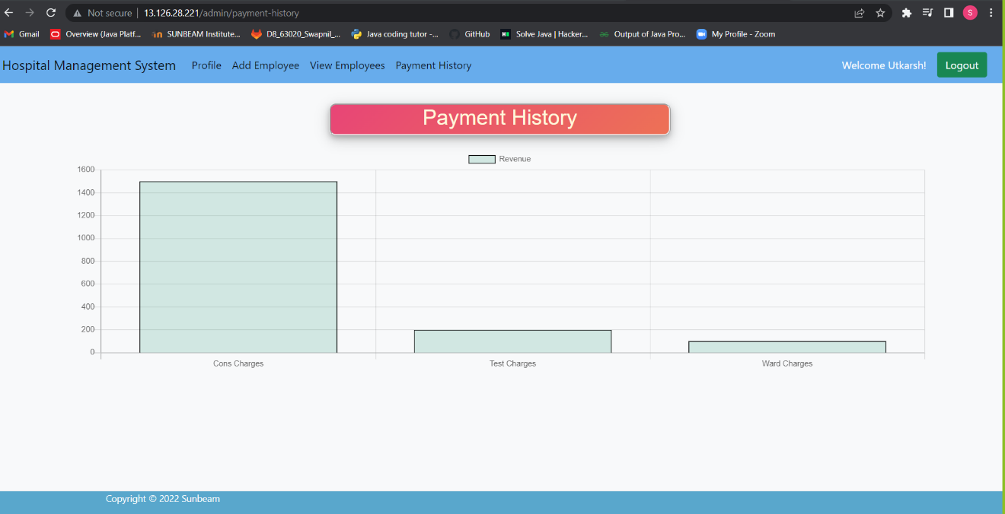

Doctors view appointment:

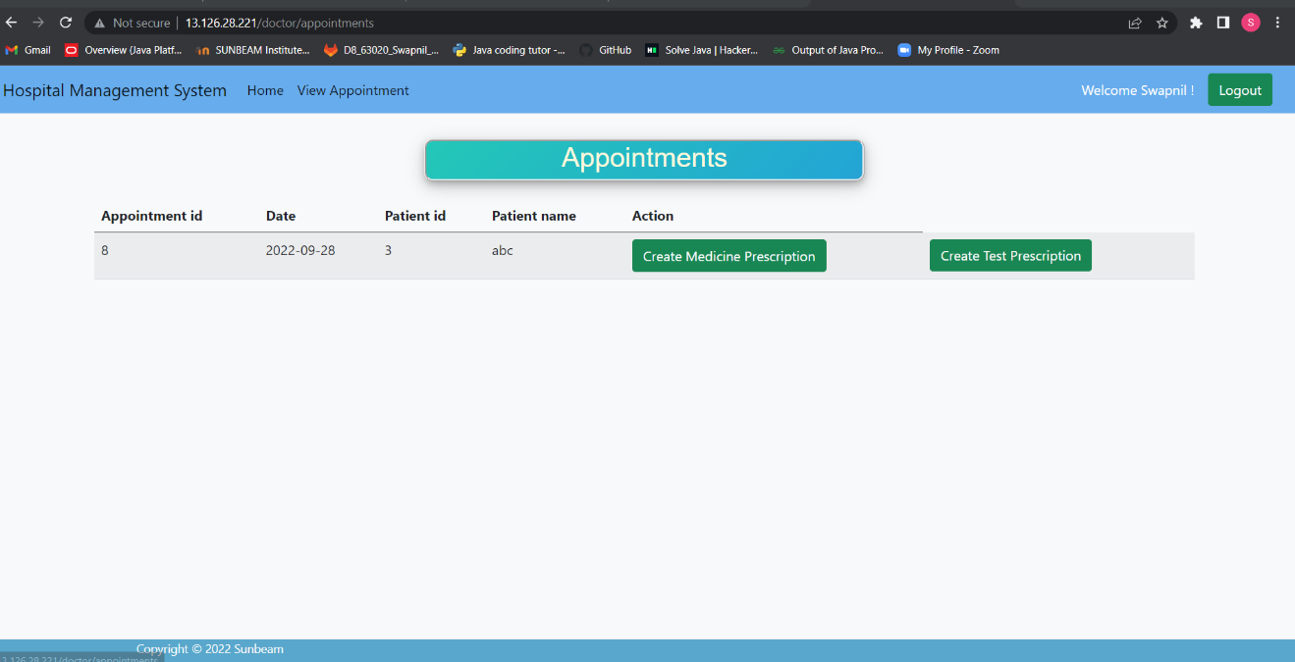

Doctor create medicines prescription:

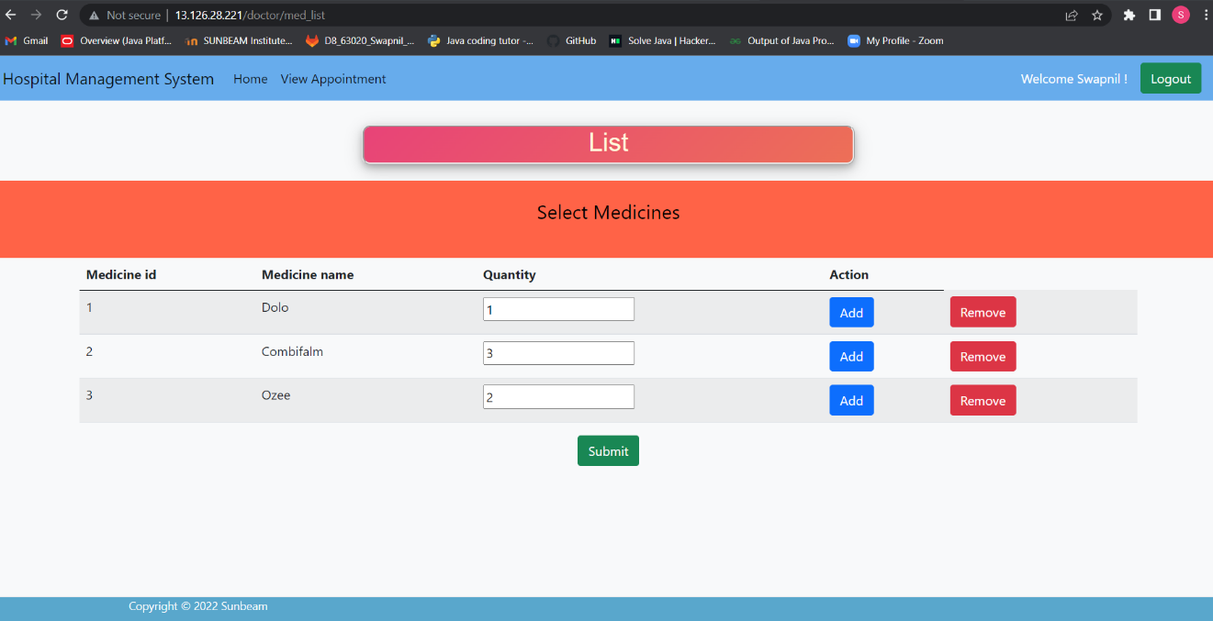

Doctor create tests prescription:

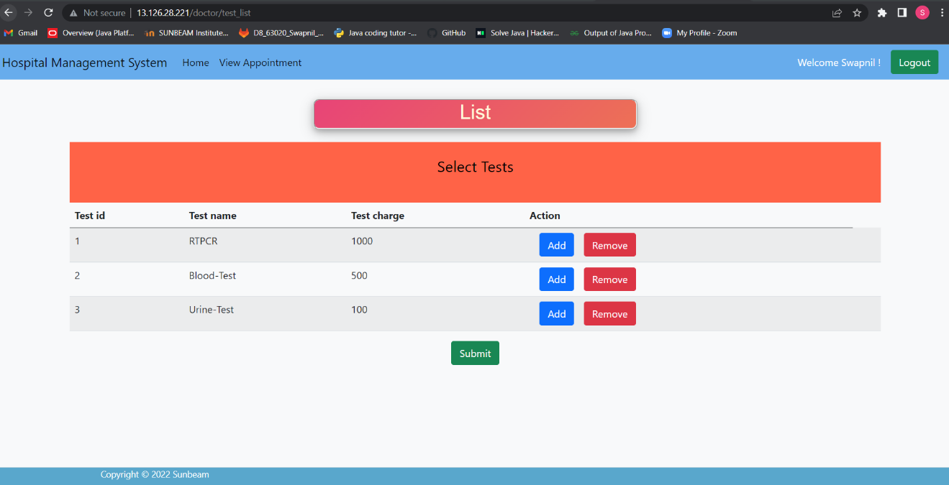

Receptionist’s_view_appointment:

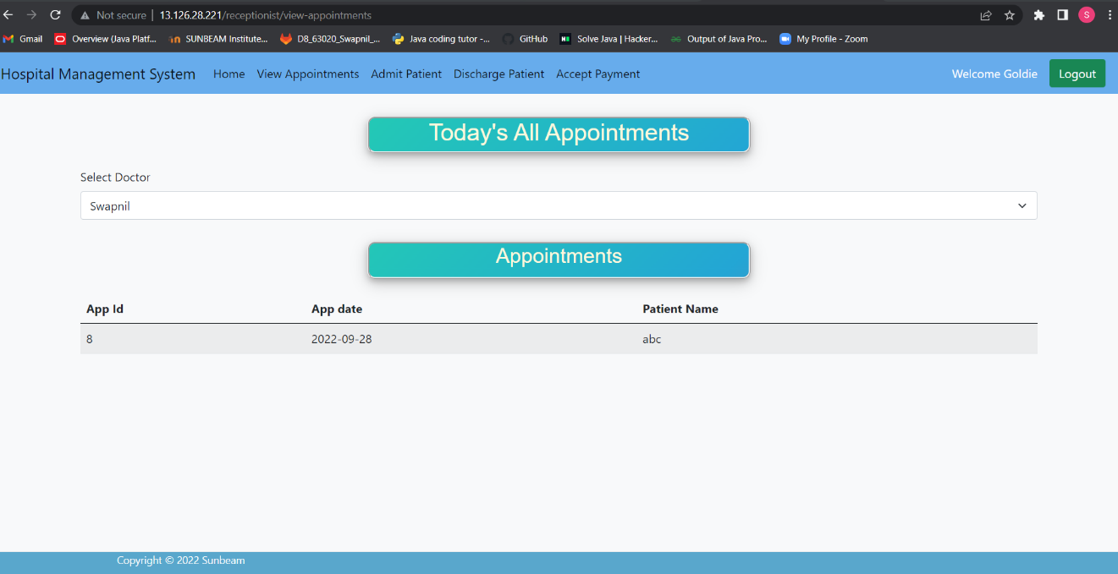

Admit_patient:

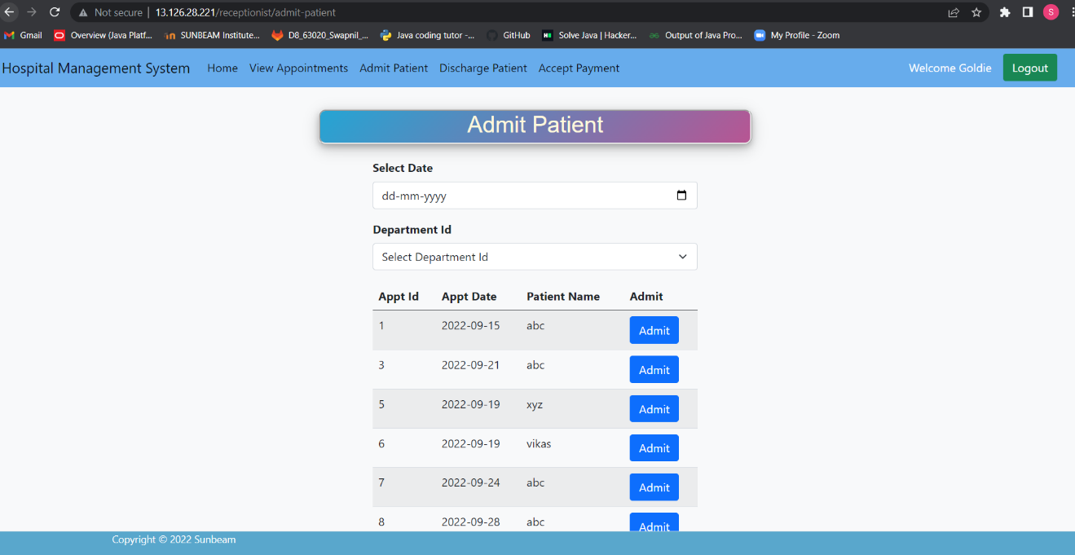

Lab_manager_view_prescription:

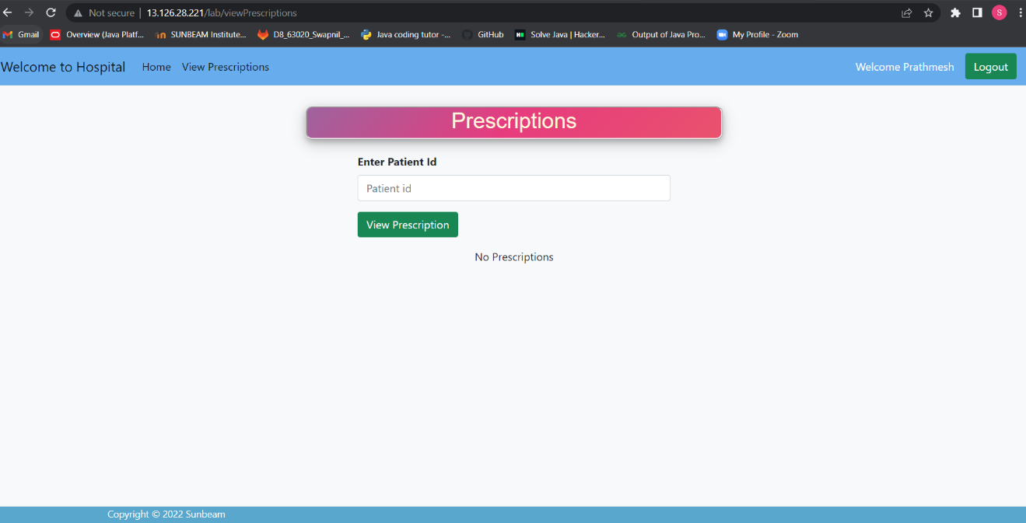

Accept_payment_by_receptionist:

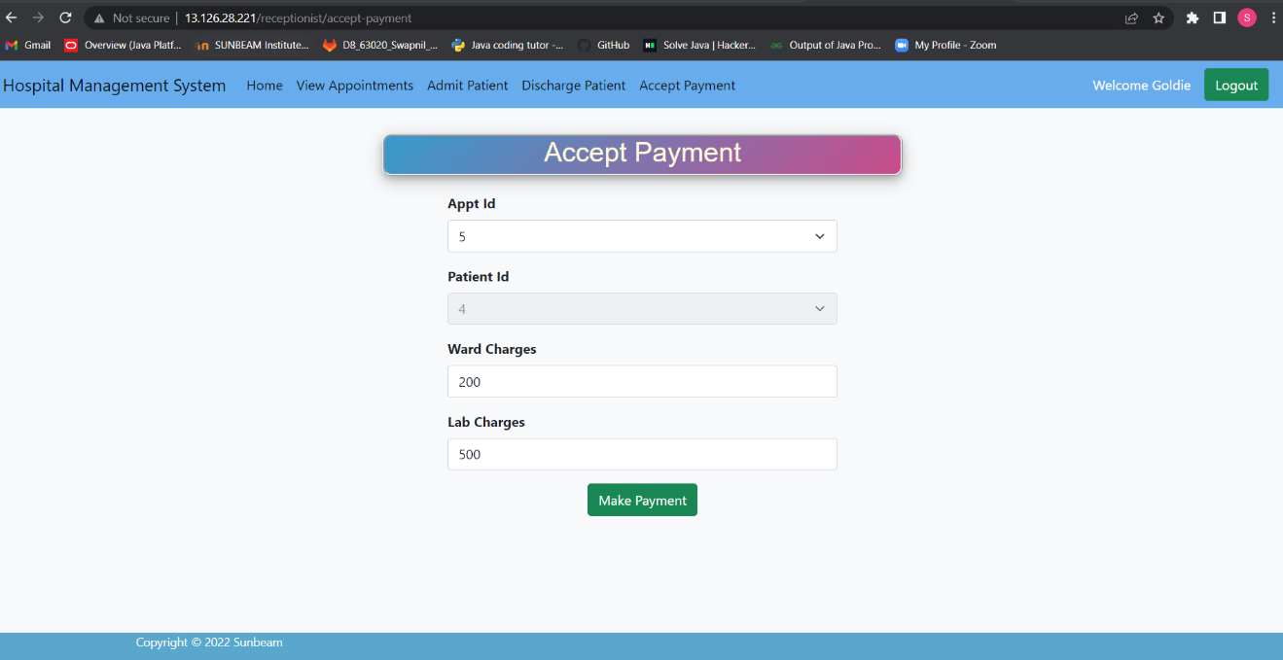

Discharge_Patient:

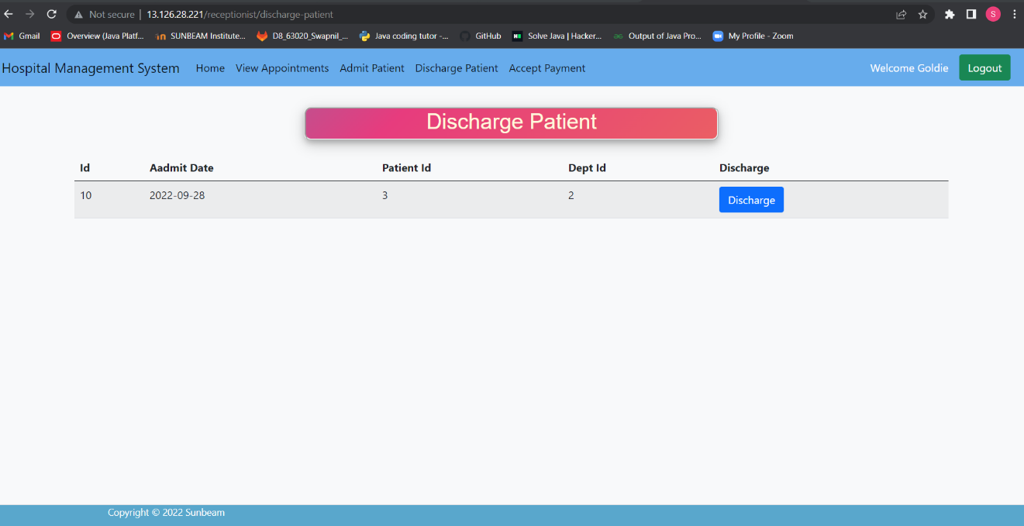

7.REFERENCES:
http://www.google.com
http://www.w3.org
http://www.wikipedia.org
http://www.delta.com

