Nova Trade Document Pipeline — Technical Write-Up

1. Architecture
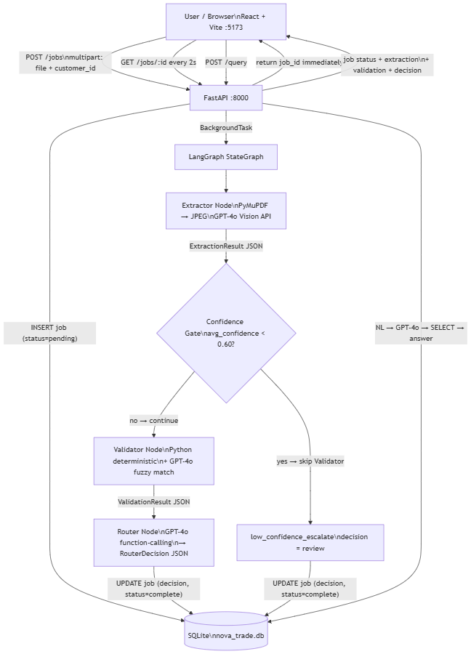
Upload returns the job_id in <100ms; LangGraph runs the pipeline as a background task. All agent handoffs are typed Pydantic models stored as JSON in SQLite — no shared in-memory state. Conditional edges enforce the confidence_gate → validator ordering so low-confidence docs never hit the Validator.

2. Three Real Failure Modes from Testing
Failure 1 — GPT-4o wraps fuzzy-match JSON in markdown fences.
The Validator calls GPT-4o for consignee name fuzzy matching. GPT-4o returned the JSON object wrapped in ```json ``` code fences, causing json.loads() to raise JSONDecodeError and silently crash every fuzzy-match field. Fix: strip fence characters before parsing. Lesson: GPT-4o adds markdown formatting even when the prompt says "return JSON only" — always strip fences regardless of whether you use function-calling.

Failure 2 — Multi-value HS codes always mismatch on multi-line-item invoices.
ELECPARTS_003's approve doc has three line items; GPT-4o extracted all three HS codes as one comma-separated string "8541.10, 8541.21, 8541.29". The exact-match check compared that whole string against single-value entries in allowed_values — always a mismatch. Fix: split by comma and check each code individually. Lesson: allowed_values validation is a set-membership check, not a string equality check — design for multi-value extraction from day one.

Failure 3 — Verbose UN/LOCODE descriptions break exact-match port validation.
Sample PDFs were generated with descriptive port text (CNSHA (Shanghai Yangshan)). GPT-4o faithfully extracted the parenthetical; the rule expected clean CNSHA. Every port check failed even on otherwise-correct documents. Fix: regenerated all 7 sample PDFs with clean UN/LOCODE codes. Lesson: sample-data quality determines test validity — if fixtures have verbose strings while rules expect codes, no amount of logic fixes will produce a passing test.

3. Observability for 50-Customer Production
The POC already has the foundation: every job carries a job_id UUID through all stages, status is updated at each hop (pending → extracting → validating → routing → complete/failed), full agent outputs are stored as JSON in SQLite, and the /query NL endpoint enables ad-hoc investigation without a separate tool.
To scale to 50 customers, add:
- `job_id`-correlated structured logging on every log line across all agents and the API layer
- Prometheus metrics — nova_jobs_total{status, customer_id} and nova_agent_latency_seconds{agent} at /metrics; alert on >10% failed over 10 minutes or p95 latency >90s
- Per-customer dashboard — auto-resolve rate, human override rate, top mismatched fields
- OpenTelemetry traces — one span per pipeline stage with job_id as trace attribute, exportable to Grafana/Jaeger

4. Cost Per Document (Back-of-Envelope)
Using Azure OpenAI GPT-4o pricing as of mid-2025 (~$0.0025\text{/}1Kinputtokens,$0.01/1K output tokens):

Stage | What runs | Tokens | Cost
Extractor | GPT-4o vision: 4 JPEG images (~500 tokens/image) + 1.5K text prompt + 600 output | ~3.6K in / 600 out | ~$0.015
Validator | GPT-4o fuzzy match (consignee only; all other fields are free Python) | ~300 in / 100 out | ~$0.002
Router | GPT-4o: ValidationResult + draft email generation | ~800 in / 400 out | ~$0.006
Total |  |  | ~$0.023/doc

Main risk: multi-page PDFs (4 pages → ~$0.05/doc) and runaway retries (capped at 9 LLM calls max via MAX_RETRIES_PER_AGENT=2 × 3 agents). Hard controls: max_pages=4 in the PDF renderer, MAX_TOKENS_PER_JOB=20000, LANGGRAPH_RECURSION_LIMIT=15.

5. Latency Breakdown
Stage | Observed | Bottleneck
PDF → JPEG (PyMuPDF) | ~200ms | CPU-bound, negligible
Extractor (GPT-4o vision) | 15–25s | Slowest hop — image tokens take time
Validator (Python) | <100ms | Free for exact/regex fields
Validator (GPT-4o fuzzy) | 1–3s | Only called when fuzzy-match fields present
Router (GPT-4o + draft email) | 3–6s | Email drafting is the longest text generation
Total p50 | ~20–30s | Dominated by Extractor

To reduce the Extractor bottleneck: enable GPT-4o prompt caching (system prompt is identical across all jobs); lower JPEG zoom from 1.5× to 1.0× (cuts image tokens ~40% with no legibility loss); parallelize per-page extraction calls for multi-page docs.

6. What I'd Do Differently with a Week
- Postgres instead of SQLite. At 50 customers with concurrent uploads, SQLite's write serialisation becomes a bottleneck. Swapping aiosqlite for asyncpg in connection.py gives native JSONB indexing, connection pooling, and truly concurrent writes — code change is small.
- Email trigger. Documents in real GoComet ops arrive as email attachments. An IMAP watcher or email-gateway webhook auto-submitting to POST /jobs would make the pipeline fully autonomous — no manual upload step.
- Cross-document consistency validation. Currently each doc (BoL, CI, Packing List) is validated in isolation. A post-validation step that cross-checks consignee, HS codes, and gross weight across all three documents in a shipment set would catch a whole class of discrepancies that per-document rules miss.
- OpenTelemetry distributed traces. Structured logging with job_id is a start, but OTel spans per pipeline stage (with model, token count, and latency as attributes) would enable single-pane-of-glass visibility in Grafana/Jaeger without log mining.
- Golden dataset eval harness. 50 manually verified documents as fixtures, scored on extraction F1 and decision accuracy via pytest --eval. Makes prompt changes and model upgrades safe to ship — regression score before merge.

