Assignment 2
Advance Data Structures
Name: Prathmesh Vishwakarma
PRN: 12411922
Roll No – 26
CSE-AIML E

Problem statement:
To implement self-balancing binary search trees and analyze their balancing mechanisms and implement insertion and deletion operations for AVL trees.

Code:
Attached in main.c file.

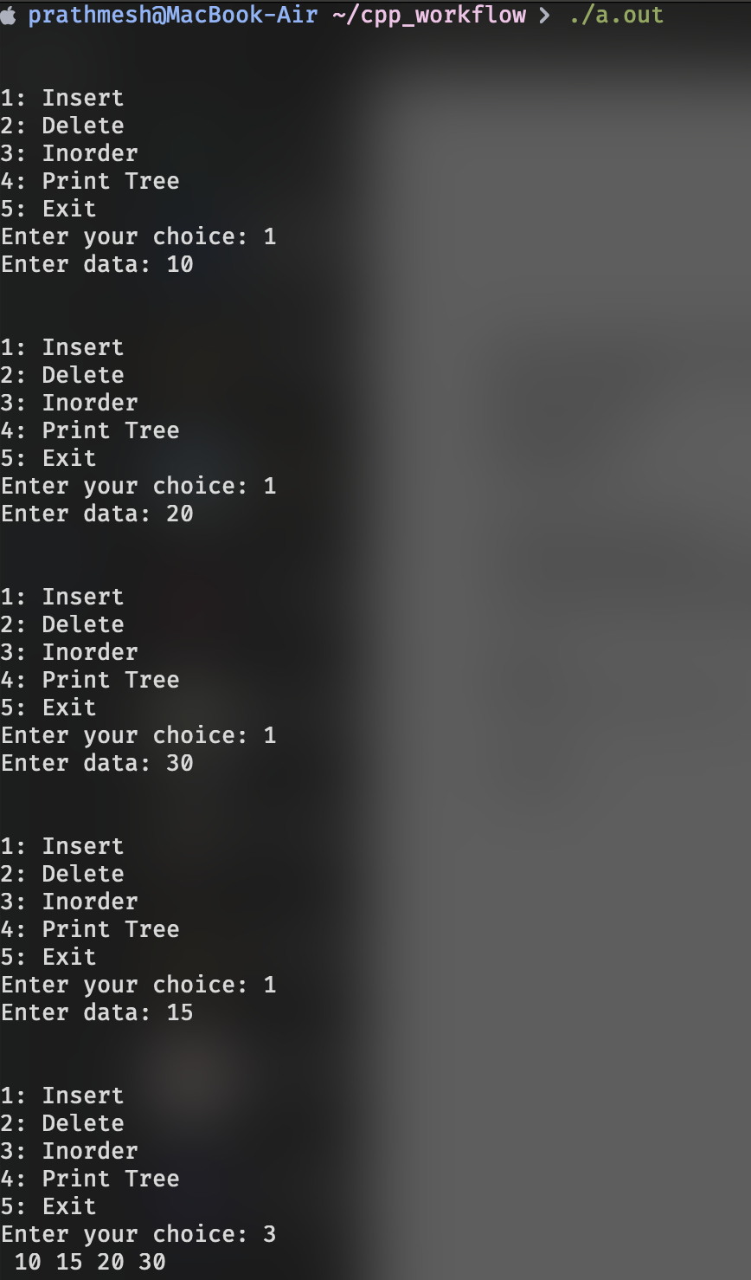
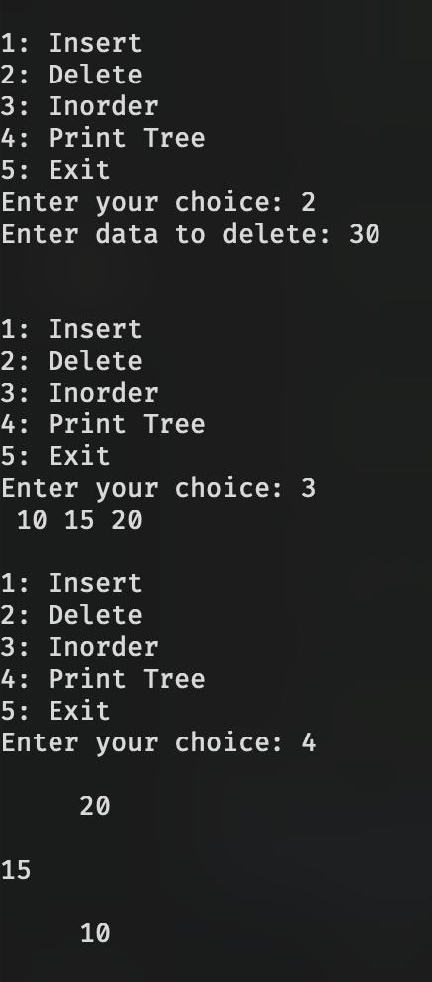
Output:

