**Experiment No 10**

#### Title:

Consider a scenario for Hospital to cater services to different kinds of patients as Serious (top priority), b) non-serious (medium priority), c) General Checkup (Least priority). Implement the priority queue to cater services to the patients.

#### Objectives:

1. To understand concept Priority Queue.
2. To understand concept & features and operations of Priority Queue.

#### Learning Objectives:

* + To understand concept Priority Queue.
  + To understand concept & features and operations of Priority Queue.

#### Learning Outcome:

* Understand concept of Priority Queue.
* Analyze working of various operations on Priority Queue.

#### Theory:

# **What is a priority queue?**

A priority queue is an abstract data type that behaves similarly to the normal queue except that each element has some priority, i.e., the element with the highest priority would come first in a priority queue. The priority of the elements in a priority queue will determine the order in which elements are removed from the priority queue.

The priority queue supports only comparable elements, which means that the elements are either arranged in an ascending or descending order.

For example, suppose we have some values like 1, 3, 4, 8, 14, 22 inserted in a priority queue with an ordering imposed on the values is from least to the greatest. Therefore, the 1 number would be having the highest priority while 22 will be having the lowest priority.

**Types of Priority Queue:**

1. Ascending order priority queue: In ascending order priority queue, a lower priority number is given as a higher priority in a priority. For example, we take the numbers from 1 to 5 arranged in an ascending order like 1,2,3,4,5; therefore, the smallest number, i.e., 1 is given as the highest priority in a priority queue.

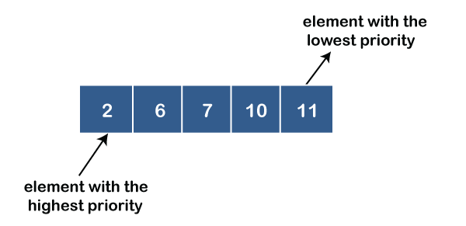

2) Descending order priority queue: In descending order priority queue, a higher priority number is given as a higher priority in a priority. For example, we take the numbers from 1 to 5 arranged in descending order like 5, 4, 3, 2, 1; therefore, the largest number, i.e., 5 is given as the highest priority in a priority queue.

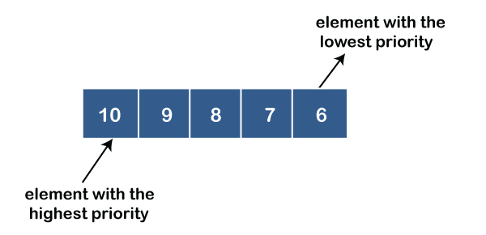

**Properties of Priority Queue:**

* Every item has a priority associated with it.
* An element with high priority is dequeued before an element with low priority.
* If two elements have the same priority, they are served according to their order in the queue.

### **Applications of Priority queue**

**The following are the applications of the priority queue:**

* It is used in the Dijkstra's shortest path algorithm.
* It is used in prim's algorithm
* It is used in data compression techniques like Huffman code.
* It is used in heap sort.
* It is also used in operating system like priority scheduling, load balancing and interrupt handling.

**Basic Operations**

* insert / enqueue − add an item to the rear of the queue.
* remove / dequeue − remove an item from the front of the queue.
* Print: print elements in queue
* Print priority: can print priority of element in queue.

**Software Required:** g++ / gcc compiler- / 64 bit Fedora, eclipse IDE

**Input:** Input data with priority of each element.

**Output:** To insert and delete the record in Queue according to its priority.

**Conclusion:** This program gives us the knowledge of Priority Queue its operations and applications.

**OUTCOME**

**Upon completion Students will be able to:**

**ELO1:** Learn Priority Queue.

**ELO2:** Understand & implement Priority Queue and its applications on it.

Question:

1. Explain Priority queue?
2. Differentiate Priority queue with Simple queue
3. List and explain applications of Priority queue.