Early Sepsis Prediction Model
A LightGBM early-warning model trained on the PhysioNet/Computing in Cardiology 2019 Sepsis Challenge dataset

1. Problem Description
The goal of this project is to predict, using only the information available up to and including a given hour of an ICU stay, whether a patient is heading toward sepsis roughly six hours before it is clinically recognized. The prediction is made fresh every hour, using only that hour's and earlier hours' vital signs and lab results — the model is never given any information from later in the stay, since a real bedside system could never see the future either. This “no look-ahead” constraint shaped every part of the feature engineering described in Section 3.
The data comes from the PhysioNet/Computing in Cardiology Challenge 2019, a public research dataset built from two hospital systems, referred to here as Hospital A and Hospital B. Each patient's ICU stay is recorded as one row per hour, with columns for 8 vital signs (heart rate, oxygen saturation, temperature, systolic/mean/diastolic blood pressure, respiration rate, end-tidal CO2), 26 laboratory values (e.g. lactate, white blood cell count, creatinine, bilirubin, platelets), basic demographics (age, gender, ICU admission timing), and a binary label, SepsisLabel, indicating whether that hour falls within the pre-onset warning window for a patient who will go on to develop sepsis.
 | Hospital A | Hospital B | Combined
Patients | 20,336 | 20,000 | 40,336
Ever-septic patients | 1,790 (8.8%) | 1,142 (5.7%) | 2,932 (7.3%)
Hourly rows | 790,215 | 761,995 | 1,552,210
Positive (SepsisLabel=1) rows | — | — | ~1.8%

Lab values are drawn far less often than vitals — most lab columns are missing in the large majority of hourly rows, since blood is only drawn periodically. This heavy, clinically meaningful missingness (as opposed to random missingness) is a central design consideration throughout the feature engineering.

2. Related Work

2.1 How the official label and scoring rule were designed
The SepsisLabel column already reflects careful clinical work by the challenge organizers, based on the Sepsis-3 clinical definition. For each septic patient, an onset time t_sepsis is computed from the earlier of (a) a suspected-infection timestamp (antibiotics ordered close to a blood culture) and (b) a timestamp where a patient's SOFA organ-dysfunction score rises by 2 or more points within 24 hours. SepsisLabel is then set to 1 starting six hours before t_sepsis, not at t_sepsis itself — which is exactly what makes this an early-warning task rather than a detection task: a model that only learns to recognize sepsis after it has already started would still score poorly, because the label it is trained on already demands six hours of advance notice.
The official evaluation is not plain accuracy or AUROC. It is a custom, time-dependent “utility function” that rewards a positive prediction more the closer it lands to exactly six hours before onset, gives no credit (but only a small penalty) for flagging far too early, and penalizes a missed case increasingly harshly the longer it goes unflagged as onset approaches. This function, and how it is used as the actual training target in this project, is explained in full with worked examples in Section 3.2.

2.2 The winning approach
The highest-ranked team in the official competition, “Can I get your signature?” (Morrill, Kormilitzin, Nevado-Holgado, Swaminathan, Howison and Lyons, University of Oxford), scored 0.360 on the hidden test set. Their approach, and the parts of it deliberately mimicked or deliberately excluded here, is described in detail:
- Rather than training a classifier on the raw SepsisLabel, they trained a LightGBM regressor to predict the difference between the utility earned by flagging a given hour versus not flagging it (“U1 − U0”) — directly chasing the official scoring rule instead of a generic classification loss. A gradient-free optimizer (Facebook's nevergrad) was then used to pick the decision threshold that maximized real utility on validation data.
- Their feature set combined hand-crafted clinical scores (Shock Index = HR/SBP, BUN/Creatinine ratio, a Partial SOFA score built from the components available in this dataset, and a SOFA-deterioration flag) with path-signature features — a mathematical technique from stochastic analysis that summarizes a irregularly-sampled time series as a compact, order-invariant vector of iterated integrals, computed here over a lead-lag transformed version of several columns.
- Their own ablation study found the signature features added only +0.012 utility over the hand-crafted features alone (0.418 → 0.430 in 5-fold cross-validation) — a real but modest gain, for a mathematically heavy technique.
This project mimics the training-target trick and the hand-crafted clinical features, but deliberately excludes the path-signature features (reasoning given in Section 3.4).

2.3 Other notable approaches and field-wide patterns
The official competition drew 104 teams and 853 submissions. Several other high-ranking and widely cited approaches informed the general design choices in this project:
Team | Approach | Result
Du, Sadr, de Chazal (“Sepsyd”) | XGBoost, 30 trees, 40:1 positive-class weighting, missing-value masks + rolling variance features | Utility 0.345 (rank 2)
Zabihi, Kiranyaz, Gabbouj (“Separatrix”) | Ensemble of 5 XGBoost models, each on a random-undersampled split, 407 engineered features including a novel missing/present-run-length feature family | Utility 0.339 (rank 3)
Chang, Rubin, Boverman et al. (“prna”, Philips) | RITS recurrent imputation network feeding a temporal convolutional network (TCN), trained to directly optimize a differentiable approximation of the utility function | Utility ≈ 0.41 (ensemble, internal validation)

Across the broader field, gradient-boosted trees (XGBoost/LightGBM) were the most common top-tier choice for this specific metric, ahead of recurrent/deep architectures. Common preprocessing patterns included forward-fill (last-observation-carried-forward) imputation, missingness-indicator features (since lab-ordering patterns are themselves informative of clinical suspicion), and rolling-window statistics over 6-24 hour windows — all of which are used in this project's own feature set (Section 3.1).

3. What Was Done Here

3.1 Feature engineering: 214 features, built causally
Every feature is computed per patient, using only that patient's own rows up to and including the current hour — verified directly by a dedicated causality test that recomputes each feature on a truncated version of a patient's history and checks the result is identical to the full-history computation. The 214 features fall into seven groups:
Category | What it captures | Count
Static demographics | Age, gender, ICU admission time, ICU unit type | 6
Measured-flag + last-known value | For each of the 34 raw vitals/labs: was it recorded this hour, and what was the last known value (forward-filled) | 68
Hours since last measured | For the 26 lab columns: how long since this lab was actually drawn (capped at 336h if never drawn) — lab-ordering frequency is itself informative | 26
Overall missingness count | How many of the 8 core vitals are missing this hour | 1
Rolling window statistics | Mean/min/max/std over the last 6h and 24h, computed on raw (pre-fill) values, for 12 key vitals/labs | 96
Hour-to-hour deltas | Change from the previous hour, for the same 12 key variables | 12
Clinical scores | Shock Index (HR/SBP), BUN/Creatinine ratio, Partial SOFA, its 24-hour change, and a SOFA-worsening flag | 5

A deliberate design decision: rolling statistics and deltas are computed on the raw, as-recorded values rather than the forward-filled series. A forward-filled series looks artificially flat (near-zero variance) whenever a single true reading gets carried forward for several hours, which would hide real instability. Missing values are left as missing (not zero-filled) wherever there is no true observation in a window, since LightGBM handles missing values natively by learning the best default split direction at each tree node.
Hospital identity (A vs. B) is deliberately excluded from the model's input features, even though it is tracked as metadata for reporting. This prevents the model from learning a hospital-specific shortcut instead of genuinely transferable clinical signal — exactly the failure mode that caused every top team's score to collapse on the official challenge's hidden, unseen third hospital.

3.2 What U1 and U0 are, with a worked example
U1 and U0 are not predictions — they are ground-truth numbers computed after the fact from each patient's real, already-known outcome, used only during training and evaluation. For any given hour, U1 is the utility score the official rule would award if the model had flagged that hour as risky, and U0 is the score it would award if the model had stayed silent. Because the true outcome (whether and when a patient became septic) is already known for every historical patient, both numbers can always be computed, regardless of whether that patient's hours end up in the training, validation, or test split.
The model itself never sees U1 or U0 — it only ever sees the 214 input features described above. During training, it is shown the input features for an hour and asked to predict the single number U1 − U0 for that hour (the LightGBM regression target). This bakes the official scoring rule's priorities directly into what the model is trying to learn, rather than training on a generic yes/no label and hoping that happens to align with how the problem is actually graded.
Concretely, for a hypothetical patient whose real sepsis onset (t_sepsis) is hour 50 of their stay:
Hour | Hours before onset | U1 (if flagged) | U0 (if not flagged) | Target (U1 − U0)
42 | 8h early | 0.667 | 0.000 | 0.667
43 | 7h early | 0.833 | 0.000 | 0.833
44 | 6h early (optimal) | 1.000 | 0.000 | 1.000
45 | 5h early | 0.889 | −0.222 | 1.111
46 | 4h early | 0.778 | −0.444 | 1.222
47 | 3h early | 0.667 | −0.667 | 1.333
48 | 2h early | 0.556 | −0.889 | 1.444
49 | 1h early | 0.444 | −1.111 | 1.556

Two patterns are worth noting. First, the reward for flagging (U1) peaks exactly at the 6-hour mark and then shrinks the closer the patient gets to actual onset — but the penalty for staying silent (U0) worsens even faster over that same stretch, so the overall training target keeps climbing. This does not create an incentive to “wait” for a bigger number: every hour is scored and summed independently, so a model that starts flagging at hour 44 and keeps flagging earns the reward from every subsequent hour too, while a model that waits until hour 47 to first flag has already accumulated the (negative) U0 penalty for hours 45 and 46. Second, for a patient who never develops sepsis, U1 is a flat −0.05 (a small false-alarm cost) and U0 is a flat 0 at every single hour of their stay — there is no ramping or timing involved at all for non-septic patients.

3.3 Reward and penalty structure
The full piecewise rule, applied to dt = (current hour) − (t_sepsis), uses six constants taken directly from the official challenge specification:
Constant | Value | Meaning
dt_early | −12 hours | Reward window opens 12h before onset
dt_optimal | −6 hours | Point of maximum reward
dt_late | +3 hours | Reward/penalty window closes 3h after onset
max_u_tp | +1.0 | Maximum reward for a correctly timed flag
min_u_fn | −2.0 | Maximum penalty for a missed case
u_fp | −0.05 | Flat penalty for any false alarm
u_tn | 0.0 | No reward or penalty for correctly staying silent

Between dt_early and dt_optimal, a correct flag's reward ramps linearly from 0 up to +1, while staying silent earns exactly 0 (no penalty yet). Between dt_optimal and dt_late, a flag's reward decays linearly from +1 back toward 0, while staying silent's penalty ramps from 0 down to −2. Outside that whole window, there is no more timing-based reward or penalty — a false alarm still costs the flat −0.05, and a correct “no risk” call earns 0.

3.4 What differs from the winning paper
Mimicked from Morrill et al. | Designed independently here
Training target: regress U1 − U0 instead of classifying the raw label | Rolling window statistics (mean/min/max/std, 6h/24h)
Hand-crafted clinical features: Shock Index, BUN/Cr ratio, Partial SOFA, SOFA-deterioration flag | Hours-since-measured / missingness features
LightGBM as the model family, and their published hyperparameters as a starting point (later refined by an independent grid search, Section 4) | Exact SOFA point-cutoff implementation, delta features

Path-signature features — the winning team's own headline technique — were deliberately excluded. Three reasons: their own ablation showed only a +0.012 utility gain over hand-crafted features alone; the technique requires a heavy extra C-extension dependency (iisignature/esig) that is non-trivial to install; and signature terms are not clinically interpretable, which would work against the explainability goals of this project (see the SHAP results in Section 5).

4. Model Architecture

4.1 Train / validation / test split
Patients — not individual hourly rows — are split 80% train / 10% validation / 10% test, so that no single patient's hours are ever divided across two splits. The split is stratified by whether a patient is ever septic, and performed independently within each hospital before being combined, so that both hospitals and both outcome classes are represented proportionally in all three sets. The training set is used only to fit the model; the validation set is used for early stopping, for the hyperparameter search, and for selecting the final decision threshold; the test set is touched exactly once, to produce every number reported in Section 5.

4.2 Model: LightGBM regressor
LightGBM was chosen over XGBoost specifically to mirror the winning team's model family, and because it has mature native handling of missing values (important given the heavy lab sparsity) and fast, exact SHAP support for explainability. It is trained as a plain regressor (squared-error loss) against the U1 − U0 target described in Section 3.2, not as a classifier against SepsisLabel.
Hyperparameter | Value
boosting_type | gbdt
num_leaves | 49
max_depth | 6
learning_rate | 0.05
n_estimators | 300
min_child_samples | 122
min_child_weight | 1
reg_alpha | 100
reg_lambda | 0
subsample | 0.3465
colsample_bytree | 0.5494
early_stopping_rounds | 20
random_state | 42

Most values (num_leaves, max_depth, min_child_samples, reg_alpha/reg_lambda, subsample, colsample_bytree) come directly from the winning team's published configuration. n_estimators and learning_rate were then refined with a light grid search: 27 combinations of n_estimators ∈ {100, 200, 300}, num_leaves ∈ {31, 49, 70}, and learning_rate ∈ {0.05, 0.10, 0.15} were each trained on the same training split and evaluated on the same validation split. The originally published configuration (100 / 49 / 0.10) ranked 14th of 27 by validation utility. The configuration ultimately adopted (300 / 49 / 0.05) improved both validation utility (0.4285 → 0.4354) and validation AUROC (0.8420 → 0.8443) over the published baseline, while changing only two of the three swept hyperparameters, keeping the tree-complexity setting (num_leaves) identical to the original published value.
Class imbalance (~1.8% positive rows) is not handled with an explicit class-weighting parameter. Because the model regresses a target that is already asymmetric by design (large positive values near real onsets, a flat small negative value everywhere else), the imbalance is handled implicitly by the target itself, matching the winning team's own approach.

5. Performance

5.1 What each metric means
- AUROC: The probability that the model ranks a randomly chosen septic hour as riskier than a randomly chosen non-septic hour. 0.5 is random guessing, 1.0 is perfect ranking. Does not depend on the chosen decision threshold.
- AUPRC: Similar to AUROC, but focused specifically on how well the model finds the rare positive class, which matters more here since only ~1.8% of rows are truly positive — a model can score well on AUROC just by being good at the easy majority class, while AUPRC exposes how good it really is at finding the rare true cases.
- Precision: Of everything the model flags as risky, the fraction that is genuinely a sepsis-warning hour.
- Recall: Of every genuine sepsis-warning hour, the fraction the model actually catches.
- F1: The harmonic mean of precision and recall, a single number balancing both.
- Lift@10%: How much more concentrated real sepsis cases are in the riskiest 10% of predictions compared to picking 10% at random. A value of 5x means the top-10%-riskiest hours contain five times more true cases than a random 10% would.
- Utility: The official challenge's own time-aware scoring rule (Section 3.3), normalized so that always predicting “no risk” scores 0 and a perfectly-timed oracle scores 1. This is the metric the model is actually trained to optimize, and the one most representative of real early-warning usefulness.

5.2 Results
Split | AUROC | AUPRC | Precision | Recall | F1 | Lift@10% | Utility
Train | 0.8816 | 0.1959 | 0.0747 | 0.7696 | 0.1362 | 6.0760 | 0.4988
Validation | 0.8443 | 0.1346 | 0.0683 | 0.7097 | 0.1247 | 5.4091 | 0.4354
Test | 0.8458 | 0.1224 | 0.0691 | 0.7049 | 0.1259 | 5.5605 | 0.4382
Test — Hospital A | 0.8308 | 0.1179 | 0.0699 | 0.7344 | 0.1276 | 5.3645 | 0.4567
Test — Hospital B | 0.8608 | 0.1427 | 0.0678 | 0.6576 | 0.1229 | 5.6220 | 0.4075

At the chosen decision threshold, the test-set confusion matrix is: 1,961 true positives, 821 false negatives (missed cases), 26,420 false positives (false alarms), and 126,831 true negatives. Validation and test scores are close to each other and noticeably lower than training scores, which is expected and indicates the model is not substantially overfit.

5.3 Plots
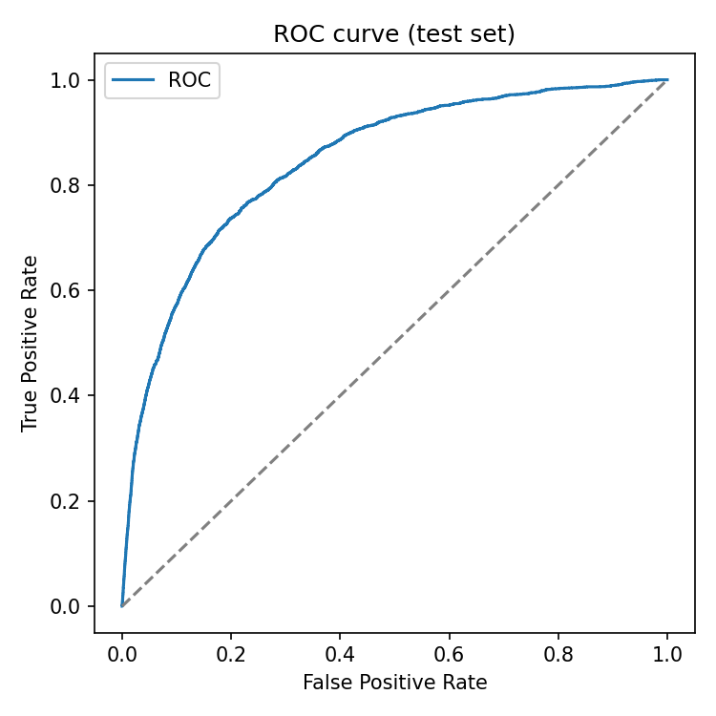
ROC curve (test set)
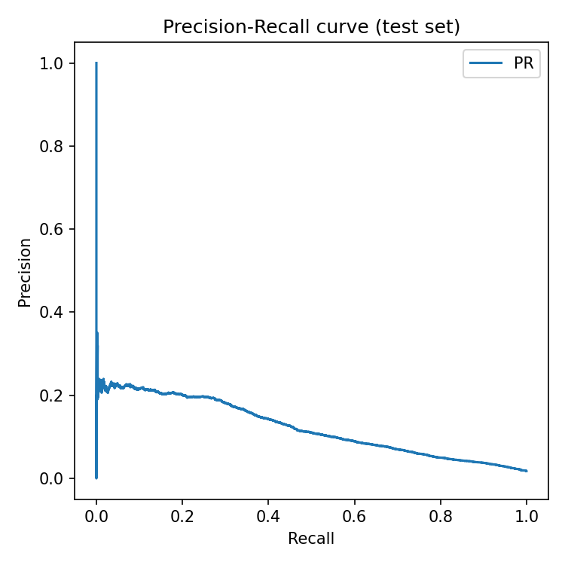
Precision-Recall curve (test set)
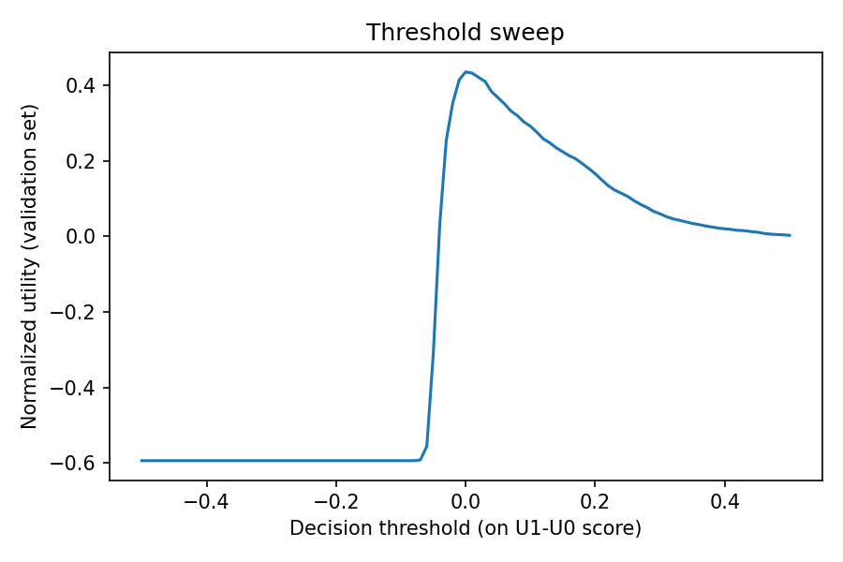
Utility vs. decision threshold (validation set), used to select the operating threshold
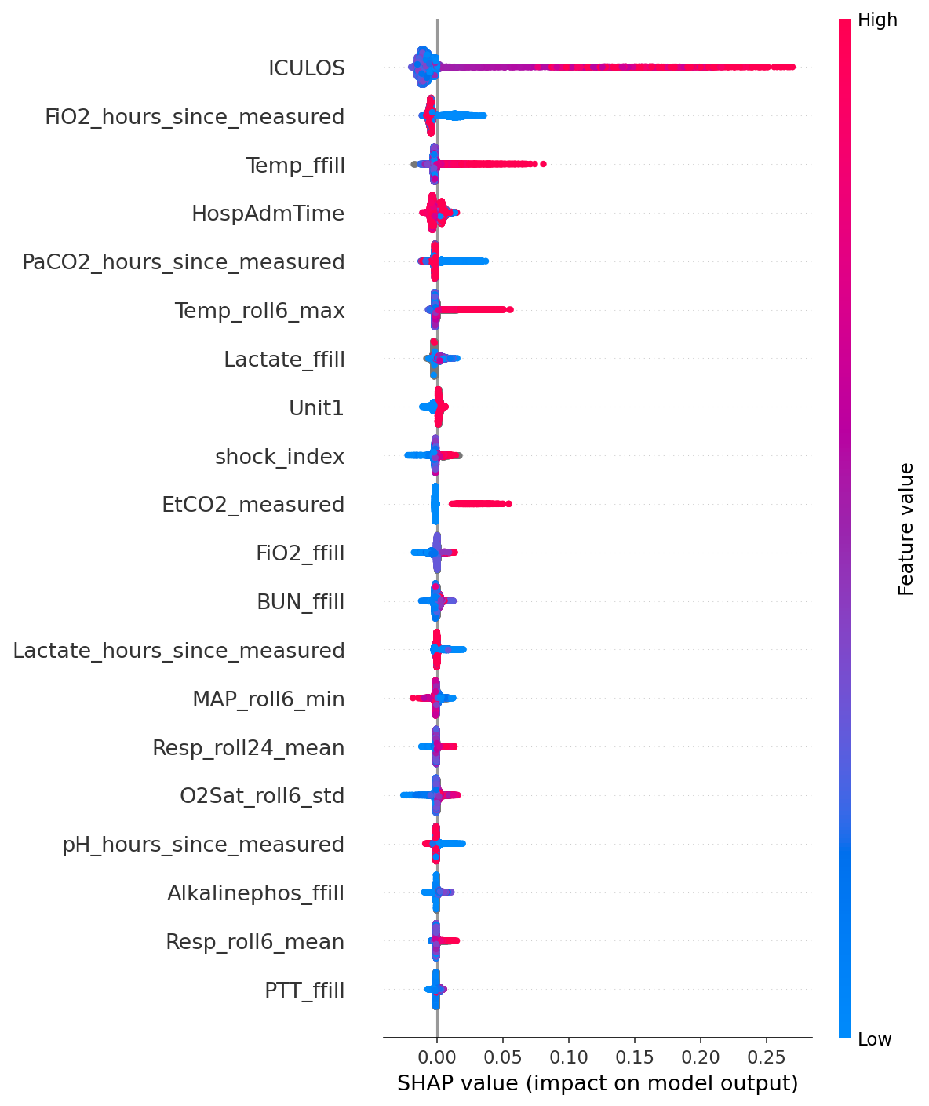
SHAP summary plot: each dot is one prediction, colored by that feature's value, positioned by its impact on the model's output — shows both which features matter most and in which direction
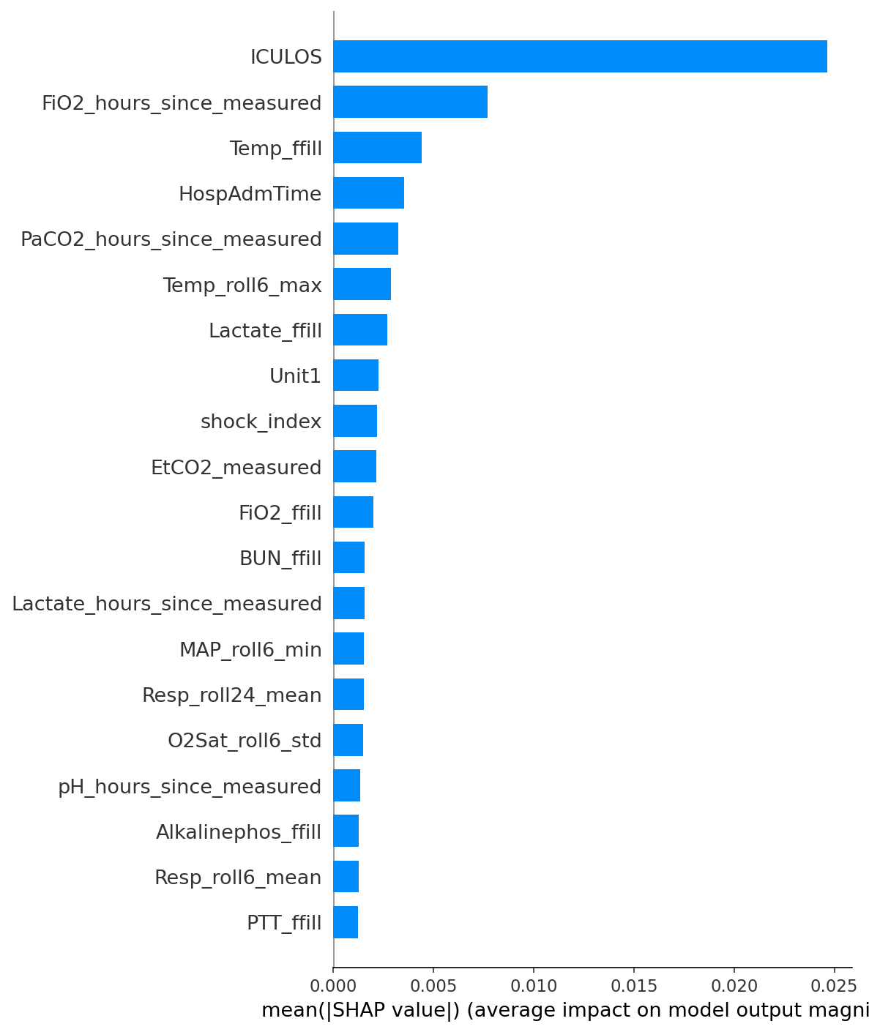
SHAP global feature importance (mean absolute impact), ranking which features drive the model's predictions overall

6. Limitations
- This is retrospective research data, not a prospective clinical trial — performance on live, real-time data is unverified.
- The test set is a random 10% holdout from the same two hospitals used for training, not a genuinely unseen third hospital. The original challenge's key finding was that every top team's score collapsed on a truly unseen hospital, so this project's test performance likely overstates real-world cross-hospital generalization.
- Precision at the current operating threshold is low (roughly 7-8%) — most flags are false alarms. This is typical for this task given how rare sepsis is, but means the model is useful for prioritizing attention, not for standalone diagnosis.
- This is a course project demonstration, not a certified or clinically validated medical device, and no care decision should be based on its output.

7. References
- Morrill, J., Kormilitzin, A., Nevado-Holgado, A., Swaminathan, S., Howison, S., Lyons, T. “The Signature-Based Model for Early Detection of Sepsis From Electronic Health Records in the Intensive Care Unit.” Computing in Cardiology, 2019. PDF: https://www.cinc.org/archives/2019/pdf/CinC2019-014.pdf
- Morrill, J. et al. Official competition code repository: https://github.com/jambo6/physionet_sepsis_challenge_2019
- Reyna, M. A., Josef, C., Jeter, R., Shashikumar, S. P., Westover, M. B., Nemati, S., Clifford, G. D., Sharma, A. “Early Prediction of Sepsis From Clinical Data: The PhysioNet/Computing in Cardiology Challenge 2019.” Critical Care Medicine, 48(2), 210-217, 2020. https://doi.org/10.1097/CCM.0000000000004145
- PhysioNet. Sepsis Challenge 2019 dataset, version 1.0.0. https://physionet.org/content/challenge-2019/1.0.0/
- Official utility-score evaluation code. https://github.com/physionetchallenges/evaluation-2019
- Zabihi, M., Kiranyaz, S., Gabbouj, M. “Sepsis Prediction in Intensive Care Unit Using Ensemble of XGBoost Models.” Computing in Cardiology, 2019. https://physionet.org/files/challenge-2019/1.0.0/papers/CinC2019-238.pdf
- Du, J., Sadr, N., de Chazal, P. “Automated Prediction of Sepsis Onset Using Gradient Boosted Decision Trees.” Computing in Cardiology, 2019. https://physionet.org/files/challenge-2019/1.0.0/papers/CinC2019-423.pdf
- Reyna, M. A., Clifford, G. D. “Voting of Predictive Models for Clinical Outcomes: Consensus of Algorithms for the Early Prediction of Sepsis.” arXiv:2012.11013, 2020. https://arxiv.org/abs/2012.11013

