SATS Ground Operations
Off Chocks Performance Report
Aug 2025 – Apr 2026 · 125,508 Turnaround Flights

1. Executive Summary

This report analyses 125,508 SATS-handled turnaround flights across 9 months (Aug 2025 – Apr 2026) to quantify how inbound arrival delays affect off-chocks punctuality. A flight is on time if it pushes back at or before its scheduled off-chocks time (off-chocks delay ≤ 0 min).
Key Findings
- Overall on-time rate: 35.7% of SATS flights push back on time. Nearly two-thirds depart late.
- Inbound delay impact: On-time rate is 46.1% for early/on-time arrivals but collapses to 16.4% for flights arriving >15 min late — a 29.8 pp drop.
- Inbound delay prevalence: 39.2% of inbound aircraft arrive more than 4 min late; 23.5% arrive more than 15 min late.
- Home-carrier advantage: SQ & TR (56.7% of dataset) consistently outperform other carriers — achieving ~2× on-time rate for late arrivals.
- Structural pattern: The inbound delay → off-chocks delay relationship is consistent across all 9 months — structural, not seasonal.

2. Data Overview

The dataset covers all flight movements at SATS-handled stations, Aug 2025 – Apr 2026.
2.1 SATS-Handled Airlines — Top 30 by Flight Count
Chart 1 — Top 30 SATS Airlines by Flight Count
How to read: Horizontal bars show total flights per airline over 9 months. Red bars = SQ (Singapore Airlines) and TR (Scoot), the Singapore home-based carriers.
What this tells us: SQ and TR dominate volume. Combined they represent 56.7% of SATS-handled flights, making them the primary driver of overall performance.
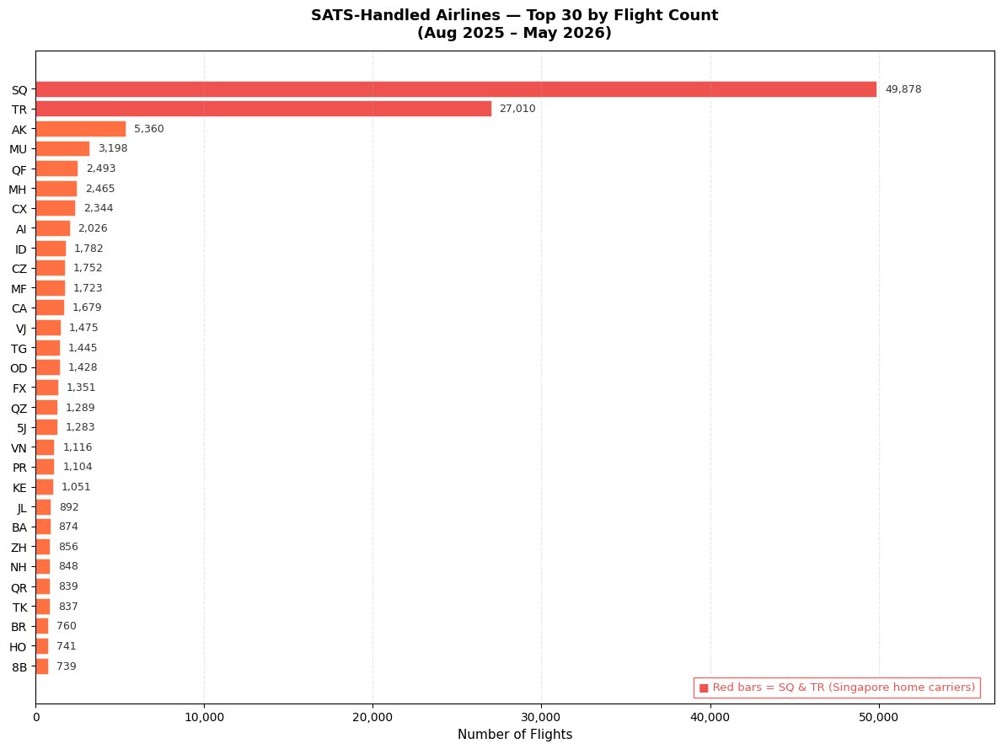
Figure 1 — SATS-Handled Airlines: Top 30 by Flight Count (Aug 2025 – Apr 2026)
2.2 Monthly SATS Flight Count
Chart 2 — Monthly Flight Count (SATS Airlines)
How to read: Each bar = total SATS-handled departures in that calendar month.
What this tells us: Volume is consistent at 13,000–14,000 flights/month, confirming the dataset reflects stable normal operations — no major disruptions that would distort the analysis.
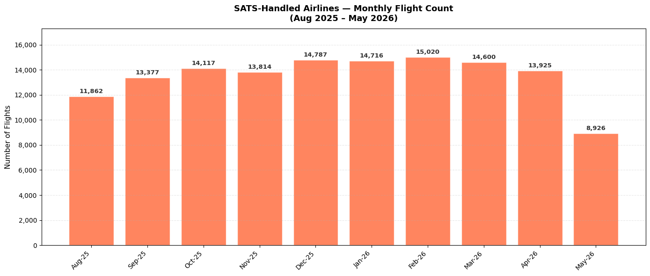
Figure 2 — SATS-Handled Airlines: Monthly Flight Count (Aug 2025 – Apr 2026)

3. Data Filtering & Methodology

Not every row in the raw database is suitable for off-chocks delay analysis. The table below shows the exact sequence of filters applied and why each step was necessary.
Step | Filter Applied | Flights Remaining | Reason
0 | Raw arrivals (direction = Arrival) | 188,504 | Starting point
1 | Drop rows missing actual arrival, scheduled arrival, or actual off-chocks time | 149,900 | Cannot compute delay without both timestamps
2 | Keep SATS-handled carriers only | 135,029 | Report scope is SATS turnarounds only
3 | Outlier filter: inbound −120 to +360 min, off-chocks −60 to +360 min | 134,395 | Remove data-entry errors and extreme outliers
4 | Exclude Jun & Jul 2025 (< 10 SATS flights each) | 125,508 ✓ | Too sparse for monthly comparisons — included months have 13,000+ flights each

Final working dataset: 125,508 flights | Aug 2025 – Apr 2026 | 9 months
Why Jun & Jul 2025 Were Excluded
Jun 2025 had only 8 SATS-handled flights and Jul 2025 had only 7.
Note: A flight is "on time" if actual off-chocks ≤ scheduled off-chocks (≤ 0 min). An alternative ≤ 4 min threshold (SQ operational standard) is also shown in the carrier group section.

4. Summary Statistics

On-time off-chocks performance broken down by inbound arrival tier. On time = off-chocks delay ≤ 0 min.
Inbound Arrival Tier | Flights | On-Time Rate | vs. Baseline
1 — Early / On-time (≤ 0 min) | ~61,500 | 46.1% | Baseline
2 — Slight delay (0–4 min) | ~21,500 | ~39% | −7 pp
3 — Moderate delay (4–15 min) | ~21,000 | ~31% | −15 pp
4 — Late (> 15 min) | ~30,500 | 16.4% | −29.8 pp
All SATS (Overall) | 125,508 | 35.7% | —

5. Analysis Charts

5.1 On-Time Off Chocks Rate by Inbound Arrival Tier
Chart 3 — On-Time Rate by Arrival Tier (Dual-Axis)
How to read: Stacked bars (left axis) show total flight count per tier, coloured by departure outcome. Three lines (right axis) show the overall on-time rate (blue), −1 Std Dev lower bound (green dashed), and +1 Std Dev upper bound (red dashed). The shaded band is the ±1 standard deviation range of monthly on-time rates per tier.
What this tells us: Clear downward progression: on-time rate falls from 46.1% (early arrivals) to 16.4% (>15 min late). The ±1 Std Dev band confirms this is not driven by one bad month — it is a consistent structural pattern across all 9 months.
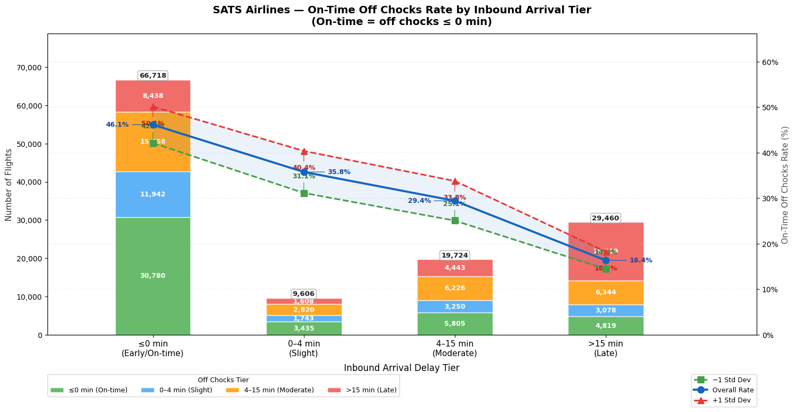
Figure 3 — On-Time Off Chocks Rate by Inbound Arrival Tier
5.2 Average Off Chocks Delay by Arrival Tier
Chart 4 — Avg Delay Minutes by Arrival Tier (Dual-Axis)
How to read: Same bar structure as Chart 3. Lines show average delay in minutes (orange = mean, green dashed = −1 Std Dev, red dashed = +1 Std Dev). The shaded band is the ±1 standard deviation range of delays within each arrival tier.
What this tells us: Average off-chocks delay increases with each arrival tier. Even when aircraft arrive early (Tier 1), they still push back ~5 min late on average — confirming baseline ground process delay exists independent of inbound pressure. For Tier 4, the average 47-min inbound delay is partially compressed to ~30 min off-chocks delay.
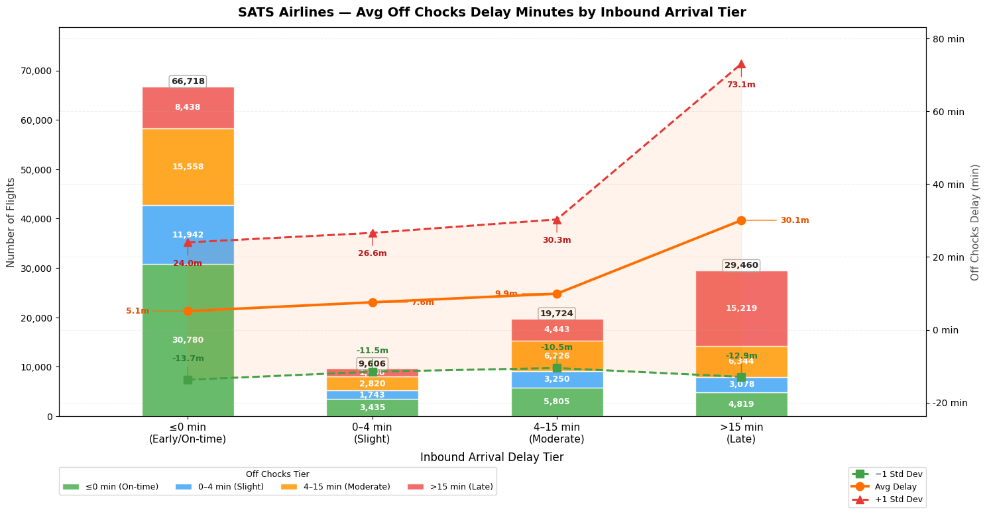
Figure 4 — Avg Off Chocks Delay Minutes by Inbound Arrival Tier

5.3 Monthly Off Chocks Delay — Box Plot
Chart 5 — Monthly Box Plot (All SATS Airlines)
Element | Meaning
Box (shaded area) | Middle 50% of flights (25th to 75th percentile)
Orange line inside box | Median — half of flights above, half below
μ = X label | Mean — pulled higher than median by a tail of very late flights
Dashed whiskers | Normal range: 1.5× the IQR beyond the box edges
Faint dots | Outliers — individually very early or very late flights
How to read: Each box = one calendar month. Vertical axis = off-chocks delay in minutes. Negative value means the aircraft pushed back early. Wide box = high variability that month.
What this tells us: The median is positive every month — flights consistently push back late. The mean (μ) sits above the median in every month, confirming a tail of very late departures. No single month is dramatically worse, confirming the delay pattern is structural.
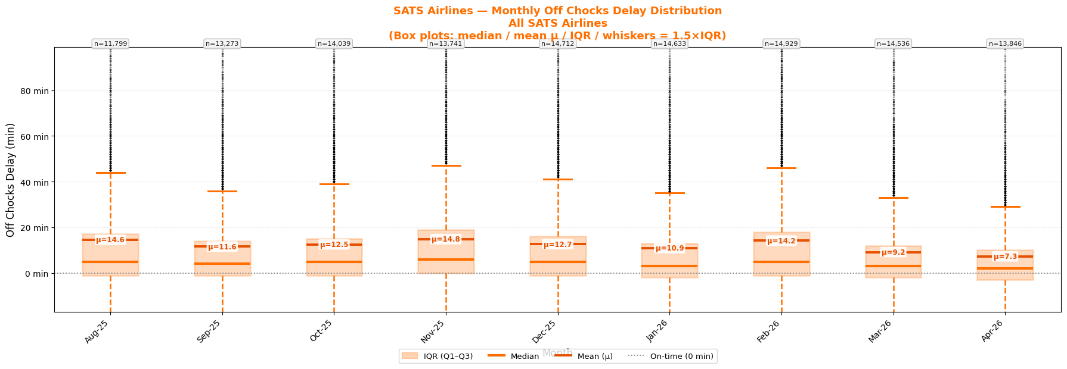
Figure 5 — Monthly Off Chocks Delay Distribution: Box Plot (All SATS)
5.4 Inbound Arrival Delay — Monthly Trend
Chart 6 — Inbound Arrival Delay by Month (Q1 / Mean / Q3)
How to read: Three lines track Q1 (green dashed), mean (orange), and Q3 (red dashed) of inbound arrival delay each month. Shaded band = IQR. Green boxes at top show monthly flight count (n=).
What this tells us: The mean inbound delay is positive every month — the average aircraft arrives late. The Q3 line consistently sits well above Q1, confirming a persistent tail of significantly late inbound flights every month. This upstream delay, outside SATS control, is the primary driver of off-chocks delay throughout the period.
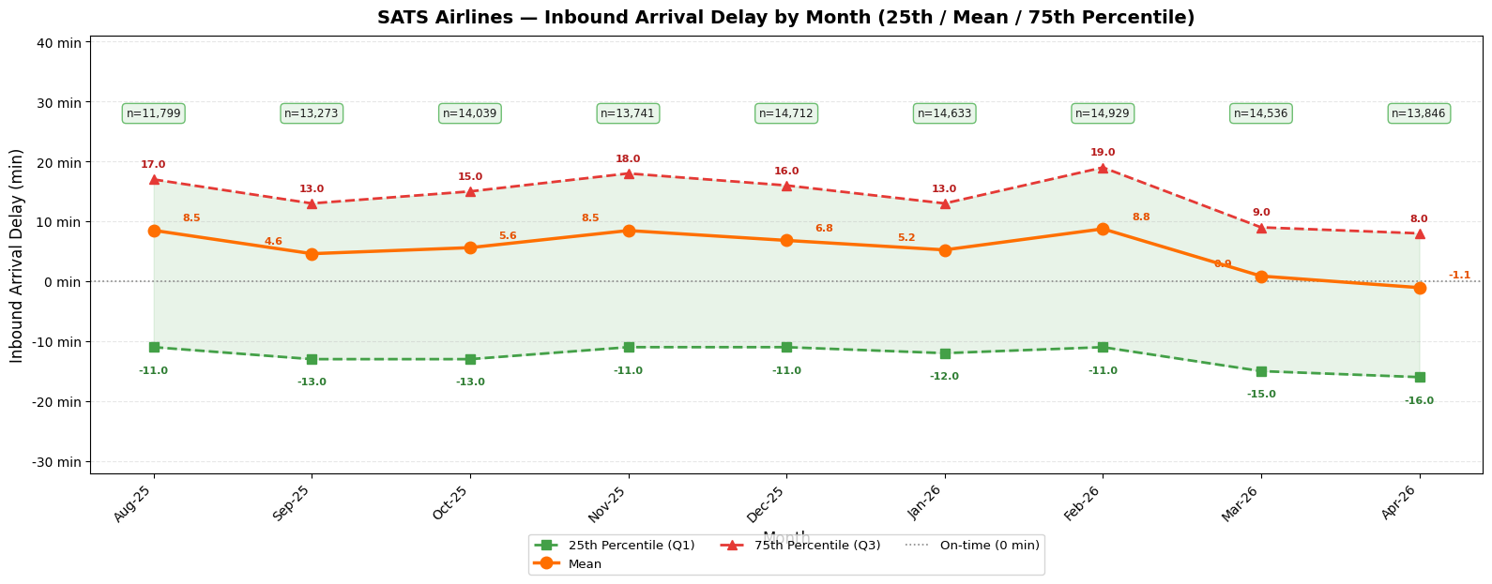
Figure 6 — Inbound Arrival Delay by Month (25th / Mean / 75th Percentile)

5.5 Off Chocks Delay — Monthly Trend
Chart 7 — Off Chocks Delay by Month (Q1 / Mean / Q3)
How to read: Same structure as Chart 6 but tracking off-chocks departure delay month by month. Blue boxes at top show flight count. The blue shaded band shows the IQR.
What this tells us: Mean off-chocks delay is lower than mean inbound delay, confirming partial ground recovery. However, the mean is still positive every month. The Q1 line (best 25% of flights) often sits near zero, showing that a significant share do manage on-time pushback even within high-volume months.
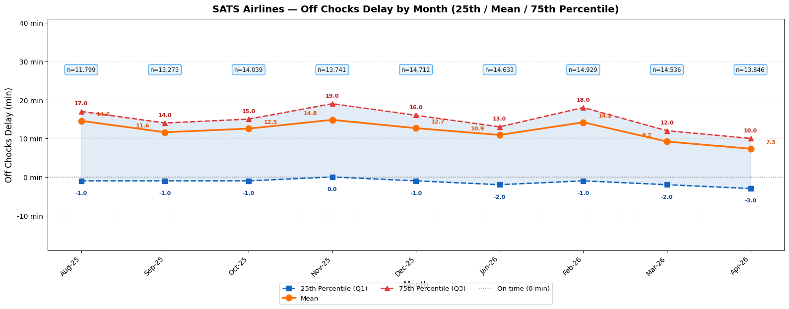
Figure 7 — Off Chocks Delay by Month (25th / Mean / 75th Percentile)
5.6 Inbound vs Off Chocks Delay — Amplification Analysis
Chart 8 — Delay Amplification by Arrival Tier
How to read: Paired bars per arrival tier: darker bar = avg inbound delay, lighter bar = avg off-chocks delay. Ratio annotations show how the delay changed from landing to pushback.
Tier | Avg Inbound | Avg Off Chocks | Ratio / Effect
Tier 1 — ≤0 min | −14.2 min (early) | +5.0 min | N/A — arrives early, still departs late
Tier 2 — 0–4 min | +2.4 min | +7.4 min | 3.0× amplification — small delay triples at pushback
Tier 3 — 4–15 min | +9.5 min | +9.8 min | ~1.0× absorbed — delay passes through unchanged
Tier 4 — >15 min | +47.1 min | +29.8 min | 0.6× partial recovery — teams recover ~37% of delay
What this tells us: Tier 2 is the most surprising: a 2.4-min late arrival triples to 7.6-min late departure. Even marginal inbound lateness disrupts ground process sequencing disproportionately. For large delays (Tier 4), teams do partially recover — a 47-min late arrival becomes 30-min late departure — but on-time performance is still only 16.4%.
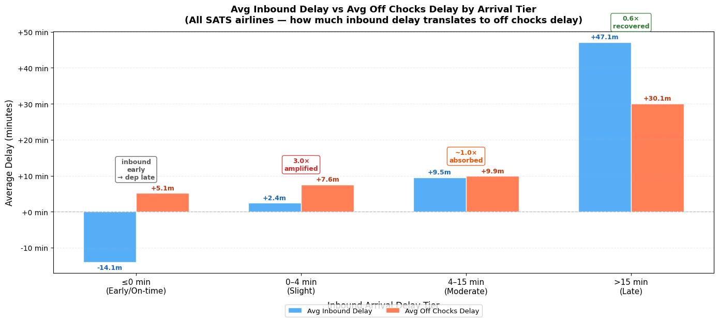
Figure 8 — Avg Inbound vs Avg Off Chocks Delay by Arrival Tier

6. Carrier Group Analysis

SQ and TR are Singapore's home-based carriers. Their operations, crew, and maintenance teams are locally headquartered, giving them a structural recovery advantage. The three groups below isolate the home-carrier effect.
Group | Flights | Share
SQ & TR only (Singapore home carriers) | 71,198 | 56.7%
All SATS-handled airlines (combined) | 125,508 | 100%
All SATS excl. SQ & TR (foreign carriers) | 54,310 | 43.1%
Each group has two charts: one using the ≤ 4 min on-time threshold (industry standard) and one using ≤ 0 min (strict). Each chart has 3 panels: (1) monthly on-time rate by tier, (2) flight volume by tier per month, (3) heatmap — green = good, red = poor.
6.1 SQ & TR — Singapore Home Carriers
Charts 9a & 9b — SQ & TR: ≤ 4 min and ≤ 0 min thresholds respectively
How to read: Three-panel chart. Top: monthly on-time rate per arrival tier (4 lines). Middle: stacked bar showing volume per tier per month. Bottom: heatmap with on-time rate (% shown) and flight count (n=) per cell.
What this tells us: SQ and TR show the highest on-time rates of any group, particularly for Tier 4 (>15 min late). Their ability to recover from severe inbound delays is significantly better than foreign carriers, pointing to priority gate allocation, pre-positioned resources, and faster ground crew response when their own flights are running late.
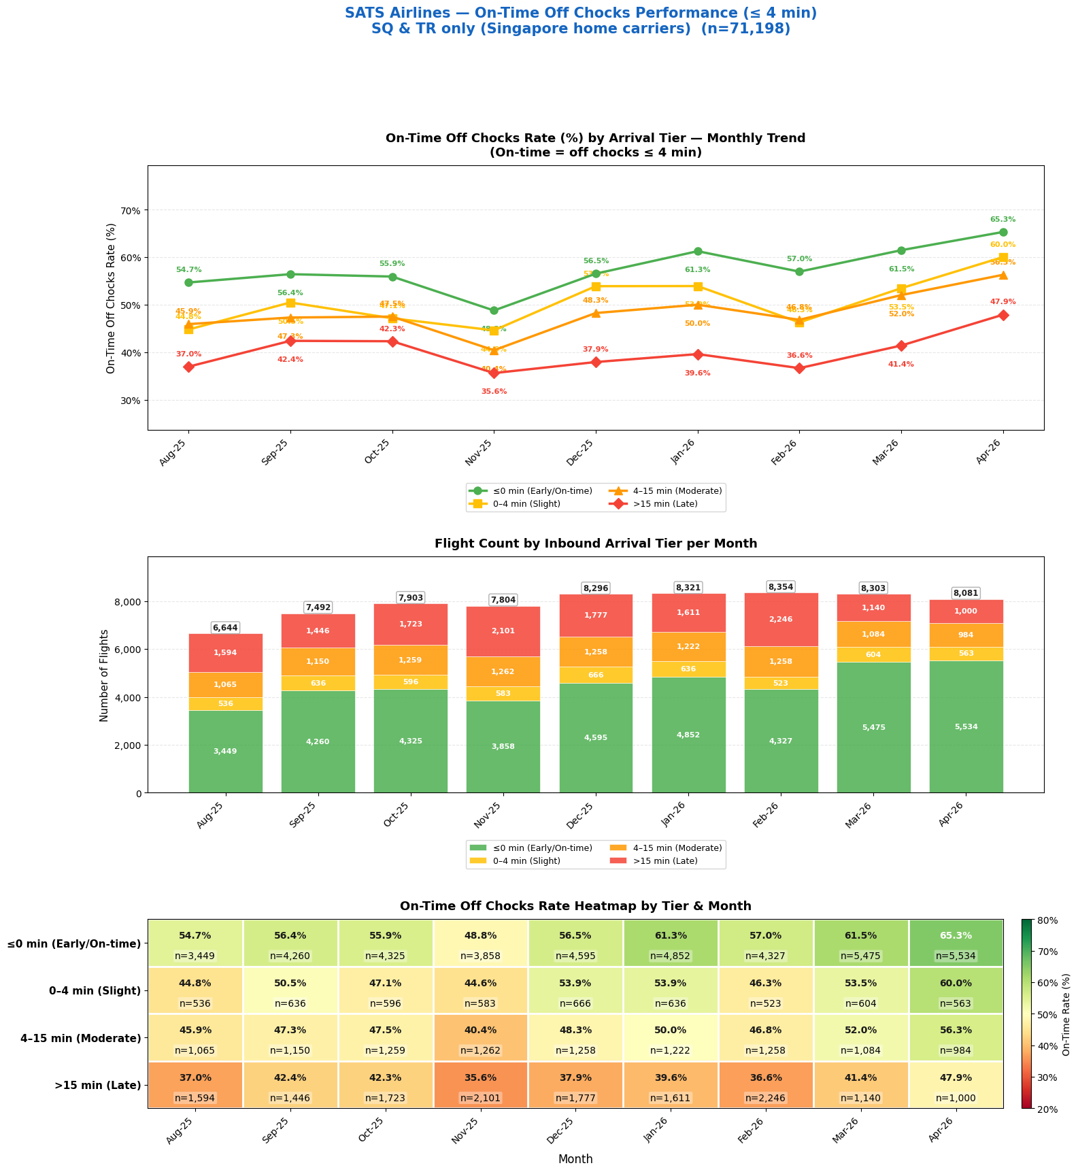
Figure 9a — SQ & TR: On-Time Off Chocks Performance (≤ 4 min threshold)
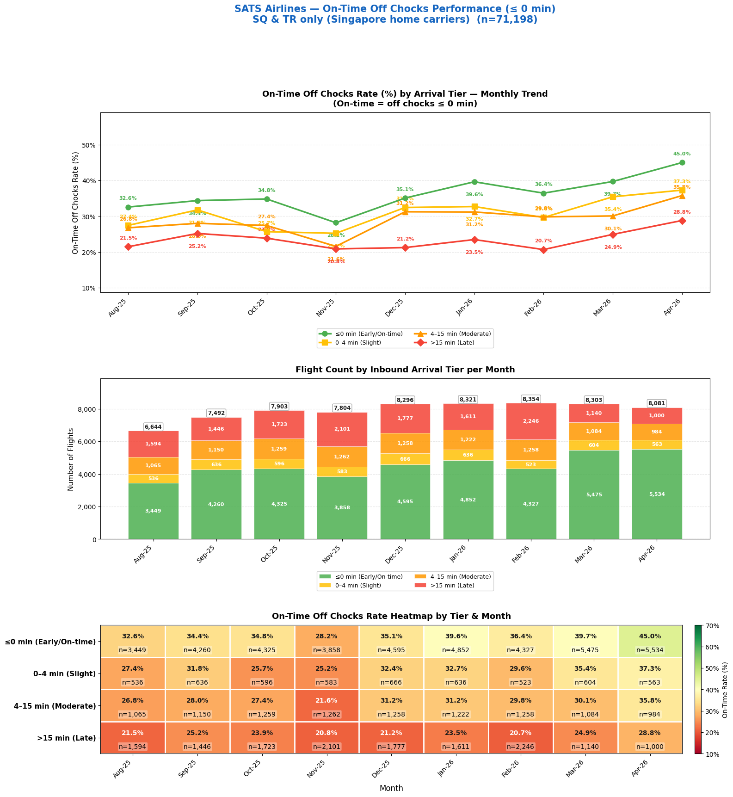
Figure 9b — SQ & TR: On-Time Off Chocks Performance (≤ 0 min threshold)

6.2 All SATS Airlines
Charts 10a & 10b — All SATS: ≤ 4 min and ≤ 0 min thresholds
How to read: Same three-panel layout covering the full 125,508-flight working dataset. This is the baseline view against which the other groups are compared.
What this tells us: The combined view reflects the volume-weighted average of the SQ/TR and non-home-carrier groups. Because SQ and TR account for 56.7% of flights and perform better, the overall SATS picture is better than non-home carriers in isolation but lower than SQ/TR alone. The tier trend is unchanged: on-time rates decline from Tier 1 to Tier 4 every month.
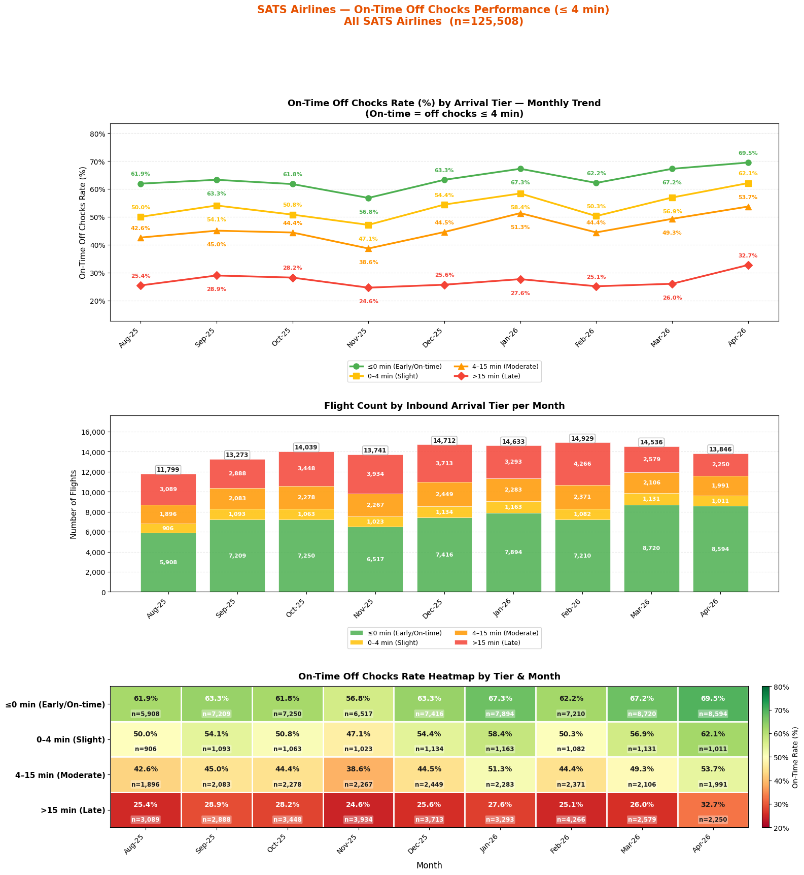
Figure 10a — All SATS Airlines: On-Time Off Chocks Performance (≤ 4 min threshold)
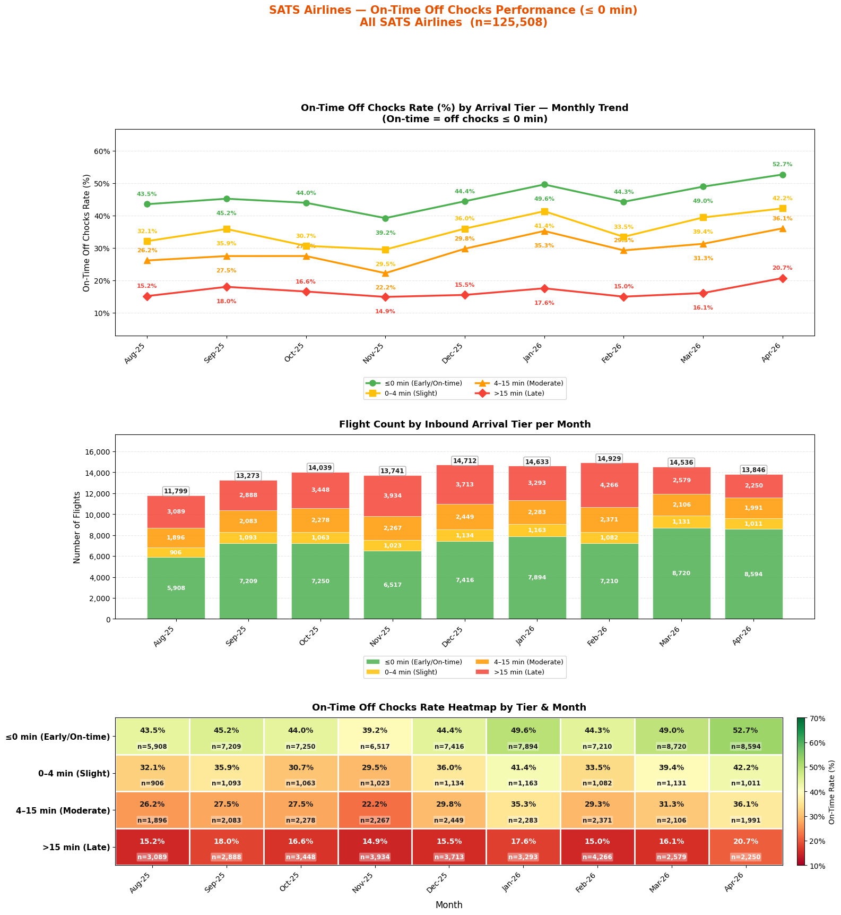
Figure 10b — All SATS Airlines: On-Time Off Chocks Performance (≤ 0 min threshold)

6.3 All SATS Excluding SQ & TR
Charts 11a & 11b — Excl. SQ & TR: ≤ 4 min and ≤ 0 min thresholds
How to read: Isolates the 54,310 flights from foreign carriers handled by SATS. For these carriers, SATS ground handling is the sole recovery mechanism.
What this tells us: Non-home carriers show materially lower on-time rates, especially in Tier 3 and Tier 4. For flights arriving >15 min late, the on-time rate is approximately half that of SQ & TR. The heatmap shows predominantly red/orange in the late arrival tiers across all months. This group represents the most challenging turnaround environment for SATS ground teams.
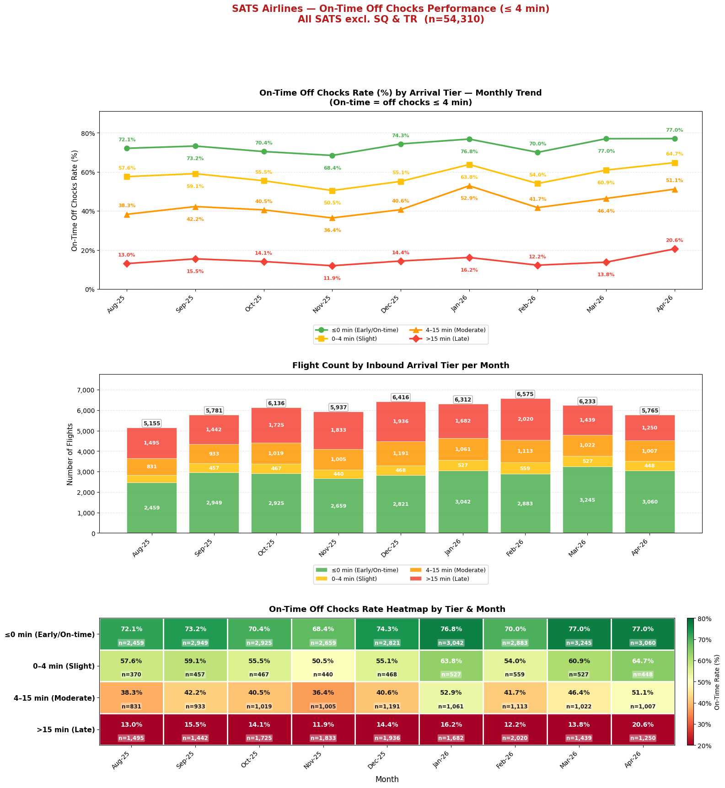
Figure 11a — Excl. SQ & TR: On-Time Off Chocks Performance (≤ 4 min threshold)
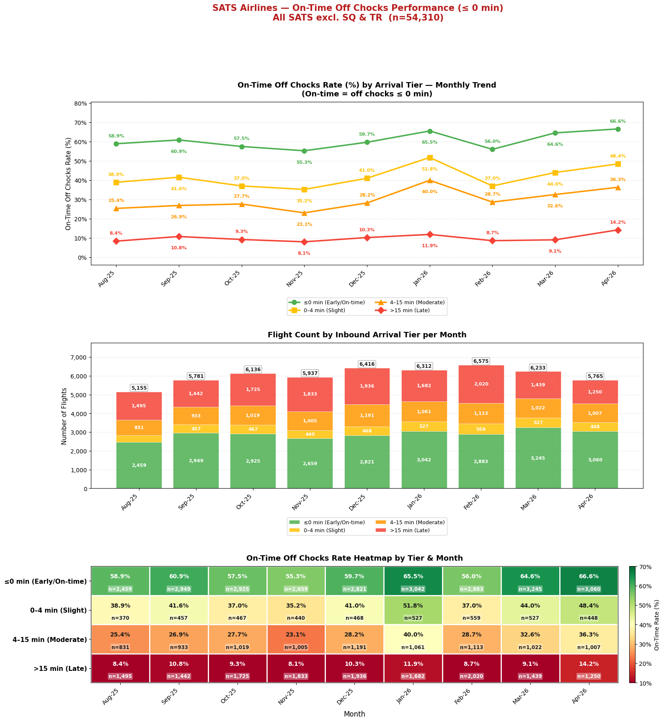
Figure 11b — Excl. SQ & TR: On-Time Off Chocks Performance (≤ 0 min threshold)

7. Key Takeaways

Finding 1 — Inbound delay is the strongest predictor of off-chocks delay
The on-time off-chocks rate drops from 46.1% for early/on-time arrivals to just 16.4% for flights arriving >15 min late — a 29.8 pp deterioration. This holds across all 9 months, confirming a structural relationship, not a seasonal effect.
Finding 2 — The majority of inbound aircraft do not arrive on time
39.2% arrive >4 min late, and 23.5% arrive >15 min late. Since turnaround time is fixed, a late arrival directly compresses available ground operations time, making on-time pushback extremely difficult regardless of ground crew performance.
Finding 3 — Even on-time arrivals have a low on-time pushback rate
When aircraft arrive on time, only 46.1% push back on time. Factors beyond inbound delay — boarding completion, cargo loading, fuelling, gate availability — also contribute significantly. A ~5-min process baseline delay exists even for early arrivals.
Finding 4 — Singapore home carriers (SQ & TR) outperform other carriers
SQ and TR (56.7% of flights) consistently show higher on-time rates across all tiers. For late arrivals (>15 min), they achieve ~2× the on-time rate of non-home carriers, pointing to a structural home-base advantage in crew readiness and operational recovery.
Finding 5 — Monthly trends are stable; no single month explains the pattern
The heatmap charts show low on-time rates for late-arriving aircraft in every month, not concentrated in a specific period. Seasonal effects exist but are secondary to the tier-level structural relationship.

Report generated from SATS operational data. All figures based on the working dataset of 125,508 flights (Aug 2025 – Apr 2026) after applying data quality and coverage filters described in Section 3.

