Using Angular, design a cool user interface that has the following features:

- Users can view a list of all enrollees in the system

- Users should be able to see all of the data related to an enrollee (their id, activation status, name, date of birth)

- Users should be able to tell which enrollees are activated and which are not at a glance

- Users should be able to change the name and activation status of an enrollee

- Users \*\*cannot\*\* modify the id or date of birth of an enrollee

Please check the attached screenshot:

\*\*💰BONUS CHALLENGE\*\*💰: A developer working on the backend mentioned that one of the enrollees doesn't appear to be working. Getting or modifying this enrollee was causing an internal server error. Sadly, they couldn't remember which enrollee had this issue. Can you fix this?

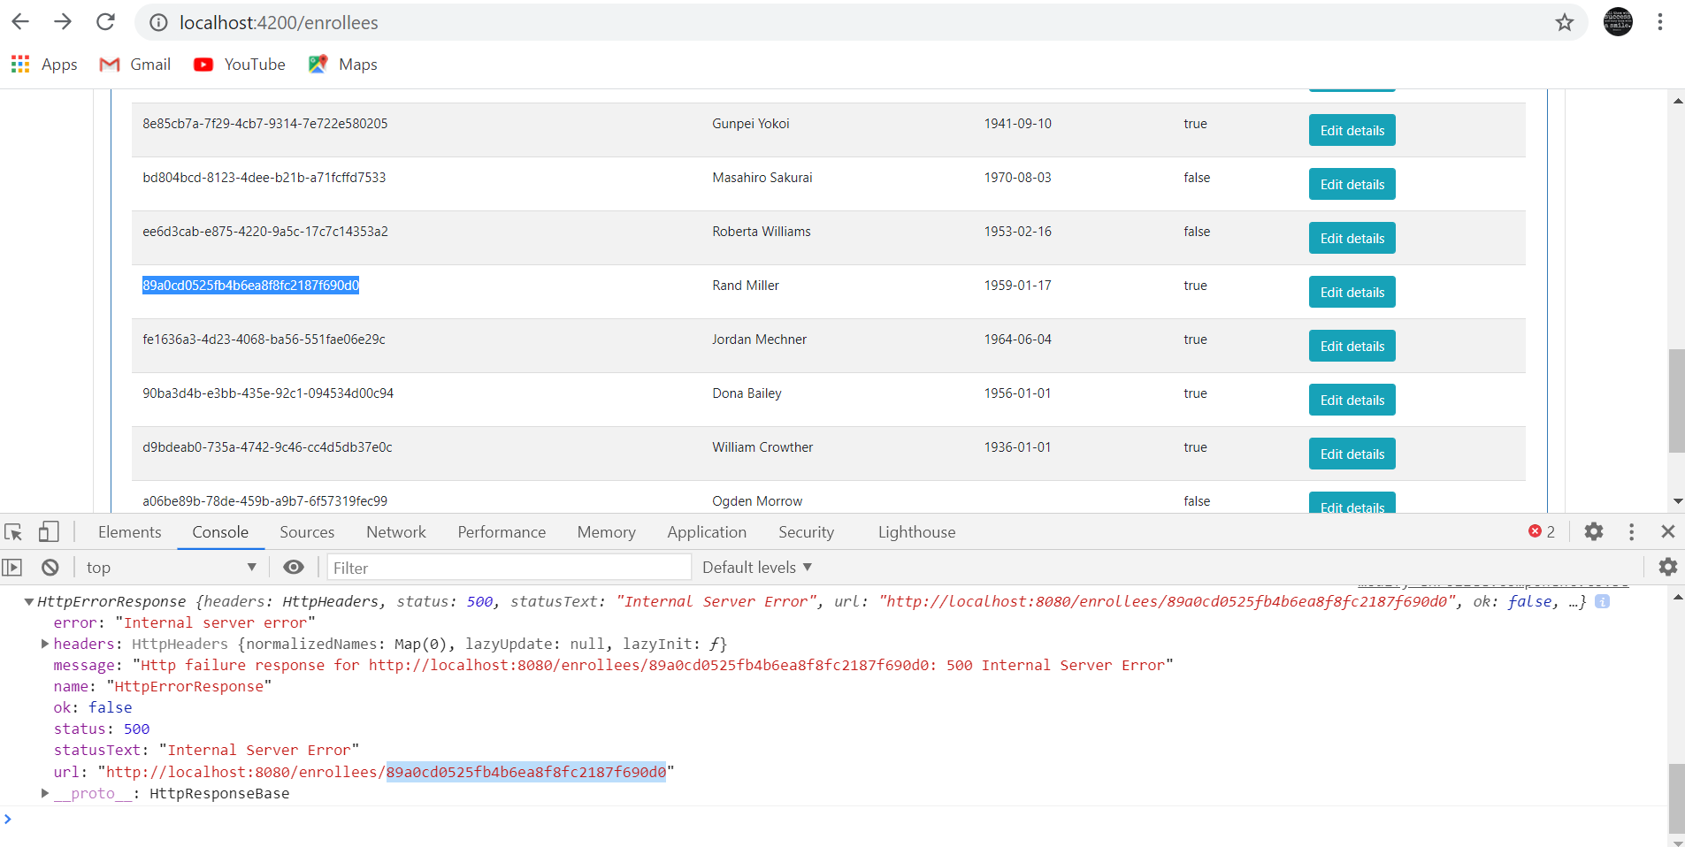

Here is the Id that is having internal server issue because:

In the backend we are using all the id’s to be generated in UUID format but this doesn’t meet the format of UUID, so we cannot retrieve the correct information of enrollee or modify his results in the frontend.