WIDS

Introduction to Kalman Filter
The Kalman Filter is an algorithm for estimating and predicting the state of a system in the presence of uncertainty, such as measurement noise or unknown influences of external factors. The Kalman Filter is an essential tool in areas like object tracking, navigation, robotics, and control. For instance, it can be applied to estimate the computer mouse trajectory by reducing noise and compensating for hand jitter, resulting in a more stable motion path.
The Kalman Filter is a state estimation algorithm that provides both an estimate of the current state and a prediction of the future state, along with a measure of their uncertainty. Moreover, it is an optimal algorithm that minimizes state estimation uncertainty. That is why the Kalman Filter has become such a widely used and trusted algorithm.
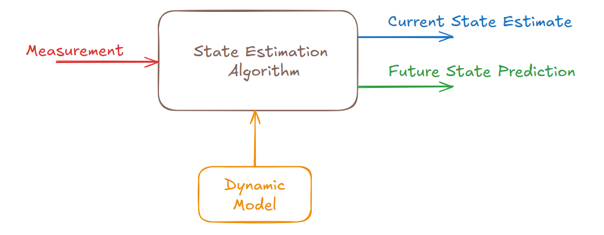

Hidden State
The term Hidden State refers to the actual state of a system that is not directly observable or measurable. Instead, the hidden state must be inferred from observable data, often using a mathematical model and estimation techniques. For instance, consider a scenario with five coins: two 5-cent coins and three 10-cent coins. The system state is the average value of the coins. By averaging the coin values, we can directly calculate this mean value.
For instance, consider a scenario with five coins: two 5-cent coins and three 10-cent coins. The system state is the average value of the coins. By averaging the coin values, we can directly calculate this mean value.

1. Foundations of Recursive State Estimation
In 1960, R.E. Kalman introduced a recursive solution to the discrete-data linear filtering problem. This discovery revolutionized the field of digital signal processing and control theory, particularly as advances in digital computing made these complex mathematical operations feasible in real-time. The Kalman filter is defined as a set of mathematical equations that provides an efficient computational means to estimate the state of a process by minimizing the mean of the squared error.
The filter is exceptionally powerful because it supports estimations of past, present, and even future states, and can function effectively even when the precise nature of the modeled system is unknown. Unlike batch processing methods like the Wiener filter, which require all data to be available directly for each estimate, the Kalman filter recursively conditions the current estimate on all past measurements. This recursive nature makes practical implementation feasible for systems with limited memory and processing power.

2. The Discrete Kalman Filter Model
2.1 The Process and Measurement Equations
The Kalman filter addresses the general problem of trying to estimate the state x of a discrete-time controlled process governed by a linear stochastic difference equation.
- State Equation: x_k = A * x_{k-1} + B * u_{k-1} + w_{k-1}.
- Matrix A: This n x n matrix relates the state at the previous time step k-1 to the state at the current step k, in the absence of a driving function or process noise.
- Matrix B: This n x l matrix relates the optional control input u to the state x.
- Process Noise (w_k): Represents the random variables of the process noise, assumed to be white with a normal probability distribution p(w) ~ N(0, Q).
The measurement z is governed by the following equation:
- Measurement Equation: z_k = H * x_k + v_k.
- Matrix H: This m x n matrix relates the state to the measurement z_k.
- Measurement Noise (v_k): Represents the measurement noise, assumed to be independent, white, and normally distributed with p(v) ~ N(0, R).
2.2 Probabilistic Origins
The Kalman filter maintains the first two moments of the state distribution.
- First Moment: The a posteriori state estimate reflects the mean of the state distribution.
- Second Moment: The a posteriori estimate error covariance reflects the variance of the state distribution.
- Probability Density: The state distribution is represented as p(x_k | z_k) ~ N(x_hat_k, P_k).

3. The Predictor-Corrector Algorithm
The equations for the Kalman filter fall into two groups: time update equations and measurement update equations. This ongoing cycle allows the filter to function as a predictor-corrector algorithm.

3.1 Time Update (Predict)
The time update equations project forward the current state and error covariance estimates to obtain the a priori estimates for the next time step.
- State Projection: x_hat_minus_k = A * x_hat_{k-1} + B * u_{k-1}.
- Error Covariance Projection: P_minus_k = A * P_{k-1} * A_transpose + Q.

3.2 Measurement Update (Correct)
The measurement update equations are responsible for the feedback—incorporating a new measurement into the a priori estimate to obtain an improved a posteriori estimate.
- Compute Kalman Gain: K_k = P_minus_k * H_transpose * (H * P_minus_k * H_transpose + R)^-1.
- Update Estimate: x_hat_k = x_hat_minus_k + K_k * (z_k - H * x_hat_minus_k).
- Update Error Covariance: P_k = (I - K_k * H) * P_minus_k.
The value (z_k - H * x_hat_minus_k) is called the measurement innovation or the residual, reflecting the discrepancy between the predicted measurement and the actual measurement.

4. The Extended Kalman Filter (EKF)
In situations where the process or measurement relationship is non-linear, a Kalman filter that linearizes about the current mean and covariance is used, known as an Extended Kalman Filter (EKF).
+3

4.1 Non-linear Equations and Jacobians
The EKF assumes the process is governed by non-linear equations:
- Non-linear Process: x_k = f(x_{k-1}, u_{k-1}, w_{k-1}).
- Non-linear Measurement: z_k = h(x_k, v_k).
To linearize these relationships, the EKF calculates Jacobian matrices of partial derivatives of the functions f and h.
- Matrix A: The Jacobian matrix of partial derivatives of f with respect to x.
- Matrix H: The Jacobian matrix of partial derivatives of h with respect to x.
While powerful, a fundamental flaw of the EKF is that the distributions of the random variables are no longer normal after undergoing non-linear transformations.

5. Parameter Tuning and Practical Simulation

5.1 Choosing Q and R
In actual implementation, the measurement noise covariance R is usually measured prior to operation through off-line sample measurements. Determining the process noise covariance Q is generally more difficult as we typically do not observe the process directly. Tuning these parameters off-line can result in superior filter performance.
The paper illustrates the filter by estimating a scalar voltage constant.
- True Constant: The simulation uses a value of x = -0.37727.
- Effect of R: When the filter is told the measurement variance R is high (e.g., R = 1), it is slower to respond to measurements, resulting in reduced estimate variance.
- Convergence: Initial error covariance P_0 is not critical; in the example, an initial choice of 1 settled to approximately 0.0002 after 50 iterations.

6. Conclusion
The Kalman filter provides a robust mathematical framework for state estimation. By effectively blending noisy sensor data with a predictive model, it minimizes squared error and provides a recursive, computationally efficient solution for linear and non-linear systems alike.

