**PART-C**

1. **Create an Android application to implement the functioning of Simple calculator**

**Activity_main.xml**

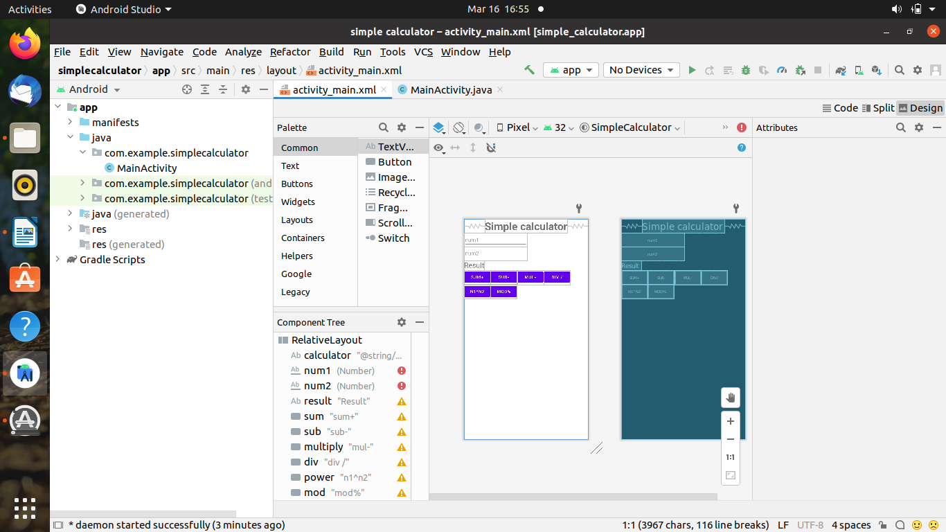

*<?*xml version="1.0" encoding="utf-8"*?>*  
<RelativeLayout xmlns:android="http://schemas.android.com/apk/res/android"  
 xmlns:app="http://schemas.android.com/apk/res-auto"  
 xmlns:tools="http://schemas.android.com/tools"  
 android:layout_width="match_parent"  
 android:layout_height="match_parent"  
 tools:context=".MainActivity">  
  
  
 <TextView  
 android:id="@+id/calculator"  
 android:layout_width="wrap_content"  
 android:layout_height="wrap_content"  
 android:layout_centerHorizontal="true"  
 android:text="@string/simple_calculator"  
 android:textSize="35sp"  
 android:textStyle="bold"  
 tools:layout_editor_absoluteX="141dp"  
 tools:layout_editor_absoluteY="82dp" />  
  
 <EditText  
 android:id="@+id/num1"  
  
 android:layout_width="wrap_content"  
 android:layout_height="wrap_content"  
 android:ems="10"  
 android:inputType="number"  
 android:hint="num1"  
 android:layout_below="@+id/calculator"  
 tools:layout_editor_absoluteX="34dp"  
 tools:layout_editor_absoluteY="192dp" />  
  
 <EditText  
 android:id="@+id/num2"  
 android:layout_width="wrap_content"  
 android:layout_height="wrap_content"  
 android:ems="10"  
 android:inputType="number"  
 android:layout_below="@+id/num1"  
 android:hint="num2"  
 tools:layout_editor_absoluteX="35dp"  
 tools:layout_editor_absoluteY="262dp" />  
  
 <TextView  
 android:id="@+id/result"  
 android:layout_width="wrap_content"  
 android:layout_height="wrap_content"  
 android:text="Result"  
 android:textSize="24sp"  
 android:layout_below="@id/num2"  
 tools:layout_editor_absoluteX="42dp"  
 tools:layout_editor_absoluteY="330dp" />  
  
 <Button  
 android:id="@+id/sum"  
 android:layout_width="wrap_content"  
 android:layout_height="wrap_content"  
 android:text="sum+"  
 android:onClick="doSum"  
 android:layout_below="@id/result"  
 tools:layout_editor_absoluteX="34dp"  
 tools:layout_editor_absoluteY="381dp" />  
  
 <Button  
 android:id="@+id/sub"  
 android:layout_width="wrap_content"  
 android:layout_height="wrap_content"  
 android:text="sub-"  
 android:onClick="dosub"  
 android:layout_below="@+id/result"  
 android:layout_toRightOf="@+id/sum"  
 tools:layout_editor_absoluteX="155dp"  
 tools:layout_editor_absoluteY="378dp" />  
  
 <Button  
 android:id="@+id/multiply"  
 android:layout_width="wrap_content"  
 android:layout_height="wrap_content"  
 android:text="mul-"  
 android:onClick="doMul"  
 android:layout_toRightOf="@id/sub"  
 android:layout_below="@id/result"  
 tools:layout_editor_absoluteX="277dp"  
 tools:layout_editor_absoluteY="376dp" />  
  
 <Button  
 android:id="@+id/div"  
 android:layout_width="wrap_content"  
 android:layout_height="wrap_content"  
 android:text="div /"  
 android:onClick="doDiv"  
 android:layout_toRightOf="@+id/multiply"  
 android:layout_below="@+id/result"  
 tools:layout_editor_absoluteX="34dp"  
 tools:layout_editor_absoluteY="470dp" />  
  
 <Button  
 android:id="@+id/power"  
 android:layout_width="wrap_content"  
 android:layout_height="wrap_content"  
 android:text="n1^n2"  
 android:layout_below="@id/sum"  
 android:onClick="doPow"  
 tools:layout_editor_absoluteX="141dp"  
 tools:layout_editor_absoluteY="470dp" />  
  
 <Button  
 android:id="@+id/mod"  
 android:layout_width="wrap_content"  
 android:layout_height="wrap_content"  
 android:text="mod%"  
 android:layout_toRightOf="@+id/power"  
 android:layout_below="@+id/sub"  
 android:onClick="doMod"  
 tools:layout_editor_absoluteX="263dp"  
 tools:layout_editor_absoluteY="470dp" />  
</RelativeLayout>

**MainActivity.java**

package com.example.simplecalculator;  
  
import androidx.appcompat.app.AppCompatActivity;  
  
import android.os.Bundle;  
import android.view.View;  
import android.widget.Button;  
import android.widget.EditText;  
import android.widget.TextView;  
  
public class MainActivity extends AppCompatActivity {  
 EditText e1, e2;  
 TextView t1;  
 int num1, num2;  
  
 @Override  
 protected void onCreate(Bundle savedInstanceState) {  
  
 super.onCreate(savedInstanceState);  
 setContentView(R.layout.*activity_main*);  
 }  
 public boolean getNumbers() {  
 e1 = (EditText) findViewById(R.id.*num1*);  
 e2 = (EditText) findViewById(R.id.*num2*);  
 t1 = (TextView) findViewById(R.id.*result*);  
 String s1 = e1.getText().toString();  
 String s2 = e2.getText().toString();  
 if ((s1.equals(null) && s2.equals(null)) || (s1.equals("") && s2.equals(""))) {  
 String result = "Please enter a value";  
 t1.setText(result);  
 return false;  
  
 } else {  
 num1 = Integer.*parseInt*(s1);  
 num2 = Integer.*parseInt*(s2);  
  
 }  
 return true;  
 }  
 public void doSum(View v){  
 if(getNumbers()){  
 int sum= num1 + num2;  
 t1.setText(Integer.*toString*(sum));  
 }  
  
  
 }  
 public void doPow(View v){  
 if (getNumbers()){  
 double sum=Math.pow(num1, num2);  
 t1.setText(Double.toString(sum));  
 }  
 }

public void dosub(View v){  
 if(getNumbers()){  
 int sum=num1-num2;  
 t1.setText(Integer.*toString*(sum));  
 }  
 }  
 public void doMul(View v){  
 if(getNumbers()){  
 int sum=num1*num2;  
 t1.setText(Integer.*toString*(sum));  
 }  
 }  
 public void doDiv(View v){  
 if(getNumbers()){  
 double sum=num1/(num2 * 1.0);  
 t1.setText(Double.*toString*(sum));  
 }  
 }  
 public void doMod(View v){  
 if (getNumbers()) {  
  
 double sum=num1%num2;  
 t1.setText(Double.*toString*(sum));  
 }  
 }  
  
  
 }

**Output :-**

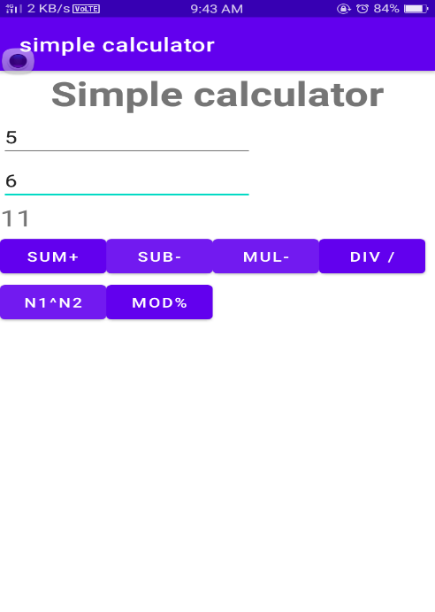

**2. Create a menu driven Android application to store data of employees (ID, Name, Salary, Designation) in SQLite database and display all stored records.**

**activity-main.xml**

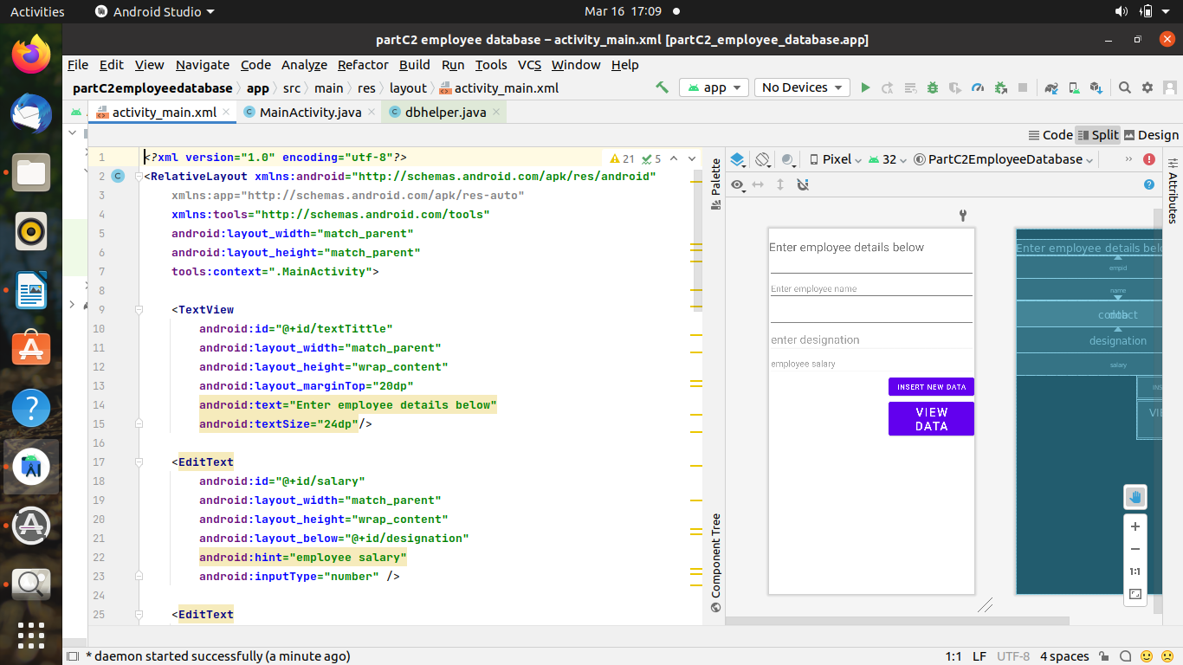

<?xml version="1.0" encoding="utf-8"?>

<RelativeLayout xmlns:android="http://schemas.android.com/apk/res/android"

xmlns:tools="http://schemas.android.com/tools"

android:layout_width="match_parent"

android:layout_height="match_parent"

android:alwaysDrawnWithCache="false"

android:animateLayoutChanges="true"

android:background="#CDDC39"

android:backgroundTint="#03A9F4"

android:padding="10dp"

tools:context=".MainActivity">

<TextView

android:id="@+id/texttitle"

android:layout_width="match_parent"

android:layout_height="wrap_content"

android:layout_marginTop="20dp"

android:text=" enter Employee details below"

android:textColor="@android:color/holo_red_dark"

android:textSize="24dp" />

<EditText

android:id="@+id/salary"

android:layout_width="match_parent"

android:layout_height="wrap_content"

android:layout_below="@+id/designation"

android:hint="employee salary"

android:inputType="number"

android:textColor="@android:color/holo_orange_dark"

android:textSize="24dp" />

<EditText

android:id="@+id/designation"

android:layout_width="match_parent"

android:layout_height="wrap_content"

android:layout_below="@+id/dob"

android:hint="enter designation of employee"

android:inputType="text"

android:textColor="@android:color/holo_orange_dark"

android:textSize="24dp" />

<EditText

android:id="@+id/name"

android:layout_width="match_parent"

android:layout_height="wrap_content"

android:layout_below="@+id/texttitle"

android:hint="enter Name"

android:inputType="textPersonName"

android:textSize="24dp" />

<EditText

android:id="@+id/contact"

android:layout_width="match_parent"

android:layout_height="wrap_content"

android:layout_below="@+id/name"

android:hint="Contact"

android:inputType="number"

android:textSize="24dp" />

<EditText

android:id="@+id/dob"

android:layout_width="match_parent"

android:layout_height="wrap_content"

android:layout_below="@+id/contact"

android:hint="Date of Birth"

android:inputType="date"

android:textSize="24dp" />

<Button

android:id="@+id/btnInsert"

android:layout_width="match_parent"

android:layout_height="wrap_content"

android:layout_below="@id/salary"

android:layout_marginTop="50dp"

android:text="Insert New Data"

android:textSize="24dp" />

<Button

android:id="@+id/btnView"

android:layout_width="match_parent"

android:layout_height="wrap_content"

android:layout_below="@id/btnInsert"

android:text="View Data"

android:textSize="24dp" />

</RelativeLayout>

**Main Activity.java**

package com.codingflow.employee_information_updated;

import androidx.appcompat.app.AlertDialog;

import androidx.appcompat.app.AppCompatActivity;

import android.app.DatePickerDialog;

import android.database.Cursor;

import android.graphics.Color;

import android.graphics.drawable.ColorDrawable;

import android.graphics.fonts.Font;

import android.os.Bundle;

import android.text.TextShaper;

import android.util.Log;

import android.view.View;

import android.widget.Button;

import android.widget.DatePicker;

import android.widget.EditText;

import android.widget.TextView;

import android.widget.Toast;

import org.w3c.dom.Text;

import java.util.Calendar;

public class MainActivity extends AppCompatActivity {

EditText name, contact, dob,salary,desig;

Button insert,view;

dbhelper DB;

String date;

private static final String TAG = "MainActivity";

EditText mDisplayDate;

private DatePickerDialog.OnDateSetListener mDateSetListener;

@Override

protected void onCreate(Bundle savedInstanceState) {

super.onCreate(savedInstanceState);

setContentView(R.layout.activity_main);

name = findViewById(R.id.name);

contact = findViewById(R.id.contact);

// dob = findViewById(R.id.dob);

insert = findViewById(R.id.btnInsert);

salary=findViewById(R.id.salary);

desig=findViewById(R.id.designation);

view = findViewById(R.id.btnView);

mDisplayDate = findViewById(R.id.dob);

mDisplayDate.setOnClickListener(new View.OnClickListener() {

@Override

public void onClick(View view) {

Calendar cal = Calendar.getInstance();

int year = cal.get(Calendar.YEAR);

int month = cal.get(Calendar.MONTH);

int day = cal.get(Calendar.DAY_OF_MONTH);

DatePickerDialog dialog = new DatePickerDialog(

MainActivity.this,

android.R.style.Theme_Holo_Light_Dialog_MinWidth,

mDateSetListener,

year,month,day);

dialog.getWindow().setBackgroundDrawable(new ColorDrawable(Color.MAGENTA));

dialog.show();

}

});

mDateSetListener = new DatePickerDialog.OnDateSetListener() {

@Override

public void onDateSet(DatePicker datePicker, int year, int month, int day) {

month = month + 1;

Log.d(TAG, "onDateSet: mm/dd/yyy: " + month + "/" + day + "/" + year);

date = month + "/" + day + "/" + year;

mDisplayDate.setText(date);

}

};

DB = new dbhelper(this);

insert.setOnClickListener(new View.OnClickListener() {

@Override

public void onClick(View view) {

String nameTXT = name.getText().toString();

String contactTXT = contact.getText().toString();

String dobTXT = date;

String sal=salary.getText().toString();

String designation=desig.getText().toString();

Boolean checkinsertdata = DB.insertuserdata(nameTXT, contactTXT, dobTXT,sal,designation);

if(checkinsertdata)

Toast.makeText(MainActivity.this, "New Entry Inserted", Toast.LENGTH_SHORT).show();

else

Toast.makeText(MainActivity.this, "New Entry Not Inserted", Toast.LENGTH_SHORT).show();

} });

view.setOnClickListener(view -> {

Cursor res = DB.getdata();

int count=1;

if(res.getCount()==0){

Toast.makeText(MainActivity.this, "No Entry Exists", Toast.LENGTH_SHORT).show();

return;

}

StringBuffer buffer = new StringBuffer();

while(res.moveToNext())

{

buffer.append("EMPLOYEE "+count++).append("\n");

buffer.append("Name :"+res.getString(0)+"\n");

buffer.append("Contact :"+res.getString(1)+"\n");

buffer.append("Date of Birth :"+res.getString(2)+"\n");

buffer.append("salary of the employee").append(res.getString(3)).append("\n");

buffer.append("designation of the employee"+res.getString(4)+"\n\n");

}

AlertDialog.Builder builder = new AlertDialog.Builder(MainActivity.this);

builder.setCancelable(true);

builder.setTitle("Employee information");

builder.setMessage(buffer.toString());

builder.show();

});

}}

**DBHELPER.JAVA**

**(NOTE :-create a class dbhelper.java by right clicking on your package statement)**

package com.codingflow.employee_information_updated;

import android.content.ContentValues;

import android.content.Context;

import android.database.Cursor;

import android.database.sqlite.SQLiteDatabase;

import android.database.sqlite.SQLiteOpenHelper;

class dbhelper extends SQLiteOpenHelper {

public dbhelper(Context context) {

super(context, "Employeedetails.db", null, 1);

}

@Override

public void onCreate(SQLiteDatabase DB) {

DB.execSQL("create Table Employeedetails(name TEXT primary key, contact TEXT, dob TEXT,sal TEXT,designation TEXT)");

}

@Override

public void onUpgrade(SQLiteDatabase DB, int i, int i1) {

DB.execSQL("drop Table if exists Employeedetails");

}

public Boolean insertuserdata(String name, String contact, String dob,String sal,String designation) {

SQLiteDatabase DB = this.getWritableDatabase();

ContentValues contentValues = new ContentValues();

contentValues.put("name", name);

contentValues.put("contact", contact);

contentValues.put("dob", dob);

contentValues.put("sal",sal);

contentValues.put("designation",designation);

long result = DB.insert("Employeedetails", null, contentValues);

if (result == -1) {

return false;

} else {

return true;

}

}

public Cursor getdata() {

SQLiteDatabase DB = this.getWritableDatabase();

Cursor cursor = DB.rawQuery("Select * from Employeedetails", null);

return cursor;

}

}

**Output :-**

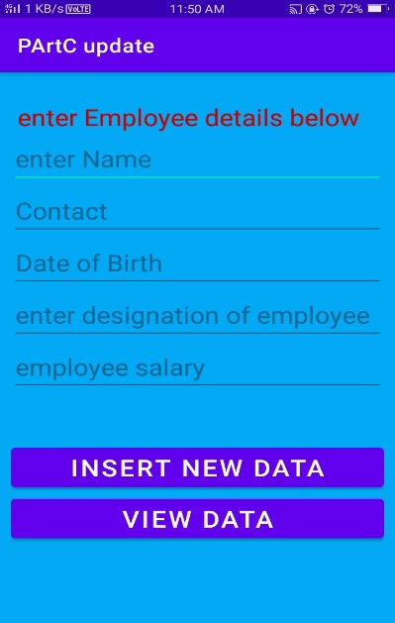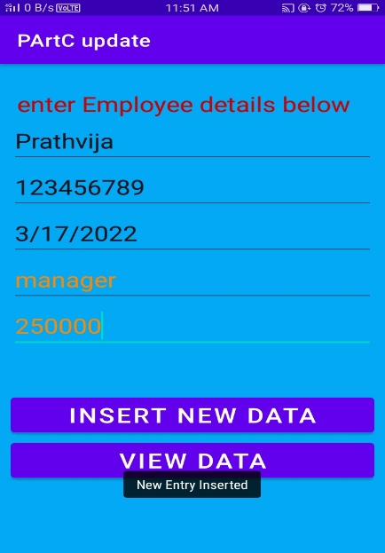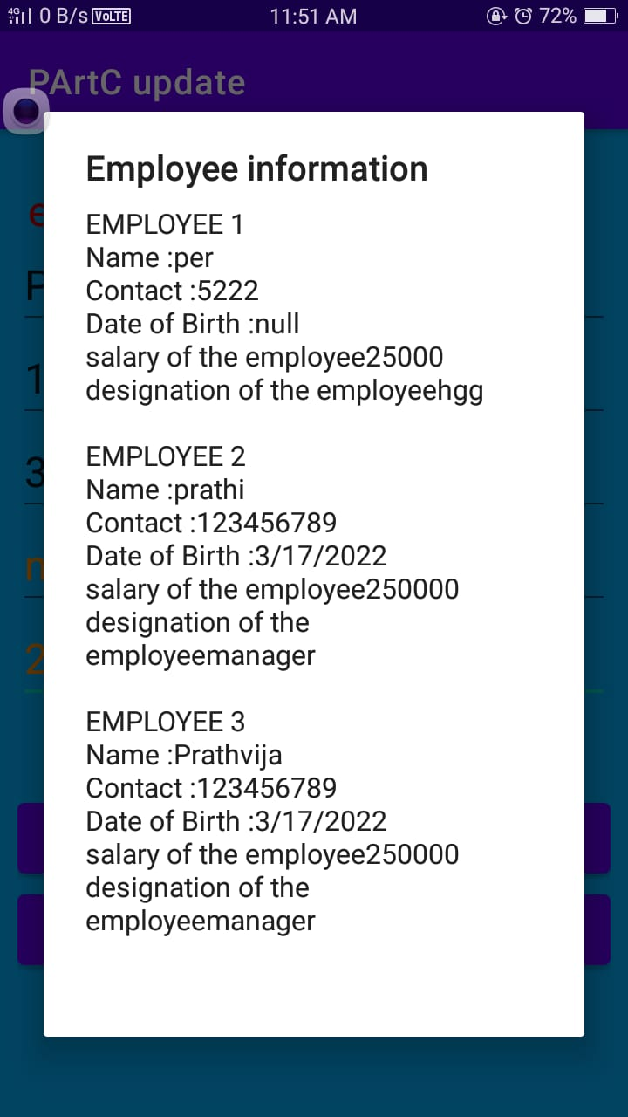

**3.Create an Android application to view Book details (Title, Author, Publisher and Price) stored in a file on a ListView in Android**

**Activity-main.xml**

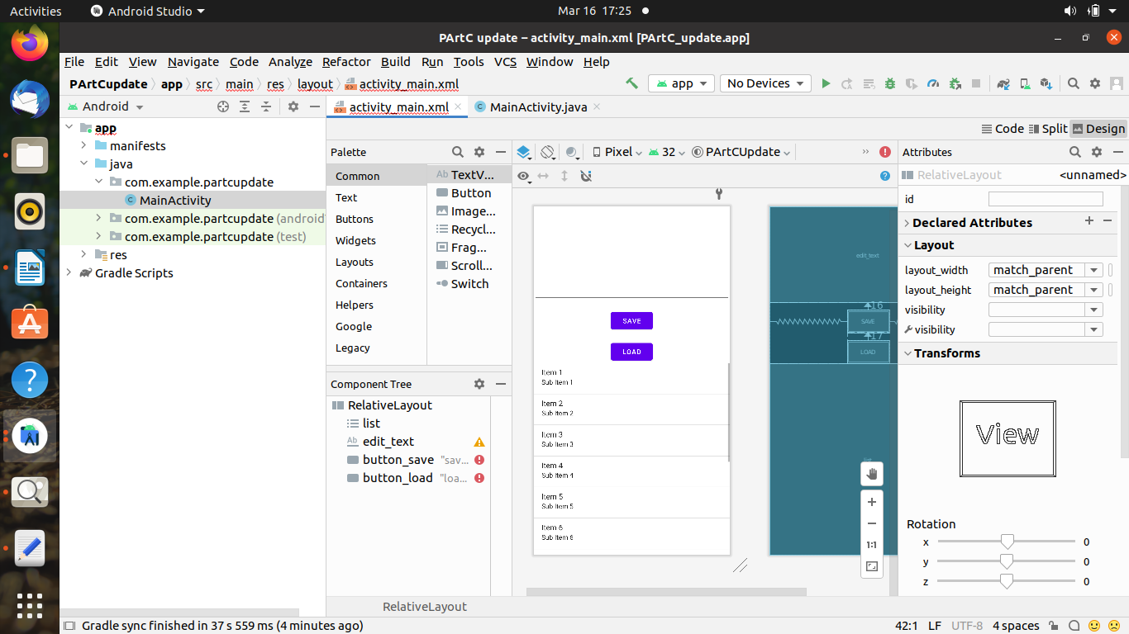

<?xml version="1.0" encoding="utf-8"?>

<RelativeLayout xmlns:android="http://schemas.android.com/apk/res/android"

xmlns:app="http://schemas.android.com/apk/res-auto"

xmlns:tools="http://schemas.android.com/tools"

android:layout_width="match_parent"

android:layout_height="match_parent"

tools:context=".MainActivity">

<ListView

android:id="@+id/list"

android:layout_width="wrap_content"

android:layout_height="wrap_content"

android:scrollingCache="true"

android:smoothScrollbar="true"

android:stretchMode="columnWidth"

android:layout_below="@+id/button_load">

</ListView>

<Button

android:id="@+id/button_load"

android:layout_width="wrap_content"

android:layout_height="wrap_content"

android:layout_marginLeft="130dp"

android:layout_marginTop="200dp"

android:onClick="load"

android:text="show_book_detail" />

</RelativeLayout>

**MAIN_ACTIVITY.JAVA**

import androidx.appcompat.app.AppCompatActivity;

import android.os.Bundle;

import android.view.View;

import android.widget.ArrayAdapter;

import android.widget.EditText;

import android.widget.ListView;

import android.widget.Toast;

import java.io.BufferedReader;

import java.io.FileInputStream;

import java.io.FileNotFoundException;

import java.io.FileOutputStream;

import java.io.IOException;

import java.io.InputStreamReader;

import java.util.ArrayList;

public class MainActivity extends AppCompatActivity {

ListView l;

private static final String FILE_NAME = "BOOK.txt";

@Override

protected void onCreate(Bundle savedInstanceState) {

super.onCreate(savedInstanceState);

setContentView(R.layout.activity_main);

l = findViewById(R.id.list);

}

public void load(View v) throws IOException {

FileInputStream fis = null;

l=findViewById(R.id.list);

ArrayList<String> arrayList=new ArrayList<>();

fis = openFileInput(FILE_NAME);

InputStreamReader isr = new InputStreamReader(fis);

BufferedReader br = new BufferedReader(isr);

StringBuilder sb = new StringBuilder();

String text;

while ((text = br.readLine()) != null) {

arrayList.add(text);

}

ArrayAdapter arrayAdapter=new ArrayAdapter<>(this,android.R.layout.simple_list_item_1,arrayList );

l.setAdapter(arrayAdapter);

}

}

**Output :-**

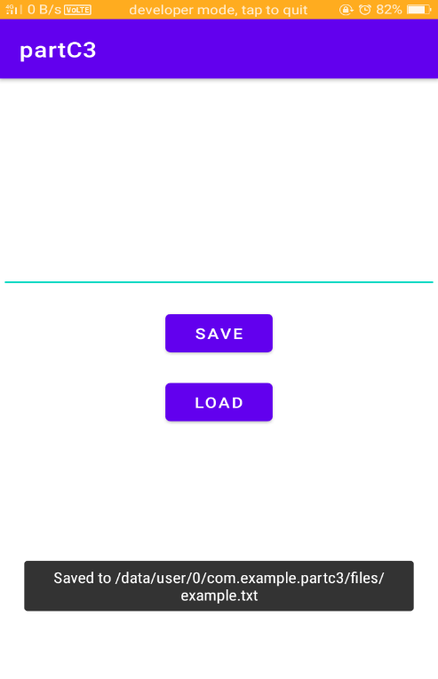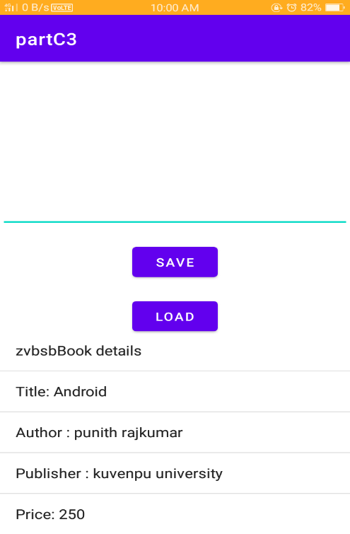

**4. . Create an Android application that implements Multi-threading.**

**ACTIVITY_MAIN.XML**

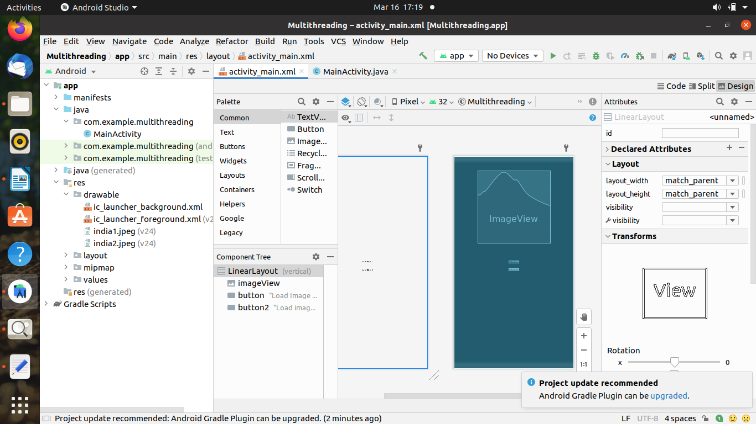

<?xml version="1.0" encoding="utf-8"?>

<LinearLayout xmlns:android="http://schemas.android.com/apk/res/android"

android:layout_width="match_parent"

android:layout_height="match_parent"

android:orientation="vertical" >

<ImageView

android:id="@+id/imageView"

android:layout_width="250dp"

android:layout_height="250dp"

android:layout_margin="50dp"

android:layout_gravity="center" />

<Button

android:id="@+id/button"

android:layout_width="wrap_content"

android:layout_height="wrap_content"

android:layout_margin="10dp"

android:layout_gravity="center"

android:text="Load Image 1" />

<Button

android:id="@+id/button2"

android:layout_width="wrap_content"

android:layout_height="wrap_content"

android:layout_margin="10dp"

android:layout_gravity="center"

android:text="Load image 2" />

</LinearLayout>

**Main_Activity.java**

package com.codingflow.multithreading;

import android.os.Bundle;

import android.widget.Button;

import android.widget.ImageView;

import androidx.appcompat.app.AppCompatActivity;

public class MainActivity extends AppCompatActivity

{

ImageView img;

Button bt1,bt2;

@Override

protected void onCreate(Bundle savedInstanceState)

{

super.onCreate(savedInstanceState);

setContentView(R.layout.activity_main);

bt1 = (Button)findViewById(R.id.button);

bt2= (Button) findViewById(R.id.button2);

img = (ImageView)findViewById(R.id.imageView);

bt1.setOnClickListener(v -> new Thread(() -> img.post(() -> img.setImageResource(R.drawable.india1))).start());

bt2.setOnClickListener(v -> new Thread(() -> img.post(() -> img.setImageResource(R.drawable.india2))).start());

}

}

**Output :-**

