PART- A

1. Create an Android application, which pop up and Alert Dialog with three buttons.

Activity_main.xml

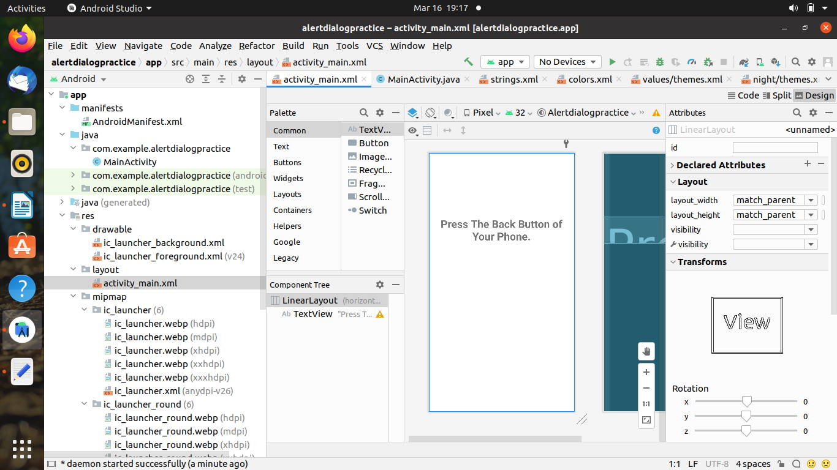

<?xml version="1.0" encoding="utf-8"?>
<LinearLayout xmlns:android="http://schemas.android.com/apk/res/android"
xmlns:app="http://schemas.android.com/apk/res-auto"
xmlns:tools="http://schemas.android.com/tools"
android:id="@+id/linearLayout"
android:layout_width="match_parent"
android:layout_height="match_parent"
tools:context=".MainActivity"
tools:ignore="MissingClass">

<TextView
android:id="@+id/textView2"
android:layout_width="wrap_content"
android:layout_height="wrap_content"
android:text="Press the back button of your phone"
android:textStyle="bold"
android:gravity="center_horizontal"
app:layout_constraintEnd_toEndOf="parent"
app:layout_constraintStart_toStartOf="parent"
android:textSize="15sp"
android:layout_marginTop="180dp"
app:layout_constraintTop_toTopOf="parent" />
</LinearLayout>

Main_Activity.java

package com.example.alert_dialog_parta_1;
import androidx.appcompat.app.AlertDialog;
import androidx.appcompat.app.AppCompatActivity;
import android.content.DialogInterface;
import android.os.Bundle;
import android.widget.TextView;
public class MainActivity extends AppCompatActivity {
@Override
protected void onCreate(Bundle savedInstanceState) {
super.onCreate(savedInstanceState);
setContentView(R.layout.activity_main);
final TextView message =new TextView(this);
message.setText("");
AlertDialog.Builder builder=new AlertDialog.Builder(this);
builder.setMessage(R.string.AlertBoxMessage);
builder.setPositiveButton(R.string.Yes, new DialogInterface.OnClickListener() {
@Override
public void onClick(DialogInterface dialogInterface, int i) {
message.setText("Your answer is yes");
//DialodInterface is used to run some code when the dialog is clicked
}
});
builder.setNegativeButton(R.string.No, new DialogInterface.OnClickListener() {
@Override
public void onClick(DialogInterface dialogInterface, int i) {
message.setText("Your ans is no");
}
});
builder.setNeutralButton(R.string.Cannot_say, new DialogInterface.OnClickListener() {
@Override
public void onClick(DialogInterface dialogInterface, int i) {
message.setText("Your ans is cannot say");
}
});
builder.show();
setContentView(message);
}
}

String.xml

<resources>
<string name="app_name">HelloWorld</string>
<string name="action_settings">settings</string>
<color name="BackGroundColor">#337700</color>
<string name="AlertBoxTitle">Alert</string>
<string name="AlertBoxMessage">Do you like Android</string>
<string name="Yes">Yes</string>
<string name="No">No</string>
<string name="Cannot_say">Cannot_say</string>
</resources>

Output :-

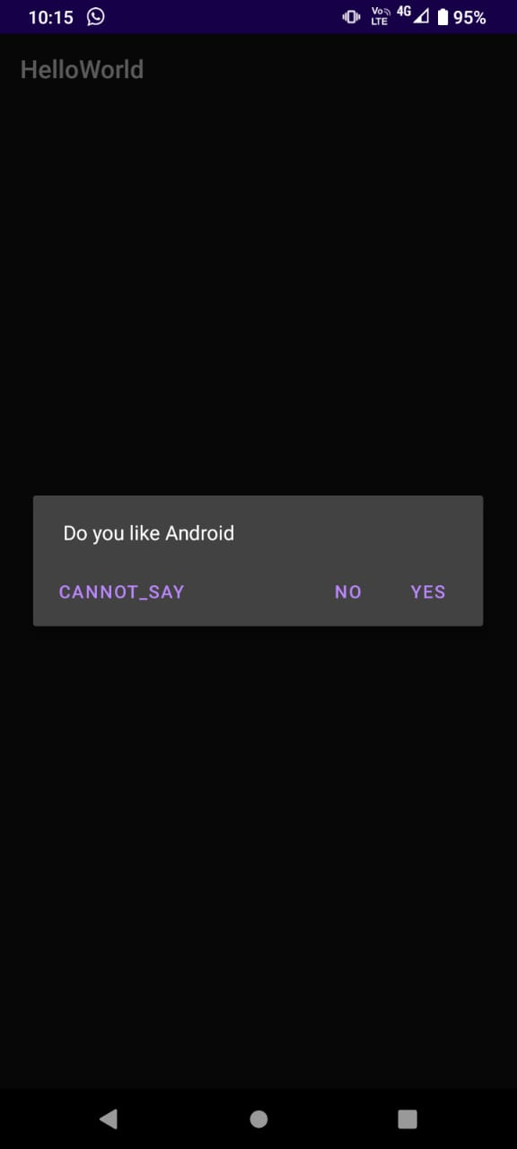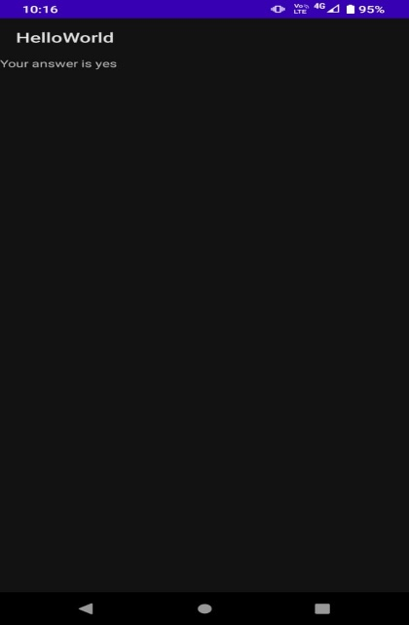

2. Create an Android application using intents and two activities. On the first activity, user can add name and then on pressing the OK button, the second activity should be started. The second activity must greet the user by using the text that entered on Activity one.

Activity_main .xml
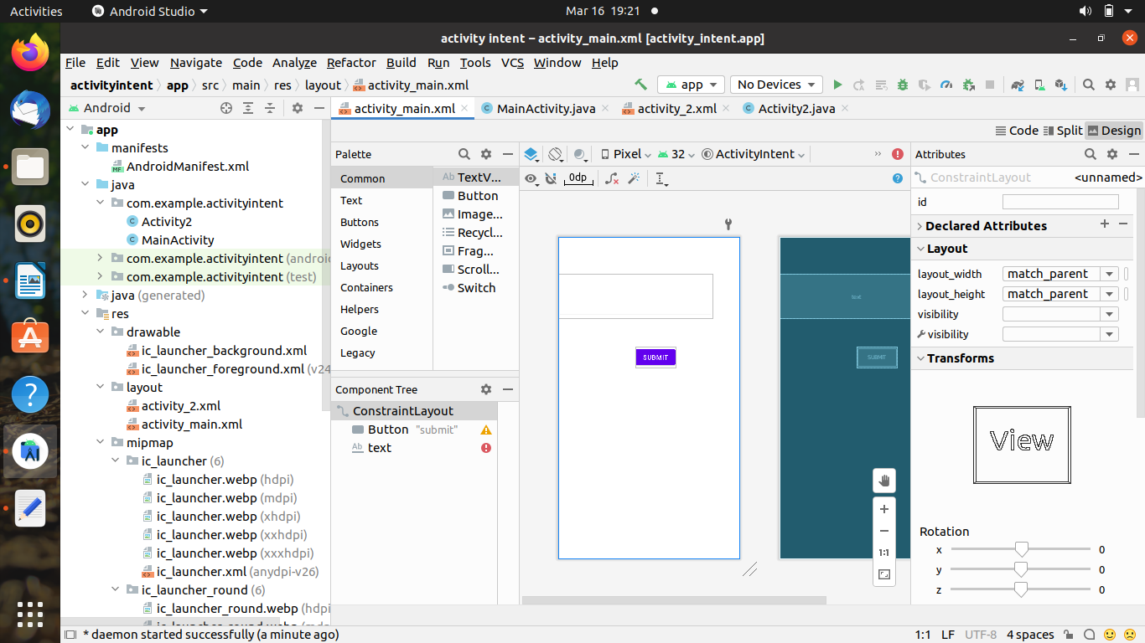

<?xml version="1.0" encoding="utf-8"?>
<androidx.constraintlayout.widget.ConstraintLayout xmlns:android="http://schemas.android.com/apk/res/android"
xmlns:app="http://schemas.android.com/apk/res-auto"
xmlns:tools="http://schemas.android.com/tools"
android:layout_width="match_parent"
android:layout_height="match_parent"
tools:context=".MainActivity">

<TextView
android:id="@+id/act1"
android:layout_width="wrap_content"
android:layout_height="wrap_content"
android:text="acticity 1"
app:layout_constraintBottom_toBottomOf="parent"
app:layout_constraintEnd_toEndOf="parent"
app:layout_constraintHorizontal_bias="0.498"
app:layout_constraintLeft_toLeftOf="parent"
app:layout_constraintRight_toRightOf="parent"
app:layout_constraintStart_toStartOf="parent"
app:layout_constraintTop_toTopOf="parent"
app:layout_constraintVertical_bias="0.22" />

<Button
android:id="@+id/submit"
android:layout_width="wrap_content"
android:layout_height="wrap_content"
android:text="submit"
app:layout_constraintBottom_toBottomOf="parent"
app:layout_constraintHorizontal_bias="0.547"
app:layout_constraintLeft_toLeftOf="parent"
app:layout_constraintRight_toRightOf="parent"
app:layout_constraintTop_toTopOf="parent"
app:layout_constraintVertical_bias="0.597" />

<EditText
android:id="@+id/text"
android:hint="enter your text here"
android:layout_width="match_parent"

android:layout_height="wrap_content"
app:layout_constraintBottom_toBottomOf="parent"
app:layout_constraintEnd_toEndOf="parent"
app:layout_constraintHorizontal_bias="0.5"
app:layout_constraintStart_toStartOf="parent"
app:layout_constraintTop_toTopOf="parent" />
</androidx.constraintlayout.widget.ConstraintLayout>

Main_Activity.java

package com.codingflow.activitylab;

import androidx.appcompat.app.AppCompatActivity;

import android.content.Intent;
import android.os.Bundle;
import android.view.View;
import android.widget.Button;
import android.widget.EditText;

public class MainActivity extends AppCompatActivity {

@Override
protected void onCreate(Bundle savedInstanceState) {
super.onCreate(savedInstanceState);
setContentView(R.layout.activity_main);
Button button = findViewById(R.id.submit);
button.setOnClickListener(new View.OnClickListener() {
@Override
public void onClick(View v) {
open1();
}
});

}
public void open1()
{
String name;
EditText editText=findViewById(R.id.text);
name=editText.getText().toString();
Intent intent=new Intent(this,MainActivity2.class);
intent.putExtra("name",name);
startActivity(intent);
}

}

Activity2. xml

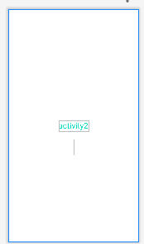

<?xml version="1.0" encoding="utf-8"?>
<androidx.constraintlayout.widget.ConstraintLayout xmlns:android="http://schemas.android.com/apk/res/android"
xmlns:app="http://schemas.android.com/apk/res-auto"
xmlns:tools="http://schemas.android.com/tools"
android:layout_width="match_parent"
android:layout_height="match_parent"
tools:context=".MainActivity2">

<TextView
android:layout_width="wrap_content"
android:layout_height="wrap_content"
android:text="activity2"
android:textSize="25dp"
android:textColor="@color/teal_200"
app:layout_constraintBottom_toBottomOf="parent"
app:layout_constraintEnd_toEndOf="parent"
app:layout_constraintHorizontal_bias="0.5"
app:layout_constraintStart_toStartOf="parent"
app:layout_constraintTop_toTopOf="parent" />
<TextView
android:id="@+id/text2"
android:layout_width="wrap_content"
android:layout_height="wrap_content"
android:textSize="35dp"
app:layout_constraintBottom_toBottomOf="parent"
app:layout_constraintEnd_toEndOf="parent"
app:layout_constraintHorizontal_bias="0.5"
app:layout_constraintStart_toStartOf="parent"
app:layout_constraintTop_toTopOf="parent"
app:layout_constraintVertical_bias=".6"/>
</androidx.constraintlayout.widget.ConstraintLayout>

Activity2.java

package com.codingflow.activitylab;

import androidx.appcompat.app.AppCompatActivity;

import android.os.Bundle;
import android.widget.TextView;

public class MainActivity2 extends AppCompatActivity {

@Override
protected void onCreate(Bundle savedInstanceState) {
super.onCreate(savedInstanceState);
setContentView(R.layout.activity_main2);
TextView t=findViewById(R.id.text2);
t.setText(getIntent().getStringExtra("name"));
}
}

Output:-

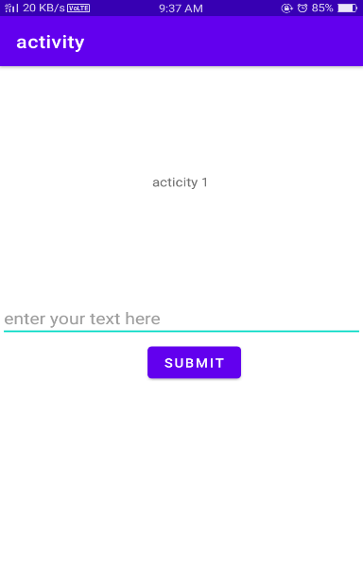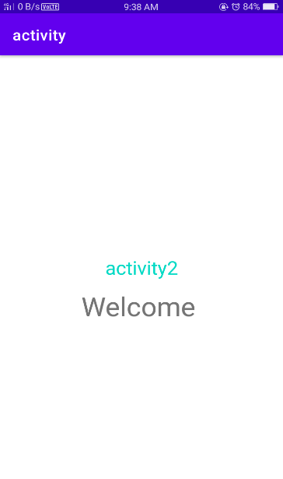

3. Create an Android application using TableLayout to arrange Text View, Edit Text, RadioButton View and CheckBox View.

ACTIVITY_MAIN.XML:-

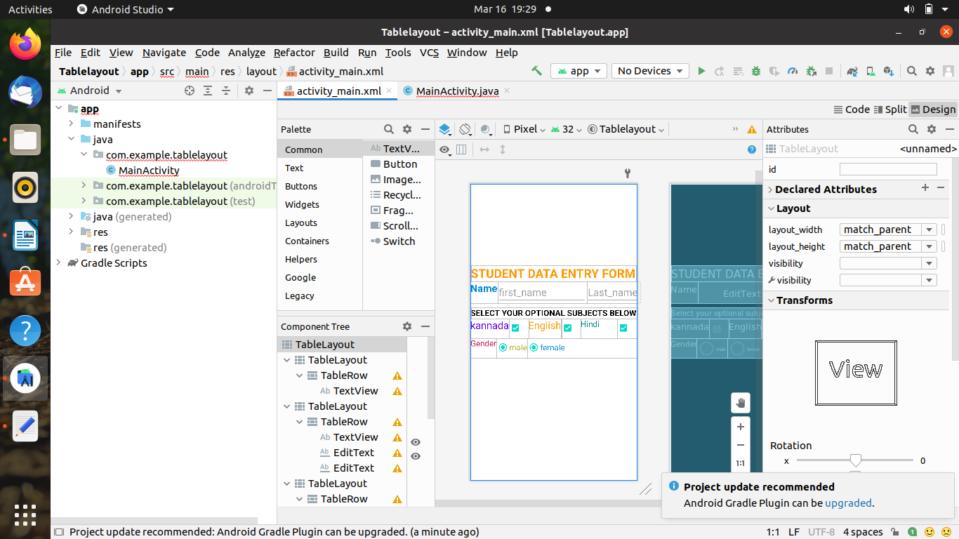

<?xml version="1.0" encoding="utf-8"?>
<TableLayout xmlns:android="http://schemas.android.com/apk/res/android"
xmlns:app="http://schemas.android.com/apk/res-auto"
xmlns:tools="http://schemas.android.com/tools"
android:layout_width="match_parent"
android:layout_height="match_parent"
tools:context=".MainActivity">
<TableLayout
android:layout_width="wrap_content"
android:layout_marginTop="200dp"
android:layout_height="wrap_content">
<TableRow
android:layout_width="match_parent"
android:layout_height="match_parent"
>
<TextView android:layout_height="match_parent"
android:layout_width="410dp"
android:text="STUDENT DATA ENTRY FORM"
android:textStyle="bold"
android:layout_gravity="center"

android:textColor="#FF9800"
android:textSize="30dp"
/>
</TableRow>
</TableLayout>
<TableLayout android:layout_height="wrap_content"
android:layout_width="wrap_content"
android:stretchColumns="1">
<TableRow android:layout_width="match_parent"
android:layout_height="wrap_content">

<TextView
android:layout_width="wrap_content"
android:layout_height="match_parent"
android:text="Name"
android:textStyle="bold"
android:textColor="#0288D1"
android:layout_column="1"
android:textSize="25dp" />

<EditText
android:layout_width="220dp"
android:layout_height="wrap_content"
android:hint="first_name"
android:textSize="25dp"
android:layout_column="2"
android:visibility="visible" />
<EditText
android:layout_width="wrap_content"
android:layout_height="wrap_content"
android:hint="Last_name"
android:textSize="25dp"
android:layout_column="3"
android:visibility="visible" />

</TableRow>

</TableLayout>
<TableLayout android:layout_height="wrap_content"
android:layout_width="match_parent"
android:layout_marginTop="10dp"
android:stretchColumns="0">
<TableRow android:layout_width="match_parent"
android:layout_height="match_parent">
<TextView android:layout_height="match_parent"
android:layout_width="match_parent"
android:layout_gravity="center"
android:textAllCaps="true"
android:textStyle="bold"
android:textSize="20dp"
android:textColor="@color/black"
android:text="Select your optional subjects below"></TextView>
</TableRow>
</TableLayout>

<TableLayout android:layout_height="wrap_content"
android:layout_width="wrap_content">
<TableRow android:layout_width="wrap_content"
android:layout_height="wrap_content">

<TextView android:layout_width="wrap_content"
android:layout_height="match_parent"
android:textSize="25dp"
android:textColor="@color/purple_500"
android:text="kannada"/>

<CheckBox android:layout_height="match_parent"
android:layout_width="match_parent"
android:checked="true"/>
<TextView android:layout_width="wrap_content"
android:layout_height="match_parent"
android:textColor="#FFA000"
android:textSize="25dp"
android:text="English"/>

<CheckBox android:layout_height="match_parent"
android:layout_width="wrap_content"
android:checked="true"/>
<TextView android:layout_width="90dp"
android:layout_height="match_parent"
android:textColor="@color/teal_700"
android:textSize="20dp"
android:text="Hindi"/>

<CheckBox android:layout_height="wrap_content"
android:layout_width="wrap_content"
android:checked="true"/>

</TableRow>
</TableLayout>
<TableLayout android:layout_width="match_parent"
android:layout_height="wrap_content"
android:stretchColumns="2">
<TableRow

android:layout_height="wrap_content"
android:layout_width="wrap_content">
<TextView android:layout_height="match_parent"
android:layout_width="wrap_content"
android:textColor="#C2185B"
android:textSize="20dp"
android:text="Gender"/>
<RadioButton android:layout_width="wrap_content"
android:layout_height="wrap_content"
android:text="male"
android:checked="true"
android:textColor="#AFB42B"
android:textSize="20dp" />

<RadioButton
android:layout_width="wrap_content"
android:layout_height="wrap_content"
android:checked="true"
android:text="female"
android:textColor="#0288D1"
android:textSize="20dp" />
</TableRow>
</TableLayout>

</TableLayout>

Output :-

4. Create an Android application with two toggle buttons named Toggle1 and Toggle2. Use an extra button called States, which on tapping shows the current states (i.e., ON or OFF) of two toggle buttons through a toast notification.

Activity_main.XML

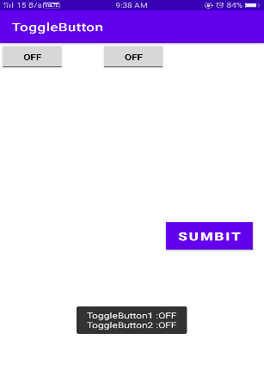

<?xml version="1.0" encoding="utf-8"?>
<LinearLayout xmlns:android="http://schemas.android.com/apk/res/android"
xmlns:app="http://schemas.android.com/apk/res-auto"
xmlns:tools="http://schemas.android.com/tools"
android:layout_width="match_parent"
android:layout_height="match_parent"
android:orientation="vertical"
tools:context=".MainActivity">

<ToggleButton
android:id="@+id/toggleButton1"
android:layout_width="wrap_content"
android:layout_height="wrap_content"
android:layout_gravity="center_horizontal"
android:checked="false"
android:drawablePadding="20dp"
android:text="ToggleButton"
android:textColor="#000" />

<ToggleButton
android:id="@+id/toggleButton2"
android:layout_width="wrap_content"
android:layout_height="wrap_content"
android:layout_gravity="center_horizontal"
android:layout_marginLeft="0dp"
android:checked="true"
android:drawablePadding="20dp"
android:text="ToggleButton"
android:textColor="@color/black" />

<Button
android:id="@+id/button"
android:layout_width="wrap_content"
android:layout_height="wrap_content"
android:layout_gravity="center"
android:layout_marginTop="50dp"
android:background="#0f0"
android:padding="10dp"
android:text="submit"
android:textColor="#fff"
android:textSize="20sp"
android:textStyle="bold" />

</LinearLayout>

Main_Activity.java_

package com.example.myapplication3;

import androidx.appcompat.app.AppCompatActivity;
import android.os.Bundle;
import android.view.Menu;
import android.view.MenuItem;
import android.view.View;
import android.widget.Button;
import android.widget.Toast;
import android.widget.ToggleButton;

import java.util.concurrent.RecursiveTask;

public class MainActivity extends AppCompatActivity {

ToggleButton simpleToggleButton1, simpleToggleButton2;
Button submit;

@Override
protected void onCreate(Bundle savedInstanceState) {
super.onCreate(savedInstanceState);
setContentView(R.layout.activity_main);

simpleToggleButton1 = (ToggleButton) findViewById(R.id.toggleButton1);
simpleToggleButton2 = (ToggleButton) findViewById(R.id.toggleButton2);
submit = (Button) findViewById(R.id.button);
submit.setOnClickListener(new View.OnClickListener() {
@Override
public void onClick(View view) {
String submit = "ToggleButton1 :" + simpleToggleButton1.getText() + "\n" + "ToggleButton2 :" + simpleToggleButton2.getText();
Toast.makeText(getApplicationContext(), submit, Toast.LENGTH_SHORT).show();
}
});
}
}
Output :-

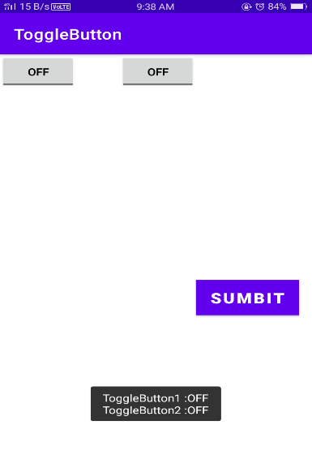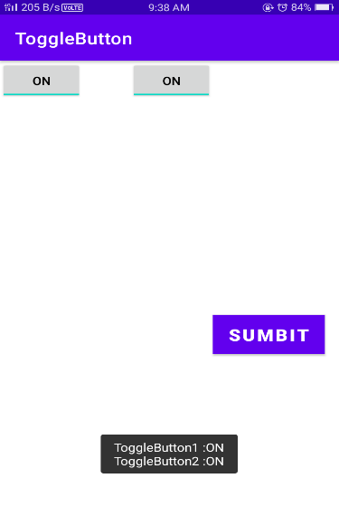

PART - B
- Create a screen that has input boxes for User Name, Password, Address, Gender (radio buttons for male and female), Age (numeric), Date of Birth (Date Picker), State (Spinner) and a Submit button. On clicking the submit button, print all the data below the Submit Button (use any layout)

Activitymain.xml.

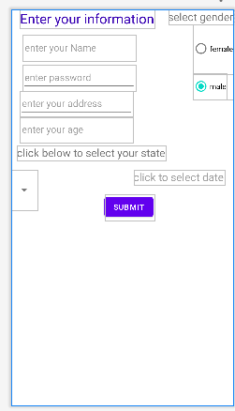

<?xml version="1.0" encoding="utf-8"?>
<androidx.constraintlayout.widget.ConstraintLayout xmlns:android="http://schemas.android.com/apk/res/android"
xmlns:app="http://schemas.android.com/apk/res-auto"
xmlns:tools="http://schemas.android.com/tools"
android:layout_width="match_parent"
android:layout_height="match_parent"
tools:context=".MainActivity"

android:outlineAmbientShadowColor="@color/teal_200">

<TextView
android:layout_width="wrap_content"
android:layout_height="wrap_content"
android:layout_marginStart="16dp"
android:text="Enter your information"
android:textColor="@color/purple_700"
android:textSize="25dp"
app:layout_constrainedHeight="true"
app:layout_constraintBottom_toTopOf="@+id/personname"
app:layout_constraintHorizontal_bias="0.098"

app:layout_constraintLeft_toLeftOf="parent"
app:layout_constraintRight_toRightOf="parent"
app:layout_constraintStart_toStartOf="parent"
app:layout_constraintTop_toTopOf="parent"
app:layout_constraintVertical_bias="0.0" />

<TextView
android:id="@+id/t"
android:layout_width="wrap_content"
android:layout_height="wrap_content"
android:text="select gender"
android:textSize="20dp"
app:layout_constraintBottom_toTopOf="@+id/radio"
app:layout_constraintEnd_toEndOf="parent"
app:layout_constraintHorizontal_bias="1.0"

app:layout_constraintStart_toStartOf="parent"
app:layout_constraintTop_toTopOf="parent" />

<RadioGroup
android:id="@+id/radio"
android:layout_width="wrap_content"
android:layout_height="wrap_content"
app:layout_constraintEnd_toEndOf="parent"
app:layout_constraintHorizontal_bias="1.0"
app:layout_constraintStart_toStartOf="parent"
app:layout_constraintTop_toBottomOf="@id/t">

<RadioButton
android:id="@+id/radio2"
android:layout_width="wrap_content"
android:layout_height="91dp"

android:text="female"
app:layout_constraintBottom_toBottomOf="parent"
app:layout_constraintEnd_toEndOf="parent"
app:layout_constraintHorizontal_bias="1.0"
app:layout_constraintStart_toStartOf="parent"
app:layout_constraintTop_toTopOf="parent"
app:layout_constraintVertical_bias="0.089" />

<RadioButton
android:id="@+id/radio1"
android:layout_width="wrap_content"
android:layout_height="wrap_content"
android:checked="true"
android:text="male"
app:layout_constraintBottom_toBottomOf="parent"
app:layout_constraintEnd_toEndOf="parent"
app:layout_constraintHorizontal_bias="1.0"
app:layout_constraintStart_toStartOf="parent"
app:layout_constraintTop_toTopOf="parent"
app:layout_constraintVertical_bias="0.013" />

</RadioGroup>

<Spinner
android:id="@+id/spinner1"
android:layout_width="wrap_content"
android:layout_height="wrap_content"
android:entries="@array/states"
android:minHeight="75dp"
app:layout_constraintBottom_toBottomOf="parent"
app:layout_constraintEnd_toEndOf="parent"
app:layout_constraintHorizontal_bias="0.0"
app:layout_constraintStart_toStartOf="parent"
app:layout_constraintTop_toTopOf="parent"
app:layout_constraintVertical_bias="0.451" />

<TextView
android:layout_width="wrap_content"
android:layout_height="wrap_content"
android:textSize="20dp"
android:text="click below to select your state"
app:layout_constraintBottom_toTopOf="@+id/spinner1"
app:layout_constraintHorizontal_bias="0.075"
app:layout_constraintLeft_toLeftOf="parent"
app:layout_constraintRight_toRightOf="parent"
app:layout_constraintTop_toBottomOf="@+id/age"
app:layout_constraintVertical_bias="0.237" />

<TextView
android:id="@+id/date"
android:layout_width="wrap_content"
android:layout_height="wrap_content"
android:hint="click to select date"
android:textColor="@android:color/darker_gray"
android:textSize="20sp"
android:title="this is your date"
app:layout_constraintBottom_toBottomOf="parent"
app:layout_constraintEnd_toEndOf="parent"
app:layout_constraintHorizontal_bias="0.93"
app:layout_constraintStart_toStartOf="parent"
app:layout_constraintTop_toTopOf="parent"
app:layout_constraintVertical_bias="0.42" />

<Button
android:id="@+id/submit"
android:layout_width="wrap_content"
android:layout_height="wrap_content"
android:text="submit"
app:layout_constraintBottom_toBottomOf="parent"
app:layout_constraintEnd_toEndOf="parent"
app:layout_constraintHorizontal_bias="0.538"
app:layout_constraintStart_toStartOf="parent"
app:layout_constraintTop_toTopOf="parent"
app:layout_constraintVertical_bias="0.499" />

<EditText
android:id="@+id/password"
android:layout_width="wrap_content"
android:layout_height="wrap_content"
android:layout_marginStart="16dp"
android:ems="10"
android:hint="enter password"
android:inputType="textPassword"
android:minHeight="48dp"
app:layout_constraintBottom_toBottomOf="parent"
app:layout_constraintEnd_toEndOf="parent"
app:layout_constraintHorizontal_bias="0.027"
app:layout_constraintStart_toStartOf="parent"
app:layout_constraintTop_toTopOf="parent"
app:layout_constraintVertical_bias="0.149" />

<EditText
android:id="@+id/address"
android:layout_width="wrap_content"
android:layout_height="wrap_content"
android:layout_marginStart="16dp"
android:ems="10"
android:hint="enter your address"
android:inputType="textPostalAddress"
android:minHeight="48dp"
app:layout_constraintBottom_toBottomOf="parent"
app:layout_constraintEnd_toEndOf="parent"
app:layout_constraintHorizontal_bias="0.0"
app:layout_constraintStart_toStartOf="parent"
app:layout_constraintTop_toTopOf="parent"
app:layout_constraintVertical_bias="0.219" />

<EditText
android:id="@+id/personname"
android:layout_width="wrap_content"
android:layout_height="wrap_content"
android:layout_marginTop="40dp"
android:ems="10"
android:hint="enter your Name"
android:inputType="textPersonName"
android:minHeight="48dp"
app:layout_constraintBottom_toTopOf="@+id/password"

app:layout_constraintEnd_toEndOf="parent"
app:layout_constraintEnd_toStartOf="@+id/radio"
app:layout_constraintHorizontal_bias="0.169"
app:layout_constraintLeft_toLeftOf="parent"
app:layout_constraintStart_toStartOf="parent"
app:layout_constraintTop_toTopOf="parent" />

<EditText
android:id="@+id/age"

android:layout_width="wrap_content"
android:layout_height="wrap_content"
android:layout_marginStart="16dp"
android:ems="10"
android:hint="enter your age"
android:inputType="number"
android:minHeight="48dp"
app:layout_constraintBottom_toBottomOf="parent"
app:layout_constraintEnd_toEndOf="parent"
app:layout_constraintHorizontal_bias="0.0"
app:layout_constraintStart_toStartOf="parent"
app:layout_constraintTop_toBottomOf="@+id/address"
app:layout_constraintVertical_bias="0.0"
tools:ignore="SpeakableTextPresentCheck" />

<TextView
android:id="@+id/t2"
android:layout_width="wrap_content"
android:layout_height="wrap_content"
android:layout_marginTop="8dp"
android:layout_marginBottom="8dp"
android:text=""
android:textColor="@android:color/black"
android:textSize="25sp"
app:layout_constraintBottom_toBottomOf="parent"

app:layout_constraintEnd_toEndOf="parent"

app:layout_constraintTop_toTopOf="parent"
app:layout_constraintVertical_bias="0.732" />

</androidx.constraintlayout.widget.ConstraintLayout>

Main_Activity.java

package com.codingflow.radioandspinner;

import androidx.appcompat.app.AppCompatActivity;

import android.app.DatePickerDialog;
import android.graphics.Color;
import android.graphics.drawable.ColorDrawable;
import android.os.Bundle;
import android.util.Log;
import android.view.View;
import android.widget.AdapterView;
import android.widget.ArrayAdapter;
import android.widget.Button;
import android.widget.DatePicker;
import android.widget.EditText;
import android.widget.RadioButton;
import android.widget.RadioGroup;
import android.widget.Spinner;
import android.widget.TextView;
import android.widget.Toast;

import java.util.Calendar;

public class MainActivity extends AppCompatActivity implements AdapterView.OnItemSelectedListener {
String text,date,name1,address1,password1;
int age1;
RadioGroup radioGroup;
RadioButton radioButton;
Button button;
TextView textView5,textView8;
EditText name,address,age,password;

private static final String TAG = "MainActivity";

private TextView mDisplayDate;
private DatePickerDialog.OnDateSetListener mDateSetListener;

@Override
protected void onCreate(Bundle savedInstanceState) {
super.onCreate(savedInstanceState);
setContentView(R.layout.activity_main);
name=findViewById(R.id.personname);
age=findViewById(R.id.age);
address=findViewById(R.id.address);
password=findViewById(R.id.password);

Spinner spinner=findViewById(R.id.spinner1);

radioGroup=findViewById(R.id.radio);
textView8=findViewById(R.id.date);
textView5=findViewById(R.id.t2);
button=findViewById(R.id.submit);

button.setOnClickListener(new View.OnClickListener() {
@Override
public void onClick(View v) {
int radioid=radioGroup.getCheckedRadioButtonId();
radioButton=findViewById(radioid);
name1=name.getText().toString();
password1=password.getText().toString();
address1=address.getText().toString();
age1= (Integer.valueOf(age.getText().toString()));

textView5.setText(new StringBuilder().append("\nname is :").append(name1).append(" \naddress :").append(address1).append("\nage :").append(age1).append("\npassword is :").append(password1).append("\ndate entered :").append(date).append("\ngender is :").append(radioButton.getText()).append("\nstate belonging : ").append(text));

}});

mDisplayDate = (TextView) findViewById(R.id.date);
mDisplayDate.setOnClickListener(new View.OnClickListener() {
@Override
public void onClick(View view) {
Calendar cal = Calendar.getInstance();
int year = cal.get(Calendar.YEAR);
int month = cal.get(Calendar.MONTH);
int day = cal.get(Calendar.DAY_OF_MONTH);

DatePickerDialog dialog = new DatePickerDialog(
MainActivity.this,
android.R.style.Theme_Holo_Light_Dialog_MinWidth,
mDateSetListener,
year,month,day);
dialog.getWindow().setBackgroundDrawable(new ColorDrawable(Color.TRANSPARENT));
dialog.show();
}
});
mDateSetListener = new DatePickerDialog.OnDateSetListener() {
@Override
public void onDateSet(DatePicker datePicker, int year, int month, int day) {
month = month + 1;
Log.d(TAG, "onDateSet: mm/dd/yyy: " + month + "/" + day + "/" + year);

date = month + "/" + day + "/" + year;
// textView8.setText("date is:"+date);

}
};

ArrayAdapter<CharSequence >adapter=ArrayAdapter.createFromResource(this,R.array.states, android.R.layout.simple_spinner_item );
adapter.setDropDownViewResource(android.R.layout.simple_spinner_dropdown_item);
spinner.setAdapter(adapter);
spinner.setOnItemSelectedListener(this);

}

@Override
public void onItemSelected(AdapterView<?> parent, View view, int position, long id) {
text=parent.getSelectedItem().toString();
// Toast.makeText(this,"text",Toast.LENGTH_SHORT).show();

}

@Override
public void onNothingSelected(AdapterView<?> parent) {

}
}

Paste under strings.xml

<resources>
<string name="app_name">spinner</string>
<string-array name="states">
<item>karnataka</item>
<item>kerla</item>
<item>delhi</item>
<item>andra</item>
</string-array>
</resources>

Output :-

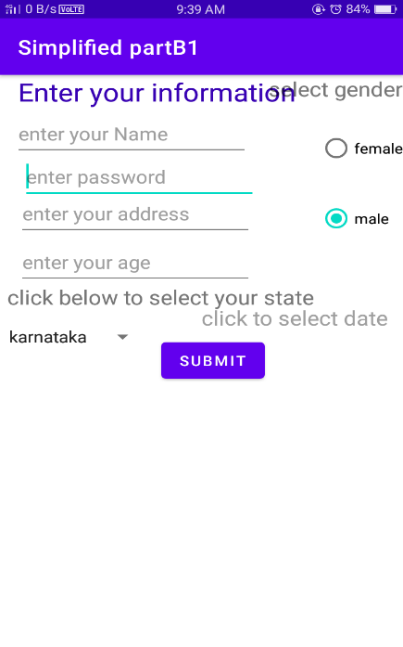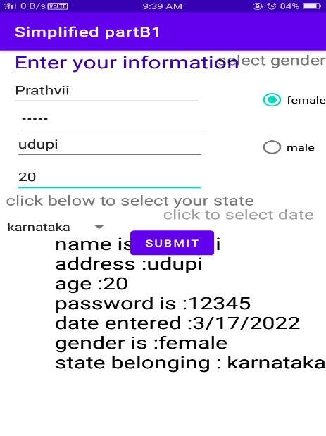

2. Create an Android application to display images in Grid View (min 5 images).

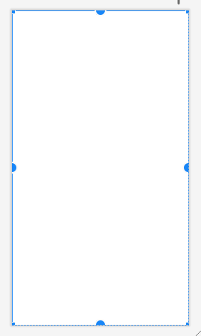
Activity-main xml

<?xml version="1.0" encoding="utf-8" ?>
<androidx.constraintlayout.widget.ConstraintLayout
xmlns:android="http://schemas.android.com/apk/res/android"
xmlns:app="http://schemas.android.com/apk/res-auto"
xmlns:tools="http://schemas.android.com/tools"
android:layout_width="match_parent"
android:layout_height="match_parent"
tools:context=".MainActivity">
<GridView
android:id="@+id/grid_view"
android:layout_width="match_parent"
android:layout_height="match_parent"
android:numColumns="1"
app:layout_constraintBottom_toBottomOf="parent"
app:layout_constraintEnd_toEndOf="parent"
app:layout_constraintHorizontal_bias="0.498"
app:layout_constraintStart_toStartOf="parent"
app:layout_constraintTop_toTopOf="parent"
app:layout_constraintVertical_bias="0.0" />
</androidx.constraintlayout.widget.ConstraintLayout>

Main-activity.java

package com.example.gridview;
import androidx.appcompat.app.AppCompatActivity;
import android.os.Bundle;
import android.widget.GridView;
import android.widget.ListAdapter;
public class MainActivity extends AppCompatActivity {
GridView gridView;
@Override
protected void onCreate(Bundle savedInstanceState) {
super.onCreate(savedInstanceState);
setContentView(R.layout.activity_main);
gridView=(GridView) findViewById(R.id.grid_view);
gridView.setAdapter(new image(this));
}
}

Imageadapter.java

package com.example.gridview;
import android.content.Context;
import android.view.View;
import android.view.ViewGroup;
import android.widget.BaseAdapter;
//import android.widget.GridView;
import android.widget.ImageView;
import com.example.gridview.R;
class image extends BaseAdapter {
private Context mContext;
public int[] image={
R.drawable.cat,R.drawable.dog, R.drawable.birds, R.drawable.chicken, R.drawable.rose
};
public image (Context mContext ) { this.mContext = mContext; }
//public myapplication5(Context mContext) {this.mContext=mContext; }
@Override
public int getCount() { return image.length; }
@Override
public Object getItem(int position) { return null; }
@Override
public long getItemId(int position) { return image[position]; }
@Override
public View getView(int position, View ConvertView, ViewGroup parent) {
ImageView imageView=new ImageView(mContext);
imageView.setImageResource(image[position]);
imageView.setScaleType(ImageView.ScaleType.CENTER_CROP);
imageView.setLayoutParams(new ViewGroup.LayoutParams(200, 100));
return imageView;
}
}
Output :-
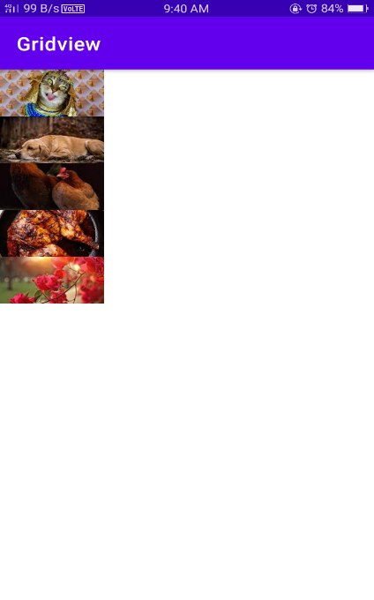

3. . Write an android program to demonstrate a Menu with name File with New, 4. Open, Save and Save As as menu items. Give toast msgs on click of each menu item.

Activity_main.XML
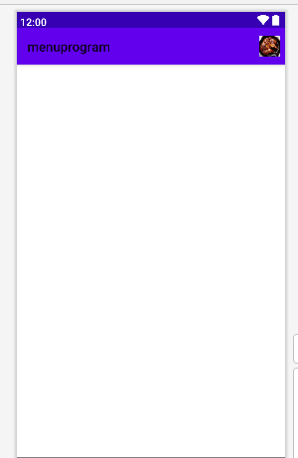

<?xml version="1.0" encoding="utf-8"?>
<menu xmlns:android="http://schemas.android.com/apk/res/android"
xmlns:app="http://schemas.android.com/apk/res-auto">
xmlns:app="http://schemas.android.com/apk/res-auto">
<item android:id="@+id/item1"
android:icon="@drawable/chicken"
android:title=""
app:showAsAction="ifRoom">
<menu>
<item android:id="@id/item2"
app:layout_constraintHorizontal_bias="1.0"
android:title="open"
app:showAsAction="collapseActionView" />
<item android:id="@id/item3"
app:layout_constraintHorizontal_bias="1.0"
android:title="save"
app:showAsAction="collapseActionView" />
<item android:id="@id/item4"
app:layout_constraintHorizontal_bias="1.0"
android:title="save as"
app:showAsAction="collapseActionView" />
</menu>
</item>
</menu>

(paste it under mainactivity.java)

package com.codingflow.filemenu;

import androidx.annotation.NonNull;
import androidx.appcompat.app.AppCompatActivity;

import android.view.Menu;
import android.view.MenuInflater;
import android.view.MenuItem;
import android.widget.Toast;

public class MainActivity extends AppCompatActivity {

@Override
public boolean onCreateOptionsMenu(Menu menu){
MenuInflater inflater=getMenuInflater();
inflater.inflate(R.menu.file,menu);
return true;
}

@Override
public boolean onOptionsItemSelected(@NonNull MenuItem item) {
switch (item.getItemId()) {
case R.id.item2:
Toast.makeText(this, "you clicked open", Toast.LENGTH_LONG).show();
break;
case R.id.item3:
Toast.makeText(this, "you clicked save", Toast.LENGTH_LONG).show();
break;
case R.id.item4:
Toast.makeText(this, "you clicked save as", Toast.LENGTH_LONG).show();
}
return super.onOptionsItemSelected(item);
}
}

File.xml

(NOTE :- paste it under resource folder with file.xml name by right clicking on menu resource folder and choose new->menu resource file)

<?xml version="1.0" encoding="utf-8"?>
<menu xmlns:android="http://schemas.android.com/apk/res/android"
xmlns:app="http://schemas.android.com/apk/res-auto">
<item android:id="@+id/item1"
android:icon="@drawable/file"

android:title=""
app:showAsAction="ifRoom">
<menu>
<item android:id="@id/item2"
app:layout_constraintHorizontal_bias="1.0"
android:title="open"
app:showAsAction="collapseActionView" />
<item android:id="@id/item3"
app:layout_constraintHorizontal_bias="1.0"
android:title="save"
app:showAsAction="collapseActionView" />
<item android:id="@id/item4"
app:layout_constraintHorizontal_bias="1.0"
android:title="save as"
app:showAsAction="collapseActionView" />
</menu>
</item>

</menu>

Output :-
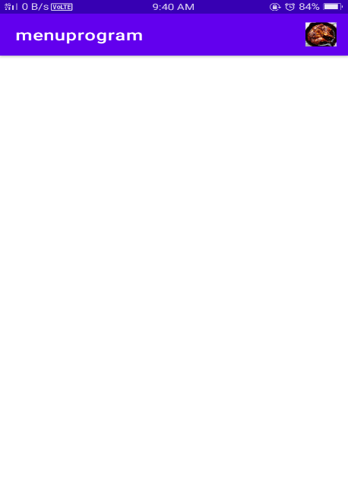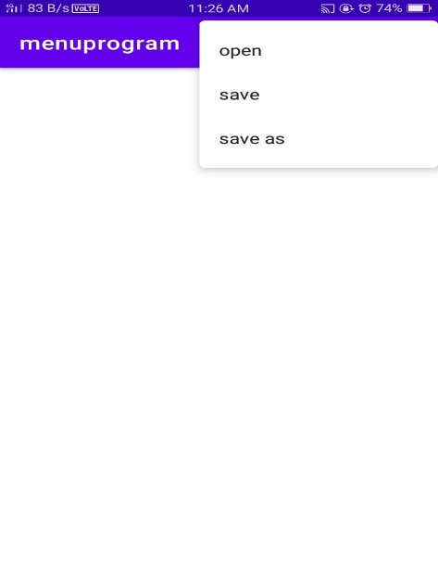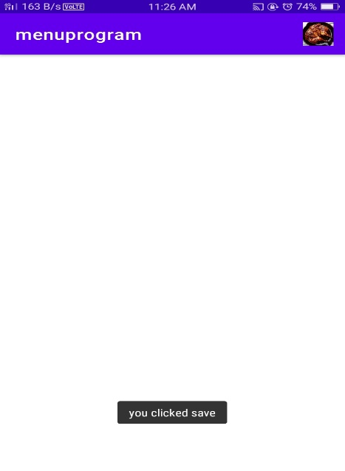

4. Create an Android application to play audio using Service.

Activity main xml

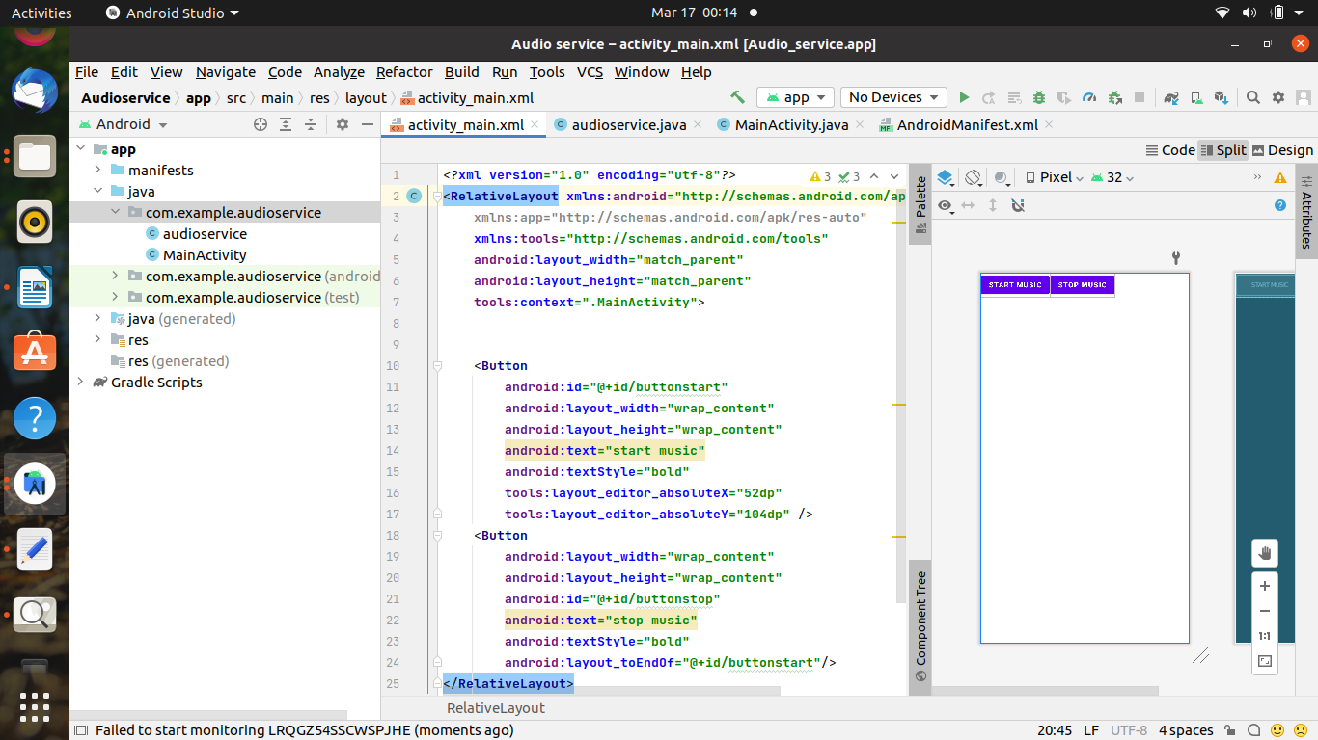

<?xml version="1.0" encoding="utf-8"?>
<RelativeLayout xmlns:android="http://schemas.android.com/apk/res/android"
xmlns:app="http://schemas.android.com/apk/res-auto"
xmlns:tools="http://schemas.android.com/tools"
android:layout_width="match_parent"
android:layout_height="match_parent"
tools:context=".MainActivity">
<Button
android:id="@+id/buttonstart"
android:layout_width="wrap_content"
android:layout_height="wrap_content"
android:text="start music"
android:textStyle="bold"
tools:layout_editor_absoluteX="52dp"
tools:layout_editor_absoluteY="104dp" />
<Button
android:layout_width="wrap_content"
android:layout_height="wrap_content"
android:id="@+id/buttonstop"
android:text="stop music"
android:textStyle="bold"
android:layout_toEndOf="@+id/buttonstart"/>
</RelativeLayout>

(paste under mainactivity.java)

package com.codingflow.audioplayer;

import android.content.Intent;
import android.media.MediaPlayer;
import android.provider.Settings;
import androidx.appcompat.app.AppCompatActivity;
import android.os.Bundle;
import android.view.View;
import android.widget.Button;

public class MainActivity extends AppCompatActivity implements View.OnClickListener {

//button objects
private Button buttonStart;
private Button buttonStop;

@Override
protected void onCreate(Bundle savedInstanceState) {
super.onCreate(savedInstanceState);
setContentView(R.layout.activity_main);

//getting buttons from xml
buttonStart = (Button) findViewById(R.id.buttonStart);
buttonStop = (Button) findViewById(R.id.buttonStop);

//attaching onclicklistener to buttons
buttonStart.setOnClickListener(this);
buttonStop.setOnClickListener(this);
}

@Override
public void onClick(View view) {
if (view == buttonStart) {
//starting service
startService(new Intent(this, audioservice.class));
} else if (view == buttonStop) {
//stopping service
stopService(new Intent(this, audioservice.class));
}
}
}

audioservice.java
(NOTE :- create by right clicking on com.codingflow.audioplayer)

package com.codingflow.audioplayer;

import android.app.Service;
import android.content.Intent;
import android.media.MediaPlayer;
import android.os.IBinder;
import android.provider.Settings;
import org.jetbrains.annotations.Nullable;

public class audioservice extends Service {
//creating a mediaplayer object
private MediaPlayer player;

@Nullable
@Override
public IBinder onBind(Intent intent) {
return null;
}

@Override
public int onStartCommand(Intent intent, int flags, int startId) {
//getting systems default ringtone
player = MediaPlayer.create(this,
Settings.System.DEFAULT_RINGTONE_URI);
//setting loop play to true
//this will make the ringtone continuously playing
player.setLooping(true);

//staring the player
player.start();

//we have some options for service
//start sticky means service will be explicity started and stopped
return START_STICKY;
}

@Override
public void onDestroy() {
super.onDestroy();

player.stop();
}
}

android manifest.xml :-

<?xml version="1.0" encoding="utf-8"?>
<manifest xmlns:android="http://schemas.android.com/apk/res/android"
package="com.codingflow.audioplayer">

<application
android:allowBackup="true"
android:icon="@mipmap/ic_launcher"
android:label="@string/app_name"
android:roundIcon="@mipmap/ic_launcher_round"
android:supportsRtl="true"
android:theme="@style/Theme.Audioplayer">
<activity
android:name=".MainActivity"
android:exported="true">
<intent-filter>
<action android:name="android.intent.action.MAIN" />

<category android:name="android.intent.category.LAUNCHER" />
</intent-filter>
</activity>
<service android:name=".audioservice" />
</application>

</manifest>

Output :-

PART-C

- Create an Android application to implement the functioning of Simple calculator

Activity_main.xml

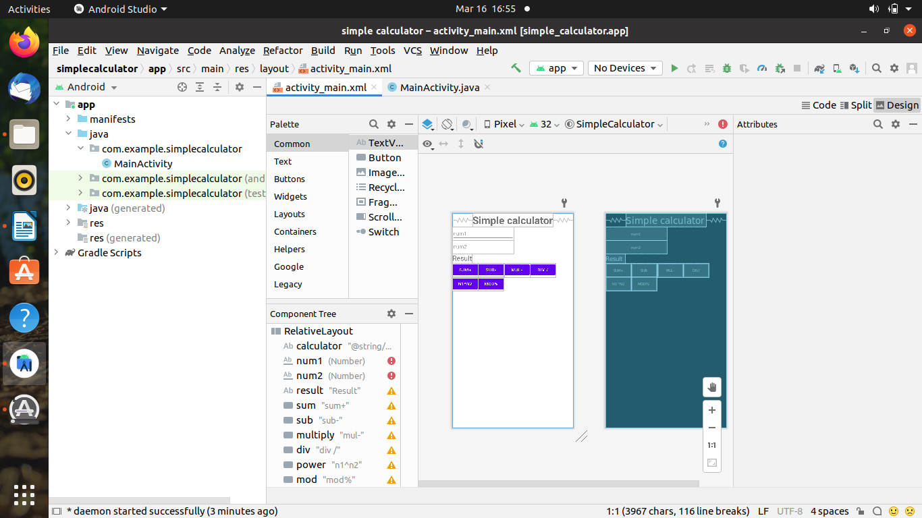

<?xml version="1.0" encoding="utf-8"?>
<RelativeLayout xmlns:android="http://schemas.android.com/apk/res/android"
xmlns:app="http://schemas.android.com/apk/res-auto"
xmlns:tools="http://schemas.android.com/tools"
android:layout_width="match_parent"
android:layout_height="match_parent"
tools:context=".MainActivity">
<TextView
android:id="@+id/calculator"
android:layout_width="wrap_content"
android:layout_height="wrap_content"
android:layout_centerHorizontal="true"
android:text="@string/simple_calculator"
android:textSize="35sp"
android:textStyle="bold"
tools:layout_editor_absoluteX="141dp"
tools:layout_editor_absoluteY="82dp" />
<EditText
android:id="@+id/num1"
android:layout_width="wrap_content"
android:layout_height="wrap_content"
android:ems="10"
android:inputType="number"
android:hint="num1"
android:layout_below="@+id/calculator"
tools:layout_editor_absoluteX="34dp"
tools:layout_editor_absoluteY="192dp" />
<EditText
android:id="@+id/num2"
android:layout_width="wrap_content"
android:layout_height="wrap_content"
android:ems="10"
android:inputType="number"
android:layout_below="@+id/num1"
android:hint="num2"
tools:layout_editor_absoluteX="35dp"
tools:layout_editor_absoluteY="262dp" />
<TextView
android:id="@+id/result"
android:layout_width="wrap_content"
android:layout_height="wrap_content"
android:text="Result"
android:textSize="24sp"
android:layout_below="@id/num2"
tools:layout_editor_absoluteX="42dp"
tools:layout_editor_absoluteY="330dp" />
<Button
android:id="@+id/sum"
android:layout_width="wrap_content"
android:layout_height="wrap_content"
android:text="sum+"
android:onClick="doSum"
android:layout_below="@id/result"
tools:layout_editor_absoluteX="34dp"
tools:layout_editor_absoluteY="381dp" />
<Button
android:id="@+id/sub"
android:layout_width="wrap_content"
android:layout_height="wrap_content"
android:text="sub-"
android:onClick="dosub"
android:layout_below="@+id/result"
android:layout_toRightOf="@+id/sum"
tools:layout_editor_absoluteX="155dp"
tools:layout_editor_absoluteY="378dp" />
<Button
android:id="@+id/multiply"
android:layout_width="wrap_content"
android:layout_height="wrap_content"
android:text="mul-"
android:onClick="doMul"
android:layout_toRightOf="@id/sub"
android:layout_below="@id/result"
tools:layout_editor_absoluteX="277dp"
tools:layout_editor_absoluteY="376dp" />
<Button
android:id="@+id/div"
android:layout_width="wrap_content"
android:layout_height="wrap_content"
android:text="div /"
android:onClick="doDiv"
android:layout_toRightOf="@+id/multiply"
android:layout_below="@+id/result"
tools:layout_editor_absoluteX="34dp"
tools:layout_editor_absoluteY="470dp" />
<Button
android:id="@+id/power"
android:layout_width="wrap_content"
android:layout_height="wrap_content"
android:text="n1^n2"
android:layout_below="@id/sum"
android:onClick="doPow"
tools:layout_editor_absoluteX="141dp"
tools:layout_editor_absoluteY="470dp" />
<Button
android:id="@+id/mod"
android:layout_width="wrap_content"
android:layout_height="wrap_content"
android:text="mod%"
android:layout_toRightOf="@+id/power"
android:layout_below="@+id/sub"
android:onClick="doMod"
tools:layout_editor_absoluteX="263dp"
tools:layout_editor_absoluteY="470dp" />
</RelativeLayout>

MainActivity.java

package com.example.simplecalculator;
import androidx.appcompat.app.AppCompatActivity;
import android.os.Bundle;
import android.view.View;
import android.widget.Button;
import android.widget.EditText;
import android.widget.TextView;
public class MainActivity extends AppCompatActivity {
EditText e1, e2;
TextView t1;
int num1, num2;
@Override
protected void onCreate(Bundle savedInstanceState) {
super.onCreate(savedInstanceState);
setContentView(R.layout.activity_main);
}
public boolean getNumbers() {
e1 = (EditText) findViewById(R.id.num1);
e2 = (EditText) findViewById(R.id.num2);
t1 = (TextView) findViewById(R.id.result);
String s1 = e1.getText().toString();
String s2 = e2.getText().toString();
if ((s1.equals(null) && s2.equals(null)) || (s1.equals("") && s2.equals(""))) {
String result = "Please enter a value";
t1.setText(result);
return false;
} else {
num1 = Integer.parseInt(s1);
num2 = Integer.parseInt(s2);
}
return true;
}
public void doSum(View v){
if(getNumbers()){
int sum= num1 + num2;
t1.setText(Integer.toString(sum));
}
}
public void doPow(View v){
if (getNumbers()){
double sum=Math.pow(num1, num2);
t1.setText(Double.toString(sum));
}
}
public void dosub(View v){
if(getNumbers()){
int sum=num1-num2;
t1.setText(Integer.toString(sum));
}
}
public void doMul(View v){
if(getNumbers()){
int sum=num1*num2;
t1.setText(Integer.toString(sum));
}
}
public void doDiv(View v){
if(getNumbers()){
double sum=num1/(num2 * 1.0);
t1.setText(Double.toString(sum));
}
}
public void doMod(View v){
if (getNumbers()) {
double sum=num1%num2;
t1.setText(Double.toString(sum));
}
}
}

Output :-
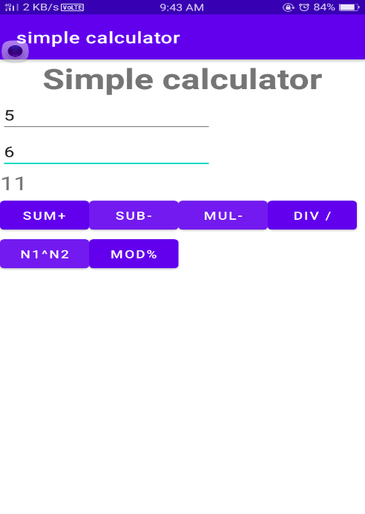

2. Create a menu driven Android application to store data of employees (ID, Name, Salary, Designation) in SQLite database and display all stored records.

activity-main.xml
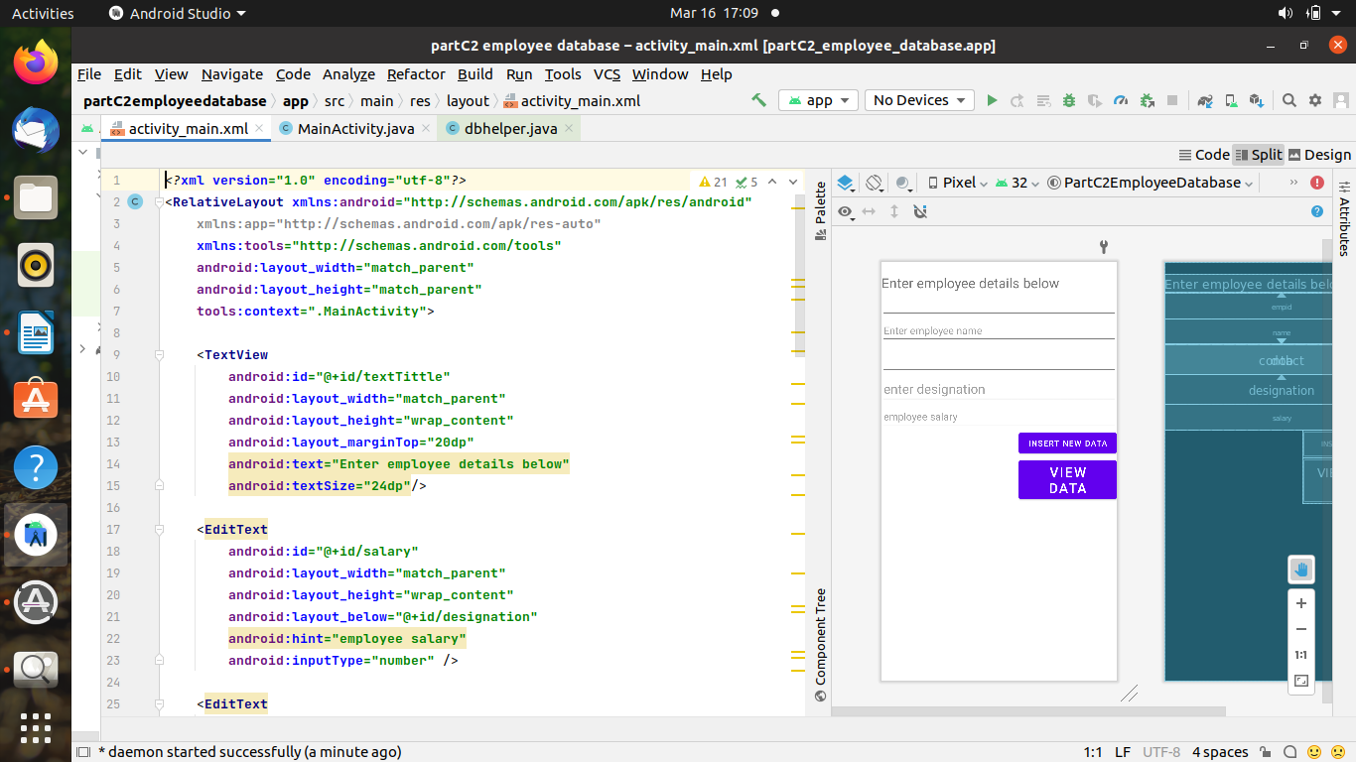

<?xml version="1.0" encoding="utf-8"?>
<RelativeLayout xmlns:android="http://schemas.android.com/apk/res/android"
xmlns:tools="http://schemas.android.com/tools"
android:layout_width="match_parent"
android:layout_height="match_parent"
android:alwaysDrawnWithCache="false"
android:animateLayoutChanges="true"
android:background="#CDDC39"
android:backgroundTint="#03A9F4"
android:padding="10dp"
tools:context=".MainActivity">

<TextView
android:id="@+id/texttitle"
android:layout_width="match_parent"
android:layout_height="wrap_content"
android:layout_marginTop="20dp"
android:text=" enter Employee details below"

android:textColor="@android:color/holo_red_dark"
android:textSize="24dp" />

<EditText
android:id="@+id/salary"
android:layout_width="match_parent"
android:layout_height="wrap_content"
android:layout_below="@+id/designation"
android:hint="employee salary"
android:inputType="number"
android:textColor="@android:color/holo_orange_dark"
android:textSize="24dp" />

<EditText
android:id="@+id/designation"
android:layout_width="match_parent"
android:layout_height="wrap_content"
android:layout_below="@+id/dob"
android:hint="enter designation of employee"
android:inputType="text"
android:textColor="@android:color/holo_orange_dark"
android:textSize="24dp" />

<EditText
android:id="@+id/name"
android:layout_width="match_parent"
android:layout_height="wrap_content"
android:layout_below="@+id/texttitle"
android:hint="enter Name"
android:inputType="textPersonName"
android:textSize="24dp" />

<EditText
android:id="@+id/contact"
android:layout_width="match_parent"
android:layout_height="wrap_content"
android:layout_below="@+id/name"
android:hint="Contact"
android:inputType="number"
android:textSize="24dp" />

<EditText
android:id="@+id/dob"
android:layout_width="match_parent"
android:layout_height="wrap_content"
android:layout_below="@+id/contact"
android:hint="Date of Birth"
android:inputType="date"
android:textSize="24dp" />

<Button
android:id="@+id/btnInsert"
android:layout_width="match_parent"
android:layout_height="wrap_content"
android:layout_below="@id/salary"
android:layout_marginTop="50dp"
android:text="Insert New Data"
android:textSize="24dp" />

<Button
android:id="@+id/btnView"
android:layout_width="match_parent"
android:layout_height="wrap_content"
android:layout_below="@id/btnInsert"
android:text="View Data"
android:textSize="24dp" />
</RelativeLayout>

Main Activity.java

package com.codingflow.employee_information_updated;

import androidx.appcompat.app.AlertDialog;
import androidx.appcompat.app.AppCompatActivity;

import android.app.DatePickerDialog;
import android.database.Cursor;
import android.graphics.Color;
import android.graphics.drawable.ColorDrawable;
import android.graphics.fonts.Font;
import android.os.Bundle;
import android.text.TextShaper;
import android.util.Log;
import android.view.View;
import android.widget.Button;
import android.widget.DatePicker;
import android.widget.EditText;
import android.widget.TextView;
import android.widget.Toast;

import org.w3c.dom.Text;

import java.util.Calendar;

public class MainActivity extends AppCompatActivity {
EditText name, contact, dob,salary,desig;
Button insert,view;
dbhelper DB;
String date;

private static final String TAG = "MainActivity";

EditText mDisplayDate;
private DatePickerDialog.OnDateSetListener mDateSetListener;

@Override
protected void onCreate(Bundle savedInstanceState) {
super.onCreate(savedInstanceState);
setContentView(R.layout.activity_main);

name = findViewById(R.id.name);
contact = findViewById(R.id.contact);
// dob = findViewById(R.id.dob);
insert = findViewById(R.id.btnInsert);
salary=findViewById(R.id.salary);
desig=findViewById(R.id.designation);
view = findViewById(R.id.btnView);

mDisplayDate = findViewById(R.id.dob);

mDisplayDate.setOnClickListener(new View.OnClickListener() {
@Override
public void onClick(View view) {
Calendar cal = Calendar.getInstance();
int year = cal.get(Calendar.YEAR);
int month = cal.get(Calendar.MONTH);
int day = cal.get(Calendar.DAY_OF_MONTH);

DatePickerDialog dialog = new DatePickerDialog(
MainActivity.this,
android.R.style.Theme_Holo_Light_Dialog_MinWidth,
mDateSetListener,
year,month,day);
dialog.getWindow().setBackgroundDrawable(new ColorDrawable(Color.MAGENTA));
dialog.show();
}
});
mDateSetListener = new DatePickerDialog.OnDateSetListener() {
@Override
public void onDateSet(DatePicker datePicker, int year, int month, int day) {
month = month + 1;
Log.d(TAG, "onDateSet: mm/dd/yyy: " + month + "/" + day + "/" + year);

date = month + "/" + day + "/" + year;
mDisplayDate.setText(date);
}
};

DB = new dbhelper(this);
insert.setOnClickListener(new View.OnClickListener() {
@Override
public void onClick(View view) {
String nameTXT = name.getText().toString();
String contactTXT = contact.getText().toString();
String dobTXT = date;

String sal=salary.getText().toString();

String designation=desig.getText().toString();

Boolean checkinsertdata = DB.insertuserdata(nameTXT, contactTXT, dobTXT,sal,designation);
if(checkinsertdata)
Toast.makeText(MainActivity.this, "New Entry Inserted", Toast.LENGTH_SHORT).show();
else
Toast.makeText(MainActivity.this, "New Entry Not Inserted", Toast.LENGTH_SHORT).show();
} });

view.setOnClickListener(view -> {
Cursor res = DB.getdata();
int count=1;
if(res.getCount()==0){
Toast.makeText(MainActivity.this, "No Entry Exists", Toast.LENGTH_SHORT).show();
return;
}
StringBuffer buffer = new StringBuffer();
while(res.moveToNext())
{

buffer.append("EMPLOYEE "+count++).append("\n");
buffer.append("Name :"+res.getString(0)+"\n");
buffer.append("Contact :"+res.getString(1)+"\n");
buffer.append("Date of Birth :"+res.getString(2)+"\n");
buffer.append("salary of the employee").append(res.getString(3)).append("\n");
buffer.append("designation of the employee"+res.getString(4)+"\n\n");
}

AlertDialog.Builder builder = new AlertDialog.Builder(MainActivity.this);
builder.setCancelable(true);
builder.setTitle("Employee information");
builder.setMessage(buffer.toString());
builder.show();
});
}}

DBHELPER.JAVA
(NOTE :-create a class dbhelper.java by right clicking on your package statement)

package com.codingflow.employee_information_updated;

import android.content.ContentValues;
import android.content.Context;
import android.database.Cursor;
import android.database.sqlite.SQLiteDatabase;
import android.database.sqlite.SQLiteOpenHelper;

class dbhelper extends SQLiteOpenHelper {
public dbhelper(Context context) {
super(context, "Employeedetails.db", null, 1);
}

@Override
public void onCreate(SQLiteDatabase DB) {
DB.execSQL("create Table Employeedetails(name TEXT primary key, contact TEXT, dob TEXT,sal TEXT,designation TEXT)");
}

@Override
public void onUpgrade(SQLiteDatabase DB, int i, int i1) {
DB.execSQL("drop Table if exists Employeedetails");
}

public Boolean insertuserdata(String name, String contact, String dob,String sal,String designation) {
SQLiteDatabase DB = this.getWritableDatabase();
ContentValues contentValues = new ContentValues();
contentValues.put("name", name);
contentValues.put("contact", contact);
contentValues.put("dob", dob);
contentValues.put("sal",sal);
contentValues.put("designation",designation);
long result = DB.insert("Employeedetails", null, contentValues);
if (result == -1) {
return false;
} else {
return true;
}
}

public Cursor getdata() {
SQLiteDatabase DB = this.getWritableDatabase();
Cursor cursor = DB.rawQuery("Select * from Employeedetails", null);
return cursor;

}
}

Output :-

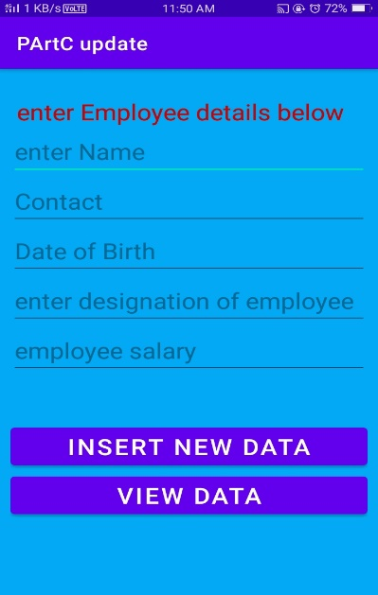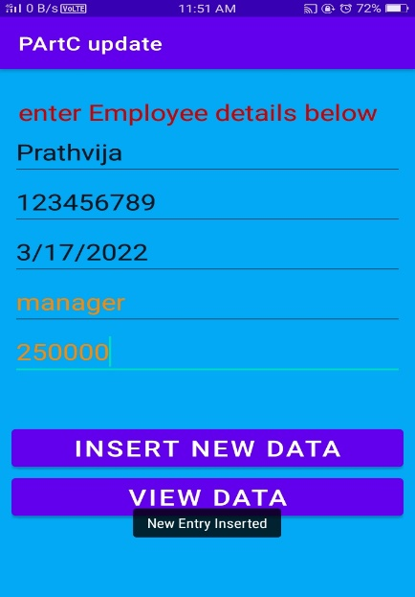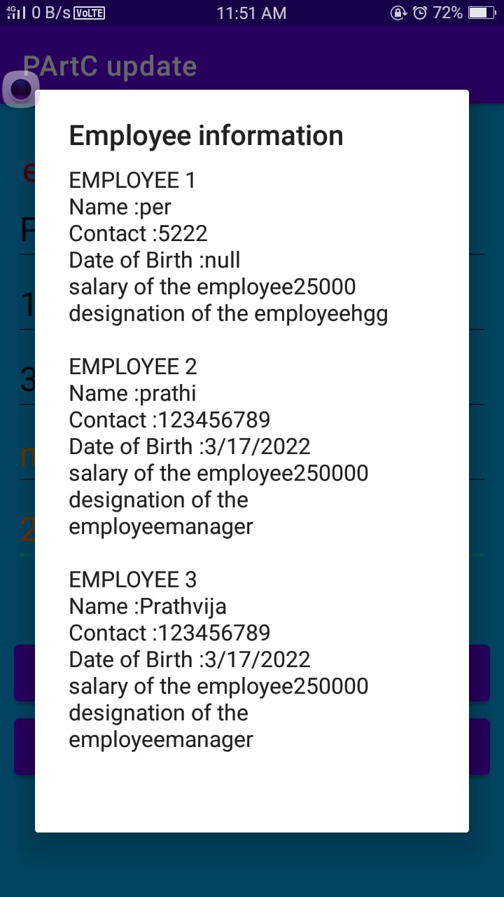

3.Create an Android application to view Book details (Title, Author, Publisher and Price) stored in a file on a ListView in Android

Activity-main.xml
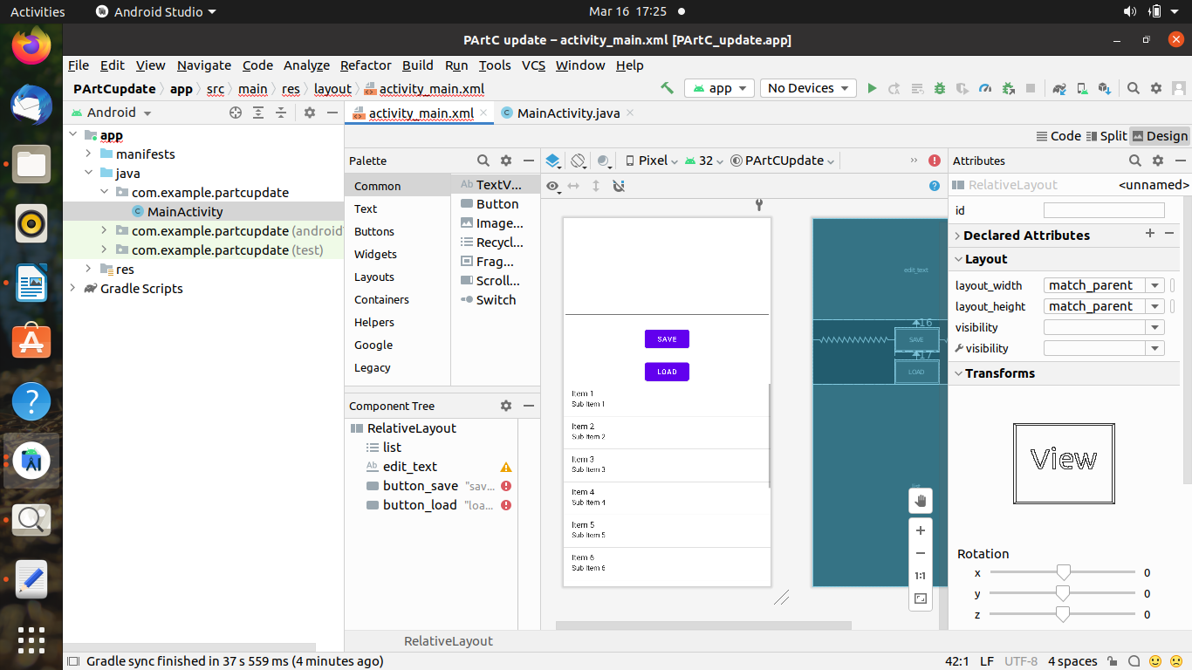

<?xml version="1.0" encoding="utf-8"?>
<RelativeLayout xmlns:android="http://schemas.android.com/apk/res/android"
xmlns:app="http://schemas.android.com/apk/res-auto"
xmlns:tools="http://schemas.android.com/tools"
android:layout_width="match_parent"
android:layout_height="match_parent"
tools:context=".MainActivity">

<ListView
android:id="@+id/list"
android:layout_width="wrap_content"
android:layout_height="wrap_content"
android:scrollingCache="true"
android:smoothScrollbar="true"
android:stretchMode="columnWidth"
android:layout_below="@+id/button_load">

</ListView>
<Button
android:id="@+id/button_load"
android:layout_width="wrap_content"
android:layout_height="wrap_content"
android:layout_marginLeft="130dp"
android:layout_marginTop="200dp"
android:onClick="load"
android:text="show_book_detail" />

</RelativeLayout>

MAIN_ACTIVITY.JAVA

import androidx.appcompat.app.AppCompatActivity;

import android.os.Bundle;
import android.view.View;
import android.widget.ArrayAdapter;
import android.widget.EditText;
import android.widget.ListView;
import android.widget.Toast;

import java.io.BufferedReader;
import java.io.FileInputStream;
import java.io.FileNotFoundException;
import java.io.FileOutputStream;
import java.io.IOException;
import java.io.InputStreamReader;
import java.util.ArrayList;

public class MainActivity extends AppCompatActivity {
ListView l;
private static final String FILE_NAME = "BOOK.txt";
@Override
protected void onCreate(Bundle savedInstanceState) {
super.onCreate(savedInstanceState);
setContentView(R.layout.activity_main);
l = findViewById(R.id.list);
}
public void load(View v) throws IOException {
FileInputStream fis = null;
l=findViewById(R.id.list);
ArrayList<String> arrayList=new ArrayList<>();

fis = openFileInput(FILE_NAME);
InputStreamReader isr = new InputStreamReader(fis);
BufferedReader br = new BufferedReader(isr);
StringBuilder sb = new StringBuilder();
String text;

while ((text = br.readLine()) != null) {
arrayList.add(text);
}
ArrayAdapter arrayAdapter=new ArrayAdapter<>(this,android.R.layout.simple_list_item_1,arrayList );
l.setAdapter(arrayAdapter);
}
}
Output :-

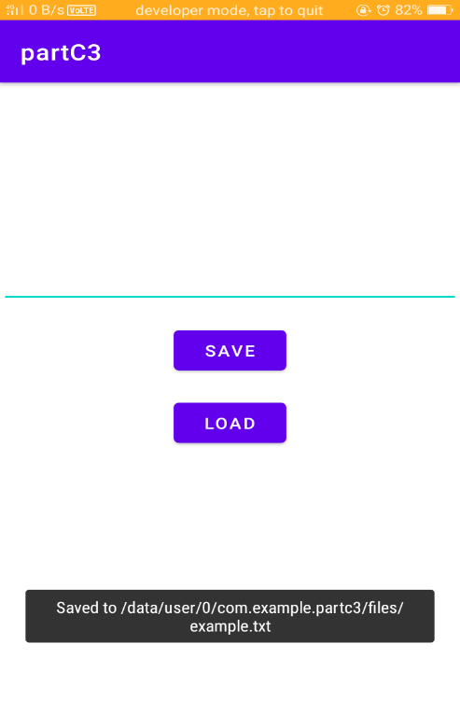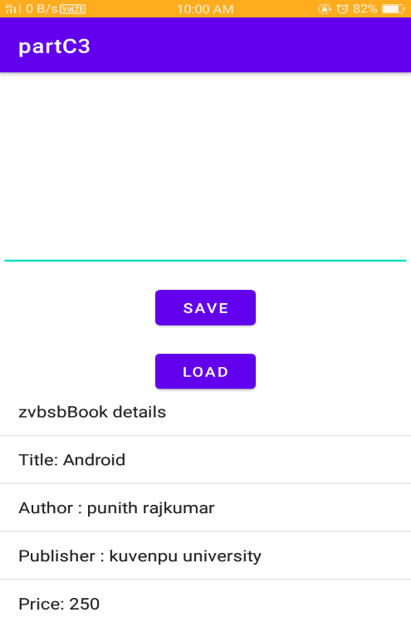

4. . Create an Android application that implements Multi-threading.

ACTIVITY_MAIN.XML
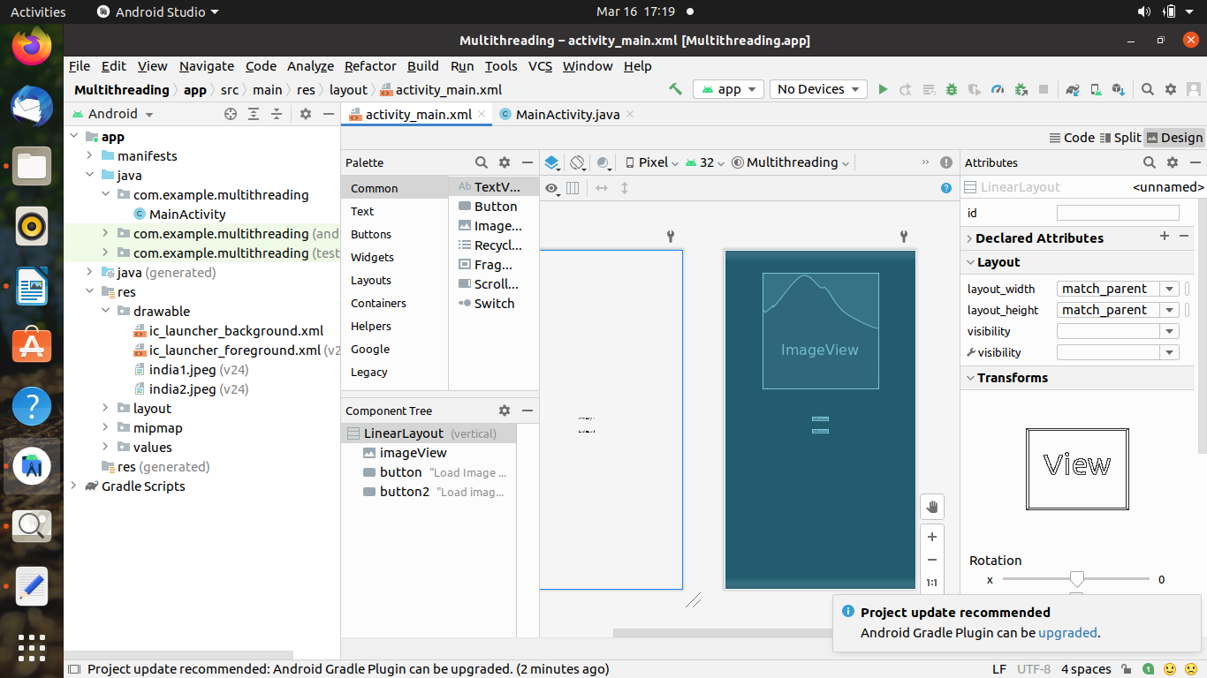

<?xml version="1.0" encoding="utf-8"?>
<LinearLayout xmlns:android="http://schemas.android.com/apk/res/android"
android:layout_width="match_parent"
android:layout_height="match_parent"
android:orientation="vertical" >

<ImageView
android:id="@+id/imageView"
android:layout_width="250dp"
android:layout_height="250dp"
android:layout_margin="50dp"
android:layout_gravity="center" />

<Button
android:id="@+id/button"
android:layout_width="wrap_content"
android:layout_height="wrap_content"
android:layout_margin="10dp"
android:layout_gravity="center"
android:text="Load Image 1" />

<Button
android:id="@+id/button2"
android:layout_width="wrap_content"
android:layout_height="wrap_content"
android:layout_margin="10dp"
android:layout_gravity="center"
android:text="Load image 2" />

</LinearLayout>

Main_Activity.java

package com.codingflow.multithreading;
import android.os.Bundle;
import android.widget.Button;
import android.widget.ImageView;

import androidx.appcompat.app.AppCompatActivity;

public class MainActivity extends AppCompatActivity
{
ImageView img;
Button bt1,bt2;
@Override
protected void onCreate(Bundle savedInstanceState)
{
super.onCreate(savedInstanceState);
setContentView(R.layout.activity_main);

bt1 = (Button)findViewById(R.id.button);
bt2= (Button) findViewById(R.id.button2);
img = (ImageView)findViewById(R.id.imageView);

bt1.setOnClickListener(v -> new Thread(() -> img.post(() -> img.setImageResource(R.drawable.india1))).start());

bt2.setOnClickListener(v -> new Thread(() -> img.post(() -> img.setImageResource(R.drawable.india2))).start());
}
}

Output :-

