**1. Create an Android application, which pop up and Alert Dialog with three buttons.**

**Activity_main.xml**

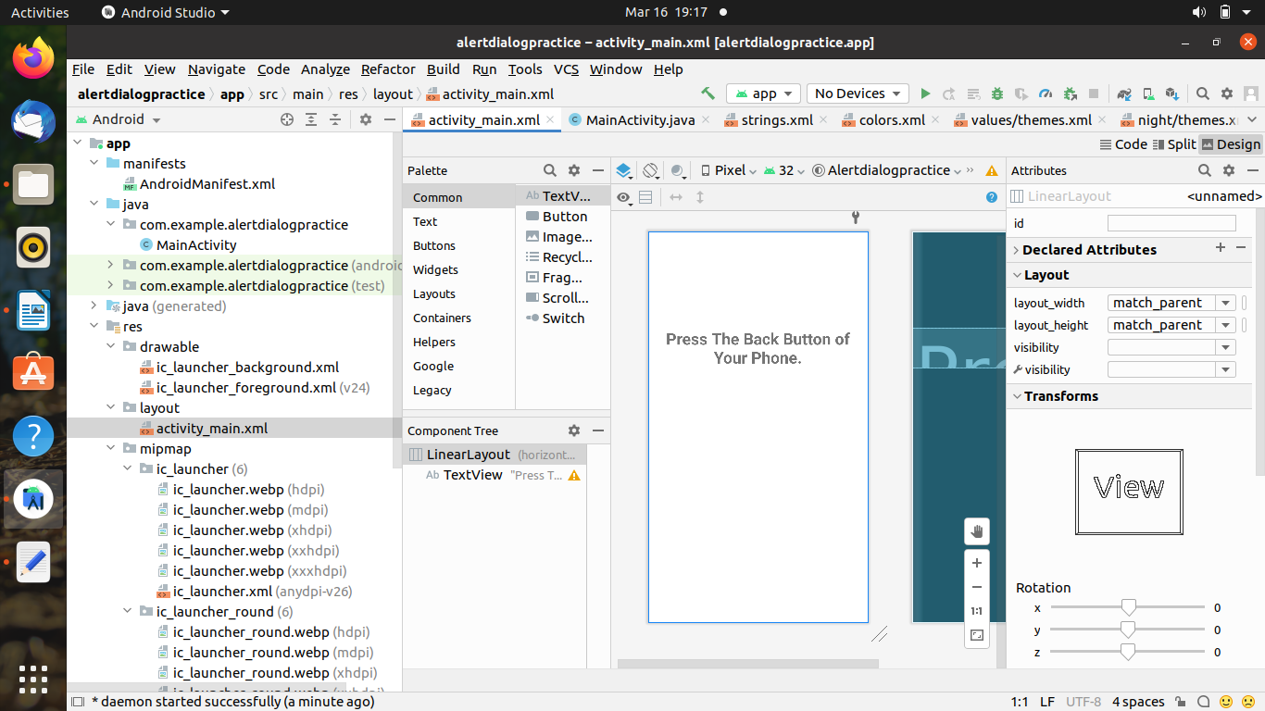

<?xml version="1.0" encoding="utf-8"?>

<LinearLayout xmlns:android="http://schemas.android.com/apk/res/android"

xmlns:app="http://schemas.android.com/apk/res-auto"

xmlns:tools="http://schemas.android.com/tools"

android:id="@+id/linearLayout"

android:layout_width="match_parent"

android:layout_height="match_parent"

tools:context=".MainActivity"

tools:ignore="MissingClass">

<TextView

android:id="@+id/textView2"

android:layout_width="wrap_content"

android:layout_height="wrap_content"

android:text="Press the back button of your phone"

android:textStyle="bold"

android:gravity="center_horizontal"

app:layout_constraintEnd_toEndOf="parent"

app:layout_constraintStart_toStartOf="parent"

android:textSize="15sp"

android:layout_marginTop="180dp"

app:layout_constraintTop_toTopOf="parent" />

</LinearLayout>

**Main_Activity.java**

package com.example.alert_dialog_parta_1;

import androidx.appcompat.app.AlertDialog;

import androidx.appcompat.app.AppCompatActivity;

import android.content.DialogInterface;

import android.os.Bundle;

import android.widget.TextView;

public class MainActivity extends AppCompatActivity {

@Override

protected void onCreate(Bundle savedInstanceState) {

super.onCreate(savedInstanceState);

setContentView(R.layout.*activity_main*);

final TextView message =new TextView(this);

message.setText("");

AlertDialog.Builder builder=new AlertDialog.Builder(this);

builder.setMessage(R.string.*AlertBoxMessage*);

builder.setPositiveButton(R.string.*Yes*, new DialogInterface.OnClickListener() {

@Override

public void onClick(DialogInterface dialogInterface, int i) {

message.setText("Your answer is yes");

//DialodInterface is used to run some code when the dialog is clicked

}

});

builder.setNegativeButton(R.string.*No*, new DialogInterface.OnClickListener() {

@Override

public void onClick(DialogInterface dialogInterface, int i) {

message.setText("Your ans is no");

}

});

builder.setNeutralButton(R.string.*Cannot_say*, new DialogInterface.OnClickListener() {

@Override

public void onClick(DialogInterface dialogInterface, int i) {

message.setText("Your ans is cannot say");

}

});

builder.show();

setContentView(message);

}

}

**String.xml**

<resources>

<string name="app_name">HelloWorld</string>

<string name="action_settings">settings</string>

<color name="BackGroundColor">#337700</color>

<string name="AlertBoxTitle">Alert</string>

<string name="AlertBoxMessage">Do you like Android</string>

<string name="Yes">Yes</string>

<string name="No">No</string>

<string name="Cannot_say">Cannot_say</string>

</resources>

**Output :-**

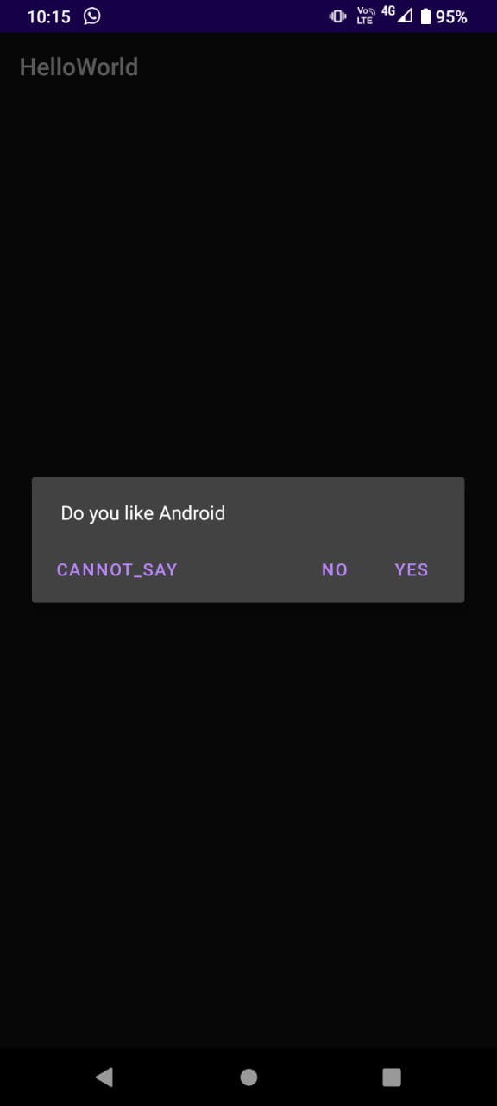 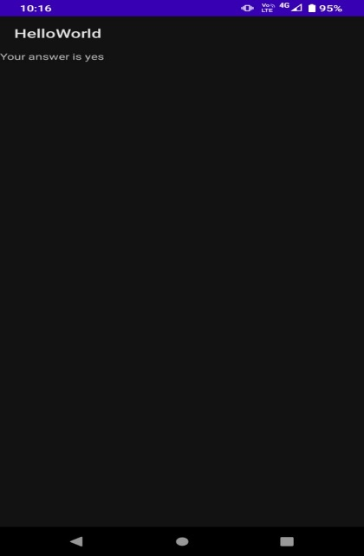

**2. Create an Android application using intents and two activities. On the first activity, user can add name and then on pressing the OK button, the second activity should be started. The second activity must greet the user by using the text that entered on Activity one.**

**Activity_main .xml**

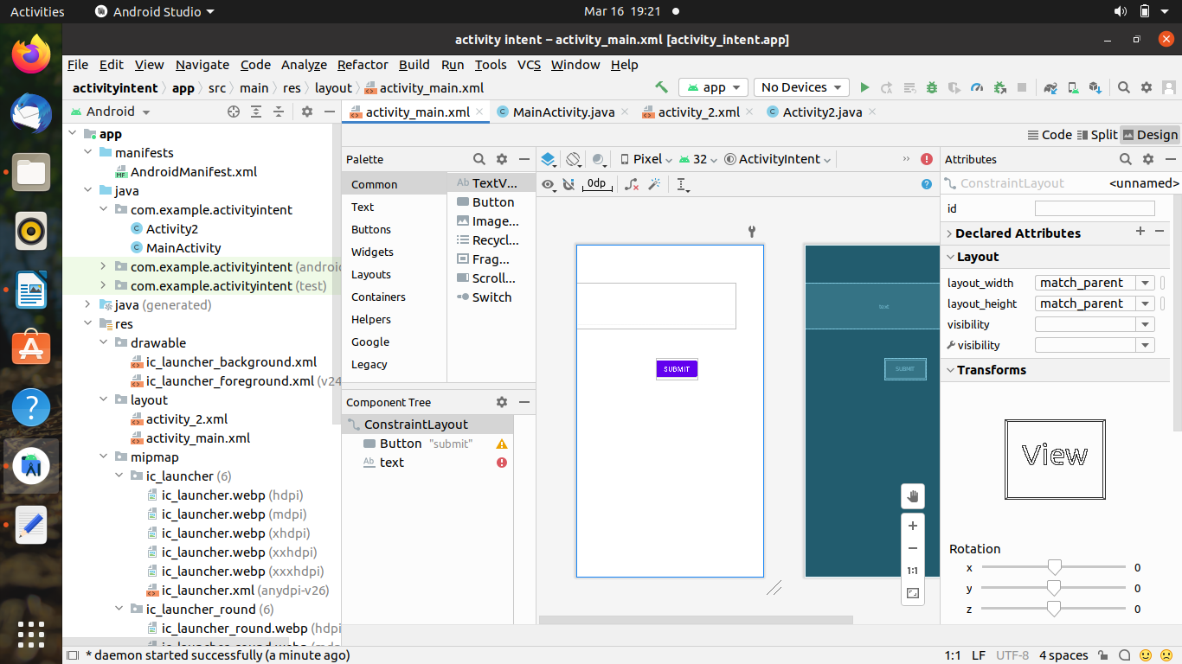

<?xml version="1.0" encoding="utf-8"?>

<androidx.constraintlayout.widget.ConstraintLayout xmlns:android="http://schemas.android.com/apk/res/android"

xmlns:app="http://schemas.android.com/apk/res-auto"

xmlns:tools="http://schemas.android.com/tools"

android:layout_width="match_parent"

android:layout_height="match_parent"

tools:context=".MainActivity">

<TextView

android:id="@+id/act1"

android:layout_width="wrap_content"

android:layout_height="wrap_content"

android:text="acticity 1"

app:layout_constraintBottom_toBottomOf="parent"

app:layout_constraintEnd_toEndOf="parent"

app:layout_constraintHorizontal_bias="0.498"

app:layout_constraintLeft_toLeftOf="parent"

app:layout_constraintRight_toRightOf="parent"

app:layout_constraintStart_toStartOf="parent"

app:layout_constraintTop_toTopOf="parent"

app:layout_constraintVertical_bias="0.22" />

<Button

android:id="@+id/submit"

android:layout_width="wrap_content"

android:layout_height="wrap_content"

android:text="submit"

app:layout_constraintBottom_toBottomOf="parent"

app:layout_constraintHorizontal_bias="0.547"

app:layout_constraintLeft_toLeftOf="parent"

app:layout_constraintRight_toRightOf="parent"

app:layout_constraintTop_toTopOf="parent"

app:layout_constraintVertical_bias="0.597" />

<EditText

android:id="@+id/text"

android:hint="enter your text here"

android:layout_width="match_parent"

android:layout_height="wrap_content"

app:layout_constraintBottom_toBottomOf="parent"

app:layout_constraintEnd_toEndOf="parent"

app:layout_constraintHorizontal_bias="0.5"

app:layout_constraintStart_toStartOf="parent"

app:layout_constraintTop_toTopOf="parent" />

</androidx.constraintlayout.widget.ConstraintLayout>

**Main_Activity.java**

package com.codingflow.activitylab;

import androidx.appcompat.app.AppCompatActivity;

import android.content.Intent;

import android.os.Bundle;

import android.view.View;

import android.widget.Button;

import android.widget.EditText;

public class MainActivity extends AppCompatActivity {

@Override

protected void onCreate(Bundle savedInstanceState) {

super.onCreate(savedInstanceState);

setContentView(R.layout.activity_main);

Button button = findViewById(R.id.submit);

button.setOnClickListener(new View.OnClickListener() {

@Override

public void onClick(View v) {

open1();

}

});

}

public void open1()

{

String name;

EditText editText=findViewById(R.id.text);

name=editText.getText().toString();

Intent intent=new Intent(this,MainActivity2.class);

intent.putExtra("name",name);

startActivity(intent);

}

}

**Activity2. xml**

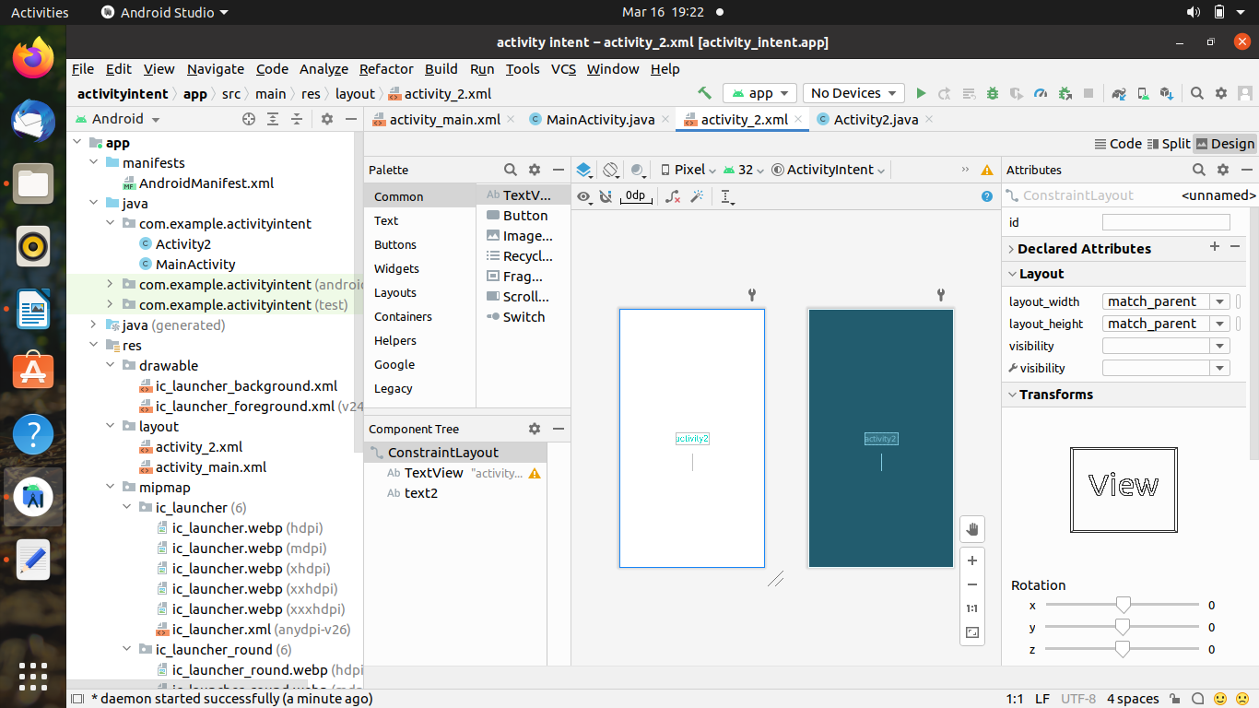

<?xml version="1.0" encoding="utf-8"?>

<androidx.constraintlayout.widget.ConstraintLayout xmlns:android="http://schemas.android.com/apk/res/android"

xmlns:app="http://schemas.android.com/apk/res-auto"

xmlns:tools="http://schemas.android.com/tools"

android:layout_width="match_parent"

android:layout_height="match_parent"

tools:context=".MainActivity2">

<TextView

android:layout_width="wrap_content"

android:layout_height="wrap_content"

android:text="activity2"

android:textSize="25dp"

android:textColor="@color/teal_200"

app:layout_constraintBottom_toBottomOf="parent"

app:layout_constraintEnd_toEndOf="parent"

app:layout_constraintHorizontal_bias="0.5"

app:layout_constraintStart_toStartOf="parent"

app:layout_constraintTop_toTopOf="parent" />

<TextView

android:id="@+id/text2"

android:layout_width="wrap_content"

android:layout_height="wrap_content"

android:textSize="35dp"

app:layout_constraintBottom_toBottomOf="parent"

app:layout_constraintEnd_toEndOf="parent"

app:layout_constraintHorizontal_bias="0.5"

app:layout_constraintStart_toStartOf="parent"

app:layout_constraintTop_toTopOf="parent"

app:layout_constraintVertical_bias=".6"/>

</androidx.constraintlayout.widget.ConstraintLayout>

**Activity2.java**

package com.codingflow.activitylab;

import androidx.appcompat.app.AppCompatActivity;

import android.os.Bundle;

import android.widget.TextView;

public class MainActivity2 extends AppCompatActivity {

@Override

protected void onCreate(Bundle savedInstanceState) {

super.onCreate(savedInstanceState);

setContentView(R.layout.activity_main2);

TextView t=findViewById(R.id.text2);

t.setText(getIntent().getStringExtra("name"));

}

}

**Output:-**

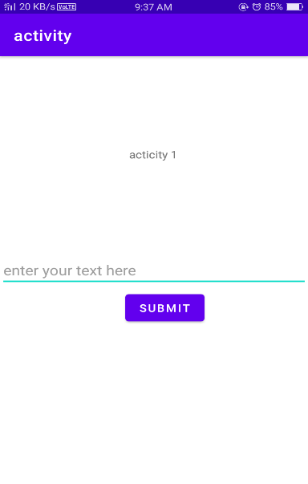 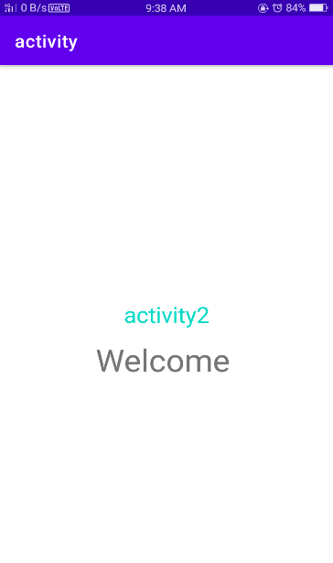

**3. Create an Android application using TableLayout to arrange Text View, Edit Text, RadioButton View and CheckBox View.**

**ACTIVITY_MAIN.XML:-**

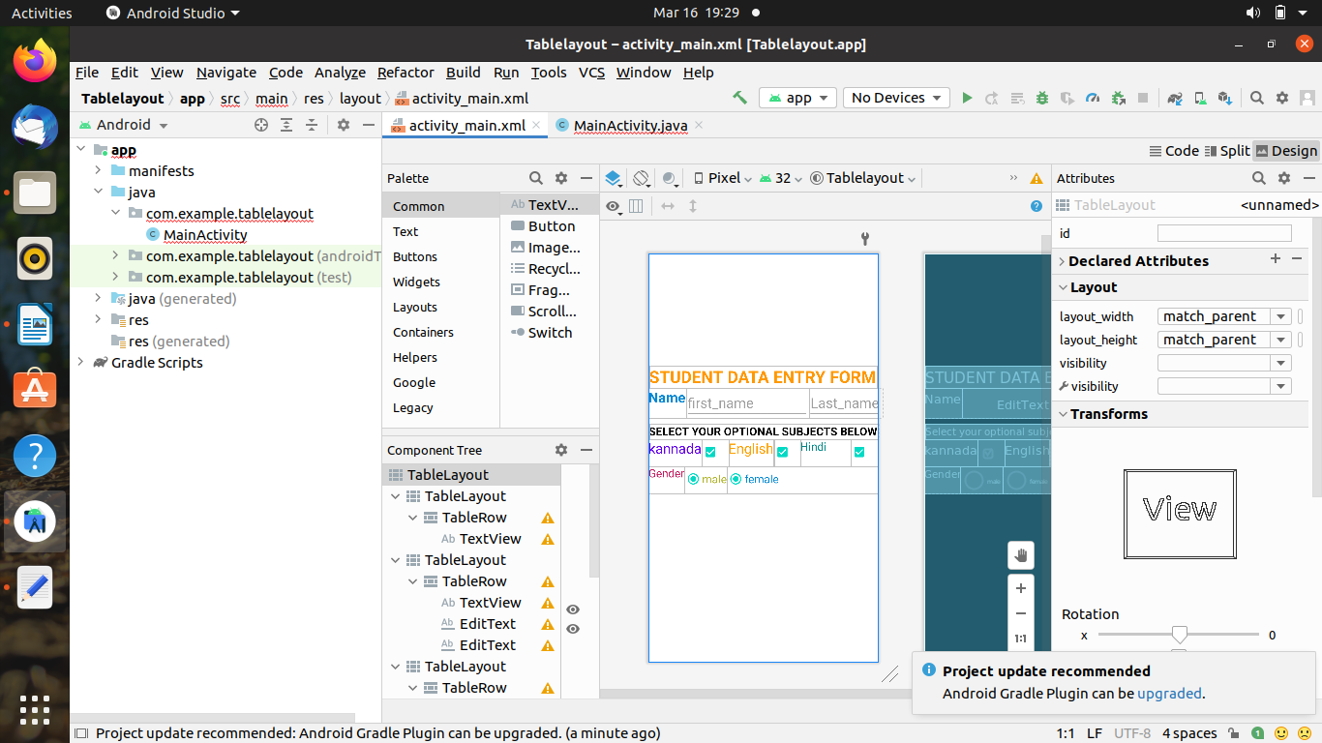

<?xml version="1.0" encoding="utf-8"?>

<TableLayout xmlns:android="http://schemas.android.com/apk/res/android"

xmlns:app="http://schemas.android.com/apk/res-auto"

xmlns:tools="http://schemas.android.com/tools"

android:layout_width="match_parent"

android:layout_height="match_parent"

tools:context=".MainActivity">

<TableLayout

android:layout_width="wrap_content"

android:layout_marginTop="200dp"

android:layout_height="wrap_content">

<TableRow

android:layout_width="match_parent"

android:layout_height="match_parent"

>

<TextView android:layout_height="match_parent"

android:layout_width="410dp"

android:text="STUDENT DATA ENTRY FORM"

android:textStyle="bold"

android:layout_gravity="center"

android:textColor="#FF9800"

android:textSize="30dp"

/>

</TableRow>

</TableLayout>

<TableLayout android:layout_height="wrap_content"

android:layout_width="wrap_content"

android:stretchColumns="1">

<TableRow android:layout_width="match_parent"

android:layout_height="wrap_content">

<TextView

android:layout_width="wrap_content"

android:layout_height="match_parent"

android:text="Name"

android:textStyle="bold"

android:textColor="#0288D1"

android:layout_column="1"

android:textSize="25dp" />

<EditText

android:layout_width="220dp"

android:layout_height="wrap_content"

android:hint="first_name"

android:textSize="25dp"

android:layout_column="2"

android:visibility="visible" />

<EditText

android:layout_width="wrap_content"

android:layout_height="wrap_content"

android:hint="Last_name"

android:textSize="25dp"

android:layout_column="3"

android:visibility="visible" />

</TableRow>

</TableLayout>

<TableLayout android:layout_height="wrap_content"

android:layout_width="match_parent"

android:layout_marginTop="10dp"

android:stretchColumns="0">

<TableRow android:layout_width="match_parent"

android:layout_height="match_parent">

<TextView android:layout_height="match_parent"

android:layout_width="match_parent"

android:layout_gravity="center"

android:textAllCaps="true"

android:textStyle="bold"

android:textSize="20dp"

android:textColor="@color/black"

android:text="Select your optional subjects below"></TextView>

</TableRow>

</TableLayout>

<TableLayout android:layout_height="wrap_content"

android:layout_width="wrap_content">

<TableRow android:layout_width="wrap_content"

android:layout_height="wrap_content">

<TextView android:layout_width="wrap_content"

android:layout_height="match_parent"

android:textSize="25dp"

android:textColor="@color/purple_500"

android:text="kannada"/>

<CheckBox android:layout_height="match_parent"

android:layout_width="match_parent"

android:checked="true"/>

<TextView android:layout_width="wrap_content"

android:layout_height="match_parent"

android:textColor="#FFA000"

android:textSize="25dp"

android:text="English"/>

<CheckBox android:layout_height="match_parent"

android:layout_width="wrap_content"

android:checked="true"/>

<TextView android:layout_width="90dp"

android:layout_height="match_parent"

android:textColor="@color/teal_700"

android:textSize="20dp"

android:text="Hindi"/>

<CheckBox android:layout_height="wrap_content"

android:layout_width="wrap_content"

android:checked="true"/>

</TableRow>

</TableLayout>

<TableLayout android:layout_width="match_parent"

android:layout_height="wrap_content"

android:stretchColumns="2">

<TableRow

android:layout_height="wrap_content"

android:layout_width="wrap_content">

<TextView android:layout_height="match_parent"

android:layout_width="wrap_content"

android:textColor="#C2185B"

android:textSize="20dp"

android:text="Gender"/>

<RadioButton android:layout_width="wrap_content"

android:layout_height="wrap_content"

android:text="male"

android:checked="true"

android:textColor="#AFB42B"

android:textSize="20dp" />

<RadioButton

android:layout_width="wrap_content"

android:layout_height="wrap_content"

android:checked="true"

android:text="female"

android:textColor="#0288D1"

android:textSize="20dp" />

</TableRow>

</TableLayout>

</TableLayout

**Output :-**



**4. Create an Android application with two toggle buttons named Toggle1 and Toggle2. Use an extra button called States, which on tapping shows the current states (i.e., ON or OFF) of two toggle buttons through a toast notification.**

**Activity_main.XML**

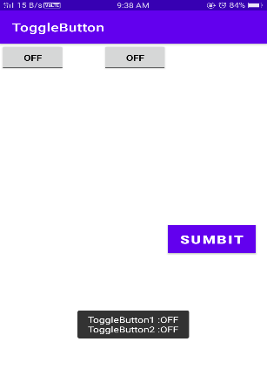

<?xml version="1.0" encoding="utf-8"?>

<LinearLayout xmlns:android="http://schemas.android.com/apk/res/android"

xmlns:app="http://schemas.android.com/apk/res-auto"

xmlns:tools="http://schemas.android.com/tools"

android:layout_width="match_parent"

android:layout_height="match_parent"

android:orientation="vertical"

tools:context=".MainActivity">

<ToggleButton

android:id="@+id/toggleButton1"

android:layout_width="wrap_content"

android:layout_height="wrap_content"

android:layout_gravity="center_horizontal"

android:checked="false"

android:drawablePadding="20dp"

android:text="ToggleButton"

android:textColor="#000" />

<ToggleButton

android:id="@+id/toggleButton2"

android:layout_width="wrap_content"

android:layout_height="wrap_content"

android:layout_gravity="center_horizontal"

android:layout_marginLeft="0dp"

android:checked="true"

android:drawablePadding="20dp"

android:text="ToggleButton"

android:textColor="@color/black" />

<Button

android:id="@+id/button"

android:layout_width="wrap_content"

android:layout_height="wrap_content"

android:layout_gravity="center"

android:layout_marginTop="50dp"

android:background="#0f0"

android:padding="10dp"

android:text="submit"

android:textColor="#fff"

android:textSize="20sp"

android:textStyle="bold" />

</LinearLayout>

**Main_Activity.java_**

package com.example.myapplication3;

import androidx.appcompat.app.AppCompatActivity;

import android.os.Bundle;

import android.view.Menu;

import android.view.MenuItem;

import android.view.View;

import android.widget.Button;

import android.widget.Toast;

import android.widget.ToggleButton;

import java.util.concurrent.RecursiveTask;

public class MainActivity extends AppCompatActivity {

ToggleButton simpleToggleButton1, simpleToggleButton2;

Button submit;

@Override

protected void onCreate(Bundle savedInstanceState) {

super.onCreate(savedInstanceState);

setContentView(R.layout.activity_main);

simpleToggleButton1 = (ToggleButton) findViewById(R.id.toggleButton1);

simpleToggleButton2 = (ToggleButton) findViewById(R.id.toggleButton2);

submit = (Button) findViewById(R.id.button);

submit.setOnClickListener(new View.OnClickListener() {

@Override

public void onClick(View view) {

String submit = "ToggleButton1 :" + simpleToggleButton1.getText() + "\n" + "ToggleButton2 :" + simpleToggleButton2.getText();

Toast.makeText(getApplicationContext(), submit, Toast.LENGTH_SHORT).show();

}

});

}

}

**Output :-**

