PART_B

3) Create a web application using PHP which takes two non-numerically indexed arrays and append both if they have same elements and store the content of only one array in a file. If the arrays do not have same elements file should contain appended content of both the arrays.

<?php

$a1=array("A"=>100,"B"=>200,"C"=>300);

$a2=array("A"=>100,"B"=>200,"C"=>300);

echo "<b>The content of Array 1 is</b><br>";

foreach($a1 as $key=>$value)

{

echo $key."=>".$value."<br>";

}

echo "<b>The content of Array 2 is</b><br>";

foreach($a2 as $key=>$value)

{

echo $key."=>".$value."<br>";

}

$arr="";

if($a1==$a2)

{

echo "<b>Arrays are equal</b><br>";

foreach($a1 as $key=>$value)

{

$arr=$arr."<br>".$key."=>".$value;

}

@$fp=fopen("file1.txt","wb");

fwrite($fp,$arr);

fclose($fp);

}

else

{

echo "<b>Arrays are not equal</b><br><br>";

$a1=$a1+$a2;

foreach($a1 as $key=>$value)

{

$arr=$arr."<br>".$key."=>".$value;

}

@$fp=fopen("file1.txt","wb");

fwrite($fp,$arr);

fclose($fp);

}

echo "<b>The Content of File is.......</b><br>";

$rs=file("file1.txt");

for($i=0;$i<count($rs);$i++)

{

echo $rs[$i];

}

?>

Output:

Arrays both are equal

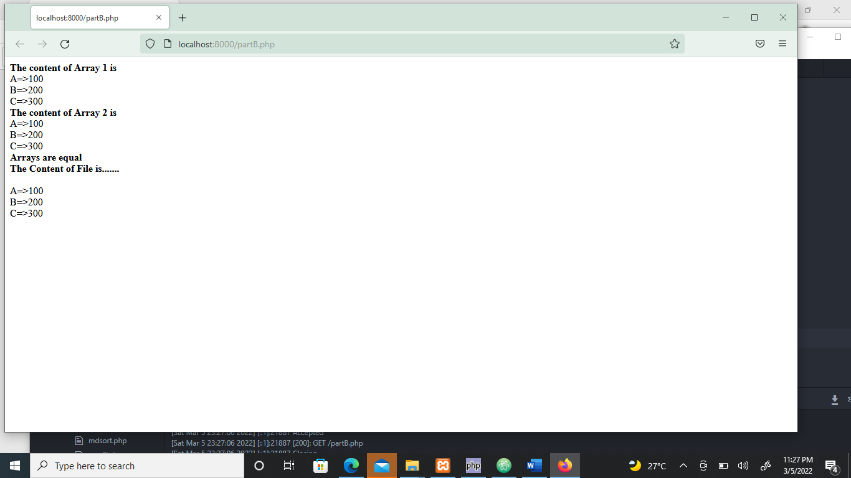

Arrays not equal

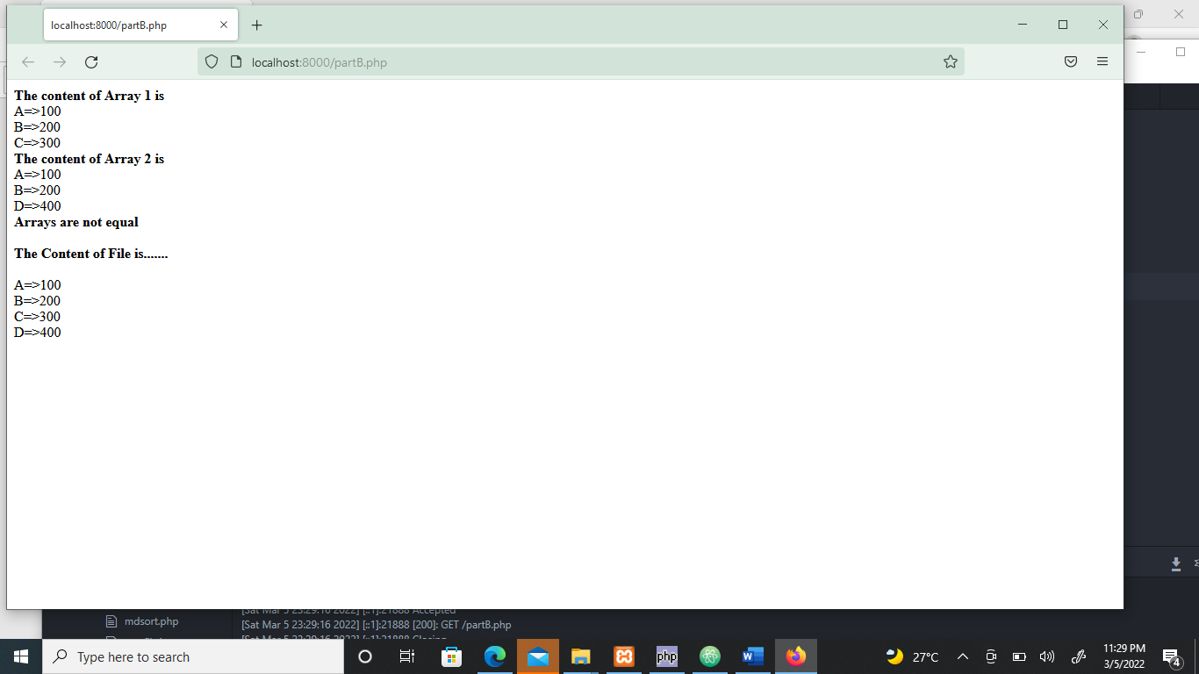

PART-B

4) Create a web application using PHP which receives a line of text and split it into words and in each of those words calculate number of letters, digits & special characters and display the result for each word. The application should also display the entire sentence by replacing a specific word with another word and represent the replaced word with uppercase letters.

**Html program:**

<html>

<head>

<title>String Splitting</title>

</head>

<body>

<form name="frm" method="POST" action="strcount.php">

<p>Enter a line of Text &nbsp&nbsp&nbsp&nbsp&nbsp&nbsp&nbsp&nbsp&nbsp&nbsp&nbsp&nbsp

<input type="text" name="st" required><br><br>

Enter the word to Find &nbsp&nbsp&nbsp&nbsp&nbsp&nbsp&nbsp

<input type="text" name="fnd" required><br><br>

Enter the word to Replace &nbsp

<input type="text" name="rpl" required><br><br>

<input type="submit" value="Split & Replace" name="ct">

</body>

</html>

**Strcount.php**

<?php

$ln=$_POST['st'];

$srh=$_POST['fnd'];

$repl=$_POST['rpl'];

echo "<h3>The line of Text is.............:".$ln."</h3><br><br>";

echo "<TR><TABLE cellspacing='4' border='1'>";

echo "<TH>Word</TH>";

echo "<TH>No of Alphabets</TH>";

echo "<TH>No of Digits</TH>";

echo "<TH>No of Special Characters</TH></TR>";

$wrd=strtok($ln," ");

$a;

while($wrd!="")

{

$alpha=preg_match_all("/[a-zA-Z]/",$wrd,$a);

$dig=preg_match_all("/[0-9]/",$wrd,$a);

$spl=preg_match_all("/[^a-zA-Z0-9]/",$wrd,$a);

echo "<TR>";

echo "<TH>".$wrd."</TH>";

echo "<TH>".$alpha."</TH>";

echo "<TH>".$dig."</TH>";

echo "<TH>".$spl."</TH></TR>";

$wrd=strtok("");

}

echo "</TABLE><br><br>";

$rln=str_replace($srh,strtoupper($repl),$ln);

echo "<h3>Replaced line to Text is.........:".$rln."</h3>";

?>

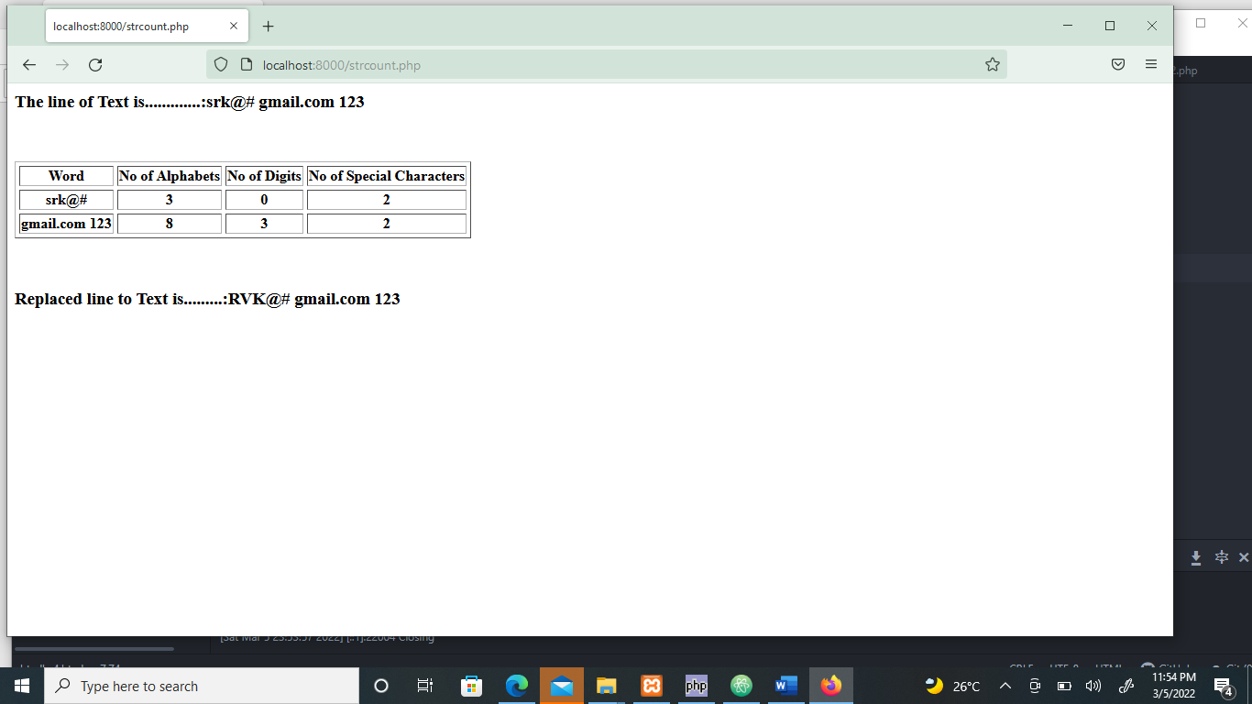Output: