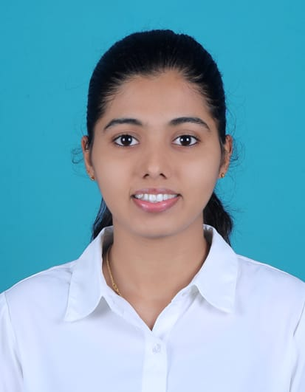**PRATHVINI**

Address: Sri Sai Balaji PG near CMRIT,

AECS layout, Bengaluru, Karnataka – 560037

Email ID: <prat22ise@cmrit.ac.in>

[prathvinipoojary2004@gmail.com](mailto:prathvinipoojary2004@gmail.com)

Mobile No: +91 7899767705

LinkedIn: <https://www.linkedin.com/in/prathvini-poojary-91b441301>

GitHub: [https://github.com/Prathvini30](https://github.com/Prathvini30%20)

**CAREER OBJECTIVE**

Aspiring Information Science student eager to contribute to dynamic, tech-driven projects by applying analytical thinking, problem-solving skills, and a strong curiosity for innovation. Seeking to join an organization that values collaboration, continuous growth, and emerging technologies, where I can contribute meaningfully to impactful initiatives.

**EDUCATION QUALIFICATION**

* **Bachelor of Engineering – Information Science and Engineering**

CMR Institute of Technology, AECS Layout, Bangalore

9.40, 2026 [Pursuing]

* **12th - Science**

R.N.S PU College, Kundapura, Udupi

97.16% (2022)

* **10th**

V.K.R High School, Kundapura, Udupi

97.6% (2020)

**TECHNICAL SKILLS**

**Programming Languages:** Python, Java

**Software:** Visual Studio Code, Jupyter Notebook, MS Excel, Eclipse, Tableau, Power BI

**Operating System:** Ubuntu, Windows

**Web Technology:** HTML, CSS

**Database:** MySQL, MongoDB

**Version Control:** GitHub

**DevOps Tools:** Jenkins, Gitbash, Azure devops

**PROJECTS**

* **Title: Full Stack Job Tracker with Analytics Dashboard**

**Description:** Designed and developed a comprehensive full-stack job tracking platform to streamline the job application process. Implemented user authentication (with session or token-based security), and enabled users to create, update, filter, and delete job entries with ease. Integrated a dynamic dashboard with real-time analytics using Chart.js to visualize trends such as application status distribution, weekly submission patterns, and interview pipelines. Added support for time-range filtering, search, and status-based insights. Built a fully responsive and accessible UI using React.js and styled components, backed by a secure Node.js + Express API and MongoDB database.

**Tech Stack:** React.js, Chart.js, Node.js, Express.js, MongoDB.

* **Title: AI-Based Multi-Modal Early Detection of Parkinson’s Disease**

**Description:** Developing an AI-driven multi-modal deep learning system for early detection of Parkinson’s Disease by integrating heterogeneous data sources such as handwriting/drawing images and structured clinical symptom data. The initiative utilizes convolutional neural networks (CNNs) to extract features from handwritten and spiral drawing samples, and fully connected neural networks for clinical data analysis. An attention-based fusion mechanism is implemented to effectively combine features from each modality, aiming to boost diagnostic accuracy and interpretability. Key responsibilities include data preprocessing, model architecture design, and managing training workflows using Python, PyTorch, and NumPy within a Visual Studio Code environment. The project features a modular design that supports expansion to additional modalities (such as speech) and includes plans for explainability components like attention heatmaps to promote clinical transparency.

**Tech Stack:** Python, CNN, VS Code, PyTorch, NumPy.

**CO-CURRICULAR & EXTRA CURRICULAR ACTIVITIES**

* **Online Courses & Certification**
* Completed a course on the topic “Artificial Intelligence with Python” from Infosys Springboard.
* Certified on topic “Maturing DevOps Practice in the Enterprise” from Infosys Springboard.
* Earned “HTML-Advanced” certificate from Infosys Springboard.
* **Hackathons**
* Participated in the Demo Day competition conducted by the ISE Department, CMR Institute of Technology.
* Participated in GEN AI Hackfest organized by CMR Institute of Technology in collaboration with HappyFox.
* **Seminar & Workshops**
* Presented a seminar on Creating Lambda functions using AWS organized by ISE Department.
* Attended a workshop on Patent Registration conducted by CMRIT.
* **Leadership Activities**
* Served as Peer Support Team Member during 5th and 6th semesters.
* Volunteered for Cultura 2024 at CMR Institute of Technology.

**ACHIEVEMENTS**

• Received the Rajya Puraskar Award under the Bharat Scouts and Guides.

* Served as Vice-Captain of the school Throwball team in 10th grade.

**PERSONAL DETAILS**

Date of Birth : 30th May, 2004

Gender : Female

Nationality : Indian

Permanent Address : Mani Ganapa Nilaya Barekattu Road, Kundapura, Udupi-576201

Linguistic Competency : English, Kannada, Hindi

Hobbies : Playing badminton, drawing and dancing