LifeLine: Redefining Blood Bank Management in the Digital Age

Shreyas Patil1, Prathvish Shetty2, Nikhil Shinde3, Piyush Takalkar4,

Ashirwad Swami5, Harish Thube6.

1-6 Students, SY BTech IT, AISSMS’s Institute of Information Technology, Pune

**Abstract** - *Lifeline is a web-based blood bank management system designed to streamline the process of blood donation and transfusion. With the aim of addressing the critical need for a sustainable blood supply and automate the current manual system with the aid of fully functional computer software and computerised equipment, Lifeline provides a centralized platform for donors, recipients, and healthcare providers to connect and coordinate blood donation activities.Key features of Lifeline include user registration and profile creation, blood donation booking system, recipient blood request management, real-time notifications, and an interactive dashboard for donors and administrators. The system leverages technology to enhance donor engagement, improve operational efficiency, and ensure timely access to blood for patients in need.*

*The goal is to automate its present manual system using computerised equipment and full-fledged computer software to meet their needs, so that their valuable data/information can be saved for a longer period of time with easy access and manipulation. Essentially, the project specifies how to control performance and provide improved services to clients.* *The system will help in the efficient management of blood donations and blood samples. The system will also allow for tracking of donor information, blood types, and inventory records.*

*Through community outreach and awareness campaigns, Lifeline aims to promote the importance of blood donation and cultivate a culture of altruism within the community. By harnessing the power of technology and collaboration, Lifeline strives to make a meaningful impact on healthcare delivery and save lives through the gift of blood donation.*

***Keywords:*** *Blood donation, Blood bank management*

*Healthcare technology, Donor registration, Recipient blood request Partnerships and collaborations.*

# INTRODUCTION

# The integration of technology into healthcare systems has transformed medical services, particularly evident in the development of blood bank management systems. This review explores a comprehensive blood bank management website, designed to optimize blood collection, storage, distribution, and tracking processes.

# Efficient blood bank management is crucial for timely access to safe blood products in various medical scenarios. Traditional paper-based methods suffer from inefficiencies like manual record-keeping and limited accessibility. In contrast, web-based platforms offer advantages such as real-time data access and streamlined workflows.

# The proposed website aims to leverage modern web development technologies to address these challenges and optimize blood bank operations. It offers features tailored to blood bank administrators, healthcare professionals, donors, and recipients, facilitating seamless information flow and collaboration.

# Key functionalities include donor management, inventory tracking, order processing, recipient management, and reporting. These functionalities enhance resource allocation, minimize wastage, and ensure patient safety through accurate matching of blood products and monitoring of transfusion reactions.

# By empowering blood bank personnel with efficient tools and insights, the website enhances the quality, safety, and accessibility of blood transfusion services, ultimately improving patient outcomes and healthcare delivery.

# Subsequent sections will delve deeper into the design architecture, features, implementation challenges, and potential future enhancements of the blood bank management website, drawing insights from existing literature and real-world case studies.

# II. LITERATURE REVIEW

Blood donation plays a vital role in healthcare systems worldwide, serving as a cornerstone for medical procedures, emergency interventions, and patient care. Numerous studies underscore the critical need for regular blood donations to maintain an adequate supply of blood and blood products for transfusion purposes (WHO, 2020). Blood transfusions are essential in treating various medical conditions, including surgical procedures, childbirth complications, cancer treatments, and traumatic injuries (Shaz et al., 2011).

Advancements in technology have revolutionized the management of blood banks and transfusion services, offering innovative solutions to address logistical, operational, and regulatory challenges. Digital platforms, including web-based applications and mobile technologies, have emerged as powerful tools for enhancing donor recruitment, engagement, and retention (Morton et al., 2014).

# III. RELATED WORK

Blood Donation Management System (BDMS) and Blood Bank Information Management System (BBIMS) are widely used software applications designed to manage blood donation activities. These systems offer features such as donor registration, blood collection, inventory management, and distribution. They help blood banks and hospitals streamline operations and ensure a steady supply of blood for transfusions.

Studies have explored the effectiveness of mobile applications in promoting blood donation. Mobile apps offer features like real-time notifications and gamification to increase donor participation. Additionally, online platforms, including websites and social media, play a crucial role in recruiting and retaining blood donors through targeted advertising campaigns and personalized messaging.

Data security and privacy concerns remain significant challenges. Ensuring the confidentiality of donor information is crucial for maintaining trust and compliance with regulations.

Integrating blood bank management systems with existing healthcare information systems presents opportunities to improve coordination and communication across healthcare settings. Seamless data exchange and interoperability can enhance patient care and support timely blood transfusions.

**Key Features and Functionalities:**

**1. User Management:**

* Seamless registration and profile creation for donors and recipients.
* Efficient management of user profiles and preferences.

**2. Appointment Booking:**

* Intuitive system for scheduling blood donation appointments.
* Flexibility in selecting preferred dates, times, and donation centers.

**3. Donation Matching:**

* Automated matching of donor availability with recipient blood requests.
* Real-time notifications for successful matches.

**4. Communication:**

* Instant notifications to donors and recipients regarding appointment confirmations and updates.
* Interactive dashboard for personalized recommendations and insights.

**5. Administration:**

* Comprehensive admin panel for managing user accounts, donation records, and system settings.
* Monitoring tools for blood inventory levels and donation activity.

**6. Community Engagement:**

* Strategic outreach campaigns to raise awareness about blood donation.
* Collaboration with stakeholders to promote participation and support.

**7. Security and Compliance:**

* Robust measures to ensure data security and privacy.
* Adherence to regulatory standards and ethical guidelines.

**Hardware used for Prototype model:**

To support the functionality of LifeLine.in, several hardware components and technology infrastructure are utilized:

* **IoT Devices:** Integration of IoT devices, such as temperature sensors and RFID tags, in blood storage units to monitor temperature conditions and track blood products in real-time.
* **Data Processing and Servers:** Robust servers for processing and analyzing the vast amounts of data collected from blood donations, inventory management, and patient records.
* **Mobile Devices:** Web based applications for donors, recipients, and healthcare professionals to access the platform, receive notifications, and manage blood donation appointments on-the-go.
* **Cloud Infrastructure:** Utilization of cloud services for secure storage, scalability, and efficient management of blood bank data.

**Frontend Technologies:**

* **HTML (Hypertext Markup Language):** HTML serves as the foundation of web pages, defining their structure and content. It enables the creation of elements like headings, paragraphs, images, and buttons, forming the visual layout of the website.
* **Tailwind CSS:** Tailwind CSS is a utility-first CSS framework used to style HTML elements efficiently. It offers a comprehensive set of pre-built utility classes for styling, enabling rapid development and customization of the website's visual appearance.
* **React:** React is a JavaScript library for building interactive user interfaces. It facilitates the creation of reusable UI components and manages the state of the application, enhancing the responsiveness and scalability of the frontend.

**Backend Technologies:**

* **Appwrite:**

Appwrite is an open-source backend server for web and mobile applications. It provides a range of features, including user authentication, database management, and file storage, making it an ideal solution for the backend of LifeLine.in. With its ease of integration and robust security features, Appwrite ensures efficient data management and seamless communication between the frontend and backend.

# IMPLEMENTATION AND RESULTS

* **Implementation:**

1. **User Registration and Profile Creation:** Users will be able to sign up for Lifeline using their email or phone number. Upon registration, users will create a profile that includes their personal details such as name, contact information, blood type, and medical history.

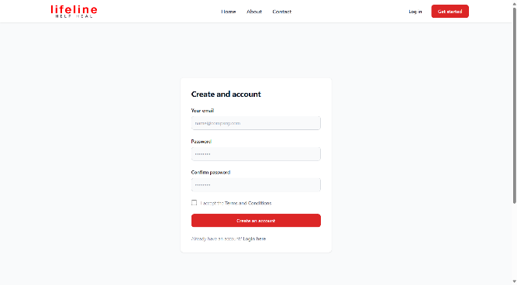

**Fig 1 Sign-up Page**

1. **Blood Donation Booking System:** Lifeline will integrate a booking system where donors can schedule appointments to donate blood. The system will allow donors to select their preferred date, time, and blood donation center.
2. **Recipient Blood Request Management:** Recipients will be able to submit requests for blood donations through the platform. They will specify their blood type, required quantity, and urgency. The system will match the request with suitable donors and notify them accordingly.
3. **Real-Time Notifications:** Lifeline will send real-time notifications to donors and recipients regarding appointment confirmations, donation requests, and other relevant updates.
4. **Community Outreach and Awareness Campaigns:** Lifeline will initiate community outreach and awareness campaigns to promote the importance of blood donation. These campaigns will utilize various channels such as social media, local events, and partnerships with educational institutions and community organizations. The goal is to educate the public about the critical need for blood donations, dispel myths and misconceptions surrounding blood donation, and encourage individuals to become regular blood donors. Lifeline will also provide resources such as informational materials, testimonials from donors and recipients, and statistics on the impact of blood donation on saving lives. By raising awareness and fostering a culture of altruism within the community, Lifeline aims to increase blood donation rates and ensure a sustainable supply of blood for those in need.

* **Results:**

1. **Efficient Blood Donation Process:** It is expected that Lifeline's streamlined process for blood donation booking and recipient blood requests will improve the efficiency of blood donation activities once launched. Donors will be able to easily schedule appointments, and recipients will quickly receive the blood they need.
2. **Increased Blood Donations:** The user-friendly interface and convenient features of Lifeline are anticipated to encourage more people to donate blood once the platform is launched. As a result, the blood bank is expected to see an increase in the number of donations, helping to address blood shortages in the community.
3. **Enhanced Communication:** Lifeline's planned real-time notifications will keep donors and recipients informed throughout the donation process, fostering better communication and coordination between them.
4. **Positive Feedback:** It is expected that upon launch, Lifeline will receive positive feedback from users, including donors, recipients, and administrators, for its simplicity and effectiveness in facilitating blood donation activities.
5. **Future Growth Potential:** Lifeline has the potential for future growth and expansion. With continued enhancements and partnerships with healthcare organizations, the platform can further strengthen its impact on blood donation and healthcare services.

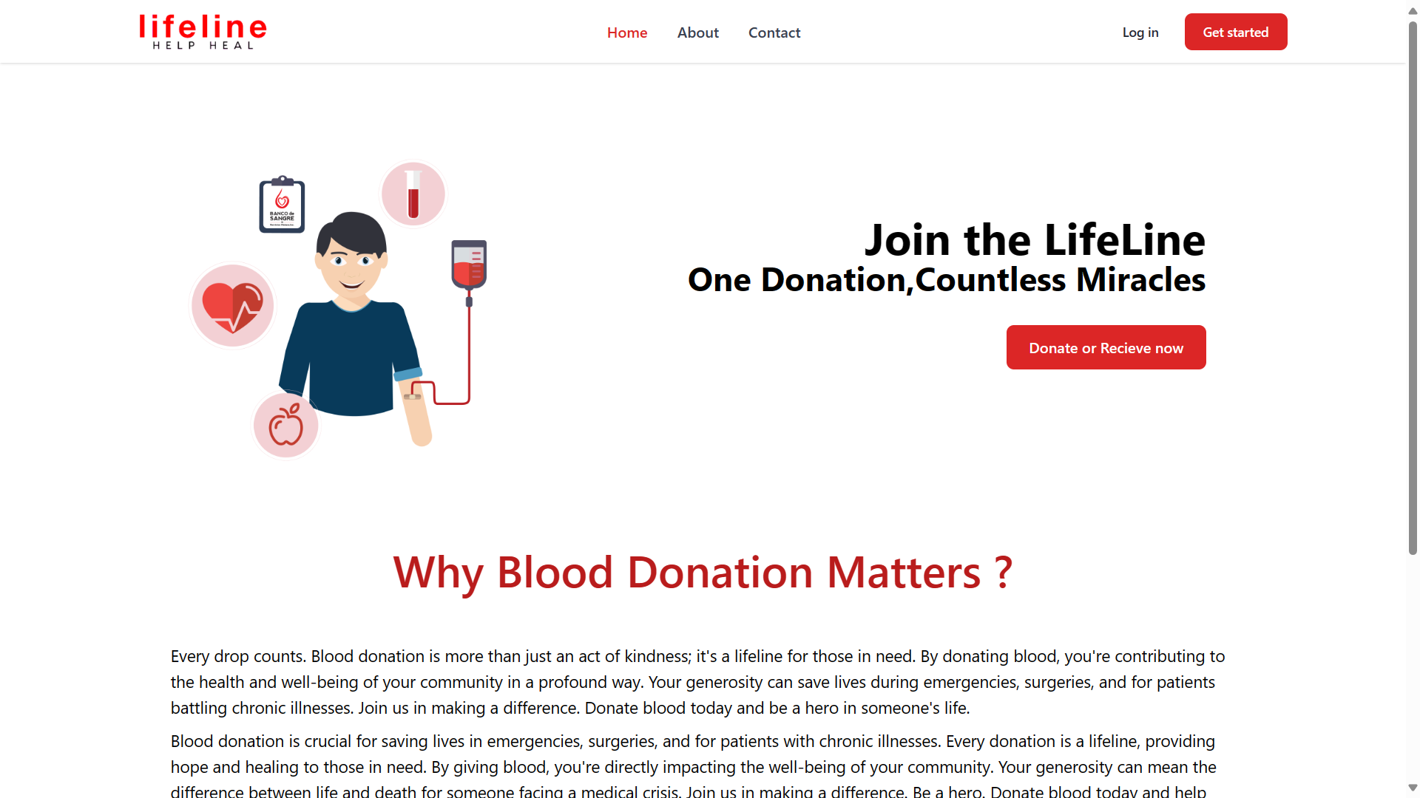

**Fig. 2 Landing Page**

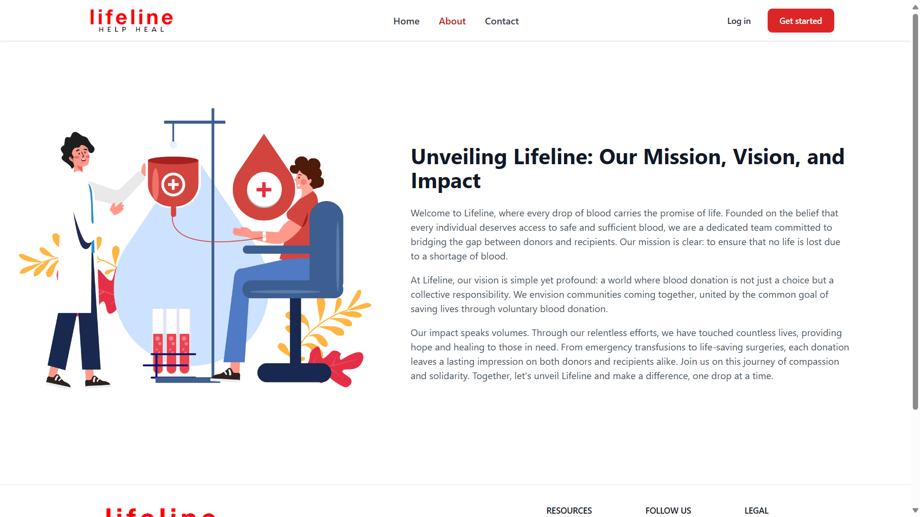 **Fig. 3 About Page**

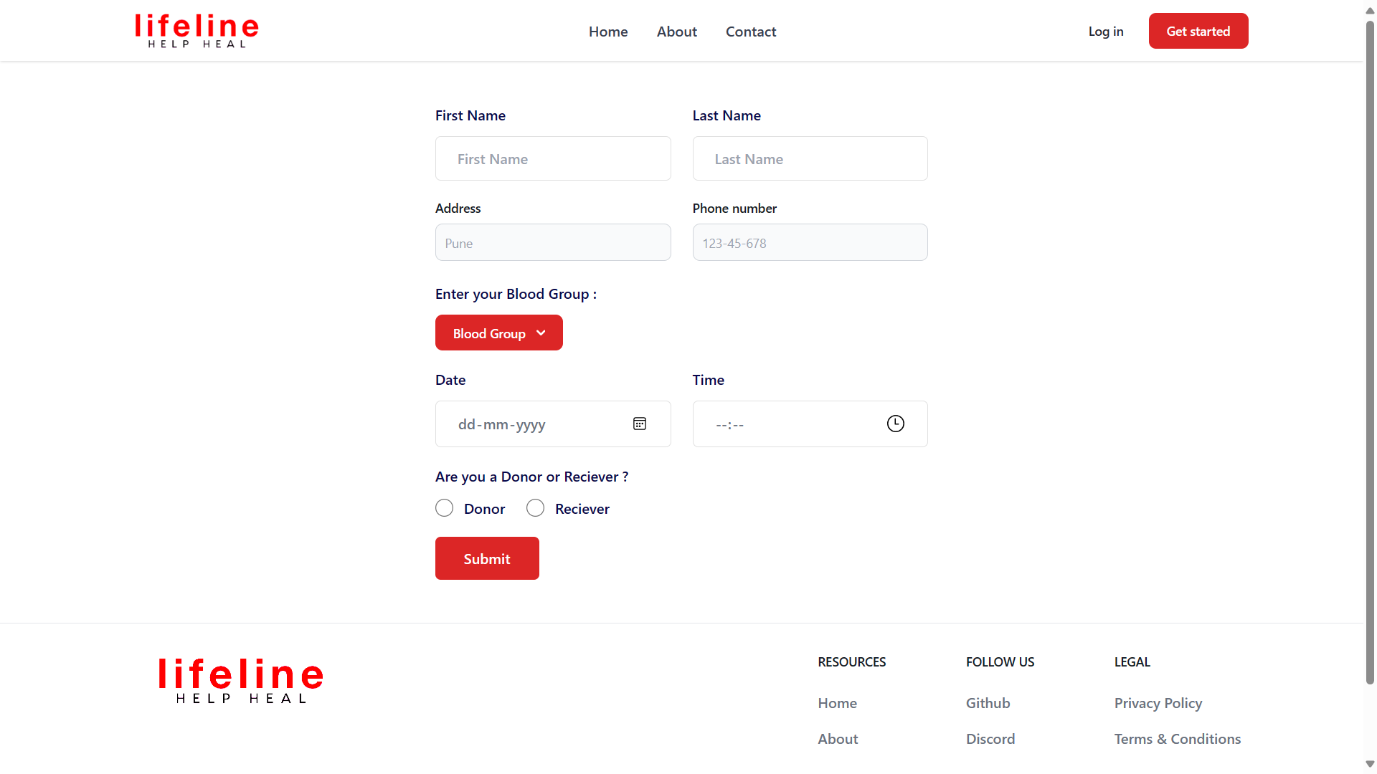

**Fig. 4 Slot Booking Page**

# CONCLUSION AND FUTURE

In conclusion, Lifeline represents a significant advancement in blood bank management, offering a comprehensive platform to streamline the blood donation process and improve access to life-saving blood transfusions. Through its user-friendly interface, real-time communication features, and robust administration tools, Lifeline has the potential to make a tangible impact on healthcare delivery and community engagement.

By facilitating donor recruitment, appointment scheduling, and blood matching, Lifeline addresses critical challenges in blood donation and transfusion services. The system's emphasis on user engagement and community outreach fosters a culture of altruism and promotes participation in blood donation activities. Additionally, Lifeline's commitment to data security and regulatory compliance ensures the confidentiality and integrity of donor information, further enhancing user trust and confidence.

Looking ahead, Lifeline has several opportunities for growth and enhancement. Future developments may include:

1. **Integration with Healthcare Systems**: Exploring integration opportunities with electronic health records (EHRs) and hospital management systems (HMS) to improve coordination and communication across healthcare settings.
2. **Expansion of Outreach Efforts**: Scaling up community outreach and awareness campaigns to reach broader demographics and promote a culture of blood donation across diverse communities.
3. **Enhanced Donor Engagement Features**: Introducing innovative features such as gamification, social sharing, and loyalty programs to incentivize donor participation and retention.
4. **Advanced Analytics and Insights**: Leveraging data analytics to gain insights into donor behavior, blood supply trends, and transfusion outcomes, enabling data-driven decision-making and resource allocation.
5. **Collaboration with Research Institutions**: Partnering with research institutions to conduct studies on blood donation behavior, transfusion outcomes, and the impact of technology on blood bank management.

Overall, Lifeline is poised to continue making significant strides in improving blood donation practices and ensuring a reliable supply of blood for patients in need.

# REFERENCES

# Vikas Kulshreshtha, Sharad Maheshwari. (2011).”Blood Bank Management Information System in India”

# International Journal of Engineering, 1,2, 260-263.

# Rational Unified Process, Best Practices for Software Development Teams. (2012).

# Core Workflows Retrieved from www.ibm.com/developerworks/rational/.../1251_bestpractices Noushin Ashrafi, & Hessam Ashrafi. (2008).

# Object Oriented Systems Analysis and Design, Pearson Higher Ed USA.

# Lions Blood Bank & Research Foundation. http://www.lionsbloodbank.net/ Blood Bank India.

# http://www.bloodbankindia.net