**#DAY-5**

**1)Flow chart of bubble sort algorithm:**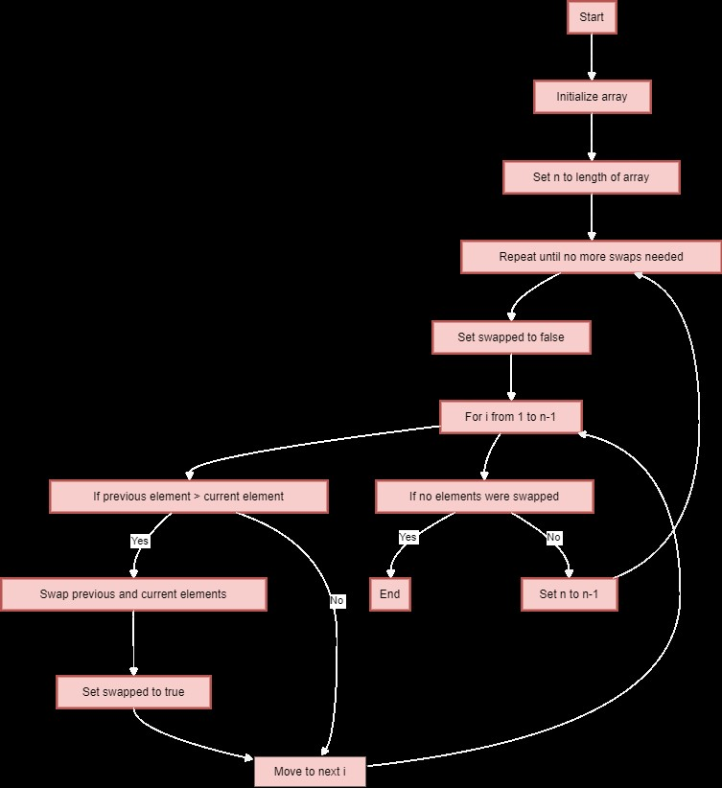

**2)Flow chart of Binary search algorithm:**

