**Business Requirement Document (BRD)**

**Project Title:** Centralized Retail Performance Dashboard: A Real-Time Solution for Tracking Sales and Customer Insights Across Multiple Regions

**1. Project Overview**

The **Centralized Retail Performance Dashboard** project aims to address the challenges faced by a growing retail business operating across multiple regions in consolidating sales data and analyzing customer behavior. Currently, the reliance on various platforms for transactions hinders effective tracking of performance metrics, leading to delays in decision-making and missed opportunities. This project seeks to develop a comprehensive dashboard that integrates sales data from multiple sources, enabling both business retailers and branch retailers to access real-time insights into sales performance and customer trends.

Key features of the dashboard will include user role management, allowing business retailers to view all regional data while branch retailers can access only their specific branch information. Additionally, the dashboard will facilitate regional performance tracking and generate automated reports to provide valuable insights into sales trends and customer behavior. By implementing this centralized solution, the company aims to streamline its sales data analysis, improve operational efficiency, and enhance decision-making capabilities, ultimately leading to increased customer satisfaction and business growth.

**2. Business Objectives**

* **Centralize Sales Data Management**: Consolidate sales data from multiple platforms into a single system to streamline access and analysis.
* **Improve Decision-Making**: Provide real-time insights into sales performance and customer behavior, enabling faster and more informed business decisions.
* **Enhance Sales Performance Tracking**: Allow business and branch retailers to easily track and compare sales performance across different regions and branches.
* **Increase Operational Efficiency**: Reduce the complexity of managing sales data across regions, improving overall operational processes.
* **Support Regional Analysis**: Enable detailed performance tracking at both regional and branch levels to identify trends and opportunities for growth.
* **Empower Role-Based Access**: Ensure business retailers have access to all regional data while branch retailers view only their branch data, improving data security and relevance.
* **Generate Actionable Insights**: Automatically produce reports and analytics that offer insights into sales trends, top-performing products, and customer behavior for strategic planning.
* **Drive Customer Satisfaction**: Use data-driven insights to optimize product offerings and customer engagement, ultimately enhancing customer satisfaction.
* **Scalability for Future Growth**: Build a system that is scalable, allowing the company to easily add more branches, products, and users as the business expands.

**3. Functional Requirements**

**3.1** **User Role Management**

* The system must allow registration of users as either business retailers or branch retailers, with branch retailers being assigned by default and business roles updated manually in the database. Business retailers can access all regional data, while branch retailers can only view data for their specific branch.

**3.2 Sales Data Consolidation**

* The system must integrate sales data from multiple branches and regions into a centralized dashboard for easy access and analysis by business retailers.

**3.3 Branch-Specific Data Access**

* Branch retailers must have access to data specific to their branch, including sales performance, customer orders, and product stock levels.

**3.4 Product and Inventory Management**

* The system must track product details and inventory levels in real-time, ensuring accurate information about stock availability and product orders across all branches.

**3.5 Order Tracking**

* The system must track customer orders, including details of the products ordered, the purchasing branch, and associated customer information.

**3.6 Real-Time Analytics and Reports**

* The system must provide real-time analytics, including sales trends, top-performing products, and branch performance. It should also generate reports tailored to business retailers and branch retailers.

**3.7 Role-Based Access Control and Security**

* The system must enforce role-based access, ensuring that business retailers have full access to all data while branch retailers only see their branch data. All data must be securely stored and accessed.

**4. Non-Functional Requirements**

**4.1 Performance and Scalability**

* The system must handle a large volume of transactions and data without slowing down, ensuring real-time data processing. It should also be scalable to accommodate additional branches, users, and products as the business grows.

**4.2 Security**

* The system must implement robust security measures, including encryption for sensitive data, secure authentication (such as multi-factor authentication), and role-based access control to protect user data and prevent unauthorized access.

**4.3 Usability**

* The user interface must be intuitive and easy to navigate for both business and branch retailers, ensuring that users with varying levels of technical expertise can access and analyze data effectively.

**4.4 Maintainability**

* The system must be modular and easy to maintain, allowing for updates, bug fixes, and enhancements without disrupting the overall functionality.

**4.5 Data Accuracy and Consistency**

* The system must ensure that all data (sales, customer orders, inventory) is accurate, consistent, and up to date in real-time, minimizing discrepancies in reporting.

**5. Project Architecture**

The project architecture follows a **microservices approach** with a frontend built using **React and Redux** for state management, and a backend developed using **Node.js and Express**. The system handles functionalities such as **User management** (business and branch retailers), **Branch management**, **Customer management**, **Product and Inventory tracking**, **Order management**, and **Sales analytics**. MongoDB is used for its **scalability and flexibility** in managing data related to retailers, branches, products, customers, orders, and sales performance, ensuring efficient data storage and retrieval across different regions and branches.

* **Front End**: React with Redux for state management (typescript).
* **Back End**: Nodejs Express RESTful APIs to manage the business logic.
* **Database:** MongoDB for efficient data storage and retrieval, managing.

**6. Database Schema Overview**

The application will include the following tables

**Users**: Stores information about users of the system, including their roles (business or branch retailer) and credentials for authentication.

**Branches**: Contains details about each retail branch, including its location and contact information, as well as the manager associated with the branch.

**Products**: Maintains records of products available for sale, including product descriptions and pricing information.

**Customers**: Stores information about customers who make purchases, including their contact details.

**Orders**: Captures details of customer orders, including which branch fulfilled the order and the status of each order.

**Inventory**: Tracks stock levels of products at each branch, ensuring accurate inventory management.

**Analytics**: Gathers data related to sales performance across branches, including metrics such as total sales and order counts over time.

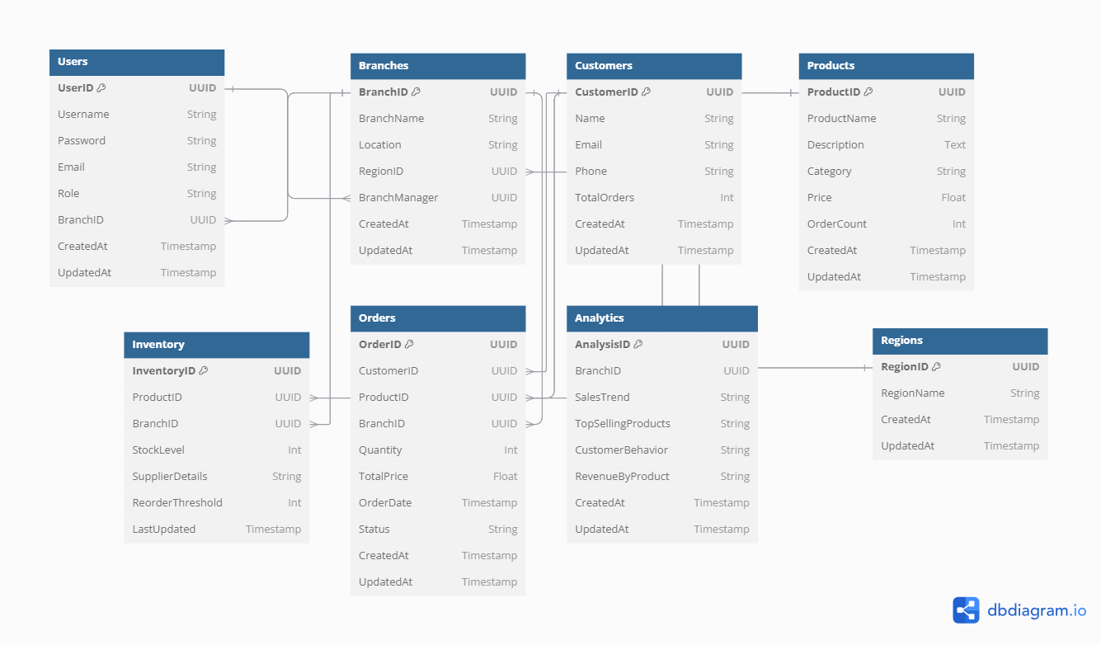

**7. Constraints**

* Development and Deployment Timelines: Project milestones and deadlines must be adhered to, ensuring that the application is delivered and deployed within the specified time frame.
* Scalability and Performance: The system must be designed to handle varying loads, ensuring performance and scalability as the number of users and data volume grows.
* Compliance and Security: The application must comply with relevant data protection regulations and ensure the security of user data.

**8. Workflow Diagram**

