16.1.1

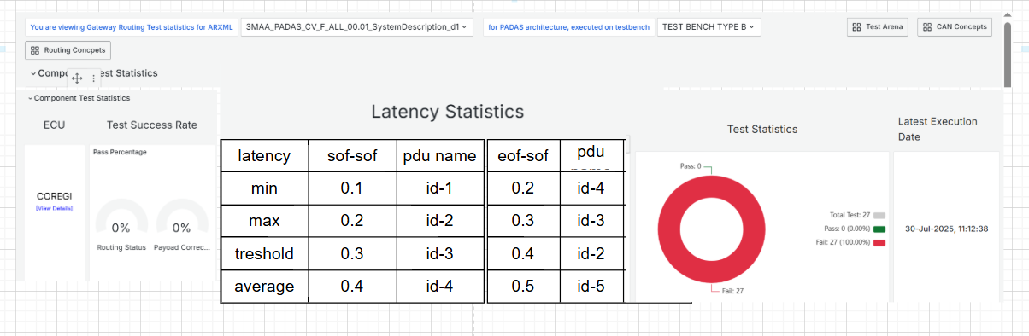

Detailed page: sof-sof

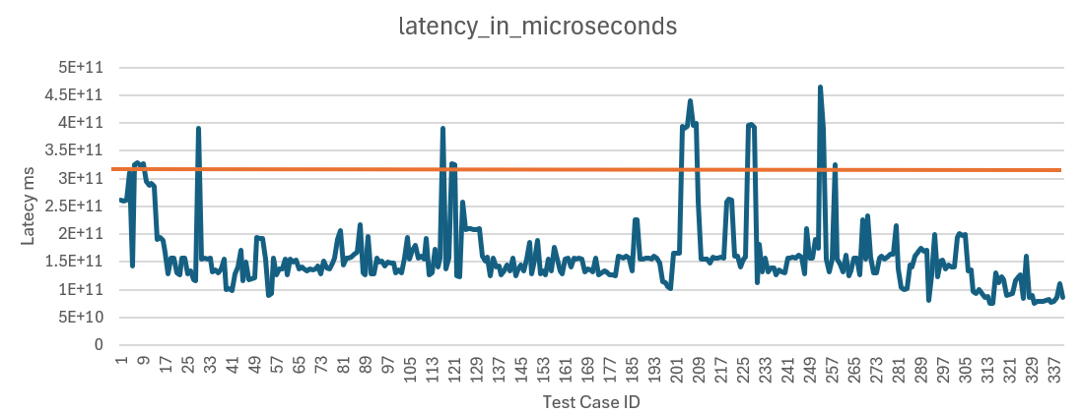

Detailed page: eof-sof



22.1