

Report on HONDA HIL FARM (M3)

CONFIG ID : KPIT_HONDA_GEN3_EE_VNA_Validation_Report_3.0
VERSION : 1.0
DATE : 30-JUNE-2025
Prepared By:

KPIT Technologies Ltd.
R.0035708.001, VNA Department
Pune, India

Pune, India

Released To:

Honda Motor Co. Ltd.
Customer’s Contact Person : YOICHI NISHIURA
Department Name : E&E Architecture Development Division
Address : Tochigi 321-3393, Japan
Telephone : +81 07015248586
Email : yoichi_nishiura@jp.honda

Revision History
Ver. | Change Description | Prepared/  Modified By | Approved By | Date of Approval
1.0 | Report on HONDA HIL FARM (M3) | Rohit Khairnar,  Ajay Singh | Tayyab G Patel,  Amol Sagvekar | 30-June-25

Table of Contents
1 Introduction 5
2 Scope 6
3 Purpose 7
4 References 8
5 Tools 9
6 Test Bench analysis​ 10
6.1 Gen3 Type ‘A’ Test Bench 10
6.1.1 Objective 13
6.1.2 HW INVENTORY 13
6.1.3 ECU Based Analysis 14
6.1.4 REMOTE ACCESSIBILITY 14
6.1.5 TESTBENCH STABILITY 15
6.1.6 Other Parameters for analysis 16
6.1.7 Our Recommendation regarding bench Analysis 16
6.2 Gen3 System Bench, Japan Analysis 17
6.2.1 Objective 18
6.2.2 HW INVENTORY 18
6.2.3 ECU Based Analysis 19
6.2.4 REMOTE ACCESSIBILITY 19
6.2.5 TESTBENCH STABILITY 19
6.2.6 Other Parameters for analysis 20
6.3 SoW2 Requirements Analysis 21
6.4 Feature Diagram 22
6.5 Test Bench Maintenance Data 23
7 Conclusion 26

LIST OF Figures

Figure 1 E&E Network Architecture PADAS Hands-off 10
Figure 2 High Level Block Diagram 11
Figure 3 Real photo of the front view of the test bench. 12
Figure 4 Real photo of the Back view of the test bench. 12
Figure 5 High level block diagram. 17
Figure 6 Image of Front view of System Test bench, Japan. 17
Figure 7 Step 1: List of major Parameters. 22
Figure 8 Step 2: Breakdown into Sub-parameters 22

Introduction
This report aims to analyze the current test benches within the advanced Gen3 architecture, focusing on dynamic switching capabilities between architectures like PADAS, ELITE, and others. The goal is to provide recommendations to Honda and KPIT for refining the HIL Farm scope, thereby optimizing test bench operations' efficiency and effectiveness.
While we have analyzed Test benches Type-A India and System-bench Japan, Certain objectives/parameters have been defined according to which we have performed this analysis activity.
Apart from this, SoW-2 requirements analysis has also been done, to ensure they align with the HIL Farm Project's aim of consolidating multiple HIL systems into a unified framework. It is crucial that all requirements are feasible and contribute to the project's goals of improving efficiency, functionality, and scalability.
A concise feature diagram’s draft version has been created and documented, providing a summary of the HIL Farm network bench development. The report addresses specified parameters, ensuring distinctions between commonalities and variants are appropriately represented.

Scope
Scope of this detailed report involves a detailed analysis and creation of a feature diagram to guide our evaluation. Our focus is on identifying all features to optimize efficiency, functionality, and scalability in the testing ecosystem. This structured and comprehensive approach ensures we achieve our goals of improving performance and reliability for both bench types, keeping a clear objective throughout the process.
This activity is designed to evaluate and improve our current test benches, focusing on a detailed inspection of various aspects such as the type and objective of the bench, hardware inventory and utilization, cost analysis, architecture support, ECU identification, remote accessibility, test management tools, and detailed configurations. Through this comprehensive analysis, we aim to ensure that our test benches are optimized for efficiency, effectiveness, and scalability.
Along with testbench analysis, a clear and comprehensive analysis of the SoW-2 requirements also in-progress, which will serve as the foundation for the HIL test bench creation. The HIL Farm Project aims to consolidate multiple HIL systems into a single, unified framework, and it is essential to verify that the SoW-2 requirements align with this project's goals.

Purpose
The purpose is to analyze the current test benches in the context of the advanced Gen3 architecture. Specifically, it aims to evaluate the dynamic switching capabilities between multiple architectures such as PADAS, ELITE, and others within the Gen3 framework.
The project will generate a comprehensive analysis report that identifies strengths and areas for improvement. Based on this analysis, recommendations will be made to Honda and KPIT to refine the scope of the Hardware-in-Loop (HIL) Farm, thereby enhancing the efficiency and effectiveness of test bench operations.
The purpose behind SoW-2 requirements analysis is to verify HIL Farm Project's objective of unifying multiple HIL systems, enhancing efficiency, functionality, and scalability.

References
Ref. No. | Reference Title | Version
1 | Customer Supplied Documents | NA
2 | https://www.technica-engineering.com/products-and-tools/ | NA

Tools
Ref. No. | Reference Title | Version
1. | NA | NA
2. | NA | NA

Test Bench analysis​

Gen3 Type ‘A’ Test Bench
This test bench have simulated ECUs, hence termed as Type A Bench. [‘Simulated ECUs/Zonal Controllers/Technica’s S32G Boards’ currently available on bench: CENTER, CORE, FRONT]. Whereas, Test bench Type B also exists which have real ECUs/Zonal Controllers.

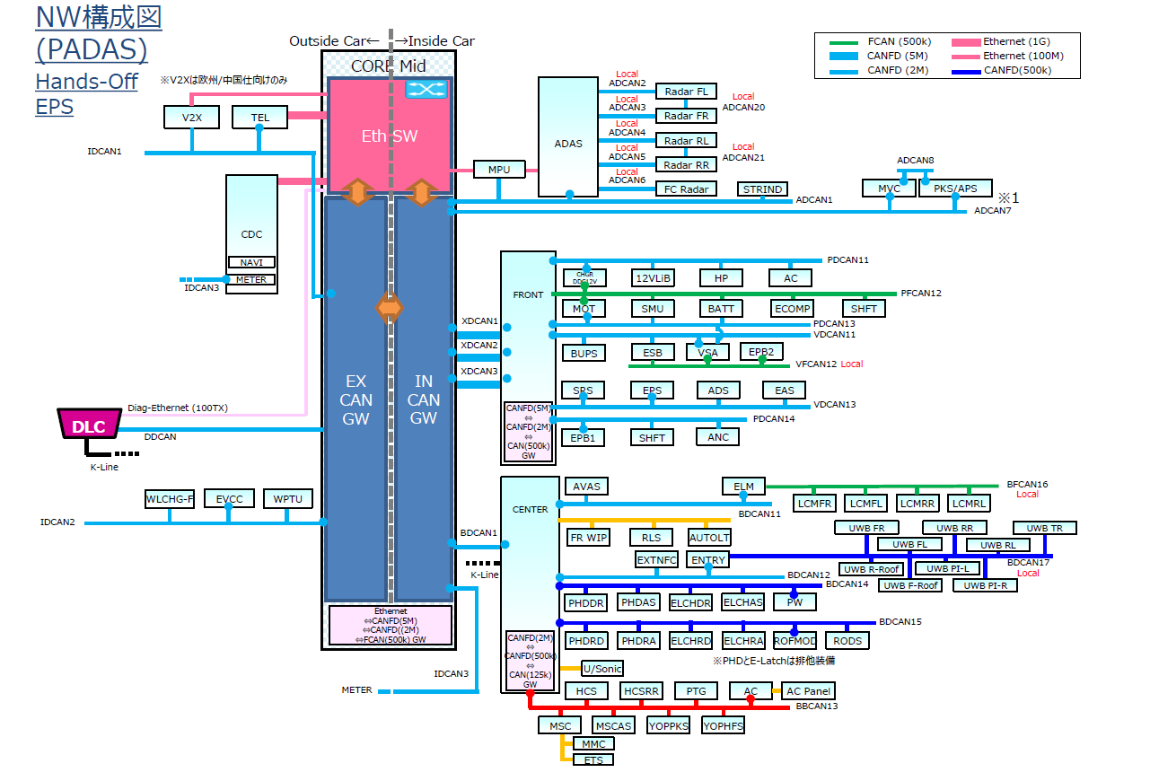
Figure 1 E&E Network Architecture PADAS Hands-off

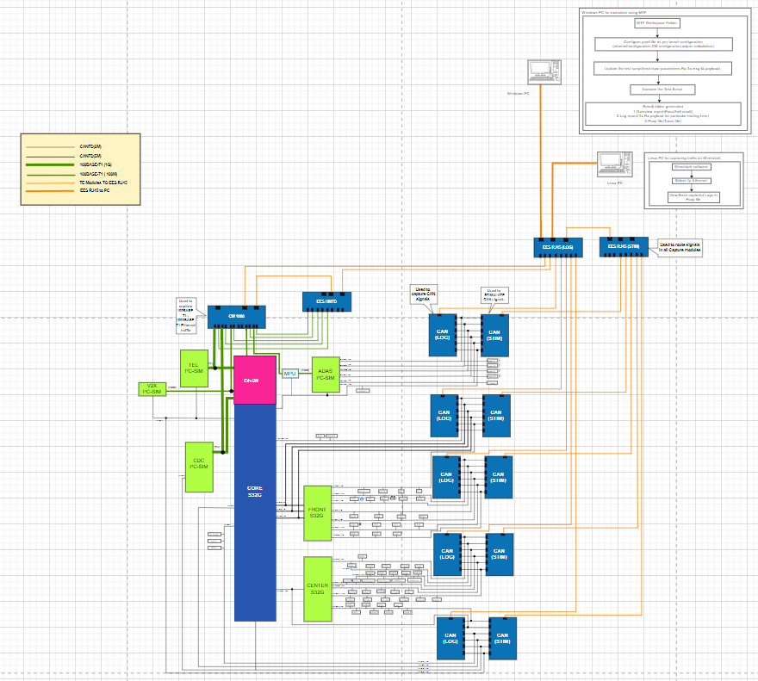
Figure 2 High Level Block Diagram

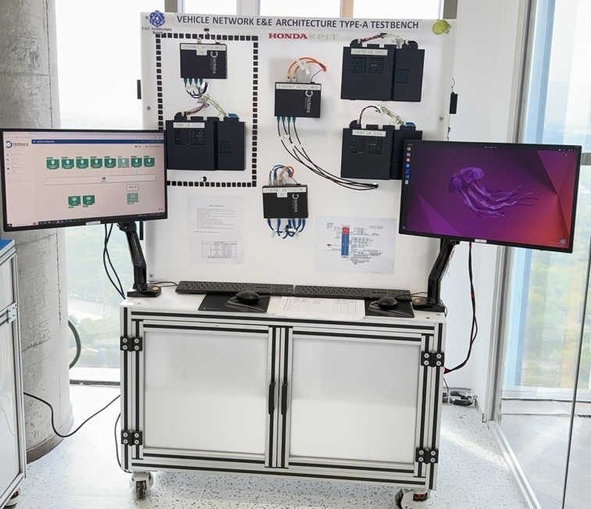
Figure 3 Real photo of the front view of the test bench.
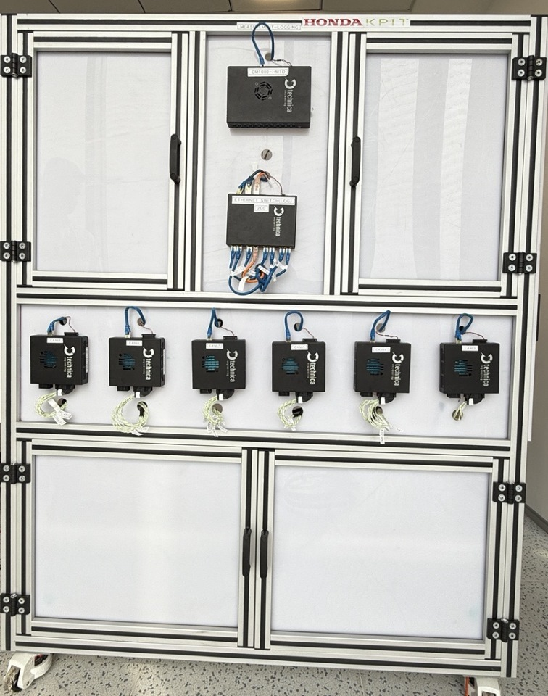
Figure 4 Real photo of the Back view of the test bench.
    - Objective
- PURPOSE OF THIS TESTBENCH DEVELOPMENT
- For network validation
- Efficiency in Simulation and Real Testing Integration
- Prototyping and Early Testing: Allow for iterative design improvements prior to hardware implementation.
- Have Ethernet setup for Layer 2 & 3 validation.

- BENCH ACCOMPLISHMENTS
- Time & Cost Saving: By allowing early testing and troubleshooting in a software simulated environment.
- Integration of new features: Test new features/updates that need to be integrated into existing systems without manually retesting the entire system.
- Validation Across Realistic Conditions: Simulated different real-world scenarios including speed, load, and environmental changes.

- AUTOMATION FEASIBILITY OVER MANUAL
- Efficiency and Speed
- Accuracy and easy defect tracking
- Data management: Automated systems can log data more comprehensively.

- IMPROVEMENT OPPORTUNITIES IN HIL FARM BENCH CREATIVITY
- Space optimization & utilization (Testbench Structure).
- Modularity & Scalability – If feasible, can be moved up-down slightly for seamless operation.
- Cost-Effectiveness - Balance cost with quality to ensure the system is financially feasible.

    - HW INVENTORY
- LOGGING DEVICES & THEIR FIRMWARE, CONFIGURATION FILES
- Logging Devices on Bench:
- CAN Capture Module (For CAN data logging)
- CM1000 Capture module (For Ethernet data logging)
- Their configuration and Firmware files are available on Testbench. A secured folder created with entire setup files.

- DEVICE UNDER TESTS (DUT)
- CORE ECU
- CENTER/FRONT ECU (Gateway Validation)

- STORAGE DEVICES
- PC 1: Windows OS (32GB Ram, GFX 4GB, SSD 1TB)
- PC 2: Linux OS (32GB Ram, GFX 4GB, SSD 1TB)

- POWER SUPPLY UNITS
- TDK Lambda Programmable Power Supply:
- G20-50 power supply.
- GENH30-25 power supply.

- LIST OF HARDWARE COMPONENTS
- Testbench location: Pune, India
- HW Components (Along with Cable Sets):
- CAN Capture Module: 6 Units
- EES RJ-45 Variant: 2 Units
- EES HMTD Variant: 2 Units
- CM1000 Capture Module: 1 Unit
- S32G Board (Simulated ECU): 3 [Front, Core, Center]
- Media Converter: 4 Units
- Cable Sets for each device
- TDK Lambda Programmable Power Supply: 2 Units
- DMM, Relay

- HW MODEL & PART NUMBERS
- CM CAN Combo: TE-1171
- EES RJ-45 Variant: TE-2002
- EES HMTD Variant: TE-2001
- CM 1000 High HMTD: TE-1177
- Media Converter: TE 1402
- S32G Zonal Controllers (3 Qty)

- TECHNICAL SPECIFICATIONS (STANDARD WEB LINK)
- https://www.technica-engineering.com/products-and-tools/

    - ECU Based Analysis
- ECU TYPE
- Major GW ECUs: CORE, FRONT, CENTER, ADAS, TEL
- Available on Bench (All Simulated): CENTER, CORE, FRONT

- ECU MANUFACTURER AND MODEL NUMBER
- Simulated ECU/Zonal controller (S32G module from Technica Engineering)

- ECU SOFTWARE AND FIRMWARE VERSIONS
- No Firmware for Technica Zonal controllers.

- CALIBRATION FILES
- An ARXML File is available based on PADAS Architecture.

- COMMUNICATION PROTOCOLS
- CAN (125kbps, 500kbps)
- CAN-FD (500Kbps, 2Mbps, 5Mbps)
- Automotive Ethernet (1Gbps)

    - REMOTE ACCESSIBILITY
- STEPS FOR ACCESSING TESTBENCH
- The User’s device should be in KPIT Network first.
- Get into KPIT-HONDA Network.
- HIL Bench should also be in KPIT-HONDA Network.
- Connect and get access to HIL bench using 'Remote Desktop Connection' application in laptop.

- REMOTE ACCESSIBILITY TOOLS
- VPN
- Remote desktop connection

- VALIDATION OF REMOTE ACCESSIBILITY
- Dedicated slots have been provided to engineers for 100% bench utilization.
- A common SharePoint sheet has been created to track usage.

- MULTIPLE USERS’ ACCESSIBILITY
- Yes (One user at a time using Remote Desktop Connection)

- TECHNICAL SPECIFICATIONS
- User's device with 'Remote Desktop Connection' application
- KPIT-HONDA VPN access

- USER AUTHENTICATION & PROTOCOLS
- Username and password protected.
- The IP address of Testbench PC should be protected from circulation (To maintain confidentiality)

    - TESTBENCH STABILITY
- CAN TRANSMISSION WITHIN GIVEN TIMESTAMP

- Test setup and configuration details:
- HIL Testbench setup will all active routings that need to be verified (physical and logical checks both).
- Physical wirings & connections, standard configuration as per requirement along with power supply.
- HW web interface should be accessible with a valid internet connection.

- Test cases and scenarios executed:
- 22 Channels with 5 iterations, i.e., 110 TCs (Routing validation)

- Results of the test, including any errors or failures:
- Execution time: <30 min
- Analysis time: 30 min [If any ERROR occurs, it may take even more time to analyze and fix the issue]

- LATENCY CHECK

- Test cases and scenarios executed (50 iterations)
- Each route check with 50 iterations. It means consider 22 available channels and 50 iterations for each, around 1100 times routing check will get performed.

- Results of the test, including any errors or failures
- Occurs rarely but chances exist when error occur, need to analyze and re-verify HW channels and our Yaml configuration.

- Average latency values, Standard deviation of latency values (if any)
- Observed average latency as 0.02 msec.

- LATEST FIRMWARE, SOFTWARE VERSIONS

- Firmware version (Every Technica modules)
- Every week, verify and flash the latest firmware versions available for every Technica modules. It is available on Technica website.

- SW version (Software available on testbench PCs)
- The latest versions of all essential software should be installed and upgraded.
    - Other Parameters for analysis
- REFER THIS LINK FOR ANALYSIS DOCUMENT:
- Bench Analysis Report_v0.2.xlsx

    - Our Recommendation regarding bench Analysis
- Regularly update Technica firmware on modules.
- Use a standard configuration.
- Maintain a resource allocation log for optimal use.
- Focus especially on latency values and recheck channels for consistency.
- Emphasize maximizing testing scenarios.
- Integration of new features: Test new features/updates that need to be integrated into existing systems without manually retesting the entire system.

Gen3 System Bench, Japan Analysis
Bench consists of Real ECUs (CORE, FRONT, CENTER, TELEMATICS). It is based on PADAS Hands-Off Architecture like Gen 3 Type-A, which is mapped for previous bench in this report.
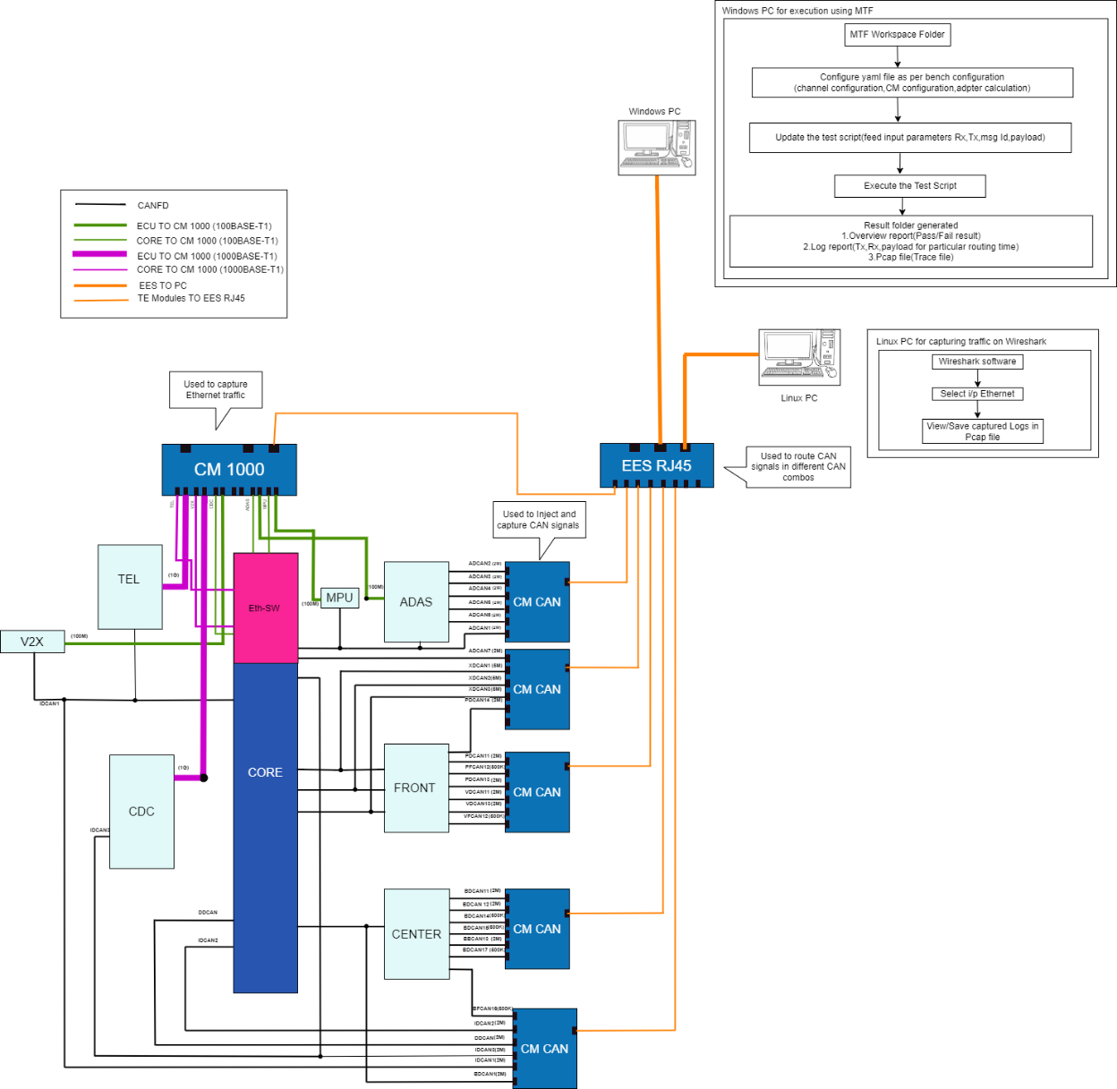
Figure 5 High level block diagram.
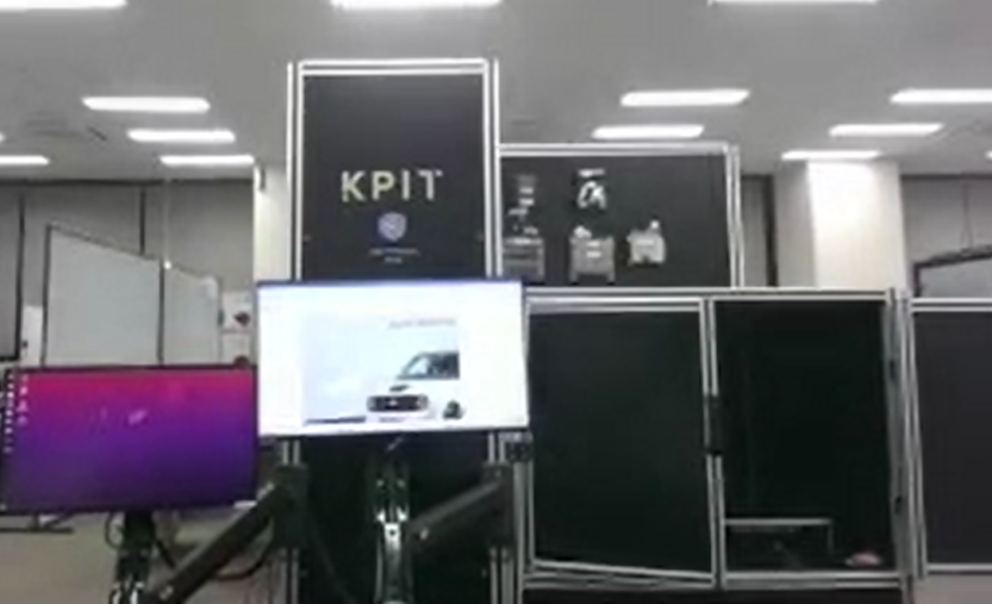
Figure 6 Image of Front view of System Test bench, Japan.
    - Objective
- PURPOSE OF THIS TESTBENCH DEVELOPMENT
- For network validation
- Efficiency in Simulation and Real Testing Integration
- Prototyping and Early Testing: Allow for iterative design improvements prior to hardware implementation.

- BENCH ACCOMPLISHMENTS
- Time & Cost Saving: By allowing early testing and troubleshooting in a software simulated environment.
- Integration of new Features: Test new features/updates that need to be integrated into existing systems without manually retesting the entire system.
- Validation Across Realistic Conditions: Simulated different real-world scenarios including speed, load, and environmental changes.

- AUTOMATION FEASIBILITY OVER MANUAL
- Efficiency and Speed
- Accuracy and easy defect tracking
- Data management: Automated systems can log data more comprehensively.

- IMPROVEMENT OPPORTUNITIES IN HIL FARM BENCH CREATIVITY
- Space utilization is already taken care of during system bench's mechanical structure creation. So, while HIL Farm bench building, reference can be taken care for optimized and better structure.

    - HW INVENTORY
- LOGGING DEVICES & THEIR FIRMWARE, CONFIGURATION FILES
- Logging Devices on Bench:
- CAN Capture Module (For CAN data logging)
- CM1000 Capture module (For Ethernet data logging)
- Their configuration and Firmware files are available on Testbench. A secured folder created with entire setup files.

- DEVICE UNDER TESTS (DUT)
- All Real ECUs as per architecture: CORE, FRONT, CENTER, TEL (Except ADAS, CDC)

- STORAGE DEVICES
- PC 1: Windows OS (32GB Ram, GFX 4GB, SSD 1TB)
- PC 2: Linux OS (32GB Ram, GFX 4GB, SSD 1TB)

- POWER SUPPLY UNITS
- TDK Lambda Programmable Power Supply:
- G20-50 power supply.
- GENH30-25 power supply.

- LIST OF HARDWARE COMPONENTS
- Testbench location: Utsunomiya, Japan
- HW Components (Along with Cable Sets):
- CAN Capture Module: 6 Units
- EES RJ-45 Variant: 2 Units
- CM1000 Capture Module: 1 Unit
- ECU: CORE, FRONT, CENTER, TELEMATICS (ADAS, CDC not available)
- Cable Sets for each device
- TDK Lambda Programmable Power Supply: 2 Units
- DMM, Relay

- HW MODEL & PART NUMBERS
- CM CAN Combo: TE-1171
- EES RJ-45 Variant: TE-2002
- CM 1000 High H-MTD: TE-1177

- TECHNICAL SPECIFICATIONS (STANDARD WEB LINK)
- https://www.technica-engineering.com/products-and-tools/

    - ECU Based Analysis

- ECU TYPE
- Major GW ECUs: CORE, FRONT, CENTER, ADAS, TEL
- Available on Bench: Real ECUs (Except ADAS, CDC)

- CALIBRATION FILES
- An ARXML File is available based on PADAS Architecture.

- COMMUNICATION PROTOCOLS
- CAN (125kbps, 500kbps)
- CAN-FD (5Mbps, 2Mbps, 500Kbps)
- Automotive Ethernet (1Gbps)

    - REMOTE ACCESSIBILITY

- STEPS FOR ACCESSING TESTBENCH
- Steps are same as per India Test bench remote connectivity.
Just a major parameter, System bench available in Japan is in HONDA network, which is prohibited for dedicated users. So, users available in Japan can use as usual after required permissions.

- REMOTE ACCESSIBILITY TOOLS
- Remote desktop connection

- VALIDATION OF REMOTE ACCESSIBILITY
- Dedicated slots have been provided to engineers for 100% bench utilization.
- A common SharePoint sheet has been created to track usage.

- MULTIPLE USERS’ ACCESSIBILITY
- Yes (One user at a time using Remote Desktop Connection)

- TECHNICAL SPECIFICATIONS
- User's device with 'Remote Desktop Connection' application
- HONDA specific VPN/network access

- USER AUTHENTICATION & PROTOCOLS
- Username and password protected.
- The IP address of Testbench PC should be protected from circulation (To maintain confidentiality)

    - TESTBENCH STABILITY
- CAN TRANSMISSION WITHIN GIVEN TIMESTAMP

- Test setup and configuration details:
- HIL Testbench setup will all active routings that need to be verified (physical and logical checks both).
- Physical wirings & connections, standard configuration as per requirement along with power supply.
- HW web interface should be accessible with a valid internet connection.

- Test cases and scenarios executed:
- 22 Channels with 5 iterations, i.e., 110 TCs (Routing validation)

- Results of the test, including any errors or failures:
- Execution time: <30 min
- Analysis time: 30 min [If any ERROR occurs, it may take even more time to analyze and fix the issue]

- LATENCY CHECK

- Test cases and scenarios executed (50 iterations)
- Each route check with 50 iterations. It means consider 22 available channels and 50 iterations for each, around 1100 times routing check will get performed.

- Maximum and minimum latency values
- Max: 0.702 ms, Min: 0.0736 ms (CORE ECU Data)

- Average latency values, Standard deviation of latency values (if any)
- Achieving valid output without any major delays.

- LATEST FIRMWARE, SOFTWARE VERSIONS

- Firmware version (Every Technica modules)
- Every week, verify and flash the latest firmware versions available for every Technica modules. It is available on Technica website.

- SW version (Software available on testbench PCs)
- The latest versions of all essential software should be installed and upgraded.

    - Other Parameters for analysis
- REFER THIS LINK FOR ANALYSIS DOCUMENT:
Bench Analysis Report_v0.2.xlsx

SoW2 Requirements Analysis

Req ID | Requirement | Objective
1.1.1 | Message Injection  - The system must inject messages at specified points in the network architecture. | System needs to be covered the following protocols:  - CAN (Cyclicity, Payload, Message size, 11 bit identifier, 29-bit)  - CAN FD  - Ethernet 100Mbps  - Ethernet 1Gbps  - LIN  Transmission timing:  - Pre Defined Periodic message based on the requirement  - Pre Defined Event type message based on the requirement  - Pre Defined Mixed type message based on the requirement  - User specified Single-shot and Periodic messages  - User can configure the transmission timing of the messages  [Ex: duration after start-up/after, specific event/cyclic, jitter]  Payload:  1. Single-shot frames:  - Sequential Value [e.g.: 0x00-0x31]  - Random Values  - User defined values.  2. Consecutive periodic messages  - User defined values.
13.1 | Core ECU performance test | What: By performing this we can achieve a detailed understanding of the Core ECU's performance and identify potential issues.  How:  ANDi Deployment:  Configure channels/buses: Define specific points for message broadcasting. As per ECU.  Create payloads: Simulate real-world operational data.  Inject test traffic: Confirm delivery efficiency and accuracy.  MTF Script Setup:  Develop YAML scripts for defined configurations in MTF.  Verify setup compatibility via script execution.  Traffic Injection & Peer Analysis:  Execute traffic inject procedures.  Use Wireshark for logging and visualization.

- REFER THIS LINK FOR LIST OF ANALYSED REQUIREMENT’S & IT’S BREAKDOWN:
- SOW2 Requirement 2025_V0.3.xlsx

Feature Diagram

- Draft Version of HIL Farm network bench Feature Diagram:

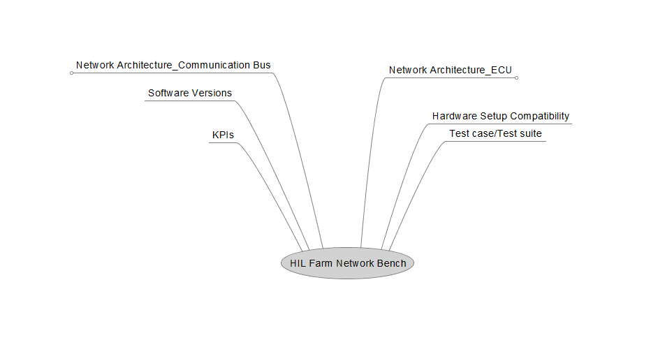
Figure 7 Step 1: List of major Parameters.

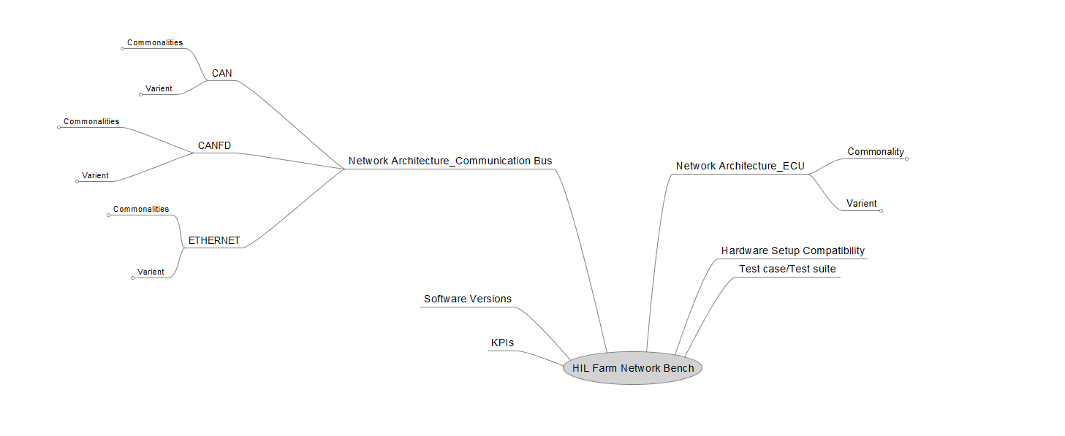
Figure 8 Step 2: Breakdown into Sub-parameters

Test Bench Maintenance Data

Maintenance Report for Gen3 Type A India Bench:

Testbench Maintenance Checklist Gen 3 Type A (India)
Sr. No. | Task | 6/6/2025 | 6/13/2025 | 6/20/2025 | 6/27/2025 | Comments
 | Physical Check
1 | CAN bus connection check | OK | OK | OK | OK
2 | Power connection check | OK | OK | OK | OK
3 | RJ45 connection check | OK | OK | OK | OK
4 | Automotive Ethernet connection check | OK | OK | OK | OK
5 | Technica Module physical stability check | OK | OK | OK | OK
 | Logical Check
6 | CAN web configuration check | OK | OK | OK | OK
7 | EES web configuration check | OK | OK | OK | OK
8 | CM1000 web configuration check | OK | OK | OK | OK
9 | Software update check | OK | OK | OK | OK
10 | Firmware Updates | OK | OK | OK | OK
 | Regression Testing Check
11 | Ethernet testing check | OK | OK | OK | OK
12 | CAN testing check | OK | OK | OK | OK

Maintenance Report for Gen3 Type B India Bench:

Testbench Maintenance Checklist Gen 3 Type B (India)
Sr. No. | Task | 6/6/2025 | 6/13/2025 | 6/20/2025 | 6/27/2025 | Comments
 | Physical Check
1 | CAN bus connection check | OK | OK | OK | OK
2 | Power connection check | OK | OK | OK | OK
3 | RJ45 connection check | OK | OK | OK | OK
4 | Automotive Ethernet connection check | OK | OK | OK | OK
5 | Technica Module physical stability check | OK | OK | OK | OK
 | Logical Check
6 | CAN web configuration check | OK | OK | OK | OK
7 | EES web configuration check | OK | OK | OK | OK
8 | CM1000 web configuration check | OK | OK | OK | OK
9 | Software update check | OK | OK | OK | OK
10 | Firmware Updates | OK | OK | OK | OK
 | Regression Testing Check
11 | Ethernet testing check | NA | NA | NA | NA
12 | CAN testing check | OK | OK | OK | OK

Maintenance Report for Gen4 Type A India Bench:

Testbench Maintenance Checklist Gen 4 Type A (India)
Sr. No. | Task | 6/6/2025 | 6/13/2025 | 6/20/2025 | 6/27/2025 | Comments
 | Physical Check
1 | CAN bus connection check | OK | OK | OK | OK
2 | Power connection check | OK | OK | OK | OK
3 | RJ45 connection check | OK | OK | OK | OK
4 | Automotive Ethernet connection check | OK | OK | OK | OK
5 | Technica Module physical stability check | OK | OK | OK | OK
 | Logical Check
6 | CAN web configuration check | OK | OK | OK | OK
7 | EES web configuration check | OK | OK | OK | OK
8 | CM1000 web configuration check | OK | OK | OK | OK
9 | Software update check | OK | OK | OK | OK
10 | Firmware Updates | OK | OK | OK | OK
 | Regression Testing Check
11 | Ethernet testing check | OK | OK | OK | OK
12 | CAN testing check | OK | OK | OK | OK

Conclusion
This report presents a thorough analysis of the existing test benches within the advanced Gen3 architecture, specifically focusing on the dynamic switching capabilities of PADAS, ELITE, and other systems. The objective was to produce actionable recommendations for both Honda and KPIT to enhance the HIL Farm's operational scope, ensuring enhanced efficiency and effectiveness. Through the analysis of Test Bench Type A in India and System Bench in Japan, and the consideration of SoW-2 requirements, the report aligns with the HIL Farm Project's goal of unifying multiple HIL systems into a cohesive framework.
A draft of the feature diagram has been included, offering a summary of HIL Farm network bench development and accurately representing commonalities and variants. The recommendations and findings will be instrumental in optimizing the overall test bench ecosystem, contributing to increased efficiency, functionality, and scalability.

