Keeping the Machines Running
  - Stakeholder journeys · Agent states · Recovery paths · Partner rails
Working design map for The Ken Case Competition Round 2 | 24 September 2026

Purpose and design stance
The desired household outcome is: after reporting a machine problem and setting boundaries, the household can safely stop coordinating the repair. The household still controls entry, risky work, material scope or price changes, and acceptance of the result. The agent owns the continuity of the incident: it gathers the minimum evidence, coordinates qualified people and parts, keeps commitments visible, detects breakdowns in the plan, and recovers or escalates until the household’s need has an honest disposition.
This is an exploration document. States, emotions, decision policies, and operating responsibilities are design hypotheses. The interviews demonstrate specific breakdowns; they do not establish population frequency, diagnosis accuracy, API eligibility, or viable unit economics. References use a source register at the end. No participant is identified in the journey examples.

The exact pain and the simplest resolution
A machine fails. The household becomes the dispatch desk: explain the fault repeatedly, remember past service, find and chase a provider, coordinate access and payment across people, judge a changed quote after inspection, and check later whether the fix lasted. The central unmet job is to delegate this coordination without losing control of home access, money, safety, or final acceptance. The simplest response is one incident owner with one shared status, one next responsible actor, and a small number of meaningful approvals. The agent should ask only for information that changes its next decision.
Avoidable technician visits are a mechanism. A visit can still be necessary for safe physical diagnosis. The customer-facing test is whether the household must keep noticing, chasing, and resolving handoff failures itself. [E1–E5]

What tracing four outcomes means
Use the same initial event for four branches: an older washing machine stops filling; the person at home can grant access, another person controls spending, and a model-label image can be taken. For each branch, trace the event that changes the plan, who learns it, what the agent knows, what it proposes or does, whose permission is needed, what each person sees, the next state, how recovery works, and what counts as finished. This is a paper stress test of a design, not a user test or a claim that these incidents happened. The four branches are correct part and repair; wrong initial hypothesis; correct part unavailable; fault returns after an apparent repair.

Research resources and method
The attached six PDFs and one EPUB were indexed in full text. Relevant chapters, passages, definitions, and diagrams informed the structures below. The complete books are retained as the attached research set; the register near the end identifies their titles and how each was applied. These are methodological sources, not evidence that the proposed agent will work. Norman’s action cycle informs action, feedback, and recovery; Kalbach’s mapping distinguishes the household journey from backstage work; Downe’s service principles motivate explicit handoffs and no dead ends; the interaction design and UX texts inform mental models and progressive disclosure. [B1–B7]

The service at a glance
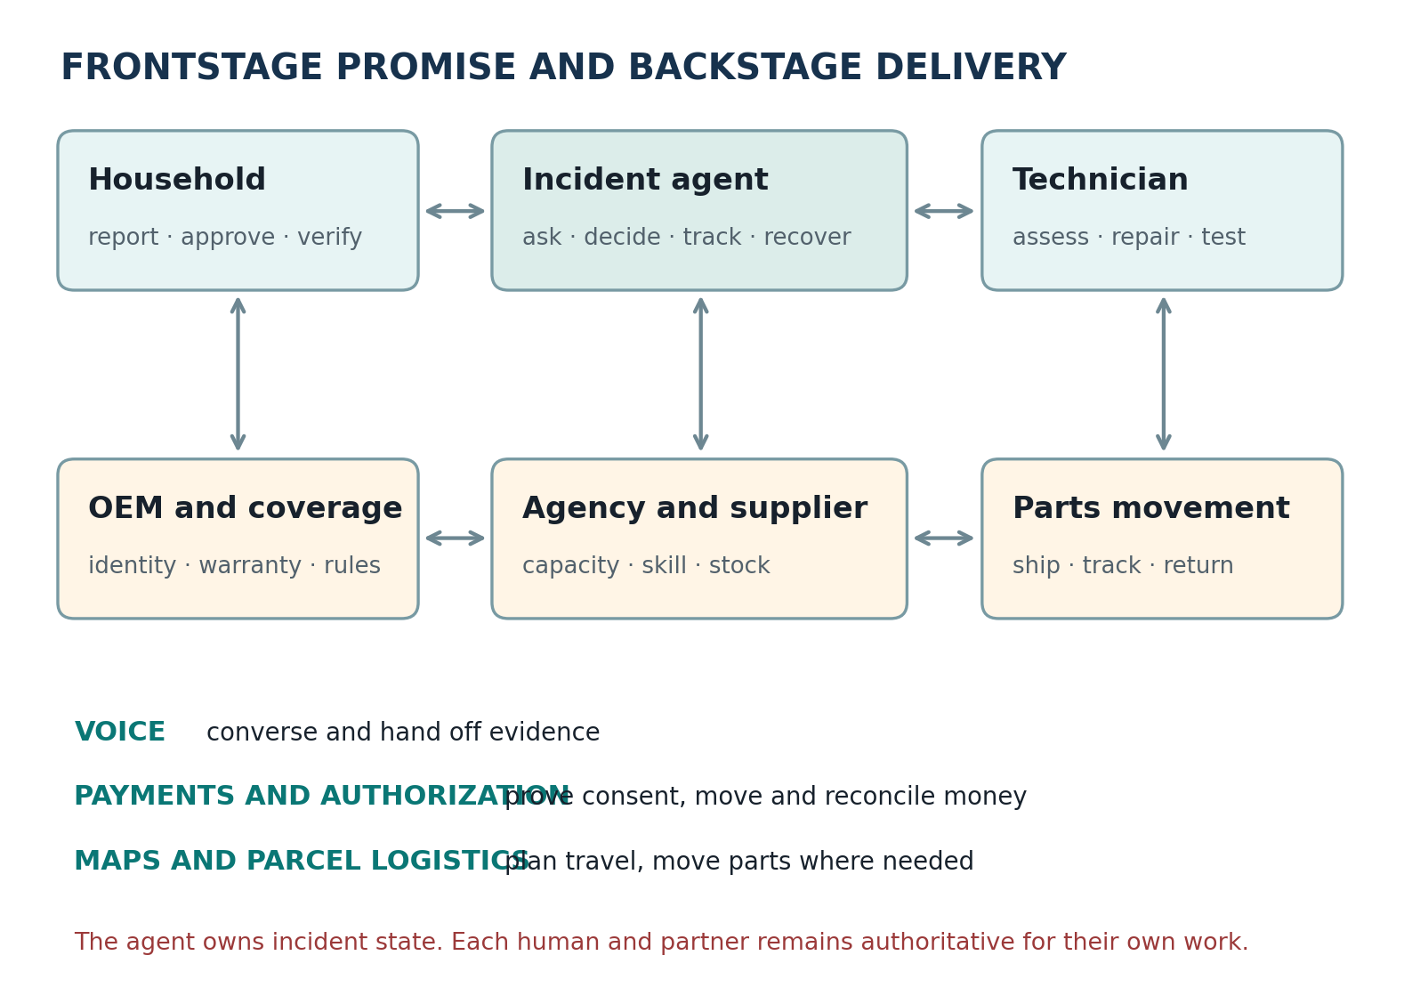
The incident agent is the coordinator and record keeper. Gnani, Pine Labs, and Delhivery are possible capabilities under it; they do not become its goals. The physical repair is performed by a technician, while eligibility and part identity must be checked against an authoritative provider or a competent human.

Stakeholders and triggers
Stakeholder | Trigger and goal | Possible concern | Simplest touchpoint
Household reporter | Breakdown, service alert, repeated poor performance — Restore the household function with little effort | Loss of routine; uncertainty about cause and whom to call | Call, chat, photo; one incident timeline
At-home person | Visit proposed or technician at door — Safe entry and manageable interruption | Is this the right person, and am I permitted to let them in? | Identity and slot card; explicit entry control
Cost approver and payer | Inspection fee or changed scope — Control spending and avoid surprise charges | What changed, why, and what happens if I decline? | Itemized decision card; approve, reject, ask
Landlord or asset owner | Tenant reports issue or coverage decision — Protect asset and decide responsibility | Am I liable, and can work proceed without my presence? | Scope, evidence and permissions on a limited link
Technician | Job offered with evidence and time window — Complete paid work efficiently and safely | Is the fault credible, part available, and job worth the travel? | Short job brief; tests, parts, price-change route
Agency dispatcher | Qualified job enters queue or exception fires — Use capacity profitably; meet promises | Who can do this, with what kit, and at what time? | Ranked dispatch options and exception queue
Parts seller or depot | Reserved candidate part or return request — Sell correct parts with low return friction | Will this fit, who pays, and when is it required? | SKU and compatibility request; hold and release
OEM or warranty provider | Serial or warranty evidence appears — Honor covered claims and protect brand/service costs | Is this device eligible, and is outside repair allowed? | Entitlement check and handoff request
Courier or local runner | Ready parcel, return, or workshop movement — Collect and deliver a valid consignment | Is it packaged, serviceable, labelled and ready? | Shipment details and tracked exception
Platform operator or human reviewer | Unsafe, disputed, ambiguous or stalled case — Resolve exceptions and limit harm and loss | Which facts are verified, and who owns the next action? | Evidence trail, timers and manual takeover

These “possible concerns” are hypotheses that should guide design and later research, not quotes. A person can hold several roles; reporter, payer, owner, and person at home may also be different people. Role assignment is incident-specific.

Journey maps by person

Household reporter
Sees and hears: Sees machine fail, perhaps a service code; tries a remembered fix or contacts someone known. Thinks and feels (hypothesis): Wants routine restored; may worry that another visit means another day lost.
Does: Shares symptom and consequence; chooses safe interim alternative; can say “call a human.” Agent interaction: Receives one question at a time, plan and next owner, changes only when necessary, and a clear result check.

At-home person
Sees and hears: Sees arrival window and verified name before opening; may know little about repair. Thinks and feels (hypothesis): Wants physical safety and no pressure to decide a costly repair.
Does: Permits or refuses entry; watches relevant test; reports any uncomfortable interaction. Agent interaction: Can validate identity, defer price to approver, and pause or end the visit.

Cost approver
Sees and hears: Sees initial fee, then perhaps an evidence-backed scope revision. Thinks and feels (hypothesis): Wants the reason for the change, the ceiling, and alternatives.
Does: Chooses inspect, proceed, defer, second opinion, or stop. Agent interaction: Gets a concise itemized request with the changed condition, consequence and expiry.

Tenant or landlord
Sees and hears: Sees fault and an ambiguous cost responsibility. Thinks and feels (hypothesis): Wants to avoid dispute and unauthorized modifications.
Does: Identifies covered responsibility; approves intrusive work or selects OEM path. Agent interaction: Sees the same scope but only the permissions and data needed for their role.

Technician
Sees and hears: Sees a case offered with symptom confidence and what remains unknown. Thinks and feels (hypothesis): Wants a workable visit, not a dictated diagnosis or unpaid return trip.
Does: Accepts job; confirms skill and kit; performs safe test; revises scope with evidence. Agent interaction: Can reject AI fault hypothesis, flag part incompatibility and get an escalation without punishment.

Agency dispatcher
Sees and hears: Sees several potential jobs, deadlines and qualified workers. Thinks and feels (hypothesis): Balances utilization, callback risk, travel, and customer commitments.
Does: Assigns, reassigns, contacts suppliers and owns missed-slot escalation. Agent interaction: Sees ranked candidates with reasons, skill gates and explicit source of stock truth.

Parts supplier
Sees and hears: Sees SKU request, stock reservation and potential unused return. Thinks and feels (hypothesis): Wants exact variant, payment assurance, cut-off time and return terms.
Does: Confirms compatible stock, reserves and packs or reports an honest shortage. Agent interaction: Receives structured part and device identifiers; can decline uncertain compatibility.

OEM or service center
Sees and hears: Sees model and serial, reported fault and coverage evidence. Thinks and feels (hypothesis): Wants warranty route honored and unauthorized service prevented.
Does: Accepts or rejects entitlement; provides case and technician route. Agent interaction: Agent hands over context once, discloses uncertainty, waits for authoritative response.

Courier
Sees and hears: Sees parcel request and scheduled collection. Thinks and feels (hypothesis): Wants complete address, packaging and pickup readiness.
Does: Moves part or appliance and returns event scans. Agent interaction: Agent converts logistics updates into repair-plan changes, not just shipment notifications.

Human reviewer
Sees and hears: Sees an exception with prior actions, permissions and source evidence. Thinks and feels (hypothesis): Wants to know what failed and what can safely be done next.
Does: Takes ownership of ambiguity, harm, dispute or prolonged delay. Agent interaction: A concise case record shows unresolved questions and the customer promise at risk.

Conditions that change the journey
Condition | Variants to map | Decision affected
Machine criticality | Purifier no safe water; refrigerator spoiling food; cosmetic noise | Priority, temporary workaround and deadlines change.
Hazard | Gas leak, electrical burning smell, water near power | Stop ordinary troubleshooting; safe instructions and emergency human route.
Coverage | In warranty; AMC; unclear warranty; out of warranty | OEM or contracted route may outrank independent technician.
Repairability | Simple owner check; field repair; workshop only; replacement preferable | Route changes; no first-visit guarantee.
Device evidence | Model clear; model obscured; serial missing; invoice disputed | Confidence and permission for parts reservation change.
Parts | In technician kit; local seller; parcel; obsolete; counterfeit risk | Dispatch waits, kit changes, or replacement considered.
Service geography | Metro, smaller city, gated society, remote address | Available technician pool and parcel feasibility vary.
Household structure | Single adult; tenant/owner; separate payer; elder alone | Permissions and contact channel differ.
Availability | Person at home, no one at home, rescheduled access | Visit must be confirmed or postponed.
Provider model | Known technician; agency; OEM; marketplace | Different trust evidence, pricing and compensation rules.
Payment | No fee; inspection fee; milestone; cash-only provider | May require manual payment and receipt capture.
Language/accessibility | Telugu/English switching; poor network; hearing limits | Offer text, repetition and human handoff.
Outcome | Resolved; symptom changed; intermittent; returned | Verification window and next route differ.

System states and ownership
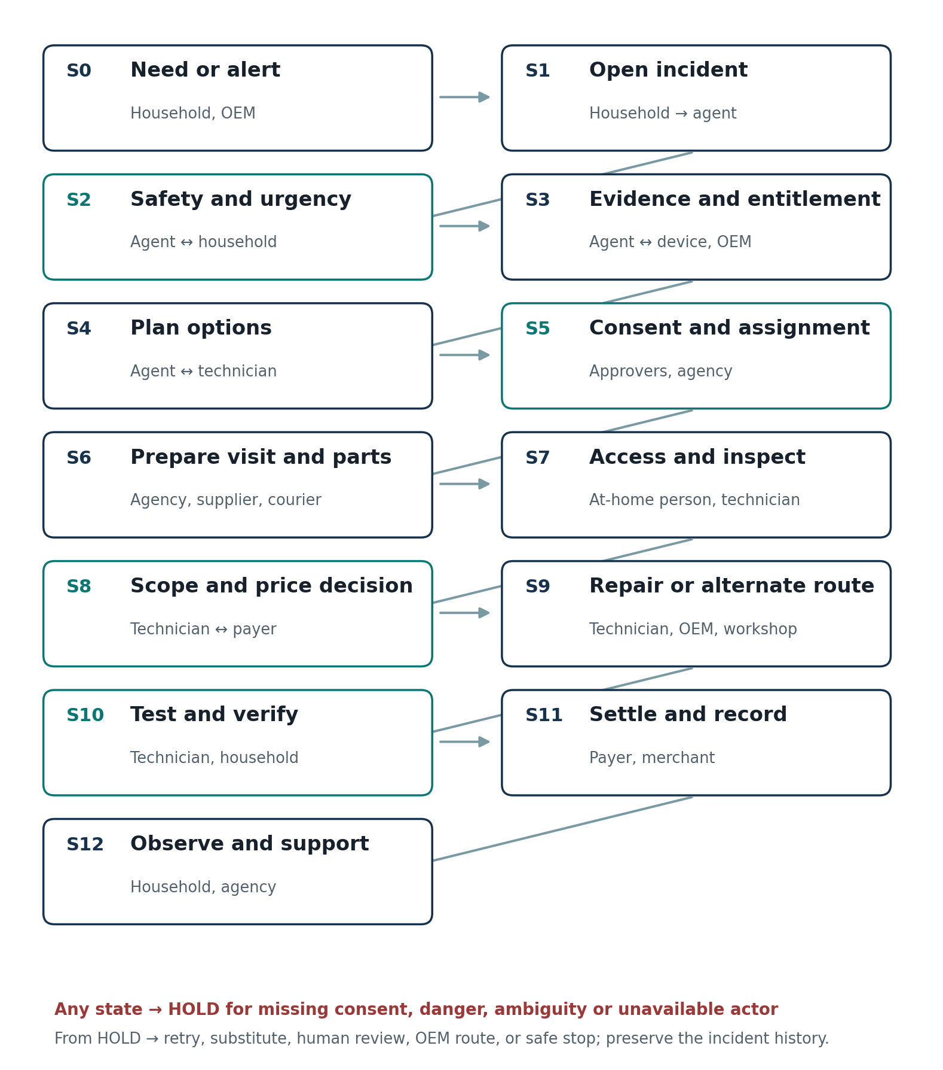
The arrows show the nominal progression; HOLD is an explicit cross-cutting state. Every hold has a reason, owner, deadline, and permitted next action. There is no automatic jump from shipment delivery or technician checkout to repair acceptance.
State | Entry and core action | Primary actor | Decision and failure rule
S0 Need arises | Breakdown, degraded performance, due service or OEM alert. | Household or authorized signal | Is it a problem worth starting? No action until reporter confirms if trigger is inferred.
S1 Incident opened | Capture appliance, function lost, location, contact and preferred language. | Reporter | Can we identify who can be contacted? Deduplicate prior open issue; do not expose house data to an unknown caller.
S2 Safety and urgency | Check danger signs, urgency, interim household need. | Agent with reporter; emergency human if needed | Can safe remote checks proceed? Halt unsafe instructions; emergency advice and human escalation.
S3 Evidence and entitlement | Request model/serial, error, photo or short sound only if useful; check prior visits and coverage. | Household, OEM, records | What route is allowed and what is unknown? If coverage uncertain, seek authoritative confirmation or stop outside intervention.
S4 Plan proposed | Offer remote step, OEM route, inspection, likely kit, workshop or replacement discussion. | Agent and qualified technician | Which option has acceptable time, risk and cost? Display uncertainty and alternatives, not a single asserted fault.
S5 Authority and assignment | Record who approves entry, inspection, dismantling, new spend and removal; choose qualified provider. | Relevant household roles, agency | Do permission and provider match the job? No implicit transfer of one person’s permission to another action.
S6 Preparation | Verify part variant and stock; reserve kit, schedule courier if needed; align actual arrival windows. | Agency, supplier, courier | Can worker and parts be present together? Replan before promising a visit; give honest earliest path.
S7 Arrival and assessment | Confirm identity, access and observations; technician tests hypothesis. | At-home person and technician | Does physical evidence support the plan? Block work if identity, access or safe conditions fail.
S8 Scope and price | Document revised fault, parts, labour, tax, reason, alternatives and expiry. | Technician and cost approver | Is the proposed work approved? Hold before irreversible work; no silent upcharge.
S9 Work or alternate | Repair, OEM transfer, workshop movement or replacement decision. | Technician, OEM or workshop | Was approved work performed, with part provenance? Record blocked work and next owner; do not call an inspection a repair.
S10 Verification | Run appliance-specific test, share result, get household response. | Technician and household | Is function restored safely enough to release the visit? Disputed test enters review; intermittent issue gets observation window.
S11 Money and record | Confirm settled amount and recipient; invoice, part, warranty and consent log. | Payer, merchant, platform | Is payment authorized and reconciled? Unknown payment state requires status lookup before any retry.
S12 Aftercare | Monitor agreed guarantee window and reopen on recurrence. | Household, agency | Has the household remained able to use the function? Reopen same case, preserve evidence, route rework or refund review.

Detailed decisions and interaction rules

S0 to S2
Start from “what cannot be done now” rather than asking for a component name. Ask whether there is heat, smoke, gas, an exposed wire, or water near electricity. If danger is possible, do not invite the user to open a casing or perform electrical tests. Offer immediate safe steps appropriate to an approved safety script and hand off to a qualified human. Keep incident initiation possible by phone or simple text.

S3 and S4
Ask for model evidence only when it can change warranty routing or compatible parts. Distinguish symptom, possible cause, diagnostic test, and part candidate in the record. If multiple causes fit, the agent requests a discriminating observation or a technician review. A remote check is offered as an option; the household may decline. If warranty is unresolved, the default is a protected inspection or OEM enquiry, not unauthorized dismantling.

S5 and S6
Permissions are a matrix: who may book, admit, inspect, dismantle, remove, spend, and confirm success. The agent can reserve a nonbinding slot within policy, but a costly kit, shipment or paid appointment follows the relevant authorization. Only promise a slot after the worker and required confirmed part are feasible together. A candidate kit can be carried without asserting every candidate part will be used.

S7 to S9
The technician is allowed to contradict the agent. New evidence changes the diagnosis and reopens scope. The on-site person need not become the payer. Send the approver a short before/after diagnosis with evidence, labor, part and total ceiling. If approval is late, pause the job and tell all parties the next time commitment. A refusal must end in a safe leave-behind condition and a clear alternative.

S10 to S12
Separate proof of attendance, proof of work, functional test, customer acceptance, payment status and guarantee status. A one-minute working test does not prove durability. Log unresolved symptoms and schedule the narrowest useful follow-up. Recurrent failures reopen the same incident with the original part and test record; the household should not re-explain the case.

A movie of one washing machine incident
This is a hypothetical exercise. The first two columns are the visible story; the last two describe parallel backstage actions and the agent’s choice. Timings are illustrative sequence markers, not promised service levels.
Scene | What people see | Parallel work and agent response | Resulting state
T0 08:10 | Washer stops taking water. Reporter calls and says laundry is piling up. | Agent opens incident, checks for unsafe conditions and records what function is lost. | Case S1–S2; urgent household need is understood.
T1 08:12 | Reporter describes error and sends model label when asked. | Agent checks past job and warranty; a qualified technician reviews inlet versus control-board hypotheses. | S3–S4; uncertainty remains visible.
T2 08:20 | Household sees “inspection tomorrow; possible inlet part; no charge beyond inspection without approval.” | Dispatcher checks skill, travel and kit. Supplier checks SKU stock in parallel. Agent checks which adult may open and who may pay. | S5–S6; visit is promised only after feasible preparation.
T3 Next day | At-home person confirms name at door and allows inspection. | Technician tests supply and inlet; may affirm or overturn initial hypothesis. | S7; scope branches according to physical findings.
T4 During visit | Payer receives an itemized change only if scope or price differs. | Technician can wait, offer safe inspection-only finish, or seek approved alternate. | S8; no irreversible work without the right approval.
T5 Finish | At-home person watches a fill cycle; reporter later confirms laundry can run. | Agent records test and part, reconciles authorized charge, keeps guarantee state open. | S9–S12; paid does not itself mean fixed.

Four branches traced from the same starting facts
Branch | Changing signal | Who decides and sees it | Next state and recovery
A Correct part, fixed | Technician test confirms inlet fault; stocked compatible valve works. | Technician tests; at-home person confirms fill; payer sees agreed price. | Close visit only after test and consent; preserve guarantee and part record.
B Initial hypothesis wrong | Physical test shows blocked supply or electrical board issue. | Technician records contradictory finding; agent revises options and stops use of wrong part. | If safe simple fix, request changed scope; otherwise second specialist, OEM, or inspection-only end.
C Correct part unavailable | Supplier refuses stock or parcel misses cutoff before dispatch. | Agent compares delayed visit, substitute approved part, or diagnostic-only trip; informs household. | Never send technician on the fiction that part is present; reschedule with accountable owner.
D Fault returns | Household reports recurrence after a passed fill cycle and payment. | Agent reopens original case with old evidence, warranty and paid scope; technician or reviewer checks root cause. | Route guaranteed rework or independent review; review money if provider cannot fulfil.

Trace template for every new branch: trigger → observation → confidence/source → alternative options → actor and permission → action → visible confirmation → timeout → owner of recovery → exit condition. Reuse it for refrigerator, purifier, AC, and non-appliance household services.

Autonomy and human control
The competition scores L1–L4 by the most consequential act the agent performs without asking anybody. An agent may have L3 authority for a refundable reservation and L2 authority for spending; its overall autonomy claim must reflect the strongest consequential autonomous act. The table is a design proposal, not a technical feature already present in a partner product. [C1]
Action | Provisional agent freedom | Human or authoritative gate
Ask questions; summarize; suggest a safe observation | May act within approved scripts | Household can correct, skip or call a human.
Compare qualified providers and candidate parts | May recommend with confidence and source | Technician confirms diagnosis and part compatibility.
Reserve a free reversible slot | May act if household specified preferred windows | Confirm before a binding cost or home access commitment.
Book inspection with published fee | Ask household for explicit approval | Payer approves if different from reporter.
Send courier with paid part | Ask relevant approver unless a narrow prior mandate covers exactly this | Supplier confirms stock; household approves cost and destination.
Admit worker, dismantle or remove machine | Never infer permission from booking | At-home/owner role grants each relevant permission.
Approve revised quote or pay extra | Never exceed explicit amount and scope grant | Named cost approver sees reason and total.
Record repair complete | Can record technician claim and objective test | Household acceptance and aftercare remain distinct states.

At every authorization the person should see the proposed act, party, amount if any, what happens if they do nothing, expiry, and how to reverse it. If no response arrives, the agent holds. Silence cannot become approval. For an ambiguous payment response, retrieve transaction state before retrying. These are safety and trust design rules, not assertions about payment-provider defaults.

Failure and edge case catalogue
The list is deliberately broad. Each row gives a detection point, the safe next action, and an owner. “Human” means the responsible operator or qualified specialist, not an anonymous support queue. Cases are designed to be reachable from any state as appropriate.

Trigger and safety
ID | Detection signal | Agent response | Next owner
E01 | Burning smell or sparks | Stop self-tests; emergency safety instruction; qualified human | Safety lead
E02 | Water near live electricity | Do not ask user to touch appliance; isolate only if safely possible | Safety lead
E03 | Gas smell | Exit routine repair; emergency service route | Safety lead
E04 | Child or elderly person alone | No entry without authorized adult; safe alternative | Household
E05 | Machine works intermittently | Capture condition/timing; observation state | Technician
E06 | Duplicate complaint for same device | Link to open incident; prevent double booking/payment | Agent
E07 | False preventive alert | Ask confirmation and check signal quality before opening case | Agent

Evidence and coverage
ID | Detection signal | Agent response | Next owner
E08 | Model image blurry | Request one better image or physical technician verification | Household
E09 | Serial conflicts with invoice | Mark entitlement unknown; OEM confirmation | OEM
E10 | Warranty unclear | Protect eligibility; no invasive outside repair | OEM
E11 | Warranty active, local tech requested | Explain consequence and ask route choice after rules check | Household
E12 | Fault has multiple likely causes | Send test plan and candidate kit only after specialist review | Technician
E13 | Remote step might void warranty | Do not recommend; ask OEM | OEM
E14 | No recorded prior repair | State unknown; do not invent maintenance history | Agent
E15 | Reported sound lacks usable recording | Offer description or visit; do not force audio retry | Household

Authority and contact
ID | Detection signal | Agent response | Next owner
E16 | Reporter differs from owner | Check scope of authority before removal or irreversible work | Owner
E17 | Payer unavailable on-site | Hold revised work; inspection-only safe exit | Payer
E18 | Landlord and tenant disagree | No unilateral costly work; preserve safe state and decisions | Owner
E19 | Consent link forwarded | Reverify identity and role; never trust URL alone | Operator
E20 | Language misunderstanding on amount | Read back amount, currency, and scope; confirm in text | Payer
E21 | Agent cannot reach person | Time out, explain next owner, never infer yes | Operator
E22 | Person withdraws consent | Stop future action; handle work already underway safely | Operator
E23 | Recorded access permission expires | Reconfirm before visit | At-home person

Provider and scheduling
ID | Detection signal | Agent response | Next owner
E24 | Technician rejects hypothesis | Accept evidence; revise plan and customer update | Technician
E25 | Wrong skill matched | Prevent dispatch or reassign with slot update | Dispatcher
E26 | Technician no-show | Proactive status check, replacement or new honest ETA | Dispatcher
E27 | Worker arrives early or unannounced | Do not pressure entry; rebook per household preference | Dispatcher
E28 | Identity mismatch at door | Refuse entry and verify via known channel | At-home person
E29 | Society gate blocks entry | Coordinate permitted access or change slot | Dispatcher
E30 | Tech discovers additional fault | Pause, document evidence, itemized quote and approval | Technician
E31 | Technician asks off-platform cash | Record request, hold digital settlement, human dispute route | Operator
E32 | Worker leaves worksite unsafe or dirty | Document and route immediate remediation | Agency
E33 | Provider has conflict of interest | Show options and independent second opinion path | Operator

Part and physical movement
ID | Detection signal | Agent response | Next owner
E34 | Similar but incompatible part | Stop install; verify exact model variant | Technician
E35 | Stock count stale | Require supplier reservation confirmation before promise | Supplier
E36 | Candidate kit too costly | Choose diagnostic visit or minimal set by expected value | Dispatcher
E37 | Courier delayed | Reconcile technician slot; no wasted arrival | Dispatcher
E38 | Parcel marked delivered, absent | Verify recipient/proof; investigate, not assume possession | Courier
E39 | Part damaged in transit | Reject and re-source; preserve cost attribution | Supplier
E40 | Unused part not returned | Track custody; reconcile supplier terms | Agency
E41 | Appliance needs workshop | Separate removal consent, packaging, custody and return | Owner
E42 | Old component disputed | Photograph and record disposition; technician review | Agency
E43 | Part discontinued | Offer safe alternative, OEM route or replacement case | Technician

Payment and settlement
ID | Detection signal | Agent response | Next owner
E44 | Price rises after machine opened | Stop irreversible work; show reason and alternatives | Payer
E45 | Initial quote ambiguous | Present range and inspection fee separately | Agent
E46 | Payment timeout | Read status before retry; keep idempotent incident reference | Operator
E47 | Charged twice | Freeze further charge; reconcile and refund route | Operator
E48 | Payer disputes completion | Hold conditional release where available; human adjudication | Operator
E49 | Independent tech not onboarded | Use approved manual settlement; no fake P3P/escrow claim | Operator
E50 | Payer uses cash | Record amount and receipt; do not claim verified digital settlement | Agency
E51 | Refund promise cannot execute | Show manual owner and deadline | Operator
E52 | Split settlement ineligible | Use ordinary merchant flow; do not call it escrow | Operator

Verification and recovery
ID | Detection signal | Agent response | Next owner
E53 | Test passes only briefly | Provisional completion; follow-up window | Technician
E54 | Household and tech disagree | Capture both accounts; independent review | Reviewer
E55 | Same fault returns in guarantee | Reopen same case; prioritize rework | Agency
E56 | New unrelated fault appears | Open linked but separate scope and quote | Technician
E57 | No household test possible | Schedule later verification; no fabricated acceptance | Household
E58 | Machine replaced instead | Close repair as alternate outcome, record trade-off | Household
E59 | Household unreachable after visit | Record technician test; acceptance pending | Operator
E60 | Service partner closes ticket early | Reopen on contrary evidence; preserve full audit trail | Operator

System and operational limits
ID | Detection signal | Agent response | Next owner
E61 | Speech transcription corrupts model | Repeat exact identifier or request photo | Agent
E62 | Provider API unavailable | Queue safe retry; human manual route; no invented success | Operator
E63 | State update arrives out of order | Use timestamp and source; verify current physical state | Operator
E64 | Conflicting stock systems | Treat unconfirmed; ask supplier to attest | Supplier
E65 | Cross-party privacy leak risk | Share only role-relevant fields; audit access | Operator
E66 | Agent loops on failed action | Cap attempts and escalate with summary | Operator
E67 | External partner refuses integration | Use human handoff; label unsupported automation | Operator
E68 | No viable provider in city | Offer OEM, workshop, delayed or self-managed option clearly | Household

Rail overlay after the journey is understood
Legend: D = public documentation names a capability. I = integration or orchestration the team must design. U = unverified eligibility or operating access. N = new rail capability or partner relationship would be needed. These labels describe *evidence for a capability*, not whether a working integration has been built. The team currently has a Gnani playground; Pine Labs and Delhivery integration behavior is untested. [G1–G4, D1–D4, P1–P4]
State | Rail | Documented building block | Input → output | Status | Forbidden inference
S1–S3 | Voice | Speech-to-text, configured agent, knowledge base, call summary | Symptom/urgency and language → transcript, disposition | D for speech; I for appliance triage | Never treat garbled model or amount as verified.
S3–S4 | Voice + custom action | On-call or post-call HTTP action to incident service | Device facts → entitlement lookup result | D integration; U OEM lookup | Never assert coverage without OEM response.
S4 | Voice + human expert | Call specialist with compact context | Evidence and hypotheses → revised test plan | D speech; I expert routing | Never disguise an AI guess as technician confirmation.
S5 | Voice | Converse separately with reporter, payer, person at home | Specific act and limits → confirmation | D voice; I verified role/consent | Never equate caller ID with spending authority.
S5–S6 | Maps | Geocoding, address validation, routing, distance matrix | Locations → normalized address, distance/time | D maps; I skill/slot optimizer | Never assume route equals technician availability.
S6 | Parcel | Serviceability, shipment/pickup, tracking, returns | SKU parcel, address → AWB and scan events | D shipment categories; U API contract | Never promise same-day part from an AWB alone.
S5–S6 | Payments | Payment link/order for disclosed inspection fee | Payer, amount → link/order and status | D payment; I policy check | Never charge because a slot was reserved.
S8 | Voice + payments | Explain revised scope; payment action after approval | Quote, authorized payer → recorded consent and payment state | D voice/payment; I binding scope consent | Never make spoken ambiguity an authorization.
S9 | Logistics + payments | Optional workshop shipment and charge | Approved removal and shipping cost → custody, payment | D parcel/payment; I custody protocol | Never remove machine under inspection consent.
S10–S11 | Payment lifecycle | Card pre-auth capture/cancel where supported; refund; split settlement where eligible | Approved order and test state → settlement | D restricted flows; U eligibility | Never call split settlement generic escrow.
S10–S12 | Voice | Follow-up call and logs | Test outcome → household acceptance or recurrence | D calls/logs; I repair verification | Never mark “fixed” solely from call disposition.
S12 | Three-rail composition | Voice recurrence + paid case + returned part | New symptom → rework plan and reconciled cost | I orchestration; N shared incident semantics | Never create a second paid incident by default.

Voice domain details
Gnani offers STT REST and real-time, TTS, an Agent Builder with knowledge bases, dynamic variables, custom HTTP actions, multilingual settings, conversation logs, and platform endpoints to configure agents and retrieve call outcomes. Good uses: voice-first reporting, precise follow-up question, technician readback, separate approval request, callback after failure. The innovation is an incident conversation that remembers contradictory evidence across actors, switches between household and technician without losing the source of each claim, and escalates on danger or low confidence. The published docs do not establish robust photo/video diagnosis, acoustic fault recognition, or an authoritative repair vocabulary. These require separate models, expert validation and evidence linking. [G1–G4]

Logistics domain details
Delhivery Maps provides address normalization/validation, travel routing and distance matrices, useful for geographies and travel costs. Delhivery One documents B2C parcel creation, pickup, tracking and reverse movement and B2B cargo workflows. Good uses: verify a deliverable parts address, compare technician travel, move a confirmed part and detect shipment delays. Innovation would combine technician skill, real availability, job duration, fault-specific kit inventory, courier deadlines and household access into a repair-aware plan. Maps cannot assign a trained technician or attest part compatibility; courier scans cannot prove the repair. Client portal API request and response detail requires access, and cost, eligibility and SLA must be verified. [D1–D4]

Payments and authorization domain details
Pine Labs documents orders, payment links, refunds, payouts and split settlements; P3P offers mandate-based agent payments with Grantex scopes and approved ceilings. Card pre-authorization and later capture/cancel have method and merchant constraints. Good uses: clearly priced inspection, scoped customer payment, refund, vendor settlement and audit of authorized spend. The innovation needed is repair-specific permission semantics: payer versus resident versus owner; scope versioning when diagnosis changes; a completion rule based on credible tests and disputed outcomes; and onboarding routes for informal local providers. A “wallet with a cap” alone is already within documented agentic payment patterns. A held split settlement exists, but is not a universal, neutral escrow for any technician. [P1–P4]

Combinations worth evaluating
Decision point | Rails combined | Potential benefit | Missing layer or failure
Call identifies urgent purifier failure | Voice + maps | Ask location, find earliest qualified route | Live technician capacity and entitlement.
Part needed before promised visit | Voice + logistics | Confirm variant verbally, ship, update both people | Compatibility and real inventory; synced deadline.
Changed quote from doorstep | Voice + payments | Call actual approver, record revised scope, authorize amount | Identity and evidence-based repair permission.
Supplier kit reserved | Logistics + payments | Fund permitted part and plan return of unused candidates | Supplier terms, custody and working capital.
Repair test passes but customer disputes | All three | Preserve call, shipment and payment evidence in one case | Independent adjudication and recovery owner.
Repeat fault during guarantee | All three | Recall original part/tech and arrange rework without new chase | Warranty rules and liability agreement.

Fourth rail as a genuine adjacent domain
A fourth rail is not another API inside the existing three. It is a distinct capability domain with its own data, infrastructure and economic reason to join. These are candidates, not a recommendation yet; each company’s current offering is only a starting point, not evidence of partnership or open API access. [F1–F5]
Domain and Indian example | What its existing infrastructure could contribute | Why that company might participate | Open feasibility question
Device identity and protection — Servify | Care plans, OEM and service-center relationships, coverage/claim history for supported products. | More eligible service volume, better loss and service data, potential distribution for protection plans. | Home-appliance breadth, cross-brand entitlement rights and live access need verification.
Home appliance after-sales and warranty — Onsitego | Appliance repair, AMC and extended-warranty service operations. | Lower callbacks and claim cost; agency channel or embedded assistant. | It may prefer owning the whole repair experience; independent interoperability unclear.
B2B parts commerce — Moglix | Procurement, vendor master data, inventory and warehousing for MRO/consumer durables. | New recurring demand and better spare-part forecasting. | Consumer appliance SKU fit, availability and returns need proof.
Building access and property operations — MyGate | Society/gate and household access coordination where deployed. | More useful resident service workflows and vendor verification. | Coverage outside managed societies and consent interoperability.
Device telemetry and OEM control — a connected-appliance OEM | Sensor events, service codes, serial entitlement and approved procedures. | Lower service costs and better retention, but proprietary advantage may discourage opening data. | Brand fragmentation; legacy appliances have no telemetry.

Decision rule for later: first choose the outcome and dominant failure mode. If wrong eligibility/part drives failure, device identity may be the highest-value domain. If local stock is the bottleneck, B2B parts commerce may matter more. If unattended access blocks repair, property operations may matter most. Do not select a fourth company because it makes a neat four-logo diagram.

Interaction design principles translated into rules
Design principle | Concrete application to this agent | Failure it prevents
Make state visible | Show next actor, promised time, evidence source and whether a claim is confirmed. | A generic “under review” hides responsibility.
Bridge action and feedback | For every approval, show proposed act; afterward show whether it happened and what changed. | A person cannot tell whether permission had effect.
Match the mental model | Lead with “get drinking water back” or “washer fills again”; reveal technical codes only when useful. | Users have to become repair dispatchers.
Design for slips and mistakes | Confirm high-cost amounts and model suffixes; reversible actions; keep a correction path. | Misheard model or accidental approval causes harm.
No dead ends | Every hold has named owner, deadline, fallback and visible next step. | The household must restart the chase.
Frontstage and backstage alignment | Keep the household promise synced with technician acceptance, stock and courier arrival. | A polished interface masks an impossible slot.
Progressive disclosure | One clear next question; details on demand; separate report, access and payer experiences. | The family receives a long technical questionnaire.
Emotional restraint | In urgent incidents, be calm, explicit and accountable; no cheerful “success” until function returns. | False reassurance erodes trust.

Norman distinguishes choosing and performing an action from perceiving and evaluating its result; both halves matter for every handoff. Kalbach’s mapping connects the outside-in journey to frontstage and backstage processes. Downe’s principles include minimum steps, no dead ends, explaining decisions, and human help. The design texts recommend testing hypotheses with users later; none yields a universal acceptable error rate. [B1–B7]

Failure thresholds and operating economics
No book or attached interview supplies a universally acceptable failure percentage for appliance diagnosis. Set thresholds by severity, not one aggregate “AI accuracy” figure. Zero unapproved home entry, unsafe suggested repair, or unauthorized spend is an intended design requirement. For fallible recommendations, measure calibration and abstention as well as accuracy: top fault candidate, part compatibility confirmed by technician, avoided sourcing trips, unused kit return, and false reassurance. All numeric targets would be proposed later after baseline collection.
Household outcome | Operator efficiency | Trust and safety guardrails
Time until household function restored; household follow-up actions per incident; repair accepted then still working after agreed window. | Technician trips per completed repair; productive jobs per technician-day; dispatch-to-start time; part kit use and return cost. | Unauthorized action count; wrong-part installations; no-show rate; price-change approvals; disputed closure; incident data exposed to wrong role.
Share of incidents where agent completed coordination without household chasing. | Contribution per completed case = fee and margin less technician, parts, delivery, voice, support, returns and rework costs. | Abstention on unsafe/uncertain diagnosis; payment reconciliation; handoff completion and recovery time.

The expected-value decision to carry a candidate part is not simply its probability of being used. Compare saved technician trip and household delay with part carrying cost, stock opportunity cost, damage/return cost, courier cost and added diagnostic risk. Track who receives the savings: household, technician, agency, parts seller and platform may have different incentives.

Research resource register
Attached books are existing Library resources. This page is the reusable index for subsequent rounds. PDF page numbers below refer to the supplied file pages where noted; pagination may differ from printed editions. Only short paraphrases are used.
ID | Resource | Attached file | Relevant method | Applied here
B1 | Don Norman, The Design of Everyday Things | 45f1b244…pdf | Seven stages of action around PDF pp 54–59; human error and slips around pp 167–197. | Action, feedback, verification and recovery.
B2 | Lou Downe, Good Services | 61d3e331…pdf | 15 service principles; no dead ends, minimum steps, explain decisions, human help. | Whole-service promise and exception owner.
B3 | James Kalbach, Mapping Experiences | 5e6a2f87…pdf | Journey maps, mental-model diagrams, frontstage/backstage service blueprints. | Cross-stakeholder journey and system diagrams.
B4 | Yvonne Rogers, Helen Sharp and Jennifer Preece, Interaction Design | 3387fa40…pdf | Conceptual models, user research and usability heuristics; error prevention and recognition rather than recall. | Mental models, interaction details and approval interface.
B5 | Christian Müller-Roterberg, Design Thinking For Dummies | 58a612a9…pdf | Empathy maps, user journey, reframing and testing assumptions. | Separate observed evidence from hypothetical emotion.
B6 | Aarron Walter, Designing for Emotion | 49a0ac2b…pdf | Function, reliability and usability precede delight; trust-sensitive tone. | Calm recovery messaging.
B7 | Kevin P. Nichols, UX For Dummies | c085bef7…epub | User scenarios, channels, architecture, testing. | Role-specific channel and content design.

Case and partner sources
ID | Source | File or URL
E1 | Attached Round 1 submission | Ken Case Submission V1.pdf
E2 | Attached household interview transcripts | Call Amma, Sai Kakki, Rk Sir, Sarala Aunty, 6128maggi
E3 | Attached technician interview | Technician Transcript; consent for external evidence use was flagged unresolved in prior context
E4 | Attached survey PDF and MASTER_CONTEXT synthesis | Small convenience sample; recheck synthesis counts against raw data
E5 | Attached service artifacts | Notebook images and Havells chat video; redact personal data before external use
C1 | The Ken Round 2 brief | https://the-ken.com/case-competition-2026/
G1 | Gnani Speech APIs | https://docs.gnani.ai/api/introduction/quick-start
G2 | Gnani Agent Builder | https://docs.gnani.ai/introduction
G3 | Gnani custom integrations | https://docs.gnani.ai/D05_Custom
G4 | Gnani platform API | https://docs.gnani.ai/Platform/platform-introduction
D1 | Delhivery Maps developer portal | https://www.delhivery.com/maps/developer
D2 | Delhivery client developer portal overview | https://help.delhivery.com/docs/client-developer-portal-1
D3 | Delhivery pickup and forward orders | https://help.delhivery.com/docs/pickup-request
D4 | Delhivery B2B order flows | https://help.delhivery.com/docs/b2b-order-creation
P1 | Pine Labs payments API reference | https://www.pinelabs.com/docs/online-payments/api
P2 | Pine Labs P3P quickstart | https://www.pinelabs.com/docs/online-payments/ai/p3p/quickstart
P3 | Pine Labs order pre-authorization | https://www.pinelabs.com/docs/online-payments/payment-lifecycle/orders
P4 | Pine Labs split settlement release | https://www.pinelabs.com/docs/online-payments/api/split-settlements/release-settlement
F1 | Servify company site | https://servify.com/in/
F2 | Onsitego company site | https://onsitego.com/about-us
F3 | Moglix business site | https://business.moglix.com/
F4 | Urban Company service model | https://content.urbancompany.com/pdfs/supply/partner-app-supply/1745898316041-eb8db0.pdf
F5 | Mygate visitor-management offering | https://mygate.com/offerings/

Source handling: web product descriptions identify marketed and documented capabilities, not guaranteed access or availability to this team. The user reports Gnani playground access only. Hitesh Agar’s suggestions were mentioned in the request, but no clearly identified Hitesh Agar transcript was among the supplied sources; this document does not attribute unverified advice to him.

