This is the Home page which contains different Articles .

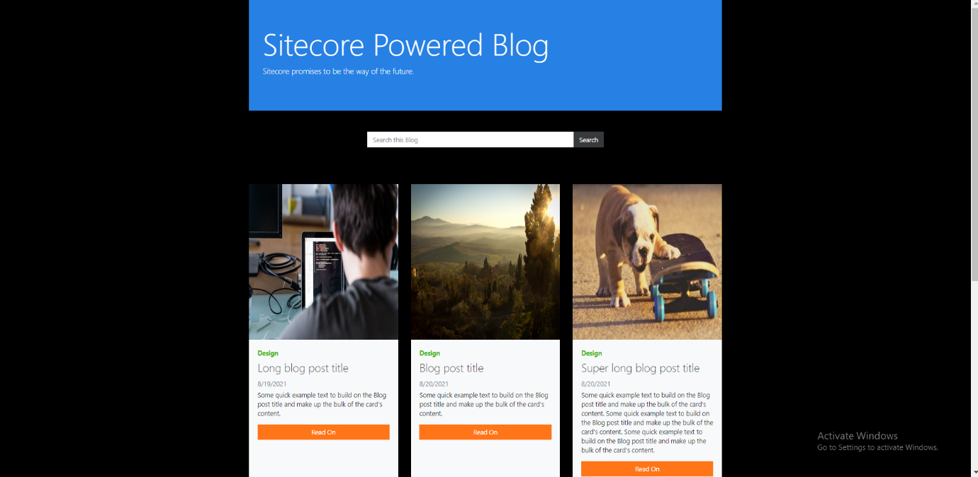

We can search for particular article based on category name , title ,description.It will display respective articles.

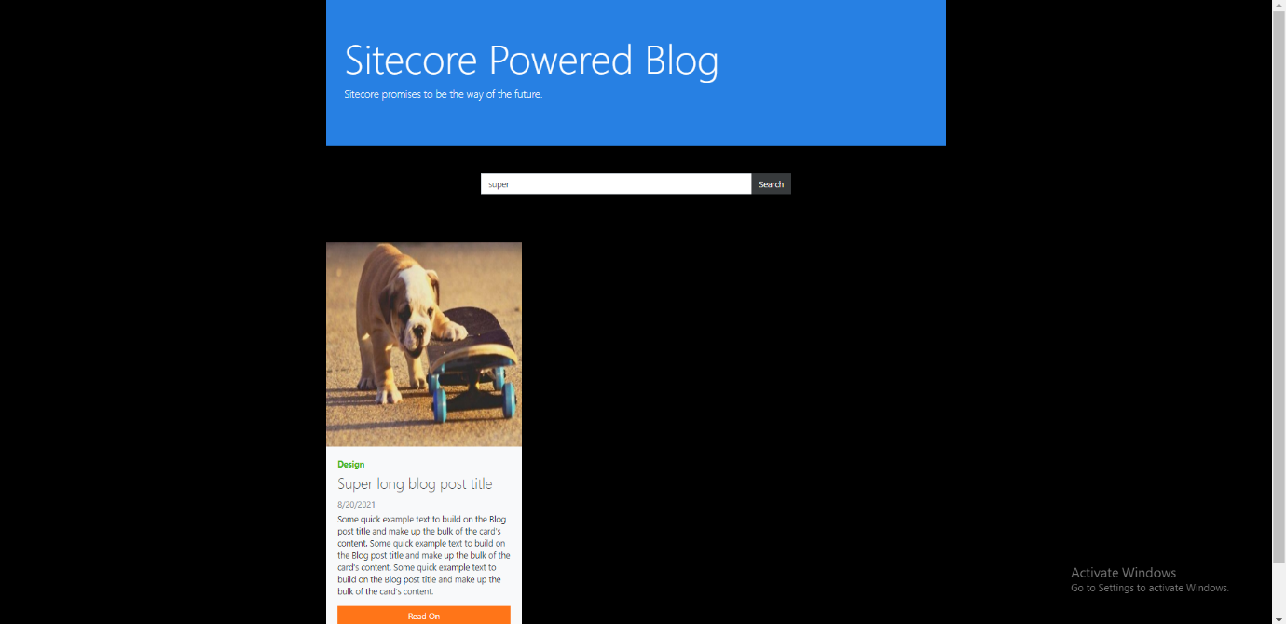

This is the page displayed when we click on readon button in homepage To read full article description .

