**Medical inventory optimization**

**Exploratory Data Analysis (SQL) by Pratiksha Saheb**

**Software: MySQL Workbench**

**Business decisions based on the unclean ‘medicines_db’ data**

**1. Set the current database to "medicines_db".**

use medicines_db;

**2. Displaying the Table**

select * from medicine_detail limit 10;

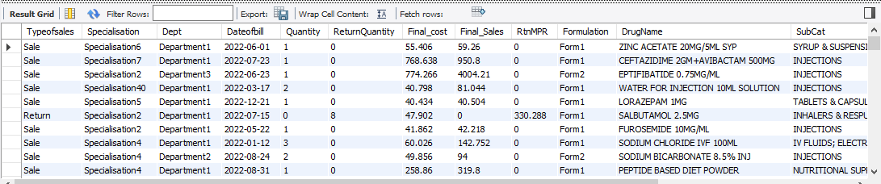

**3. Calculating the first moment (measures of central tendency such as mean, median, mode) for the dataset.**

**Mean:**

select

round(avg(Quantity),2) as mean_Quantity,

round(avg(ReturnQuantity),2) as mean_ReturnQuantity,

round(avg(Final_cost),2) as mean_Final_cost,

round(avg(Final_Sales),2) as mean_Final_Sales,

round(avg(RtnMPR),2) as mean_RtnMPR

from

medicine_detail;

**Output:**

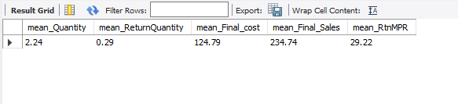

**Median:**

with ranked as

(

select Final_cost,

Final_Sales,

Quantity,

ReturnQuantity,

RtnMPR,

row_number() over (order by Final_cost) as r,

count(*) over () as c

from medicine_detail),

median as

(

select Final_cost,

Final_Sales,

Quantity,

ReturnQuantity,

RtnMPR

from ranked

where r in (floor((c+1)/2),ceiling((c+1)/2))

)

select round(avg(Final_cost), 2),

round(avg(Final_Sales),2),

round(avg(Quantity),2),

round(avg(ReturnQuantity),2),

round(avg(RtnMPR),2)

from median;

**Output:**

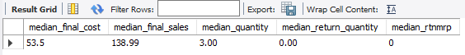

**Mode:**

select

mode_Quantity.mode_value as mode_Quantity,

mode_Quantity.mode_count as mode_Quantity_count,

mode_ReturnQuantity.mode_value as mode_ReturnQuantity,

mode_ReturnQuantity.mode_count as mode_ReturnQuantity_count,

mode_Final_Sales.mode_value as mode_Final_Sales,

mode_Final_Sales.mode_count as mode_Final_Sales_count,

mode_Final_cost.mode_value as mode_Final_cost,

mode_Final_cost.mode_count as mode_Final_cost_count,

mode_RtnMPR.mode_value as mode_RtnMPR,

mode_RtnMPR.mode_count as mode_RtnMPR_count

from(

SELECT Quantity AS mode_value, COUNT(*) AS mode_count

FROM medicine_detail

GROUP BY Quantity

ORDER BY COUNT(*) DESC

LIMIT 1 ) as mode_Quantity,

( SELECT ReturnQuantity AS mode_value, COUNT(*) AS mode_count

FROM medicine_detail

GROUP BY Quantity

ORDER BY COUNT(*) DESC

LIMIT 1

) as mode_ReturnQuantity,

(SELECT final_cost AS mode_value, COUNT(*) AS mode_count

FROM medicine_detail

GROUP BY Quantity

ORDER BY COUNT(*) DESC

LIMIT 1

) as mode_Final_cost,

(SELECT Final_Sales AS mode_value, COUNT(*) AS mode_count

FROM medicine_detail

GROUP BY Quantity

ORDER BY COUNT(*) DESC

LIMIT 1

) as mode_Final_Sales,

( select RtnMPR AS mode_value, COUNT(*) AS mode_count

FROM medicine_detail

GROUP BY Quantity

ORDER BY COUNT(*) DESC

LIMIT 1

) as mode_RtnMPR;

**Output:**



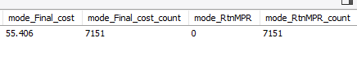

**4. Calculating the second moment (measures of dispersion such as variance, standard deviation, range) for the dataset.**

**Variance:**

SELECT

ROUND(VARIANCE(Quantity), 2) AS variance_quantity,

ROUND(VARIANCE(ReturnQuantity), 2) AS variance_return_quantity,

ROUND(VARIANCE(Final_Cost), 2) AS variance_final_cost,

ROUND(VARIANCE(Final_Sales), 2) AS variance_final_sales,

ROUND(VARIANCE(RtnMPR), 2) AS variance_rtnmrp

FROM medicine_detail;

**Output:**

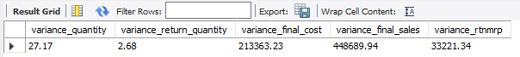

**Standard Deviation:**

SELECT

ROUND(STDDEV(Quantity), 2) AS stddev_quantity,

ROUND(STDDEV(ReturnQuantity), 2) AS stddev_return_quantity,

ROUND(STDDEV(Final_Cost), 2) AS stddev_final_cost,

ROUND(STDDEV(Final_Sales), 2) AS stddev_final_sales,

ROUND(STDDEV(RtnMPR), 2) AS stddev_rtnmrp

FROM medicine_detail;

**Output:**

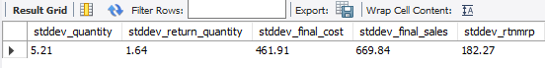

**Range:**

SELECT

MAX(Quantity) - MIN(Quantity) AS range_quantity,

MAX(ReturnQuantity) - MIN(ReturnQuantity) AS range_return_quantity,

MAX(Final_Cost) - MIN(Final_Cost) AS range_final_cost,

MAX(Final_Sales) - MIN(Final_Sales) AS range_final_sales,

MAX(RtnMPR) - MIN(RtnMPR) AS range_rtnmrp

FROM medicine_detail;

**Output:**

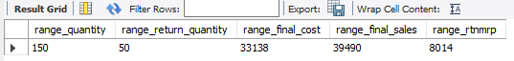

**5. Calculating the third moment (skewness) for the dataset.**

**Skewness:**

select Quantity_skewness1.Quantity_skewness,

ReturnQuantity_skewness1.ReturnQuantity_skewness,

Final_cost_skewness1.Final_cost_skewness,

Final_Sales_skewness1.Final_Sales_skewness,

RtnMPR_skewness1.RtnMPR_skewness

from

(SELECT

ROUND((SUM(POW(Quantity - (SELECT AVG(Quantity) FROM medicine_detail), 3)) / (COUNT(*) *

POW(STDDEV(Quantity), 3))), 2) AS Quantity_skewness

FROM medicine_detail) Quantity_skewness1,

(select

round((sum(pow(ReturnQuantity - (select avg(ReturnQuantity) from medicine_detail),3))/(count(*) *

pow(stddev(ReturnQuantity),3))),2) as ReturnQuantity_skewness from medicine_detail)

ReturnQuantity_skewness1,

(select

round((sum(pow(Final_cost - (select avg(Final_cost) from medicine_detail),3))/(count(*) *

pow(stddev(Final_cost),3))),2) as Final_cost_skewness from medicine_detail)

Final_cost_skewness1,

(

select

round((sum(pow(Final_Sales - (select avg(Final_Sales) from medicine_detail),3))/(count(*) *

pow(stddev(Final_Sales),3))),2) as Final_Sales_skewness from medicine_detail)

Final_Sales_skewness1,

(select

round((sum(pow(RtnMPR - (select avg(RtnMPR) from medicine_detail),3))/(count(*) *

pow(stddev(RtnMPR),3))),2) as RtnMPR_skewness from medicine_detail)

RtnMPR_skewness1;

**Output:**

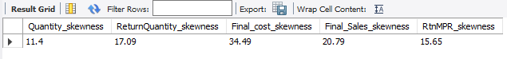

**6. Calculating the fourth moment (kurtosis) for the dataset.**

**Kurtosis:**

select

kurtosis_quantity1.kurtosis_quantity,

kurtosis_Returnquantity1.kurtosis_Returnquantity,

kurtosis_Final_cost1.kurtosis_Final_cost,

kurtosis_Final_Sales1.kurtosis_Final_Sales,

kurtosis_RtnMPR1.kurtosis_RtnMPR

from

(SELECT

ROUND((SUM(POWER(Quantity - (SELECT AVG(Quantity) FROM medicine_detail), 4)) / (COUNT(Quantity) * POWER(STDDEV(Quantity),

4))), 2) AS kurtosis_quantity

from medicine_detail) kurtosis_quantity1,

(SELECT

ROUND((SUM(POWER(ReturnQuantity - (SELECT AVG(ReturnQuantity) FROM medicine_detail), 4)) / (COUNT(ReturnQuantity) * POWER(STDDEV(ReturnQuantity),

4))), 2) AS kurtosis_Returnquantity

from medicine_detail) kurtosis_Returnquantity1,

(SELECT

ROUND((SUM(POWER(Final_cost - (SELECT AVG(Final_cost) FROM medicine_detail), 4)) / (COUNT(Final_cost) * POWER(STDDEV(Final_cost),

4))), 2) AS kurtosis_Final_cost

from medicine_detail) kurtosis_Final_cost1,

(SELECT

ROUND((SUM(POWER(Final_Sales - (SELECT AVG(Final_Sales) FROM medicine_detail), 4)) / (COUNT(Final_Sales) * POWER(STDDEV(Final_Sales),

4))), 2) AS kurtosis_Final_Sales

from medicine_detail) kurtosis_Final_Sales1,

(SELECT

ROUND((SUM(POWER(RtnMPR - (SELECT AVG(RtnMPR) FROM medicine_detail), 4)) / (COUNT(RtnMPR) * POWER(STDDEV(RtnMPR),

4))), 2) AS kurtosis_RtnMPR

from medicine_detail) kurtosis_RtnMPR1;

**Output:**

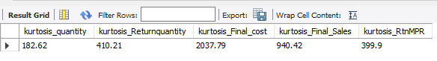

**Pre-processing Code (SQL)**

**Software: MySQL Workbench**

**1. Creating the database.**

CREATE DATABASE medicines_db;

**2. Set the current database to " medicines_db ".**

USE med_inventory;

**3. Importing the table in CSV format into MySQL.**

Right-click on tables -> table data import wizard -> browse to select the table ‘medicine_detail’.

**4. Displaying the table.**

SELECT * FROM medicine_detail LIMIT 10

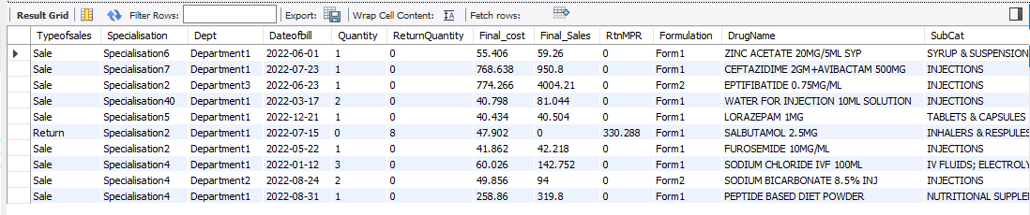

**5. Checking the schema of the dataset to ensure that all columns have the correct format.**

DESCRIBE medicine_detail;

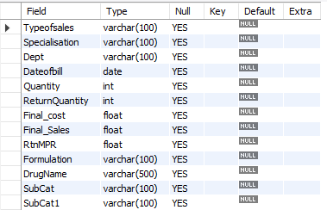

**6. Counting the missing and non-missing values for each column and the total number of rows in the 'medicine_detail' table.**

SELECT

COUNT(CASE WHEN TRIM(Typeofsales) = '' OR Typeofsales IS NULL THEN 1 END) AS

typeofsales_missing,

COUNT(CASE WHEN TRIM(Typeofsales) <> '' AND Typeofsales IS NOT NULL THEN 1 END) AS

typeofsales_non_missing,

count(case when trim(Typeofsales) = '' or Typeofsales is null then 1 end) as Typeofsales_missing,

count(case when trim(Typeofsales) <> '' or Typeofsales is not null then 1 end) as Typeofsales_non_missing,

COUNT(CASE WHEN TRIM(Specialisation) = '' OR Specialisation IS NULL THEN 1 END) AS

specialisation_missing,

COUNT(CASE WHEN TRIM(Specialisation) <> '' AND Specialisation IS NOT NULL THEN 1 END) AS

specialisation_non_missing ,

COUNT(CASE WHEN TRIM(Dept) = '' OR Dept IS NULL THEN 1 END) AS dept_missing,

COUNT(CASE WHEN TRIM(Dept) <> '' AND Dept IS NOT NULL THEN 1 END) AS dept_non_missing,

COUNT(CASE WHEN TRIM(Dateofbill) = '' OR Dateofbill IS NULL THEN 1 END) AS dateofbill_missing,

COUNT(CASE WHEN TRIM(Dateofbill) <> '' AND Dateofbill IS NOT NULL THEN 1 END) AS

dateofbill_non_missing,

COUNT(CASE WHEN Quantity IS NULL THEN 1 END) AS quantity_missing,

COUNT(CASE WHEN Quantity IS NOT NULL THEN 1 END) AS quantity_non_missing,

COUNT(CASE WHEN ReturnQuantity IS NULL THEN 1 END) AS returnquantity_missing,

COUNT(CASE WHEN ReturnQuantity IS NOT NULL THEN 1 END) AS returnquantity_non_missing,

COUNT(CASE WHEN Final_Cost IS NULL THEN 1 END) AS final_cost_missing,

COUNT(CASE WHEN Final_Cost IS NOT NULL THEN 1 END) AS final_cost_non_missing,

COUNT(CASE WHEN Final_Sales IS NULL THEN 1 END) AS final_sales_missing,

COUNT(CASE WHEN Final_Sales IS NOT NULL THEN 1 END) AS final_sales_non_missing,

COUNT(CASE WHEN RtnMPR IS NULL THEN 1 END) AS rtnmrp_missing,

COUNT(CASE WHEN RtnMPR IS NOT NULL THEN 1 END) AS rtnmrp_non_missing,

COUNT(CASE WHEN TRIM(Formulation) = '' OR Formulation IS NULL THEN 1 END) AS

formulation_missing,

COUNT(CASE WHEN TRIM(Formulation) <> '' AND Formulation IS NOT NULL THEN 1 END) AS

formulation_non_missing,

COUNT(CASE WHEN TRIM(DrugName) = '' OR DrugName IS NULL THEN 1 END) AS

drugname_missing,

COUNT(CASE WHEN TRIM(DrugName) <> '' AND DrugName IS NOT NULL THEN 1 END) AS

drugname_non_missing,

COUNT(CASE WHEN TRIM(SubCat) = '' OR SubCat IS NULL THEN 1 END) AS subcat_missing,

COUNT(CASE WHEN TRIM(SubCat) <> '' AND SubCat IS NOT NULL THEN 1 END) AS

subcat_non_missing,

COUNT(CASE WHEN TRIM(SubCat1) = '' OR SubCat1 IS NULL THEN 1 END) AS subcat1_missing,

COUNT(CASE WHEN TRIM(SubCat1) <> '' AND SubCat1 IS NOT NULL THEN 1 END) AS

subcat1_non_missing,

COUNT(*) AS total_rows

FROM medicine_detail;

**Output:**

   

**Observation: Missing values have been identified in the following columns: Formulation(672), DrugName(1705), SubCat(1705), and SubCat1(1729).**

**8. Replacing the missing values with ‘unknown’ in the columns Formulation, DrugName, SubCat and SubCat1.**

UPDATE medicine_detail

SET Formulation = CASE WHEN Formulation = '' THEN 'unknown' ELSE Formulation END;

UPDATE medicine_detail

SET DrugName = CASE WHEN DrugName = '' THEN 'unknown' ELSE DrugName END;

UPDATE medicine_detail

SET SubCat = CASE WHEN SubCat = '' THEN 'unknown' ELSE SubCat END;

UPDATE medicine_detail

SET SubCat1 = CASE WHEN SubCat1 = '' THEN 'unknown' ELSE SubCat1 END;

**Showing the columns after replacing the missing values with ‘unknown’:**

select Formulation, DrugName,SubCat,SubCat1 from medicine_detail;

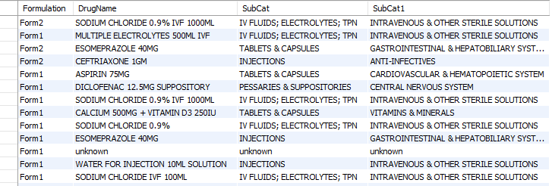

**9. Creating a new table called `missing_values` by selecting rows from `medicine_detail` where any of the columns (`Formulation`, `DrugName`, `SubCat`, or `SubCat1`) has the value 'unknown'.**

CREATE TABLE missing_values AS

SELECT *

FROM medicine_detail

WHERE Formulation = 'unknown'

OR DrugName = 'unknown'

OR SubCat = 'unknown'

OR SubCat1 = 'unknown';

**Showing missing_values table and count of records with at least one or more missing values:**

select * from missing_values;

select count(*) as missing_recods_count from missing_values;

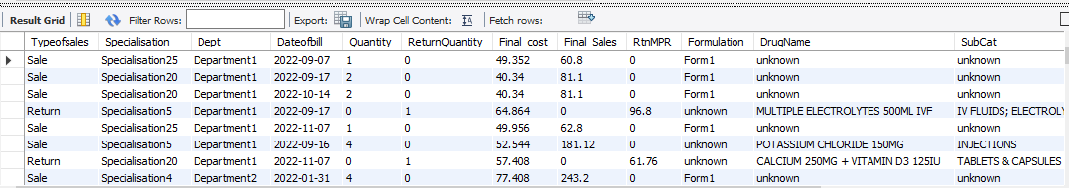 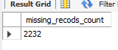

**10. Identifying duplicate rows based on Typeofsales, Specialisation, Dept, Dateofbill, Quantity, ReturnQuantity, Final_cost, Final_Sales, RtnMPR, Formulation, DrugName, SubCat, SubCat1, Dateofbill, where the DrugName is 'unknown',** **SubCat is 'unknown',** **subcat1 is 'unknown' and Formulation is 'unknown'.**

select Typeofsales, Specialisation, Dept, Dateofbill, Quantity, ReturnQuantity,

Final_cost, Final_Sales, RtnMPR, Formulation, DrugName, SubCat, SubCat1, count(*)

from medicine_detail

WHERE Formulation<>'unknown'and DrugName <> 'unknown'and SubCat <> 'unknown' and subcat1 <>'unknown'

GROUP BY Typeofsales, Specialisation, Dept, Dateofbill, Quantity, ReturnQuantity,

Final_cost, Final_Sales, RtnMPR, Formulation, DrugName, SubCat, SubCat1

HAVING COUNT(*) > 1;

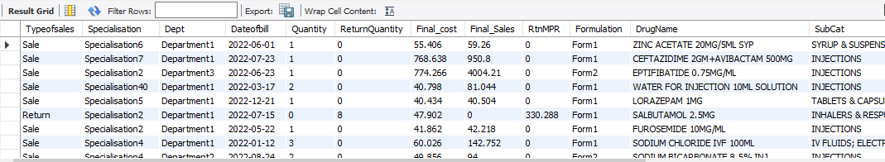

**11. Removing the duplicate rows from medicine_detail table and counting the remaining rows.**

DELETE FROM medicine_detail

WHERE (Typeofsales, Specialisation, Dept, Dateofbill, Quantity, ReturnQuantity,

Final_cost, Final_Sales, RtnMPR, Formulation, DrugName, SubCat, SubCat1) IN (

SELECT t.Typeofsales, t.Specialisation, t.Dept,t.Dateofbill,t.Quantity,

t.ReturnQuantity,t.Final_cost,t.Final_Sales,t.RtnMPR,t.Formulation,t.DrugName,t.SubCat,t.SubCat1

FROM (

SELECT Typeofsales, Specialisation, Dept, Dateofbill, Quantity, ReturnQuantity,

Final_cost, Final_Sales, RtnMPR, Formulation, DrugName, SubCat, SubCat1

FROM medicine_detail

WHERE Formulation<>'unknown'and DrugName <> 'unknown'and SubCat <> 'unknown' and subcat1 <>'unknown'

GROUP BY Typeofsales, Specialisation, Dept, Dateofbill, Quantity, ReturnQuantity,

Final_cost, Final_Sales, RtnMPR, Formulation, DrugName, SubCat, SubCat1

HAVING COUNT(*) > 1

) AS t

);

SELECT COUNT(*) AS total_rows FROM medicine_detail;

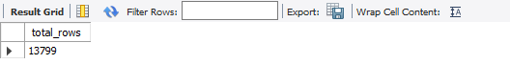

**12. In a normal distribution, approximately 68%, 95%, and 99.7% of the data falls within one, two, and three standard deviations of the mean respectively. By using three standard deviations as the threshold for removing outliers, we are effectively removing data points that are more than three standard deviations away from the mean.**

CREATE TABLE new_table AS

SELECT *

FROM medicine_detail

WHERE Quantity BETWEEN

(SELECT AVG(Quantity) - 3 * STDDEV(Quantity) FROM medicine_detail)

AND

(SELECT AVG(Quantity) + 3 * STDDEV(Quantity) FROM medicine_detail)

AND ReturnQuantity BETWEEN

(SELECT AVG(ReturnQuantity) - 3 * STDDEV(ReturnQuantity) FROM medicine_detail)

AND

(SELECT AVG(ReturnQuantity) + 3 * STDDEV(ReturnQuantity) FROM medicine_detail)

AND Final_Cost BETWEEN

(SELECT AVG(Final_Cost) - 3 * STDDEV(Final_Cost) FROM medicine_detail)

AND

(SELECT AVG(Final_Cost) + 3 * STDDEV(Final_Cost) FROM medicine_detail)

AND Final_Sales BETWEEN

(SELECT AVG(Final_Sales) - 3 * STDDEV(Final_Sales) FROM medicine_detail)

AND

(SELECT AVG(Final_Sales) + 3 * STDDEV(Final_Sales) FROM medicine_detail)

AND RtnMPR BETWEEN

(SELECT AVG(RtnMPR) - 3 * STDDEV(RtnMPR) FROM medicine_detail)

AND

(SELECT AVG(RtnMPR) + 3 * STDDEV(RtnMPR) FROM medicine_detail);

select count(*) as total_rows from new_table;



**Exploratory Data Analysis (SQL)**

**Software: MySQL Workbench**

**Business decisions based on the clean**

**‘medicines_db’ data**

**1. Calculating the first moment (measures of central tendency such as mean, median, mode) for the dataset.**

**Mean :**

select

round(avg(Quantity),2) as mean_Quantity,

round(avg(ReturnQuantity),2) as mean_ReturnQuantity,

round(avg(Final_cost),2) as mean_Final_cost,

round(avg(Final_Sales),2) as mean_Final_Sales,

round(avg(RtnMPR),2) as mean_RtnMPR

from

new_table;

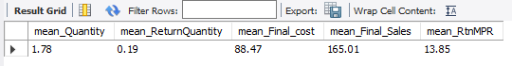

**Median:**

with ranked as

(

select Final_cost,

Final_Sales,

Quantity,

ReturnQuantity,

RtnMPR,

row_number() over (order by Final_cost) as r,

count(*) over () as c

from new_table),

median as

(

select Final_cost,

Final_Sales,

Quantity,

ReturnQuantity,

RtnMPR

from ranked

where r in (floor((c+1)/2),ceiling((c+1)/2))

)

select round(avg(Final_cost), 2),

round(avg(Final_Sales),2),

round(avg(Quantity),2),

round(avg(ReturnQuantity),2),

round(avg(RtnMPR),2)

from median;

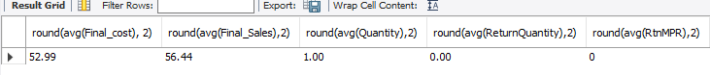

**Mode:**

select

mode_Quantity.mode_value as mode_Quantity,

mode_Quantity.mode_count as mode_Quantity_count,

mode_ReturnQuantity.mode_value as mode_ReturnQuantity,

mode_ReturnQuantity.mode_count as mode_ReturnQuantity_count,

mode_Final_Sales.mode_value as mode_Final_Sales,

mode_Final_Sales.mode_count as mode_Final_Sales_count,

mode_Final_cost.mode_value as mode_Final_cost,

mode_Final_cost.mode_count as mode_Final_cost_count,

mode_RtnMPR.mode_value as mode_RtnMPR,

mode_RtnMPR.mode_count as mode_RtnMPR_count

from(

SELECT Quantity AS mode_value, COUNT(*) AS mode_count

FROM new_table

GROUP BY Quantity

ORDER BY COUNT(*) DESC

LIMIT 1 ) as mode_Quantity,

( SELECT ReturnQuantity AS mode_value, COUNT(*) AS mode_count

FROM new_table

GROUP BY Quantity

ORDER BY COUNT(*) DESC

LIMIT 1

) as mode_ReturnQuantity,

(SELECT final_cost AS mode_value, COUNT(*) AS mode_count

FROM new_table

GROUP BY Quantity

ORDER BY COUNT(*) DESC

LIMIT 1

) as mode_Final_cost,

(SELECT Final_Sales AS mode_value, COUNT(*) AS mode_count

FROM new_table

GROUP BY Quantity

ORDER BY COUNT(*) DESC

LIMIT 1

) as mode_Final_Sales,

( select RtnMPR AS mode_value, COUNT(*) AS mode_count

FROM new_table

GROUP BY Quantity

ORDER BY COUNT(*) DESC

LIMIT 1

) as mode_RtnMPR;

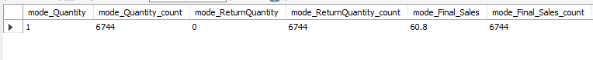 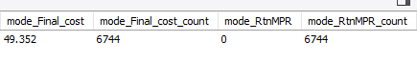

**2. Calculating the second moment (measures of dispersion such as variance, standard deviation, range) for the dataset.**

**Variance:**

SELECT

ROUND(VARIANCE(Quantity), 2) AS variance_quantity,

ROUND(VARIANCE(ReturnQuantity), 2) AS variance_return_quantity,

ROUND(VARIANCE(Final_Cost), 2) AS variance_final_cost,

ROUND(VARIANCE(Final_Sales), 2) AS variance_final_sales,

ROUND(VARIANCE(RtnMPR), 2) AS variance_rtnmrp

FROM new_table;



SELECT

ROUND(STDDEV(Quantity), 2) AS stddev_quantity,

ROUND(STDDEV(ReturnQuantity), 2) AS stddev_return_quantity,

ROUND(STDDEV(Final_Cost), 2) AS stddev_final_cost,

ROUND(STDDEV(Final_Sales), 2) AS stddev_final_sales,

ROUND(STDDEV(RtnMPR), 2) AS stddev_rtnmrp

FROM new_table;



**Range:**

SELECT

MAX(Quantity) - MIN(Quantity) AS range_quantity,

MAX(ReturnQuantity) - MIN(ReturnQuantity) AS range_return_quantity,

MAX(Final_Cost) - MIN(Final_Cost) AS range_final_cost,

MAX(Final_Sales) - MIN(Final_Sales) AS range_final_sales,

MAX(RtnMPR) - MIN(RtnMPR) AS range_rtnmrp

FROM new_table;

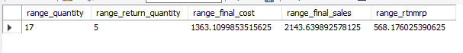

**3. Calculating the third moment (skewness) for the dataset.**

**Skewness:**

select Quantity_skewness1.Quantity_skewness,

ReturnQuantity_skewness1.ReturnQuantity_skewness,

Final_cost_skewness1.Final_cost_skewness,

Final_Sales_skewness1.Final_Sales_skewness,

RtnMPR_skewness1.RtnMPR_skewness

from

(SELECT

ROUND((SUM(POW(Quantity - (SELECT AVG(Quantity) FROM new_table), 3)) / (COUNT(*) *

POW(STDDEV(Quantity), 3))), 2) AS Quantity_skewness

FROM new_table) Quantity_skewness1,

(select

round((sum(pow(ReturnQuantity - (select avg(ReturnQuantity) from new_table),3))/(count(*) *

pow(stddev(ReturnQuantity),3))),2) as ReturnQuantity_skewness from new_table)

ReturnQuantity_skewness1,

(select

round((sum(pow(Final_cost - (select avg(Final_cost) from new_table),3))/(count(*) *

pow(stddev(Final_cost),3))),2) as Final_cost_skewness from new_table)

Final_cost_skewness1,

(

select

round((sum(pow(Final_Sales - (select avg(Final_Sales) from new_table),3))/(count(*) *

pow(stddev(Final_Sales),3))),2) as Final_Sales_skewness from new_table)

Final_Sales_skewness1,

(select

round((sum(pow(RtnMPR - (select avg(RtnMPR) from new_table),3))/(count(*) *

pow(stddev(RtnMPR),3))),2) as RtnMPR_skewness from new_table)

RtnMPR_skewness1;



**4. Calculating the fourth moment (kurtosis) for the dataset.**

**Kurtosis:**

select

kurtosis_quantity1.kurtosis_quantity,

kurtosis_Returnquantity1.kurtosis_Returnquantity,

kurtosis_Final_cost1.kurtosis_Final_cost,

kurtosis_Final_Sales1.kurtosis_Final_Sales,

kurtosis_RtnMPR1.kurtosis_RtnMPR

from

(SELECT

ROUND((SUM(POWER(Quantity - (SELECT AVG(Quantity) FROM new_table), 4)) / (COUNT(Quantity) * POWER(STDDEV(Quantity),

4))), 2) AS kurtosis_quantity

from new_table) kurtosis_quantity1,

(SELECT

ROUND((SUM(POWER(ReturnQuantity - (SELECT AVG(ReturnQuantity) FROM new_table), 4)) / (COUNT(ReturnQuantity) * POWER(STDDEV(ReturnQuantity),

4))), 2) AS kurtosis_Returnquantity

from new_table) kurtosis_Returnquantity1,

(SELECT

ROUND((SUM(POWER(Final_cost - (SELECT AVG(Final_cost) FROM new_table), 4)) / (COUNT(Final_cost) * POWER(STDDEV(Final_cost),

4))), 2) AS kurtosis_Final_cost

from new_table) kurtosis_Final_cost1,

(SELECT

ROUND((SUM(POWER(Final_Sales - (SELECT AVG(Final_Sales) FROM new_table), 4)) / (COUNT(Final_Sales) * POWER(STDDEV(Final_Sales),

4))), 2) AS kurtosis_Final_Sales

from new_table) kurtosis_Final_Sales1,

(SELECT

ROUND((SUM(POWER(RtnMPR - (SELECT AVG(RtnMPR) FROM new_table), 4)) / (COUNT(RtnMPR) * POWER(STDDEV(RtnMPR),

4))), 2) AS kurtosis_RtnMPR

from new_table) kurtosis_RtnMPR1;



**Comparison table showing the business decisions results for the unclean and clean data:**

|  |  |  |
| --- | --- | --- |
| **Parameter** | **Uncleaned Data** | **Cleaned_Data** |
| **Mean** | **Quantity -2.25** | **Quantity-1.78** |
|  | **ReturnQuantity -0.30** | **ReturnQuantity -0.19** |
|  | **Final_cost-124.43** | **Final_cost-88.47** |
|  | **Final_Sales-232.79** | **Final_Sales-165.01** |
|  | **RtnMPR-29.95** | **RtnMPR-13.85** |
| **Median** | **Quantity-3.00** | **Quantity-1.00** |
|  | **ReturnQuantity -0.00** | **ReturnQuantity -0.00** |
|  | **Final_cost-141** | **Final_cost-52.99** |
|  | **Final_Sales-53.57** | **Final_Sales-56.44** |
|  | **RtnMPR-0-00** | **RtnMPR-0.00** |
| **Mode** | **Quantity-1** | **Quantity-1** |
|  | **ReturnQuantity -0** | **ReturnQuantity -0** |
|  | **Final_cost-49.352** | **Final_cost-49.352** |
|  | **Final_Sales-60.8** | **Final_Sales-60.8** |
|  | **RtnMPR-0** | **RtnMPR-0** |
| **Variance** | **Quantity-27.14** | **Quantity-3.32** |
|  | **ReturnQuantity 2.17** | **ReturnQuantity -0.41** |
|  | **Final_cost-221685.41** | **Final_cost-17736.69** |
|  | **Final_Sales-458223.23** | **Final_Sales-71134.19** |
|  | **RtnMPR-34178.39** | **RtnMPR-2596.22** |
| **StandardDeviation** | **Quantity-5.21** | **Quantity-1.82** |
|  | **ReturnQuantity -1.67** | **ReturnQuantity -0.64** |
|  | **Final_cost-470.83** | **Final_cost-133.18** |
|  | **Final_Sales-676.93** | **Final_Sales-266.71** |
|  | **RtnMPR-184.87** | **RtnMPR-49.96** |
| **Range** | **Quantity-150** | **Quantity-17** |
|  | **ReturnQuantity -50** | **ReturnQuantity -5** |
|  | **Final_cost-33138** | **Final_cost-1363.11** |
|  | **Final_Sales-39490** | **Final_Sales-2143.64** |
|  | **RtnMPR-8014** | **RtnMPR-568.18** |
| **Skewness** | **Quantity-11.27** | **Quantity-2.91** |
|  | **ReturnQuantity -16.88** | **ReturnQuantity -4.23** |
|  | **Final_cost-34.22** | **Final_cost-5.86** |
|  | **Final_Sales-21.09** | **Final_Sales-4.3** |
|  | **RtnMPR-15.58** | **RtnMPR5.11** |
| **Kurtosis** | **Quantity-180.5**   |  |  |  |  |  |  | | --- | --- | --- | --- | --- | --- | |  |  |  |  |  |  | | **Quantity-14.7** |
|  | **ReturnQuantity -398.03** | **ReturnQuantity -23.43** |
|  | **Final_cost-1984.44** | **Final_cost-41.6** |
|  | **Final_Sales-947.71** | **Final_Sales-24.76** |
|  | **RtnMPR-395.28** | **RtnMPR-35.42** |

**Observation: Overall, the results indicate that the unclean data exhibits higher mean, variance, standard deviation, range, skewness, and kurtosis values compared to the clean data. This suggests greater inconsistencies, variability, and potential outliers in the unclean data. Cleaning the data has resulted in more stable and normalized distributions with reduced variability and potential biases, making it more reliable for business decision-making.**