Indira Gandhi Delhi Technical University for Women
Department of Computer Science & Engineering

SOFTWARE ENGINEERING

PRACTICAL FILE
Experiments 1–5
Submitted by: ______________________________
Roll No.: ______________________________
Class / Section: ______________________________
Submitted to: ______________________________
Academic Session: ______________________________

INDEX
Exp. No. | Title of Experiment | Date | Page No. | Teacher's Signature
1 | Design of Flow Chart |  | 2
2 | Draw E-R Diagram for the Specified System |  | 4
3 | System Modeling – DFD Level 0 (Context Diagram) |  | 7
4 | System Modeling – DFD Level 1 |  | 9
5 | Perform the User's View Analysis |  | 11

EXPERIMENT – 1
Title: Design of Flow Chart
Date: ______________________________
Aim: To perform the requirement analysis of the specified problem and draw a flowchart.
Tools/Apparatus: Rational Rose or any suitable diagramming tool.
References:
1. Pankaj Jalote, An Integrated Approach to Software Engineering
2. K. K. Aggarwal and Yogesh Singh, Software Engineering
3. Roger Pressman, Software Engineering
4. Terry Quatrani, Visual Modeling with Rational Rose 2000 and UML

Theory
A flowchart is a visual representation of the steps and decisions involved in a process. It uses standard symbols: an oval for Start/End, a parallelogram for input/output, a rectangle for processing, a diamond for decisions, and arrows to show the flow of control.

Problem Statement
Design a flowchart to classify a triangle using three side lengths A, B and C.

Requirement Analysis
Item | Description
Input | Three side lengths A, B and C.
Processing | Validate the inputs, check the triangle inequality, and compare the sides.
Output | Equilateral, isosceles, scalene, “not a triangle” or “invalid input”.

Procedure
1. Identify the inputs, processing steps and decisions required by the problem.
2. Check that all side lengths are positive and within the accepted range.
3. Check the triangle inequality conditions: A+B>C, A+C>B and B+C>A.
4. If valid, compare the sides to classify the triangle as equilateral, isosceles or scalene.
5. Draw the flowchart using standard symbols and labelled decision branches.

Flowchart
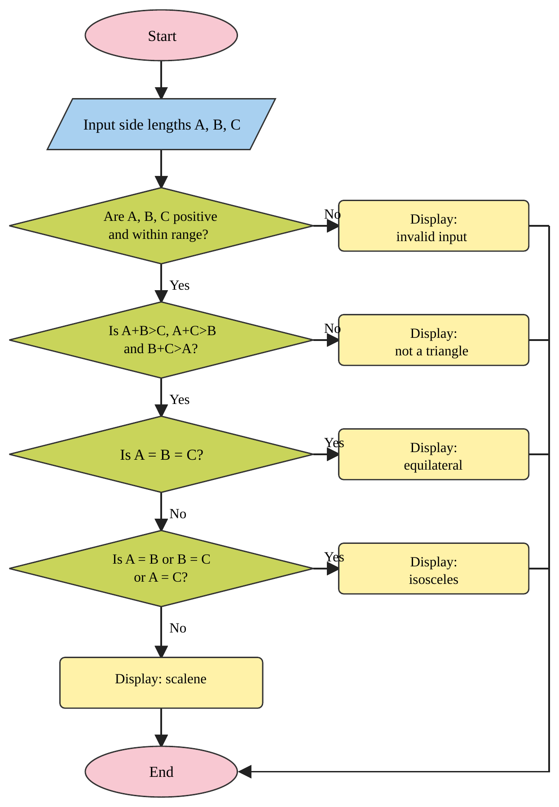
Fig. 1.1: Flowchart for classifying a triangle

Result
The requirement analysis was performed and the flowchart for validating three side lengths and classifying a triangle was designed.
EXPERIMENT – 2
Title: Draw E-R Diagram for the Specified System
Date: ______________________________
Aim: To draw an ER diagram illustrating entities, relationships, generalization, specialization and aggregation.
Tools/Apparatus: Rational Rose or any suitable diagramming tool.
References:
1. Pankaj Jalote, An Integrated Approach to Software Engineering
2. K. K. Aggarwal and Yogesh Singh, Software Engineering
3. Roger Pressman, Software Engineering
4. Terry Quatrani, Visual Modeling with Rational Rose 2000 and UML

Theory
An Entity-Relationship (ER) model is a conceptual representation of data. Entities represent distinguishable objects, relationships describe associations between entities, and attributes describe their properties. A primary/key attribute uniquely identifies an entity. Cardinality describes the number of instances that can participate in a relationship.
Generalization combines entity types that share common features into a common superclass. Specialization divides a superclass into more specific subclasses. Aggregation treats a relationship and its participating entities as a higher-level unit.

Problem Statement
Create an ER model for a course registration system in which students can register for courses.

Entities and Attributes
Entity | Attributes
STUDENT | Student_ID (primary key), Name, Email, Phone
COURSE | Course_ID (primary key), Course_Name, Duration
ENROLLMENT | Student_ID, Course_ID, Registration_Date, Status (associative entity for the many-to-many relationship)

Relationship and Cardinality
A student can enroll in many courses, and a course can have many students. This is a many-to-many relationship, which can be implemented through the ENROLLMENT associative entity.

Procedure
1. Identify entities and their attributes from the problem statement.
2. Choose primary keys that uniquely identify each entity.
3. Identify relationships and specify their cardinalities.
4. Represent the entities and relationships in an ER diagram.
5. Identify possible superclass/subclass structures for generalization and specialization.

ER Diagram
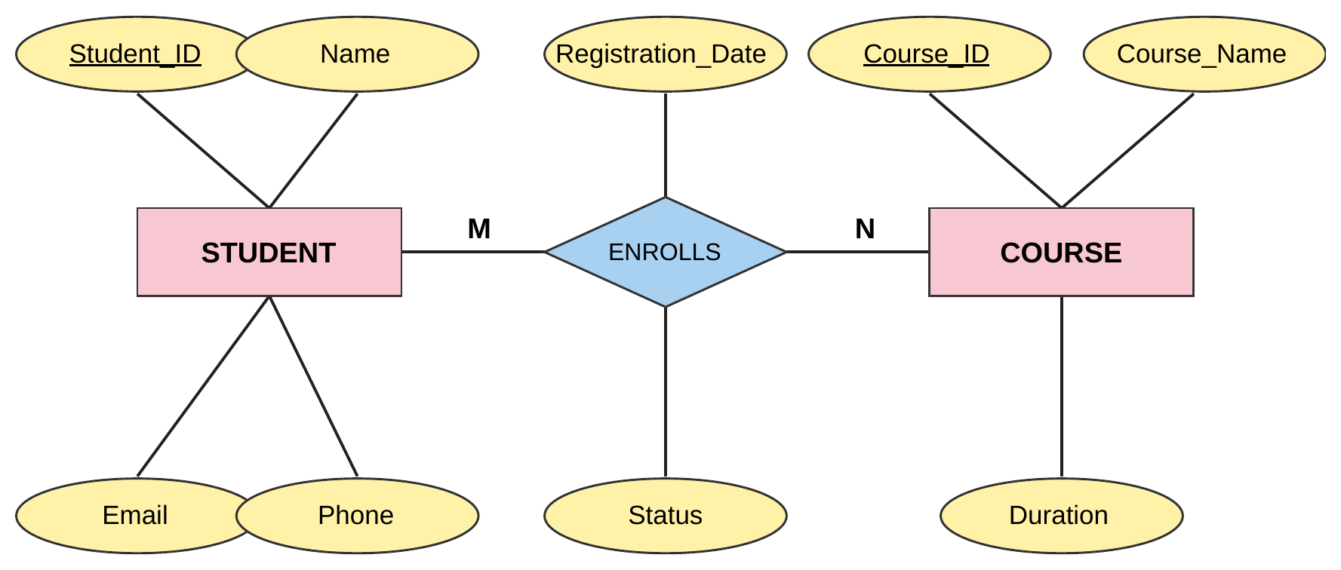
Fig. 2.1: ER diagram of the Course Registration System

Generalization / Specialization Example
PERSON can be a superclass with common attributes such as Person_ID and Name. It may be specialized into STUDENT and ADMINISTRATOR, each with additional role-specific attributes. For example, STUDENT may have Student_ID and program details, while ADMINISTRATOR may have Admin_ID and role.
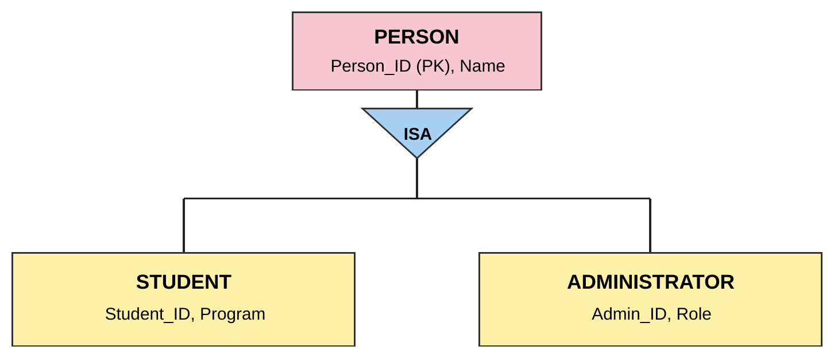
Fig. 2.2: Generalization / specialization of PERSON

Aggregation Example
The ENROLLS relationship together with the STUDENT and COURSE entities can be treated as a single higher-level unit. This unit can then take part in another relationship; for example, an ADMINISTRATOR reviews enrollments.
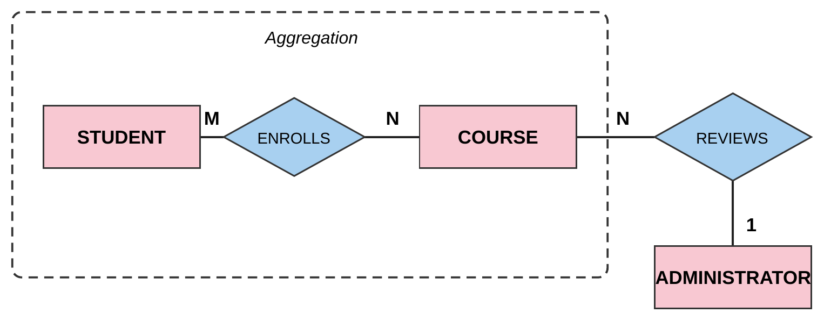
Fig. 2.3: Aggregation of the ENROLLS relationship

Result
The ER model for the course registration system was designed with entities, attributes, relationship cardinality, and examples of generalization, specialization and aggregation.
EXPERIMENT – 3
Title: System Modeling – DFD Level 0 (Context Diagram)
Date: ______________________________
Aim: To understand functional modeling and draw a Level 0 Data Flow Diagram (context diagram).
Tools/Apparatus: Rational Rose or any suitable diagramming tool.
References:
1. Pankaj Jalote, An Integrated Approach to Software Engineering
2. K. K. Aggarwal and Yogesh Singh, Software Engineering
3. Roger Pressman, Software Engineering
4. Terry Quatrani, Visual Modeling with Rational Rose 2000 and UML

Theory
A Data Flow Diagram (DFD) represents how data moves through a system. Its main components are external entities, processes, data stores and data flows. A context diagram shows the system as one main process and its interactions with external entities.

Problem Statement
Model the data flow for a Course Registration System.

Procedure
1. Identify the system boundary and external entities.
2. Identify data supplied to the system and outputs returned by it.
3. Represent the entire system as one process.
4. Connect external entities to the process with labelled data-flow arrows.

DFD Level 0 (Context Diagram)
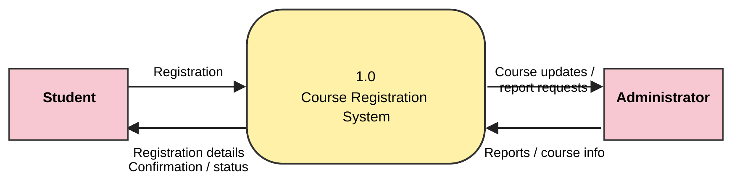
Fig. 3.1: DFD Level 0 (context diagram) of the Course Registration System

Data Flows
From | To | Data Flow
Student | System | Registration details
System | Student | Confirmation and registration status
Administrator | System | Course updates and report requests
System | Administrator | Reports and course-related information

Result
The Level 0 context diagram for the Course Registration System was drawn, showing its external entities and principal data flows.
EXPERIMENT – 4
Title: System Modeling – DFD Level 1
Date: ______________________________
Aim: To understand functional modeling and draw a Level 1 Data Flow Diagram.
Tools/Apparatus: Rational Rose or any suitable diagramming tool.
References:
1. Pankaj Jalote, An Integrated Approach to Software Engineering
2. K. K. Aggarwal and Yogesh Singh, Software Engineering
3. Roger Pressman, Software Engineering
4. Terry Quatrani, Visual Modeling with Rational Rose 2000 and UML

Theory
A Level 1 DFD decomposes the main process shown in a context diagram into major subprocesses. It shows how data moves among processes, external entities and data stores.

Problem Statement
Decompose the Course Registration System into registration, validation, course management and confirmation processes.

Procedure
1. Identify the major subprocesses within the system.
2. Identify the data stores required by the subprocesses.
3. Connect processes with labelled data-flow arrows.
4. Check that the inputs and outputs are consistent with the context diagram.

DFD Level 1
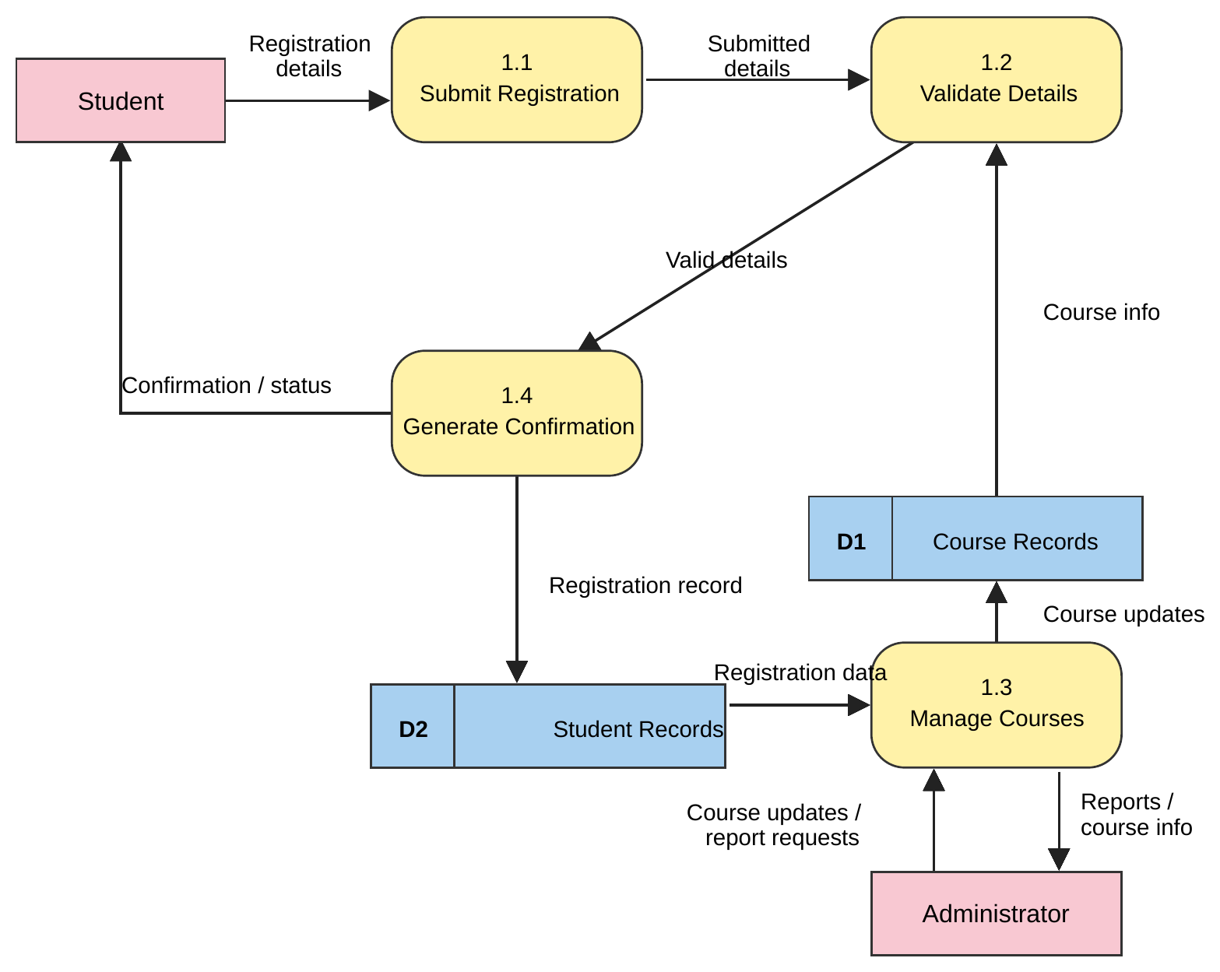
Fig. 4.1: DFD Level 1 of the Course Registration System

Main Processes and Data Stores
ID | Name | Description
1.1 | Submit Registration | Receives student registration details.
1.2 | Validate Details | Checks the submitted information against the course records.
1.3 | Manage Courses | Allows the administrator to maintain course information and obtain reports.
1.4 | Generate Confirmation | Produces a registration confirmation and saves the student's record.
D1 | Course Records | Data store holding course information.
D2 | Student Records | Data store holding student registration records.

Result
The Level 1 DFD was designed to show the main subprocesses and data stores of the Course Registration System.
EXPERIMENT – 5
Title: Perform the User's View Analysis
Date: ______________________________
Aim: To identify actors and use cases for the specified problem and represent them using a use-case model.
Tools/Apparatus: Rational Rose or any suitable diagramming tool.
References:
1. Pankaj Jalote, An Integrated Approach to Software Engineering
2. K. K. Aggarwal and Yogesh Singh, Software Engineering
3. Roger Pressman, Software Engineering
4. Terry Quatrani, Visual Modeling with Rational Rose 2000 and UML

Theory
An actor is an external role that interacts with a system. A use case describes a sequence of actions that provides a meaningful result to an actor. Associations connect actors with use cases. The system boundary separates the functionality being modeled from external roles.

Problem Statement
Perform user-view analysis for a Course Registration System.

Actors
Actor | Role in the System
Student | Views courses, registers for a course, checks registration status and cancels a registration.
Administrator | Manages course information and reviews registration-related information.

Use Cases
• View Courses
• Register for Course
• Check Registration
• Cancel Registration
• Manage Courses
• Review Registrations

Procedure
1. Read the problem statement and identify external roles that interact with the system.
2. Identify the system functions that provide value to each actor.
3. Draw a system boundary and place use cases inside it.
4. Connect each actor to the relevant use cases with association lines.

Use-Case Diagram
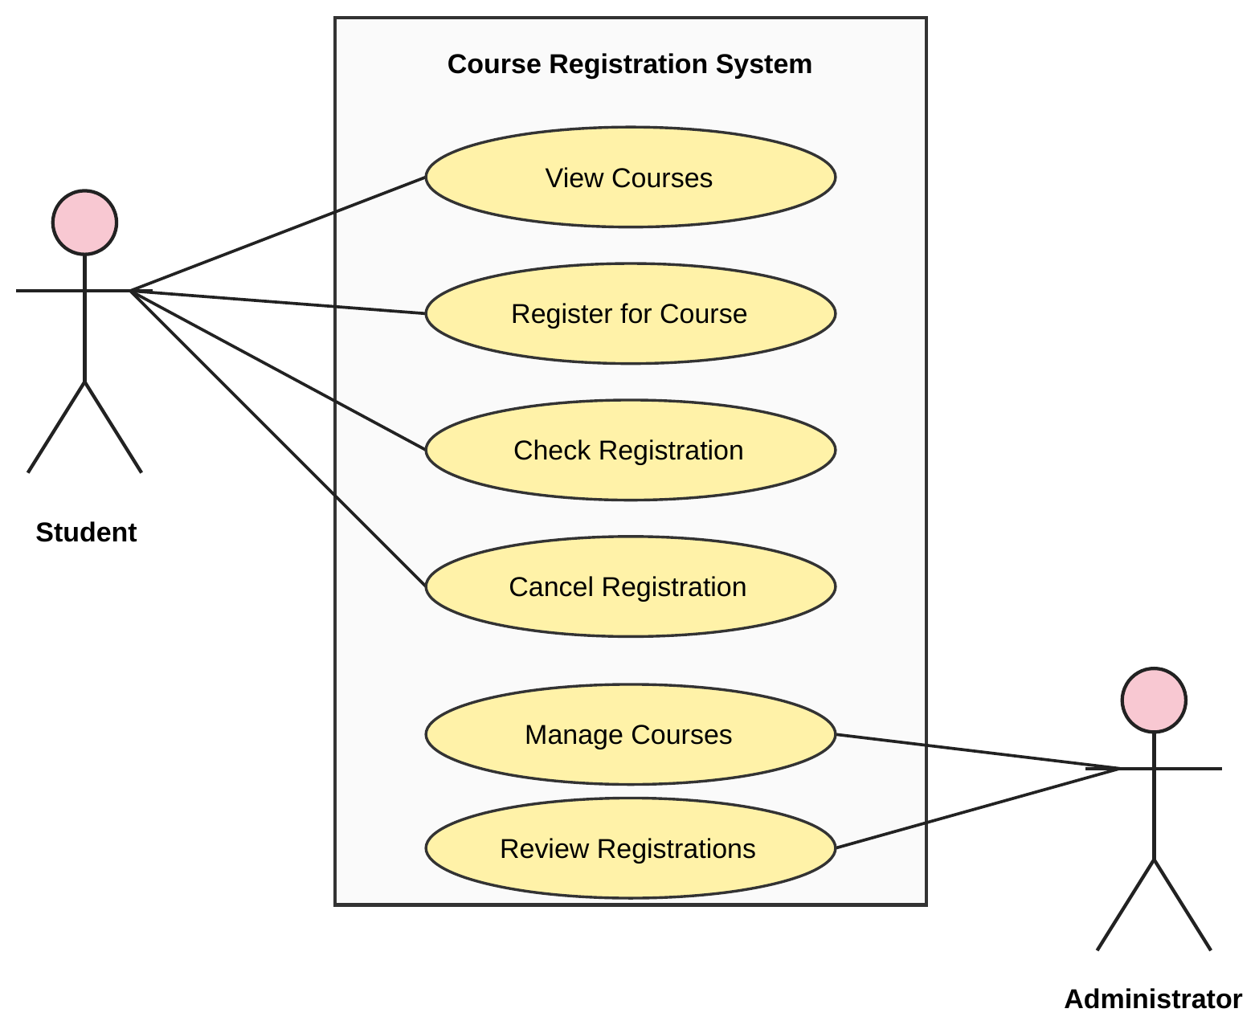
Fig. 5.1: Use-case diagram of the Course Registration System

Result
The user-view analysis was completed by identifying the Student and Administrator actors and their main use cases.

