**PROGRAM 7. BOOK DEALER DATABASE**

The following tables are maintained by a book dealer:  
AUTHOR(author-id: int, name: String, city: String, country: String)  
PUBLISHER(publisher-id: int, name: String, city: String, country: String)  
CATALOG (book-id: int, title: String, author-id: int, publisher-id: int, category-id: int, year: int, price: int)  
CATEGORY(category-id: int, description: String)  
ORDER-DETAILS (order-no: int, book-id: int, quantity: int)

**i. Create the above tables by properly specifying the primary keys and the foreign keys.**

CREATE TABLE AUTHOR (

AUTHORID INT,

NAME VARCHAR (15),

CITY VARCHAR (15),

ACOUNTRY VARCHAR (15),

PRIMARY KEY(AUTHORID));

CREATE TABLE PUBLISHER(

PUBLISHERID INT,

NAME VARCHAR(15),

CITY VARCHAR(15),

COUNTRY VARCHAR(15),

PRIMARY KEY(PUBLISHERID));

CREATE TABLE CATEGORY(

CATEGORYID INT,

DESCRIPTION VARCHAR(15),

PRIMARY KEY(CATEGORYID));

CREATE TABLE CATALOG(

BOOKID INT,

TITLE VARCHAR(15),

AUTHORID INT,

PUBLISHERID INT,

CATEGORYID INT,

YEAR INT,

PRICE INT,

PRIMARY KEY(BOOKID),

FOREIGN KEY(AUTHORID) REFERENCES AUTHOR(AUTHORID),

FOREIGN KEY(PUBLISHERID) REFERENCES PUBLISHER(PUBLISHERID),

FOREIGN KEY(CATEGORYID) REFERENCES CATEGORY(CATEGORYID));

CREATE TABLE ORDER_DETAILS(

ORDERNO INT,

BOOKID INT,

QUANTITY INT,

PRIMARY KEY(ORDERNO,BOOKID),

FOREIGN KEY(BOOKID) REFERENCES CATALOG(BOOKID) );

**ii. Enter at least five tuples for each relation.**

INSERT INTO AUTHOR VALUES

(101, 'ABC', 'DELHI','NDIA'),

(102,'TONY','HAYHOOD','USA'),

(103,'GHI','PATNA','INDIA'),

(104,'JKL','BELM','SRILANKA'),

(105,'MND','BANGALORE','INDIA');

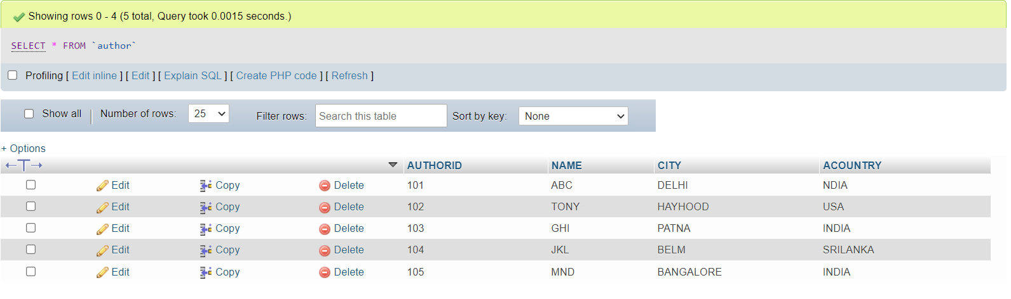INSERT INTO PUBLISHER VALUES

(1001, 'POOJA','BANGALORE', 'INDIA'),

(1002, 'PALAK','DELHI' ,'INDIA'),

(1003, 'PRANAV', 'MUMBAI', 'INDIA'),

(1004, 'RAM', 'RANCHI', 'INDIA'),

(1005, 'ROHAN', 'VADODRA', 'INDIA');

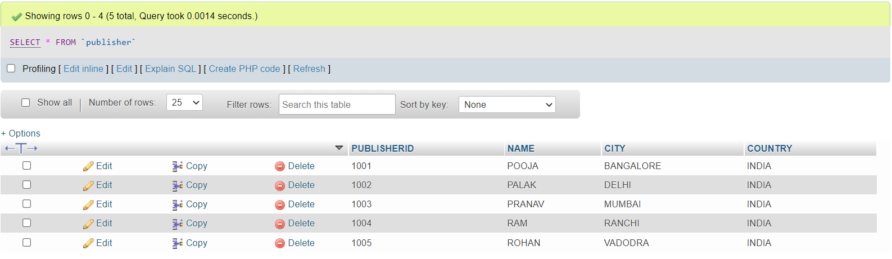

INSERT INTO CATEGORY VALUES

(10001, 'cs'),

(10002, 'med'),

(10003, 'bio'),

(10004, 'meteor'),

(10005, 'mech');

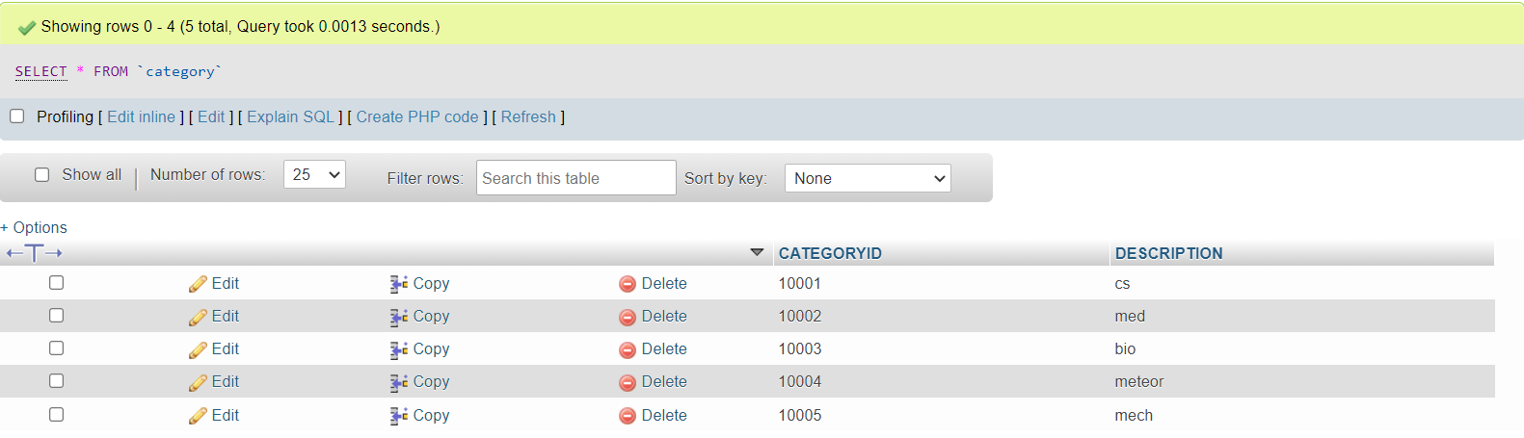INSERT INTO CATALOG VALUES

(1000001, 'dbms', 101, 1001, 10001, 1998, 235),

(1000002, 'or', 101, 1002, 10003, 1997, 255),

(1000003, 'cn', 102, 1003, 10002, 2001, 352),

(1000004, 'se', 102, 1003, 10001, 2002, 523),

(1000005, 'ada', 103, 1004, 10004, 2003, 124);  
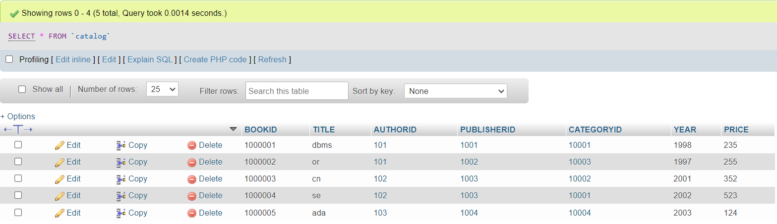INSERT INTO ORDER_DETAILS VALUES

(1, 1000001, 12),

(1, 1000002, 2),

(2, 1000002, 15),

(3, 1000003, 23),

(4, 1000003, 14),

(5, 1000005, 7);

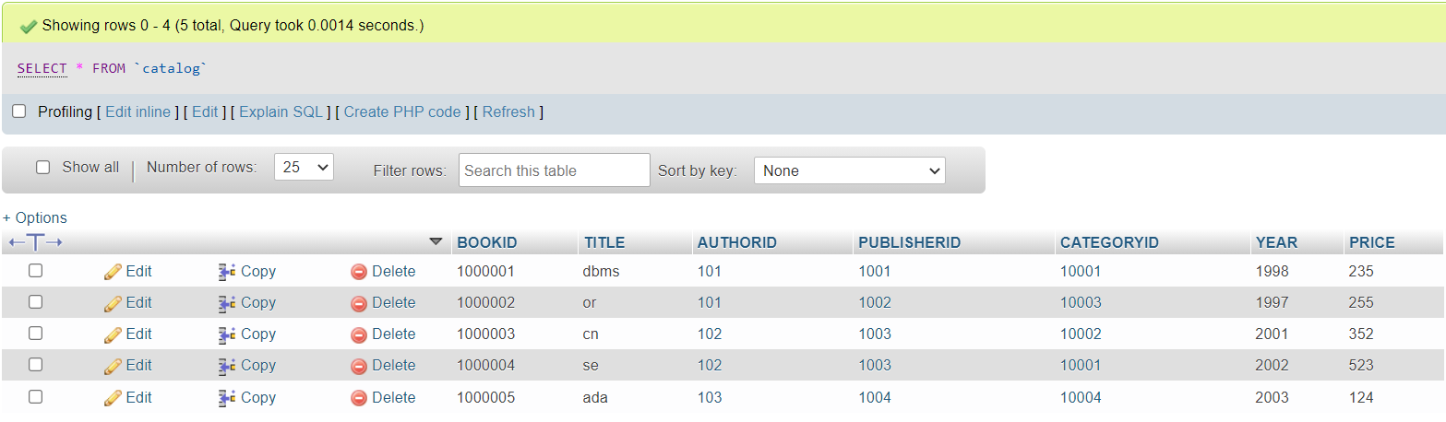

**iii. Give the details of the authors who have 2 or more books in the catalog and the price of the books in the**   
**catalog and the year of publication is after 2000.**

SELECT * FROM AUTHOR A WHERE A.AUTHORID IN

(SELECT C.AUTHORID FROM CATALOG C

WHERE YEAR>2000 AND

C.PRICE > (SELECT AVG (PRICE) FROM CATALOG)

GROUP BY C.AUTHORID HAVING COUNT(AUTHORID)>=2);

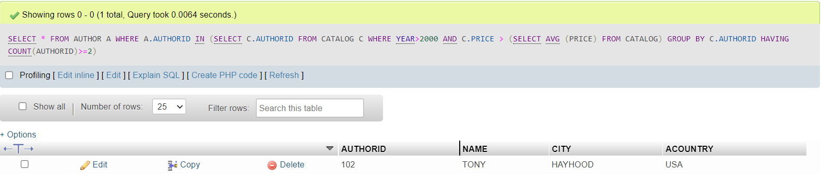  
**iv. Find the author of the book which has maximum sales.**

SELECT NAME FROM AUTHOR A,CATALOG C

WHERE A.AUTHORID=C.AUTHORID AND BOOKID IN

(SELECT BOOKID FROM ORDER_DETAILS WHERE QUANTITY= (SELECT MAX(QUANTITY) FROM ORDER_DETAILS));

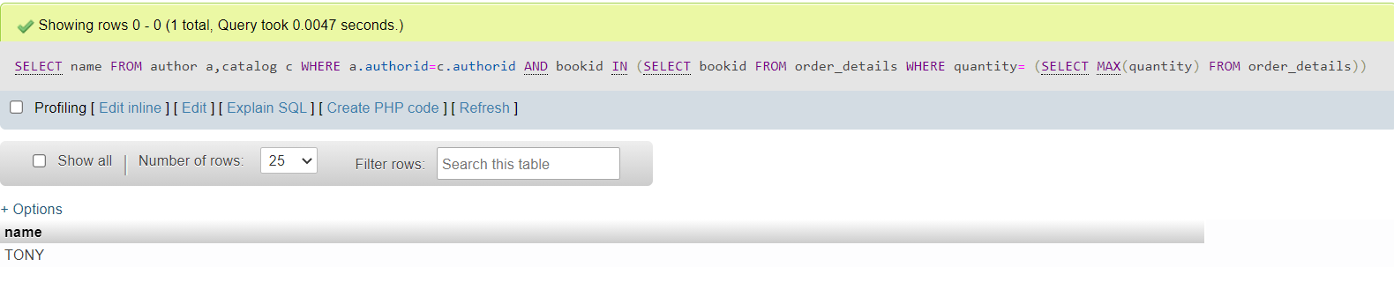

**v. Demonstrate how you increase the price of books published by a specific publisher by 10%.**

UPDATE CATALOG

SET PRICE = PRICE*1.1

WHERE PUBLISHERID IN ( SELECT PUBLISHERID FROM PUBLISHER

WHERE NAME= 'POOJA');

