**Practice Programs for OOJ Lab – Week 1**

1. Write a menu driven C Program to design a simple calculator which solves 10 operations - 4 Arithmetic, 4 Relational and any two of your choice. The program should loop till the user wishes to stop.

#include<stdio.h>

#include<math.h>

#include<stdlib.h>

void main()

{

int a,b,c;

float avg;

printf("Enter the first number\n");

scanf("%d",&a);

printf("Enter the second number\n");

scanf("%d",&b);

while(1)

{

printf("\nEnter the choice\n");

printf("\n 1-Addition \n 2-Subtraction \n 3-Multiplication \n 4-Division");

printf("\n 5-Greatest of two numbers \n 6-Smallest of two numbers \n 7-The two numbers are equal \n 8-The two numbers are not equal \n 9-Remainder \n 10-Average\n 0-To exit\n");

scanf("%d",&c);

switch(c)

{

case 1:

printf("Sum=%d",a+b);

break;

case 2:

printf("Difference=%d",a-b);

break;

case 3:

printf("Product=%d",a*b);

break;

case 4:

printf("Quotient=%d",a/b);

break;

case 5:

if(a>b)

printf("The Greatest number among the two is %d",a);

else

printf("The Greatest number among the two is %d",b);

break;

case 6:

if(a<b)

printf("The Smallest number among the two is %d",a);

else

printf("The Smallest number among the two is %d",b);

break;

case 7:

if(a==b)

printf("True\n");

else

printf("False\n");

break;

case 8:

if(a!=b)

printf("True\n");

else

printf("False\n");

break;

case 9:

printf("Remainder=%d",a%b);

break;

case 10: ;

printf("Average=%f",(a+b)/2.0);

break;

case 0:

exit(0);

default:

printf("Invalid input!Please try again later\n");

}

}

}

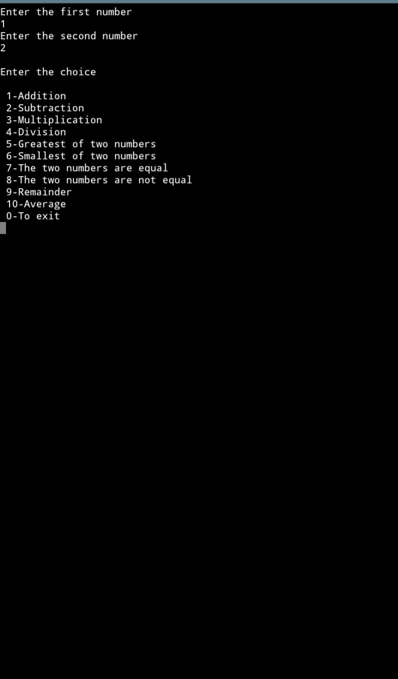

1. Write a C program to accept three numbers from the user. Find the greater two among the three and pass them as parameters to the user defined functions given below.
   1. **sumaver ( … )** which finds the sum and average of the two numbers. Print the sum and return the average.
   2. **printeven ( … )** whichprints all the even numbers between the given two numbers

#include <stdio.h>

float sumaver(int x,int y)

{

printf("Sum: %d\n",x+y);

return((x+y)/2.0);

}

void printeven(int x,int y)

{

printf("All the even numbers from %d to %d are\n",y,x);

for(int i=y;i<=x;i++)

{

if(i%2==0)

printf("%d ",i);

}

}

int main()

{

int a[3],g1,g2,t;

printf("Enter the three numbers\n");

scanf("%d%d%d",&a[0],&a[1],&a[2]);

for(int i=0;i<3;i++)

{

for(int j=i+1;j<3;j++)

{

if(a[i]<a[j])

{

t=a[i];

a[i]=a[j];

a[j]=t;

}

}

}

g1=a[0];

g2=a[1];

float aver=sumaver(g1,g2);

printf("Average: %f\n",aver);

printeven(g1,g2);

return 0;

}

