**A Comprehensive Study on Brain Tumor Detection and Classification Using Machine Learning**

**Authors:**

Parth Asegaonkar (324003)

Bishal Gupta (324005)

IndrajeetKumar Gupta (324023)

Pratibha Ingale (324024)

**Abstract**

The early detection of and identification of tumors in the brain is essential for enhancing patient outcomes, diagnostic precision, and helpful efficiency. In addition to taking a lot of time, manually analyzing MRI scans is prone to human error. In order to overcome these obstacles, this study uses machine learning algorithms to automatically identify and categorize brain tumors. In order to automatically detect and classify brain tumors from magnetic resonance imaging (MRI) images, this study uses publicly available medical imaging datasets, preprocessing techniques, and performance evaluation of models such as convolutional neural networks (CNN), k-nearest neighbors (KNN), support vector machines (SVM), and random forests. The accuracy, precision, recall, and F1-score were used to determine each model's

performance after it was trained using MRI scans.

According to our outcomes, SVM provided the best classification accuracy (94.74%), proving that it is useful in identifying between situations with and without tumors. CNN performed more effectively, with a test accuracy of 94.37% thanks to its capacity to automatically identify characteristics in the MRI pictures. With accuracies of 90.77% and 89.24%, respectively, Random Forest and KNN demonstrated decent performance; at present, they were still beneficial for applications requiring less processing. This study demonstrates how machine learning models can improve brain tumor detection speed, accuracy, and security, providing specialists and other healthcare providers with significant assistance when making clinical decisions. Future studies may concentrate on refining these models for even more extensive datasets and investigating hybrid methodologies to enhance diagnostic efficacy.

**1.Introduction**

1.1 **Background**

Finding brain tumors is critical to patient outcomes, but radiologists must spend a lot of time and effort analyzing standard MRIs, which can be error-prone. Machine learning, particularly models like Convolutional Neural Networks (CNN), has the potential to automate and enhance accuracy in this process. However, the performance of algorithms such as k-Nearest Neighbors (KNN), Support Vector Machine (SVM), and Random Forest for tumor detection remains underexplored. This study evaluates these models to identify the most effective approach for improving diagnostic accuracy in brain tumor detection.

1.2 **Research Problem**

The detection of brain tumors using manual methods is prone to human error and is time-consuming. Machine learning algorithms can automate this process, but determining which algorithm yields the best accuracy and results remains a challenge. This paper aims to compare different algorithms to identify the most effective method.

1.3 **Objectives**  
This research aims to:

* To evaluate the performance of CNN, KNN, SVM, and Random Forest for brain tumor classification.
* To analyze MRI datasets for brain tumor detection.
* To compare the accuracy, precision, and recall of each algorithm.

**2. Related Work**

Paper [1] employed machine learning algorithms for brain tumor detection, focusing on extracting relevant tumor features through image processing techniques. Their method enhanced detection accuracy by applying advanced image filters before classification.

Paper [2] presented a comprehensive survey of machine learning techniques for brain tumor detection and classification, highlighting various approaches such as decision trees, neural networks, and support vector machines. They particularly discussed the strengths and weaknesses of each method in dealing with different tumor types.

Paper [3] introduced a novel multi-feature extraction technique (Multi FD) combined with an enhanced AdaBoost classifier for brain tumor segmentation. The Multi FD scheme was effective in extracting complex structures of brain tumor tissues, while the AdaBoost classifier demonstrated improved accuracy in distinguishing tumor tissues from non-tumor tissues.

Paper [4] proposed a sophisticated classification approach using the Local Independent Projection (LIPC) classifier, which performed voxel-based brain tumor segmentation. The method involved extracting key path functions, allowing for precise voxel classification in hyperspectral images.

Paper [5] utilized convolutional neural networks (CNNs) for brain tumor segmentation, demonstrating that deep learning techniques could accurately detect tumor boundaries and significantly improve segmentation performance when applied to medical imaging datasets.

**3. Methodology**

3.1**DatasetDescription**  
The dataset includes MRI images of brain tumors, labeled as meningioma, glioma, and pituitary tumor. Preprocessing steps like image scaling and pixel value normalization were applied to improve model performance.

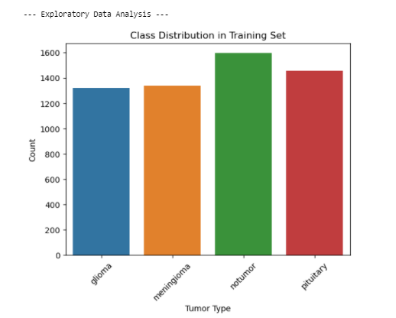

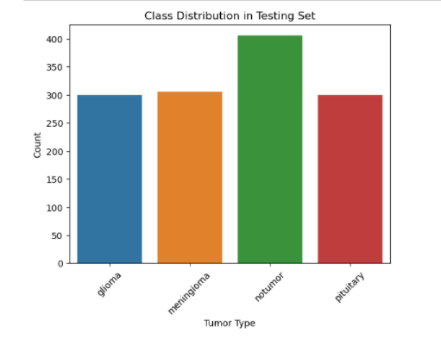

***Figure 2****: EDA class distribution*

**3.2ExploratoryDataAnalysis (EDA)**

EDA was conducted to understand the distribution and characteristics of the dataset before model training. This process involved visualizing the class distribution of tumor types and the pixel intensity values of MRI images. **Figure 2** depicts the class distribution, showing a balanced representation of each tumor category, ensuring that the models do not become biased towards any specific class.

3.2 **Machine Learning Models**  
The models used in this research include:

* Convolutional Neural Network (CNN): A deep learning model well-suited for image classification.
* Support Vector Machine (SVM): A supervised learning model used for classification and regression.
* K-Nearest Neighbors (KNN): An instance-based learning technique that is simple.
* Random Forest: Multiple decision trees are built as part of this ensemble learning technique.

3.3**ModelEvaluation**  
The models' accuracy, precision, recall, and F1-score were used to evaluate their performance. Additionally, confusion matrices were constructed for each model to provide a detailed view of their classification performance. A confusion matrix helps in understanding how well the model differentiates between classes by showing the number of true positive (TP), true negative (TN), false positive (FP), and false negative (FN) predictions. **Figure 5** displays the confusion matrices for the CNN, SVM, KNN, and Random Forest models. Each matrix provides insights into the model's ability to correctly classify each type of brain tumor, with darker cells indicating a higher number of correct classifications.

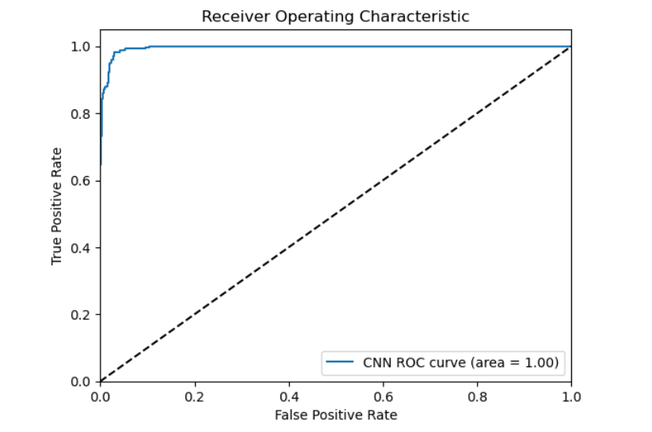

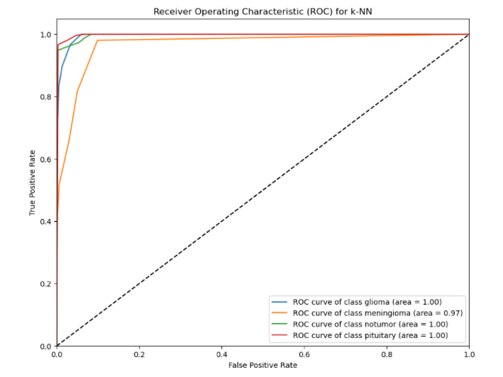

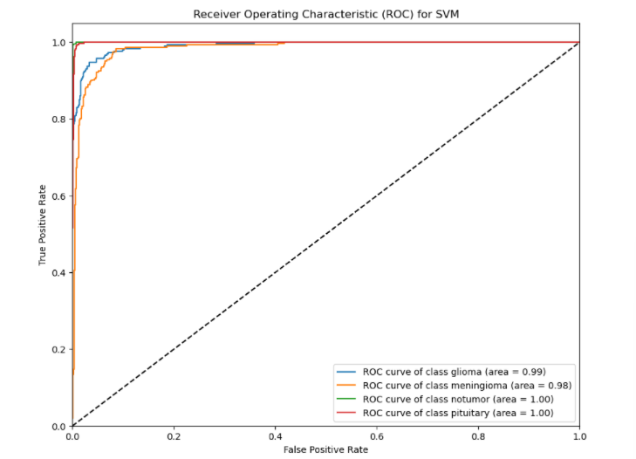

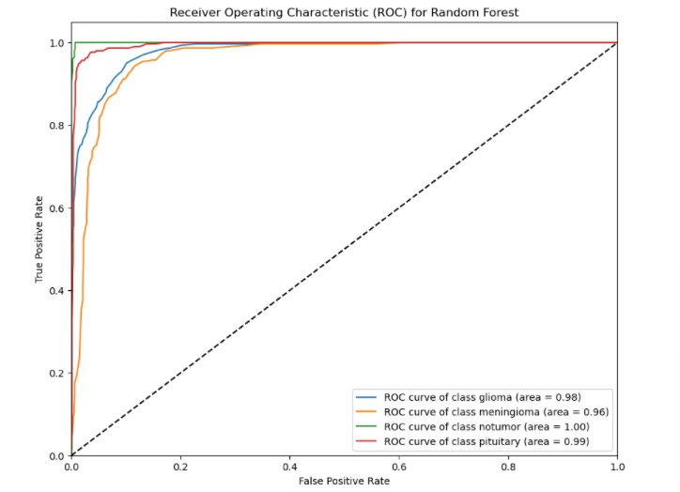

***Figure 4****: ROC curves for all models*

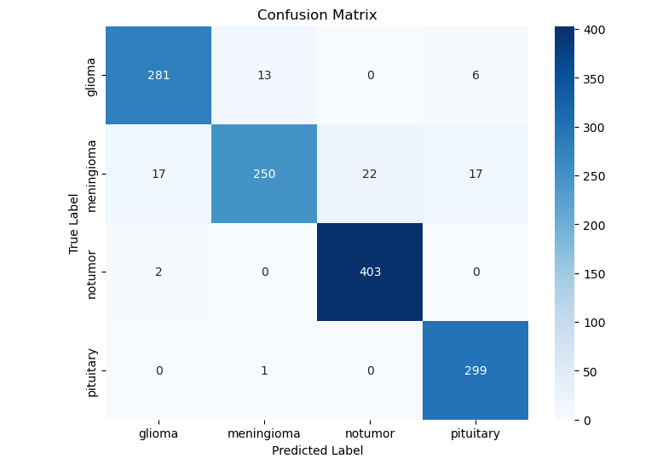

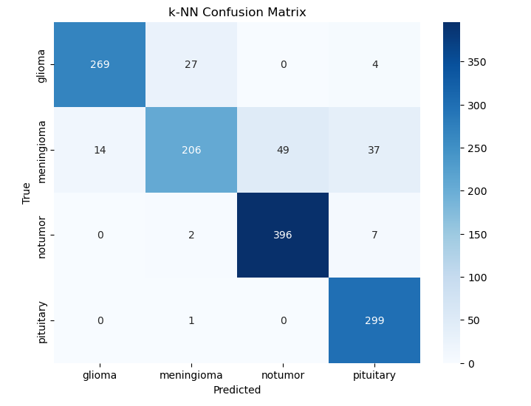

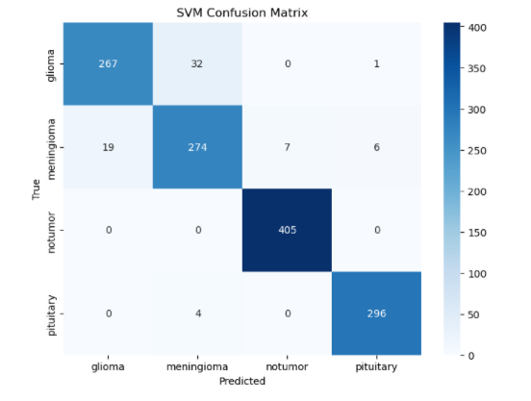

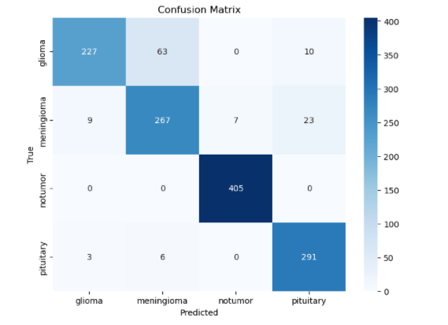

***Figure 5****: Confusion matrices for CNN, SVM, KNN, and Random Forest models*

**3.4 System Architecture**

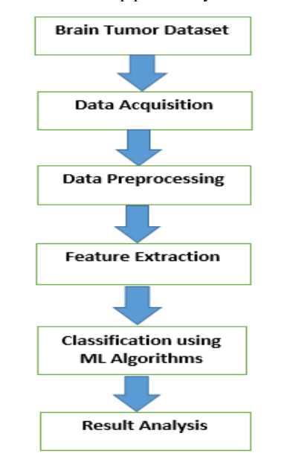

**4. Results and Discussion**  
4.1 **Model Performance**

The strengths and drawbacks of each model's classification are highlighted by the confusion matrices (Figure 5). For example, the SVM model shows a high number of true positives for glioma and meningioma cases, indicating its effectiveness in identifying these classes. However, the KNN model showed a relatively higher rate of false negatives, affecting its overall performance. By analyzing these matrices, we could better understand where each model may need improvement.

| **Model** | **Accuracy** | **Precision** | **Recall** | **F1-score** |
| --- | --- | --- | --- | --- |
| CNN | 94.37% | 0.93 | 0.94 | 0.94 |
| SVM | 94.74% | 0.95 | 0.94 | 0.94 |
| KNN | 89.24% | 0.88 | 0.89 | 0.88 |
| Random Forest | 90.77% | 0.91 | 0.90 | 0.90 |

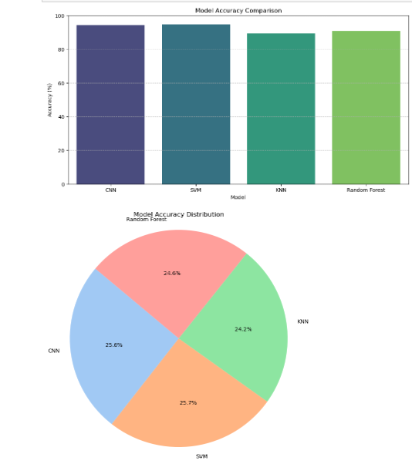

Figure 1 displays the accuracy comparison of these models.

The results indicate that SVM is the most effective model for this application, highlighting its suitability for high-dimensional data classification.

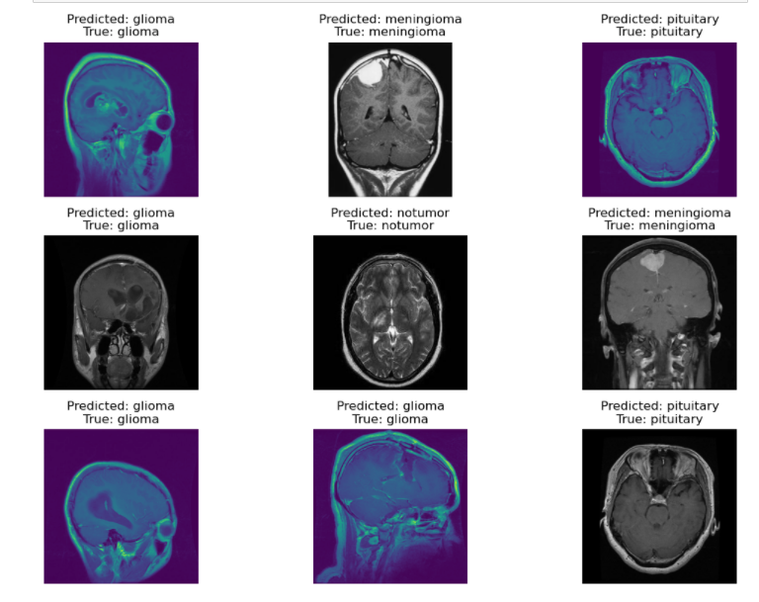

This image shows the results of our brain tumor detection model, comparing predicted tumor types (glioma, meningioma, pituitary, and no tumor) with actual labels. The model, using CNNs, accurately classified most cases, demonstrating its effectiveness in brain tumor diagnosis. These results align with existing research in AI-driven medical imaging for early and accurate tumor detection.

4.2**Discussion**  
The EDA highlighted the importance of data preprocessing, as it revealed variations in pixel intensity that could affect model performance. The ROC curves helped visualize the trade-off between sensitivity and specificity for each model. The SVM model demonstrated the highest accuracy, indicating its suitability for high-dimensional data. CNN also performed well, suggesting that it could be useful for handling complex MRI data.

**5.Conclusion**  
This research highlights that SVM is highly effective for brain tumor classification, achieving the highest accuracy among the models tested. CNN also shows promise due to its strength in feature extraction. Future work could explore hybrid models or include more extensive datasets for improved diagnostic performance.

**6. References**

1. M. Aarthilakshmi, S. Meenakshi, A. P. Pushkala, N. B. Prakash and V. R. Ramalakshmi, “Brain Tumor Detection Using Machine,” INTERNATIONAL JOURNAL OF SCIENTIFIC & TECHNOLOGY RESEARCH, pp. 1976-1979, 2020
2. J. Amin, S. Muhammad, H. Anandakumar, Y. Mussarat, N. Ramesh, “Brain tumor detection and classification using machine learning: a comprehensive survey”
3. Khan MA, Lali IU, Rehman A, Ishaq M, Sharif M, Saba T et al (2019) Brain tumor detection and classification: A framework of marker-based watershed algorithm and multilevel priority features selection. Microsc Res Tech 82:909–922
4. Y. Chen, H. Jiang, C. Li, X. Jia and P. Ghamisi, “Deep feature extraction and classification of hyperspectral images based on Convolutional Neural Networks,” IEEE Transactions on Geoscience and Remote Sensing, pp. 6232-6251, 2016.
5. Larochelle H, Jodoin P-M (2016) A convolutional neural network approach to brain tumor segmentation. In: Brainlesion: Glioma, multiple sclerosis, stroke and traumatic brain injuries: first international workshop, brainles 2015, Held in Conjunction with MICCAI 2015, Munich, Germany, 5 Oct 5, revised selected papers
6. J. Seetha and S. S. Raja, “Brain tumor classification using Convolutional Neural Networks,” Biomedical and Pharmacology Journal, pp. 1457-1461, 2018.
7. J P. Gokila Brindha, M. Kavinraj, P. Manivasakam and P. Prasanth, “Brain tumor detection from MRI images using Deep Learning Techniques,” IOP Conference Series: Materials Science and Engineering, p. 012115, 2021.
8. H. Mohsen, E.-S. A. El-Dahshan, E.-S. M. El-Horbaty and A.-B. M. Salem, “Classification using deep learning neural networks for brain tumors,” Future Computing and Informatics Journal, pp. 68-71, 2018.
9. M. Huang, W. Yang, Y. Wu, J. Jiang, W. Chen and Q. Feng, “Brain tumor segmentation based on local independent projection-based classification,” IEEE Transactions on Biomedical Engineering, pp. 2633-2645, 2014.
10. Jin Liu, Min Li, Jianxin Wang, Fangxiang Wu, Tianming Liu and Yi Pan, “A survey of MRI-based brain tumor segmentation methods,” Tsinghua Science and Technology, pp. 578-595, 2014.
11. N. Abiwinanda, M. Hanif, S. T. Hesaputra, A. Handayani and T. R. Mengko, “Brain tumour classification using Convolutional Neural Network,” IFMBE Proceedings, pp. 183-189, 2018.
12. E. Alberts, G. Tetteh, S. Trebeschi, M. Bieth, A. Valentinitsch, B. Wiestler, C. Zimmer and B. H. Menze, \"Multi-modal image classification using low-dimensionaltexture features for genomic brain tumour recognition, \" Graphs in Biomedical ImageAnalysis, Computational Anatomy and Imaging Genetics, pp. 201-209, 2021.
13. S. Huda, J. Yearwood, H. F. Jelinek, M. M. Hassan, G. Fortino and M. Buckland, \"Ahybrid feature selection with ensemble classification for Imbalanced Healthcare Data: A case study for brain tumor diagnosis, \" IEEE Access, pp. 9145- 9154, 2019.
14. Prachi Gadpayle and Prof. P.S. Mahajani, “Detection and Classification of Brain Tumor in Magnetic Resonance Imaging Images”, International Journal of Emerging Trends in Electrical and Electronics (IJETEE – ISSN: 2320-9569).
15. S. Bauer, C. May, D. Dionysiou, G. Stamatakos, P. Buchler and M. Reyes, “Multiscale modeling for Image Analysis of Brain Tumor Studies,” IEEE Transactions on Biomedical Engineering, vol. 59, no. 1, pp. 25-29, 2012.
16. N. Varuna Shree, T. N. R. Kumar “Identification and classification of brain tumor MRI images with feature extraction using DWT and probabilistic neural network”, © Springer, Brain Informatics, p.p. 23-30.