**ECT_Test: Readme file**

CreatedOn: 15th Jan 2022

Created By: Pratibha Jadhav

**Javascript:**

Please find Questions 1, 2 and 3 solutions in attached file named as “ECT_JavaScript.js”.

Folder Path: “JavaScriptCode/ ECT_JavaScript.js”

Following is a sample screenshot of output.

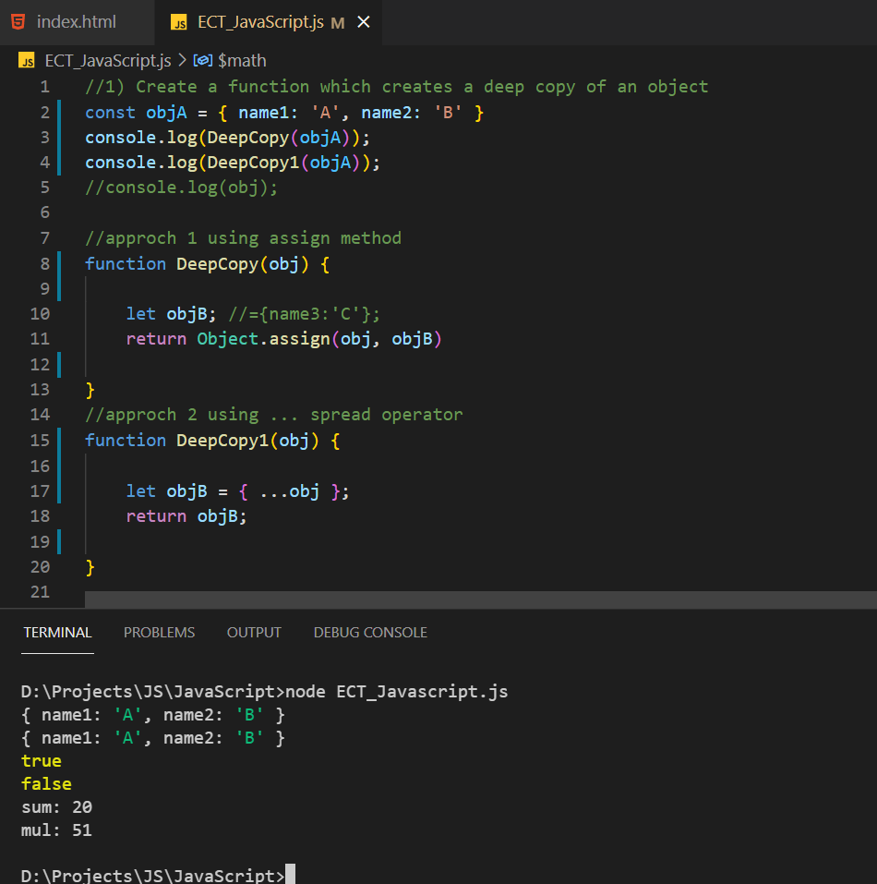

**Angular:**

Please find Questions 4 and 5 solutions in attached folder named as “AngularCode”.

Folder Path: “AngularCode/ectangular/src/app”

For Question 4, created custom pipe in “Pipes” folders, implemented sorting logic in pipe transform method. Refer “Show.comopent.html” to see the pipe applied code.

For Question 5, created component named as “Repeater” and use @Input() Decorator.

To run the code, follow the following steps:

Run npm install

Run npm install bootstrap

Run npm start

Following is a sample screenshot of output.

