**HOME PAGE :-**

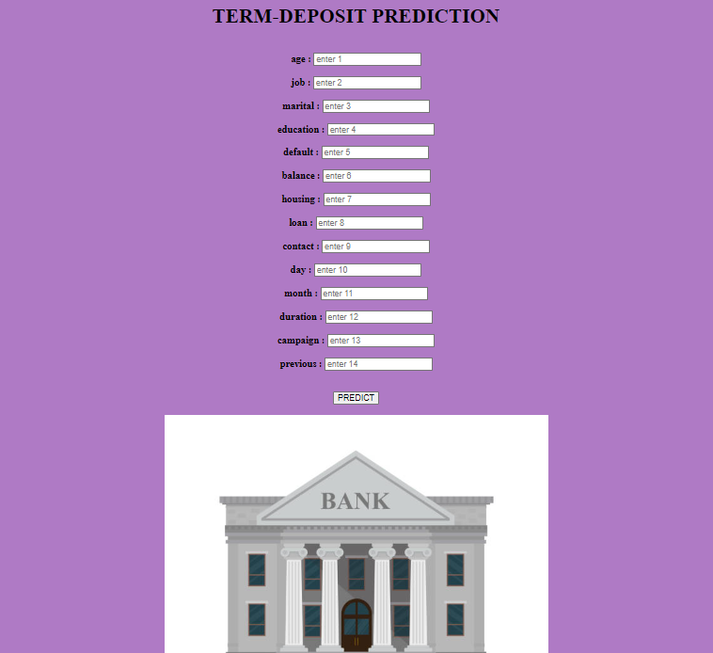

**Entering Values :-**

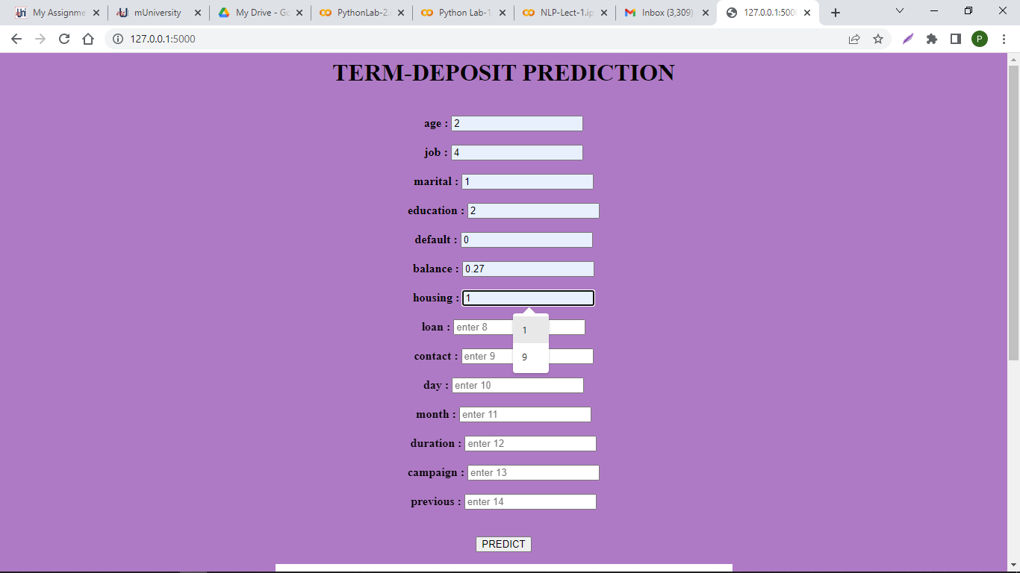

**PREDICTION : Client will buy the TERM-DEPOSIT !**



**PREDICTION : Client will not buy the TERM-DEPOSIT !**

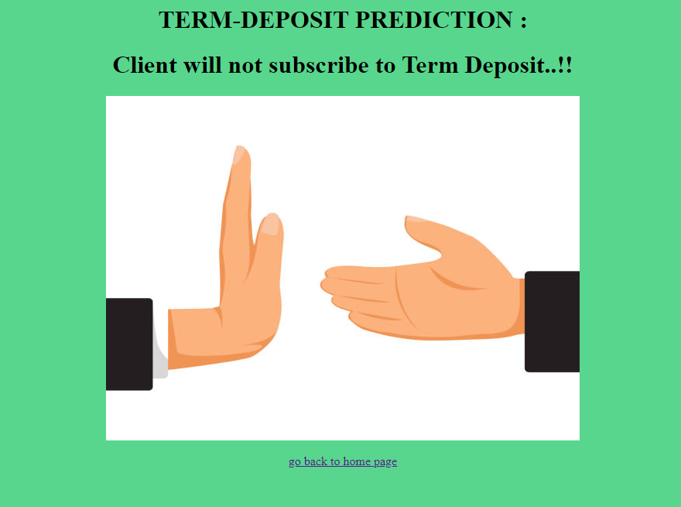

**Terminal :-**

