**Reinforcement Learning To Predict Loan Underwriting**

**Pratik Bhujade**

3010568

Submitted in partial fulfillment for the degree of

Master of Science in Big Data Management & Analytics

Griffith College Dublin

September, 2020

Under the supervision of **Prof. Abubakr Siddig**

**Disclaimer**

I hereby certify that this material, which I now submit for assessment on the programme of study leading to the Degree of Master of Science in Applied Digital Media at Griffith College Dublin, is entirely my own work and has not been submitted for assessment for an academic purpose at this or any other academic institution other than in partial fulfilment of the requirements of that stated above.

**Signed: _____________________ Date: ___________________**

Acknowledgements

Throughout the writing of this dissertation I have received a great deal of support and assistance. I have been fortunate to study in Griffith College and had the pleasure of learning and working with great people. Every individual mentioned in this page have guided me and helped me to the best of their potential.

I would like to thank my thesis supervisor Prof. Abubakr Siddig for helping me with the visions of my thesis, motivating me to achieve excellent results.

I am extremely grateful to Dr. Waseem Akhthar and the faculty of Big Data Analytics for guiding me through this process. Also, for giving me insights, their valuable time and advice, and instilling confidence in me.

Finally I would like to thank my parents forr their unconditional love, support and encouragement for my educational pursuits positively. My friends who always cheer me up in the lowest of time. Thank you for always watching and being there for me.

All these people were a part of this manifestion of this thesis and I could not have completed it without them. Thank you.

**Table of Contents**

Acknowledgements iii

List of Equations v

List of Figures v

List of Tables vi

Abstract vii

Chapter 1. Introduction 7

1.1 Introduction 2

1.2 Background of study 3

1.3 Research rationale 4

1.4 Research aim 5

1.5 Research questions 5

1.6 Structure of the research 6

1.7 Conclusion 6

Chapter 2. Background 8

2.1 Literature Review 8

2.2 Related Work 9

2.3 Conceptual Framework 12

2.4 Theories and models 19

2.5 Literature Gap 21

2.6 Conclusion 22

Chapter 3. Methodology 23

3.1 Python 23

3.2 Flask Application 23

3.3 Q Learning 24

3.4 Evaluation Metrics 24

Chapter 4. System Design and Specifications 25

Chapter 5. Implementation 28

Chapter 6. Testing and Evaluation 31

Chapter 7. Conclusions and Future Work 32

References 36

Appendex I 39

# List of Equations

**Equation 1: Q-learning algorithm**  13

**Equation 2: Q-learning algorithm** **temporal difference**  13

**Equation 3: Q-learning algorithm** **state action function**  14

# List of Figures

Figure 1 **Research Structure**. 5

Figure 2 **Conceptual framework**. 11

**Figure 3: Q-learning algorithm**. 12

**Figure 4 Comparison between Q-learning & deep Q-learning. 14**

Figure 5 **Meaning of FICO scores**. 17

Figure 6 **Machine learning Taxonomy**. 20

Figure 7 **System Flow Diagram** 25

Figure 8 **Flask app initialization and function implementation**. 28

Figure 9 **User Interface working**. 29

Figure 10 **User Interface prediction result**. 30

Figure 11 **User Interface prediction result**. 33

Figure 12 **User Interface prediction result**. 34

# Abstract

Be it a home loan, business loan, car loan or a personal loan, underwriting is a crucial aspect of the loan process. During underwriting, the lender gauges the creditworthiness of the borrower and assesses whether the applicant meets the loan eligibility criteria or not. This check helps to set fair borrowing rates for loans, establishes appropriate premiums to adequately cover the true cost of insuring policyholders, and creates a market for securities by accurately pricing investment risk. If the risk is deemed too high, an underwriter may refuse coverage.

Risk is the underlying factor in all underwriting. In the case of a loan, the risk has to do with whether the borrower will repay the loan as agreed, or will default. With insurance, the risk involves the likelihood that too many policyholders will file claims at once. With securities, the risk is that the underwritten investments would not be profitable.

All loans undergo some form of underwriting. In many cases, underwriting is automated and involves appraising an applicant's credit history, financial records, and the value of any collateral offered, along with other factors that depend on the size and purpose of the loan. Depending on the process and whether a human underwriter is involved, the appraisal process can be almost instant or take a few hours, days, or even weeks. The underwriter assesses income, liabilities (debt), savings, credit history, credit score, and more depending on an individual's financial circumstances. Mortgage underwriting typically has a “turn time” of a week or less.

To predict loan underwriting reinforcement learning model Q-learning is implemented on the data downloaded from Kaggle. The model is then evaluated on a variety of evaluation metrics to be confirmed on the model’s performance.

# Chapter 1. Introduction

In this section, the aim is to analyse the research topic in depth, forming the foundation for the research that is performed. The aim to finalise on the research topic, the problems in the current system and thus finalising the research question that we aim to answer.

## 1.1 Introduction

The processes of taking the loans are used in the financial sectors from decades. Underwriting is one of the crucial aspects in any types of loan processes like home loan, car loan, business or personal loans. The categorization of the loans is mostly done based on the usages of the loan amounts and depending on that the interest rates are varied. But the processes of taking these types of loans are more or less the same. The eligibility criteria of the lions play a crucial aspect where meeting the loan eligibility is necessary for getting loans from financial sectors.

The underwriting processes contain the mechanism where the lender is responsible

for gauging the creditworthiness from the borrowers and checking if they are eligible or not. Though the entire process is trusted, it consumes a lot of time, and negative and ineffective outcomes are also seen in some segments. The risks are there as an underlying factor in the underwritings. The repaying of the loan is crucial and covers a huge risk for the lender if the borrower is able to repay the loan or not (Pillai et al. 2019). Hence, risks are one of the crucial aspects of learning loans. Therefore, the conventional models are to be changed here in this research, where proposing more effective systems acquiring the reinforcement learning is considered here by analyzing various data points having the credit bureau sources and provides the flexibility to modelling most accurate risks based on the consumers.

All the risk factors are also considered here properly so that the overview and destruction of the issues could be done effectively in the rationale portions mentioning the cause of the issues and the contribution of this research for resolving these issues by providing the techniques using artificial intelligence and machine learning techniques. Using artificial intelligence, the dells could be built and provide more simplistic strategies concentrating on the profitability outcomes and the lifetime values of consumers. It will be responsible for entirely leveraging the AI techniques for increasing the performance of loan lending processes conveniently.

## 1.2 Background of study

The loan lenders processes are acquired by the financial sectors very aggressively having the checking activities of the eligibility criteria, which become one of the crucial factors before lending the loan to specific consumers. The checking of criteria is responsible for setting the fair borrowing rates of loans, establishing the sufficient premiums for adequately covering the true costs in ensuring the policyholders and creating the market with the help of sufficiently pricing investments risks along with the security aspects. If the risks are determined to be very high, then the coverage might be refused by the underwriter. All the loans contain several types of underwriting. In several cases, the underwriting mechanism contains the automated system and involves appraising the credit history of the applicant along with the financial records and "value of collateral offered". The other factors are also considered in the automatic processes which mostly belong to the purpose of the loan. The appraisal processes can be mostly instant, which is directly dependent on the processes of the underwriter like it is manually or automated.

The most "common type of loan underwriting" involves the "human underwriter having the mortgages" for a limited time period (Bogdanova, 2019). These procedures can contain several types of risks which individuals can create more risks in paying the loan amount by the consumers. The manual processes are always Being considered as Less efficient than the automated or computerized processes. As the technologies are also evolving every day, consumers are getting familiar with the new technologies effectively and using them in their daily life mostly. Therefore, prediction of the loan underwriting is considered here involving various reinforcement learning algorithms using "Q learning or deep neural networks Q learning". Determination of the loan underwriting is to be happened here by using the FICO scores for evaluating the model termination of thousands of data points would be possible by using the reinforcement learning which is impossible in using the traditional models of underwriting concentrating on the handful credit attributes only.

## Research rationale

Predicting future outcomes and the behaviour of the consumers is always a huge issue in financial sectors. The statistical data and their analysis are used in the financial sectors usually, which help in determining the prediction of consumers and their behaviour in paying their loans suitably.

The issue now is the manual loan underwriting process which might contain various types of risks and cannot determine the behaviour of the consumers. In some purposes, it takes huge time, and consumers face several issues injecting the loans at the most needful time.

The reason behind the issue is the use of manual processes and techniques in the digital era. When the entire world is changing, and technologies are accepted by every sector effectively, predicting loan underwriting techniques are following the conventional manual processes still now. Therefore, it's a suitable time when the lone departments should acquire machine learning and artificial intelligence techniques having more size of data and better efficiency.

This research is responsible for providing the usage of "Q learning and deep neural networks Q learning" to find out the FICO scores for evaluating the prediction loan models along with automated loan underwriting. The determination of the FICO scores will be responsible for containing the credit scores which is directly created by the "Fair Isaac Corporation" (Lavagna-Slater and Powell, 2019). Using these quotes, lenders could determine the capability of the borrower along with all the fundamental details and credit reports for assessing the credit risks and determining the extension of kids based on the borrower.

## Research aim

The “primary aim of the research” is to provide effective learning models using machine learning and artificial intelligence algorithms. The determination of the cube hello functions is to be done here for inputting all the detailed borders and cube values having all the possible actions in the output. Moreover, providing the most effective loan underwriting system having robust prediction models is a crucial aim of the research. Besides that, determining all the problems and risks available in the manual loan underwriting process is to be done here with proper justifications so that the solutions could be provided considering those negative aspects (Wu, 2018). Moreover, generating the credit scores using the FICO scoring techniques is to be provided here along with all the details of the borrowers determining their capabilities in “payment histories, types of credit used, length of credit history and new credit accounts”.

## Research questions

RQ1: How to predict the loan underwriting by using the Q-learning and is it better?

RQ2: What all features are significant in evaluating the models effectively and provide the eligibility criteria properly?

## Structure of the research

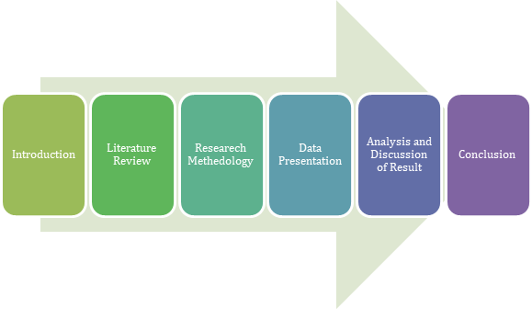

**Figure 1: Research Structure**

## Conclusion

The introduction party is responsible for providing the entire overview of the dissertation topic, i.e. "deep reinforcement learning to predict loan underwriting" effectively. The usage of the manual and automated loan underwriting processes is described and elaborated very effectively here with providing the background of the predicting loan underwriting. All the risk factors are also considered here properly so that the overview and destruction of the issues could be done effectively in the rationale portions mentioning the cause of the issues and the contribution of this research for resolving these issues by providing the techniques using artificial intelligence and machine learning techniques. Besides that, determining the primary aim while conducting the research is done focusing on proposing effective techniques with emerging technologies. Furthermore, including the objective of the rich is narrowed to the specific segments of using the deep neural networks with Q-learnings and FICO scores providing the hypothesis if the “Q learning or deep neural networks with Q learning” is more efficient in terms of predicting the underwriting (Frame *et al.* 2018). Though the entire conventional process is trusted, it consumes a lot of time, and negative and ineffective outcomes are also seen in some segments. The risks are there as an underlying factor in the underwritings. Hence, the determination of effective techniques with emerging technologies is crucial here and can be used as a complement to manual processes in loan underwriting processes.

# Chapter 2. Background

In this section, the topics covered revolve around the literature review done for the research. This section summarizes some of the researches done so far in our research topic. We aim is to study the results of these researches and thus formulating the foundation of our research. The shortcoming or in other words of these researches helped us to identify the correct path and the motivation for selecting reinforcement learning as the model in focus.



## Literature Review

The literature review contains an in-depth understanding of the theories and concepts of the given topic where the prediction strategies of loan underwriting and their implications are taken here associated with the research studies. All the authentic literature from valid resources are considered here for reviewing them focusing on the contribution of authors so that their thoughts about the prediction algorithms could be used here in conducting the research effectively. Moreover, the secondary data acquired here in the literature review provided an in-depth understanding of the topic so that the research could be more authentic based on their data (Dikshit and Kumar, 2019).

The several gaps in the literature by several are also to be mentioned here so that focusing and taking those gaps into consideration could lead to huge impacts on future studies as well contribute in detecting the effective areas using the neural networks and AI in predicting the behaviour of the consumers based on a huge amount of data of individuals. Clear discussions are provided here with proper evaluations obtained from various research done before, and all the models and theories are also elaborated here with proper justification. It is to be noted that though the thoughts and researches are considered herein analyzing the prediction techniques, the entire research is mostly focusing on the narrow elements where the FICO scores and Deep neural networks will be responsible for providing the outcomes. Determination of the framework and elaborating those in this research is possible and discussed with the framework so that the workflow of those tools could be determined effectively.

## Related Work

Abel, 2018, suggests that artificial intelligence and machine learning algorithms are being considered and applied in most financial institutions nowadays for dealing with the larger scale data of consumers where the seller rhythms are crucial for assessing the quality of credits and pricing the loan contracts. Similarly, according to the author, this data can be helpful for assessing all the risks of credits and price the insurance policies. The interactions with the clients are also nowadays conducted by the AI interfaces having the chatbots or virtual assistants which can interact with the clients in their familiar language (Abel, 2018). Using machine learning, the credit scoring tools are designed for speeding of the lending decisions along with limiting all the incremental risks. The banks mostly rely on the credit scores for making lending decisions for the organizations and consumers. The information about the payment and transaction history from the financial institutions are responsible for serving the credit scoring models using various types of tools like decision trees regression statistical analysis for generating the credit scores using less amount of structured data. Besides that, the author provided his thought that the banks and lenders are mostly turning into the unstructured additional and semi-structured data sources also which includes the social media activities using mobile phones messaging activities for capturing the more nuanced view of the creditworthiness. It also improves the rating accuracy of the loans. Enabling the assessment of several types of quality factors like having the complexities and payment willingness are conducted by applying various types of machine learning algorithms in constellating the new data (Ravyse et al. 2017). Abilities to leverage the additional data based on those measures responsible forever living the faster better and cheaper segmentations of the quality of words and directly leads to faster credit decisions. Using confidential personal data can be responsible for teasing various types of policy issues which includes the protection and privacy of data.

According to Gönül, 2018, adding the facilitating with “segmental assessment of creditworthiness and using machine learning algorithms in credit scoring can help in enabling better access for credit. The market using the conventional credit scoring models containing the activities for the potential borrower must consist of the sufficient amounts of previous credit information considering the scorable. Without this information, the credit scores could not be generated, and the borrowers cannot obtain the credits and build credit histories (Gönül, 2018). The development of the axis names having abilities and willingness for repaying the lenders can be conducted by using the applications having machine learning algorithms and the alternative data sources. It helps the lenders for arriving at the credit decisions, which was impossible previously. The train can be responsible for benefiting The economies having shallow credit markets, which leads to the non-sustainable increase of credits in various countries along with in-depth credit markets. The author argued that there is not enough evidence in favour of machine learning credit scoring models which directs that the traditional models are mostly usable and accepted by a wide range of consumers effectively in assessing the creditworthiness.

Jim, 2017, pointed out various types of advantages and disadvantages for using artificial intelligence in credit scoring models. AI is responsible for allowing a huge amount of data which is to be analyzed by the analyst quickly (Jim, 2017). It resulted in the yielding of credit scoring policies which is considered for handling the wider range of “credit inputs”, lowering the assessing credit risks in specific individuals and increasing the individuals” depending on which the credit risks can be measured. The uses of big data for kids coding can include all the “assessment of non-credit bill payments” like “timely payment of cell phones” and various types of “utility bills combining with other data”. The individuals without having any credit histories or credit scores can get the loan or credit cards due to the artificial intelligence where the lack of credit histories are being considered as the constraining factor for repaying having the lack of “conventional credit scoring models” (turing.ac.uk, 2020).

According to Ravyse, 2016, using the complex algorithms can be responsible for resulting in the lack of transparency to the customers. The rising of the concerns can be conducted by the “machine learning algorithms” having the aspect of a black box. Machine learning for assigning the credit scores to make the three decisions can be very difficult for providing the consumer's supervisors and auditors having the appropriate explanation of credit scores and out coming the credit decisions containing challenges. Besides that, the authors argued about using alternative data resources like “online behaviour or non-traditional financial information” can be responsible for introducing the bias activities in the credit decisions (Ravyse, 2016). The market using the conventional credit scoring models containing the activities for the potential borrower must consist of the sufficient amounts of previous credit information considering the scorable. It is determined that higher media pessimism good credit the downward pressures efficiently based on the market prices, which is directly followed by the reversion to fundamentals. “Consumer advocacy groups” are mostly responsible for pointing out the building combinations of machine learning tools having various characteristics of borrowers which can predict the gender and all the factors which are prohibited by the “fair lending laws” considering various jurisdictions. The rating of borrowers can be done by the algorithms from the ethnic minorities having default higher risks so the similar type of words may be given “fewer favorable loan conditions”. The author suggested that the performance of the tools mostly depends on the “availability of historical data” throughout the wider range of borrowers and the loan products. The performance of the Risk models is also dependent on the "quality, availability and reliability" of huge data on the performance of borrower-products having a wider range of various financial circumstances. Ladies are also responsible for noting the various types of financial circles considered for the performance of machine learning models and artificial intelligence affected by the lack of proper information.

## Conceptual Framework

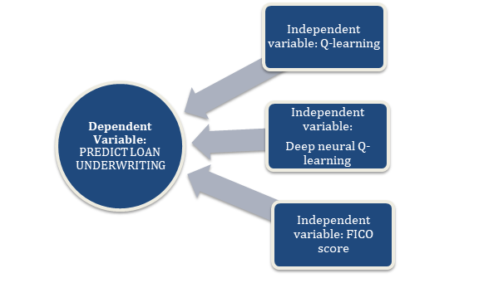

**Figure 2: Conceptual framework**

The conceptual framework provides the entire framework of the research in which the entire flow is dependent. The dependent and independent variables are responsible for determining the main aspects of the research. Here prediction of the loan underwriting is determined as the dependent variable, whereas, the Q-learning, “deep neural network Q-learning” and the FICO scores are the independent variables in which the dependent variable is based (emerj.com, 2020).

**Q-learning**

“Q-Learning” is one of the "off-policy reinforcement learning algorithms" which is responsible for seeking the finding strategies of the best actions taking the provided current states. The techniques are considered as off-policy because of its functions which are mainly dependent on the current states and actions and based on those actions, and it learns how to work (Bruckner, 2019). The actions are mostly on the outside of current policies and take random actions so that it doesn't require any policies. It is also considered as the "model-free reinforcement learning" as the algorithms don't need any models in the environment and are able to handle all types of problems with "stochastic transitions and rewards" without adapting strategies.

In every type of "finite Markov decision process" (FMDP), “Q-learning” is responsible for finding the optimal policies having the sense to maximize the expected values having total rewards over all the successful processes and steps started from the current state. Moreover, “Q-learning” can be considered for the identification of optimized "action-selection policies" for any "provided FMDP, provided infinitive exploration times" and "partly-random policies" (Sabharwal, 2018). The function is named as "Q" which is responsible for returning the used rewards and provides the reinforcements and stands for the better quality of the actions taken in specific given states (towardsdatascience.com, 2020).

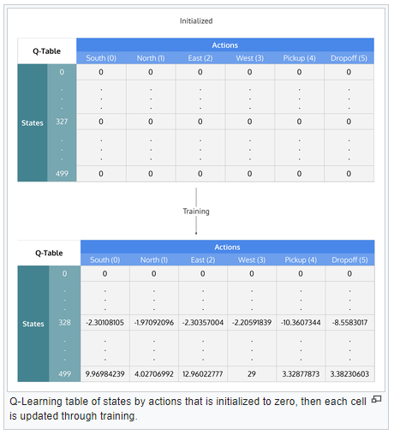

**Figure 3: Q-learning algorithm**

The algorithm of the Q-learning is provided and elaborated in the above figure (Davenport, 2018). The specific weight in a particular step from the state Δt is responsible for stepping into the calculated future which is also denoted as “ $γ^{Δt}$” in which $γ$ is the discount factors having the number between 0 and 1 (0 $≤γ≤$ 1) and "contains the effect of valuing rewards" receiving the "earlier higher" than the "received later" which reflects the good start value. The probabilities in the successes are interpreted as $γ$ at every step $Δt$ (analyticsvidhya.com, 2020).

Hence the algorithm contains the function which is considered for calculating the “quality of state action combination”:



**Equation 1: Q-learning algorithm**

Before beginning the learning, the initialization of Q is conducted towards the "possible arbitrary fixed values".

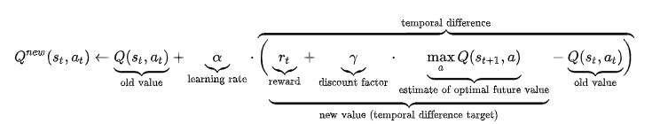

**Equation 2: Q-learning algorithm temporal difference**

Whenever the agents “*t*” do the selection process of any actions $a^{t}$, observing reward $r^{t}$, and entering into new state $s_{t+1}$ then Q is to be updated. However, the “new state” is dependent on the “previous states and chosen actions”.

**Deep neural network Q-learning**

The “deep Q-learning” is an “expanded form of Q-learning” which also uses a neural network for approximating the function of Q-value. Q-learning contains a very simpler and powerful algorithm for creating the cheat sheets for the agents, helping them in figuring out the actions which are to be performed (Bazarbash, 2019). But if the cheat sheet is huge, having a huge number of actions and states in the environment, then the table will be filled with more than a million cells which will be out of control.

In “deep Q learning”, the “neural network” is considered for approximating the “functions of Q-value”. The input is here “the state”, and the output directs to the “Q-value” of all "the possible actions". The figure is provided below focusing on the differences between Q-learning and deep Q-learning (towardsdatascience.com, 2020).

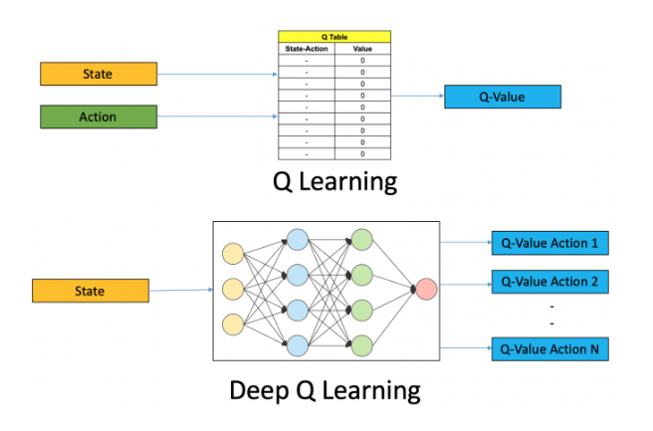

**Figure 4: comparison between Q-learning & deep Q-learning**

(Source: <https://www.analyticsvidhya.com/blog/2019/04/introduction-deep-q-learning-python/>)

The steps in deep Q-learning are quite different from reinforcement learning. The user is responsible for storing all the past experiences in memory. The maximum output in Q-network is responsible for determining the next actions (Han, 2019). The loss function is calculated by the "mean squared error" of "the predicted Q-value and the target Q-value – Q*". However, it is impossible for knowing the actual targeted value which could deal with the "reinforcement learning problem".

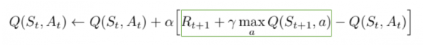

**Equation 3: Q-learning algorithm state action function**

Here in the equation, the squared part is responsible for representing the target. It can be argued that the prediction is conducted based on its own values but containing the “unbiased true reward” as R, the network will go for updating the gradient by using the backpropagation methods in converging finally.

**FICO scores**

FICO score contains one type of credit score which is directly created by the “Fair Isaac Corporation”. The FICO scores of the body words are used by lenders having different types of details on the credit reports of words for assessing the credit risks and determining if they are eligible for extending the credits. The FICO scores are taken into consideration having various types of factors in five different areas for determining the creditworthiness. The crucial five areas are “payment history, current level of indebtedness, types of credit used, length of credit history and the new credit accounts”.

Understanding the FICO scores is very crucial where FICO contains the “major analytics software company” which is responsible for providing the services to “both the consumers and business organizations”. The company was known as “Fair Isaac Corporation” previously and now changed the name into FICO after the year 2009 (Homonoff*et al*. 2019). It is widely known as the most effective credit score generator for the consumers by which the financial institutions can decide if issuing credits or lending money to the specific consumer is eligible or not.

The range of the FICO scores varies from 300 to 850 in which scoring above 650 directly indicated toward the effective credit history. The individuals having less than 620 scores find huge difficulties obtaining financing at familiar rates. The lenders can take the FICO scores of borrowers and also gain the access of several information and details like their incomes, jobs and types of credit requests for determining the creditworthiness.

FICO scores are used by most of the banks and lenders for making the credit decisions rather than other models. Though there can be negative items there in borrowers, the fact is crucial where lower FICO scores can be a deal breaker in various lenders. Most of the lenders use hard and fast FICO scores up the mortgage industry provides the approvals. The denials can be resulted if the single point below the threshold is conducted.

To achieve higher FICO scores, it is mandatory for having the mixes of credit accounts and maintaining great payment histories. The restraint should be shown by the borrowers in keeping the credit balances sufficient below their limits. “Maxing out credit cards, paying late, and applying for new credit” can affect the FICO scores hugely.

The calculation of the FICO scores contains the determination of credit scores where the “Fair Isaac Corporation” differs in various categories. The division of the FICO scores are conducted like this: “payment history is 35% of the score, accounts owed is 30%, length of credit history is 15%, new credit is 10%, and credit mix is 10%”. The crucial factors are:

1. **Payment history**

The payment history refers towards the activities of individuals determining if they pay their credit accounts timely or not (Romer, 2020). All the credit lines submitted by the consumers are shown in the credit report along with the indication of payment modes in receiving the payment in 30, 60, 90 and 120 days late.

**b. Account owed**

The amount owed is responsible for referring to the “amount of money owed by the individuals”. It is not necessary to have low credit scores to have “a lot of debt”. Moreover, FICO is responsible for considering the “ratio of money” which is owed to the “amount of credit” available. It is to be illustrated in such a way that one who owes $50,000 but containing all the credit lines mostly extended having the making out of all credit cards which directs that the credit score will be lower (Sterne, 2017). But individuals have owed more than $100,000 but “not close to the limits” can contain more credits.

**c. Length of credit history**

Generally, the length of the credit histories matters hugely where having the credits in a longer period by the individuals could contain better credit scores. However, having shortened credit histories with “favorable score in other categories” can have good scores. FICO scores also consider the duration of the account opening and how old the accounts are along with overall averages.

**d. Credit mix**

The credit mix contains the various types of accounts for obtaining the higher credit scores, and the individuals required the robust mix of the retail accounts, instalment loans and the credit cards like mortgages, vehicle and signature loans.

**e. New credit**

The new credit is referring to the newly opened accounts where opening newer accounts in a very short period of time leads to identifying that there must be some risks and lowers the credit scores.

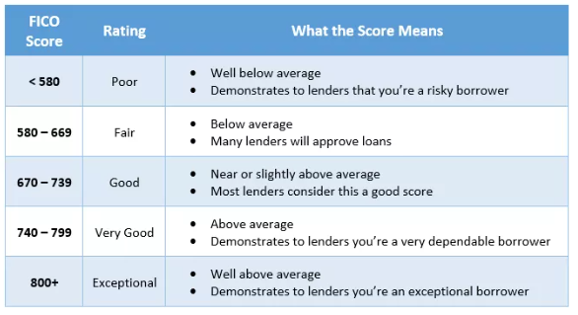

**Figure 5: Meaning of FICO scores**

(Source: https://www.investopedia.com/terms/f/ficoscore.asp)

The versions of the FICO are also matters containing various types of versions as companies are continuously updating the calculation methods for better output since its introduction in 1989. All the new versions and released in the market and provide the ability to the lenders for using it but it is totally dependent on the landers for determining if they should implement the addition to the latest versions or not.

The latest version is FICO 8, which was introduced in the year 2009 containing the base of scoring and algorithms (Zhinin Vera, 2020). According to FICO, the current version contains more stability and consistency compared to the previous versions along with several emerging features which makes the system more efficient in predicting the credit scores than the previous versions.

Like most of the previous FICO scoring systems, FICO 8 is also responsible for attempting to the conditions of how effectively the interactions of the individual borrower could be done with the Debt. Ten courses will be higher if the individuals always pay their bills, maintaining the deadlines and keeping lowered credit card balances along with opening the new accounts to target the particular purchasers are also considered here—the lowest scores calculated whenever individuals content the frequent delinquent and overleveraged in the credit decisions. The collection of the accounts is also completely ignored by the system having the original balance of less than $100.

Various types of editions are conducted in the FICO version 8 including more efficient sensitivities in highly utilized credit cards which means that the least number of credit card balances in the active cards can be more positive in terms of influencing the scores of the borrower. FICO 8 is also responsible for treating the isolated late payments very judiciously compared to the previous versions (Sawh, 2016). According to the FICO, where “If the late payment is an isolated event and other accounts are in good standing” where scoring 8 is hugely forgiving. FICO 8 is responsible for dividing the consumers into various types of categories for providing the beta statistical representation of several risks. The fundamental need of the changes in the newer version was for keeping the borrowers containing lo to you know credit histories in graded on the similar curves having strong credit histories (fsb.org, 2020).

The version 9 is also released in the year 2016 by Fair Isaac having the adjust means with the various types of treatments in collecting medical accounts increasing the sensitivities to the dental histories and it better for giving approaches for fully paying the third party collections. However, this latest version is not mostly adopted by businesses and companies effectively.

## Theories and models

**Clustering theories and topic model**

The plastering theories generally contain the clustering algorithms which are mostly used for understanding the behaviour of the consumers and traders. The banks are using these algorithms for getting a better understanding of the happenings in the individuals causing specific situations. The clustering algorithms can be used to buy the regulators for understanding the traders more confidently and categorizing The business models of various organizations visiting the advanced regulators.

The topic models are considered for understanding behavioral drivers in several types of market participants. The applications of machine learning at US SEC were used in text mining having formal language processing for detecting the fraud activities in accounting. It is determined that higher media pessimism good credit the downward pressures efficiently based on the market prices, which is directly followed by the reversion to fundamentals. Tetlock 2007, found that the prediction of the “high market trading volume” is conducted by the “high and low pessimism”.

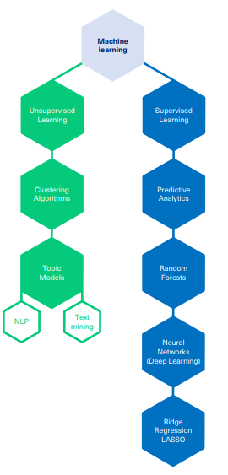

**Figure 6: Machine learning Taxonomy**

(Source: https://www.turing.ac.uk/sites/default/files/2019-04/artificial_intelligence_in_finance_-_turing_report_0.pdf)

The dictionary-based approaches used by researchers for examining the measurement of languages can be used for predicting the accounting earnings of several organizations and their stock returns. It is found that the media content is considered for capturing the “hard-to-quantify” aspects of fundamentals of several organizations the stock prices are quickly incorporated by the investors. The classification of the forward-looking statements is done to show the association with the characteristics of organizations using “Naive Bayes algorithm”.

**Supervised machine learning model**

In the supervised learning model, the specific algorithm is responsible for trying to fit the targets by using the provided input features. The training data containing the levels in the observations are provided to the algorithms. The learning activity of the algorithms in the classification rule is dependent on the range of data set which will be used for predicting the labels having the “out of sample observations”. The differences between the supervised and unsupervised machine language are mostly directed to the “lack of labelled training data” to be determined by the correlations.  The “predictive analytics, neural networks, random forest and LASSO techniques” are included in the supervised learning (arxiv.org, 2020).

The reinforcement learning contains the roots of the optimistic controls and falls between the "supervised and unsupervised machine learning". The relationship between the rewards and actions is mostly unknown in reinforcement learning, and the interactions of the agent with the environment should be inferred". Examination of the actions dependent on each data point after feeding to the algorithms is conducted by the "unlabeled set of data". Both the topic models and the clustering algorithms are considered here as the precursors for the predictive analytics being the form of the "supervised machine learning". The Past breaches are always playing a crucial role in detecting the newer breaches in the regulations.

## Literature Gap

The literature gap focuses towards the limitations or the segments where the past researchers didn’t consider. The entire credit scoring system is based on the AI and machine learning techniques where it is seen that most of the activities inside the system is based on the previous activities and information about individuals’ payment histories and past transactions or repaying activities. But one of the crucial literature gaps is that if an individual can contain the capabilities of repaying the loan but doesn’t have any types of previous records of payments and repaying history, then the system cannot recognize the capability of the individual and a negative credit score will be shown about the borrower. Hence, the borrower couldn’t get the loan whenever the need was there. Besides that, if one contains several bank accounts for personal reasons, the system can detect the individual as containing several risks and provide fewer credit scores so that they can’t get the loan. These types of gaps are there in the literature where the researchers couldn't focus much. Though some of them detected these issues and elaborated them, the solutions for the scenario is not provided by them till now to deal with the issue. Moreover, though the version 9 is already introduced in 2016, the usage and adaptability rate of the version is not much higher. Hence, it proved that many segments should be considered in the future so that the upcoming versions could deal with the gaps and future researchers could mention and provide the solutions against the gaps and drawbacks in the calculation of credit scoring process.

## Conclusion

The review of the literature is elaborated here effectively taking huge types of secondary resources from authentic sources containing the journals, books, online articles. These resources are responsible for getting the knowledge about the Q-learning and Deep Learning Q-algorithms along with the FICO scoring techniques to provide and calculate the credit scores based on several criteria. The conceptual framework is constructed acquiring the dependent and independent variable which is very crucial for gaining the huge knowledge in conducting the research. Various types of literature are taken for analyzing the system and their workflow along with the thoughts of several researchers highlighting all the positive and negative aspects of the system. Besides that, the theories and models which are very crucial for the system are elaborated with proper figures. The calculations and determination of the FICO credit scores are also elaborated in a very effective way determining all the types of versions of FICO along with the improvements done in the latest version. It is quite evident that though the algorithms are quite helpful and consumes less time for determining the credit scores with minimal activities and actions, the system also contains some demerits and disadvantages. These disadvantages are to be acquired and focussed in the research here and the further processes of the research will be conducted based on the data obtained from the literature review section.

# Chapter 3. Methodology

To generate a Loan Underwriting prediction, we are using Python as a tool and jupyter notebook for the IDE. To generate the user interface we have used Flask tool. The reinforcement learning model that is implemented is Q-Learning model. The evaluation metrics used are accuracy score, F1-Score, precision score, precision recall curve and classification report.

* 1. **Python**

Python is an interpreted, high-level general-purpose programming language. It is created by Guido van Rossum made public in 1991. Python design was focuses on the readablility of the code. It forces the us to indent the code else it’s an error. This contributes a lot in code readability. It is based on OOPs framework. Its aim is to aid in clear logical codes for all kinds of small or big scale applications.

It is open-source and easy to learn, the availability of the packages makes it easy for even non-programmers to code at ease. This is why this tool is chosen as there a vast variety of libraries available which are reliable and are tuned to work easily.

* 1. **Flask Application**

Flask Application is python’s micro web framework. It is named as a micro framework as it is not dependent on a particular tools or libraries to start the web service. It even does not have a database, form validation, or any other components where pre-existing third-party libraries provide common functions. Thus making it suitable for our application.

* 1. **Q Learning**

Q-learning is an off policy reinforcement learning algorithm which aims to seeks the best action that will be taken for the given current state. It's labelled as off-policy for the reason that the q-learning function learns from actions that are outside the current policy, like taking some random set of actions, and hence a policy is not required. This models aims to improve itself from and is rewarded with negative score when the performance is not good, hence it continously aim to make the right predictions. For the critical task of loan underwriting where we neither want to sanction loan to non-credible person nor to reject loan of a credible person in need, reinforcement learning model Q-Learning seems the right model.

* 1. **Evaluation Metrics**

These are the metrics used to evaluate the model’s performance. We have used a variety of metrics: accuracy score, F1-Score, precision score, precision recall curve and classification report. Classification Accuracy is what we usually mean, when we use the term accuracy. It is the ratio of number of correct predictions to the total number of input samples. F1 Score is the Harmonic Mean between precision and recall. The range for F1 Score is [0, 1]. It tells you how precise your classifier is (how many instances it classifies correctly), as well as how robust it is (it does not miss a significant number of instances). F1 Score tries to find the balance between precision and recall. Precision is the number of correct positive results divided by the number of positive results predicted by the classifier. Recall is the number of correct positive results divided by the number of all relevant samples (all samples that should have been identified as positive). The classification report visualizer displays the precision, recall, F1, and support scores for the model.

# Chapter 4. System Design and Specifications

The system design and implementation is based on the below Figure 7 design flow

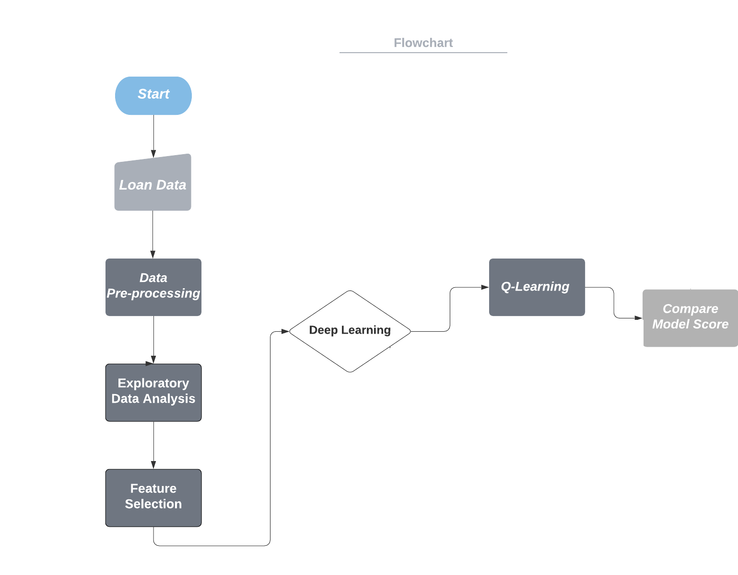

**Figure 7: System Flow Diagram**

The system flow starts by importing the data into the python environment. The data used is downloaded from Kaggle from the link <https://www.kaggle.com/c/home-credit-default-risk/data>. The data folder contains various files. For the purpose of our research we have used application_train.csv which has all the information required for our research. The data has 122 columns and 307491 entries in rows.

We then move to Data Exploration and Data pre-processing, these steps are correlated. This is because the data analysis done in one step leads to the processing/ fixing of the issues in the data in the next step. In these steps the following tasks are performed:

**Missing Data Analysis**: The data is checked for the missing values which are nan or null fields. The treatment of missing data can be done in two ways: dropping the rows/ columns which contain values or we can replace the missing values with some default value or mean/median of the data. For the research, we used the second method where we replaced the missing value with the median. This method preserves the credibility of the data and also leaves us with good enough data size so models can be trained well.

**Class Balance**: The data is checked for the balance of the target class. The balance needs to be right as if the balance is off the accuracy/ performance of the model suffers. To fix class balancing SMOTE oversampling method is used. Where the data from the majority class is replicated to be of minority class by transforming it on the basis of the data present in the minority class.

**Outliers**: The outliers are the very high or low values in the data that affects the total mean of the data and hence leading it to bad predictions.

Feature Selection is performed next where we find the right set of features for the model. To find the best feature we are taking advantage of three methods for feature selection. We select 20 features from each feature selection model. The first is the chi-square test, where the data features are analysed and the probability score is provided to the data. The second method is the Pearson correlation coefficient where the strength of the relationship of the features are tested. The last method implemented is Recursive Feature elimination, in this methods the insignificant features are dropped from the feature set recursively. Once all the methods implemented we combine the selected features from all the models and removed the duplicate entries.

The q-learning model is implemented next. The data is split into training and test set both the purpose of the training/fitting the model and then to test of the model is working right. Once the model is implemented the training set is used to train the model. Then using the test set we make the predictions. Then predicted values are then compared with the actual values and the performance metrics are generated.

# Chapter 5. Implementation

The implementation section with code output and details is covered in the jupyter notebook. For the user interface, we used the dataset which is the subset of the application_train.csv file. Once in the code, we have finalised the features using feature selection methods, the data is then exported as a CSV file. That CSV file is used for the user interface implementation so the time for all the feature selection and data cleaning process can be reduced. From the exported csv file, we reoved some data points and saved then in a separate file that will be used in the user interface for the upload of the entries for which the model will make predictions.

The prototype of the user interface is generated using flask application of python. The application is first initaialisaed and then the function on the basis of application routing are implemented. For this research we have implemented two functions as shown in figure 8.

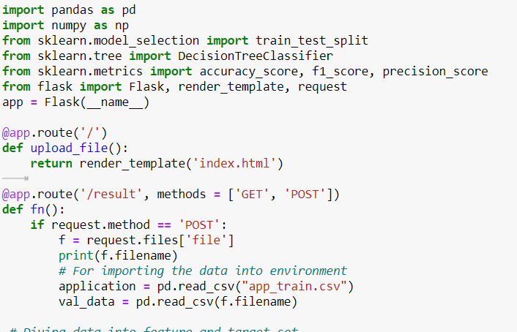

**Figure 8: Flask app initialization and function implementation**

The first function will generate the landing page where the user will import the file for the prediction of the loan should be granted to the user in the records or not. The user interface screen is shown in Figure 9 below.

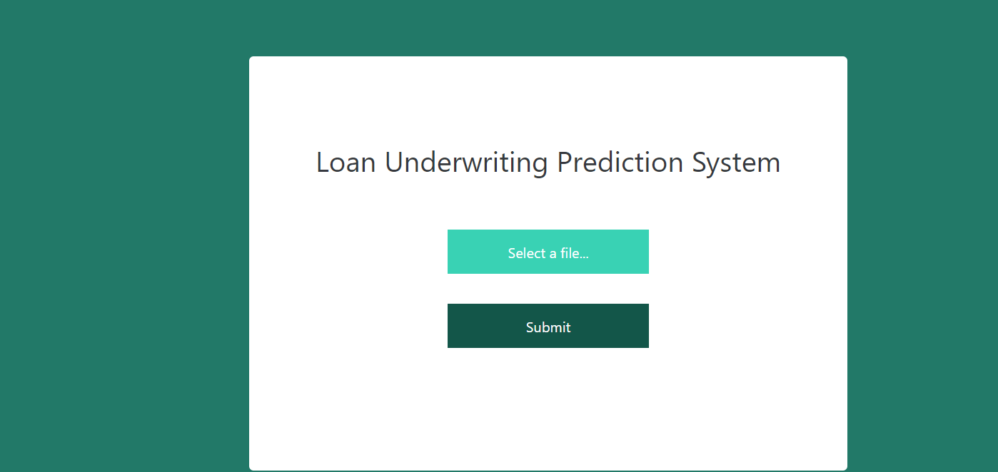

**Figure 9: User Interface working**

The file is uploaded and the result for the user records is generated. The output screen looks like.

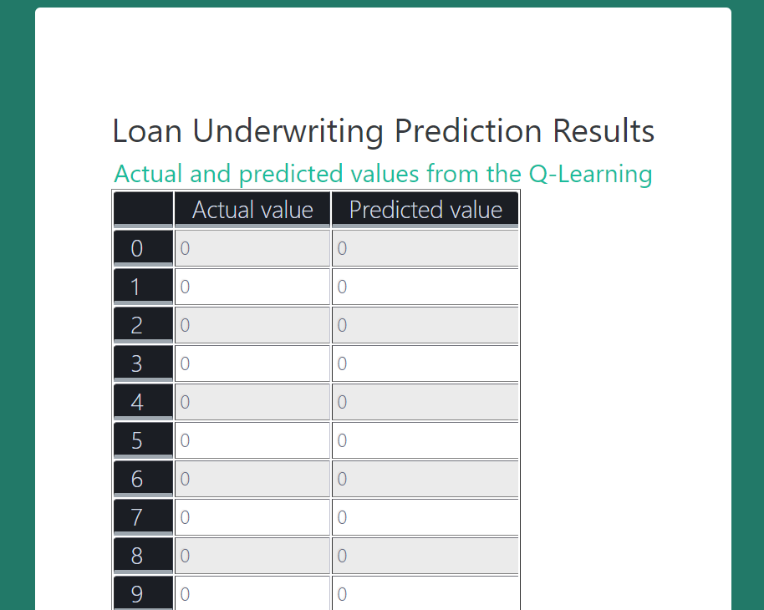

**Figure 10: User Interface prediction result**

# Chapter 6. Testing and Evaluation

For model testing, the test data set which was generating by data split in code is used. The model makes predictions for the features present in the test data. The predicted data is compared with the actual data and thus performing the model evaluation. The accuracy score, F1-score, classification report of the model. All these are also explained in the jupyter notebook of the code.

# Chapter 7. Conclusions and Future Work

To conclude the research done, we start by summarising the literature review done. From the literature review, we find that numerous research has been performed on traditional machine learning models. The researches done are working good but there is still a huge room of error present in them. To minimize this gap of models needing constant improvement to perform better every time, we used the reinforcement model. Using this model the model which learns to adapt as per the data and the changes in the data pattern, we have received good accuracy ranging from 95-100% in every run. In the data where the result is obtained from the UI, the model performance was 96% accuracy.

The predictions made by the model for the data imported in the user interface shows that the model, that only for the only value the model didn’t predict the actual value. The model performed well in predicting the values correct.

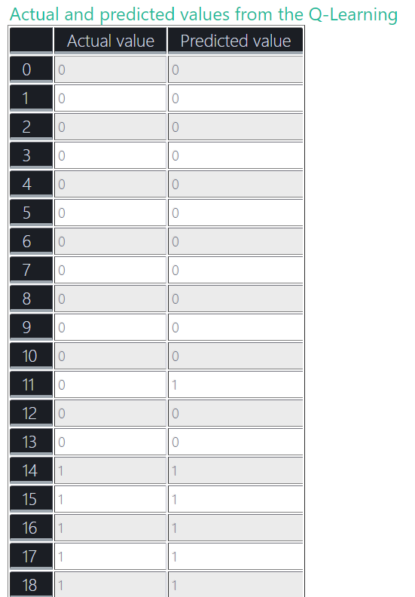

**Figure 11: User Interface prediction result**

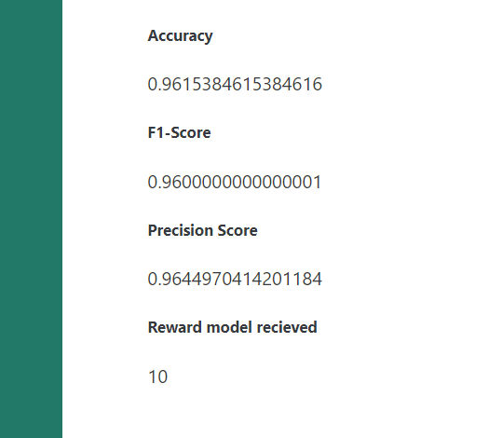

**Figure 12: User Interface prediction result**

The accuracy score from Figure 12 above of the user interface test, shows that the model accuracy score is 96.1%, F1-Score is 96% and the precision score is 96.45%. The model receiving the reward of 10 as it achieved the accuracy score of more than 95%. There is negligible gap in accuracy and F1-score this means that the model is working fine and there are no problems of overfitting or Underfitting or class imbalance in the data.

For future work, we recommend using deep q-learning where we can add the benefit of neural network in the process of off-policy model implementation. The neural network is the branch of artificial intelligence. A neural network is a series of algorithms that works towards recognizing the underlying relationships that are present in the data contemplating the process of acting the way the human brain operates. This way, neural networks refer to systems of neurons which are either organic or artificial.

The use of H2O streaming library implementing spark framework can also be investigated. The use of big data can also lead to better performing models. As the model is as good the data is.

# References

**Book**

1. Sterne, J., 2017. *Artificial intelligence for marketing: practical applications*. John Wiley & Sons.

**Journal**

1. Bazarbash, M., 2019. *Fintech in financial inclusion: machine learning applications in assessing credit risk*. International Monetary Fund.
2. Bogdanova, M., 2019. Fintech Underwriting using Machine Learning.
3. Bruckner, M.A., 2019. Preventing Predation & Encouraging Innovation in Fintech Lending. *Available at SSRN 3406045*.
4. Davenport, T.H., 2018. From analytics to artificial intelligence. *Journal of Business Analytics*, *1*(2), pp.73-80.
5. Dikshit, N. and Kumar, A., 2019. Machine Learning Analysis of Mortgage Credit Risk. *MID*, p.16.
6. Frame, W.S., Wall, L.D. and White, L.J., 2018. Technological change and financial innovation in banking: Some implications for fintech.
7. Han, C., 2019. *Loan Repayment Prediction Using Machine Learning Algorithms* (Doctoral dissertation, UCLA).
8. Lavagna-Slater, S. and Powell, R.J., 2019. Behavioural underwriting using non-traditional data sources: Evidence from stokvels. In *The proceedings of 3rd Business Doctoral and Emerging Scholars Conference* (p. 4).
9. Pillai, S.G., Woodbury, J., Dikshit, N., Leider, A. and Tappert, C.C., 2019, October. Machine Learning Analysis of Mortgage Credit Risk. In *Proceedings of the Future Technologies Conference* (pp. 107-123). Springer, Cham.
10. Sabharwal, C.L., 2018. The rise of machine learning and robo-advisors in banking. *IDRBT Journal of Banking Technology*, p.28.
11. Wu, W., 2018. Final Project: Prediction of Loan Default with Machine Learning Method.
12. Zhinin Vera, L.F., 2020. *Credit Card Fraud Detection using Artificial Intelligence* (Bachelor's thesis, Universidad de Investigación de Tecnología Experimental Yachay).
13. Sawh, D., 2016. Financial Fraud Detection and Data Mining of Imbalanced Databases using State Space Machine Learning.
14. Abel, D., 2018. ICML 2018 Notes.
15. Ravyse, W.S., Blignaut, A.S., Leendertz, V. and Woolner, A., 2017. Success factors for serious games to enhance learning: a systematic review. *Virtual Reality*, *21*(1), pp.31-58.
16. Gönül, S., 2018. *A Framework for design and personalization of digital, just-in-time, adaptive interventions* (Doctoral dissertation, MIDDLE EAST TECHNICAL UNIVERSITY).
17. Jim, S., 2017. Artificial Intelligence for Marketing.
18. Ravyse, W.S., 2016. *Investigating the success factors of serious games: a systematic review* (Doctoral dissertation).

**Online article**

1. arxiv.org, 2020, Reinforcement Learning in Economics and Finance, available at: https://arxiv.org/pdf/2003.10014.pdf [Accessed on 14.8.2020]
2. turing.ac.uk, 2020, Artificial intelligence in finance, available at: https://www.turing.ac.uk/sites/default/files/2019-04/artificial_intelligence_in_finance_-_turing_report_0.pdf [Accessed on 14.8.2020]
3. fsb.org, 2020, Artificial intelligence and machine learning in financial services, available at: https://www.fsb.org/wp-content/uploads/P011117.pdf [Accessed on 14.8.2020]

**Website**

1. analyticsvidhya.com, 2020, A Hands-On Introduction to Deep Q-Learning using OpenAI Gym in Python, available at: https://www.analyticsvidhya.com/blog/2019/04/introduction-deep-q-learning-python/ [accessed on 12.7.2020]
2. emerj.com, 2020, Machine Learning for Underwriting and Credit Scoring – Current Possibilities, available at: https://emerj.com/partner-content/machine-learning-underwriting-credit-scoring/ [accessed on 12.7.2020]
3. towardsdatascience.com, 2020, Qrash Course: Reinforcement Learning 101 & Deep Q Networks in 10 Minutes, available at: https://towardsdatascience.com/qrash-course-deep-q-networks-from-the-ground-up-1bbda41d3677 [accessed on 12.7.2020]
4. towardsdatascience.com, 2020, Why Going from Implementing Q-learning to Deep Q-learning Can Be Difficult, available at: https://towardsdatascience.com/why-going-from-implementing-q-learning-to-deep-q-learning-can-be-difficult-36e7ea1648af [accessed on 12.7.2020]

# Appendix I

Evaluation metrics

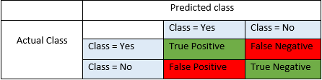

(Source: https://blog.exsilio.com/all/accuracy-precision-recall-f1-score-interpretation-of-performance-measures/)