TITILE - Football Performance and Transfer Data Analysis using SQL
SUBTITLE - Data-Driven Insights into Player Performance, Team Efficiency, and Transfer Trends
NAME – Pratik Mahesh Garud
DATE - 09/10/2025

1) Top Performers Analysis -
SELECT p.name AS player_name, t.team_name AS team_name, p.goals_scored AS goals_scored , p.position AS position
FROM players p
JOIN teams t
ON p.team_id = t.team_id
ORDER BY goals_scored DESC
LIMIT 5;

Explanation:
- This query retrieves the top 5 players who have scored the most goals.
- It joins the players table with the teams table using the team_id to show each player’s team name.
- The results are sorted in descending order of goals_scored so that the highest scorers appear first.
- Finally, it limits the output to the top 5 performers.

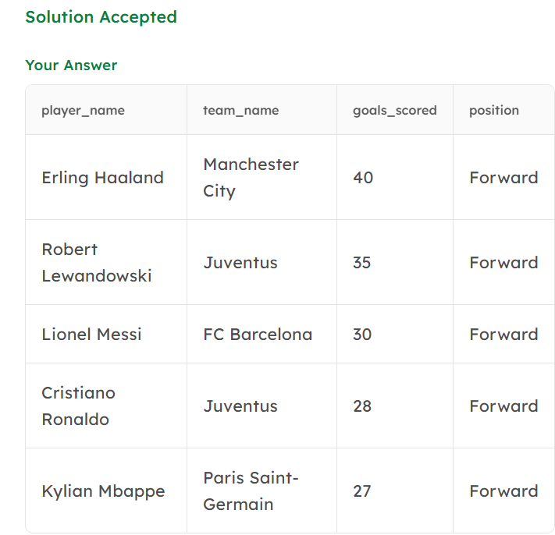

2) Best Value for Money Players -
SELECT p.name AS player_name, t.team_name AS team_name, p.goals_scored AS goals_scored ,p.salary AS salary,ROUND((p.goals_scored*1000000.0/p.salary) :: numeric,1) AS value_for_money_ratio
FROM players p
JOIN teams t
ON p.team_id = t.team_id
ORDER BY value_for_money_ratio DESC
LIMIT 3;
Explanation:
- This query identifies the top 3 players who offer the best return on investment based on their performance.
- It calculates a value-for-money ratio as goals scored per million dollars of salary.
- The query joins players and teams to show team names, then sorts results in descending order of this ratio to highlight the most efficient players.

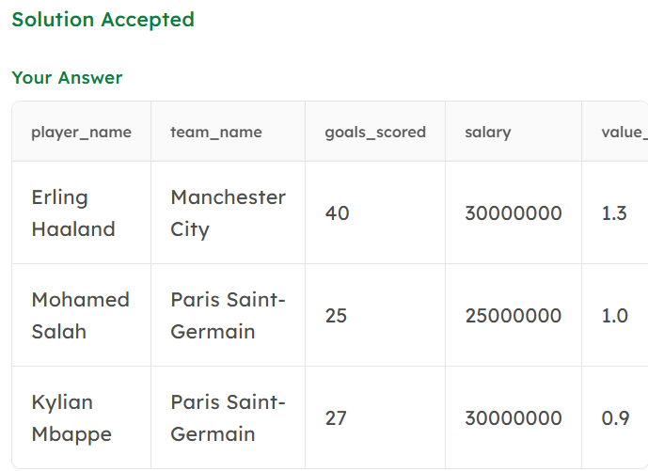

3) Team Performance Summary -
SELECT t.team_name AS team_name,t.wins AS wins ,t.losses AS losses ,t.draws AS draws,SUM(goals_scored) AS total_goals,t.league_position AS league_position
FROM teams t
JOIN players p
ON t.team_id = p.team_id
GROUP BY team_name,wins,losses,draws,league_position
ORDER BY wins DESC;
Explanation:
- This query summarizes each team’s overall performance in the league.
- It joins the teams and players tables to aggregate total goals scored by all players on each team.
- The output displays each team’s wins, losses, draws, total goals, and league position, ordered by the number of wins to highlight top-performing teams.

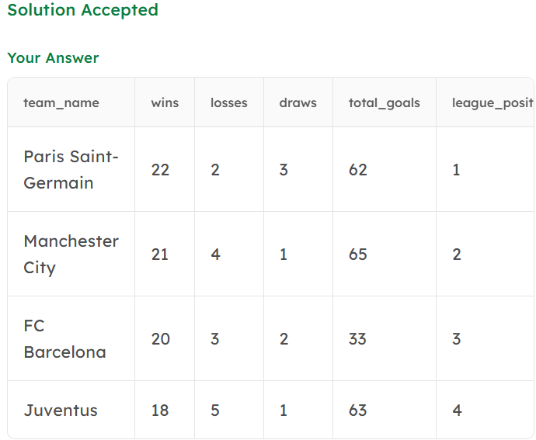

4) Player Transfer Analysis -

SELECT p.name AS player_name, t1.team_name AS original_team , t2.team_name AS new_team, tn.transfer_fee FROM transfers tn
JOIN players p
ON tn.player_id = p.player_id
JOIN teams t1
ON t1.team_id = tn.from_team_id
JOIN teams t2
ON t2.team_id = tn.to_team_id
ORDER BY player_name;
Explanation:
- This query identifies all players who have been transferred to different teams.
- It joins the transfers, players, and teams tables to show each player’s original team, new team, and transfer fee.
- Results are ordered alphabetically by player name for clarity.

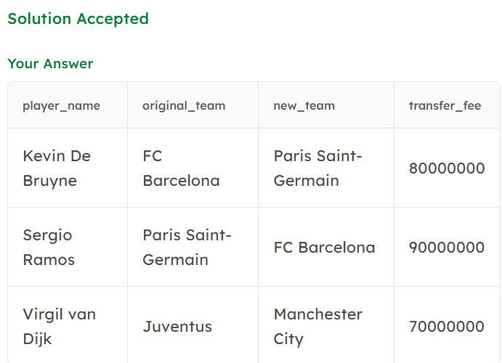

5) Identify Potential Underperformers -

SELECT p.name AS player_name , t.team_name AS team_name, p.matches_played AS matches_played ,p.goals_scored AS goals_scored
FROM players p
JOIN teams t
ON p.team_id = t.team_id
WHERE matches_played > 10 AND goals_scored < 4
Explanation:
- This query highlights players who have played more than 10 matches but scored fewer than 3 goals, indicating low performance relative to playtime.
- It joins the players and teams tables to show each player’s name, team, matches played, and goals scored — helping identify those needing performance review.

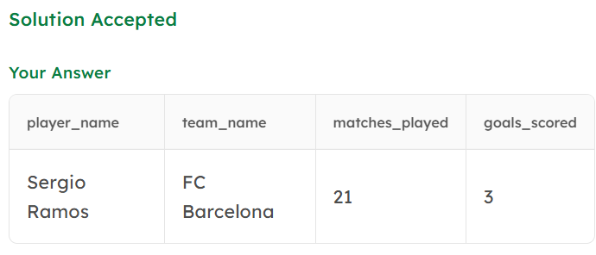

6) Team Budget Efficiency -
SELECT team_name, wins, budget, ROUND((wins*1000000 / budget) :: numeric,2 ) AS win_to_budget_ratio
FROM teams
ORDER BY win_to_budget_ratio DESC
LIMIT 3;

Explanation:
- This query evaluates how efficiently each team converts its budget into wins.
- It calculates a win-to-budget ratio to measure cost-effectiveness and ranks teams in descending order.
- The top 3 teams with the best ratio are displayed, showing strong performance relative to financial spending.

