MPTCP Capture Log — Aug 30, 2026
Goal for today: get a real MPTCP connection running with 2 paths, and actually see the handshake happen — specifically MP_CAPABLE (proves both sides support multipath) and MP_JOIN (proves a second path really belongs to the same connection).
Environment: WSL2 (Ubuntu 24.04), 2 simulated paths built using Linux network namespaces + veth pairs (a “fake second computer” living inside the same machine, connected by two virtual cables instead of one).

The Setup (recap, in plain words)
We built this topology:
HOST (client) ns_server (fake "server")

veth0 (10.0.0.1) <----Path 1----> veth0-s (10.0.0.2)
veth1 (10.0.1.1) <----Path 2----> veth1-s (10.0.1.2)

Two virtual cables between the host and an isolated namespace acting as the server — mirroring how a real phone with WiFi + mobile data would have two separate paths to the same destination.

Attempt 1 — Baseline, signal only
Command used (server side):
sudo ip netns exec ns_server ip mptcp endpoint add 10.0.1.2 dev veth1-s signal
Prediction: “MP_CAPABLE in the first SYN, then MP_JOIN once the server signals its second address.”
What we saw:
✓ MP_CAPABLE handshake — both sides confirmed multipath support.
✓ add-addr — server correctly announced its second address (10.0.1.2) via the signal flag.
✗ No MP_JOIN — the client learned about the second address but never acted on it.
Why: we used a very simple tool (nc) that sends one small message and closes immediately. There was no reason for the OS to bother opening a second path for such a short-lived exchange — and more importantly, signal only announces an address, it doesn't tell the client to actually use it.

Attempt 2 — Swapped to fullmesh only
Command used (server side):
sudo ip netns exec ns_server ip mptcp endpoint add 10.0.1.2 dev veth1-s fullmesh
(Note: ip mptcp rejects signal and fullmesh together on the same endpoint — they can't be combined on one entry.)
What we saw: No add-addr at all this time — the client never even learned the second address existed.
Why — the key lesson from this attempt: fullmesh means “aggressively try to open subflows to every address you already know about” — but it doesn't announce anything by itself. By removing signal, we removed the only mechanism that tells the client the second address exists in the first place. signal = announce. fullmesh = react to announcements. They're complementary, not interchangeable — and we had swapped one for the other instead of using both, on the correct sides.

Attempt 3 — signal (server) + fullmesh (client) together
Commands used:
# server: announce the second address
sudo ip netns exec ns_server ip mptcp endpoint add 10.0.1.2 dev veth1-s signal

# client: react to announced addresses by actively opening subflows
sudo ip mptcp endpoint add 10.0.0.1 dev veth0 subflow fullmesh
What we saw: add-addr appeared again (server announcing) — but still no MP_JOIN.
Why: we found a second blocker in setup_check.sh's original output from Day 1:
add_addr_accepted 0 subflows 2
add_addr_accepted 0 is a client-side policy limit — even with the right flags in place, the client isn't permitted to accept an announced address and turn it into a real subflow if this limit is zero. The flags said “try,” but the limit said “not allowed.”
Fix:
sudo ip mptcp limits set add_addr_accepted 4 subflows 4

Attempt 4 — Success
With signal (server) + fullmesh (client) + add_addr_accepted raised, we re-ran the capture and typed 4 separate messages with pauses in between.
Result: MP_JOIN appeared, fully. A second, independent TCP handshake occurred — this time going to 10.0.1.2 instead of 10.0.0.2 — carrying join, a token, and a nonce, followed by an HMAC exchange proving both sides belong to the original connection. At the end of the session, both subflows closed independently, back to back — solid proof two real, separate connections were alive as one logical MPTCP session.

Screenshot 1 — MP_CAPABLE (packet 1, the very first SYN)
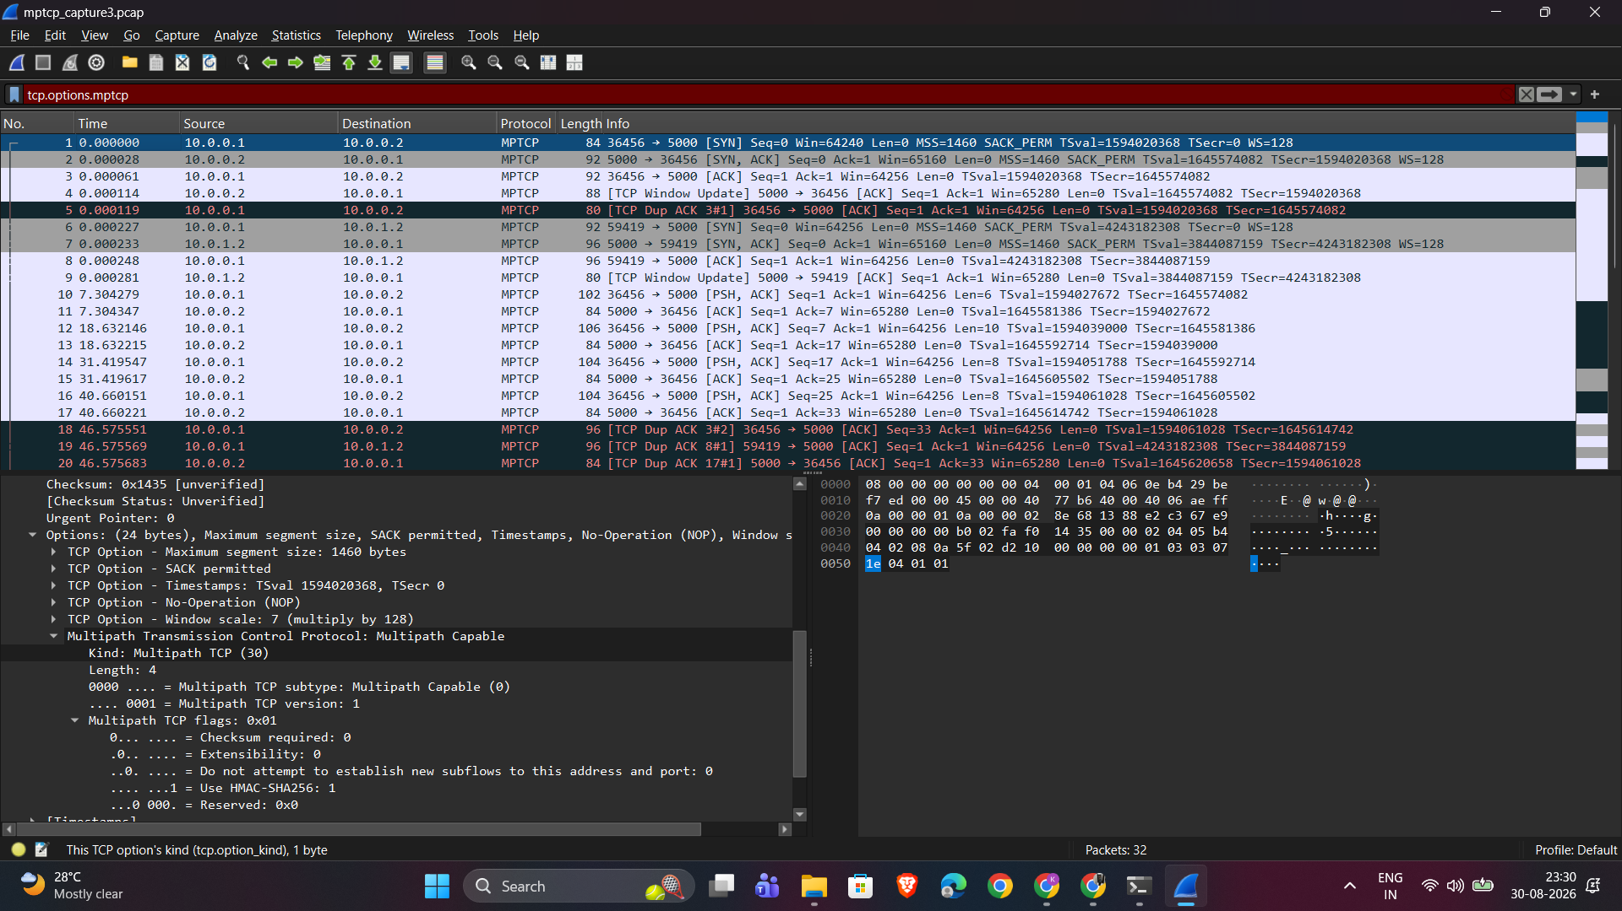
MP_CAPABLE handshake in Wireshark
Notice Use HMAC-SHA256: 1 — the client is promising, in this very first packet, that it will use HMAC-SHA256 to cryptographically prove any future subflow really belongs to this connection. This promise is what gets used in the next screenshot.

Screenshot 2 — MP_JOIN (packet 6, the second subflow's SYN, going to 10.0.1.2)
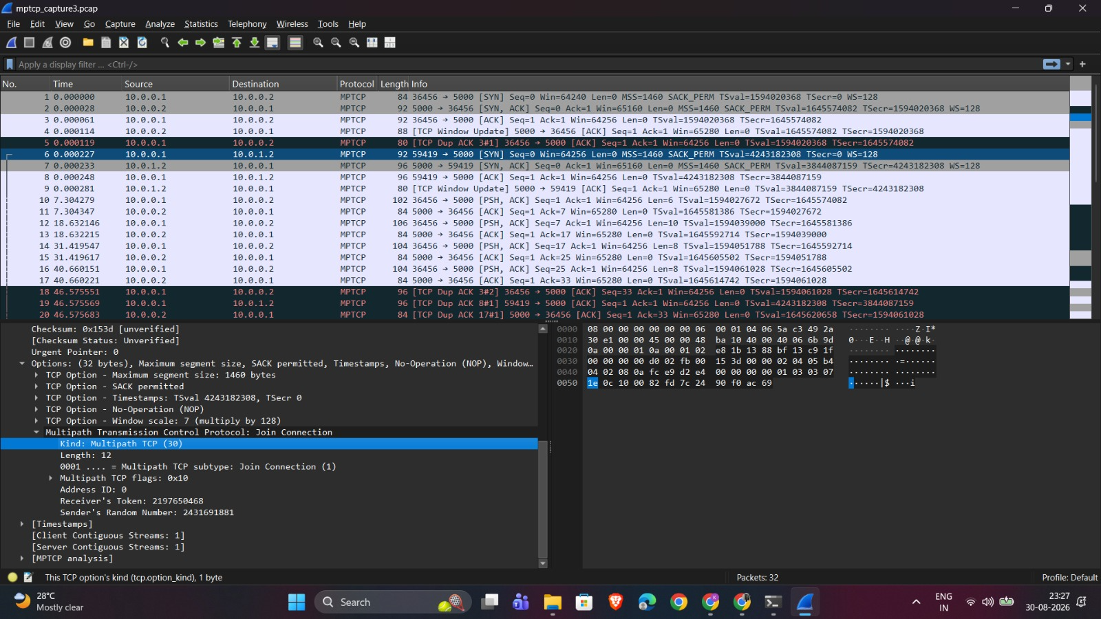
MP_JOIN handshake in Wireshark
Subtype: Join Connection (1), plus a Receiver's Token and Sender's Random Number — this is the second path proving it belongs to the same original conversation, exactly the mechanism promised back in packet 1.

What We Actually Learned (the part that matters for viva)
- MP_CAPABLE and MP_JOIN are connected, not two separate features. MP_CAPABLE (packet 1) negotiates how future proof will work (HMAC-SHA256); MP_JOIN (packet 6) is where that promise is actually used.
- signal and fullmesh are complementary, not interchangeable. One announces, the other reacts. Using only one half of the pair silently fails — no error, just nothing happens.
- Flags aren't the whole picture — policy limits (add_addr_accepted) can silently block behavior even when flags are correctly set. This is a real, multi-layered debugging story: three separate reasons MP_JOIN didn't fire, found one at a time.
- A short-lived, single-message connection may never trigger multipath behavior at all, regardless of config — there has to be a reason (data volume, time, or explicit policy) for the kernel to bother.

Files for GitHub
mptcp/
scripts/
setup_check.sh (already pushed — verifies kernel MPTCP support)
mptcp_endpoint_setup.sh (today's topology + endpoint config)
captures/
mptcp_capture.pcap (Attempt 1 — signal only)
mptcp_capture2.pcap (Attempt 2/3 — fullmesh variants)
mptcp_capture3.pcap (Attempt 4 — final success, MP_JOIN captured)
screenshots/
mp_capable_wireshark.png
mp_join_wireshark.png
capture_log.md / capture_log.docx (this document)

