IINVENTIV 2026
Global Innovation Showcase – IIT (ISM) Dhanbad

Visit Report & Innovation Summary
Assignment – Mine Automation Course
Submitted by | PRATIK KUMAR
Admission No. | 25DR0173
Department | Mining Engineering
Institution | IIT (ISM) Dhanbad
Course | Mine Automation (NMND508)
Course Instructor | Prof. Siddhartha Agarwal
Event Visited | IInvenTiv 2026 – Global Innovation Showcase
Visit Date | 6th – 7th April 2026
Submission Date | 20th April 2026

1. Introduction
IInvenTiv is a flagship annual R&D fair organized by the Ministry of Education, Government of India, established to showcase indigenous innovations and strengthen India's research-to-technology ecosystem. First launched in 2022 at IIT Delhi as part of the Azadi ka Amrit Mahotsav celebrations, the event initially brought together all Indian Institutes of Technology (IITs) and has since expanded to include NITs, IISc, and other leading universities across the country. IInvenTiv serves as a strategic platform that bridges academia and industry by promoting technology transfer, commercialization, and collaborative innovation across priority sectors including healthcare, energy, manufacturing, digital technologies, mobility, and infrastructure.

The event is closely aligned with national initiatives such as Make in India and Atmanirbhar Bharat, advancing India's vision of self-reliance and innovation-led growth. The 2026 edition of IInvenTiv was hosted at IIT (ISM) Dhanbad and was held on 6th and 7th April 2026. The event brought together researchers, startups, industry professionals, academicians, and students to present and discuss cutting-edge innovations across multiple engineering and technology domains, with particular emphasis on mining, energy, advanced materials, and digital applications. The vision behind the event is captured in the words of the Prime Minister of India, Shri Narendra Modi: "When science is scaled, innovation becomes inclusive, and technology drives transformation, it lays the foundation for major achievements."

This report documents 13 distinct innovations encountered during the visit, covering their descriptions, key features, and relevance to modern mining operations and the broader goal of indigenous technological advancement.

2. Event Overview

Event Name | IInvenTiv 2026 – A Global Innovation Showcase
Organizer | Jointly organized by IIT Kharagpur, IIT (BHU) Varanasi, IIT (ISM) Dhanbad, IIT Patna and IIT Bhubaneswar
Venue | IIT (ISM) Dhanbad, Jharkhand – 826004
Dates | 6th – 7th April 2026
Participating Institutes | IISc, IITs & associated TIHs; IIMs; IIEST & NITs; IISERs & associated TIHs; Top 100 NIRF-ranked Institutes (Engineering Category)
Total Innovations Observed | 13 (documented in this report)

Thematic Areas & Lead Institutes
IInvenTiv 2026 was structured around five core thematic areas, each coordinated by a lead IIT:

S.No. | Thematic Area | Lead Institute
1 | Earth Science | IIT (ISM) Dhanbad (Host Institute)
2 | Health Care | IIT Kharagpur
3 | Materials Science | IIT (BHU) Varanasi
4 | Artificial Intelligence | IIT Patna
5 | Semiconductor Technology & Chip Design | IIT Bhubaneswar

As the host institute for the Earth Science thematic area, IIT (ISM) Dhanbad anchored innovations pertaining to mining, geology, energy resources, and geospatial technologies — making the event particularly relevant for students and researchers in the Mining Engineering department.

3. Innovations Observed
The following sections provide detailed descriptions of each mining-related innovation observed during the visit. The observations are based on exhibit boards, product demonstrations, brochures, and interactions with presenters.

1. Folium Sensing – Distributed Fiber Optic Sensing System (DSS & DTS)
Category | Digital Monitoring & Sensing Technology
Mining Relevance | Directly Mining-Related

Folium Sensing showcased a cutting-edge Distributed Strain Sensing (DSS) and Distributed Temperature Sensing (DTS) system based on fiber optic technology. The system is designed to enable continuous, real-time structural and thermal monitoring across extended infrastructure lengths using a single fiber cable. The exhibit highlighted its applicability toward Industry 5.0, emphasizing the three Ps: Predictive Maintenance, Product Quality Assurance, and Process Control. In the context of mining, this technology can be deployed along conveyor belts, mine shafts, tunnels, and underground pipelines to detect stress, strain, deformation, and temperature anomalies before they escalate into failures. The poster from IIT Madras also showcased a collaboration between academia and industry to commercialize fiber-optic shape monitoring for mining and geotechnical environments.

Key Features & Highlights:
- Real-time distributed monitoring over kilometers using a single fiber
- Applications: conveyor belt health, tunnel wall deformation, slope stability monitoring
- Industry 5.0 alignment: supports predictive maintenance in mining operations
- Shape monitoring using distributed fiber sensors (IIT Madras collaboration)

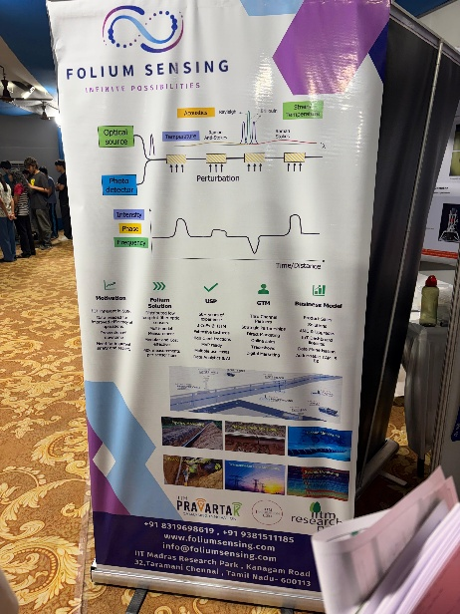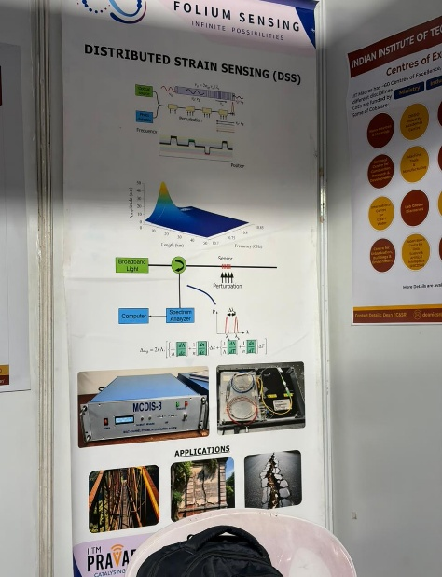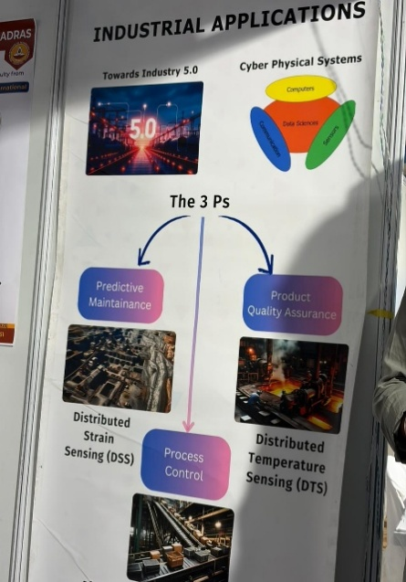

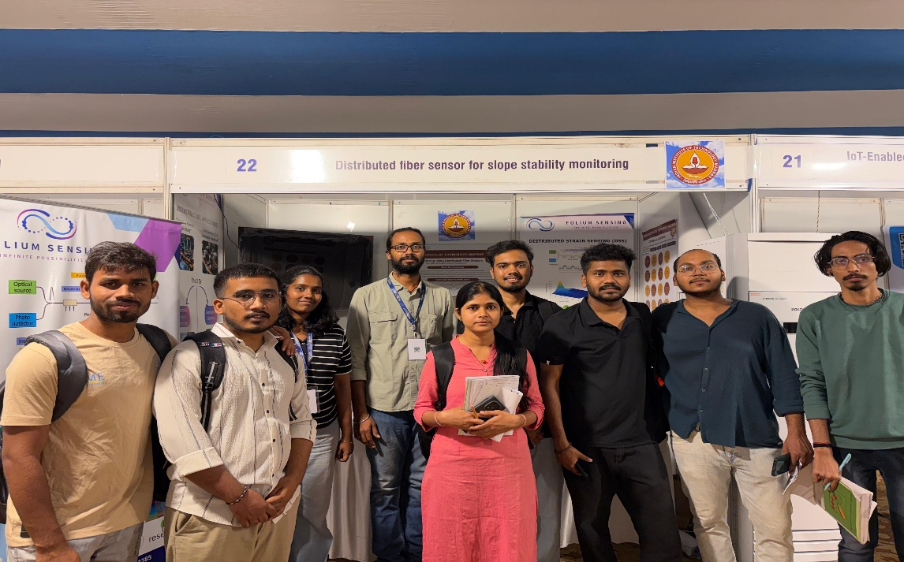

2. Jain Mineral Concentrator – Enhanced Gravity Concentration Technology
Category | Mineral Processing Equipment
Mining Relevance | Directly Mining-Related

Developed by Prof. Pankaj Kumar Jain and the Mineral Processing Research group of the FMME department at IIT (ISM) Dhanbad, the Jain Mineral Concentrator (JMC) is an innovative enhanced gravity separation device designed for fine mineral processing. The exhibit featured a working prototype of the concentrator, which uses spiral and fluidized-bed mechanisms to achieve efficient mineral separation from complex ores. The technology is particularly suited for low-grade ores, fine particles, and heavy minerals such as chromite, ilmenite, and gold. The equipment targets cost-effective beneficiation where conventional methods fail to achieve adequate grade-recovery performance. The use of enhanced gravity rather than chemicals makes it an environmentally cleaner alternative to flotation.

Key Features & Highlights:
- Spiral concentration for fine mineral separation (particle size: ~100 kg/hr throughput)
- Enhanced gravity separation suitable for chromite, gold, coal fines, and other minerals
- Eco-friendly: no chemical reagents required
- Compact design suitable for both lab-scale and industrial deployment

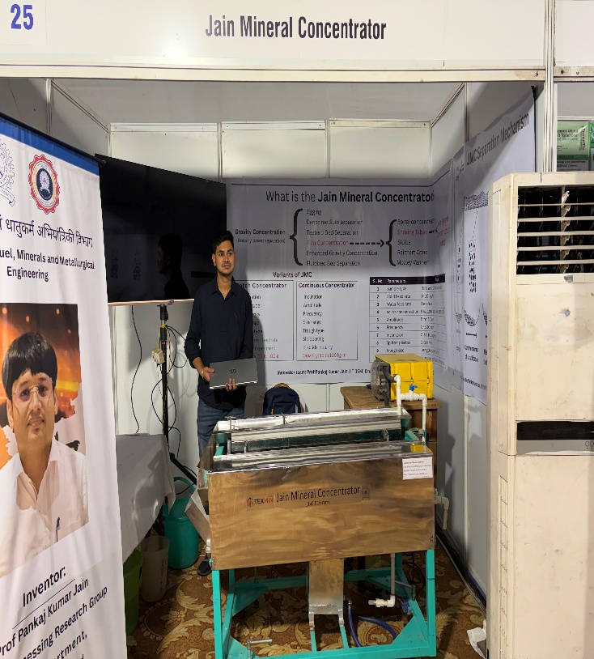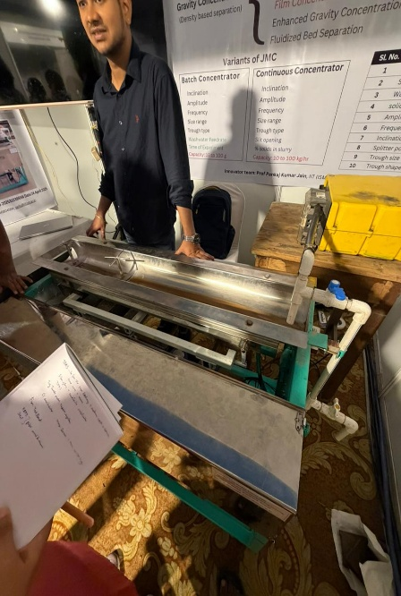
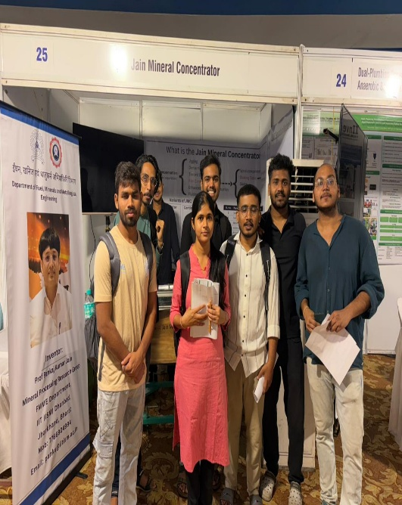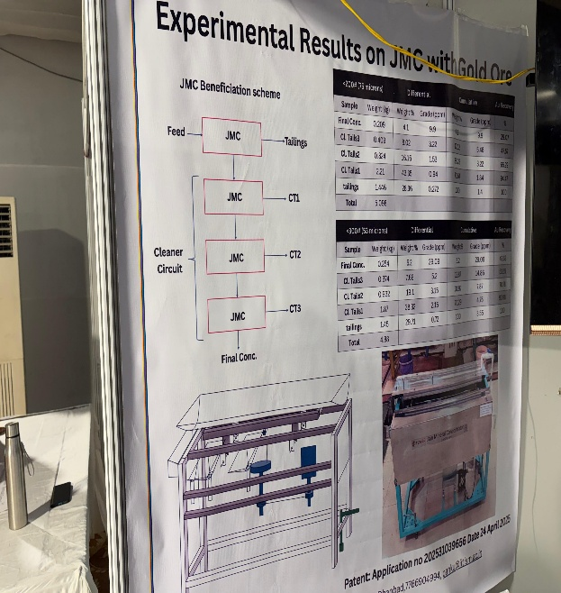

3. Conformal MIMO Antenna System for Open-Cast Mining UAV Communication
Category | UAV / Communication Technology for Mining
Mining Relevance | Directly Mining-Related

Presented at Booth 28, this innovation addresses a critical communication challenge in open-cast mining operations: reliable high-definition (5G) video transmission from UAVs (Unmanned Aerial Vehicles/drones) operating in complex terrain. The conformal CP (Circularly Polarized) antenna system employs MIMO (Multiple Input Multiple Output) technology to enhance video data throughput and signal reliability in multipath-rich environments typical of open pit mines. A working prototype of the FPV (First Person View) racing-style UAV was also displayed alongside the antenna system and its technical brochure. The technology is relevant for drone-based mine surveying, stockpile measurement, slope monitoring, and blasting documentation.

Key Features & Highlights:
- MIMO antenna system enabling robust UAV video transmission in open-cast mines
- Circularly polarized antenna design reduces signal loss in rugged terrain
- Physical UAV prototype with FPV goggles on display
- Applicable for mine surveying, blast documentation, and safety monitoring

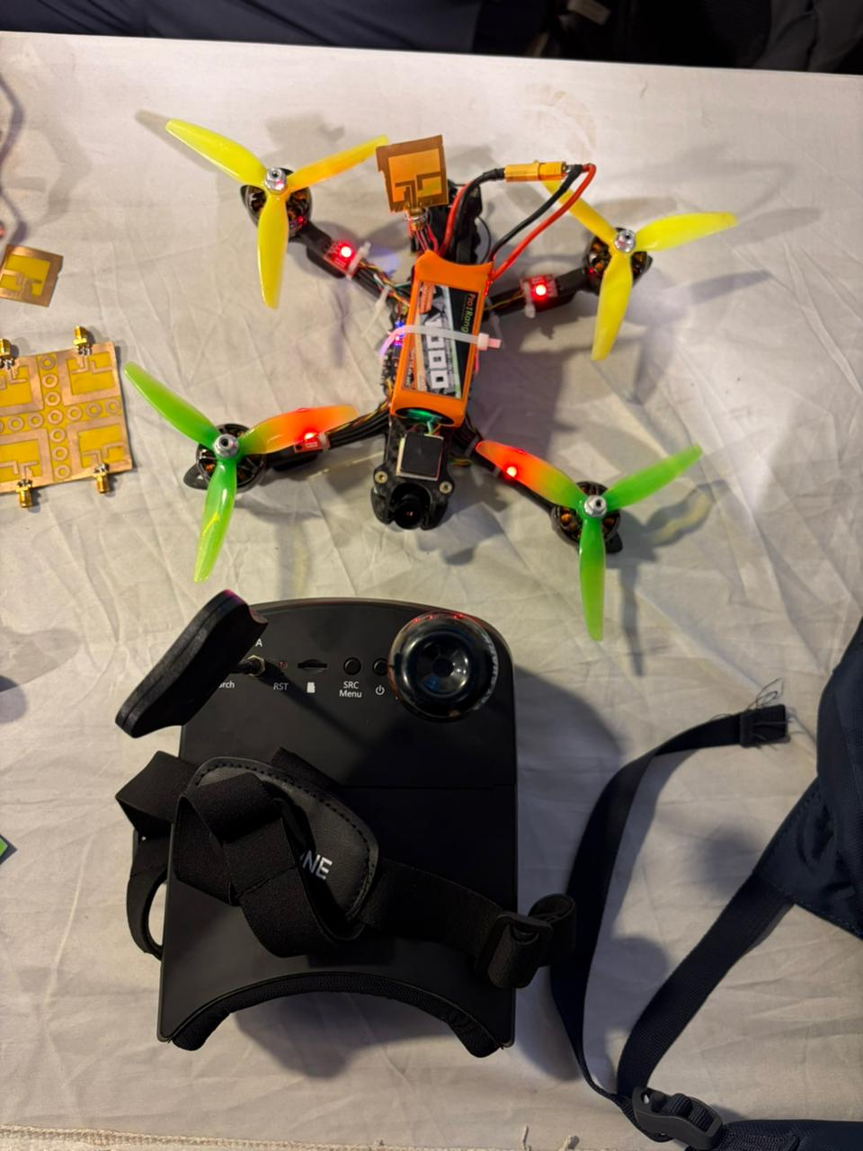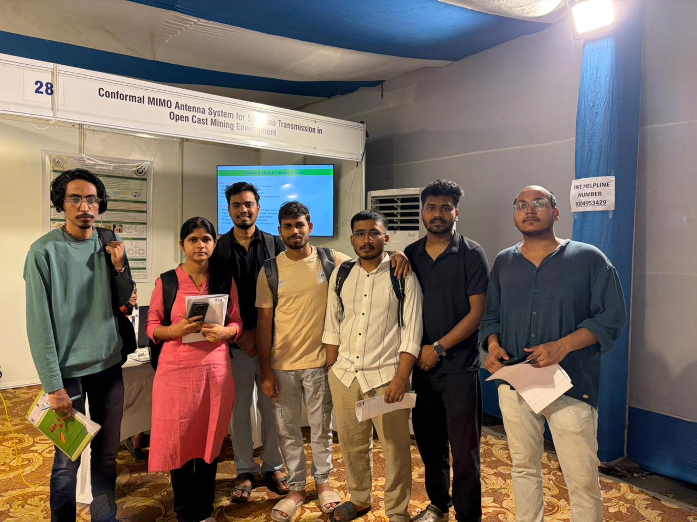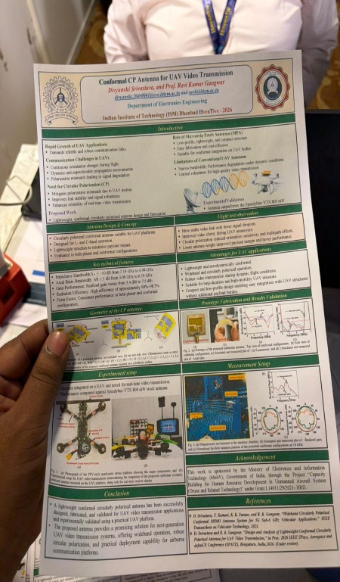

4. TechBond Global – Molecular Integration Adhesive Technology
Category | Advanced Materials for Mining & Industry
Mining Relevance | Directly Mining-Related
TechBond Global showcased their proprietary Molecular Integration Technology (MIT), which represents a breakthrough in materials engineering. Unlike conventional adhesives that merely bond at the surface, TechBond's technology creates molecular-level integration between substrates, resulting in significantly stronger, more durable, and longer-lasting bonds. The exhibit highlighted applications relevant to mining including wear-resistant coatings, pipe joint sealing, structural repairs in harsh environments, and subsea/offshore applications. Products on the table included industrial sealants, repair compounds, and demonstration blocks showing bonded metal assemblies. The technology claims to reduce maintenance costs across mining, oil & gas, marine/nautical, water/wastewater, and solar industries.

Key Features & Highlights:
- Molecular-level bonding that eliminates interface failures
- Applications: mining equipment repair, pipe sealing, structural bonding
- Sectors served: mining, oil & gas, marine/nautical, solar, water/wastewater
- Creates stronger, more durable bonds compared to conventional adhesives

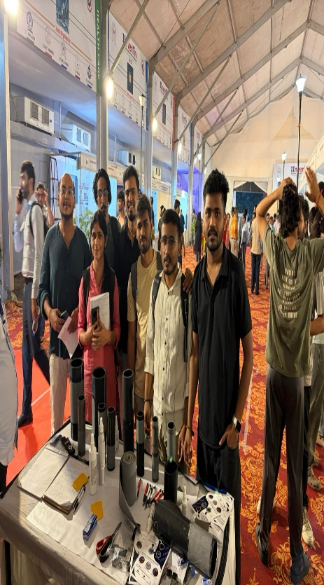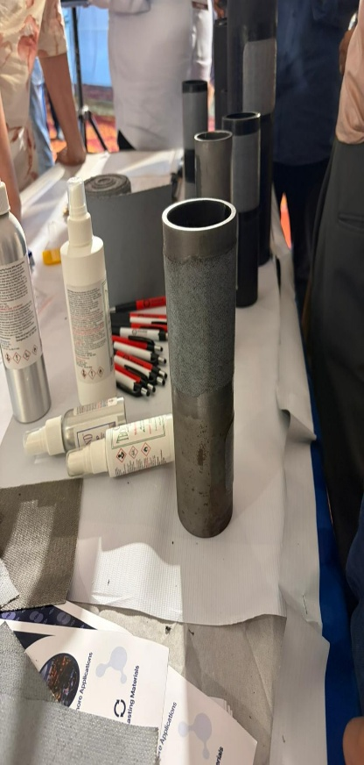
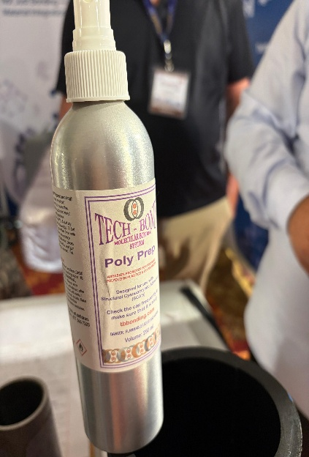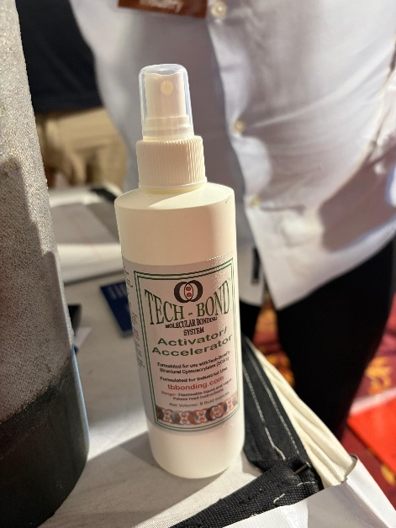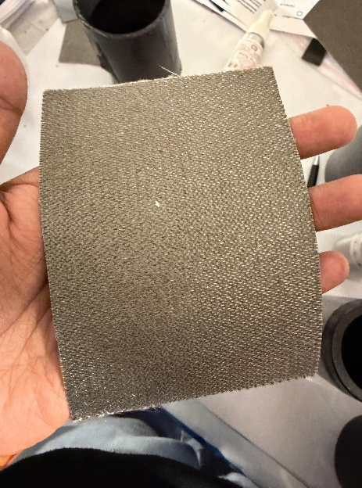

5. Lyfcell Innovation Private Limited – Next-Generation Battery Solutions
Category | Energy Storage Technology
Mining Relevance | Adjacent / Enabling Technology

Lyfcell Innovation, a startup incubated at the Workshop Complex of IIT Bhubaneswar, presented their advanced battery solutions for industrial and energy storage applications. The company focuses on next-generation battery chemistries including improved cathode materials and electrolyte formulations to deliver higher energy density, lower cost, and longer cycle life than conventional Li-ion batteries. Their products target energy storage systems (ESS), electric vehicles, logistics automation, drones, and manufacturing sectors. The exhibit included product samples, technical presentations, and discussions with the founding team about their commercialization strategy.

Key Features & Highlights:
- Advanced battery chemistry with improved energy density and cycle life
- Applications: ESS, EVs, industrial automation, drones
- Incubated at IIT Bhubaneswar – local startup ecosystem
- Potential relevance to HEMM electrification and mine energy storage
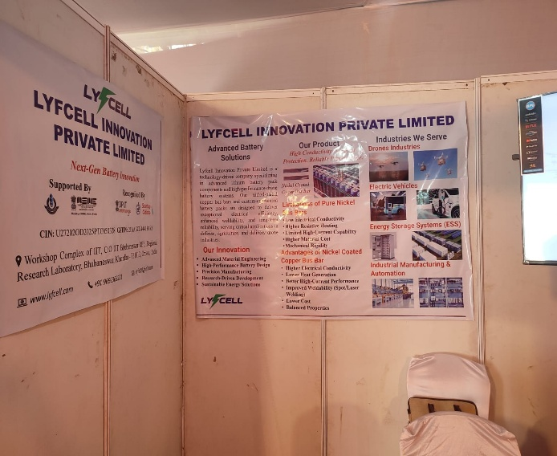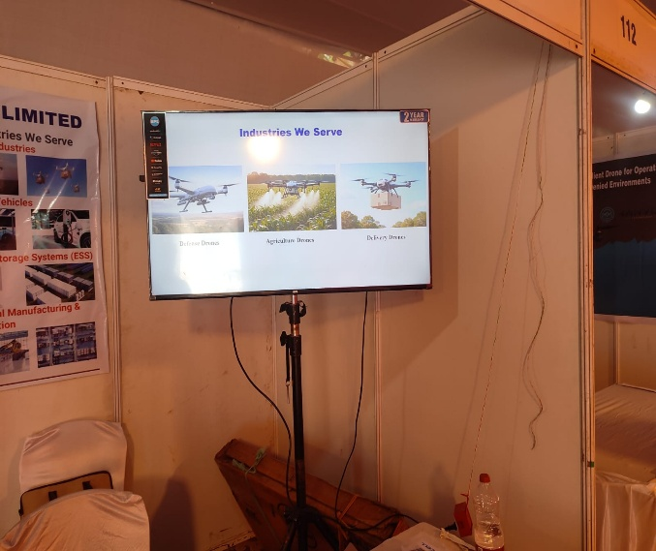

6. Coal-to-Methanol Technology with CO₂ Capture & Utilization (CCU) – THERMAX/CEST & NITI Aayog Initiative
Category | Carbon Capture, Clean Coal Valorization & Methanol Technology
Mining Relevance | Directly Mining-Related

This exhibit, jointly presented by THERMAX, the Centre for Climate, Energy, and Sustainable Technology (CEST), and aligned with NITI Aayog’s Methanol Economy Mission, showcased an integrated research programme covering the complete coal-to-methanol value chain along with carbon capture and utilization (CCU). The booth displayed two complementary innovations at a single stall: first, a CCU integration framework where CO₂ captured from coal combustion or gasification is converted into methanol via catalytic hydrogenation, enabling a near-zero net CO₂ coal utilization pathway; and second, a pilot plant-scale methanol production process specifically engineered for Indian coal, addressing the unique challenges of high-ash content coals from Jharkhand and Odisha through modified catalyst formulations and ash management strategies. Together, these innovations form an end-to-end clean coal technology solution – from capturing harmful emissions to synthesizing a commercially valuable, low-carbon fuel. The work is of direct strategic significance to Indian coal mining, offering a pathway to monetize coal resources while meeting India’s climate obligations and decarbonization targets.

Key Features & Highlights:
- Integrated CCU framework: CO₂ from coal combustion captured and converted to methanol via catalytic hydrogenation
- Pilot plant methanol synthesis tailored to high-ash Indian coal (Jharkhand & Odisha) with modified catalyst formulations
- End-to-end clean coal technology solution: emission capture → syngas → methanol synthesis → scale-up
- Strategically aligned with NITI Aayog Methanol Economy Mission and India’s net-zero decarbonization roadmap

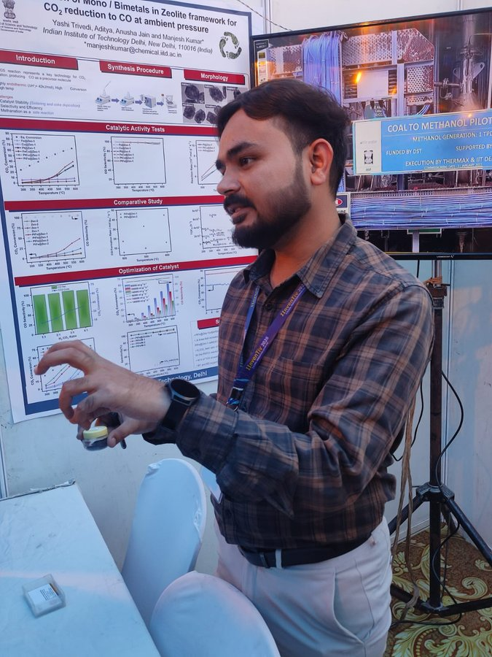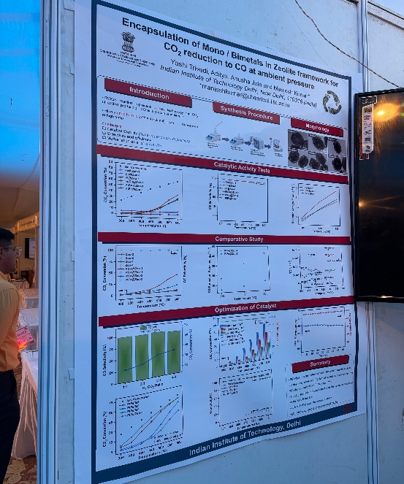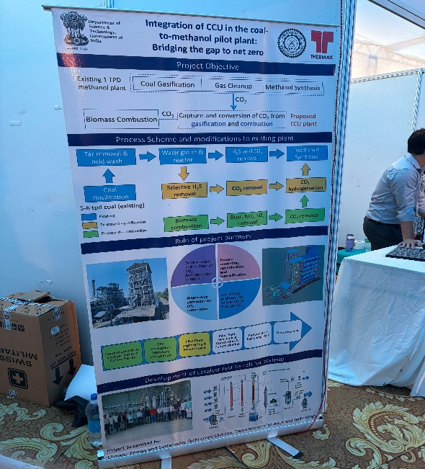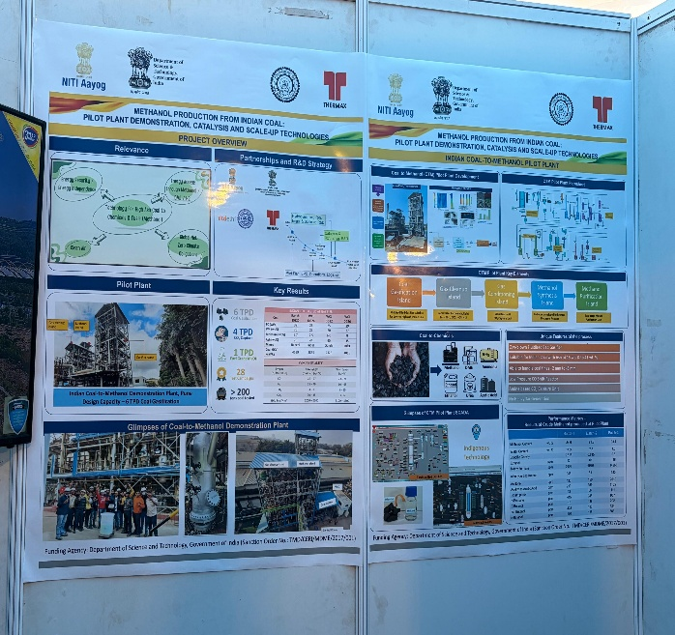

7. H-CBM (Hydrogen-enriched Coal Bed Methane) via Catalytic Methane Pyrolysis – Jharia Coalfields Case Study
Category | Clean Energy / Coal Bed Methane Valorization & Hydrogen Production
Mining Relevance | Directly Mining-Related

This innovation presents an integrated pathway to convert fugitive coal bed methane (CBM) from the Jharia coalfields into a cleaner transport fuel (H-CBM) while simultaneously producing solid carbon nanotubes (CNTs) as a value-added co-product. The work quantifies the site-level opportunity at Dhanbad's Jharia coalfields, which produce approximately 30 million tonnes of coal annually, with gassy seams releasing nearly 10 m³ of methane per tonne – resulting in about 300 m³ of methane vented every year. At a methane density of 0.717 kg/m³, this corresponds to roughly 215,000 tonnes of CH₄ annually, with a global warming potential (GWP) of 28, equating to nearly 6 million tonnes of CO₂-equivalent emissions – comparable to emissions from ~1.3 million passenger cars (~2.6% of India's fleet). Methane is captured via vertical drilling from coal seams and purified using a two-stage process (desiccant dehydration followed by amine scrubbing to remove CO₂, H₂S, and moisture) to yield 95–98% pure methane. The purified CH₄ is then processed in a fixed-bed reactor at ~800 °C and 1 atm over Fe/Ni catalysts, undergoing catalytic pyrolysis (CH₄ → C(CNT) + 2H₂). For every 1 kg of methane, the process yields about 0.75 kg of carbon nanotubes and 0.25 kg of hydrogen, operating in an oxygen-free environment – resulting in zero direct CO₂ emissions, with carbon permanently sequestered as a solid product. The produced hydrogen is blended with methane to form H-CBM fuel (80% CH₄ + 20% H₂), which raises flame speed from ~38 cm/s to ~48 cm/s (+26%), enables leaner combustion, and delivers up to ~73% reduction in thermal NOx emissions. H-CBM acts as a drop-in fuel requiring only minor ECU recalibration and is compatible with existing 200-bar CNG storage infrastructure, improving vehicle thermal efficiency by ~4.7%. Scaled to a fleet of 1,000 vehicles operating 15,000 km/year, the pathway delivers approximately 375 tonnes of CO₂ reduction annually and achieves a carbon-negative footprint when combined with the permanent carbon storage in CNTs – positioning H-CBM as a scalable bridge fuel for the transition to a hydrogen-based economy.

Key Features & Highlights:
- Site-level quantification at Jharia: ~215,000 tonnes CH₄/year vented (~6 Mt CO₂-eq)
- Two-stage CBM purification (desiccant dehydration + amine scrubbing) yielding 95–98% CH₄
- Catalytic methane pyrolysis over Fe/Ni catalysts at ~800 °C producing 0.75 kg CNT + 0.25 kg H₂ per kg CH₄, with zero direct CO₂
- H-CBM blend (80% CH₄ + 20% H₂): +26% flame speed, ~73% NOx reduction, ~4.7% thermal efficiency gain
- Drop-in compatibility with existing CNG engines and 200-bar storage – minimal infrastructure change
- Fleet-scale impact: ~375 tCO₂/year savings per 1,000 vehicles; carbon-negative when CNT sequestration is credited
- Directly addresses Jharia coalfield methane emissions – strategically aligned with India's net-zero and hydrogen economy roadmaps

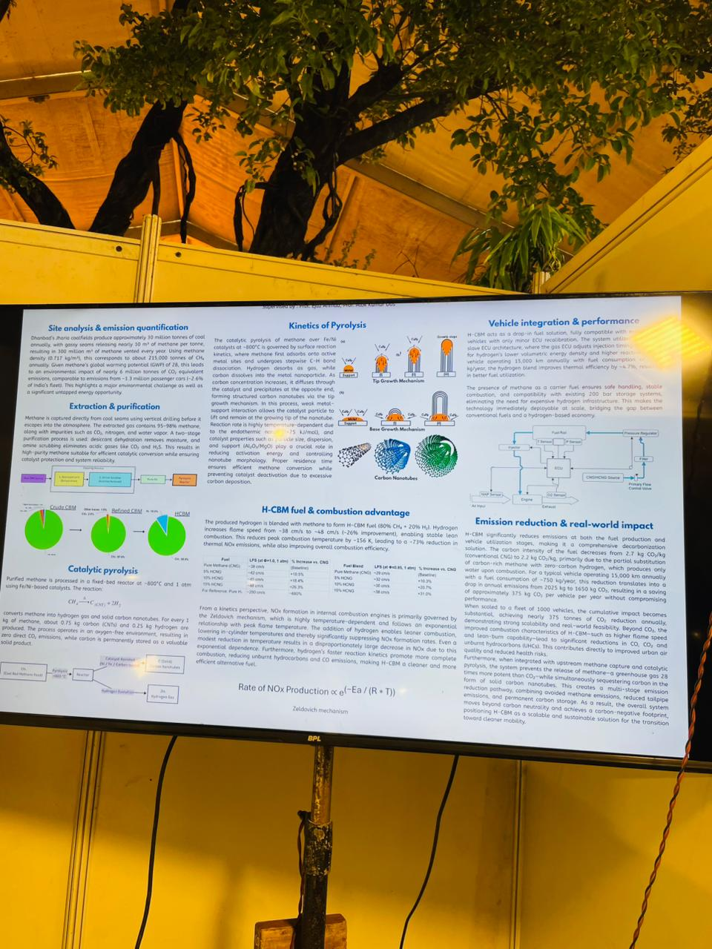

8. Integrated Iron Ore Valorization – Multi-Metal Recovery & Hydrogen-Based Direct Reduction (IIT (BHU) Varanasi)
Category | Hydrometallurgy, Green Steel & Hydrogen Metallurgy
Mining Relevance | Directly Mining-Related

This combined exhibit, anchored by IIT (BHU) Varanasi, presented an end-to-end iron ore valorization pathway spanning two complementary innovations displayed together. In the first stage, Prof. Girija Shankar Mahobia and Dr. Biswajit Mishra demonstrated a novel method for recovering multiple valuable metals (iron, manganese, aluminium, titanium) from complex multi-mineral iron ore deposits using physical beneficiation followed by selective hydrometallurgical leaching, achieving significantly improved grade and recovery compared to conventional processing of low-grade or complex ores. In the second stage, the recovered/beneficiated iron ore — in pelletized form — is subjected to hydrogen-based direct reduction: hardened pellets are treated in a resistive tube furnace at 900°C for 45 minutes in a pure hydrogen atmosphere, producing reduced pellets and, on further reduction and consolidation, high-purity metal nuggets. By replacing coking coal with clean hydrogen, the downstream step eliminates the CO₂ emissions of traditional blast-furnace ironmaking. Together, the two stages form an integrated clean-metallurgy value chain — from complex ore to green metal nuggets — directly relevant to Indian iron ore mining, the Green Steel Mission, and net-zero commitments in the metals sector.

Key Features & Highlights:
- Multi-metal recovery (Fe, Mn, Al, Ti) from complex iron ore matrices via hydrometallurgical leaching
- Significantly improved grade-recovery performance vs. conventional beneficiation methods
- Downstream hydrogen-based direct reduction of pellets at 900°C for 45 minutes in a resistive tube furnace
- Three-stage reduction demonstrated: Hardened Pellets → Reduced Pellets → Metal Nuggets
- Eliminates CO₂ emissions vs. coking coal-based blast furnace iron reduction
- Aligned with India's Green Steel Mission and net-zero decarbonization roadmap
- IIT (BHU) Varanasi – published and patented technology

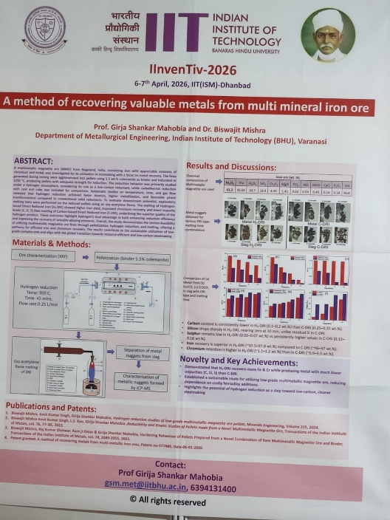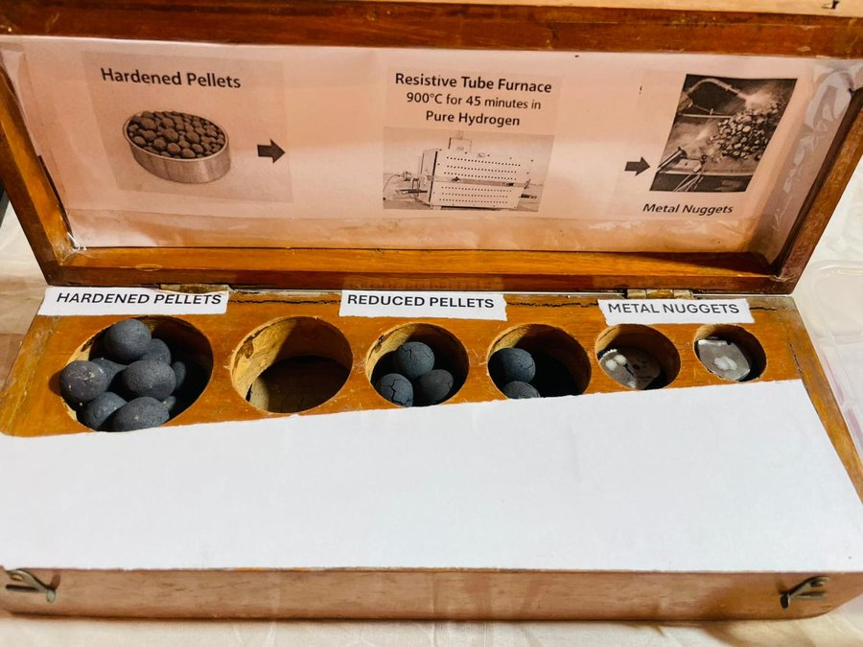

9. Dozer House – AI-Powered E-Commerce Platform for Mining & Construction Machinery
Category | Digital Platform / Mining Equipment Commerce
Mining Relevance | Directly Mining-Related

Dozer House is an innovative B2B e-commerce platform specifically designed for the construction, mining, and material handling industries. The platform enables buyers and sellers of heavy machinery, spare parts, and equipment to transact online with confidence. A key differentiator showcased was the CLARITY system – an AI-powered spare parts identification technology that uses computer vision and AI (Scan → AI Scan → CLARITY) to identify industrial spare parts from photos, eliminating the challenge of sourcing obscure or legacy components. The platform aims to transform India's fragmented heavy equipment market by bringing transparency, speed, and trust to machinery procurement. The exhibit included a live demonstration on screen at the IInvenTiv venue.

Key Features & Highlights:
- B2B online marketplace for construction and mining heavy machinery
- CLARITY: AI-powered spare parts identification using computer vision
- Reduces procurement time and cost for mining spare parts
- Addresses transparency and trust issues in India's used equipment market

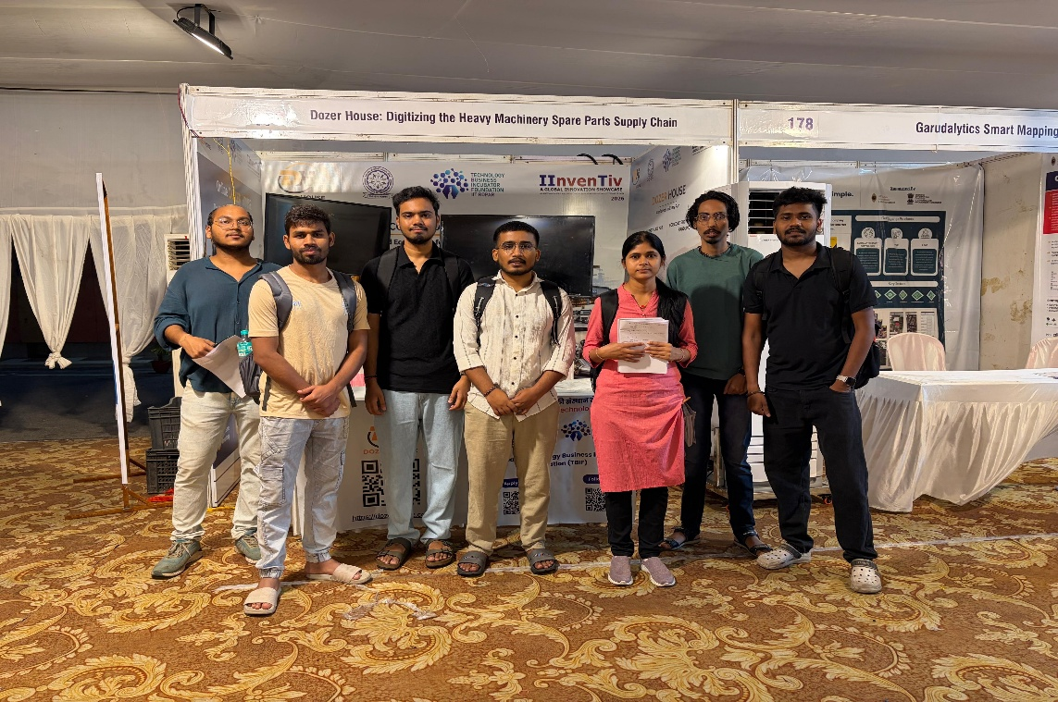
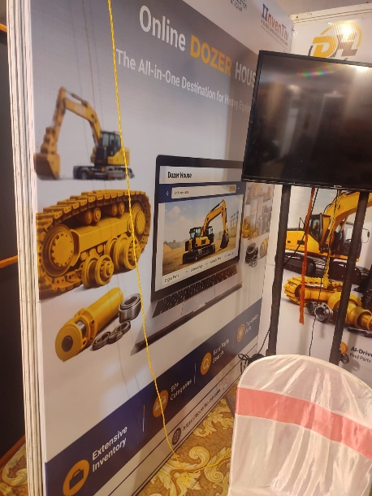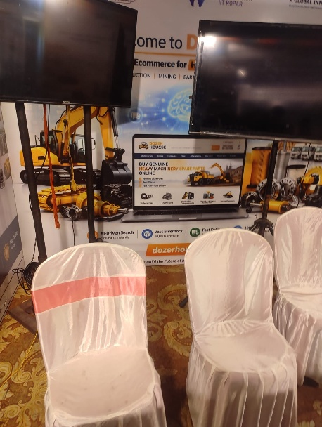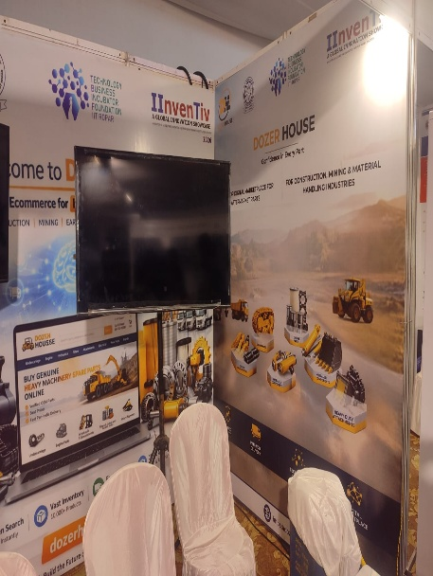

10. Garudalytics – Geospatial AI Intelligence Platform
Category | Geospatial Technology & Smart Intelligence
Mining Relevance | Directly Mining-Related

Garudalytics showcased their platform for transforming geospatial data into smart intelligence using AI/ML. The company's solutions span multiple sectors including mining, agriculture, urban planning, and environment & natural resources. For mining, the platform offers geointelligence services such as mine site mapping, land use change detection, environmental monitoring, terrain analysis, and cross-sector spatial analytics using satellite and drone-derived data. The brochure detailed their capabilities across G-Map, G-Field, and G-Solutions product lines, with clients from BPCL, ONGC, and Smart City missions. The platform is particularly relevant to surface mine planning, overburden mapping, and environmental compliance reporting.

Key Features & Highlights:
- AI-driven geospatial analytics for mining, agriculture, and urban sectors
- Products: G-Map, G-Field, G-Solutions for spatial data services
- Mine site terrain analysis, land use monitoring, and compliance reporting
- Deployed across 75+ projects; serves BPCL, ONGC, smart city clients

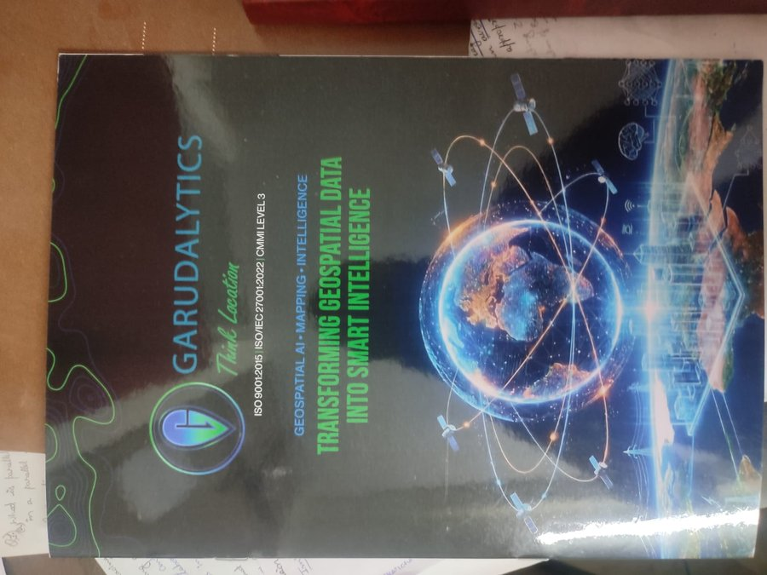
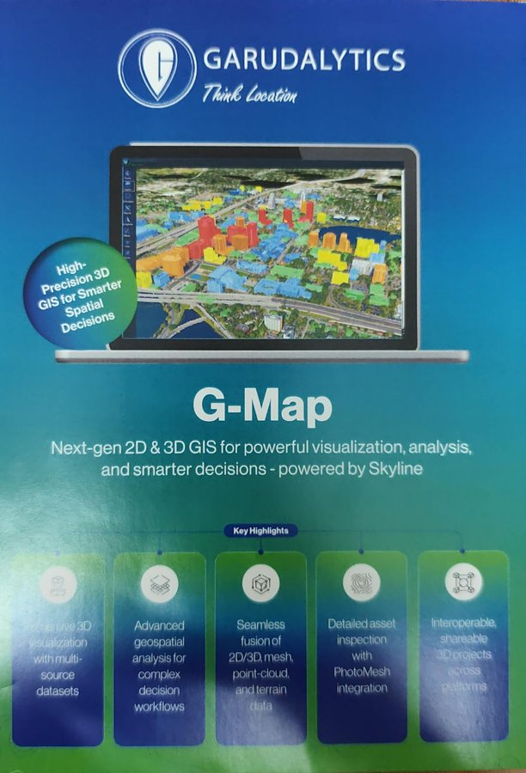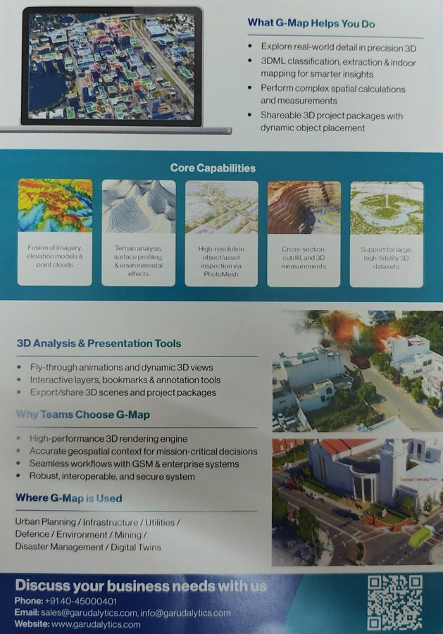

11. RK Casting Engineering Pvt. Ltd. – Precision Industrial Casting Solutions
Category | Industrial Casting & Manufacturing (Mining-Use Components)
Mining Relevance | Directly Mining-Related

RK Casting Engineering Pvt. Ltd., a ZED Certified MSME startup incubated at TEXMIN – Technology Innovation Hub at IIT (ISM) Dhanbad, presented their precision casting capabilities for mining and industrial components. The company manufactures critical cast metal parts used in heavy equipment, conveyor systems, and structural assemblies for mining applications. Their incubation at IIT (ISM)'s TEXMIN hub provides access to advanced manufacturing research and quality testing facilities. Being a locally incubated startup, RK Casting represents the entrepreneurial ecosystem being built around India's largest mining engineering institution.

Key Features & Highlights:
- ZED Certified MSME startup from IIT (ISM) Dhanbad's TEXMIN Innovation Hub
- Precision casting of components for heavy mining and industrial equipment
- Supports domestic supply chain for mining machinery parts
- Local entrepreneurship in mining manufacturing at IIT ISM ecosystem

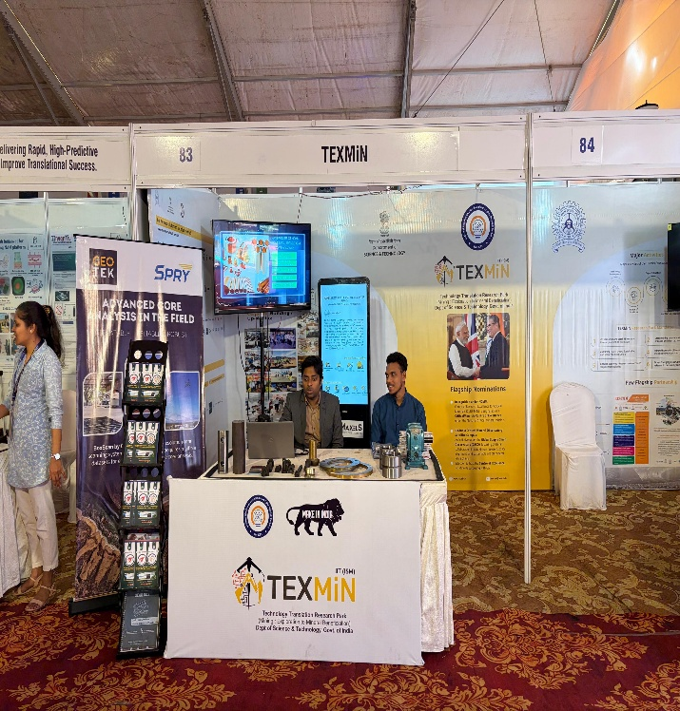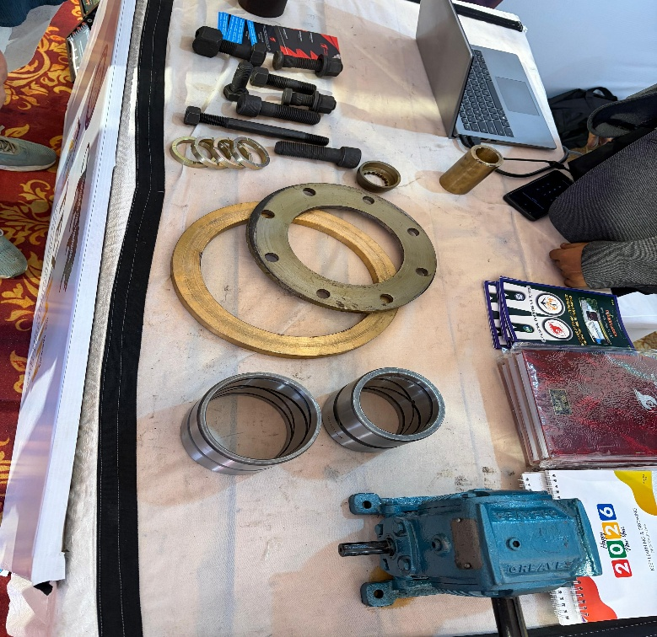

12. Geotechnical Multifunctional Scale – VNIT Nagpur (Patented)
Category | Geotechnical Instrumentation & Field Testing Technology
Mining Relevance | Directly Mining-Related

Presented by Mr. Jalinder (Kumaar) Salunkhe, Research Scholar, and guided by Dr. Shrabony Adhikary, Assistant Professor, Geotechnical Engineering Division, Department of Civil Engineering, VNIT Nagpur, the Geotechnical Multifunctional Scale is a patented all-in-one handheld device (Design & Utility Patent) that integrates multiple geotechnical field testing functions into a single portable instrument. The scale is based on IS 1498 (1970) and enables quick field identification of soil types, core-length and diameter measurement, direct in-situ soil pH and moisture detection, and reference to standard geotechnical drilling sizes (hole diameter, core diameter, casing OD). Additional integrated features include real soil samples for grain-size comparison, a magnifying lens for texture inspection, an embedded GPS for geotagging field data, a digital display, solar charging panel, in-built rechargeable battery, and data export for digital reporting. The tool is designed for use by geotechnical and mining engineers working in exploration, site investigation, and surface/underground mining applications where rapid soil characterization in the field is essential.

Key Features & Highlights:
- Patented handheld geotechnical scale integrating 12 field-testing functions in one instrument
- IS 1498 (1970) based soil classification for quick in-situ identification of boulder, cobble, gravel, sand, silt and clay
- Embedded pH and moisture sensors with digital display for direct in-situ soil measurement
- Integrated GPS for geotagging, solar panel with rechargeable battery, and data export system
- Reference chart for geotechnical drilling sizes (R, E, A, B, N, H, P, S, U, Z series – hole/core/casing dimensions)
- Highly relevant for mine exploration, overburden sampling, slope-stability studies, and site investigation

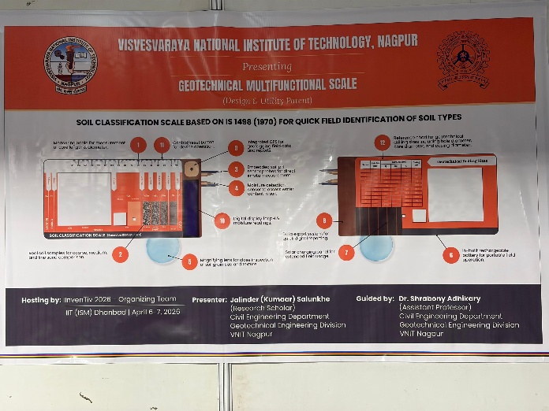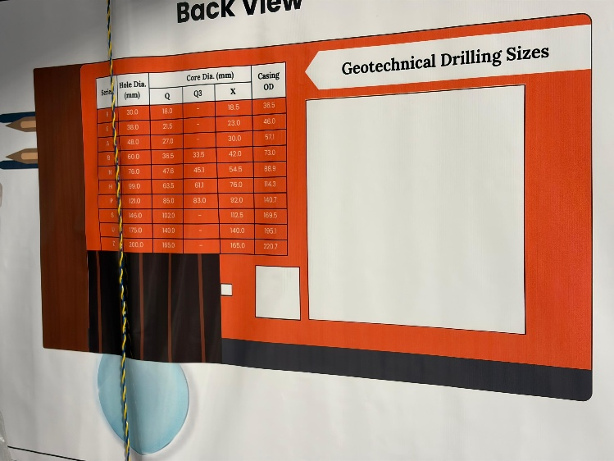

13. ‘Nickel-Free’ Stainless Steel for Biomedical Applications – IIT (BHU) Varanasi (Patented)
Category | Advanced Metallurgy & Biomedical Materials
Mining Relevance | Indirectly Mining-Related (Metallurgy / Materials Science)
Developed by Prof. Girija Shankar Mahobia, Dr. Chandrashekhar Kumar, and V. Singh from the Department of Metallurgical Engineering, IIT (BHU) Varanasi, this innovation presents an indigenous austenitic stainless steel that is free of nickel – a known allergen and toxin – and is instead stabilized using manganese and nitrogen. The patent (Patent No. 509030, awarded 09.02.2024) was funded by the Ministry of Steel, Government of India (Budget: Rs. 284 lakhs, 2017–2021), with collaborators including IMS (BHU), M/s Jindal Stainless Limited, NCCS Pune, MIDHANI Hyderabad, and SCTIMST Thiruvananthapuram. The exhibit displayed physical samples of orthopaedic fracture implants (LCDCP-3.5-7H plates) manufactured from the new steel alongside the research poster detailing corrosion fatigue tests, biocompatibility tests, electrochemical corrosion tests, and mechanical property evaluation. The nearly doubled yield strength of the new steel vs. conventional 316L enables approximately 50% weight reduction in implants, while also being more cost-effective. Although a biomedical product, this innovation is highly relevant to mining engineers interested in metallurgy, indigenous materials development, and the ‘Make in India’ ecosystem for advanced alloys.

Key Features & Highlights:
- Indigenous austenitic stainless steel stabilized with manganese and nitrogen instead of toxic/allergenic nickel
- Funded by Ministry of Steel, GoI (Rs. 284 lakhs); Patent No. 509030 awarded 09.02.2024
- Nearly 2× yield strength of 316L SS → ≈50% weight reduction in orthopaedic implants
- Comprehensive biocompatibility, corrosion-fatigue, and electrochemical tests completed per ISO standards
- Collaboration with Jindal Stainless, MIDHANI, NCCS Pune, IMS BHU, SCTIMST – full India supply chain
- Targets ~USD 5.08 billion Indian orthopaedic implants market by 2035; ready for clinical trials
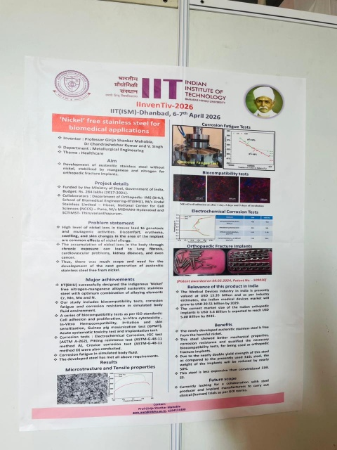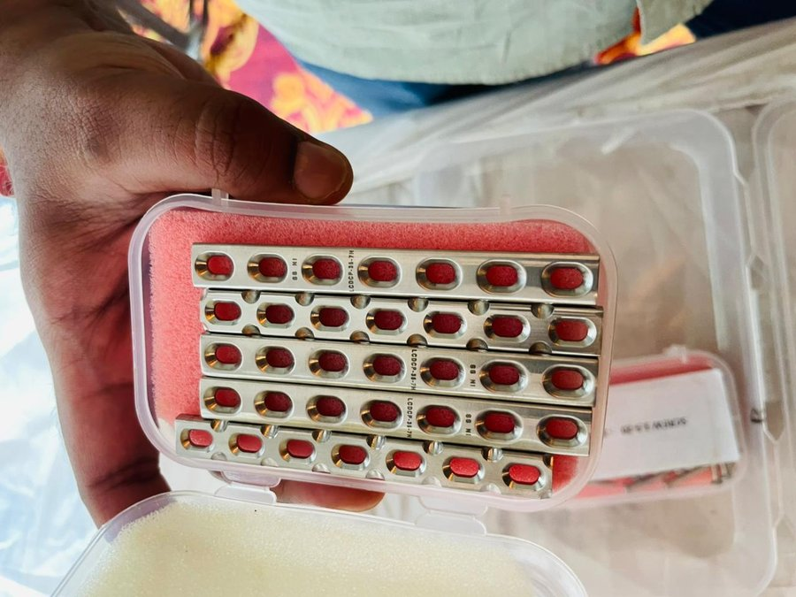

4. Summary of Innovations
The table below provides a quick reference overview of all innovations observed at IInvenTiv 2026:

S.No. | Innovation / Product Name | Category | Mining Relevance
1 | Folium Sensing – Distributed Fiber Optic Sensing System (DSS & DTS) | Digital Monitoring & Sensing Technology | Yes
2 | Jain Mineral Concentrator – Enhanced Gravity Concentration Technology | Mineral Processing Equipment | Yes
3 | Conformal MIMO Antenna System for Open-Cast Mining UAV Communication | UAV / Communication Technology for Mining | Yes
4 | TechBond Global – Molecular Integration Adhesive Technology | Advanced Materials for Mining & Industry | Yes
5 | Lyfcell Innovation Private Limited – Next-Generation Battery Solutions | Energy Storage Technology | Related
6 | Coal-to-Methanol Technology with CO₂ Capture & Utilization (CCU) – THERMAX/CEST & NITI Aayog Initiative | Carbon Capture, Clean Coal Valorization & Methanol Technology | Yes
7 | H-CBM (Hydrogen-enriched Coal Bed Methane) via Catalytic Methane Pyrolysis – Jharia Coalfields Case Study | Clean Energy / CBM Valorization & Hydrogen Production | Yes
8 | Integrated Iron Ore Valorization – Multi-Metal Recovery & H₂-Based Direct Reduction – IIT (BHU) Varanasi | Hydrometallurgy, Green Steel & Hydrogen Metallurgy | Yes
9 | DozerHouse – AI-Powered E-Commerce Platform for Mining & Construction Machinery | Digital Platform / Mining Equipment Commerce | Yes
10 | Garudalytics – Geospatial AI Intelligence Platform | Geospatial Technology & Smart Intelligence | Yes
11 | RK Casting Engineering Pvt. Ltd. – Precision Industrial Casting Solutions | Industrial Casting & Manufacturing (Mining-Use Components) | Yes
12 | Geotechnical Multifunctional Scale – VNIT Nagpur (Patented) | Geotechnical Instrumentation | Yes
13 | ‘Nickel-Free’ Stainless Steel for Biomedical Applications – IIT (BHU) Varanasi | Advanced Metallurgy & Biomedical Materials | Related

5. Conclusion
The IInvenTiv 2026 Global Innovation Showcase at IIT (ISM) Dhanbad offered an enriching exposure to the frontier of mining and industrial technology innovation. The event demonstrated that the mining sector is undergoing a transformative phase, with innovations spanning digital sensing, mineral processing, autonomous systems, clean energy, advanced materials, and AI-driven platforms converging to address longstanding operational, safety, and sustainability challenges.

Particularly noteworthy were the distributed fiber-optic sensing solutions (Folium Sensing / IIT Madras) and the UAV-MIMO communication system, both of which directly align with the direction of digital and automated mining. The emphasis on coal valorization through CCU, methanol production, and the H-CBM pathway (catalytic methane pyrolysis of Jharia CBM into hydrogen-blended fuel with carbon nanotubes as a solid co-product) is especially significant in the context of Jharkhand's coal economy and India's net-zero transition targets. The Jain Mineral Concentrator represents a locally developed, globally relevant innovation in mineral processing.

From the perspective of a PhD researcher working on Digital Twin frameworks and HEMM electrification in surface mining, several exhibits – including Lyfcell's advanced battery solutions, Garudalytics' geospatial AI platform, DozerHouse's digital machinery marketplace, and the distributed sensor systems – highlight the rapid convergence of IoT, AI, and mining engineering that forms the bedrock of modern digital mining research.

Overall, the visit was highly informative and broadened the understanding of both technological possibilities and real-world commercialization pathways available to mining engineers and researchers today.

