Creators and Insta

Name : Atharva Ruke
Image:
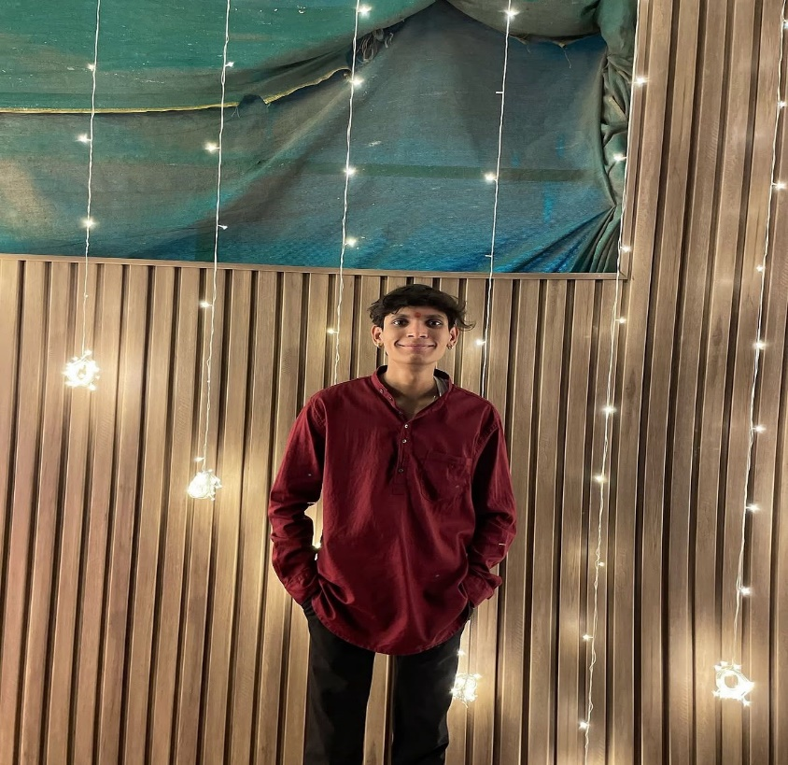

Insta link : https://www.instagram.com/ruke_atharva/

Name : Vishal Shatri
Image :

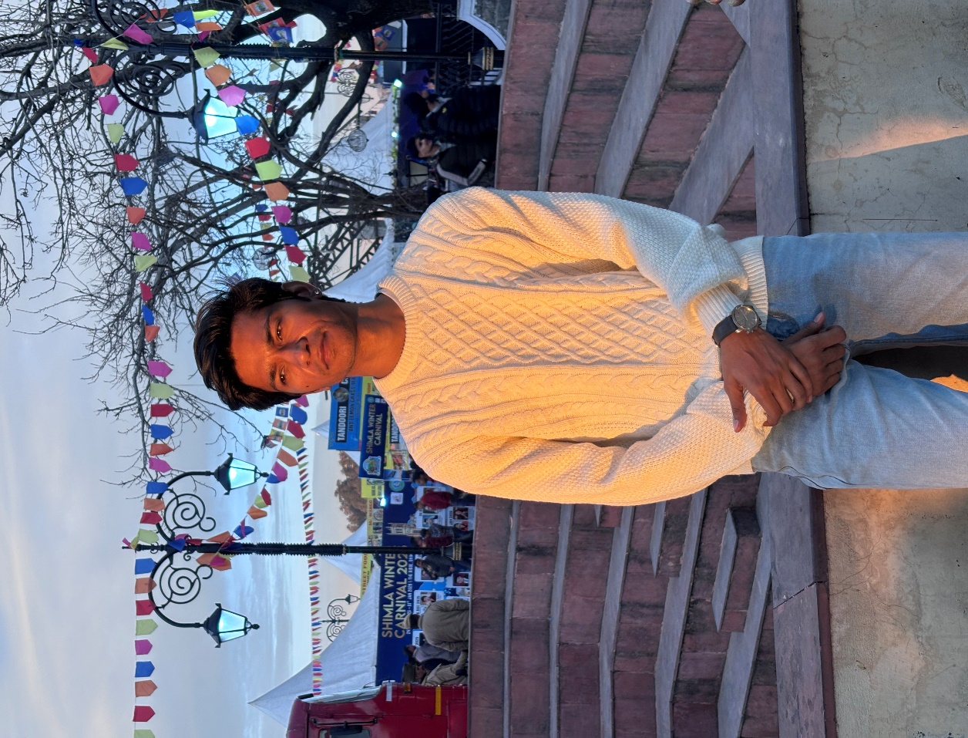

Insta Link : https://www.instagram.com/theramvishal/

Name : Ayush Khandekar
Image :
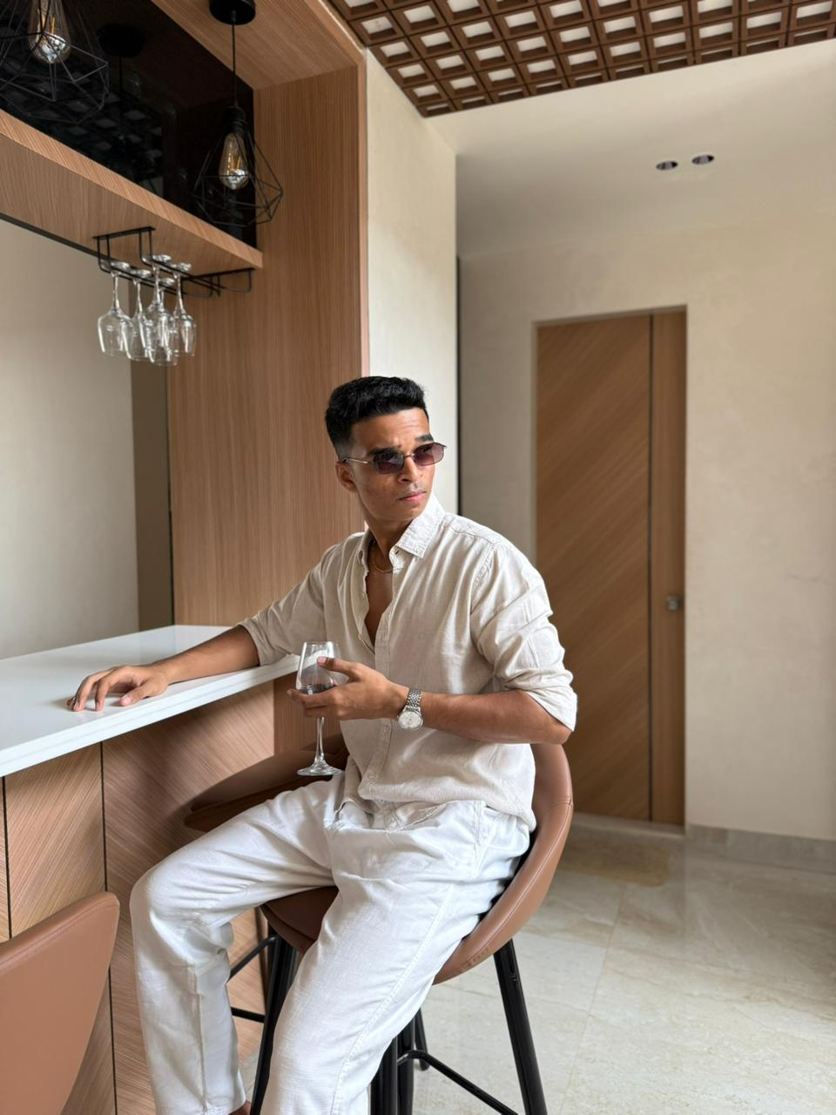

Insta Link : https://www.instagram.com/buntastic_29/

Name : Prabhal Bhat
Image :
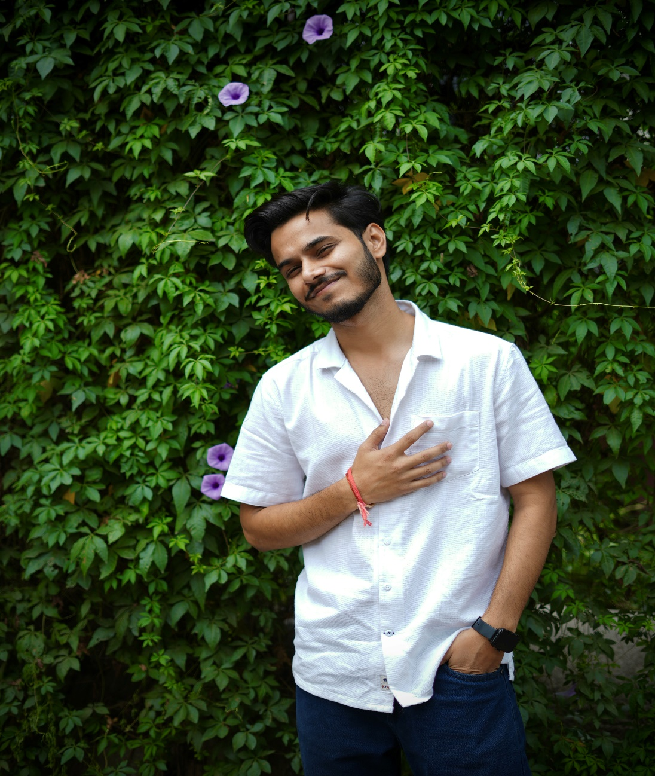

Insta Link : https://www.instagram.com/prabalbhatt16/

Name : Anshman Sandhu
Image :
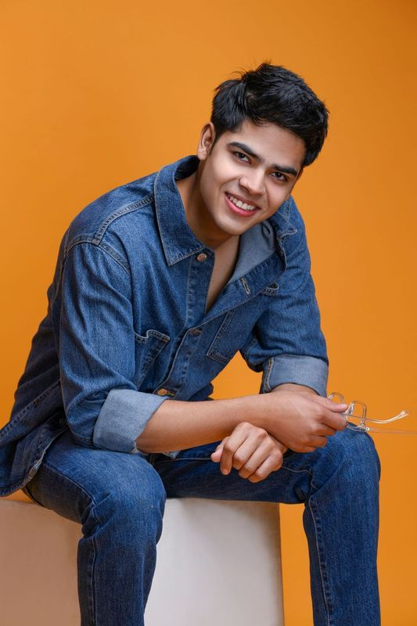

Insta Link : https://www.instagram.com/theanshmansandhu

Name : Pink Smile
Image :
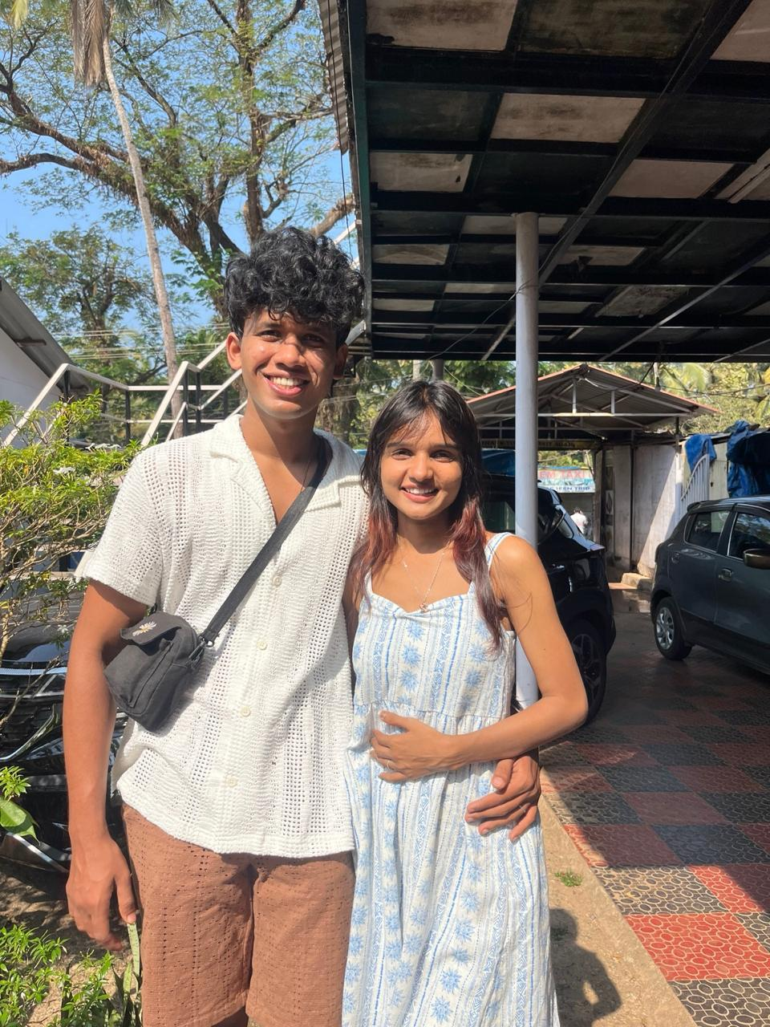

Insta Link : https://www.instagram.com/pinksmile14_

Name : Sunny Gupta
Image :
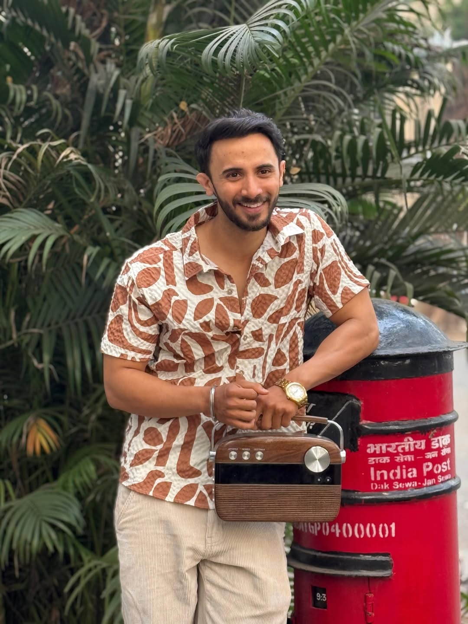

Insta Link : https://www.instagram.com/sunny_gupta__/

