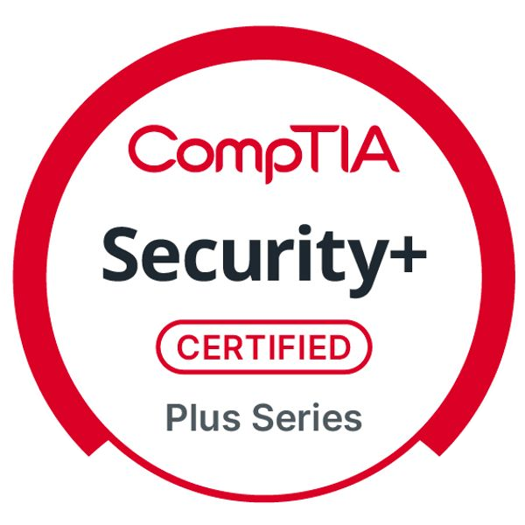
Pratik Anil Pawar
Information Security & Cybersecurity Fresher
​ LinkedIn ​ Portfolio

SUMMARY
Cybersecurity fresher (B.Sc. Electronics, CGPA 9.47) with CompTIA Security+ and Google Cybersecurity certifications. Hands-on experience in SIEM alert triage, phishing analysis, and incident response through LetsDefend and TryHackMe. Developed an n8n-based phishing analyzer automating IOC enrichment and threat classification, cutting manual triage effort ~50%. Working knowledge of cloud security fundamentals (AWS/Azure) and scripting (Python, Bash, PowerShell,). Seeking InfoSec Engineer role to contribute to enterprise security operations, threat detection, and compliance in dynamic security environments.

TECHNICAL SKILLS
SOC SIEM Incident Response Fundamentals Digital Forensics Cyber Forensics Kali Linux Bash Python

PowerShell ISO 27001 Fundamentals AWS Azure Cloud Security Fundamentals

EDUCATION

Bachelor of Science in Electronics - CGPA: 9.47/10

Solapur University
2022 - 2025

Senior Secondary (Class 12) - 67.23%

Maharashtra State Board
2018 - 2020

Secondary (Class 10) - 90.20%

Maharashtra State Board
2016 - 2018

CERTIFICATIONS

CompTIA Security+ SY0-701
CompTIA

Google Cybersecurity
Coursera

Cisco SOC
Coursera

ONGOING CERTIFICATIONS
TryHackMe SAL1 (Security Analyst Level 1) TryHackMe PT1 (Junior Penetration Tester)

PROJECT

n8n-based Phishing Email Analyzer
An automated workflow project for phishing email analysis
- Engineered an n8n-based automated workflow to classify emails as benign, suspicious, or phishing, reducing manual triage effort by approximately 50%
- Integrated Gmail and Outlook APIs to extract MIME headers, URLs, and attachments for threat analysis
- Automated IOC enrichment via Python reputation checks against threat intelligence sources
- Built n8n workflow automating email extraction, threat scoring, and alert generation, validated against MITRE ATT&CK T1566

ACADEMIC ACHIEVEMENTS

National Mathematics Day - Quiz Competition Winner
Captured 1st Rank in Quiz Competition – National Mathematics Day 2023, awarded by Solapur University.

