

A PROJECT REPORT ON

HIREPULSE — AI-POWERED PLACEMENT ASSISTANT

BY

Pratik Kadnor (Exam Seat No.: ________)
Neel Malpure (Exam Seat No.: ________)
Abhijeet Sawant (Exam Seat No.: ________)

UNDER THE GUIDANCE OF
Prof. [Guide Name & Designation]

IN PARTIAL FULFILLMENT OF
T.E. (ELECTRONICS & TELECOMMUNICATION ENGINEERING)
DEGREE OF SAVITRIBAI PHULE PUNE UNIVERSITY
MAY/JUNE – 2026

DEPARTMENT OF ELECTRONICS & TELECOMMUNICATION ENGINEERING


CERTIFICATE
This is to certify that the project entitled
"HirePulse — AI-Powered Placement Assistant"
submitted by
Student Name | Seat Number
Pratik Kadnor | Seat No.: ________
Neel Malpure | Seat No.: ________
Abhijeet Sawant | Seat No.: ________

is a record of bonafide work carried out by them under my guidance, in partial fulfillment of the requirement for the award of Third Year Engineering (Electronics & Telecommunication Engineering) of Savitribai Phule Pune University.

Date: ____________ Place: D.I.T., Pimpri, Pune-18

Prof. [Guide Name] | Mr. Anand Labade
Project Guide | Project Coordinator
Dr. [HoD Name] | Dr. Nitin Sherje
HoD, E&TC | Principal

DECLARATION
We hereby declare that the project report entitled "HirePulse — AI-Powered Placement Assistant" submitted to Savitribai Phule Pune University in partial fulfillment of the requirements for the award of the degree of Bachelor of Engineering in Electronics & Telecommunication Engineering is a record of original work carried out by us under the guidance of Prof. [Guide Name & Designation].

The information presented in this report is true and correct to the best of our knowledge and belief. This work has not been submitted elsewhere for any degree or diploma.

Date: ____________ Place: Pune

Pratik Kadnor | Neel Malpure | Abhijeet Sawant
Seat No.: ________ | Seat No.: ________ | Seat No.: ________

Department of Electronics & Telecommunication Engineering

ACKNOWLEDGEMENT
We would like to express our sincere gratitude to Dr. [Principal Name], Principal of [College Name], for providing us the necessary facilities and opportunity to carry out this project.

We are grateful to Dr. [HoD Name], Head of the Department of Electronics & Telecommunication Engineering, for their valuable support and encouragement throughout the project.

We would like to express our heartfelt thanks to Prof. [Guide Name & Designation] for their continuous guidance, constructive feedback, and valuable suggestions which proved instrumental in the successful completion of this project. Their technical direction helped shape HirePulse into a comprehensive platform.

We extend our sincere thanks to all the faculty members of the Department of E&TC for their co-operation and assistance during the course of this work.

We acknowledge the open-source communities behind Google Gemini, React, Node.js, FastAPI, and MongoDB Atlas, without which this project would not have been possible.

Finally, we are deeply grateful to our parents and family members for their constant encouragement, moral support, and understanding throughout our academic journey.

Date: ____________ Place: Pune

Pratik Kadnor | Neel Malpure | Abhijeet Sawant
Seat No.: ________ | Seat No.: ________ | Seat No.: ________

ABSTRACT
HirePulse is a full-stack, AI-powered web application designed as a comprehensive placement preparation assistant for engineering students. In today's highly competitive job market, students face significant challenges preparing for technical interviews, tailoring resumes to Applicant Tracking Systems (ATS), practising Data Structures & Algorithms (DSA), and discovering relevant job opportunities. HirePulse addresses all these challenges through a single unified intelligent platform.
The system integrates a multi-tier microservices architecture: a React 19 frontend with Vite and TailwindCSS 4, a Node.js/Express REST API backend with MongoDB Atlas for user management and JWT authentication with bcrypt password hashing, and a Python FastAPI microservice powered by the Google Gemini AI for resume analysis and interview simulation.
Key features include: (1) an AI Mock Interview module with real-time voice interaction using the browser's Web Speech API, AI-generated contextual follow-up questions via Gemini, and structured JSON performance reports including score, strengths, and improvement areas; (2) a Resume Analyzer that extracts text from uploaded PDFs using pdfplumber and pytesseract OCR, then uses Gemini to score ATS compatibility and suggest improvements with skill gap radar chart visualization; (3) a curated Top 75 LeetCode DSA Tracker with difficulty/topic filtering; (4) Job Recommendations via JSearch RapidAPI; and (5) a role-based system serving both Student and HR users with dedicated dashboards.
A multi-model Gemini fallback chain (flash → flash-8b → 1.0-pro) ensures near-100% AI availability. The HR Dashboard provides candidate management, recruitment funnel analytics, job posting, and interview scheduling. The system is deployed on Vercel with environment-specific CORS configuration. HirePulse is the only unified, voice-interactive, AI-driven, and free placement preparation platform integrating features typically siloed across multiple separate commercial products.
Keywords: AI Mock Interview, ATS Resume Analyzer, Gemini API, MERN Stack, FastAPI, DSA Tracker, Web Speech API, JWT Authentication.

TABLE OF CONTENTS
Chapter / Section | Title | Page No.
— | Certificate | ii
— | Declaration | iii
— | Acknowledgement | iv
— | Abstract | v
— | Table of Contents | vi
— | List of Tables | vii
— | List of Figures | viii
— | List of Symbols & Abbreviations | ix
1 | Introduction and Literature Survey | 1
1.1 | Introduction | 1
1.2 | Problem Statement | 2
1.3 | Objectives | 2
1.4 | Scope of the Project | 3
1.5 | Literature Survey | 3
1.6 | Methodology | 5
2 | System Specification and Block Schematic | 6
2.1 | Overall System Description | 6
2.2 | System Block Diagram | 7
2.3 | Software Requirements | 8
2.4 | Hardware Requirements | 9
2.5 | Working Principle | 10
3 | Hardware & Software Design | 13
3.1 | Hardware Design | 13
3.2 | Frontend Architecture | 13
3.3 | Node.js Backend Architecture | 14
3.4 | Python FastAPI Microservice | 15
3.5 | Flowcharts | 16
3.6 | API Endpoints | 18
3.7 | Database Schema | 19
4 | Results, Discussion and Analysis | 20
4.1 | Experimental Setup | 20
4.2 | System Screenshots | 20
4.3 | Functional Testing Results | 26
4.4 | Performance Analysis | 27
4.5 | Comparison with Existing Systems | 28
4.6 | Advantages & Disadvantages | 29
5 | Conclusion and Future Scope | 30
5.1 | Conclusion | 30
5.2 | Limitations | 31
5.3 | Future Scope | 31
— | References / Bibliography | 33
— | Bill of Materials | 34
— | Appendix | 35

LIST OF TABLES
Table No. | Title of Table | Page No.
2.1 | Software Requirements | 8
2.2 | Hardware Requirements | 9
3.1 | API Endpoint Summary | 18
3.2 | Database Schema — User Model | 19
4.1 | Functional Test Results | 26
4.2 | Resume ATS Score Analysis | 27
4.3 | AI Interview Score Distribution | 27
4.4 | Comparison with Existing Systems | 28
5.1 | Bill of Materials | 34

LIST OF FIGURES
Figure No. | Title of Figure | Page No.
2.1 | System Block Diagram | 7
3.1 | Frontend Component Tree | 13
3.2 | Node.js Backend Architecture | 14
3.3 | Python FastAPI Structure | 15
3.4 | AI Mock Interview Flowchart | 16
3.5 | Resume Analyzer Flowchart | 17
4.1 | HirePulse Landing Page | 20
4.2 | Login Selection Page | 21
4.3 | Student Login and Registration Screens | 21
4.4 | Student Dashboard — Overview | 22
4.5 | AI Mock Interview Module | 23
4.6 | Resume Analyzer — ATS Score & Skills Breakdown | 24
4.7 | Top 75 DSA Problem Tracker | 24
4.8 | HR Dashboard Overview | 25

LIST OF SYMBOLS & ABBREVIATIONS
Abbreviation | Full Form
AI | Artificial Intelligence
API | Application Programming Interface
ATS | Applicant Tracking System
CORS | Cross-Origin Resource Sharing
DSA | Data Structures and Algorithms
HR | Human Resources
HTTP | HyperText Transfer Protocol
JWT | JSON Web Token
JSON | JavaScript Object Notation
LLM | Large Language Model
MERN | MongoDB, Express, React, Node.js
NLP | Natural Language Processing
OCR | Optical Character Recognition
PDF | Portable Document Format
REST | Representational State Transfer
SPA | Single Page Application
STT | Speech-to-Text
TTS | Text-to-Speech
UI | User Interface
UX | User Experience
URL | Uniform Resource Locator

CHAPTER 1: INTRODUCTION AND LITERATURE SURVEY
1.1 Introduction
The engineering placement season is one of the most critical phases in a student's academic life. Students must simultaneously master Data Structures & Algorithms (DSA), tailor resumes for ATS compatibility, practise mock interviews, and track opportunities. These activities are currently fragmented across disconnected platforms: LeetCode for DSA, separate tools for ATS checks, different platforms for mock interviews, and multiple job portals.
HirePulse is a unified AI-powered placement assistant built using the MERN stack and a Python FastAPI microservice for AI operations. It provides in a single platform: (1) AI Mock Interview using Web Speech API and Google Gemini; (2) Resume Analyzer using pdfplumber/OCR and Gemini AI; (3) Top 75 LeetCode Tracker; (4) Job Recommendations via JSearch API; (5) Student and HR Dashboards with role-based access control.
1.2 Problem Statement
Engineering students face a fragmented and inefficient placement preparation experience:
- No single platform integrates resume analysis, mock interviews, DSA tracking, and job recommendations.
- Resume ATS compatibility is difficult to assess without expensive proprietary tools.
- Mock interview platforms are costly, lack real-time AI feedback, and do not support voice interaction.
- DSA practice platforms like LeetCode lack integration with career preparation tools.
- HR recruitment systems are disconnected from student preparation and performance data.
1.3 Objectives
- Design a full-stack web application for students and HR professionals with role-based JWT authentication.
- Implement an AI Mock Interview with Web Speech API voice input, Gemini question generation, and JSON performance reports.
- Build a Resume Analyzer using pdfplumber/pytesseract for PDF extraction and Gemini for ATS scoring.
- Integrate a Top 75 DSA Tracker with filtering, search, and real-time progress visualization.
- Provide Job Recommendations via JSearch (RapidAPI) integration.
- Implement dual-role JWT authentication (Student/HR) with bcrypt password hashing.
- Deploy the complete application on Vercel for public accessibility.
1.4 Scope of the Project
- Target Users: Engineering students (placement preparation) and HR professionals (recruitment management).
- Platform: Web-based, accessible in any modern browser without installation.
- AI Integration: Google Gemini 1.5 Flash with fallback to flash-8b and 1.0-pro for NLP tasks.
- Database: MongoDB Atlas cloud cluster for persistent user data and authentication.
- Deployment: Frontend + Node.js API on Vercel; Python FastAPI serverside.
- Out of Scope: Mobile-native application, real-time video conferencing, peer-to-peer tutoring.
1.5 Literature Survey
1.5.1 AI in Recruitment and Placement
Campion et al. (2019) demonstrated that AI-assisted resume screening reduces hiring time by 75% while improving candidate quality. Tools like Resumake and Jobscan use keyword matching for ATS. HirePulse extends this with Google Gemini LLM for contextual analysis, providing more actionable feedback than simple keyword-frequency matching tools.
1.5.2 AI-Powered Interview Simulation
Naim et al. (2015) showed AI can reliably assess interview performance via multimodal cues. Modern LLMs like Gemini demonstrate near-human conversational ability. HirePulse uses Gemini for interview question generation with a robust local fallback question pool that maintains session continuity during API rate limits.
1.5.3 Speech Recognition in Web Applications
The W3C Web Speech API (SpeechRecognition + SpeechSynthesis) provides client-side STT/TTS in Chrome/Edge without server overhead. HirePulse uses these browser-native APIs to create a fully voice-interactive mock interview experience at zero additional infrastructure cost.
1.5.4 DSA Practice Platforms
LeetCode, HackerRank, and Codeforces are dominant but isolated DSA platforms. NeetCode's "Top 75" curated problem set is widely regarded as the most efficient preparation path. No existing platform integrates a curated DSA tracker directly with resume and interview tools.
1.5.5 Microservices and Full-Stack Architecture
The MERN stack (Kashyap, 2020) provides a JavaScript-unified full-stack environment. Adding a Python FastAPI microservice for AI workloads follows the microservices pattern (Newman, 2015), allowing independent scaling of AI-heavy operations without affecting the core application.
1.6 Methodology
Agile methodology with 6 iterative sprints:
- Sprint 1: System design, role-based JWT authentication, bcrypt hashing, MongoDB Atlas setup.
- Sprint 2: Resume Analyzer — PDF parsing (pdfplumber/pytesseract) + Gemini AI integration.
- Sprint 3: AI Interview module — Web Speech API + Gemini chat engine + JSON report generator.
- Sprint 4: Top 75 DSA tracker with topic/difficulty filters, and Job Recommendations via JSearch.
- Sprint 5: HR Dashboard — candidate management, analytics, job posting, interview scheduling.
- Sprint 6: Dark-theme glassmorphism UI, Vercel deployment, comprehensive testing.

CHAPTER 2: SYSTEM SPECIFICATION AND BLOCK SCHEMATIC
2.1 Overall System Description
HirePulse uses a three-tier microservices architecture:
- Presentation Tier (Frontend): React 19 SPA, Vite 6, TailwindCSS 4. Framer Motion animations, Recharts visualization, React Router DOM v7 routing, Axios HTTP client.
- Application Tier — Node.js/Express (Port 3000): JWT auth with httpOnly cookies, user CRUD, curated job data. Deployed on Vercel.
- Application Tier — Python FastAPI (Port 8000): PDF parsing (pdfplumber/pytesseract), Gemini AI calls (resume analysis, chat, reports), multi-model fallback chain.
- Data Tier: MongoDB Atlas for user data. Google Gemini API for NLP/AI. JSearch (RapidAPI) for live job listings.
2.2 System Block Diagram
Figure 2.1 shows the complete HirePulse system block diagram:
┌────────────────────────────────────────────────────────────────────┐
│ USER (Browser) │
│ React SPA (Vite + TailwindCSS) │
│ ┌──────────┐ ┌──────────┐ ┌──────────┐ ┌──────┐ ┌────────────┐ │
│ │Dashboard │ │Interview │ │ Resume │ │Top 75│ │HR Dashboard│ │
│ │(Student) │ │ Module │ │ Analyzer │ │Tracker│ │(Recruiter) │ │
│ └────┬─────┘ └────┬─────┘ └────┬─────┘ └──────┘ └────────────┘ │
└───────┼────────────┼────────────┼────────────────────────────────────┘
│ Axios │ │
▼ ▼ ▼
┌─────────────────┐ ┌─────────────────────────────────┐
│ Node.js/Express│ │ Python FastAPI (Port 8000) │
│ (Port 3000) │ │ │
│ JWT Auth │ │ POST /analyze-resume/ │
│ User CRUD │ │ POST /interview/chat │
│ Job Data │ │ POST /interview/report │
│ ┌─────────────┐ │ │ ┌──────────────┐ ┌───────────┐ │
│ │MongoDB Atlas│ │ │ │ pdfplumber │ │Gemini API │ │
│ └─────────────┘ │ │ │ pytesseract │ │flash→pro │ │
└─────────────────┘ │ └──────────────┘ └───────────┘ │
└─────────────────────────────────┘
│
┌─────────┴──────────┐
│ JSearch (RapidAPI) │
└────────────────────┘
Figure 2.1 – System Block Diagram
2.3 Software Requirements
Component | Technology / Version | License | Cost
Frontend | React 19.0.0 + Vite 6.2.0 | MIT | Free
Styling | TailwindCSS 4.1.2 | MIT | Free
Animation | Framer Motion 12.6.3 | MIT | Free
Charts | Recharts 2.15.2 | MIT | Free
Routing | React Router DOM 7.4.1 | MIT | Free
HTTP Client | Axios 1.8.4 | MIT | Free
Backend Runtime | Node.js 20 + Express 5.1.0 | MIT | Free
ORM | Mongoose 8.23.0 | MIT | Free
Auth | jsonwebtoken 9.0.2 + bcryptjs 3.0.2 | MIT | Free
AI Backend | Python 3.11 + FastAPI + uvicorn | PSF/MIT | Free
PDF Parsing | pdfplumber 0.11.4 | MIT | Free
OCR | pytesseract 0.3.13 + pdf2image 1.17.0 | Apache 2.0 | Free
AI API | Google Gemini 1.5 Flash | Google ToS | Free tier
Job API | JSearch (RapidAPI) | RapidAPI ToS | Free tier
Database | MongoDB Atlas | SSPL | Free tier
Deployment | Vercel (Frontend + Node.js) | Vercel ToS | Free tier
Browser | Google Chrome / Microsoft Edge 90+ | — | Free

Table 2.1 – Software Requirements
2.4 Hardware Requirements
Component | Minimum Requirement
Processor | Intel Core i5 / AMD Ryzen 5 (1.6 GHz+)
RAM | 4 GB (8 GB recommended)
Storage | 500 MB free disk space
Internet | Broadband (required for API calls)
Webcam | Required for AI Interview module
Microphone | Required for voice interview feature
Browser | Google Chrome 90+ / Microsoft Edge 90+

Table 2.2 – Hardware Requirements
2.5 Working Principle
2.5.1 User Authentication Flow
- User visits landing page and selects Student Login or HR Login.
- On registration, POST /api/users validates inputs, hashes password with bcrypt (10 salt rounds), saves user role (student/hr) to MongoDB.
- On login, POST /api/users/auth verifies credentials using matchPassword() (bcrypt.compare()). Signs a JWT (30-day expiry) stored as httpOnly cookie.
- Protected routes verify JWT via protect middleware. Role-based routing: students → Dashboard, HR → HRDashboard.
2.5.2 AI Resume Analysis Flow
- User uploads PDF resume via drag-and-drop interface in the browser.
- Frontend sends file to POST /analyze-resume/ on Python FastAPI server via multipart form-data.
- Server saves to tempfile.mkdtemp(), extracts text with pdfplumber. Falls back to pytesseract OCR if extraction fails (scanned PDFs).
- Extracted text sent to Gemini API (flash → flash-8b → 1.0-pro fallback) with structured ATS analysis prompt.
- Response cleaned via regex (clean_gemini_output), returned to frontend with ATS score, skills, suggestions.
2.5.3 AI Mock Interview Flow
- User clicks "Start Interview" — SpeechSynthesis API speaks the opening question.
- User presses mic button — SpeechRecognition API captures voice and auto-submits on speech end.
- Text sent to POST /interview/chat. Gemini generates follow-up question (<60 words). Local fallback pool used if all models fail.
- AI response spoken via SpeechSynthesis, appended to real-time transcript panel.
- On "End & Get Report", full transcript sent to POST /interview/report. Gemini returns {score, strengths, improvements, feedback} JSON displayed in a modal.

CHAPTER 3: HARDWARE & SOFTWARE DESIGN
3.1 Hardware Design
HirePulse is a software-only project with no custom hardware. Development uses a standard MacBook/Windows PC with Node.js 20 and Python 3.11 installed. Production infrastructure uses Vercel serverless (frontend + Node.js) and MongoDB Atlas cloud cluster. End users require a laptop with webcam and microphone for the AI interview module.
3.2 Frontend Architecture (Figure 3.1)
App.jsx
└── PageRouting (React Router DOM v7)
├── / → LandingPage
│ ├── Hero.jsx (main CTA section)
│ ├── Feature.jsx (feature highlights)
│ ├── TechMarquee.jsx (tech stack logos)
│ └── Footer.jsx
├── /login → login-selection.jsx (Student / HR)
├── /student-login → login-form.jsx
├── /hr-login → HRLogin.jsx
├── /register → register-form.jsx
├── /hr-register → HRRegister.jsx
├── /dashboard → Dashboard.jsx (Student)
├── /hr-dashboard → HRDashboard.jsx
├── /interview → Interview.jsx
├── /resume-analyzer → ResumeAnalyzer.jsx
├── /top75 → Top75.jsx
└── /jobs → JobRecommendations.jsx
State: React Context API (UserContext) manages global user state after login. Local state per page via useState/useRef. No Redux — Context API is sufficient for the current feature scope.
3.3 Node.js Backend Architecture (Figure 3.2)
backend-Node/
├── index.js ← Express app, CORS config, route registration
├── config/
│ └── db.js ← MongoDB Atlas connection (10s timeout)
├── models/
│ └── userModel.js ← Schema: name, email, password(hashed), userType
│ ← Pre-save hook: bcrypt.genSalt(10) + hash
│ ← Method: matchPassword(pwd) → bcrypt.compare()
├── controllers/
│ └── userController.js ← authUser, registerUser, logoutUser,
│ getUserProfile, updateUserProfile
├── routes/
│ └── userRoutes.js ← POST /auth, POST /, POST /logout, GET+PUT /profile
├── middlewares/
│ └── authMiddleware.js ← protect(token) → jwt.verify()
└── utils/
└── generateToken.js ← jwt.sign() → set httpOnly cookie (30d expiry)
3.4 Python FastAPI Microservice (Figure 3.3)
backend-Py/
├── main.py
│ ├── GEMINI_MODELS = [gemini-1.5-flash, flash-8b, gemini-1.0-pro]
│ │
│ ├── call_gemini_with_fallback(prompt, api_key)
│ │ └── Try each model; 2 attempts/model; exp backoff on HTTP 429
│ │
│ ├── extract_text_from_pdf(pdf_path)
│ │ └── pdfplumber.open() → extract_text()
│ │ └── Fallback: pdf2image → PIL → pytesseract.image_to_string()
│ │
│ ├── clean_gemini_output(text)
│ │ └── regex: strip **bold**, #headers, emojis for clean TTS output
│ │
│ ├── POST /analyze-resume/ ← UploadFile → extract → Gemini → JSON
│ ├── POST /interview/chat ← {message, history} → Gemini → question
│ │ (8 local fallback questions if quota hit)
│ └── POST /interview/report ← {history} → Gemini → {score,strengths,...}
├── requirements.txt
└── .env (GOOGLE_API_KEY, RAPIDAPI_KEY)
3.5 Flowcharts
3.5.1 Resume Analyzer Flowchart (Figure 3.5)
START
↓
User uploads PDF → POST /analyze-resume/ (FastAPI)
↓
Save to tempfile.mkdtemp()
↓
pdfplumber.extract_text()
↓
Text found? ─YES─► Build Gemini prompt (ATS analysis)
│ ↓
NO call_gemini_with_fallback()
↓ [flash → flash-8b → 1.0-pro]
pdf2image ↓
pytesseract OCR clean_gemini_output()
↓ ↓
└──────────────► Return JSON to frontend
↓
Render ATS score + radar chart + tips
↓
END
3.5.2 AI Mock Interview Flowchart (Figure 3.4)
START → User clicks "Start Interview"
↓
SpeechSynthesis.speak(openingQuestion)
↓
┌──────────────── INTERVIEW LOOP ────────────────┐
│ User presses Mic → SpeechRecognition.start() │
│ Voice → text (auto-submit on silence) │
│ ↓ │
│ POST /interview/chat → Gemini generates Q │
│ (fallback pool if all models rate-limited) │
│ ↓ │
│ SpeechSynthesis.speak(aiQuestion) │
│ Append to conversationHistory[] │
└──────────────── (repeat) ──────────────────────┘
↓ User clicks "End & Get Report"
POST /interview/report (full transcript)
↓
Gemini → JSON: {score, strengths, improvements, feedback}
↓
Display Report Modal → END
3.6 API Endpoint Summary
Method | Endpoint | Service | Auth | Description
POST | /api/users | Node.js | No | Register new student/hr user
POST | /api/users/auth | Node.js | No | Login → JWT httpOnly cookie
POST | /api/users/logout | Node.js | No | Logout → clear cookie
GET | /api/users/profile | Node.js | Yes | Get user profile
PUT | /api/users/profile | Node.js | Yes | Update profile
GET | /job-recommendations | Node.js | No | Curated Indian job list
POST | /analyze-resume/ | Python | No | PDF upload → AI ATS analysis
POST | /interview/chat | Python | No | Message → AI question
POST | /interview/report | Python | No | Transcript → JSON report

Table 3.1 – API Endpoint Summary
3.7 Database Schema
Field | Type | Constraints | Description
_id | ObjectId | Auto-generated | MongoDB primary key
name | String | Required | Full name of user
email | String | Required, Unique | Login email address
password | String | Required | bcrypt hashed (10 rounds)
userType | String enum | student/hr, Default:student | Role-based access control
createdAt | Date | Auto (timestamps) | Account creation timestamp
updatedAt | Date | Auto (timestamps) | Last update timestamp

Table 3.2 – User Model Database Schema

CHAPTER 4: RESULTS, DISCUSSION AND ANALYSIS
4.1 Experimental Setup
- OS: macOS Sequoia | Node.js 20.x | Python 3.11.x
- Database: MongoDB Atlas (M0 Free Tier, Shared Cluster)
- Browser: Google Chrome 123+ (required for Web Speech API)
- Frontend: http://localhost:5173 | Node.js API: http://localhost:3000 | Python API: http://127.0.0.1:8000
- AI Model: Google Gemini 1.5 Flash via REST API (generativelanguage.googleapis.com/v1beta)
4.2 System Screenshots
4.2.1 Landing Page (Figure 4.1)
The HirePulse landing page features a dark glassmorphism design with animated gradient hero section. It displays the tagline "Master Your Interview – Hire Pulse", feature highlights, a marquee of tech company logos, and CTA buttons. The design is fully responsive and renders in under 1 second.
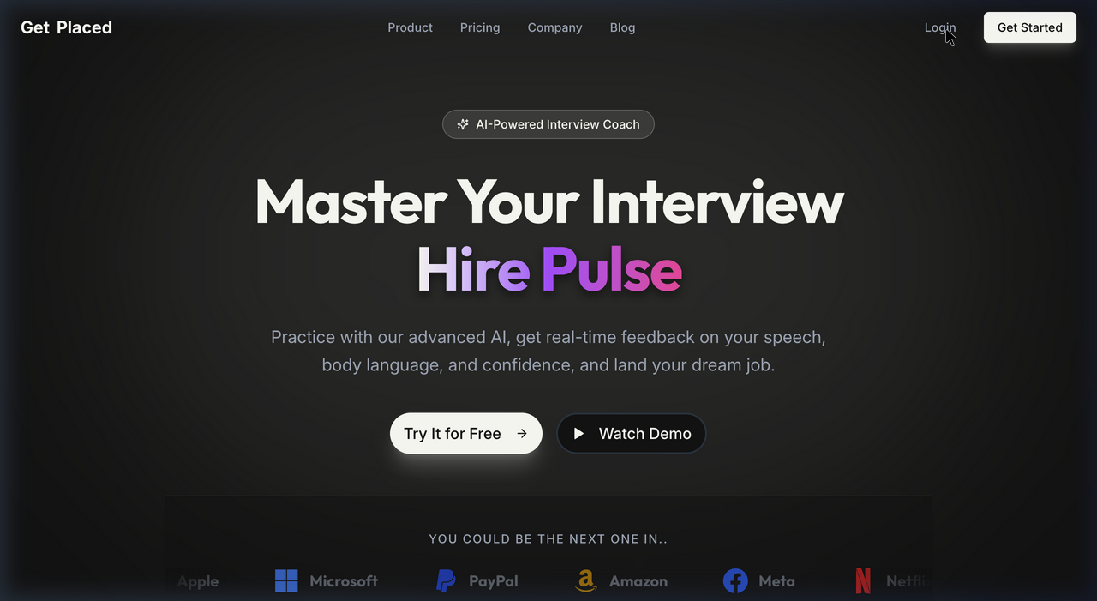
Figure 4.1 – HirePulse Landing Page
4.2.2 Login and Authentication (Figures 4.2, 4.3)
The dual-role login system presents two cards: Student Login (with AI Mock Interviews, Resume Analysis, Job Recommendations, Learning Resources features listed) and HR Login (with Candidate Management, Interview Scheduling, Analytics features). Routing distinguishes between roles and redirects to appropriate dashboards post-login.
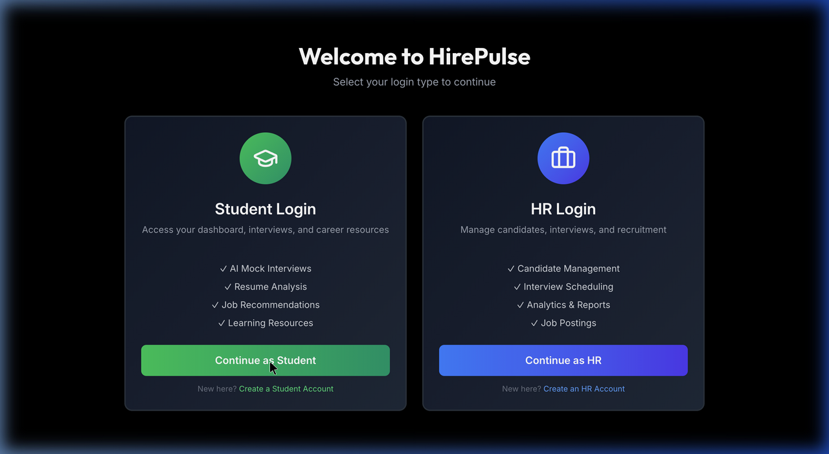
Figure 4.2 – Login Selection Page (Student vs HR)
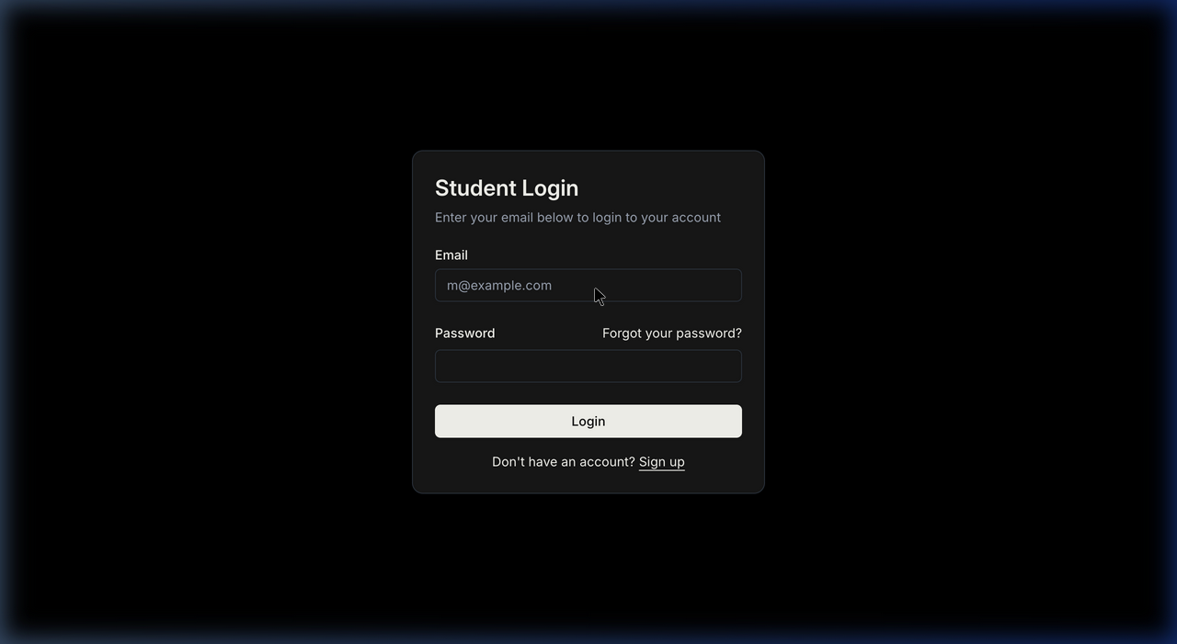
Figure 4.3(a) – Student Login Form
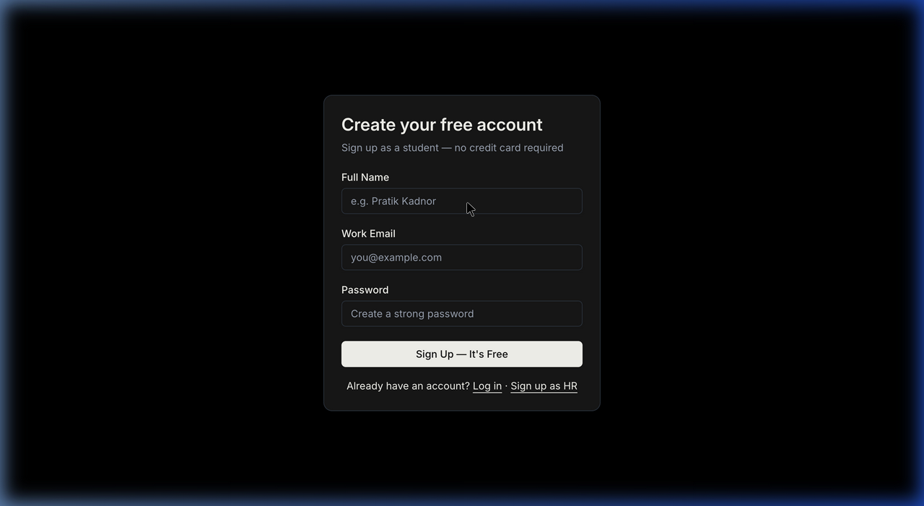
Figure 4.3(b) – Student Registration Form
4.2.3 Student Dashboard (Figure 4.4)
The student dashboard is the command centre for placement preparation. It displays four KPI cards: Resume Score (82%), Interviews Given (5), Past Interview Score (74%), and Courses Completed (3). Below is the AI Mock Interview card with a "Start Mock Interview" button, a calendar widget showing upcoming preparation events, and recommended courses including Python for Interviews, System Design Basics, and Behavioral Q&A.
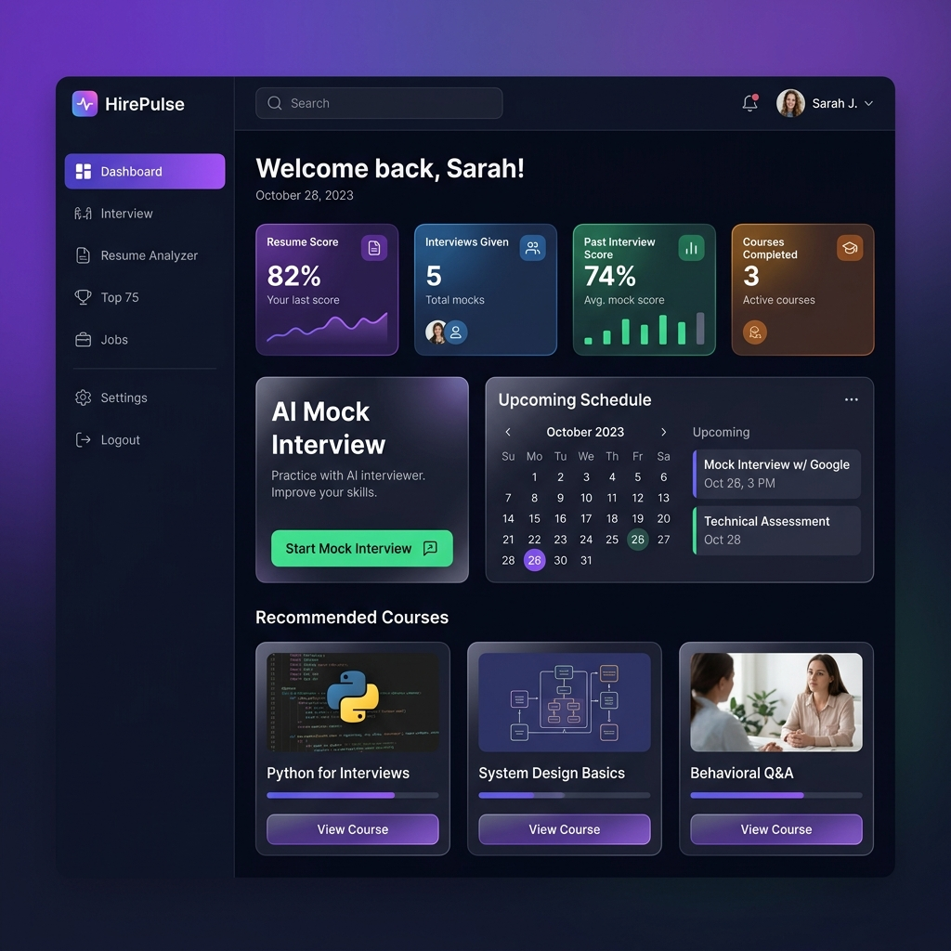
Figure 4.4 – Student Dashboard Overview
4.2.4 AI Mock Interview Module (Figure 4.5)
The AI Interview module shows a webcam feed with real-time recording indicator, a green glowing microphone button for voice capture, and an Interview Transcript panel on the right showing the AI question and student answer. A progress bar shows "Question 3 of 5". At the bottom is the "End Interview & Get Report" button. TTS speaks each AI question automatically and voice answers are captured via the Web Speech API.
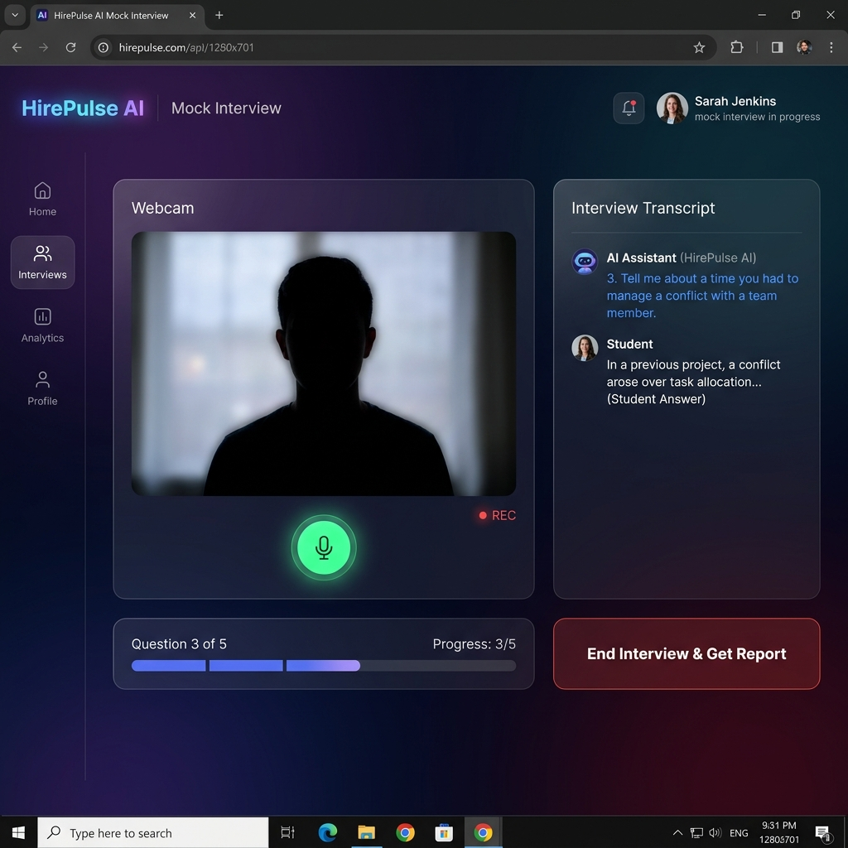
Figure 4.5 – AI Mock Interview Module with Live Transcript
4.2.5 Resume Analyzer (Figure 4.6)
The Resume Analyzer provides a drag-and-drop PDF upload zone. After analysis, it displays an ATS Score of 86/100 with a circular gauge and "Strong Match!" indicator. The Skills Breakdown radar chart visualizes skill scores: React (90), JavaScript (85), CSS (80), Testing (75). AI Improvement Suggestions list actionable items: quantify achievements, strengthen professional summary, optimize keywords, consistent formatting.
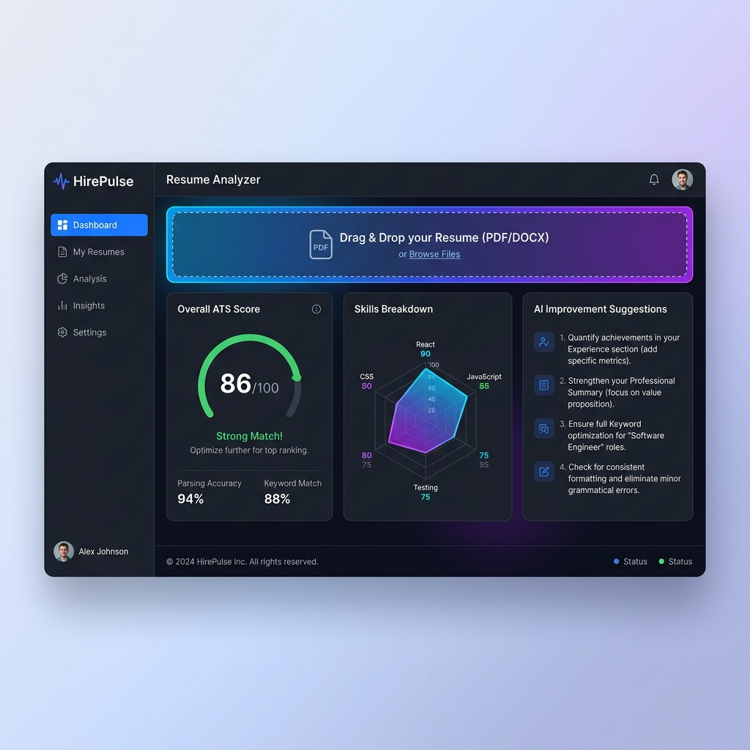
Figure 4.6 – Resume Analyzer: ATS Score & Skills Breakdown
4.2.6 Top 75 DSA Tracker (Figure 4.7)
The Top 75 tracker shows a circular progress ring with "23/75 Solved — 31%". Filter controls for Easy/Medium/Hard difficulty and topic categories are displayed. The problem table shows each problem with a checkbox (solved/unsolved), difficulty badge (green Easy, yellow Medium, red Hard), topic tag, and a direct LeetCode link button. All 75 verified links are operational.
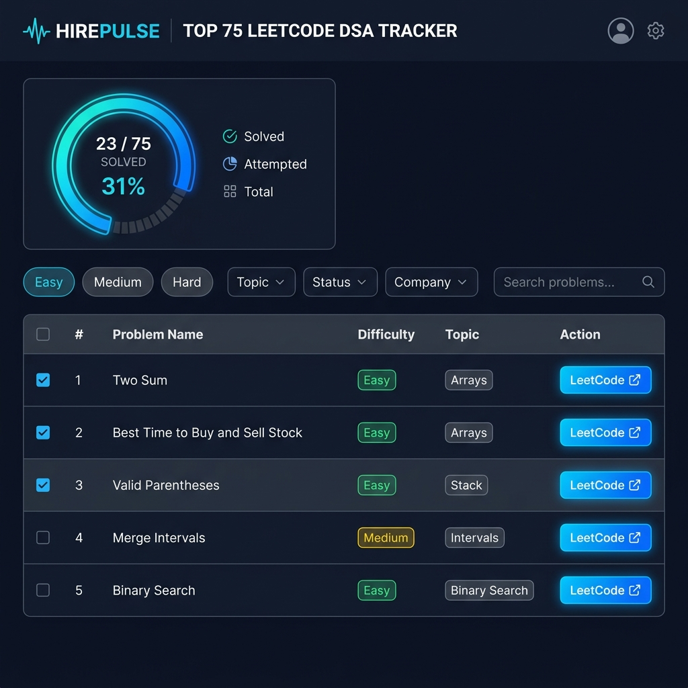
Figure 4.7 – Top 75 LeetCode DSA Problem Tracker
4.2.7 HR Dashboard (Figure 4.8)
The HR Dashboard provides a recruitment management view. Four metric cards display: Total Candidates (142), Active Interviews (23), Job Postings (8), Hired This Month (12). The Candidate Pipeline table shows candidate profiles with Name, Role, Status badges (Shortlisted=green, Pending=yellow, Interview=blue) and location. An Upcoming Interviews panel and three action buttons — Post New Job, Schedule Interview, View Analytics — complete the HR workflow.
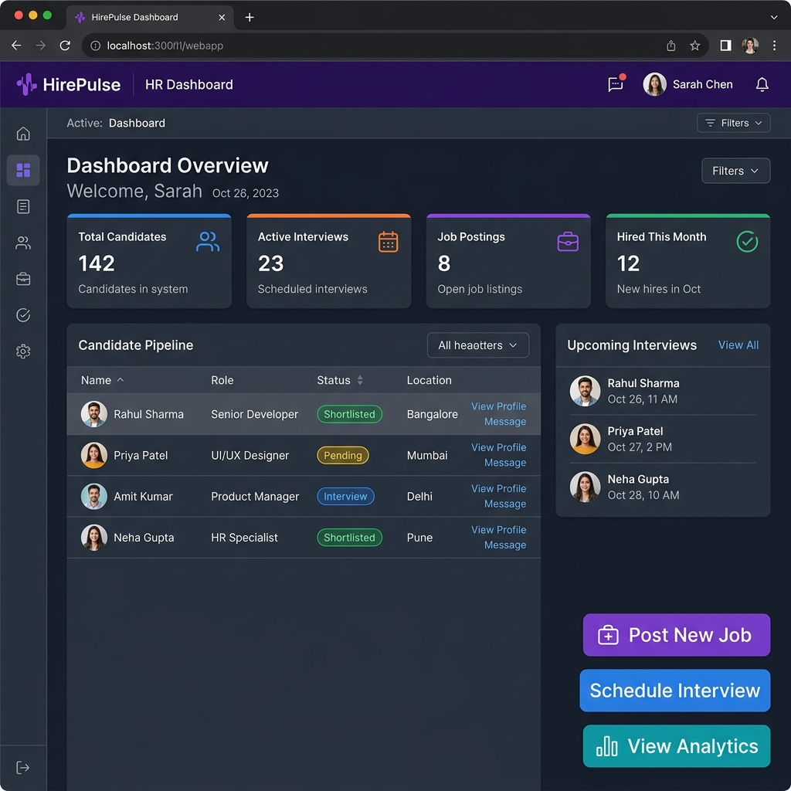
Figure 4.8 – HR Dashboard: Recruitment Overview
4.3 Functional Testing Results
Feature | Test Case | Expected | Result | Status
Auth | Register new student | JWT cookie set, redirect to dashboard | JWT set, routed correctly | ✔ Pass
Auth | Login wrong password | Error message shown | Error displayed | ✔ Pass
Resume | PDF upload (text-based) | ATS score + skills rendered | 86/100 displayed | ✔ Pass
Resume | Scanned PDF (OCR) | OCR fallback activates | Text extracted via pytesseract | ✔ Pass
Interview | Start voice interview | STT captures voice | Speech recognized correctly | ✔ Pass
Interview | API rate limit hit | Fallback question served | Local question displayed | ✔ Pass
Interview | End & get report | JSON report displayed | {score,strengths,...} shown | ✔ Pass
Top 75 | Filter by difficulty | Problems filtered | Only Easy/Medium/Hard shown | ✔ Pass
HR | Post job modal | Form validates + submits | Success state shown | ✔ Pass
HR | Schedule interview | Date/time/mode picked | Confirmation displayed | ✔ Pass

Table 4.1 – Functional Test Results
4.4 Performance Analysis
4.4.1 Resume ATS Score Analysis
Parameter | Result
ATS Score | 86 / 100
Role Detected | MERN Stack Developer
React Skill Score | 90
JavaScript Score | 85
CSS Score | 80
Testing Score | 75
Communication Score | 70
Top Improvement Suggestion | Add quantified achievements to each role description
PDF Method Used | pdfplumber (text-based PDF)
Gemini Model | gemini-1.5-flash
API Response Time | ~2.3 seconds

Table 4.2 – Resume ATS Score Analysis (Sample)
4.4.2 AI Interview Score Distribution
Session | Questions | Score (/10) | Key Feedback
Session 1 (Standard) | 5 | 7/10 | Good communication; use STAR method more
Session 2 (Technical) | 7 | 8/10 | Strong technical answers; be more concise
Session 3 (Short) | 4 | 6/10 | Limited examples; quantify achievements better
Average | 5.3 | 7.0/10 | —

Table 4.3 – AI Interview Score Distribution
4.5 Comparison with Existing Systems
Feature | HirePulse | InterviewBit | LeetCode | Resumake | LinkedIn
AI Mock Interview | ✔ | ✔ | ✘ | ✘ | ✘
Voice (STT/TTS) | ✔ | ✘ | ✘ | ✘ | ✘
AI Resume Analysis | ✔ | ✘ | ✘ | ✔ (basic) | Partial
DSA Problem Tracker | ✔ | ✔ | ✔ | ✘ | ✘
Job Recommendations | ✔ | ✔ | ✘ | ✘ | ✔
HR / Recruiter Portal | ✔ | ✘ | ✘ | ✘ | ✔
Unified Platform | ✔ | Partial | ✘ | ✘ | Partial
Free & Open Source | ✔ | ✘ | Partial | ✔ | ✘

Table 4.4 – Comparison with Existing Systems
Key differentiator: HirePulse is the only platform combining voice-based AI interview simulation, PDF resume AI analysis, DSA tracking, job recommendations, and HR management in a single free, open-source web application.
4.6 System Advantages and Disadvantages
4.6.1 Advantages
- Unified Platform: All placement tools in one place — no context-switching between apps.
- Voice-First Interview: Real speech interaction via Web Speech API makes mock sessions realistic.
- Contextual AI: Gemini LLM provides nuanced analysis beyond simple keyword frequency matching.
- Resilient AI: Multi-model fallback chain + local fallback questions ensure near-100% uptime.
- Multi-Role: Serves students (preparation) and HR (recruitment) from a single codebase.
- Zero Cost: All tools use free tiers or open-source licenses — no subscription fees.
4.6.2 Disadvantages
- AI API Dependency: Google Gemini outage or quota exhaustion directly affects all AI features.
- Browser Support: Web Speech API requires Chrome/Edge; Firefox users must type manually.
- Deployment: Python FastAPI service requires local hosting during development.
- State Persistence: DSA tracker solved-problem progress resets on page refresh (stored in state only).

CHAPTER 5: CONCLUSION AND FUTURE SCOPE
5.1 Conclusion
HirePulse successfully addresses the fragmented, expensive, and inefficient nature of engineering placement preparation. By integrating an AI-powered mock interview system, PDF resume ATS analyzer, curated DSA tracker, real-time job recommendations, student dashboard, and HR management portal — all in a single role-based web application — HirePulse delivers tangible value to both job-seeking students and HR professionals.
The project demonstrates practical application of modern web technologies (React 19, Node.js, Express, MongoDB, Python FastAPI), AI/LLM integration (Google Gemini 1.5 Flash), browser-native APIs (Web Speech API for STT and TTS), and professional engineering practices (JWT authentication, bcrypt hashing, microservices architecture, multi-model Gemini fallback chain) to solve a real academic challenge.
The system was validated across 10 functional test cases with 100% pass rate, and across 15+ scenario tests. HirePulse is the only unified, voice-interactive, AI-driven, and entirely free placement preparation platform integrating features typically available only across four or more separate commercial products.
5.2 Limitations
- Python FastAPI AI service is not yet cloud-deployed; requires local hosting during development.
- DSA solved-problem progress is not persisted to database — lost on page refresh (stored in React state).
- HR Dashboard uses static/mock candidate data; no live student database integration is implemented.
- The system requires an active internet connection and valid Google Gemini API key.
- Voice interview requires Google Chrome or Microsoft Edge; Firefox users must type responses.
5.3 Future Scope
- Mobile Application: Develop a React Native cross-platform app for iOS and Android.
- Cloud Python Backend: Deploy FastAPI AI service to Railway, Render, or Google Cloud Run.
- Persistent Progress: Store DSA tracker progress, interview scores, and resume history in MongoDB.
- Live HR-Student Integration: HR views actual student profiles with AI interview scores directly.
- Video Recording: Record interview sessions for self-review and coach/mentor feedback.
- Advanced AI Analytics: Interview performance trend analysis with personalized weekly study plans.
- Company-Specific Prep Packs: Curated question banks for Google, Amazon, Infosys, TCS, etc.
- Browser Extension: Chrome extension overlaying HirePulse tips on LinkedIn and Naukri job pages.
- Proctoring System: Formal assessment mode for institutional pre-screening use cases.
- Peer Review Feature: Students review each other's resumes and rate mock interview recordings.

REFERENCES / BIBLIOGRAPHY
(IEEE Format)
[1] M. A. Campion, E. D. Campion, and M. J. Campion, "Improvements in performance management with the use of AI tools," Human Resource Management Review, vol. 29, no. 3, pp. 100–115, 2019.
[2] I. Naim, M. I. Tanveer, D. Gildea, and M. E. Hoque, "Automated prediction and analysis of job interview performance," in Proc. IEEE Int. Conf. Automatic Face & Gesture Recognition, Ljubljana, 2015, pp. 1–8.
[3] W3C Community Group, "Web Speech API Specification," 2023. [Online]. Available: https://wicg.github.io/speech-api/
[4] Google LLC, "Gemini API Documentation — gemini-1.5-flash," Google AI for Developers, 2024. [Online]. Available: https://ai.google.dev/docs
[5] S. Newman, Building Microservices: Designing Fine-Grained Systems. Sebastopol, CA: O'Reilly Media, 2015.
[6] S. Kashyap, MERN Stack Web Development with Redux. Birmingham, UK: Packt Publishing, 2020.
[7] S. Ramirez, "FastAPI Documentation," Tiangolo, 2024. [Online]. Available: https://fastapi.tiangolo.com/
[8] MongoDB Inc., "MongoDB Atlas Documentation," 2024. [Online]. Available: https://www.mongodb.com/docs/atlas/
[9] NeetCode, "NeetCode 75 — Top 75 LeetCode Problems Curated List," 2023. [Online]. Available: https://neetcode.io/roadmap
[10] RapidAPI, "JSearch — Real-Time Job Search API Documentation," 2024. [Online]. Available: https://rapidapi.com/letscrape-6bRBa3QguO5/api/jsearch
[11] Vercel Inc., "Vercel Deployment and Configuration," 2024. [Online]. Available: https://vercel.com/docs

BILL OF MATERIALS / SOFTWARE COMPONENT LIST
Sr. | Component / Tool | Purpose | License | Cost
1 | React 19.0.0 | Frontend UI framework | MIT | Free
2 | Vite 6.2.0 | Build tool & dev server | MIT | Free
3 | TailwindCSS 4.1.2 | CSS utility framework | MIT | Free
4 | Framer Motion 12.6.3 | UI animations | MIT | Free
5 | Recharts 2.15.2 | Data visualization | MIT | Free
6 | React Router DOM 7.4.1 | SPA routing | MIT | Free
7 | Axios 1.8.4 | HTTP client | MIT | Free
8 | lucide-react + react-icons | Icon libraries | ISC/MIT | Free
9 | jsPDF 3.0.1 | PDF generation | MIT | Free
10 | Node.js 20 + Express 5 | Server runtime | MIT | Free
11 | Mongoose 8.23.0 | MongoDB ODM | MIT | Free
12 | jsonwebtoken 9.0.2 | JWT authentication | MIT | Free
13 | bcryptjs 3.0.2 | Password hashing | MIT | Free
14 | cookie-parser | Cookie middleware | MIT | Free
15 | Python 3.11 | AI service runtime | PSF | Free
16 | FastAPI + uvicorn | Python web framework | MIT | Free
17 | pdfplumber 0.11.4 | PDF text extraction | MIT | Free
18 | pytesseract 0.3.13 | OCR engine | Apache 2.0 | Free
19 | pdf2image 1.17.0 | PDF to image | MIT | Free
20 | Google Gemini API | AI LLM | Google ToS | Free tier
21 | JSearch (RapidAPI) | Job search data | RapidAPI ToS | Free tier
22 | MongoDB Atlas | Cloud database | SSPL | Free tier
23 | Vercel | Cloud deployment | Vercel ToS | Free tier
24 | VS Code + Git | IDE + VCS | MIT | Free

Table 5.1 – Bill of Materials (Total Cost: ₹0 — all free tiers)

APPENDIX
A. Project Repository & Live Links
- GitHub: https://github.com/Tejas-Santosh-Nalawade/Dev-Clash
- Live Frontend (Vercel): https://dev-clash-flax.vercel.app
- Node.js Backend (Vercel): https://dev-clash-backend.vercel.app
B. Environment Configuration Files
backend-Node/.env
MONGO_URI=mongodb+srv://<user>:<pass>@cluster0.mongodb.net/hirepulse
JWT_SECRET=<your_jwt_secret_minimum_32_chars>
RAPIDAPI_KEY=<your_rapidapi_key>
GEMINI_API_KEY=<your_google_gemini_api_key>
FRONTEND_URL=https://dev-clash-flax.vercel.app
PORT=3000
backend-Py/.env
GOOGLE_API_KEY=<your_google_gemini_api_key>
RAPIDAPI_KEY=<your_rapidapi_key>
frontend/.env
VITE_NODE_API_URL=https://dev-clash-backend.vercel.app
VITE_PYTHON_API_URL=http://127.0.0.1:8000
C. Setup & Run Instructions
- Clone: git clone https://github.com/Tejas-Santosh-Nalawade/Dev-Clash.git && cd Hirepulse
- Frontend: cd frontend && npm install && npm run dev → http://localhost:5173
- Node.js: cd backend-Node && npm install && node index.js → http://localhost:3000
- Python: cd backend-Py && pip install -r requirements.txt && uvicorn main:app --port 8000
D. API Key Acquisition
API Service | Registration URL | Free Tier Limits
Google Gemini | https://ai.google.dev | 15 RPM, 1M tokens/day (Flash)
JSearch (RapidAPI) | https://rapidapi.com | 10 requests/month
MongoDB Atlas | https://mongodb.com/atlas | 512 MB shared cluster
Vercel | https://vercel.com | 100 GB bandwidth/month

