ANNASAHEB DANGE COLLEGE OF ENGINEERING AND TECHNOLOGY
(An Empowered Autonomous Institute)

Micro Project
ON
“Canteen Food Demand & Waste Analysis Using R”
Under The Course
Data Science Using R (1ADPC306)
Academic Year – 2026 – 2027
Under the Guidance
Prof. Priyanka P. Suryawanshi
Submitted By
Name | Roll_No
Pratik Bikkad | 3027
CERTIFICATE
This is to certify that Pratik Bikkad, Roll No. 3027, a student of Fifth Semester of Degree in B.Tech – Artificial Intelligence & Data Science of Institute Annasaheb Dange College of Engineering & Technology, Ashta has successfully completed the Micro Project work entitled “Canteen Food Demand & Waste Analysis Using R” in the subject “Data Science using R” 1ADPC306 for the academic year 2026 to 2027 as prescribed in the curriculum.
Place: Ashta
Date: ___________
Subject Teacher
(Signature)
ACKNOWLEDGEMENT
I would like to express my sincere gratitude to my guide Prof. Priyanka P. Suryawanshi for the valuable guidance and constant support throughout this micro project on “Canteen Food Demand & Waste Analysis Using R”. I am also thankful to Dr. Asma Shaikh, Head of the Department for providing the computer laboratory and software facilities required to complete this work. Finally, I thank all the teaching and non-teaching staff, my family and my friends who helped me directly or indirectly in completing this project.
Pratik Bikkad
Roll No. 3027
INDEX
Sr. No. | Title | Page No.
1 | Aims / Benefits of the Micro Project | 1
2 | Course Outcomes Achieved | 1
3 | Literature Review | 2
4 | Actual Methodology Followed | 3
5 | Actual Resources Used | 5
6 | Outputs of the Micro Project | 5
7 | Skills Developed | 17
8 | Applications of the Micro Project | 17
9 | Conclusion | 17
10 | References | 17

MICRO PROJECT REPORT
Canteen Food Demand & Waste Analysis Using R

1. Aim and Benefits
Aim: To analyse the daily preparation, sales and waste records of a canteen using R in order to find out how much food is prepared, how much is sold and how much is wasted, which food items and which days of the week waste the most, and how preparation could be matched better to demand, and to present the results in an interactive R Shiny dashboard. The project follows the complete exploratory workflow: data import, validation, summary statistics, visualisation, simple statistical checks and dashboard development. It is a descriptive project with a simple what-if estimate; it is not a forecasting model and it does not prove the causes of waste. The central question is whether waste is spread evenly or concentrated in particular items and days; the analysis shows that it is concentrated mainly on weekends.
Benefits:
- Gives hands-on practice with a real-life style business problem (food demand and waste) instead of a purely academic table.
- Shows how to validate data in R (missing values, duplicates, and consistency checks such as Prepared = Sold + Waste and Revenue = Sold × Price) and to record the results of each check.
- Shows how waste can be measured in three ways – units, percentage of preparation and value in rupees – and why each view highlights a different item.
- Turns a small table of 42 records into ten charts and an interactive dashboard with filters, summary cards, automatically calculated insights and a what-if planner.
- Introduces simple statistical checks (Pearson correlation, Kruskal–Wallis and Wilcoxon signed-rank tests) suitable for small samples.
- Uses free tools only (R, RStudio and Shiny), so the work can be repeated at no cost.
- Reports only recorded results and states clearly what was not done; no values are assumed or invented.

2. Course Outcomes Achieved
CO | Outcome (general wording) | Where achieved in the project
CO1 | Understand the fundamental concepts of data science and the R programming environment. | Importing the CSV with readr, inspecting its structure (42 rows × 8 columns), data types and categories, and understanding the data science workflow from collection to communication.
CO2 | Apply R packages and tools for data cleaning, transformation and analysis. | Using readr, dplyr and tidyr to validate the data and to create waste percentage, sell-through, waste value and weekday/weekend fields.
CO3 | Perform exploratory data analysis and statistical summaries. | Calculating totals, percentages and group summaries by item and day, and applying correlation, Kruskal–Wallis and Wilcoxon signed-rank tests.
CO4 | Visualise data using appropriate charts and interactive tools. | Creating ten ggplot2 charts and building an interactive Shiny dashboard with plotly charts, filters, summary cards and a what-if planner.
CO5 | Interpret results and communicate findings for real-world problems. | Writing evidence-based findings, data-quality observations, limitations and practical recommendations for reducing canteen food waste.

3. Literature Review

Food waste in food service
The United Nations Environment Programme estimated that about 931 million tonnes of food were wasted in 2019, equal to roughly 17% of the food available to consumers, and that food service (restaurants, canteens and catering) accounted for about 26% of this waste [1]. Earlier work by the Food and Agriculture Organization had already shown that about one-third of the food produced for human consumption is lost or wasted along the supply chain [2]. Canteens are therefore a small but real part of a much larger problem, and measuring waste at the level of a single kitchen is the first step towards reducing it.

Demand and production planning for perishable items
Items such as samosas, sandwiches, tea and coffee cannot be stored for the next day, so every day the canteen must decide how much to prepare. Inventory theory describes this as a balance between two costs: preparing too much creates waste, while preparing too little causes lost sales; the classic “newsvendor” model chooses the quantity that balances these two costs using the pattern of demand [3]. Even without a full model, comparing quantities prepared with quantities sold, item by item and day by day, shows where the balance is wrong. This project uses that idea in a descriptive way.

Exploratory data analysis and tidy data
Tukey introduced exploratory data analysis as the practice of looking at data through summaries and graphs before drawing formal conclusions [4]. Wickham’s tidy-data principles, in which each variable is a column and each observation is a row, make such analysis easier in R [5]. Wickham and Grolemund describe the usual R workflow of importing, tidying, transforming, visualising and communicating data, which this project follows [6].

Visualisation and dashboards in R
The ggplot2 package builds charts layer by layer from a grammar of graphics and is the standard R tool for static charts [7]. The plotly package converts such charts into interactive versions with tooltips, which can be embedded in Shiny applications [8]. Shiny allows an R analysis to be delivered as an interactive web application whose outputs update when the user changes an input [9]. Few defines a dashboard as the most important information consolidated on a single screen so that it can be monitored at a glance, which guided the summary cards and filters used here [10].

Statistical checks for small samples
With only 42 records, tests that do not assume a normal distribution are safer. The Wilcoxon signed-rank test compares paired measurements, here the waste percentage of the same item on weekdays and on weekends [11]. The Kruskal–Wallis test compares several groups, here the waste percentage of the six items and of the seven days [12]. Pearson’s correlation measures the strength of a linear relationship between two quantities. A statistically significant result shows association only, not cause.

Gap addressed
The motivation is practical and methodological rather than a claim of new findings: to show a complete, reproducible R workflow that validates a canteen sales file, measures waste in several ways, tests whether the visible differences are meaningful and turns the result into an interactive tool that a canteen manager could use. The literature supports the chosen tools and ideas; it does not establish that the findings of this particular small file describe every canteen.

4. Actual Methodology Followed
Phase 1 – Data collection and inspection. The dataset is the file canteen_food_demand_waste_dataset.csv supplied for this project. It contains one row for each food item on each day. The file does not state which canteen it comes from or how the figures were collected.
Item | Finding from the CSV
Records and columns | 42 rows × 8 columns
Period | 01 Sep 2026 to 14 Sep 2026 (14 days, 3 items recorded each day)
Food items | 6: Samosa, Vada Pav, Sandwich (recorded 01–07 Sep) and Tea, Coffee, Poha (recorded 08–14 Sep); 7 records per item
Totals | 4,480 units prepared; 3,527 sold; 953 wasted; revenue ₹66,975
Missing values | None
Duplicate rows | 0
Prices | One fixed price per item: Tea ₹10, Samosa ₹15, Coffee ₹15, Vada Pav ₹20, Poha ₹25, Sandwich ₹40

The eight original variables and the variables derived in R are listed below (the grouping is a project design choice):
Group | Count | Variables
Time | 2 | Date, Day
Item | 2 | Food_Item, Price_Per_Item_INR
Quantities | 3 | Quantity_Prepared, Quantity_Sold, Waste_Quantity
Money | 1 | Sales_Revenue_INR
Derived in R | 5 | Waste_Pct (waste ÷ prepared), Sell_Through (sold ÷ prepared), Waste_Value (waste × price), Day_Type (weekday / weekend), ordered Day factor

Phase 2 – Data cleaning and validation (R). The following checks were run before any analysis and every result was recorded:
Check | Result | Action taken
Exact duplicate rows | 0 | None found; nothing removed
Missing values | 0 | None to treat
Prepared = Sold + Waste | 0 mismatches in 42 rows | Quantities are internally consistent
Revenue = Sold × Price | 0 mismatches in 42 rows | Revenue is consistent with price
Price per item | Constant for every item | No price changes during the period
Sell-outs (Sold = Prepared) | 0 records | Every record has some waste (minimum 2 units)
Day label vs calendar date | 42 of 42 differ | Day column used as recorded; reported in Section 6.6
Records before / after cleaning | 42 / 42 | No rows dropped

Phase 3 – Exploratory data analysis. Totals, waste percentages (waste ÷ prepared), sell-through (sold ÷ prepared), revenue and the value of wasted units (waste × selling price) were calculated for every item, every day of the week and for weekdays against weekends. Pearson’s correlation was used for prepared against sold quantities, the Kruskal–Wallis test for differences in waste percentage between items and between days, and an exact Wilcoxon signed-rank test for the paired weekday/weekend waste percentages of the six items.
Phase 4 – Visualisation (ggplot2). Ten charts were produced from the fields in the file:
Figure | Visualisation | Chart type | Fields used
1 | Daily prepared, sold and wasted units | Line chart | Date, quantities
2 | Prepared vs sold by item | Grouped bar chart | Food_Item, quantities
3 | Revenue by item | Horizontal bar chart | Food_Item, revenue
4 | Waste percentage by item | Bar chart | Food_Item, Waste_Pct
5 | Sold and wasted units by day | Stacked bar chart | Day, quantities
6 | Waste percentage, item × day | Heatmap | Food_Item, Day, Waste_Pct
7 | Weekday vs weekend waste by item | Grouped bar chart | Day_Type, Food_Item
8 | Prepared vs sold | Scatter plot | Prepared, Sold, Waste
9 | Sell-through distribution by item | Box plot | Food_Item, Sell_Through
10 | Value of wasted units by item | Horizontal bar chart | Food_Item, Waste_Value

Phase 5 – What-if analysis. To test an alternative preparation policy, the average quantity sold for each item on weekdays and on weekends was calculated. A planned preparation quantity was then set to this average plus a safety buffer (0%, 5%, 10%, 15% or 20%). For every record the planned quantity sold was taken as the smaller of the actual quantity sold and the planned preparation, so waste, sales that would have been lost and the resulting waste percentage could be compared with the actual figures.
Phase 6 – Dashboard (R Shiny). The data and charts were combined into a Shiny application (app.R) built with the bslib, plotly and DT packages. It provides filters (food item, day of week, date range), summary cards, interactive charts, a what-if planner, automatically calculated insights, a data table with CSV download and a reset button.
Phase 7 – Interpretation and documentation. The outputs were interpreted, data-quality observations and limitations were recorded, and this report was prepared.

5. Actual Resources Used
Category | Resource
Hardware | Laptop / desktop computer
Programming language | R (version 4.x)
Development environment | RStudio with a project folder containing app.R and the CSV file
Analysis packages | readr, dplyr, tidyr, ggplot2, scales
Dashboard packages | shiny, bslib, plotly, DT
Dashboard execution | Run locally with shiny::runApp(); not deployed to a public web server
Dataset | canteen_food_demand_waste_dataset.csv (42 records, 8 columns)
Documentation | Microsoft Word (this report)

6. Outputs of the Micro Project

6.1 Dataset summary
The cleaned dataset contains 42 records for 14 days (01–14 September 2026). The totals for each food item over its seven recorded days are shown below. Waste % is waste divided by quantity prepared; waste value is the number of wasted units multiplied by the selling price.
Item | Price (₹) | Prepared | Sold | Wasted | Waste % | Revenue (₹) | Waste value (₹)
Sandwich | 40 | 560 | 390 | 170 | 30.4% | 15,600 | 6,800
Coffee | 15 | 700 | 513 | 187 | 26.7% | 7,695 | 2,805
Poha | 25 | 630 | 491 | 139 | 22.1% | 12,275 | 3,475
Samosa | 15 | 700 | 555 | 145 | 20.7% | 8,325 | 2,175
Tea | 10 | 1,050 | 848 | 202 | 19.2% | 8,480 | 2,020
Vada Pav | 20 | 840 | 730 | 110 | 13.1% | 14,600 | 2,200
Total | – | 4,480 | 3,527 | 953 | 21.3% | 66,975 | 19,475

6.2 Visualisations
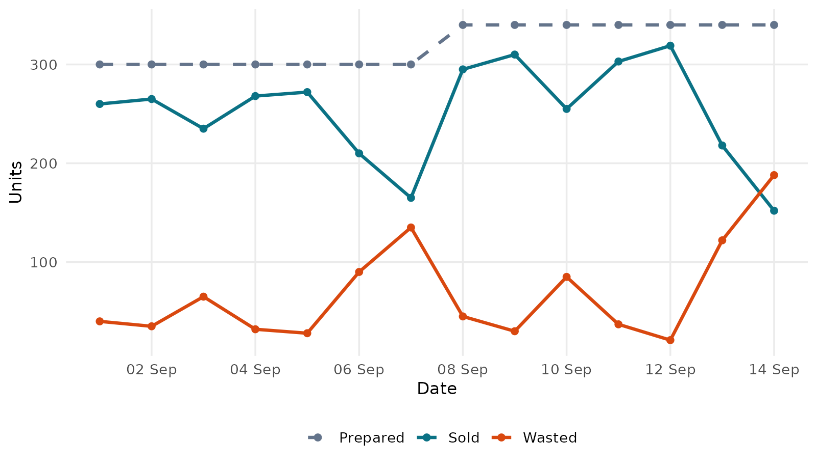
Figure 1: Daily prepared, sold and wasted units (01–14 Sep 2026)
The canteen prepared 300 units a day in the first week and 340 units a day in the second week. This step is caused by the different set of items recorded in each week (Section 6.6), not by a change in demand, so the chart should not be read as a trend. What it does show clearly is the weekly pattern: sold units fall on the sixth and seventh day of each week while the prepared quantity stays the same, so the gap, which is waste, widens (90 and 135 units in week 1; 122 and 188 units in week 2).
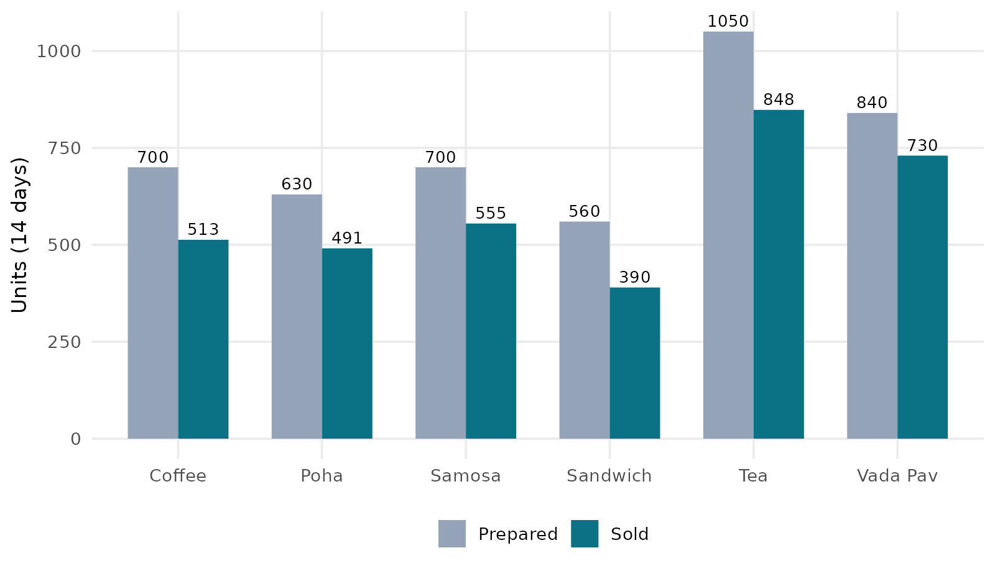
Figure 2: Quantity prepared and sold by item
Tea is prepared and sold in the largest quantities (1,050 prepared, 848 sold), followed by Vada Pav (840 and 730). Sandwich has the smallest volume (560 and 390). Every item is prepared in a larger quantity than it sells, and the gap is widest for Coffee (187 units) and Sandwich (170 units) relative to their size.
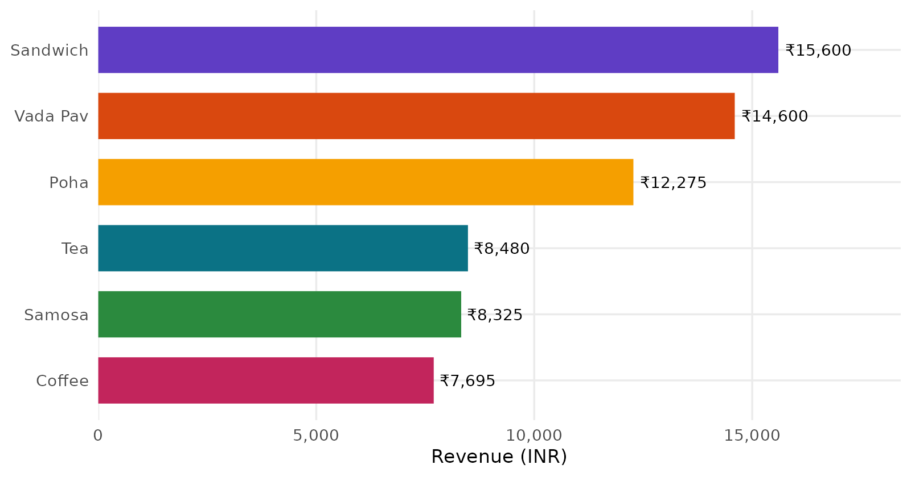
Figure 3: Revenue by item (₹)
Sandwich earns the highest revenue (₹15,600; 23.3% of the total) even though it sells the fewest units, because of its ₹40 price. Vada Pav is second (₹14,600; 21.8%) and Poha third (₹12,275; 18.3%). Tea sells the most units but earns only ₹8,480 (12.7%).
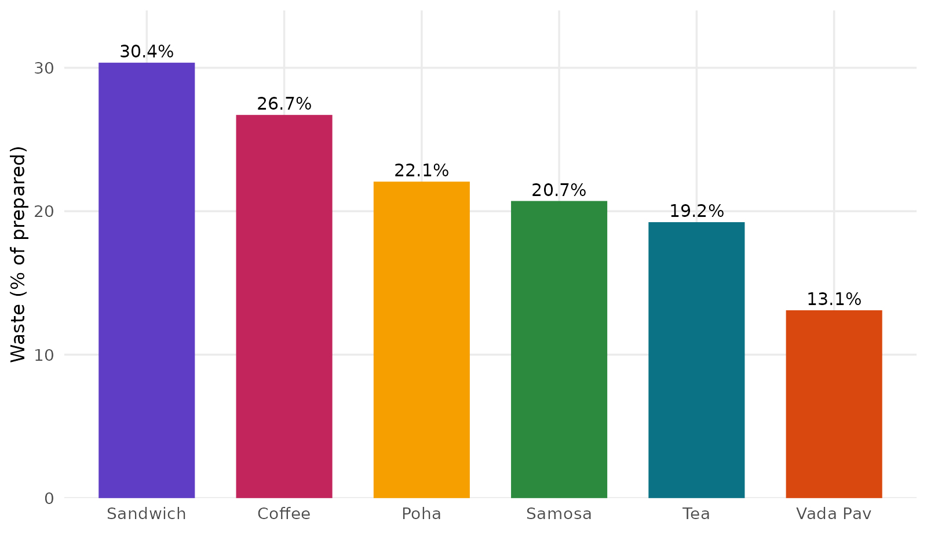
Figure 4: Waste as a percentage of quantity prepared
Sandwich has the highest waste rate (30.4%), followed by Coffee (26.7%), Poha (22.1%), Samosa (20.7%) and Tea (19.2%). Vada Pav has the lowest (13.1%) and is the best-managed item. The overall waste rate is 21.3%, so roughly one unit in every five prepared is not sold.
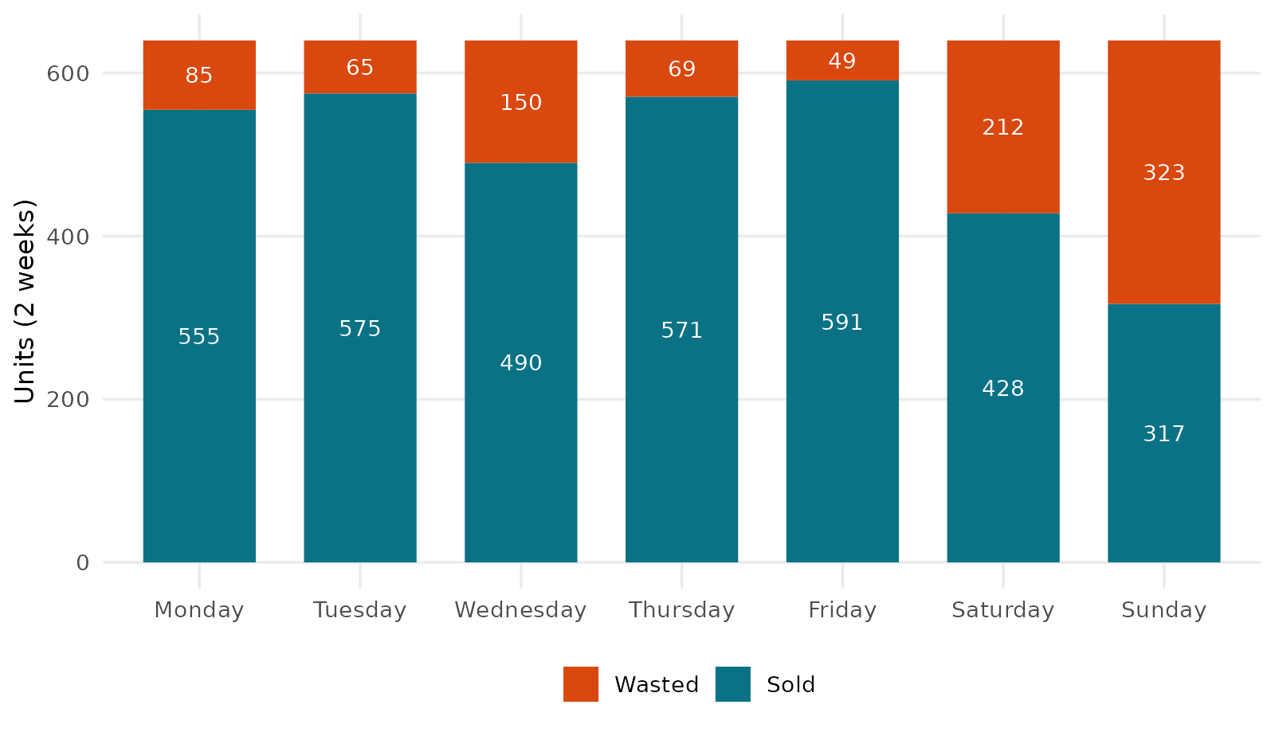
Figure 5: Sold and wasted units by day of the week (both weeks)
Each day of the week has 640 units prepared (two weeks combined), but sales are very different: 591 sold on Friday against only 317 on Sunday. Waste is lowest on Friday (49 units; 7.7%) and highest on Sunday (323 units; 50.5%), followed by Saturday (212 units; 33.1%) and Wednesday (150 units; 23.4%). On Sunday more food is wasted than sold.
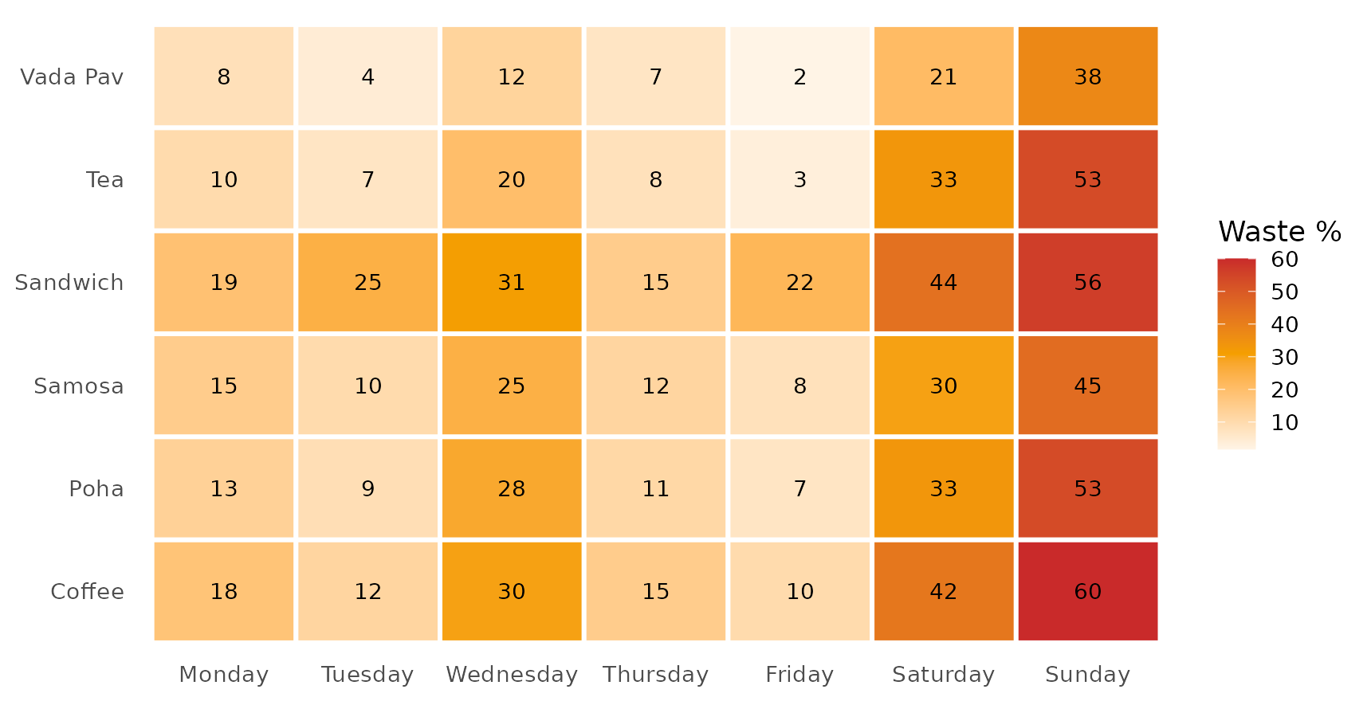
Figure 6: Waste percentage by item and day (heatmap)
The heatmap shows that the weekend problem is not limited to one item: every item has its darkest cells on Saturday and Sunday. Wednesday is also darker than the other weekdays for all six items (for example Coffee 30.0% and Poha 27.8%).
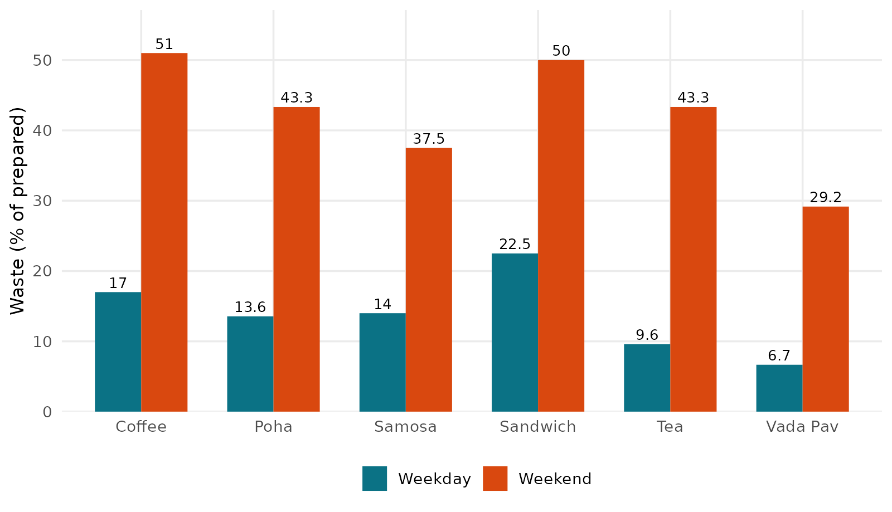
Figure 7: Waste percentage on weekdays and weekends by item
Waste percentage is higher on weekends for all six items. The increase ranges from about 22 percentage points (Vada Pav: 6.7% to 29.2%) to about 34 percentage points (Tea: 9.6% to 43.3%); on average the increase is 28.5 percentage points. Weekends make up 2 of 7 days and 28.6% of the units prepared, but 56.1% of the wasted units (535 of 953) and only 21.2% of the revenue.
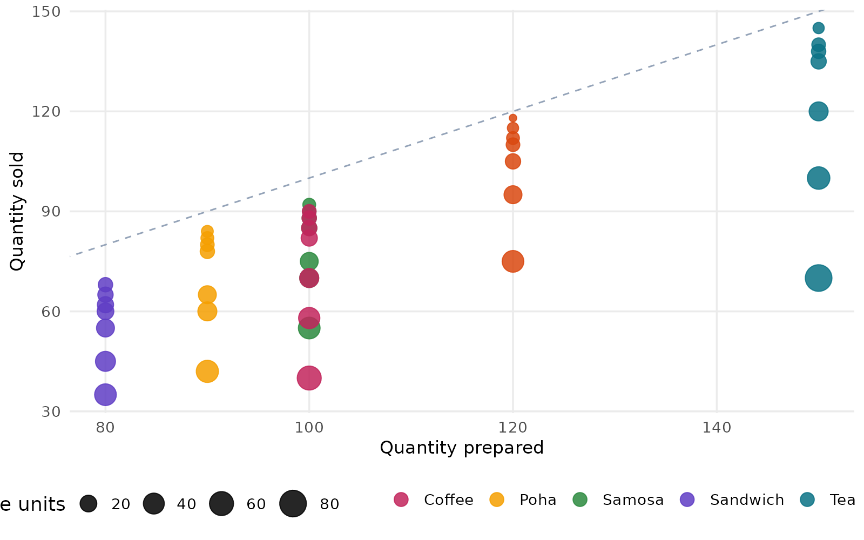
Figure 8: Quantity prepared against quantity sold
Every point lies below the dashed line (sold = prepared), confirming that no item sold out in any record. The points form vertical groups because each item is prepared in the same quantity every day, while sales vary widely; the larger points (more waste) are mostly the low-sales weekend records.
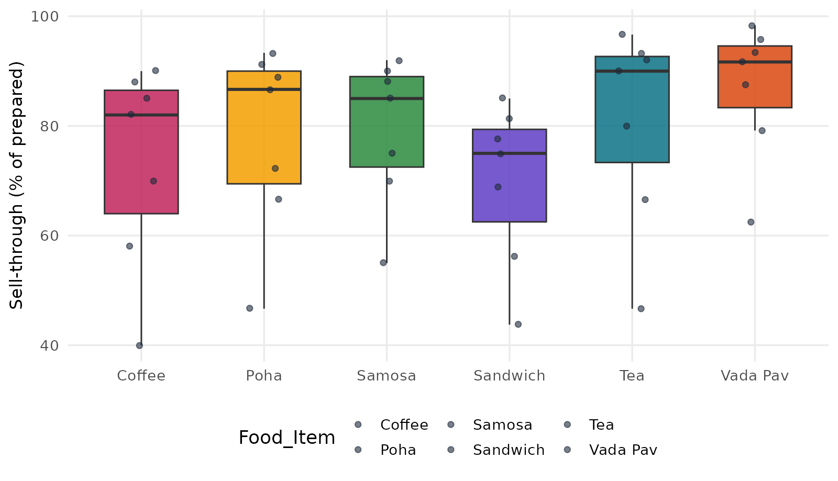
Figure 9: Sell-through rate (sold ÷ prepared) by item
Vada Pav has the highest median sell-through (91.7%) and the narrowest spread, so its preparation level matches demand best. Sandwich (75.0%) and Coffee (82.0%) have the lowest medians, and Coffee has the widest spread, meaning that a fixed daily quantity suits them least.
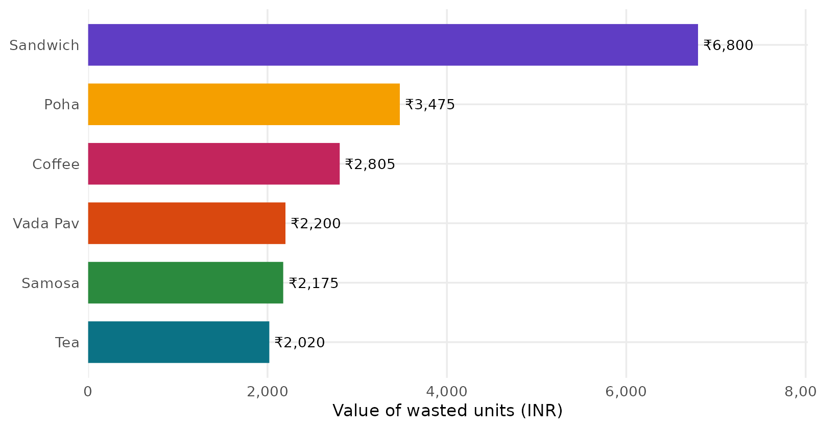
Figure 10: Value of wasted units by item (₹)
Valued at the selling price, 953 wasted units are worth ₹19,475, equal to 29.1% of the actual revenue. Sandwich alone accounts for ₹6,800 (34.9%) because of its high price, although Tea and Coffee waste more units. Reducing Sandwich waste is therefore the most valuable single action.

6.3 Statistical checks
Question | Test | Result | Interpretation
Do larger preparation quantities go with larger sales? | Pearson correlation (n = 42) | r = 0.79 (95% CI 0.64 to 0.88); p < 0.001; R² = 0.62 | Strong positive relationship, largely because bigger items such as Tea are prepared and sold in larger quantities
Does waste % differ between the six items? | Kruskal–Wallis | χ² = 7.32, df = 5, p = 0.198 | Not significant; the item differences could be chance with 7 records per item
Does waste % differ between the seven days? | Kruskal–Wallis | χ² = 31.37, df = 6, p < 0.001 | Significant; waste depends strongly on the day
Is waste % higher on weekends than on weekdays (same item)? | Wilcoxon signed-rank, exact, paired (n = 6 items) | V = 0, p = 0.031 | Significant; all six items have higher waste on weekends

The day of the week is the factor that is clearly linked to waste, while the differences between items are not statistically distinguishable in this small sample. The weekday/weekend test is the smallest possible p-value for six pairs (0.031), so its result is consistent but the sample is small. These tests show association, not cause.

6.4 What-if analysis: preparation planned from average demand
Preparation was recalculated as the average quantity sold for the same item and day type (weekday or weekend) plus a safety buffer. The table compares the results with the actual figures for all 42 records (actual: 4,480 prepared, 953 wasted, 21.3% waste).
Buffer | Units prepared | Units wasted | Waste % | Waste reduced | Sales lost (units) | Revenue at risk (₹)
0% | 3,531 | 130 | 3.7% | 823 (86.4%) | 126 | 2,395
5% | 3,728 | 244 | 6.5% | 709 (74.4%) | 43 | 815
10% | 3,904 | 393 | 10.1% | 560 (58.8%) | 16 | 270
15% | 4,070 | 547 | 13.4% | 406 (42.6%) | 4 | 60
20% | 4,251 | 724 | 17.0% | 229 (24.0%) | 0 | 0

A 10% buffer cuts waste from 953 to 393 units (58.8%) while putting only about ₹270 of revenue (0.4% of the total) at risk. The recommended daily quantities with a 10% buffer, compared with the quantities actually prepared, are shown below.
Item | Prepared now | Avg sold (weekday) | Plan: weekday | Avg sold (weekend) | Plan: weekend
Coffee | 100 | 83.0 | 92 | 49.0 | 54
Poha | 90 | 77.8 | 86 | 51.0 | 57
Samosa | 100 | 86.0 | 95 | 62.5 | 69
Sandwich | 80 | 62.0 | 69 | 40.0 | 44
Tea | 150 | 135.6 | 150 | 85.0 | 94
Vada Pav | 120 | 112.0 | 124 | 85.0 | 94

The averages come from the same 14 days that are used to evaluate the plan, so these results are an optimistic estimate of what the policy could achieve; they should be checked on new data. They also assume that the quantity sold equals demand, which is reasonable here because no item ever sold out.

6.5 Key findings
- Volume: 4,480 units were prepared, 3,527 sold (78.7% sell-through) and 953 wasted (21.3%). Revenue was ₹66,975 and the wasted units were worth ₹19,475 at selling prices.
- Items: Sandwich has the highest waste rate (30.4%) and the highest waste value (₹6,800); Vada Pav has the lowest waste rate (13.1%). Tea wastes the most units (202) but they are cheap (₹2,020).
- Days: Waste is lowest on Friday (7.7%) and highest on Sunday (50.5%); Saturday (33.1%) and Wednesday (23.4%) are also above the overall rate.
- Weekend effect: Average sales of each item are 24% to 41% lower on weekends (33% lower on average), but the same quantity is prepared every day. As a result the weekend waste rate is 41.8% against 13.1% on weekdays.
- Preparation policy: Each item is prepared in one fixed quantity (for example Samosa 100, Vada Pav 120, Sandwich 80, Tea 150, Coffee 100, Poha 90) regardless of the day, and no item sold out in any record.
- Potential improvement: Planning preparation from average demand by day type with a 10% buffer would cut waste by about 59% in this dataset.

6.6 Data-quality observations
- Small sample. There are only 42 records and each item is observed on seven days only, so all results describe this file and the seasonal or long-term behaviour of the canteen cannot be judged.
- Different items in the two weeks. Samosa, Vada Pav and Sandwich are recorded only from 01 to 07 September and Tea, Coffee and Poha only from 08 to 14 September. No item is observed in both weeks, so week-to-week changes cannot be separated from the effect of the item, and the step between the two weeks in Figure 1 is not a trend.
- Day names do not match the calendar. The Day column labels 01 September 2026 as Monday, but that date falls on a Tuesday; all 42 rows differ from the calendar weekday in the same way. The Day column was used as recorded. If the dates are correct and the labels are wrong, the weekday and weekend results would shift by one day and should be rechecked.
- Round preparation figures. Every preparation quantity is a multiple of five and each item has one fixed quantity, which suggests a fixed daily plan, but the file does not say how the numbers were recorded.
- No sell-outs. Because every record has leftover stock, the real demand above the quantity prepared was never observed.

6.7 Suggested actions for the canteen
- Prepare less on Saturday and Sunday: with average weekend sales 24% to 41% lower, weekend quantities should be set from weekend demand (for example Tea about 94 instead of 150).
- Start with Sandwich, the item with the highest waste rate and the highest waste value; consider a smaller batch or preparing in two rounds.
- Use the Vada Pav quantities as a benchmark for the other items, because they match demand best.
- Check Wednesday, which is above the weekday waste rate, for a possible cause such as a timetable or event pattern.
- Record at least a few weeks of data for every item, with correct day labels and a note when an item sells out, so that demand can be estimated more reliably.

6.8 Interactive dashboard
The results are presented through an interactive R Shiny dashboard (app.R). A filter panel on the left (food item, day of week and date range) controls every chart, card, table and insight on the right, and a reset button restores all filters. The dashboard has the following tabs:
Tab | Contents
Overview | Summary cards (total revenue, units sold, units prepared, waste %, waste value), daily trend of prepared, sold and wasted units, revenue share by item, prepared vs sold by item and revenue by day of week.
Waste Analysis | Waste % by item, sold and wasted units by day, item × day waste heatmap and waste value by item.
Demand Patterns | Prepared vs sold scatter plot, sell-through box plots and average units sold per day of week for each item.
What-If Planner | A slider for the safety buffer (0–30%) that recalculates waste, waste saved and revenue at risk, with a chart of current against planned waste and a table of recommended quantities.
Insights | Automatically written findings: highest waste rate, most expensive waste, weakest day, best-managed item, top revenue driver, best sales day and weekday versus weekend waste.
Data | Searchable, sortable table of the filtered records with a download button for the filtered CSV.

Charts show tooltips when the mouse is moved over them. Figures 11 to 16 show the six dashboard tabs.
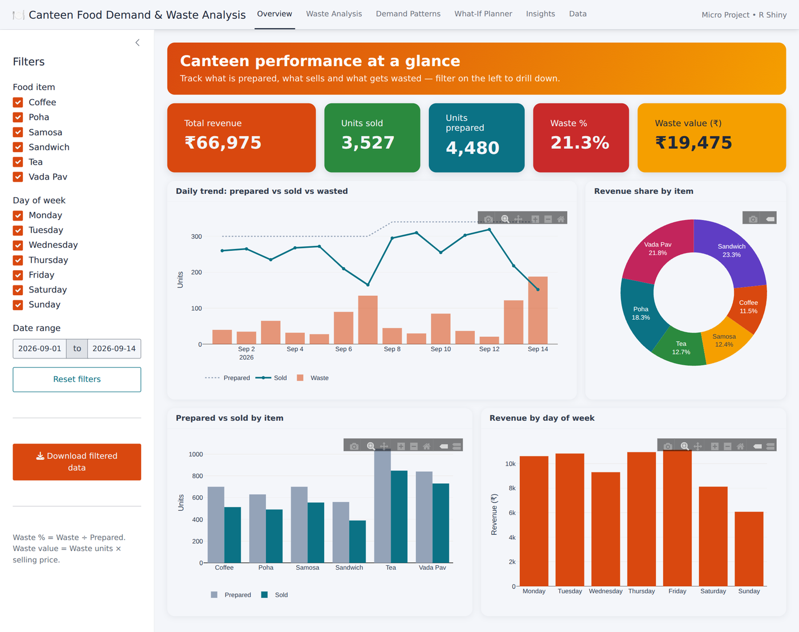
Figure 11: Dashboard – Overview tab
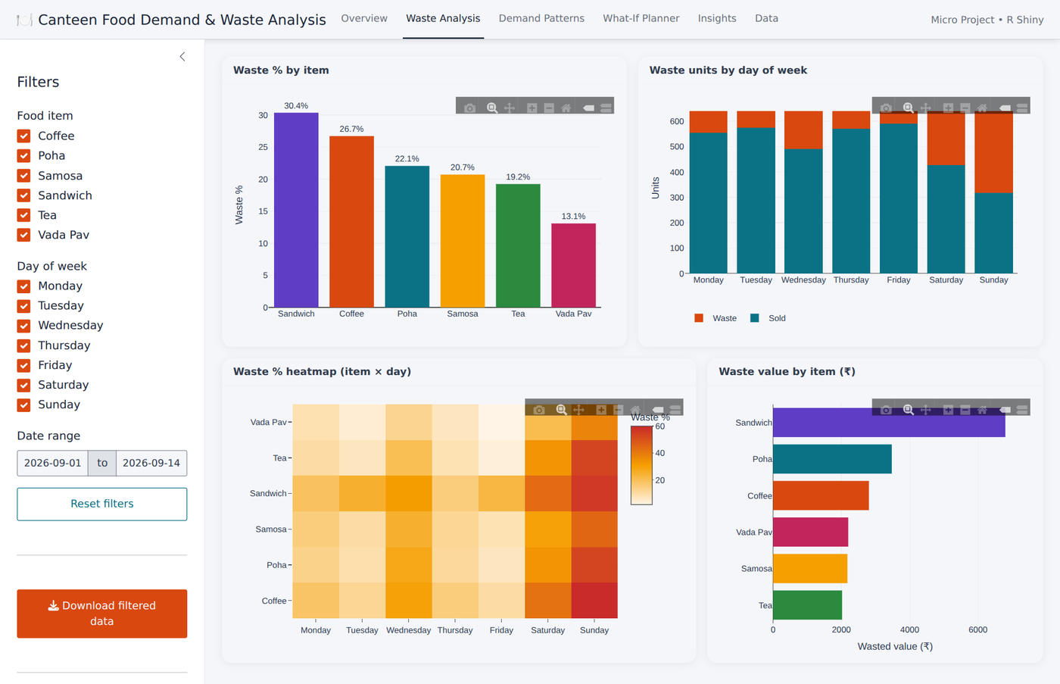
Figure 12: Dashboard – Waste Analysis tab
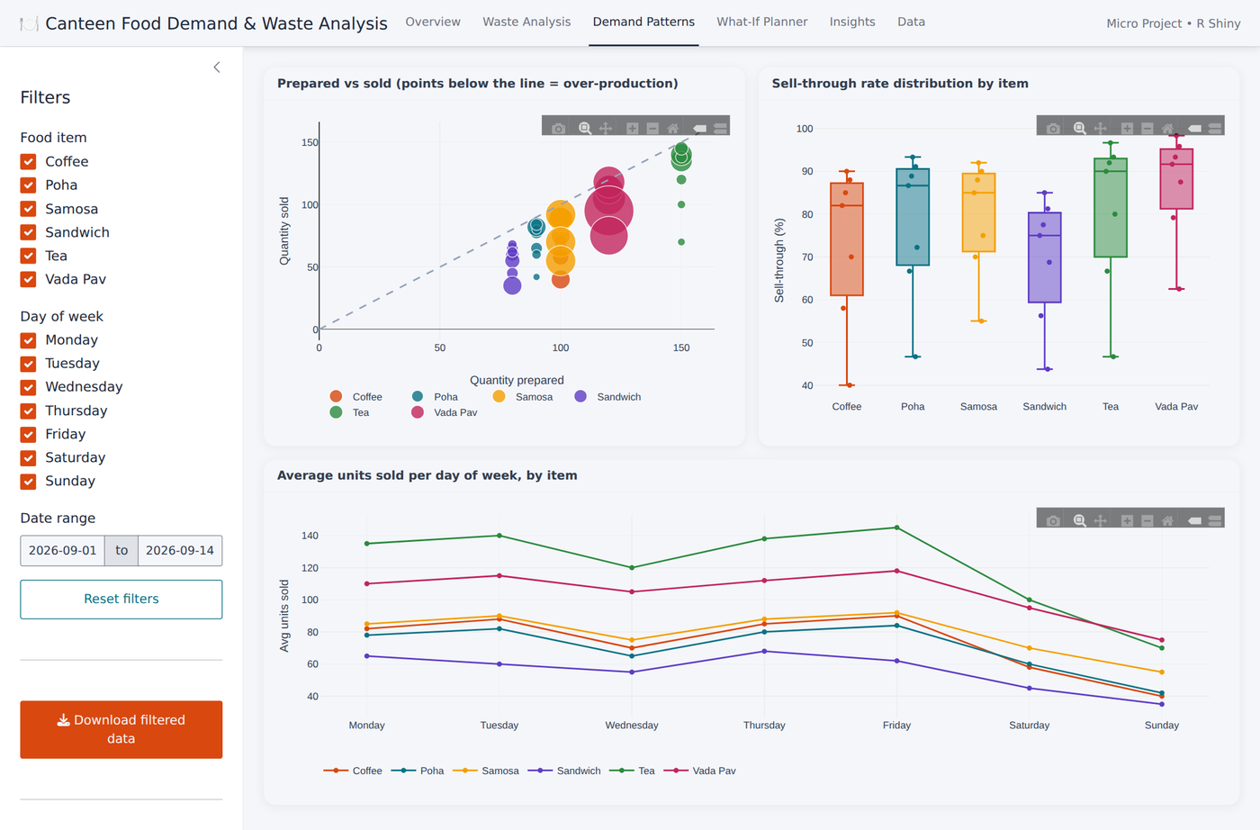
Figure 13: Dashboard – Demand Patterns tab
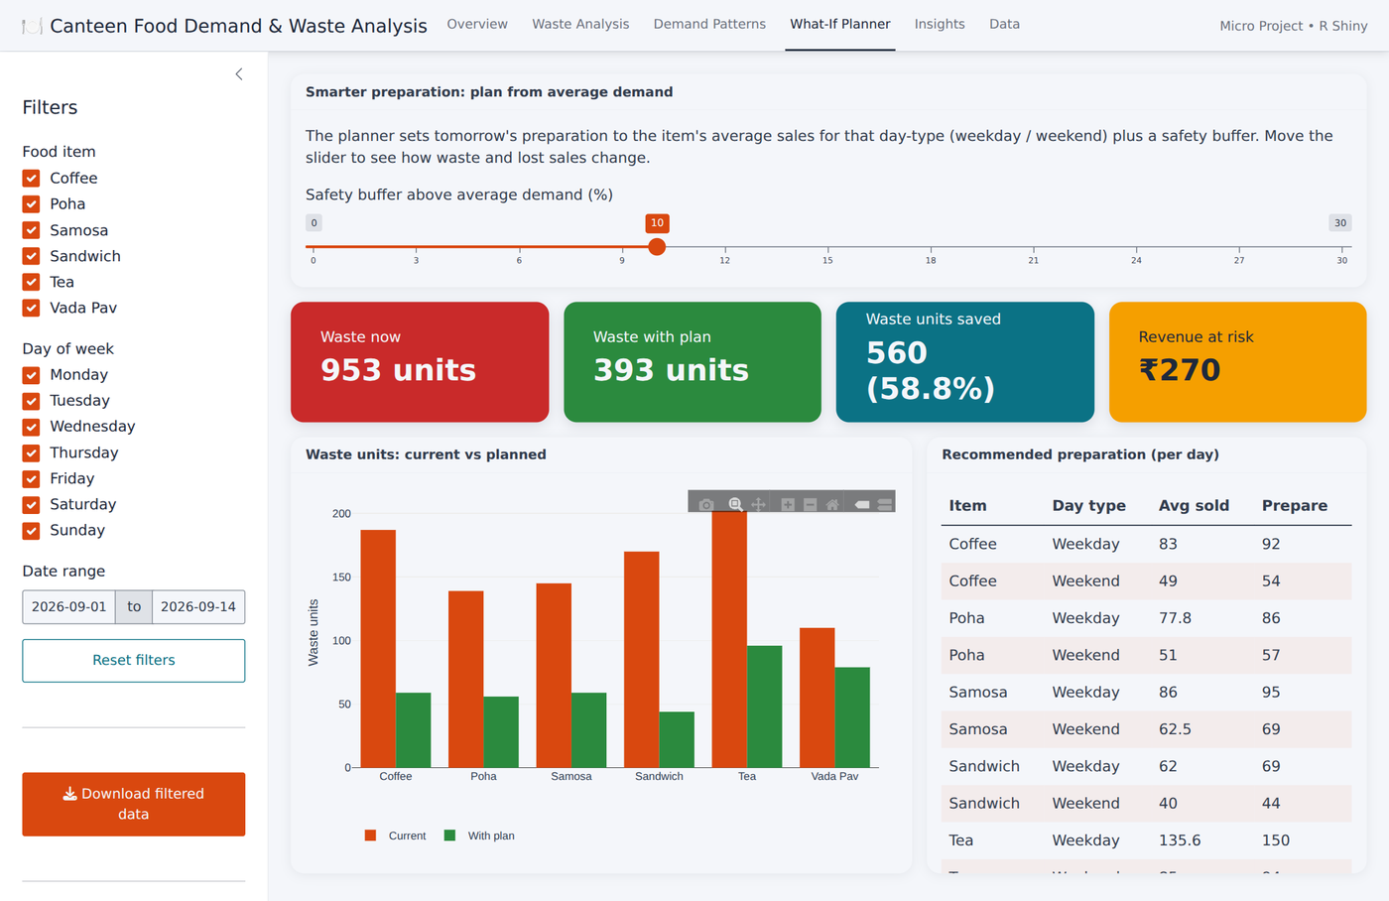
Figure 14: Dashboard – What-If Planner tab (10% buffer)
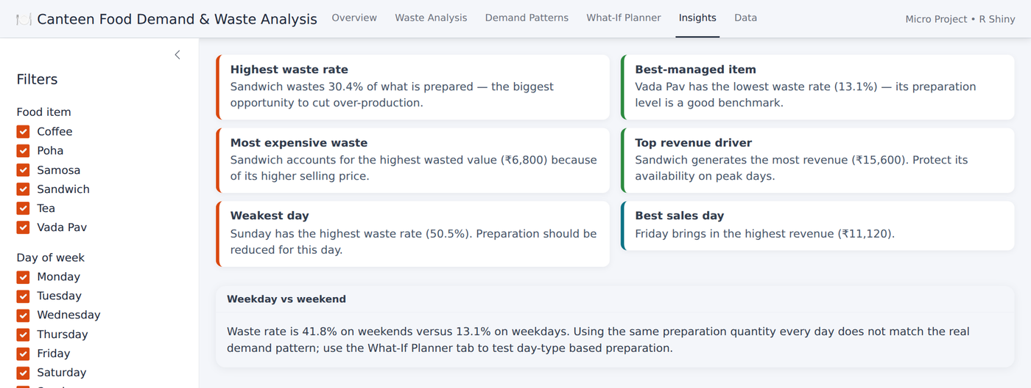
Figure 15: Dashboard – Insights tab
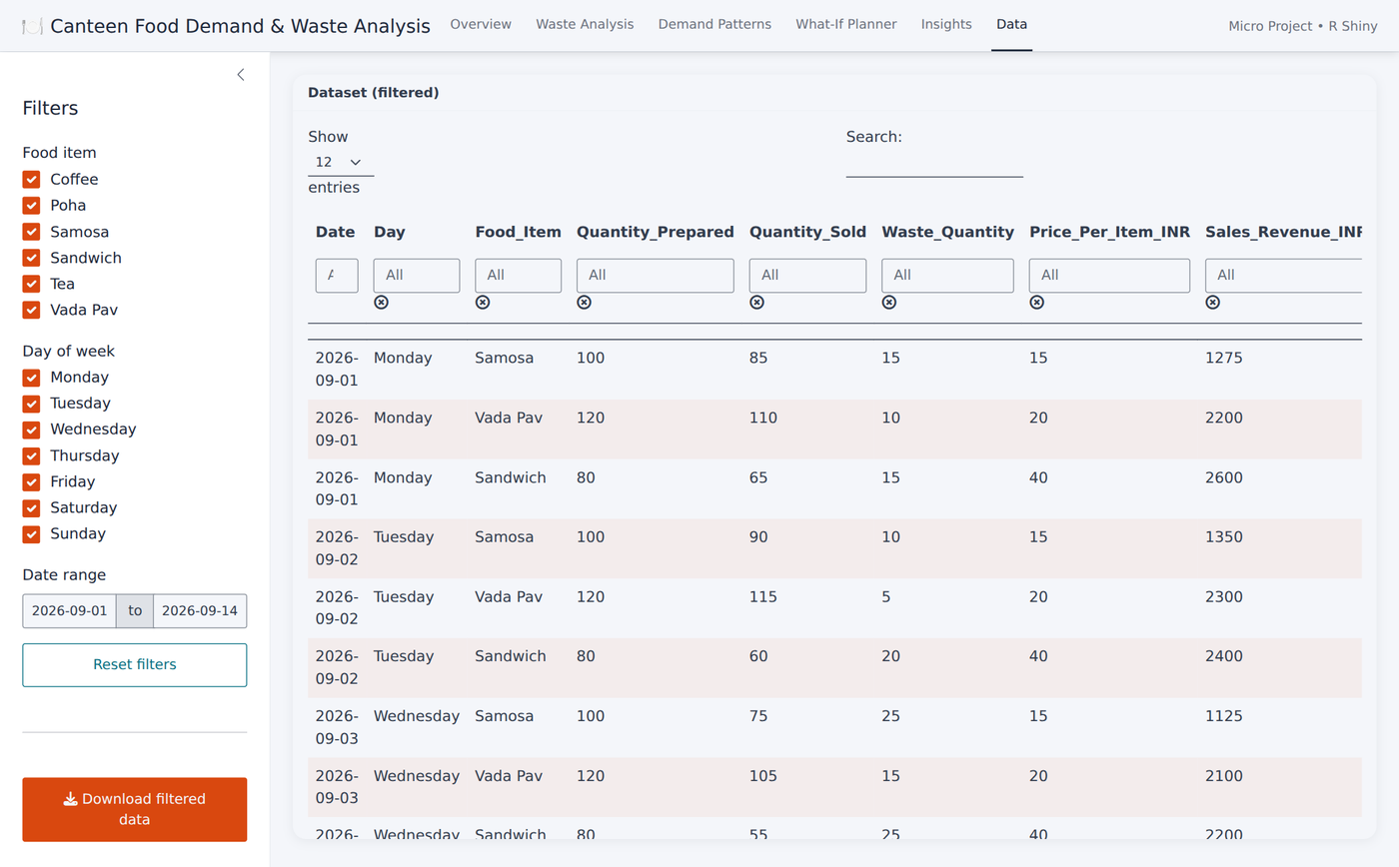
Figure 16: Dashboard – Data tab

6.9 Limitations
- The dataset is small (42 records, 14 days) and each item is seen in one week only, so the results are not general rules for all canteens or all weeks.
- The project is descriptive; tests and correlations do not prove that any factor causes waste, and no forecasting model was built.
- Waste is valued at the selling price. The real cost of waste is the cost of ingredients and labour, which is not in the file.
- The what-if estimate uses the same data to set and to evaluate the plan and assumes that sales equal demand; it must be validated on new data.
- Information about weather, events, timetable and menu changes is not available, so reasons for the weekend and Wednesday patterns cannot be tested.
- The Day labels do not match the calendar dates; the labels were used as recorded.
- The dashboard runs locally and has not been deployed online; the screenshots in Figures 11–16 were taken from the running application.

7. Skills Developed
Area | Skills
Data handling | Importing a CSV, validating missing values, duplicates and arithmetic consistency, and deriving new variables
Exploratory analysis | Totals, percentages, group summaries, comparing weekdays with weekends, correlation, Kruskal–Wallis and Wilcoxon signed-rank tests
Visualisation | Choosing suitable chart types, building ggplot2 charts, heatmaps and box plots
Dashboard development | R Shiny, bslib layouts, plotly interactivity, reactive filters, DT tables and file download
Decision support | Building a what-if planner that links data analysis to a practical decision
Critical thinking | Recognising the limits of a small sample, spotting an item-mix and a weekday-label problem, and stating limitations honestly
Documentation | Reproducible scripts and a structured technical report

8. Applications of the Micro Project
- Canteen and mess management: planning daily preparation quantities by item and day to reduce waste and save money.
- Food service businesses: hostels, cafeterias, tiffin services and small restaurants can reuse the same method with their own sales and waste records.
- Sustainability reporting: measuring and tracking food waste as a first step towards reduction targets.
- Education: demonstrating a complete R workflow of validation, exploration, visualisation, statistical testing and dashboard building on a simple business problem.

9. Conclusion
The micro project validated, analysed and visualised the canteen preparation, sales and waste records of 14 days using R and presented the results in an interactive Shiny dashboard. The 42 records contained no missing values or duplicates, and the quantities and revenues were arithmetically consistent. Of 4,480 units prepared, 3,527 were sold and 953 (21.3%) were wasted, worth ₹19,475 at selling prices. Sandwich has the highest waste rate and value, and Vada Pav is the best managed. The strongest finding is the weekend effect: the same quantity is prepared every day although average sales fall by about one-third on Saturday and Sunday, so the weekend waste rate is 41.8% against 13.1% on weekdays (Wilcoxon signed-rank p = 0.031), and waste differs significantly between days (Kruskal–Wallis p < 0.001) but not clearly between items. A what-if estimate showed that preparing the average weekday or weekend demand plus a 10% buffer would cut waste by about 59% at a small risk to sales. Important limitations are the small sample, the fact that each item is recorded in only one week, the mismatch between day names and calendar dates, and the use of selling price instead of cost. The project gave practical experience of the full R workflow from data validation to an interactive dashboard and reports only recorded results. Future scope includes collecting several weeks of data for all items, correcting the day labels, adding ingredient cost, building a demand forecast and deploying the dashboard on a public Shiny server.

10. References
1. United Nations Environment Programme, “Food Waste Index Report 2021,” UNEP, Nairobi, 2021.
2. J. Gustavsson, C. Cederberg, U. Sonesson, R. van Otterdijk and A. Meybeck, “Global Food Losses and Food Waste: Extent, Causes and Prevention,” Food and Agriculture Organization of the United Nations, Rome, 2011.
3. E. A. Silver, D. F. Pyke and D. J. Thomopoulos, Inventory and Production Management in Supply Chains, 4th ed. Boca Raton, FL: CRC Press, 2016.
4. J. W. Tukey, Exploratory Data Analysis. Reading, MA: Addison-Wesley, 1977.
5. H. Wickham, “Tidy Data,” Journal of Statistical Software, vol. 59, no. 10, pp. 1–23, 2014, doi: 10.18637/jss.v059.i10.
6. H. Wickham and G. Grolemund, R for Data Science. Sebastopol, CA: O’Reilly Media, 2017.
7. H. Wickham, ggplot2: Elegant Graphics for Data Analysis, 2nd ed. Cham: Springer, 2016.
8. C. Sievert, Interactive Web-Based Data Visualization with R, plotly, and shiny. Boca Raton, FL: Chapman and Hall/CRC, 2020.
9. W. Chang et al., “shiny: Web Application Framework for R,” R package. Available: https://shiny.posit.co
10. S. Few, Information Dashboard Design: The Effective Visual Communication of Data. Sebastopol, CA: O’Reilly Media, 2006.
11. F. Wilcoxon, “Individual comparisons by ranking methods,” Biometrics Bulletin, vol. 1, no. 6, pp. 80–83, 1945.
12. W. H. Kruskal and W. A. Wallis, “Use of ranks in one-criterion variance analysis,” Journal of the American Statistical Association, vol. 47, no. 260, pp. 583–621, 1952.
13. R Core Team, “R: A Language and Environment for Statistical Computing,” R Foundation for Statistical Computing, Vienna, Austria. Available: https://www.r-project.org

