**PART A**

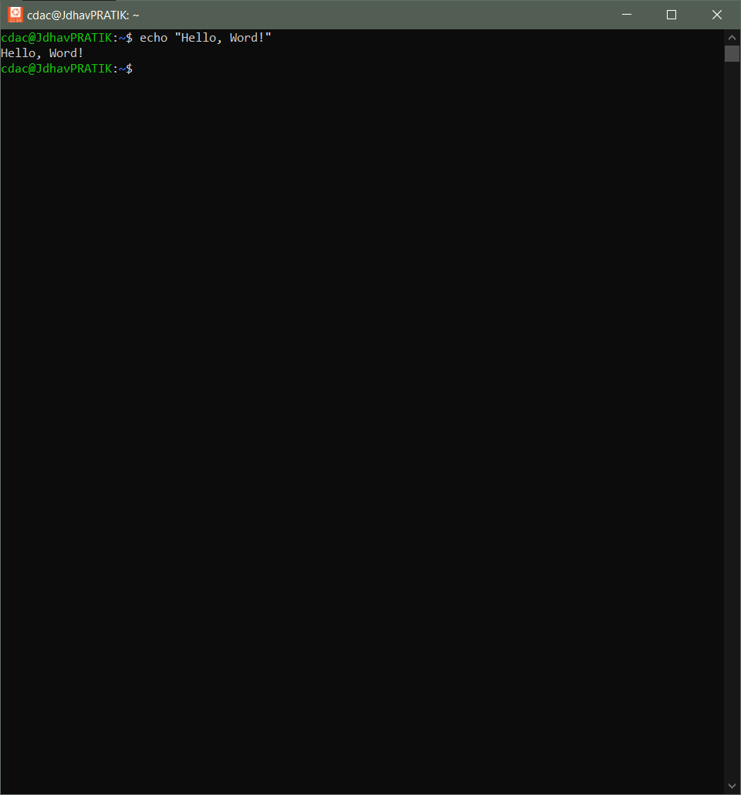**echo** command will print data inside double quotes.

-------------------------------------------------------------------------

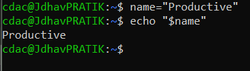name=”Productive” “=” will assign a value to “name” variable

--------------------------------------------------------------------------------------------

touch file.txt will create empty file.



--------------------------------------------------------------------------------------------

ls -a command shows hidden files.

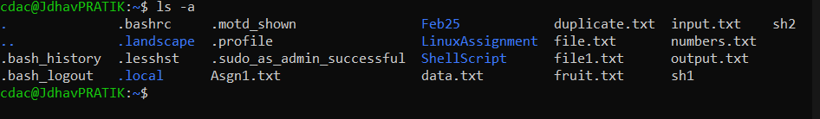

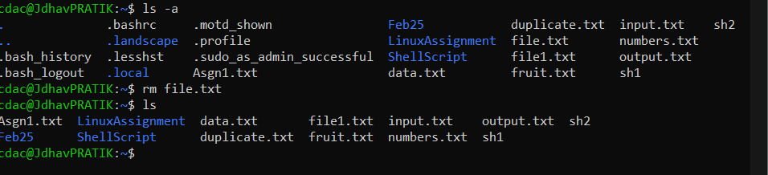rm file.txt command delete the file.txt.

--------------------------------------------------------------------------------------------

cp file0.txt file2.txt command copies the content of file0.txt to file2.txt.

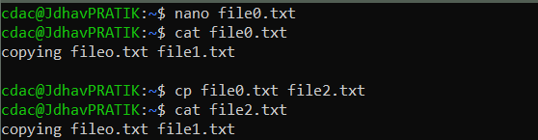

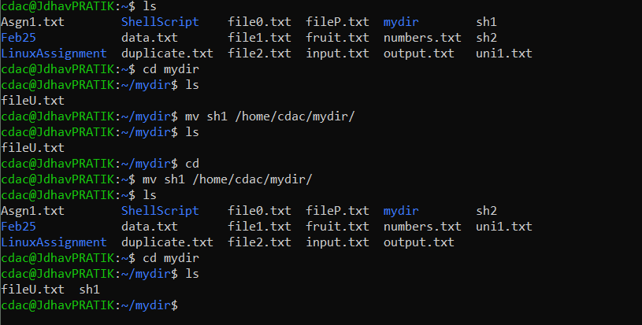mv sh1/home/cdac/mydir this command will move sh1 file to mydir directory.

--------------------------------------------------------------------------------------------

Chmod 755 script.sh command use to give read, write and execute permission to owner and read and execute permission to group

and other users respect. To script.sh.

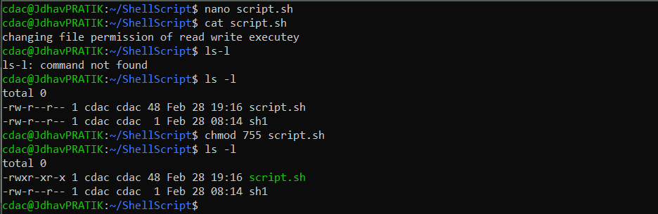

--------------------------------------------------------------------------------------------

grep “pattern” file.txt command will search for specific given pattern

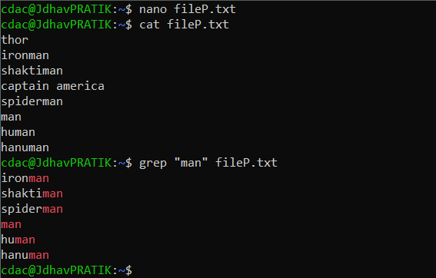and will display.

--------------------------------------------------------------------------------------------

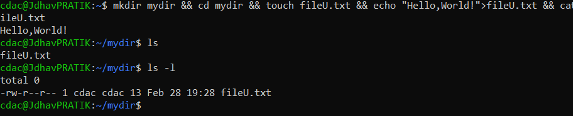

mkdir mydir && cd mydir && touch fileU.txt && echo “Hello,World”>fileU.txt &&cat fileU.txt

mkdir command creates a mydir directory

cd command will change currant directory to new created mydir directory

touch fileU.txt will create an empty file

echo command will display “Hello, World” on terminal

redirect operator > command will insert into fileU.txt

&& operator helps to use more than one commands in one command.



--------------------------------------------------------------------------------------------

ls -l | grep”.txt” piping command will combine the output of ls and group command.

-l will show details of contents.

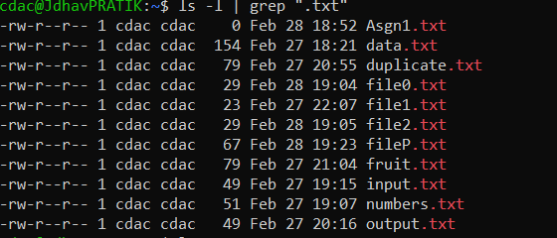

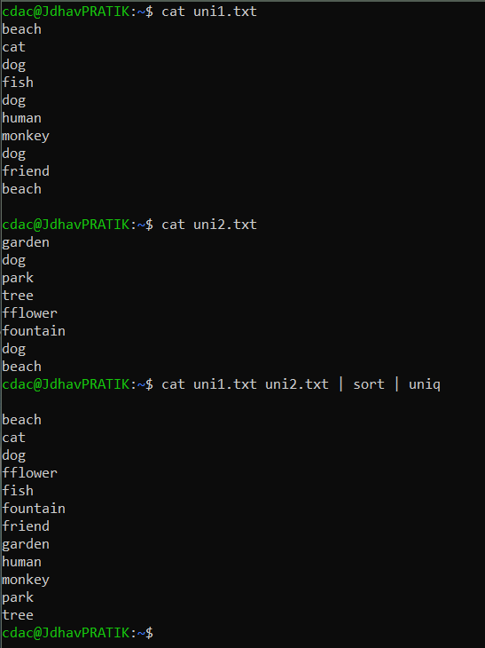cat uni1.txt uni2.txt | sort | uniq cat command will display content of both the files

sort command will sort the contents of both file

uniq will display only Unique content.

--------------------------------------------------------------------------------------------

ls -l | grep “^d”

-l will display the details of files.

grep “^d” will show lines starting with letter d

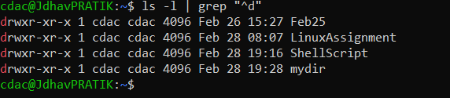particularly this command filter out directories.

grep -r “Pattern” /path/to/directory/

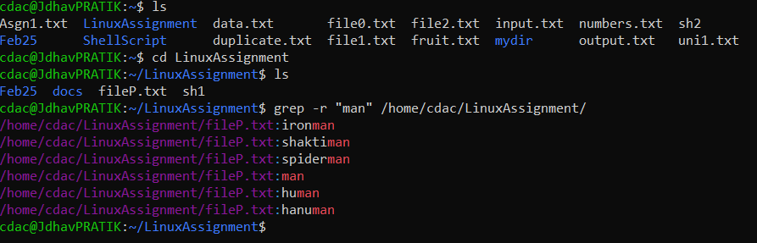this command will display particular pattern contents of given directory.

--------------------------------------------------------------------------------------------

Cat uni1.txt uni2.txt | sort uniq -d

This command will take contents of both files and display only duplicate content.

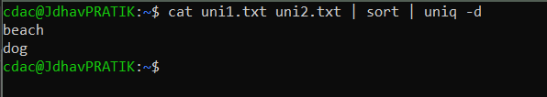

--------------------------------------------------------------------------------------------

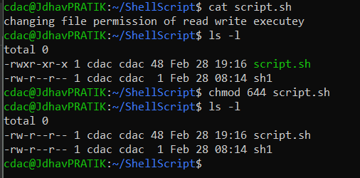chmod 644 script.shh modifies the permission of file.

--------------------------------------------------------------------------------------------

Cp -r Feb25 LinuxAssignment command will copy Feb25 Directory to LinuxAssignment directory

-r will copy it recursively

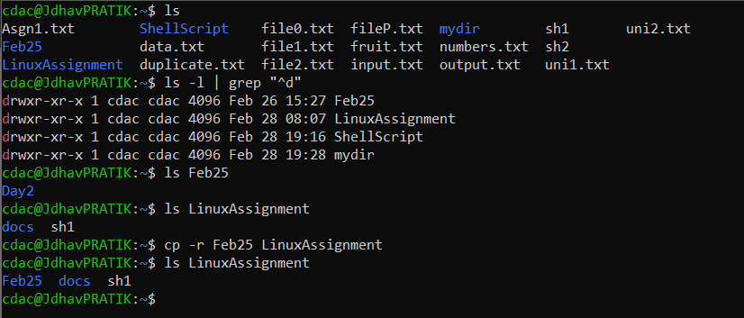

------------------------------------------------------------------------------------

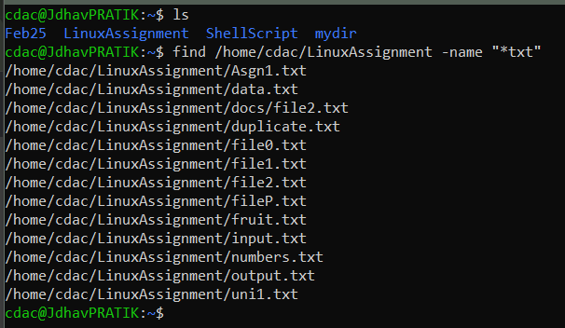Find /home/cdac/LinuxAssignment -name “*txt” this command will search file ending with .txt in directories.

--------------------------------------------------------------------------------------------

Chmod u+x script.sh command will modify permissions to execute script.sh to owner of the file.

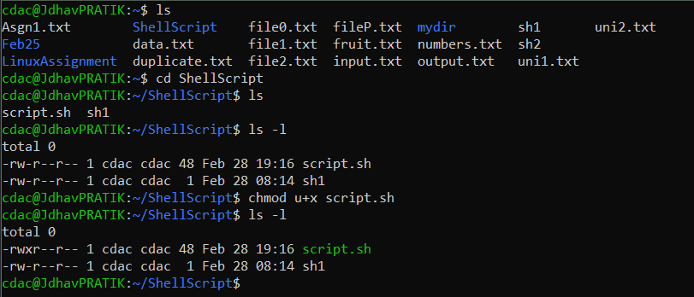

--------------------------------------------------------------------------------------------

**PART B**

Identify true or false

* ls is used to list files and directories in a directory. – TRUE
* mv is used to move files and directories. -TRUE
* cd is used ton copy files and directories. – FALSE

it is used to change the directory.

* Pwd stands for “Print Working Directory” and displays the current directory. – TRUE
* grep is used to search for patterns in files. -TRUE
* chmod 755 file.txt gives read, write, and execute permissions to group and others. -TRUE
* rm -rf file.txt deletes a file forcefully without confirmation.-FALSE

-r is used for deleting directories.

Identify the incorrect commands:

1.chmodx is used to change file permissions.

Chmod command is used to change file permissions.

2.cpy is used to copy files and directories.

Cp command is used to copy files and directories.

3.mkfile is used to create a new file.

Touch command is used to create a new file.

Mkdir command is used to create a new directory.

4.catx is used to concatenate files.

Cat command is used to concatenate files.

5.rn is used to rename files.

Mv command is used to rename files when 2 files names are passed

As arguments.

**PART C**

Q1.write a shell script that prints “Hello, World!” to the terminal.

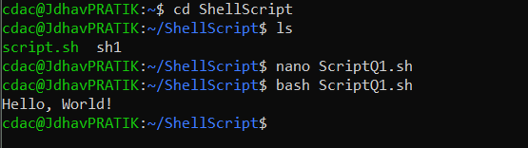

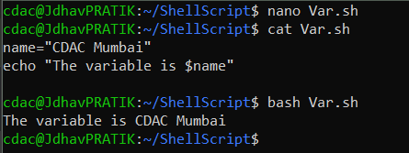Q2 Declare a variable named “name ” and assign the value “CDAC Mumbai” to it. Print the value of the variable.

Q3. Write a shell script that takes a number as input from the user and prints it.



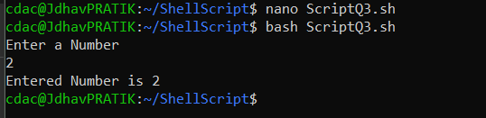

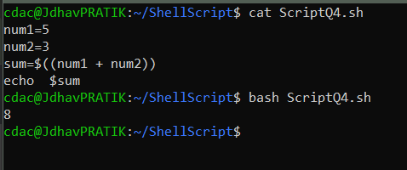Q4. Write a shell script that performs addition of two numbers(e.g 5 and 3) and prints the result.

Q5. Write a shell script that takes a number as input and prints “Even” if it even, otherwise prints “odd”.

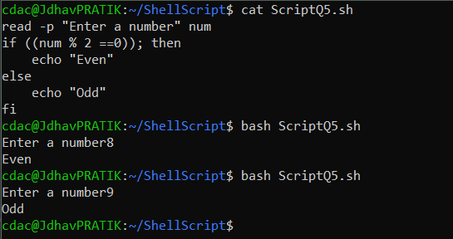

Q6. Write a shell script that uses a for loop to print number from 1 to 5.

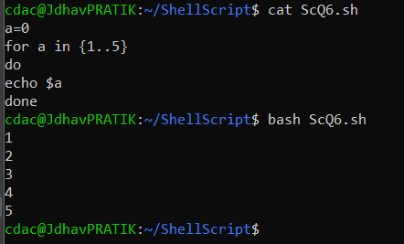

Q7. Write a shell script that uses a while loop to print number from 1 to 5.

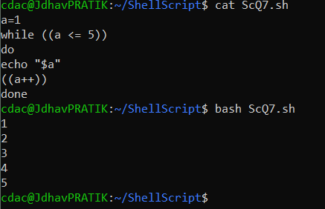

--------------------------------------------------------------------------------------------

Q8. Write a shell script that checks if a file named “file.txt” exists in the current directory. If it does, print “file exists”, otherwise, print “file does not exist”

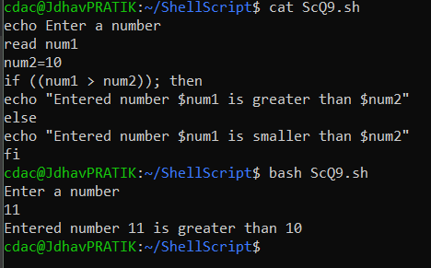

Q9. Write a shell script that uses the if statement to check if a number is greater than 10 and prints a message accordingly.

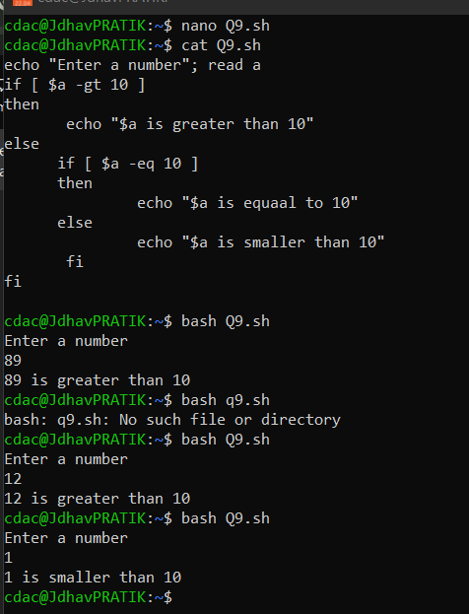

Q10. Write a shell script that uses nested for loops to print a multiplication table for numbers from 1 to 5. The output

Should be formatted nicely, with each row representing a number and each column representing the multiplication result for that number.

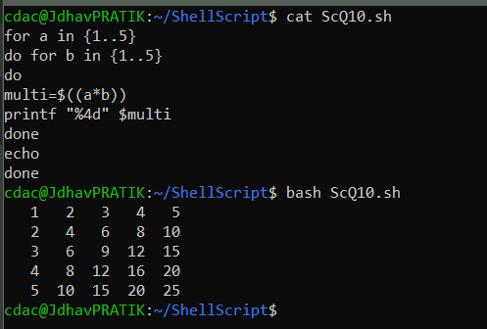

Q11. Write a shell script that uses a while loop read numbers from the user until the user enters a negative number. Use the break statement to exit the loop when a negative number is entered.

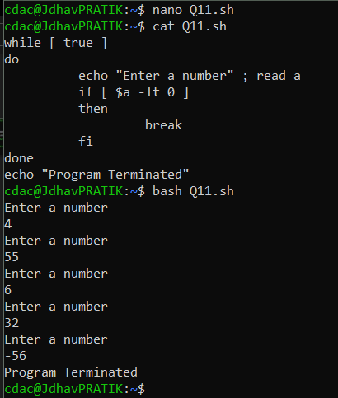

**PART E**

Q1. FCFS

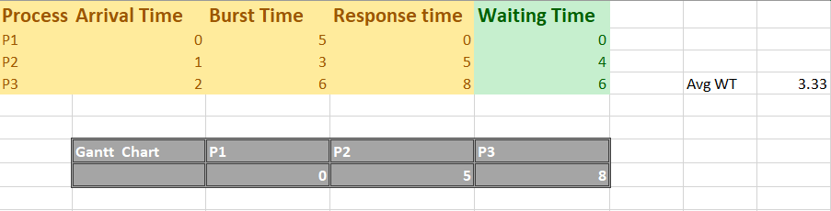

Q2. SJF

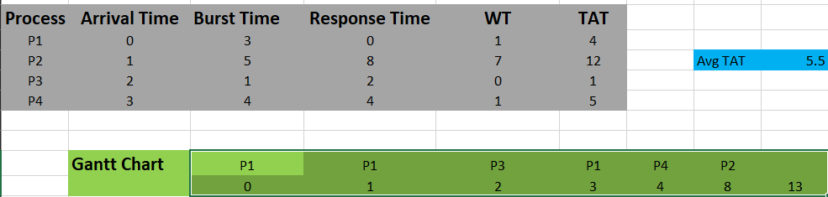

Q3 Priority Scheduling

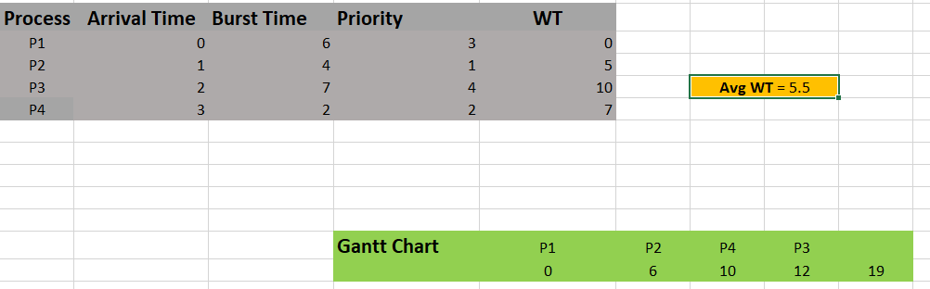

Q4

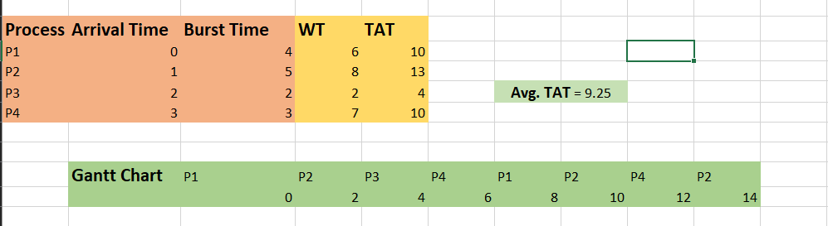

Q5.

* Fork() system call creates a child process which creates clone copy of parent process
* Final value of X = 6
* Child process x = 6