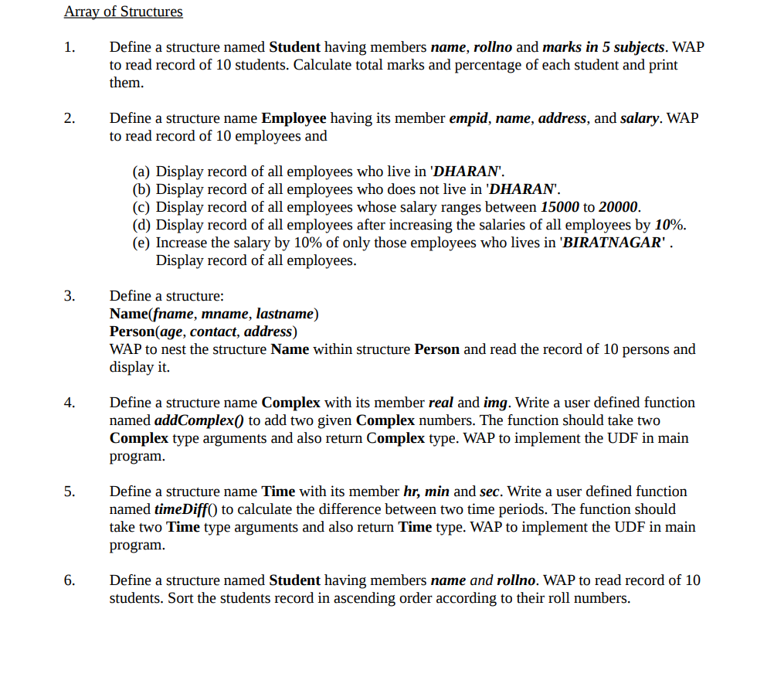

1).

a).

#include<stdio.h>

struct employee

{

int empid ,salary;

char name[10],address[10];

};

int main()

{

int n,i;

printf("enter a number of people lives in dharan :");

scanf("%d",&n);

struct employee s1[n];

for(i=0;i<n;i++)

{

printf("enter a employee id :");

scanf("%d",&s1[i].empid);

printf("enter a employee name :");

scanf("%s",s1[i].name);

printf("entera a employee address :");

scanf("%s",s1[i].address);

printf("enter a employee salary :");

scanf("%d",&s1[i].salary);

printf("the employee id is :%d\n",s1[i].empid);

printf("the employee name is :%s\n",s1[i].name);

printf("the employee address is :%s\n",s1[i].address);

printf("the employee salary is :%d\n",s1[i].salary);

}

return 0;

}

b).

#include<stdio.h>

struct employee

{

int empid ,salary;

char name[10],address[10];

};

int main()

{

int n,i;

printf("enter a number of people who does not lives in dharan :");

scanf("%d",&n);

struct employee s1[n];

for(i=0;i<n;i++)

{

printf("enter a employee id :");

scanf("%d",&s1[i].empid);

printf("enter a employee name :");

scanf("%s",s1[i].name);

printf("entera a employee address :");

scanf("%s",s1[i].address);

printf("enter a employee salary :");

scanf("%d",&s1[i].salary);

printf("the employee id is :%d\n",s1[i].empid);

printf("the employee name is :%s\n",s1[i].name);

printf("the employee address is :%s\n",s1[i].address);

printf("the employee salary is :%d\n",s1[i].salary);

}

return 0;

}

c).

#include<stdio.h>

struct employee

{

int empid ,salary;

char name[10],address[10];

};

int main()

{

int n,i;

printf("enter a number of Employee who lives in dharan :");

scanf("%d",&n);

struct employee s1[n];

for(i=0;i<n;i++)

{

printf("EMPLOYEE %d\n",i+1);

printf("Enter a Employee id :");

scanf("%d",&s1[i].empid);

printf("Enter a Employee name :");

scanf("%s",s1[i].name);

printf("Entera a Employee address :");

scanf("%s",s1[i].address);

printf("Enter a Employee salary :");

scanf("%d",&s1[i].salary);

}

printf("\n Name ranges between 15000-20000\n");

printf("Emp id \t Emp name \tEmp address \t Emp salary\n");

for(i=0;i<n;i++)

{if(s1[i].salary>=15000 && s1[i].salary<=20000 )

{

printf("%d \t %s \t \t%s \t\t %d \t\n",s1[i].empid,s1[i].name,s1[i].address,s1[i].salary);

}

}

return 0;

}

d).

#include<stdio.h>

struct employee

{

int empid ,salary;

char name[10],address[10];

};

int main()

{

int n,i,percent;

printf("enter a number of Employee who lives in dharan :");

scanf("%d",&n);

struct employee s1[n];

for(i=0;i<n;i++)

{

printf("EMPLOYEE %d\n",i+1);

printf("Enter a Employee id :");

scanf("%d",&s1[i].empid);

printf("Enter a Employee name :");

scanf("%s",s1[i].name);

printf("Entera a Employee address :");

scanf("%s",s1[i].address);

printf("Enter a Employee salary :");

scanf("%d",&s1[i].salary);

}

printf("by increasing salary by 10%%\n ");

printf("Emp Id\t\tEmp name\tEmp Address\t Emp salary\n");

for(i=0;i<n;i++)

{

percent=(float)(0.1)\*s1[i].salary+s1[i].salary;

printf("%d\t\t%s\t\t%s\t\t%d\t\n",s1[i].empid,s1[i].name,s1[i].address,percent);

}

return 0;

}

e).

#include<stdio.h>

struct employee

{

int empid ,salary;

char name[10],address[10];

};

int main()

{

int n,i,percent;

printf("enter a number of Employee who lives in dharan :");

scanf("%d",&n);

struct employee s1[n];

for(i=0;i<n;i++)

{

printf("EMPLOYEE %d\n",i+1);

printf("Enter a Employee id :");

scanf("%d",&s1[i].empid);

printf("Enter a Employee name :");

scanf("%s",s1[i].name);

printf("Entera a Employee address :");

scanf("%s",s1[i].address);

printf("Enter a Employee salary :");

scanf("%d",&s1[i].salary);

}

printf("by increasing salary by 10%%\n ");

printf("Emp Id\t\tEmp name\tEmp Address\t Emp salary\n");

if(s1[i].address =='biratnagar')

{ for(i=0;i<n;i++)

{

percent=(float)(0.1)\*s1[i].salary+s1[i].salary;

printf("%d\t\t%s\t\t%s\t\t%d\t\n",s1[i].empid,s1[i].name,s1[i].address,percent);

}}

else

{ for(i=0;i<n;i++)

{

printf("%d\t\t%s\t\t%s\t\t%d\t\n",s1[i].empid,s1[i].name,s1[i].address,s1[i].salary);

}}

return 0;

}

2).

#include<stdio.h>

struct student

{

char name[10];

int rollno,mark,k;

};

int main()

{

struct student s1[10];

int total=500;

float z;

int i,k=0;

printf("enter a detail fot 10 student\n");

for(i=0;i<10;i++)

{

printf("enter a name of %d student :",i+1);

scanf("%s",s1[i].name);

printf("enter a roll no %d student :",i+1);

scanf("%d",&s1[i].rollno);

int j;

for(j=0;j<5;j++)

{

printf("enter a mask in %d subject :",j+1);

scanf("%d",&s1[j].mark);

}

printf("the name of student is :%s \n",s1[i].name);

printf("the roll no of student is :%d \n",s1[i].rollno);

for(j=0;j<5;j++)

{

k+=s1[j].mark;

}

printf("the total mask otained is %d\n",k);

z=(float)k/total \* 100;

printf("percent = %.2f%%\n",z);

k-=k;

}

return 0;

}

3).

#include<stdio.h>

struct name

{

char fname[10],mname[10],lastname[10];

};

struct person

{

int age ,contact;

char add[10];

};

int main()

{

struct person s1[3];

struct name s2[3];

int i;

for(i=0;i<2;i++)

{

printf("Person %d\n\n",i+1 );

printf("Enter a first name : ");

scanf("%s",s2[i].fname);

printf("Enter a middle name : ");

scanf("%s",s2[i].mname);

printf("Enter a last name : ");

scanf("%s",s2[i].lastname);

printf("enter a person age :");

scanf("%d",&s1[i].age);

printf("enter a person contact :");

scanf("%d",&s1[10].contact);

printf("enter a person address :");

scanf("%s",s1[i].add);

}

for(i=0;i<2;i++)

{ printf("The Name of Person is : %s %s %s\n",s2[i].fname,s2[i].mname,s2[i].lastname);

printf("the person age is :%d\n",s1[i].age);

printf("the person contact is :%d\n",s1[i].contact);

printf("the person contact is :%s\n",s1[i].add);

}

return 0;

}

4)

#include<stdio.h>

typedef struct time

{

int hr,min,sec;

}time;

time timediff(time,time);

int main()

{

int i;

struct time t1,t2,t3;

{ printf("enter a hour :");

scanf("%d",&t1.hr);

printf("enter a first minute : ");

scanf("%d",&t1.min);

printf("enter a second :");

scanf("%d",&t1.sec);

printf("enter a 2nd hour :");

scanf("%d",&t2.hr);

printf("enter a 2nd minute :");

scanf("%d",&t2.min);

printf("enter a 2nd second :");

scanf("%d",&t2.sec);

t3=timediff(t1,t2);

printf("\nthe final hour is %d:%d:%d -",t3.hr,t3.min,t3.sec);

return 0;

}

}

time timediff(time x,time y)

{

time z;

z.hr=x.hr-y.hr;

z.min =x.min -y.min;

z.sec=x.sec - y.sec;

return z;

}

5).

#include<stdio.h>

struct student

{

int rollno;

char name[5];

};

int main()

{

struct student p[4],q[4],temp;

int i,j;

for(i=0;i<4;i++)

{printf("enter a %d student name :",i+1);

scanf("%s",p[i].name);

printf("entera a %d roll no :",i+1);

scanf("%d",&p[i].rollno);

}

for(i=0;i<4;i++)

{

q[i]=p[i];

for(j=i;j<4;j++)

{

if(q[i].rollno > p[j].rollno)

{

temp=p[i];

p[i]=p [j];

p[j]=temp;

}

}

}

printf("the student in asceding order are \n");

for(i=0;i<4;i++)

{

printf(" %d - %s\n ",p[i].rollno,p[i].name);

}

return 0;

}