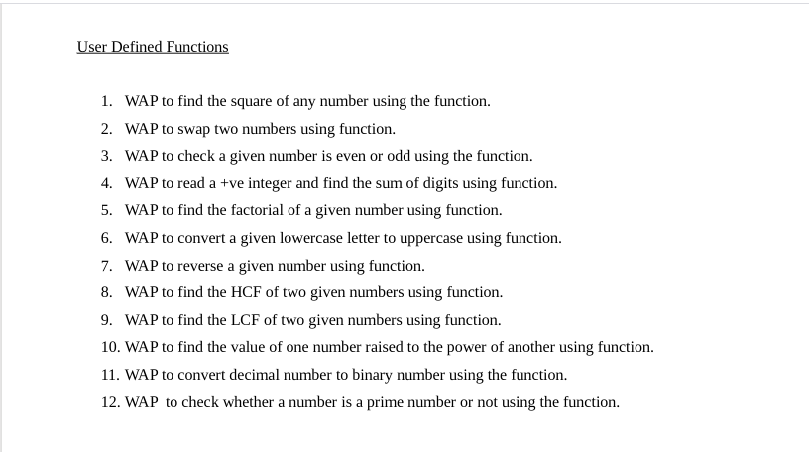

`1).

#include<stdio.h>

int squ(int);

int main()

{

int n,res;

printf("enter a number: ");

scanf("%d",&n);

res=squ(n);

printf("the square of number is %d\n",res);

return 0;

}

int squ(int a)

{

int c;

c=a*a;

return c;

}

2).

#include<stdio.h>

int swap(int,int);

int main()

{

int a,b;

printf("enter a number a and b:");

scanf("%d %d",&a,&b);

printf("\nthe num before swaping a=%d and b=%d",a,b);

swap(a,b);

return 0;

}

int swap(int x,int y)

{

int z;

z=x;

x=y;

y=z;

printf("\nthe num after swapping a=%d and b=%d\n",x,y);

}

3).

#include<stdio.h>

int oddeven(int);

int main()

{

int a;

printf("enter a number a:=" );

scanf("%d",&a);

oddeven(a);

return 0;

}

int oddeven(int x)

{

if (x % 2 == 0)

{

printf("the number is even\n ");

}

else

{

printf("the number is odd\n");

}

}

4).

#include<stdio.h>

int positive(int);

int main()

{

int n;

printf("enter a n th term: ");

scanf("%d",&n);

positive(n);

return 0;

}

int positive(int x)

{

int i,sum=0;

for(i=1;i<=x;i++)

{

sum +=i;

}

printf("%d\n",sum);

}

5).

#include<stdio.h>

int fact(int);

int main()

{

int n;

printf("enter a n number:");

scanf("%d",&n);

fact(n);

return 0;

}

int fact(int n)

{

int i,fac=1;

if (n<0)

{

printf("the factorial does not exists");

}

else

{

for (i=1;i<=n;i++)

{

fac *=i;

}

printf("the factorial is: %d\n",fac);

}

}

6).

#include<stdio.h>

int upper(char);

int main()

{

char c,s;

printf("enter a character:");

scanf("%c",&c);

upper(c);

return 0;

}

int upper(char x)

{

if(x>='a' && x<='z')

{

x= x-32;

printf("the upper case is:%c\n",x);

}

else

{

printf("is not a lower case ");

}

return 0;

}

7).

#include<stdio.h>

int rev(int);

int main()

{

int n;

printf("enter a number:");

scanf("%d",&n);

rev(n);

return 0;

}

int rev(int x)

{

int rem,revn=0;

while(x!=0)

{

rem= x % 10;

revn= revn *10 + rem;

x= x / 10;

}

printf("the reverse number is :%d",revn);

}

8).

#include<stdio.h>

int hcf(int,int);

int main()

{

int a,b;

printf("enter a two number:");

scanf("%d%d",&a,&b);

hcf(a,b);

return 0;

}

int hcf(int x,int y)

{

int a,b,t,HCF;

a=x;

b=y;

while(b!=0)

{

t=b;

b= a % b;

}

a=t;

HCF=a;

printf("the hcf is:%d",HCF);

}

9).

#include<stdio.h>

int hcf(int,int);

int upper(char);

int main()

{

int a,b;

char c,s;

printf("enter a two number:"); scanf("%d%d",&a,&b);

hcf(a,b);

return 0;

}

int hcf(int x,int y)

{

int a,b,t,HCF,LCM;

a=x;

b=y;

while(b!=0)

{

t=b;

b= a % b;

}

a=t;

HCF=a;

LCM=(x*y)/HCF;

printf("the lcm is:%d\n",LCM);

}

10).

#include<stdio.h>

#include<math.h>

int power(int,int);

int main()

{

int a,b,res;

printf("enter a two number :");

scanf("%d%d",&a,&b);

res=power(a,b);

printf("the power of number is %d\n",res);

return 0;

}

int power(int x , int y)

{

int p=1,a,b;

b=y;

while(y!=0)

{

p=p*x;

y=y-1;

}

return p;

}

11).

**#include<stdio.h>**

**int deci(int);**

**int main()**

**{**

**int num;**

**printf("enter a decimal number:");**

**scanf("%d",&num);**

**deci(num);**

**return 0;**

**}**

**int deci(int numb)**

**{**

**int rem,place=1,bin=0;**

**while (numb !=0)**

**{**

**rem = numb % 2;**

**numb = numb /2;**

**bin =bin +(rem * place);**

**place =place *10;**

**}**

**printf("thne binary of number is :%d\n",bin);**

**}**

**12).**

#include<stdio.h>

int prime(int);

int main()

{

int n;

printf("enter a number:");

scanf("%d",&n);

prime(n);

return 0;

}

int prime(int x)

{

int i,count=0;

for(i=1;i <= x ;i++)

{

if(x % i==0)

{

count ++;

}

}

if (count==2)

{

printf("the %d is prime number\n",x);

}

else{

printf("the %d is not prime \n",x);

}

}